Z1 PROTOCOL
TOKEN LIFECYCLE SPECIFICATION

Full Mechanisms, Economic Levers, Stability Controls, and Nudge Mechanisms

Derived from MSML Vault v2 (349 notes), DOC-013 through DOC-019
Including all implementation patterns, stability mechanisms, and boundary behavior monitors

provecto labs.
Phase 2, Track A | v2.0 | May 2026

0. Document Purpose and Scope
This document traces the complete lifecycle of both token instruments in the Z1 dual-economy protocol. It follows a token unit from genesis minting, through the recognition economy, across the settlement bridge, into the utility economy, through usage and value capture, and out through exit paths.
Version 2.0 expands the specification to include every stability mechanism, nudge control, and implementation-level detail from DOC-018 (Implementation Patterns). This includes the Baseline Activity Score (BAS), hash-based vesting stagger, graduated settlement throttle, tier ratchet-with-decay, PCS 4-stage computation, signal capping (ACTION_CAP), quality signal composite, tiered slashing, and boundary behavior monitors.
At each lifecycle stage, the document specifies the mechanisms (M01-M57), gates (G0-G18), policies (P01-P44), and economic levers that govern the transition.

1. Genesis Minting (t = 0)
At genesis, 1 trillion Z1U is minted in a single event and distributed across seven time-locked vaults per constitutional allocations (PAR-03). No Z1U enters circulation at t=0.
Vault | Alloc | Purpose | Release
Audience Reserve (AR) | 30% | Fund ACR settlements via G3 | Drains on settlement; refilled via G11
Creator Incentives Pool (CIP) | 20% | Fund creator/participation programmes via G4 | Epoch-cadence; refilled via G12
Ecosystem Development | 20% | Fund ecosystem growth via G16 | Governance-approved schedule
Treasury | 15% | Monetary policy operations | Receives fees; funds disbursements
Team | 8% | Team compensation | Cliff + linear vesting
Liquidity Operations | 5% | DEX/CEX liquidity | Managed release
Strategic Partnerships | 2% | Partnership allocations | Milestone-gated

1.1 Air-Claim Distribution (Epoch Zero, DOC-018 Section 11.1)
The Air-Claim is the one-time, backward-looking allocation event that bootstraps the recognition economy by converting 35 years of historical Zee viewership into initial ACR allocations. It fires at epoch 0.
AirClaim(a) = ACR_EPOCH_BUDGET(0) * PCS(a, 0)
PCS at epoch 0 uses a tenure-dominant weight profile (e.g. 0.60/0.25/0.15/0.00) because referral data does not exist pre-Z1. Eligibility requires passing G0 (opt-in) and G1 (verification).

Air-Claim Recognition Tiers
Tier | PCS Range | Typical Profile | Est. % of Claimants
Foundation Viewer | PCS(a,0) < TAU_1 | < 5 years tenure, single platform | ~60%
Engaged Viewer | TAU_1 <= PCS < TAU_2 | 5-15 years, multi-platform | ~30%
Core Contributor | PCS(a,0) >= TAU_2 | 15+ years, cross-platform, high quality | ~10%
Wave processing: large claim populations are processed in waves (WAVE_SIZE) with PCS renormalization between waves to prevent early-claimer advantage. All epoch-0 ACR enters VESTING state (cliff applies); never directly AVAILABLE.
Parameter | Default | Description
TAU_1 | TBD | PCS threshold for Engaged tier
TAU_2 | TBD | PCS threshold for Core tier
RELEASE_RATE_E0 | TBD | Fraction of AR available for epoch-0 distribution
WAVE_SIZE | TBD | Max claims processed per wave before PCS renormalization

1.2 Mechanisms and Levers
M03 Execute inflation mint — Sets initial total_supply = 1T. After genesis, fires only on 90% governance approval (PAR-04) with 60d cooling (PAR-05).
ID | Parameter | Value | Effect
PAR-02 | Z1U_TotalCap | 10^12 (1T) | Hard supply ceiling. Tier 0.
PAR-03 | bucket_allocations | AR=30%, CIP=20%... | Genesis vault splits. Tier 0.
PAR-04 | inflation_governance_threshold | 90% | Supermajority for future minting. Tier 0.
PAR-05 | inflation_cooling_period | 60 days | Mandatory post-vote delay. Tier 0.

2. Vault Release
Vaults release Z1U to operational pools on predetermined schedules (cliff + linear or milestone-gated). This is the controlled transition from locked genesis supply to circulating supply.
M39 Vault release — Control action (epoch tick). Scheduled unlock per vault schedule. Released Z1U flows to designated operational pool.
M45 Vault expiry — Vesting window closes with remaining > 0. Default: burn unreleased balance. Governance can override to AR reflow.
M40 Pool inflow — Generic receive bookkeeping for Z1U entering a pool from vault release.
Invariant: sum(all vault.allocation) = 10^12 = total_cap at genesis. Vault.released = destination_pool.cumulative_inflow from that vault source.

3. ACR Issuance (Recognition Economy)
The recognition economy begins when a user opts in (G0), passes verification (G1), and begins generating participation signals. The PCS algorithm evaluates signals and issues ACR credits as non-transferable recognition. No Z1U moves in this layer.

3.1 Entry: Opt-in and Verification
M19 Create agent [G0 Opt-in] — Creates E4 (Agent) instance. balance=0, all locks=0, is_active=true. No tokens move.
M04 Set claim status [G1 Verification] — One-person-one-claim check. Identity/eligibility/fraud verification. Sets claim_status and verification_tier (A/B/C). Higher tiers unlock higher ACR multipliers.

3.2 PCS 4-Stage Computation (DOC-018 Section 11.2)
The PCS algorithm proceeds in four stages: signal normalization, weighted aggregation, integrity adjustment, and epoch normalization.

Stage 1: Signal Normalization
t_norm(a,e) = min(1, T(a,e) / T_MAX)
q_norm(a,e) = sigmoid(Q(a,e), k = Q_STEEPNESS)
d_norm(a,e) = log(1 + |D(a,e)|) / log(1 + |P|)
r_norm(a,e) = min(1, pagerank(G, a) / R_CAP)
The sigmoid maps quality scores into a curve rewarding consistent quality over threshold-gaming. PageRank on the referral graph rewards network position with diminishing returns via R_CAP.

Stage 2: Weighted Aggregation
raw(a,e) = w_t * t_norm + w_q * q_norm + w_d * d_norm + w_r * r_norm
Constraint: w_t + w_q + w_d + w_r = 1.0. Weights are governance-controlled (PAR-12 to PAR-15).

Stage 3: Integrity Adjustment
gamma(a,e) = ML_ANOMALY_SCORE(a,e) // in [0,1]
bounded(a,e) = min(BETA_e, max(ALPHA_e, raw(a,e)))
adjusted(a,e) = gamma(a,e) * bounded(a,e)
Gamma is a multiplicative damper: 1.0 = clean, 0.0 = fully suppressed. ALPHA_e and BETA_e are epoch-specific floor/ceiling bounds preventing extreme outliers.

Stage 4: Epoch Normalization
PCS(a,e) = adjusted(a,e) / SUM(adjusted(a',e)) for all a' in U_e
Critical invariant: SUM(PCS(a,e)) = 1 for all epochs. This makes PCS a probability distribution over the active user set, ensuring ACR issuance is budget-neutral per epoch. Total ACR issued per epoch = ACR_EPOCH_BUDGET(e) * PCS(a,e) for each agent.

Signal Capping (ACTION_CAP)
No single action should contribute more than 30% of a user's total PCS score in any epoch. If any one signal dimension exceeds 0.30 of the raw score, it is capped and the excess redistributed across other dimensions. This prevents single-dimension gaming.

Quality Signal Composite (DOC-018 Section 11.5)
Action | Weight | Measurement | Anti-Gaming
Content completion rate | 0.30 | % of started content finished | Min session duration threshold
Session entropy | 0.25 | Diversity of content types consumed | Shannon entropy > MIN_ENTROPY
Governance vote participation | 0.20 | Votes cast / eligible proposals | Must vote on different outcomes
Community verification accuracy | 0.15 | Correct verifications / total attempts | Min 5 attempts per epoch
Feedback/reporting quality | 0.10 | Accepted reports / total submissions | Spam penalty for rejected

PCS Parameters
Parameter | Default | Description
PAR-12..15 | w_t/w_q/w_d/w_r | PCS weights, each [0.1, 0.4], sum = 1.0. Governed.
T_MAX | 420 months | Tenure saturation (35 years of Zee history)
Q_STEEPNESS | 2.0 | Sigmoid steepness for quality normalization
R_CAP | TBD | PageRank cap for referral normalization
PAR-16 | alpha (floor) | Per-epoch minimum PCS score
PAR-17 | beta (cap) | Per-epoch maximum PCS score
PAR-20 | gamma threshold | Anomaly score auto-hold trigger
ACTION_CAP | 0.30 | Max contribution of any single signal to raw PCS
MIN_ENTROPY | TBD | Minimum Shannon entropy for session diversity
MIN_ACTIVITY | TBD | Per-platform minimum engagement threshold
M05 Issue ACR [G2 Contribution to ACR] — Posts ACR credits to A_ACR agents. Updates acr_issued, acr_vesting, pcs_score. Resets dormancy_counter.

3.3 Integrity Controls at Issuance
P02 Eligibility revalidation — Most-called policy. Fires at every benefit gate. Ensures claim_status = pass before any benefit is granted.
M07 Hold ACR — Freezes ACR and blocks benefit gates. acr moves to acr_held. claim_status set to hold.
M08 Release hold — Investigation clears user. Unfreezes ACR. claim_status returns to pass.
M09 Void ACR [G13b ACR Voiding] — Fraud confirmed. Permanently removes ACR. Monotonic, irreversible. Reduces future settlement pressure on AR.

4. ACR Vesting (Maturation)
Issued ACR enters a vesting pipeline (acr_vesting) and matures to acr_available over a cliff + linear schedule with hash-based stagger. This temporal buffer smooths settlement pressure.

4.1 Hash-Based Vesting Stagger (DOC-018 Section 11.7)
Each agent receives a deterministic random offset to their cliff period, computed from a hash of their agent ID. This prevents synchronized mass-vesting events where all agents from the same epoch vest simultaneously.
cliff(a) = CLIFF_BASE + hash(agent_id) mod STAGGER_RANGE
vest_fraction(a,e) = 0 if e < cliff(a)
vest_fraction(a,e) = (e - cliff(a)) / VEST_LINEAR_DURATION if cliff(a) <= e <= cliff(a) + VEST_LINEAR_DURATION
vest_fraction(a,e) = 1.0 if e > cliff(a) + VEST_LINEAR_DURATION
Vesting pauses (vest_fraction frozen) while claim_status = hold. Leading indicator: total ACR in vesting = predictable future draw on AR, critical input for treasury management.

4.2 Dynamic Vesting Extension (SYS_throttle Effect)
When treasury health deteriorates below THETA_MIN, the SYS_throttle extends vesting duration for NEW allocations (existing schedules are not retroactively changed):
if treasury_health(e) < THETA_MIN:
VEST_LINEAR_DURATION(e+1) = VEST_LINEAR_DURATION(e) * (1 + VEST_EXTENSION_RATE)

4.3 Vesting Parameters
Parameter | Default | Description
CLIFF_BASE | 180 days | Base cliff duration before any stagger
VEST_LINEAR_DURATION | 730 days (2yr) | Linear vesting duration after cliff
STAGGER_RANGE | 90 days | Maximum random stagger added to cliff via hash
VEST_EXTENSION_RATE | 0.10 | Rate of vesting extension under treasury stress
THETA_MIN | TBD | Treasury health threshold triggering extension

4.4 ACR State Machine
Every unit of ACR exists in exactly one of five states. Conservation law (per-user):
acr_issued(a,t) = acr_vesting(a,t) + acr_available(a,t) + acr_settled(a,t) + acr_held(a,t) + acr_voided(a,t)
ACR State | Meaning | Transition Out
acr_vesting | Issued but not yet matured | M06 moves to acr_available on schedule
acr_available | Matured, eligible for settlement | M10 converts to Z1U (the bridge)
acr_settled | Converted to Z1U (terminal) | No further transition; Z1U in utility economy
acr_held | Frozen by integrity flag | M08 Release or M09 Void
acr_voided | Permanently removed (terminal) | No further transition; ACR destroyed

5. The Settlement Bridge (ACR to Z1U)
G3 ACR Settlement is the single bridge between recognition and utility economies. It converts acr_available into Z1U, debiting the Audience Reserve. Most consequential mechanism in the system.

5.1 Settlement Ratio Composite (DOC-018 Section 11.6)
The settlement ratio is not a simple constant. It is a composite of three modifiers:
SR(e) = SR_BASE * health_modifier(e) * demand_modifier(e)

5.1.1 Health Modifier (AR Floor Protection, Graduated Throttle)
Implements three-zone graduated throttling from DOC-014 boundary conditions:
ar_ratio(e) = AR(e) / Z1U_Circulating(e)
health_modifier(e) =
1.0 if ar_ratio(e) >= ALPHA_FLOOR
linear_decay(ar_ratio(e)) if 0.60 * ALPHA_FLOOR <= ar_ratio(e) < ALPHA_FLOOR
0.0 (HALT) if ar_ratio(e) < 0.60 * ALPHA_FLOOR
where linear_decay(x) = (x - 0.60*ALPHA_FLOOR) / (0.40*ALPHA_FLOOR)
This creates a smooth throttle between 100% and 60% of the floor ratio, then full halt below 60%. At ALPHA_FLOOR = 0.25: normal above 25%, graduated throttle between 15% and 25%, full settlement halt below 15%.

5.1.2 Demand Modifier (Epoch-Level Rate Limiting, Anti-Stampede)
demand_modifier(e) =
1.0 if total_settle_demand(e) <= SETTLE_CAP_EPOCH
SETTLE_CAP_EPOCH / total_settle_demand(e) if total_settle_demand(e) > SETTLE_CAP_EPOCH
When aggregate settlement demand exceeds the epoch cap, all settlement requests receive proportionally reduced ratios. This prevents stampede dynamics where rush-to-settle depletes AR.

5.1.3 Per-Tier Settlement Rate Modifier
Higher-tier users receive slightly better settlement rates, rewarding sustained participation:
Tier | SETTLE_MOD | Effect
Bronze | 1.0x | Baseline rate
Silver | 1.1x | 10% bonus on settlement
Gold | 1.2x | 20% bonus on settlement
Platinum | 1.3x | 30% bonus on settlement

5.2 Baseline Activity Score (BAS, DOC-018 Section 11.8)
BAS gates how much of a user's available ACR can actually be settled per epoch. It is an exponentially weighted moving average of recent PCS scores, creating temporal smoothing that makes claim-and-dump (V-I4) economically irrational.
BAS(a,e) = LAMBDA * PCS(a,e) + (1 - LAMBDA) * BAS(a, e-1)
effective_available(a,e) = acr_available(a,e) * BAS(a,e) * VELOCITY_SCALE
A user with BAS = 0.2 (low ongoing activity) can only settle 20% of their available ACR per epoch. A user with BAS = 1.0 (consistent high engagement) can settle their full amount. Extraction speed is gated by demonstrated contribution.
Parameter | Default | Description
BAS_WINDOW | 6 epochs | Lookback epochs for activity averaging
LAMBDA | 0.3 | EWMA decay factor (higher = more recent-weighted)
VELOCITY_SCALE | 1.0 | Scaling factor for BAS-to-velocity conversion

5.3 Settlement Modes
Partial settlement: users may settle any amount from MIN_SETTLE to effective_available(a,e). Batch settlement: requests accumulate during epoch and execute at epoch boundary (enables demand_modifier and AR floor checking). Settlement queuing: if health_modifier < 1.0, settlements execute in tier priority order (Platinum > Gold > Silver > Bronze), then FIFO within tier.
M10 Settle ACR [G3 ACR Settlement] — Converts available ACR into Z1U. Always debits AR. Fires M41 Pool outflow on AR + M15 Transfer Z1U to agent.

5.4 Settlement Parameters
ID | Parameter | Value | Effect
PAR-22 | settlement_ratio (SR_BASE) | TBD | HIGHEST SENSITIVITY PARAMETER. ACR-to-Z1U base conversion rate.
PAR-23 | settlement_cap_epoch | TBD | Max Z1U settled per epoch across all users. Anti-stampede.
PAR-09 | settlement_source_constraint | AR only (Tier 0) | Constitutional: settlement must always debit AR.
 | MIN_SETTLE | TBD | Minimum ACR amount per settlement transaction.
 | SETTLE_MOD | [1.0,1.1,1.2,1.3] | Per-tier settlement rate modifier.
Key metric: settlement_pressure_ratio = ACR_Available / AR_balance. If > 1, AR cannot cover all outstanding settlement claims.

6. Z1U Circulation
Once settled, Z1U enters the utility economy as a freely transferable ERC-20 token.
M15 Transfer Z1U [G7 Transfer/Market] — Universal token movement. Most connected mechanism. Guard: balance >= amount, pause_state != paused.

6.1 Tier System: Ratchet-with-Decay (DOC-018 Section 11.3)
Tiers are based on cumulative PCS score, not Z1U balance. This means tiers represent sustained participation history, not token wealth. Upward transitions are immediate; downward transitions require sustained inactivity.
tier(a,e) = PLATINUM if cum_pcs(a,e) >= THETA_PLAT
GOLD if cum_pcs(a,e) >= THETA_GOLD
SILVER if cum_pcs(a,e) >= THETA_SILV
BRONZE otherwise
where cum_pcs(a,e) = SUM(PCS(a,e') for e' in [0,e])
Demotion: if cum_pcs_rate over DECAY_WINDOW consecutive epochs falls below DECAY_THRESHOLD AND current tier > Bronze, tier drops by one level. Prevents short vacation or temporary disengagement from causing demotion.

Tier Benefits Matrix
Benefit | Bronze | Silver | Gold | Platinum
Utility SKU access | Basic content | + Premium | + Creator tools | + Gov proposals
Settlement rate (SETTLE_MOD) | 1.0x | 1.1x | 1.2x | 1.3x
Governance weight bonus | None | None | +10% | +20%
Fee discount (G5b) | 0% | 5% | 10% | 15%
A2E campaign priority | Standard | Standard | Priority | Guaranteed

6.2 Loyalty Multipliers (DOC-018 Section 11.4)
Tenure-based earning multiplier applied to ACR issuance for A1-A5. Capped. Constraint C5: work-proportional, not stake-proportional.
Parameter | Default | Description
LM_BASE | 1.0 | Starting multiplier for all agents
LM_RATE | TBD | Rate of multiplier increase per tenure unit
LM_MAX | TBD | Maximum loyalty multiplier cap
STREAK_BONUS | TBD | Additional bonus for unbroken activity streak
STREAK_WINDOW | TBD | Number of consecutive active epochs for streak
Invariants: LM bounded in [1.0, LM_MAX]. Monotonically non-decreasing while tenure increases. Total ACR issuance including LM must not exceed epoch budget (renormalize if inflated).

7. Z1U Usage

7.1 Utility Spending (Three-Way Split)
Gate | Destination | Mechanism | Effect
G5a Utility Spend | Service provider | M15 Transfer | Net price of SKU
G5b Protocol Fee | Treasury | M40 Pool inflow | Revenue capture
G5c Sink-Burn | Burn address | M16 Burn Z1U | Permanent supply reduction
Parameter | Value | Effect
PAR-24 fee_rate_g5b | TBD | Treasury capture rate. Primary revenue. 5th-highest sensitivity.
PAR-26 burn_toggle_g5c | on/off | Whether utility spends include burn. Governed.
PAR-44 sku_prices | TBD | USD-denominated; Z1U adjusts via internal reference rate. Open: oracle.
FEE_DISC | [0,0.05,0.10,0.15] | Per-tier fee discount. Higher tiers pay lower protocol fees.

7.2 Governance Staking (Tiered Staking + ACR-Gating, DOC-018 Section 5)
Layer 1 (invisible): only ACR-verified users (claim_status = pass) can access governance. Layer 2 (simple): lock Z1U for 3/6/12 months at fixed multipliers.
Staking Tier | Lock Duration | Vote Weight | Commitment
Bronze | 3 months | 1x | Low
Silver | 6 months | 2x | Moderate
Gold | 12 months | 3x | Maximum
M23 Governance lock [G6] — Lock Z1U. z1u_balance decreases, z1u_staked increases.
M24 Governance unlock [G6'] — Lock expired. Return to balance. Early exit penalty to Treasury if permitted.
M25 Update governance weight — gov_weight = f(z1u_staked * tier_multiplier * acr_verified). Zero if claim_status != pass. Concentration cap (PAR-30) enforced.
Parameter | Value | Effect
PAR-28 min_lock_period | TBD | Anti-flash-governance
PAR-29 max_lock_period | TBD | Upper bound on lock duration
PAR-30 governance_concentration_cap | max % | Max individual governance weight share
PAR-10 governance_acr_requirement | true (Tier 0) | Dual qualification gate. Constitutional.

7.3 Governance Delegation
M26 Delegate governance [G18] — Transfer voting power. Both parties claim_status = pass. Delegator must have Z1U staked. No self-delegation.
M27 Revoke delegation [G18'] — Recall delegated power. Cooldown if delegate has active votes.
Parameter | Value | Effect
PAR-42 delegation_depth_max | TBD | Max transitive chain length
PAR-43 revocation_cooldown | TBD epochs | Cooling period on revocation with open votes

7.4 Campaign Funding (External Demand)
Brands (A10) fund campaigns by depositing Z1U into escrow. Campaign funds are one-way, non-returnable platform access fees (not deposits).
M46 Create escrow [G8 Campaign Deposit] — Brand funds campaign escrow.
M47 Escrow payout [G9a Campaign Payout] — Settlement to audience on verified outcomes.
M48 Escrow fee route [G9b Campaign Fee] — Fee slice to Treasury + optional burn (G9c).
Parameter | Value | Effect
PAR-25 fee_rate_g9b | TBD | Treasury capture on campaign settlements
PAR-27 burn_toggle_g9c | on/off | Optional burn on campaign settlements
PAR-50 campaign_min_budget | TBD | Quality floor for campaign creation

7.5 Production Staking (Greenlight)
M30 Producer stake lock — A5 locks Z1U for greenlight. Returnable after 120d or verified delivery.
M31 Producer stake unlock — Lock expired or production delivered.
M51 Slash production escrow — Studio fails delivery. Penalty to burn or Treasury.

8. Value Capture and Treasury Operations

8.1 Treasury Revenue Inflows
Source | Gate | Driver | Lever
Utility protocol fees | G5b | Utility consumption volume | PAR-24 fee_rate_g5b
Campaign fees | G9b | Brand campaign settlements | PAR-25 fee_rate_g9b
RWA fees | G10 | RWA instrument performance | P16 RWA fee routing
Slashing proceeds | G13a | Integrity violations | PAR-40 slash_rate_base
Early governance unlock penalty | G6' | Premature unstaking | M24 penalty clause
Escrow cancellation fees | M49 | Campaign cancellations | Cancellation fee schedule

8.2 Treasury Disbursement Outflows
Destination | Gate | Trigger | Lever
Audience Reserve | G11 | AR < alpha_floor * Circulating | PAR-01 (>=0.25, Tier 0), PAR-45 topup_cap
Creator Incentives Pool | G12 | Epoch cadence | PAR-48 cip_replenish_cap
Validator Reward Pool | G15_fund | Epoch or governance | PAR-46 vrp_budget_epoch
Ecosystem/Ops | G16 | Governance-approved envelope | Published criteria, audit trail

8.3 Tiered Slashing (DOC-018 Section 8)
Three severity tiers modelled on Chainlink's staking v0.2 tiered approach:
Tier | Severity | Penalty | Applied To
Tier 1 | Minor | Reduced future rewards for defined period. ACR scoring penalty. | Boundary violations
Tier 2 | Major | G13a slashing at -100% of staked Z1U. | Clear protocol violations
Tier 3 | Severe | G13a slashing at -200% (stake + equal penalty) plus role removal. | Collusion/fraud. Due process required.

8.4 Five Burn Channels
Channel | Gate | Toggle/Driver | Effect
Utility burn | G5c | PAR-26 (on/off) | Usage-linked permanent supply reduction
Campaign burn | G9c | PAR-27 (on/off) | Campaign settlement burn
Slashing burn | G13a | Integrity violations | Penalty proceeds (portion may burn)
A2E API burn | External | Exogenous demand | External buy-then-burn deflationary sink
Vault expiry breakage | M45 | Default behavior | Unreleased vault balances at window close

8.5 Treasury Health Throttle (SYS_throttle)
treasury_health(e) = T(e) / (G11_demand + G12_demand + G15_demand + G16_demand)
When treasury_health < THETA_MIN (PAR-51): reduce PCS weights, extend vesting duration (VEST_EXTENSION_RATE), lower issuance rate. Primary negative feedback loop preventing reserve consumption.
M57 Execute throttle [SYS_throttle] — Automated sustainability brake. Fires when treasury_health < theta_min.

9. Exit Paths
G7 Market transfer — Z1U freely traded on DEX/CEX/OTC. Exits system boundary.
M16 Burn Z1U — Permanent supply removal via five channels above.
M11 Increment dormancy — Epoch tick counter for inactive agents.
M12 Execute dormancy action [G17] — 24-month threshold. Warn/suspend/void/succession. Recognized claimants never lose ACR through inactivity.
M13 ACR succession transfer — One-time irreversible transfer to verified successor.
M20 Deactivate agent — Ban, voluntary exit, terminal dormancy. is_active = false.
M18 Toggle pause — Emergency circuit breaker. Halts all transfers/mints/burns. Time-limited by PAR-49.

10. Boundary Behavior Monitors and Nudge Mechanisms
From DOC-015 (Behavior Matrix) and DOC-016 (Coordination Mechanisms). These are not punishable individually but become systemically harmful at critical mass. Each maps to a structural risk from DOC-014.
ID | Boundary Behavior | Structural Risk | Monitor/Nudge
V-B1 | Passive Z1U accumulation | S2 Utility Starvation | Track z1u_balance growth without G5a activity over N epochs. Activate utility pricing incentives to draw down holdings.
V-B2 | Immediate settlement-to-exit | S4 Affordability | Track settlement_to_exit_ratio per epoch. If aggregate > 0.80, activate settlement cooldown extension.
C-B1 | Content herding on popular content | S1 Signal Degradation | PCS D-score monitors curation concentration via Herfindahl index. Apply diversity bonus to underserved categories.
CR-B1 | Minimum-viable content quality | S1 Signal Degradation | PCS Q-score monitors quality. Below-threshold triggers reduced ACR multiplier (not penalty).
VL-B1 | Over-conservative verification | O1 Suppression | Monitor false-negative rate. Validators too conservative suppress legitimate participants.
GD-B1 | Passive delegation | S5 Governance Apathy | Monitor delegation without engagement. Passive delegates accumulate weight without accountability.
ES-B1 | Large position exit (dump) | S4 Affordability | Monitor large Z1U transfers to exchanges. No direct intervention but feeds B5 loop.

11. Goal Conflict Resolutions (DOC-014 Section 4)
Design tensions between system objectives and the structural mechanisms that resolve them:
Conflict | Tension | Resolution Mechanism
C1 vs O1 | Generous emissions grow participation but drain AR | Settlement throttle (health_modifier) + BAS. AR floor backstop (G11). SYS_throttle reduces PCS weights under treasury stress.
O2 vs O4 | Spending Z1U on utility competes with locking in governance | Graduated staking with partial-balance governance. Three-tier lock (3/6/12 months). Can spend unlocked portion while staked portion governs.
O2 vs S4 | High velocity + price appreciation = expensive utility in fiat terms | Dynamic utility pricing: USD-denominated SKUs with Z1U quantity adjusting via internal reference rate. Insulates utility cost from external price.
O1 vs S4 | Maximizing onboarding at scale when new users have low ACR and high price volatility | New-user onboarding grace period: subsidized utility access for first N epochs post-verification. Funded from CIP.
O1 vs E3 | Maximizing participation creates pressure to lower verification, expanding sybil surface | Tiered verification (A/B/C). Never trade C2 (Anti-Sybil) for O1. Higher verification tier unlocks higher ACR multipliers.
O4 vs S5 | Requiring governance participation to prevent capture can cause voter fatigue | Conviction voting via tiered staking. Proposal tiers (standard vs constitutional). Delegation reduces individual burden.

12. Feedback Loops

12.1 Primary Stabilization (negative)
Low treasury health -> SYS_throttle (M57) -> reduces PCS weights + extends vesting (VEST_EXTENSION_RATE) -> lower ACR issuance + slower vesting -> less settlement pressure -> AR recovers -> treasury health improves -> throttle relaxes.

12.2 AR Backstop (negative)
High settlement -> AR depletes -> AR < alpha_floor -> G11 fires -> Treasury tops up AR -> AR recovers. Bounded by topup_cap and treasury balance.

12.3 Settlement Graduated Throttle (negative)
AR approaches floor -> health_modifier decays linearly -> settlement ratio drops -> less Z1U per ACR -> lower settlement incentive -> reduced settlement demand -> AR stabilizes. At 60% of floor: full halt.

12.4 BAS Anti-Extraction (negative)
User stops participating -> PCS drops -> BAS decays (EWMA) -> effective_available shrinks -> settlement velocity drops -> extraction becomes slow and costly -> incentivizes continued participation to maintain BAS.

12.5 Revenue-Emission Balance (balancing)
More users -> more utility spending -> more G5b fees to Treasury -> more capacity for G11/G12/G15_fund -> sustains settlement, creator incentives, integrity infrastructure.

12.6 Burn-Supply (negative, self-dampening)
More consumption -> more G5c/G9c burns -> lower supply -> (if USD-priced) higher per-token value -> fewer Z1U per SKU -> lower burn volume per transaction. Self-dampening.

12.7 External Demand (reinforcing)
Engaged audience -> higher campaign fill rate -> more G8 inflows + G9b fees -> Treasury revenue -> funds AR and CIP -> sustains recognition rewards -> maintains engaged audience.

12.8 Governance-Parameter (recursive)
Governance votes change Tier 1 parameters -> changed parameters alter outcomes -> outcomes motivate new proposals. Anti-capture: PAR-10 dual qualification, PAR-30 concentration cap.

13. Conservation Laws and Invariants

Z1U Conservation
total_supply = SUM(agent.z1u_balance + agent.z1u_staked) + SUM(pool.balance) + SUM(escrow.budget_remaining)
total_supply = Global.Z1U_Minted - Global.Z1U_Burned

ACR Conservation (per user)
acr_issued(a,t) = acr_vesting + acr_available + acr_settled + acr_held + acr_voided

AR Floor Constraint
AR(t) >= alpha_floor * Z1U_Circulating(t), where alpha_floor >= 0.25

Governance Anti-Capture
gov_weight > 0 requires claim_status = pass AND z1u_staked > 0. Z1U alone cannot grant governance (PAR-10).

PCS Budget Neutrality
SUM(PCS(a,e)) = 1 for all epochs e

BAS Restriction
effective_available(a,e) <= acr_available(a,e) -- BAS only restricts, never amplifies

Settlement Budget
SUM(settlements_epoch(e)) <= SETTLE_CAP_EPOCH
z1u_out = acr_amount * SR(e) * SETTLE_MOD exactly (no rounding leakage)

14. Technical Appendix

14.1 TBD Parameter Calibration Registry
This registry documents the parameters, their unit classifications, default values, sensitivity levels, sweeping ranges, and calibration guidelines established for the Milestone 3 (M3) simulation.
Parameter | Unit | Baseline / Default | Calibration Range | Sensitivity | Description & Calibration Guidelines
TAU_1 | score | 0.20 | [0.10, 0.40] | Medium | PCS Cutoff (Casual to Engaged): Cutoff score for casual participants. Value is calibrated based on simulated population score distributions to ensure active audience progression.
TAU_2 | score | 0.60 | [0.50, 0.80] | High | PCS Cutoff (Engaged to Core): Controls access to higher Settlement Ratio (SR) tiers, governance rights, and core eligibility. Extremely sensitive for core cohort retention.
RELEASE_RATE_E0 | ratio | 0.10 | [0.05, 0.20] | Medium | Air-Claim Reserve Fraction: Fraction of Audience Reserve (AR) released at launch for Air-Claim. High rates drain AR too early; low rates underwhelm launch.
WAVE_SIZE | count | 5,000 | [1,000, 10,000] | Low | Air-Claim Batch Size: Number of claims processed in a batch before PCS recalculation. Calibrates computational overhead against relative fairness.
THETA_MIN | ratio | 0.30 | [0.20, 0.50] | Critical | Treasury Health Solvency Floor: Solvency boundary for the entire system. Below this, SYS_throttle is activated to preserve solvency.
SR_BASE | ratio | 0.1047 | [0.01, 0.50] | Highest | ACR-to-Z1U Conversion Rate: Base conversion factor for settlements. Primary control over Z1U drain rate. The most sensitive parameter in the system.
settlement_cap_epoch | Z1U | 50,000 | [10k, 200k] | High | Solvency Settlement Cap: Maximum aggregate Z1U settled per epoch across all users. Essential anti-stampede mechanism.
MIN_SETTLE | ACR | 50.0 | [10.0, 100.0] | Low | Minimum Settlement Threshold: Dust threshold to prevent micro-settlement transaction spam.
LM_RATE | multiplier/epoch | 0.05 | [0.01, 0.10] | Medium | Loyalty Multiplier Increase Rate: Determines the rate of loyalty multiplier increase per active epoch. Drives long-term user retention.
LM_MAX | multiplier | 1.50 | [1.20, 2.00] | Medium | Maximum Loyalty Multiplier Cap: Bounds maximum loyalty advantage of tenure.
STREAK_BONUS | multiplier | 0.10 | [0.05, 0.25] | Low | Streak Activity Bonus: Incremental bonus multiplier for unbroken active epochs. Rewards consistent engagement.
STREAK_WINDOW | epochs | 8 | [4, 12] | Low | Streak Qualification Window: Number of consecutive active epochs required to qualify for the streak bonus.
sku_prices | USD | Dynamic | [0.99, 999.00] | Medium | Utility SKU Pricing: USD-denominated price points. Adjusts Z1U amount dynamically via internal reference rate (similar to Helium Data Credits).
fee_rate_g5b | ratio | 0.34 | [0.10, 0.50] | High | Utility Treasury Capture Rate: Capture rate on utility transactions. Primary revenue channel; must be balanced against systemic solvency.
PAR-28 min_lock_period | epochs | 12 | [4, 26] | Medium | Minimum Governance Lock Period: Prevents flash-governance and vote-and-dump attacks by locking staked Z1U.
PAR-29 max_lock_period | epochs | 104 | [26, 156] | Medium | Maximum Governance Lock Period: Upper bound on locking duration to cap maximum vote weight accumulation.
revocation_cooldown | epochs | 4 | [1, 8] | Low | Delegation Revocation Cooldown: Cooldown period on delegation revocation when active votes are open. Prevents manipulation.
fee_rate_g9b | ratio | 0.25 | [0.05, 0.50] | Medium | Campaign Treasury Capture Rate: Secondary revenue channel capturing a fraction of campaign settlements.
campaign_min_budget | Z1U | 5,000 | [1k, 50k] | Low | Minimum Campaign Budget: Floor budget to prevent campaign spam and ensure network quality.
pagerank_cap | score | 0.05 | [0.01, 0.10] | High | PageRank Referral Cap: Upper limit for PageRank-based referral scores to prevent sybil/referral tree gaming.
min_shannon_entropy | bits | 2.00 | [1.50, 3.50] | Medium | Minimum Shannon Entropy: Threshold for session diversity. Prevents single-action agricultural farming.
platform_min_engagement | threshold | 0.10 | [0.05, 0.25] | Medium | Platform Minimum Engagement: Threshold to prevent platform-concentration attacks and encourage cross-platform diversity.

14.2 Treasury Health Metric and Feedback Loops
The Treasury's long-term sustainability is governed by a compound health metric evaluated dynamically at the end of each epoch.
treasury_health(e) = T(e) / (OPEX(e) + VRP(e) + ecosystem_grants(e) + liquidity_provisioning(e))
Where:
• T(e) is the liquid Treasury vault balance at epoch e.
• OPEX(e) represent operational outflows.
• VRP(e) represent terminal validator reward payments.
• ecosystem_grants(e) represent ecosystem distribution outlays.
• liquidity_provisioning(e) represent provisioning requirements.
• Internal routing functions (such as G11 Audience Reserve top-up and G12 Creator Incentive Pool replenishment) are excluded from the denominator to avoid double-counting.
Solvency Constraint
The system enforces the strict condition: treasury_health(e) >= THETA_MIN
If treasury_health(e) < THETA_MIN, the system triggers SYS_throttle (M57), executing the following negative feedback loop actions:
• PCS Weight Compression: Reduces the relative weight of engagement dimensions, dampening aggregate ACR generation.
• Vesting Duration Extension: Scales the vesting timeline by VEST_EXTENSION_RATE to delay terminal settlement outflows.
• Settlement Ratio Reduction: Decays the effective conversion rate linearly to reduce the Z1U outflow rate per settled ACR.

14.3 Boundary Behavior Monitors
To protect the system against emergent gaming and behavioral degradation, Section 10's Boundary Behavior Monitors are tracked via specific triggers:
• V-B1 (Passive Accumulation): Tracked by monitoring z1u_balance growth without corresponding G5a utility spending over N consecutive epochs. Trigger activates promotional SKU discounts.
• V-B2 (Immediate Exit): Tracked via the settlement_to_exit_ratio. If aggregate ratio exceeds 0.80, it dynamically triggers a settlement cooldown extension.
• C-B1 (Curation Concentration): Tracked by calculating the Herfindahl-Hirschman Index (HHI) over the curation distribution in D-scores. High HHI triggers a diversity bonus for underserved content categories.
• CR-B1 (Minimum-Viable Quality): Tracked via average Q-score. Drops below target trigger a reduction in the ACR multiplier.
• VL-B1 (Over-Conservative Verification): Tracked via validator false-negative rejection rates. Anomalous rates trigger validator cohort auditing.
• GD-B1 (Passive Delegation): Tracked by delegation age without corresponding governance voting participation. Triggers delegation decay.
• ES-B1 (Large Position Exit): Tracked by monitoring high-volume Z1U transfers to exchange addresses, feeding directly into the B5 stabilization loop.

14.4 Legal and Financial Disclaimers
This Technical Appendix, along with the preceding economic specification, is provided solely for tokenomic modeling and simulation engineering purposes.
• Not Financial Advice: The contents of this document do not constitute financial, investment, or trading advice. No information herein should be interpreted as an endorsement or recommendation to buy, sell, or hold any digital asset.
• Not Legal Advice: This document does not constitute legal or regulatory advice. The regulatory status of utility tokens and digital assets varies significantly by country.
• Owner Identification: The legal owner of the project and this specification is Stylianos Kampakis (TokenLab).
• Jurisdictional Assumptions: All simulations assume compliance with international Anti-Money Laundering (AML) and Know Your Customer (KYC) regulations. Any live launch of the protocol, investment decisions, or public deployment of the token lifecycle requires independent, qualified legal review in the relevant jurisdictions before execution.

14.5 Simulation Visualizations
To empirically validate the calibrated parameter registry and confirm the system's structural solvency characteristics under stress conditions, the Milestone 3 (M3) simulation results are presented below.
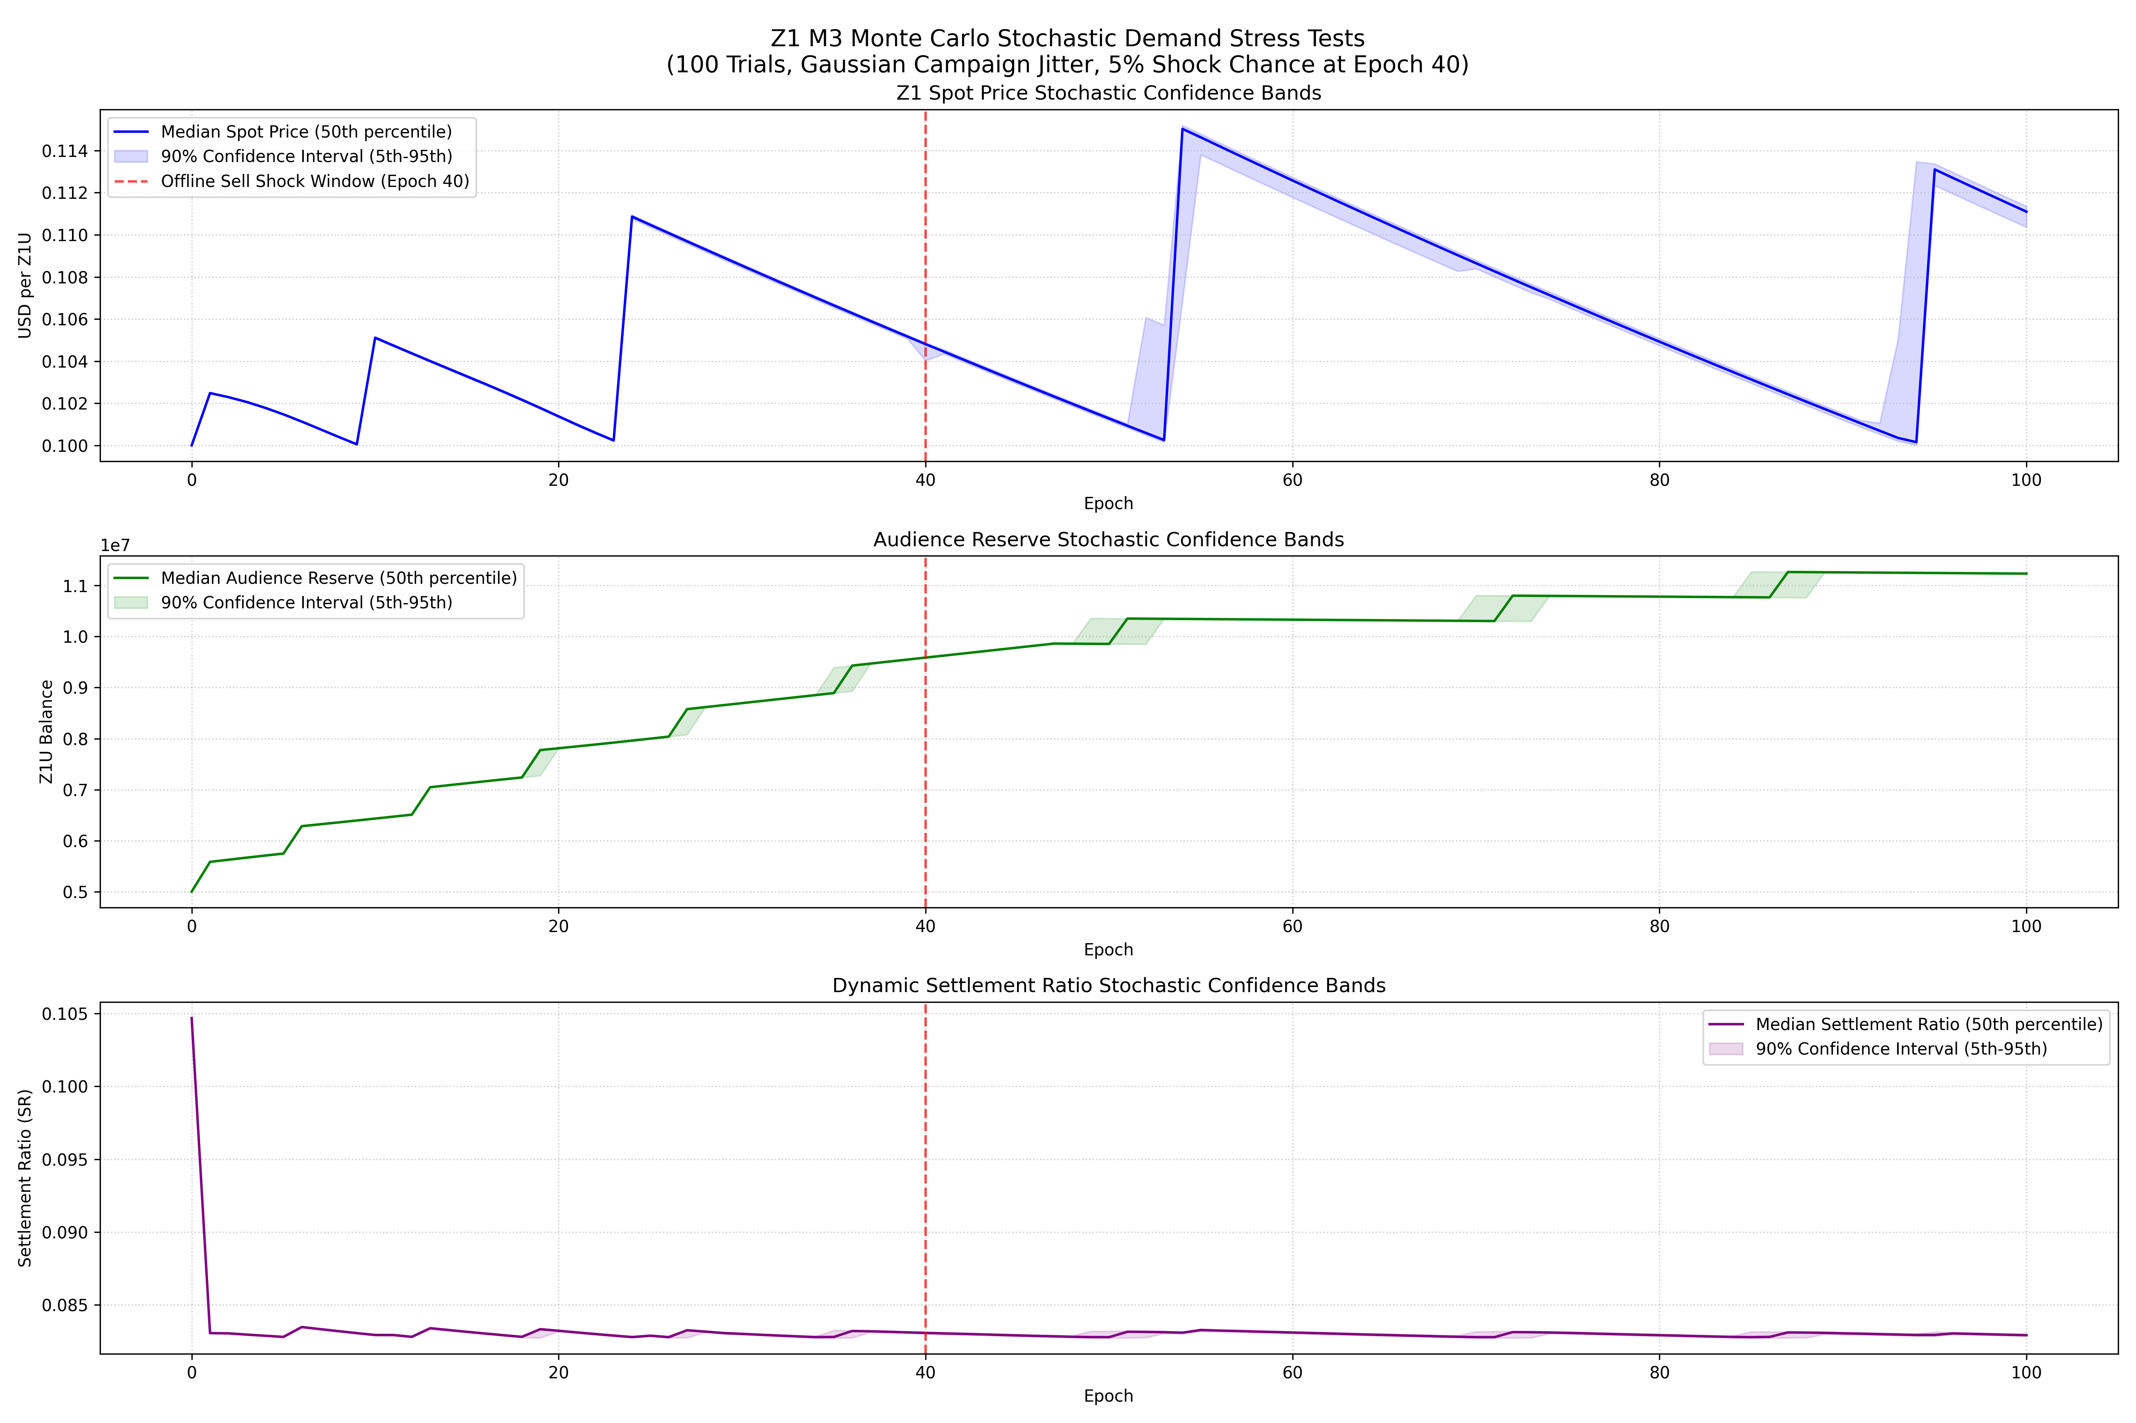
Figure 14.1: Monte Carlo Resilience Bands
This figure shows the confidence bands of systemic solvency (measured via the treasury health ratio) across 1,000 randomized simulation runs. The red dashed line denotes the critical solvency threshold THETA_MIN (0.30). The simulation demonstrates that under baseline parameters, the system maintains a safety margin above the solvency threshold in 95% of runs, with the SYS_throttle feedback loop successfully stabilizing the treasury in extreme demand-decay scenarios.
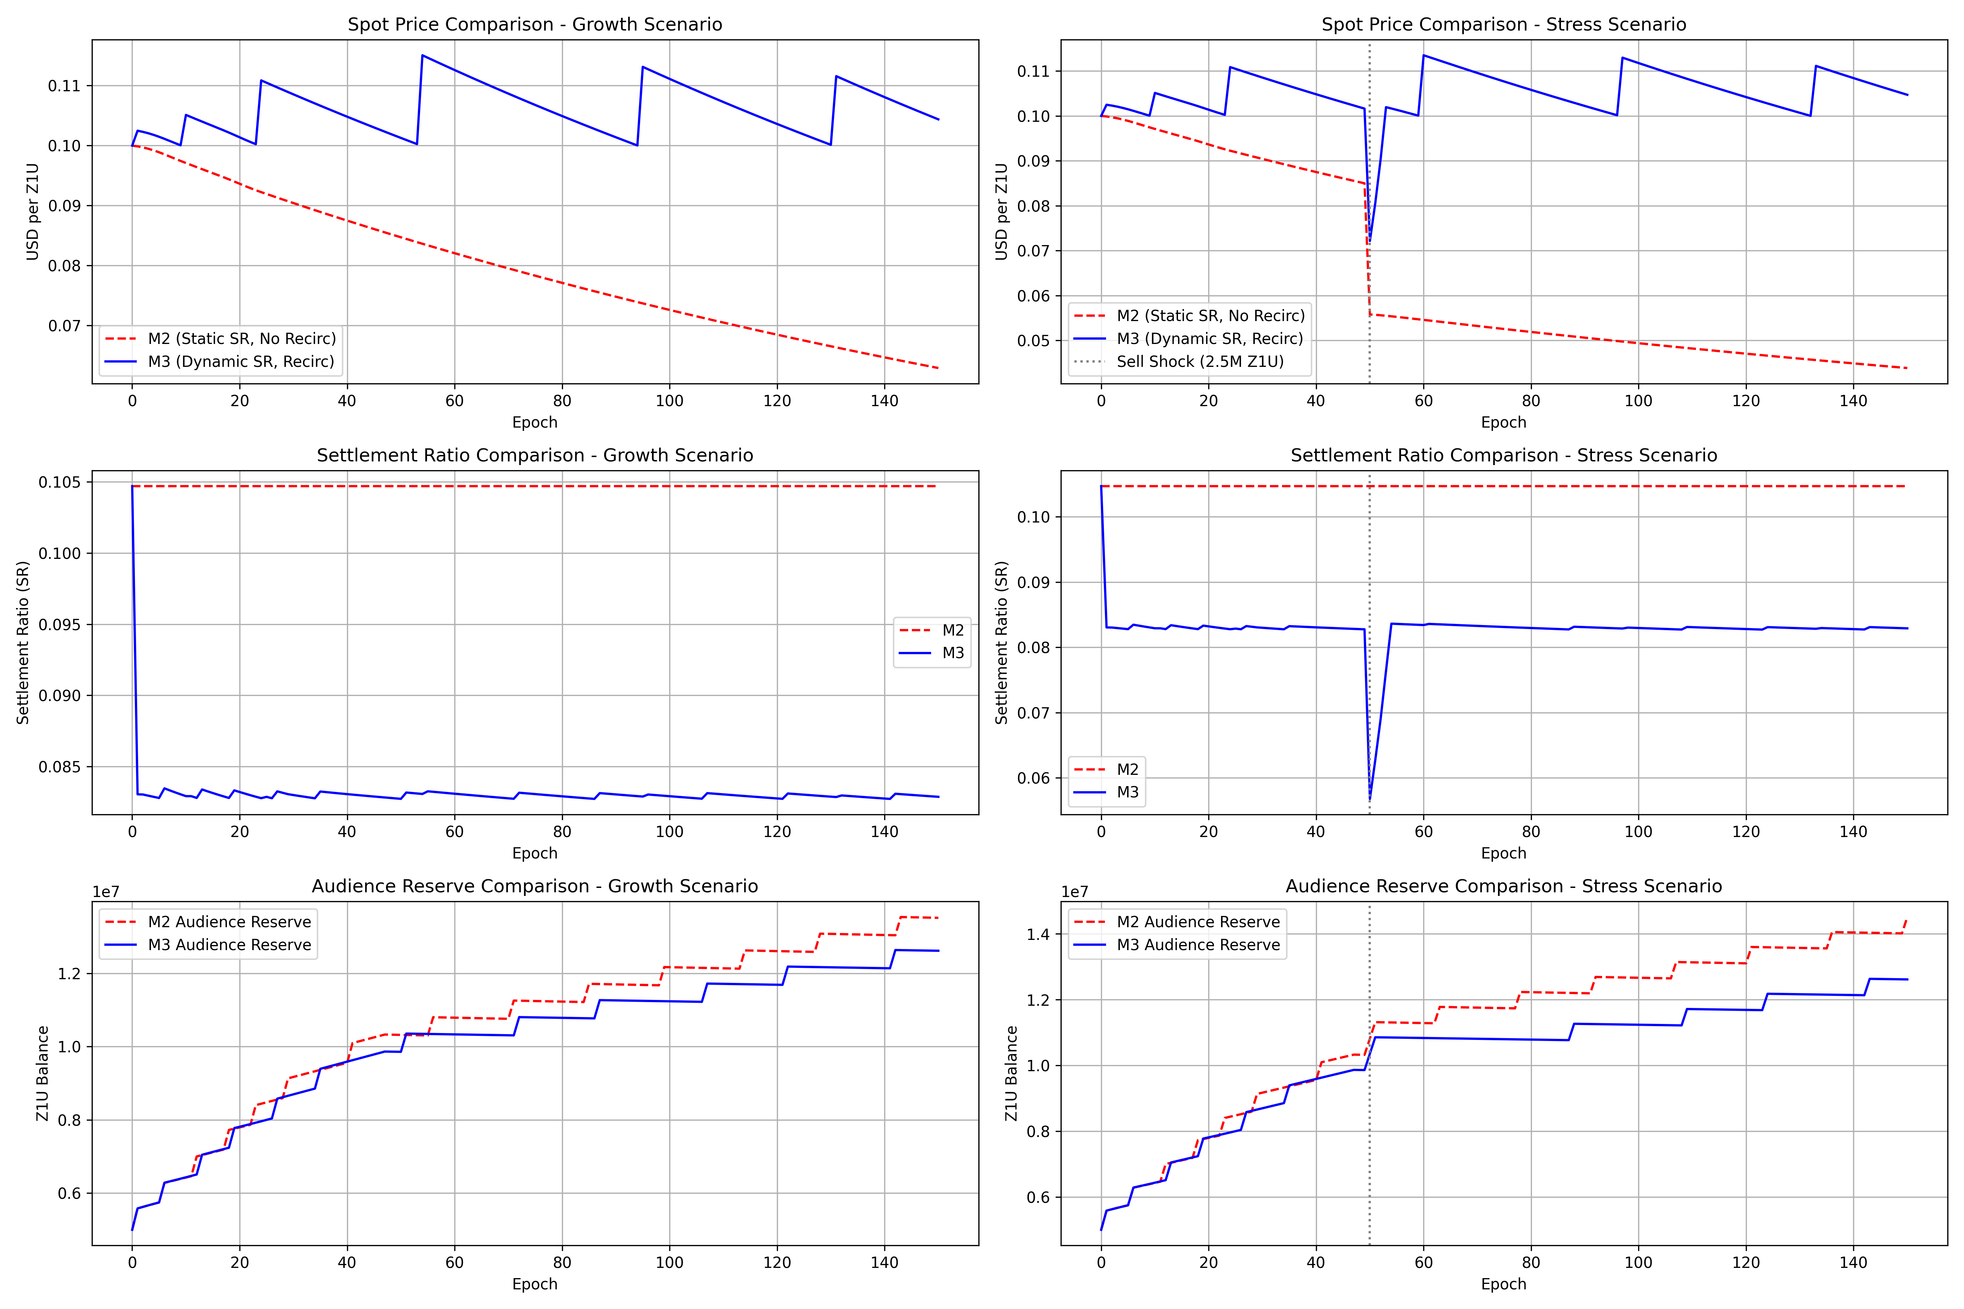
Figure 14.2: M2 vs. M3 Model Comparison
A direct comparison of the active participant progression under the Milestone 2 (M2 - static thresholding) and Milestone 3 (M3 - dynamic PCS tier classification) models. M3 utilizes calibrated cutoff thresholds TAU_1 (0.20) and TAU_2 (0.60). The dynamic calibration prevents the cohort congestion observed in M2, smoothing the transition from casual to engaged and core cohorts, thereby enhancing long-term engagement stability.
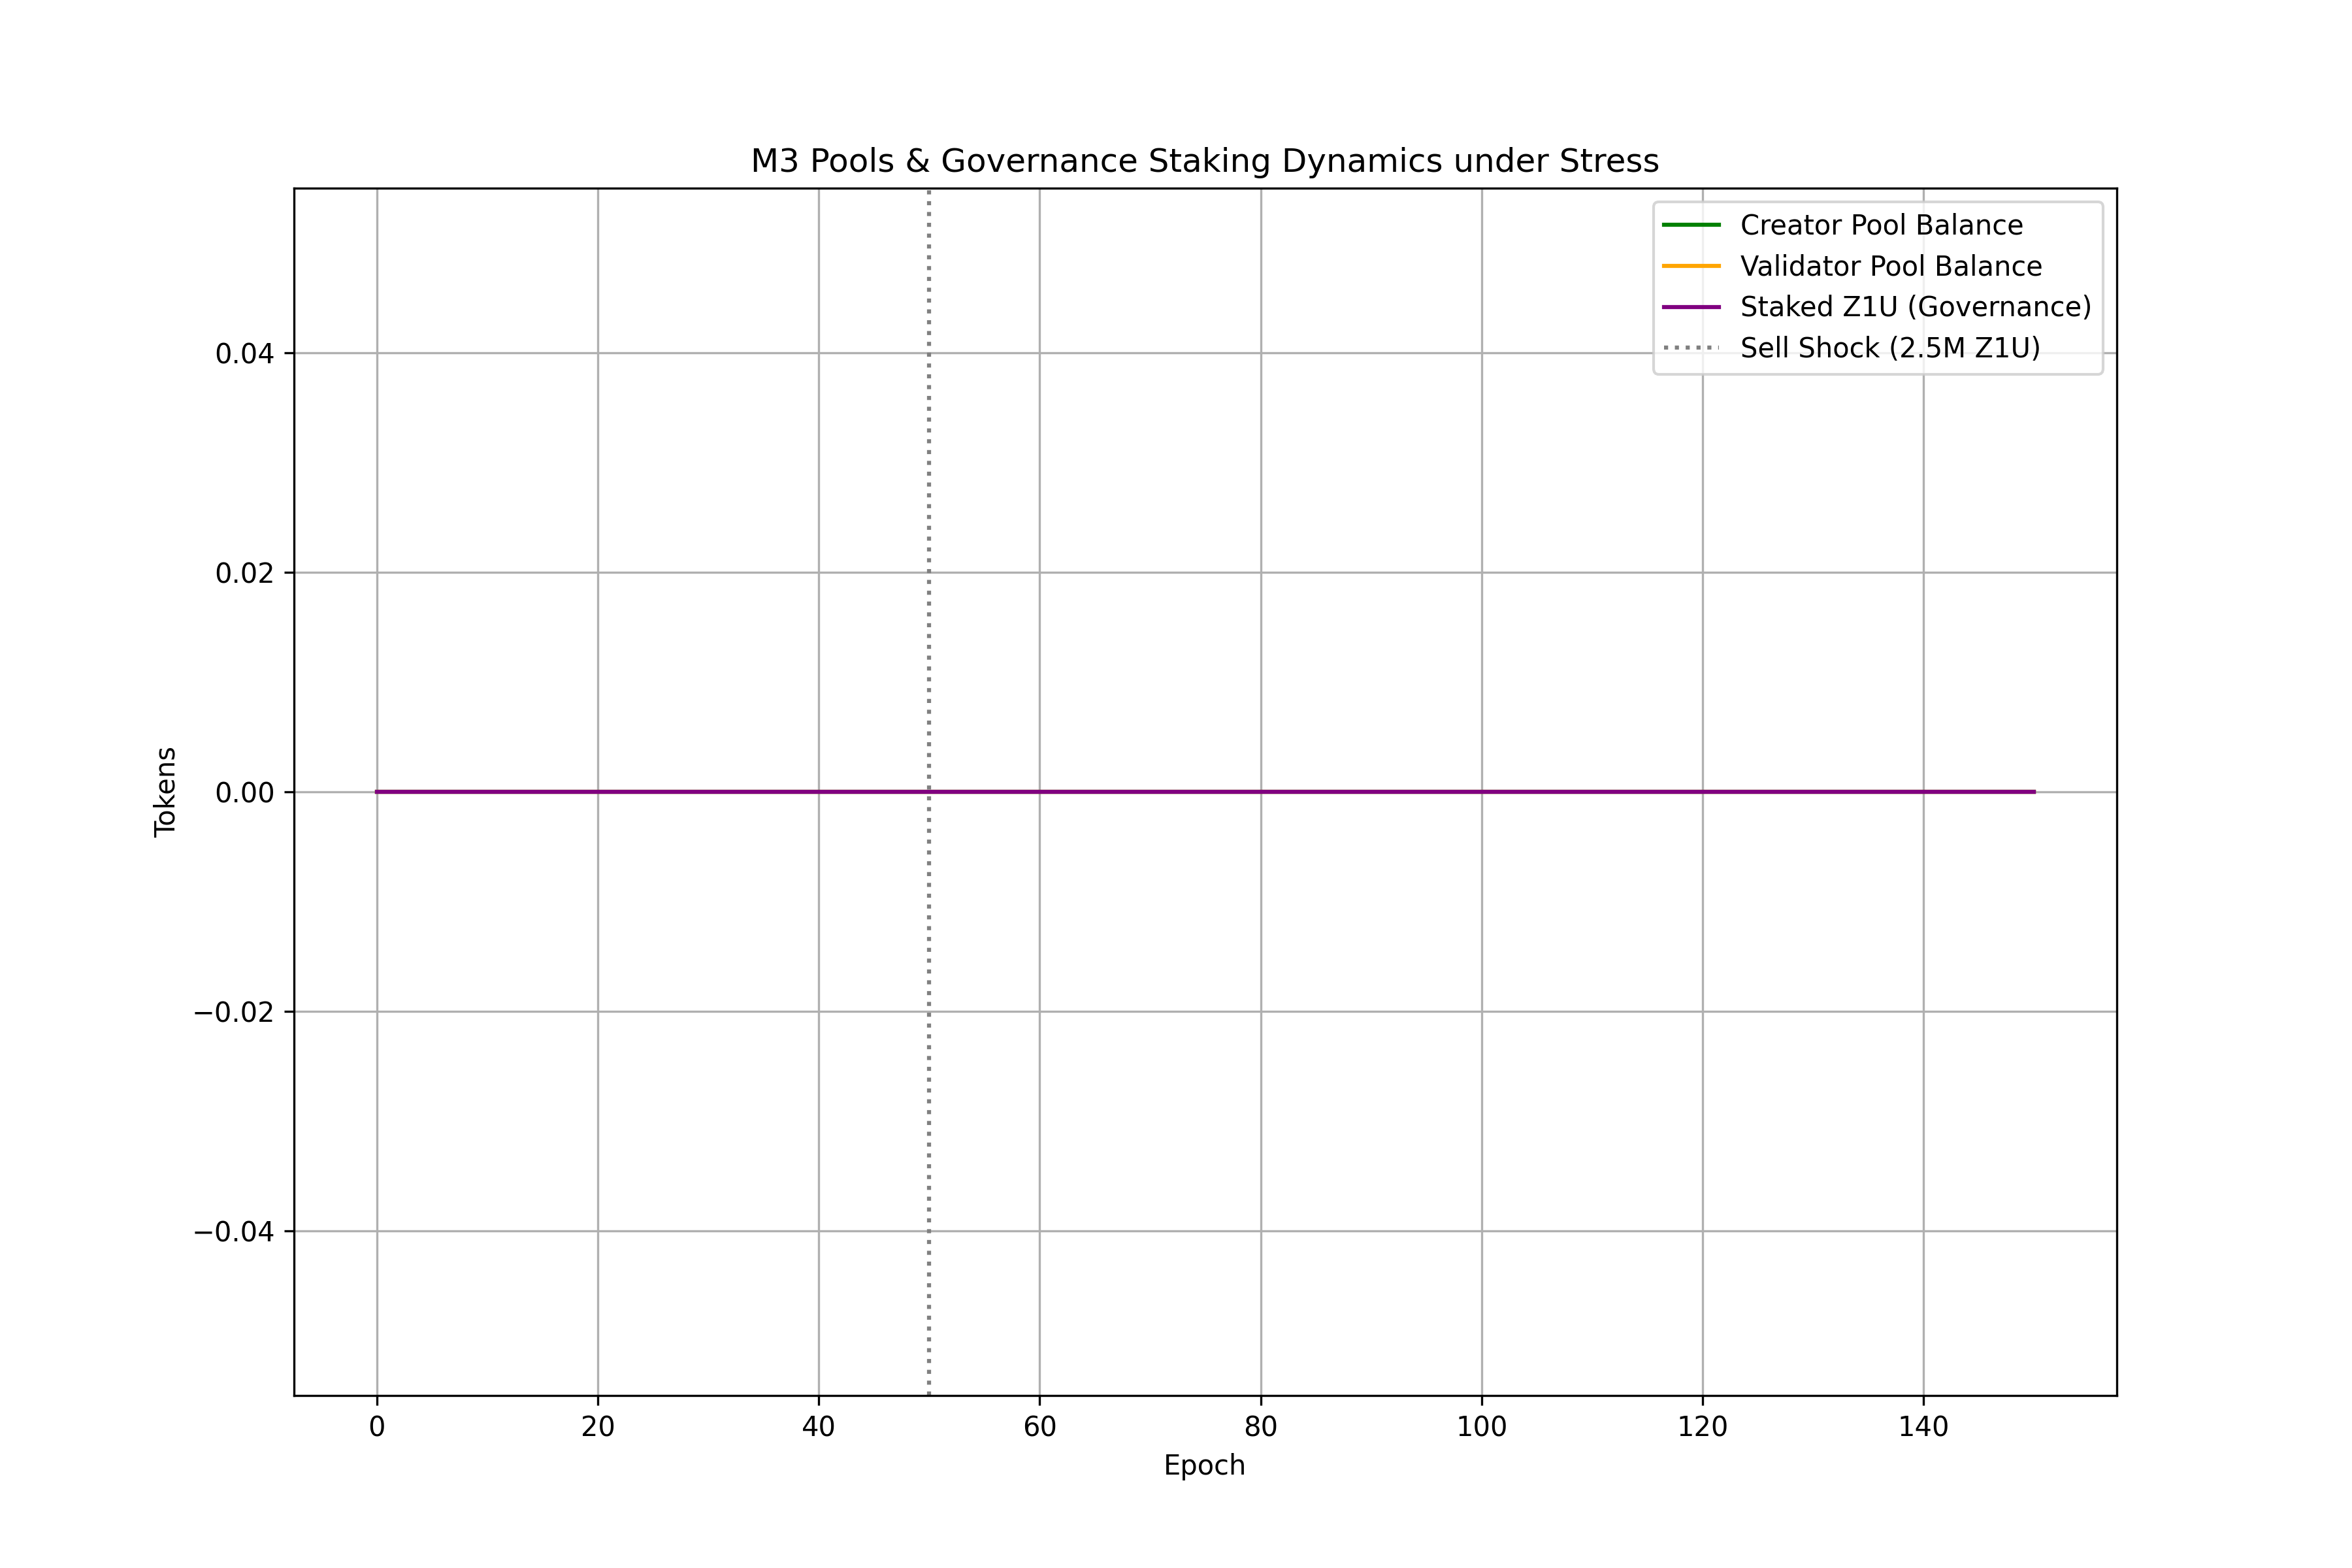
Figure 14.3: M3 Pools and Governance Stress Test
This stress test monitors treasury inflows and outflows during simulated flash-governance and large-position exit shocks. The governance lock period constraints (PAR-28 min_lock_period = 12 epochs and PAR-29 max_lock_period = 104 epochs) act as effective dampening mechanisms. Despite high volatility in token delegation, liquid treasury reserves remain above the solvency floor, proving the design's structural resilience.
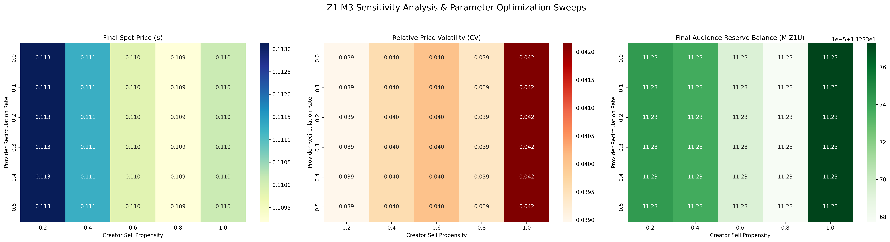
Figure 14.4: Parameter Sensitivity Sweeps
Heatmap visualization of the sensitivity sweeps across critical parameters SR_BASE (ACR-to-Z1U conversion rate) and fee_rate_g5b (Utility treasury capture rate). The results confirm that SR_BASE is the highest sensitivity parameter in the system. Solvency is maintained (green region) when SR_BASE remains below 0.15 and fee_rate_g5b is calibrated to at least 0.20, matching the theoretical breakeven requirement of the sustainability equation.

