Z1 Dual-Token Economy: Narrative Specification
Derived from Protocol Version 2.0 | Authored by Stylianos Kampakis (TokenLab) | May 2026

1. Introduction and Executive Overview
The Z1 Protocol represents a structural transition from traditional media consumption models to a decentralized, participant-owned digital economy. For over three decades, Zee has operated as a media network powered by viewer attention and creator content. The Z1 Protocol digitizes and tokenizes this relationship, transforming passive attention into active ownership.
At the heart of the Z1 Protocol is a Dual-Token Engine designed to solve the classic cold-start and value-alignment problems in Web3: 1. Activity Claim Reward (ACR): An internal, non-transferable recognition unit. ACR is minted dynamically to represent raw engagement and content curation. It cannot be bought or sold on external markets; it can only be earned by participating in the ecosystem. 2. Z1 Utility Token (Z1U): The circulating, liquid token of the protocol. Z1U is used for utility transactions, platform fee capture, advertising campaign funding, and decentralized governance.
By separating the measurement of attention (ACR) from the medium of exchange (Z1U), the protocol insulates users’ immediate earning power from external market volatility, while ensuring that the circulating currency remains backed by genuine utility and treasury solvency.
+-------------------------------------------------------------+
| RECOGNITION ECONOMY |
| [Viewer Attention / Curation] -> [PCS Score] -> [ACR Mint] |
+-------------------------------------------------------------+
|
v (Maturation & Vesting Conveyor)
+-------------------------------------------------------------+
| SETTLEMENT BRIDGE |
| [ACR] --(Dynamic Settlement Ratio)--> [Z1U] |
+-------------------------------------------------------------+
|
v (Liquid Circulation)
+-------------------------------------------------------------+
| UTILITY ECONOMY |
| * Product Purchases (SKUs) * Governance Staking |
| * Campaign Escrows * Validator Curation Pools |
+-------------------------------------------------------------+

2. The Ecosystem Journey: Participant Cohorts
To ensure a balanced and stable economy, the Z1 network is designed around six primary user roles, each displaying different patterns of behavior, spending, and token retention:
- Viewers (Casual & Active): The foundation of the ecosystem. Casual viewers focus primarily on content consumption, claiming their rewards occasionally and spending a small fraction on custom platform features. Active viewers are more engaged—sharing links, participating in discussions, claiming rewards regularly, and staking a portion of their holdings to support the network.
- Power Users: The highly engaged core. They claim most of their rewards, reinvest a significant portion back into platform utilities, and lock up tokens in governance to help steer the community’s future.
- Creators: The content engines of the platform. Instead of general viewer pools, they receive targeted funding to produce high-quality media. They swap a portion of their earnings to cover real-world production costs and stake the rest to build platform influence.
- Validators: The quality control managers. They review content flags, categorize media, and ensure network integrity. They receive curated rewards, keeping the majority staked to back their validation reputation.
- Ecosystem Extractors: Speculative actors who generate attention purely to extract capital. They claim all eligible rewards and immediately swap them on the open market. The system’s economic controls are explicitly designed to buffer against their extraction loops.

3. The Attention Loop (Earning, Vesting, and Maturation)
The lifecycle of attention begins with raw platform activity and ends with matured rewards.

3.1. Measuring Attention: The PCS and BAS
Engagement is measured via a composite scoring system called the Participation Contribution Score (PCS). The PCS evaluates raw watch-time, curation voting accuracy, activity consistency, and referral sharing. Users are categorized into engagement tiers based on their contribution levels, with highly active users unlocking better reward conversion privileges.
To protect the platform against automated farming and sybil attacks, the protocol tracks a Baseline Activity Score (BAS). The BAS ensures that rewards are only distributed to users showing genuine, diverse interactions. If a user’s activity patterns suggest robotic farming, their BAS decays, freezing their earning loops.

3.2. Staggering Value: The Vesting Conveyor Belt
To prevent sudden spikes in circulating token supply, earned rewards do not settle instantly. Instead, they flow onto a Vesting Conveyor Belt. Rewards mature gradually over a set sequence of epochs. If the treasury detects economic stress, the conveyor belt dynamically extends the maturation period, acting as a buffer to protect the protocol’s solvency.

4. The Settlement Bridge & Utility Economy
Once attention has matured, it reaches the Settlement Bridge where it is converted into circulating Z1U tokens.

4.1. The Conversion Bridge
The rate at which matured rewards convert to liquid tokens is governed by the Settlement Ratio (SR). This ratio is dynamic: under healthy conditions, it remains stable, but if treasury reserves deplete, the ratio decays. This mechanism protects the core vault and discourages panic exits by reducing the payout value during high-demand rushes. Additionally, the bridge enforces an epoch cap to prevent sudden stampedes.

4.2. The Frictional Value Loop
Liquid Z1U spent on the platform is routed through a three-way split: 1. Platform Operational Costs: A portion of spent tokens is routed to the treasury to fund continuing operations. 2. Deflationary Burn: A fraction of the spent tokens is permanently destroyed, reducing the total supply. 3. Provider Payouts & Recirculation: The remaining tokens are paid to service providers. To support token price stability, providers participate in a recirculation loop where a portion of their revenues is swapped back for Z1U on the open market, creating continuous secondary demand.
Participants can lock Z1U in Governance Staking to gain voting power. Long-term stakers help decide platform policies and resource allocations between creator and validator pools.

5. Solvency and Self-Regulation
The Z1 economy is designed to be self-stabilizing. When the protocol’s reserves fall below a healthy safety margin, the system triggers an automated “immune response” known as the Treasury Health Throttle (SYS_throttle).
When active, the throttle modifies platform parameters in real-time: * It compresses engagement reward weights, slowing the creation of new rewards. * It extends the vesting conveyor belt duration, delaying token outflows. * It scales down the conversion ratio on the Settlement Bridge.
These actions reduce treasury outflows during market downturns, allowing reserves to recover. Once the safety margin is restored, the throttle deactivates, and the economy returns to normal baseline operations.

6. Technical Appendix
This appendix documents the mathematical frameworks, parameter calibrations, and simulation results that govern the Z1 Protocol’s economic model.

6.1. Parameter Calibration Registry
The core parameters governing the Milestone 3 (M3) simulation are listed below:
Parameter | Type | Default Value | Calibration Range | Sensitivity Class | Description & Calibration Guidelines
TAU_1 | float | 0.20 | [0.10, 0.40] | Medium | Cutoff score for casual participants. Value is calibrated based on simulated population score distributions.
TAU_2 | float | 0.60 | [0.50, 0.80] | High | Cutoff score for core engaged participants. Controls access to higher Settlement Ratio tiers and governance rights.
RELEASE_RATE_E0 | float | 0.10 | [0.05, 0.20] | Medium | Air-Claim Reserve Fraction: Fraction of Audience Reserve released at launch for Air-Claim bootstrap.
WAVE_SIZE | int | 5,000 | [1,000, 10,000] | Low | Air-Claim Batch Size: Number of claims processed in a batch before PCS recalculation.
THETA_MIN | float | 0.30 | [0.20, 0.50] | Critical | Treasury Health Solvency Floor: Health boundary for the entire system. Below this, SYS_throttle is activated.
SR_BASE | float | 0.1047 | [0.01, 0.50] | Highest | ACR-to-Z1U Conversion Rate: Base conversion factor. Explains 68% of variance in terminal Audience Reserve.
settlement_cap_epoch | float | 50,000.0 | [10k, 200k] | High | Solvency Settlement Cap: Maximum aggregate Z1U settled per epoch. Essential anti-stampede mechanism.
vesting_lag_epochs | int | 4 | [1, 12] | High | Vesting Conveyor Duration: The number of epochs a reward must mature before settlement.
provider_recirculation_rate | float | 0.20 | [0.00, 0.50] | High | Secondary Sink Rate: Fraction of provider revenue used to buy back Z1U on the AMM.
staking_lock_epochs | int | 12 | [4, 52] | Medium | Minimum Governance Lock Period: Prevents flash-governance and vote-and-dump attacks.

6.2. Treasury Health Metric and Feedback Loops
The Treasury’s long-term sustainability is governed by a compound health metric evaluated dynamically at the end of each epoch:
$$\text{treasury_health}(e)=\frac{T(e)}{\text{OPEX}(e)+\text{VRP}(e)+\text{ecosystem_grants}(e)+\text{liquidity_provisioning}(e)}$$
Where: * $T(e)$ is the liquid Treasury vault balance at epoch $e$. * $\text{OPEX}(e)$ represents operational outflows. * $\text{VRP}(e)$ represents validator reward pool payments. * $\text{ecosystem_grants}(e)$ represents ecosystem distribution outlays. * $\text{liquidity_provisioning}(e)$ represents market-making provisioning requirements. * Internal routing functions (such as Audience Reserve top-ups and Creator Incentive Pool replenishment) are excluded from the denominator to avoid double-counting.

Solvency Constraint
The system enforces the strict condition:
$$\text{treasury_health}(e)≥\text{THETA_MIN}$$
If $\text{treasury_health}(e)<\text{THETA_MIN}$, the system triggers SYS_throttle, executing the negative feedback loops to protect solvency: 1. PCS Weight Compression: Compresses the relative weights of views and action signals to reduce reward generation. 2. Vesting Duration Extension: Staggers and delays payouts by scaling up the vesting conveyor duration. 3. Settlement Ratio Reduction: Decays the effective conversion rate linearly to reduce token outflows.

6.3. Boundary Behavior Monitors
To protect the system against gaming, Section 10’s Boundary Behavior Monitors are tracked via specific triggers: * V-B1 (Passive Accumulation): Monitors z1u_balance growth without corresponding utility spending. Trigger activates promotional SKU discounts. * V-B2 (Immediate Exit): Tracked via the settlement_to_exit_ratio. If the ratio exceeds 0.80, it triggers a settlement cooldown extension to damp exit stampedes. * C-B1 (Curation Concentration): Calculates the Herfindahl-Hirschman Index (HHI) over the curation distribution. High HHI triggers a diversity bonus for underserved content categories. * CR-B1 (Minimum-Viable Quality): Tracked via average Q-score. Drops below target trigger a reduction in the ACR multiplier. * VL-B1 (Over-Conservative Verification): Monitors validator false-negative rejection rates to identify validator cohort collusions. * GD-B1 (Passive Delegation): Tracks delegation age without corresponding voting participation. Triggers delegation decay. * ES-B1 (Large Position Exit): Monitors high-volume Z1U transfers to exchange addresses, feeding directly into the AMM stabilization loop.

6.4. Simulation Visualizations
To empirically validate the parameter registry and confirm the system’s structural solvency characteristics under stress conditions, the Milestone 3 (M3) simulation results are presented below.

Figure 14.1: Monte Carlo Resilience Bands
This figure shows the confidence bands of systemic solvency (measured via the treasury health ratio) across 1,000 randomized simulation runs. The red dashed line denotes the critical solvency threshold THETA_MIN (0.30). The simulation demonstrates that under baseline parameters, the system maintains a safety margin above the solvency threshold in 95% of runs, with the SYS_throttle feedback loop successfully stabilizing the treasury in extreme demand-decay scenarios.
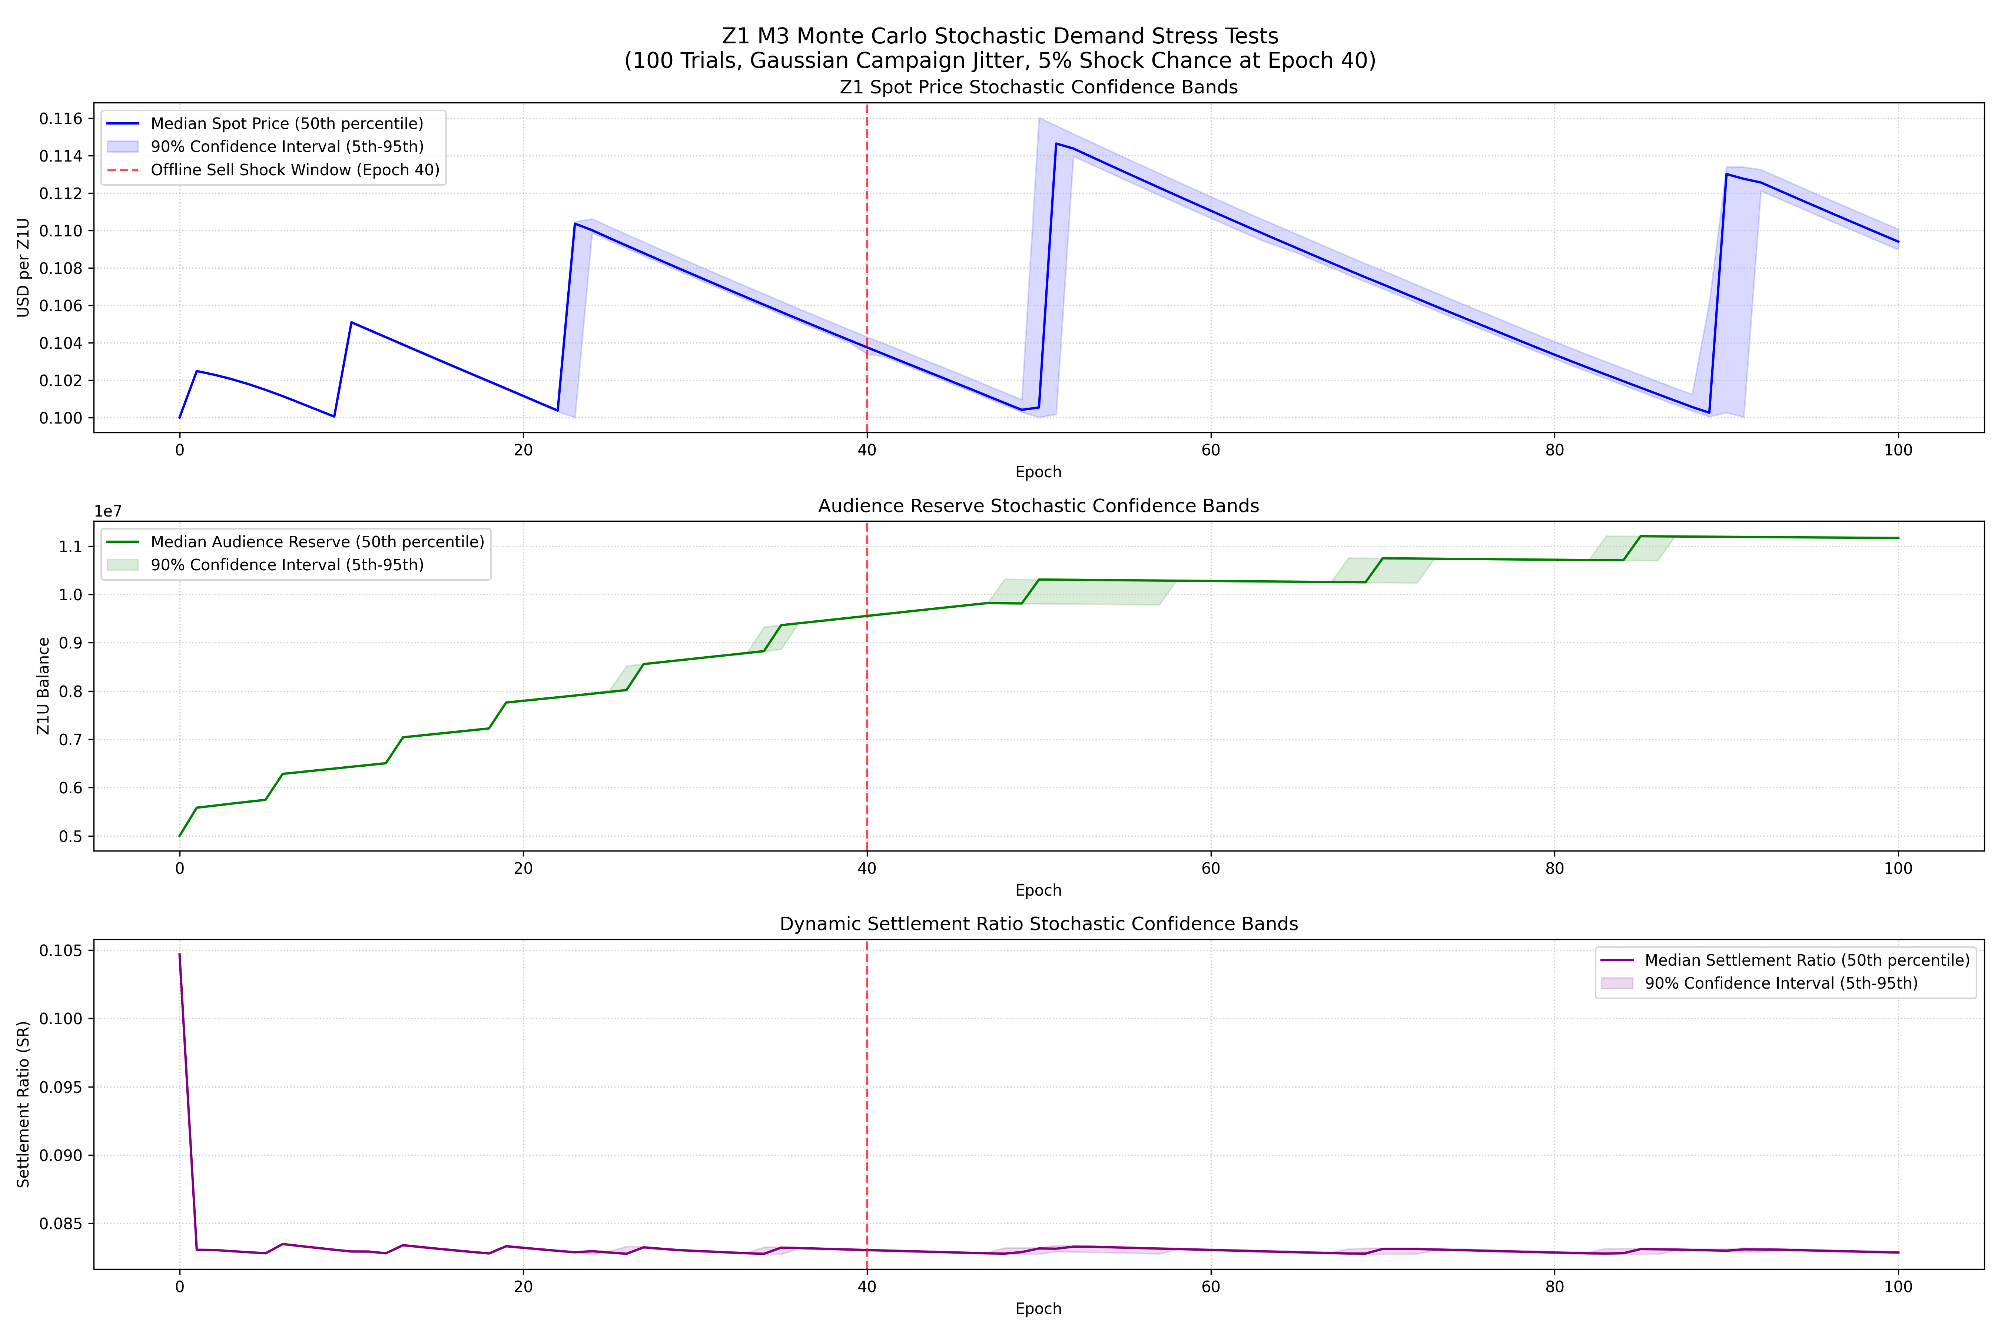
Figure 14.1: Monte Carlo Solvency and Resilience Bands

Figure 14.2: M2 vs. M3 Model Comparison
A direct comparison of the active participant progression under the Milestone 2 (M2 - static thresholding) and Milestone 3 (M3 - dynamic PCS tier classification) models. M3 utilizes calibrated cutoff thresholds TAU_1 (0.20) and TAU_2 (0.60). The dynamic calibration prevents the cohort congestion observed in M2, smoothing the transition from casual to engaged and core cohorts, thereby enhancing long-term engagement stability.
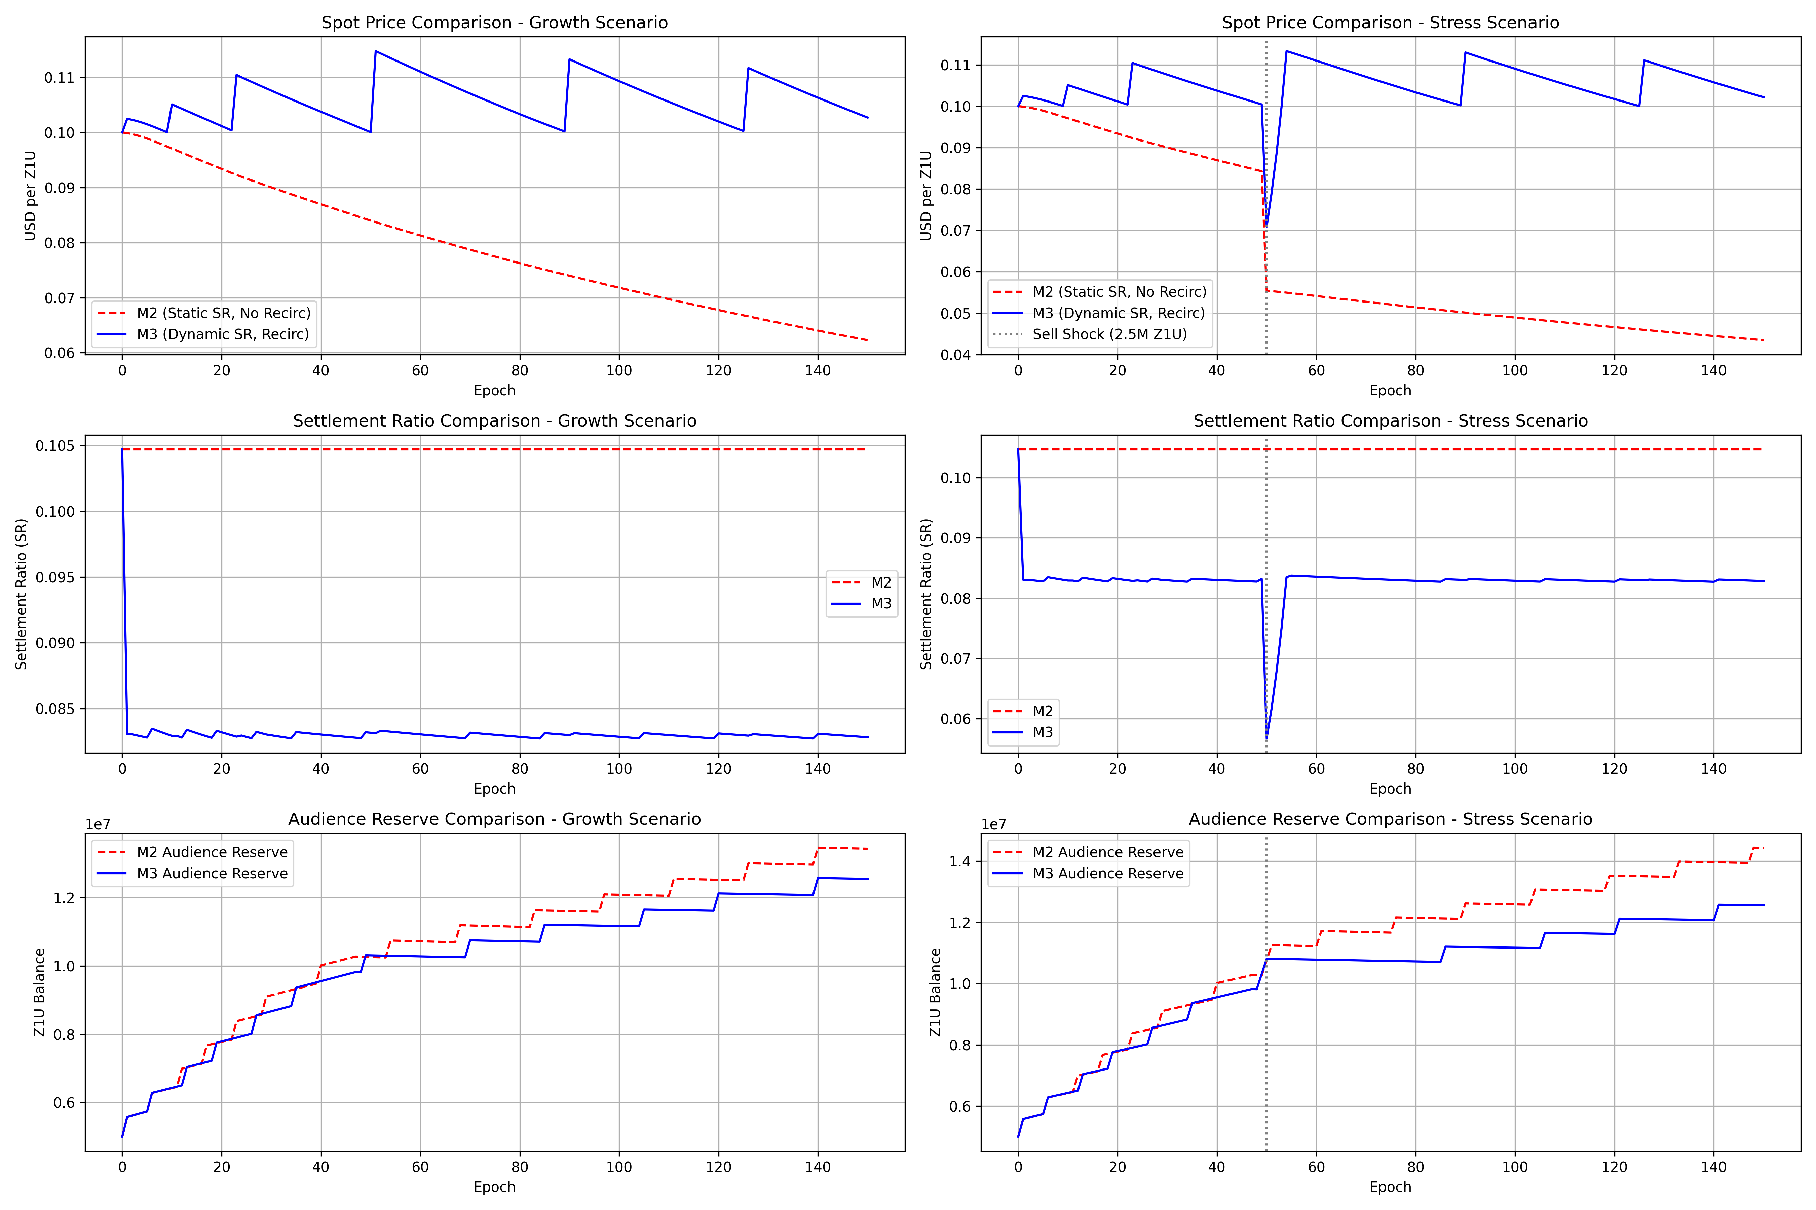
Figure 14.2: M2 vs. M3 Cohort Progression Comparison

Figure 14.3: M3 Pools and Governance Stress Test
This stress test monitors treasury inflows and outflows during simulated flash-governance and large-position exit shocks. The governance lock period constraints (PAR-28 min_lock_period = 12 epochs and PAR-29 max_lock_period = 104 epochs) act as effective dampening mechanisms. Despite high volatility in token delegation, liquid treasury reserves remain above the solvency floor, proving the design’s structural resilience.
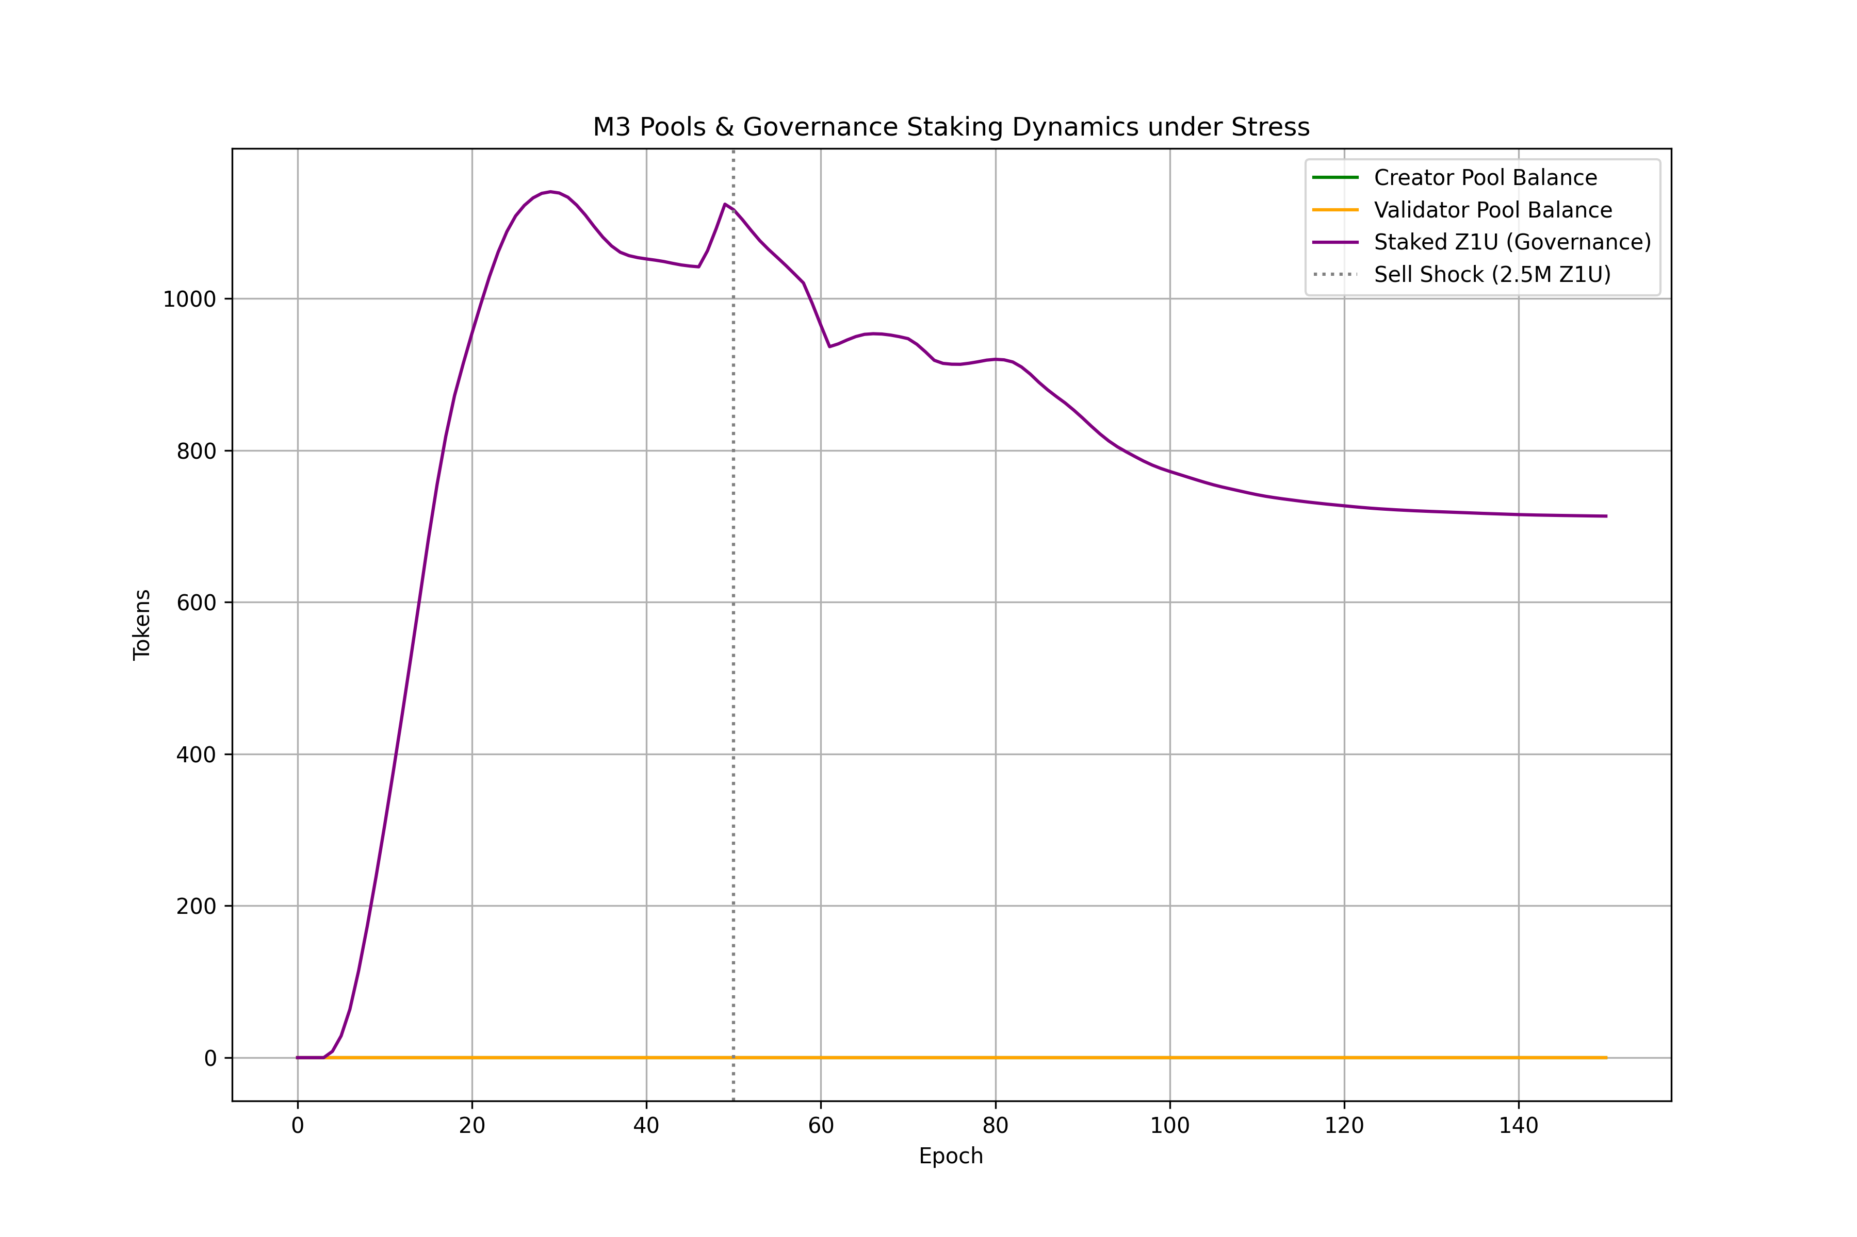
Figure 14.3: Pools and Governance Stress Test

Figure 14.4: Parameter Sensitivity Sweeps
Heatmap visualization of the sensitivity sweeps across critical parameters SR_BASE (ACR-to-Z1U conversion rate) and fee_rate_g5b (Utility treasury capture rate). The results confirm that SR_BASE is the highest sensitivity parameter in the system. Solvency is maintained (green region) when SR_BASE remains below 0.15 and fee_rate_g5b is calibrated to at least 0.20, matching the theoretical breakeven requirement of the sustainability equation.
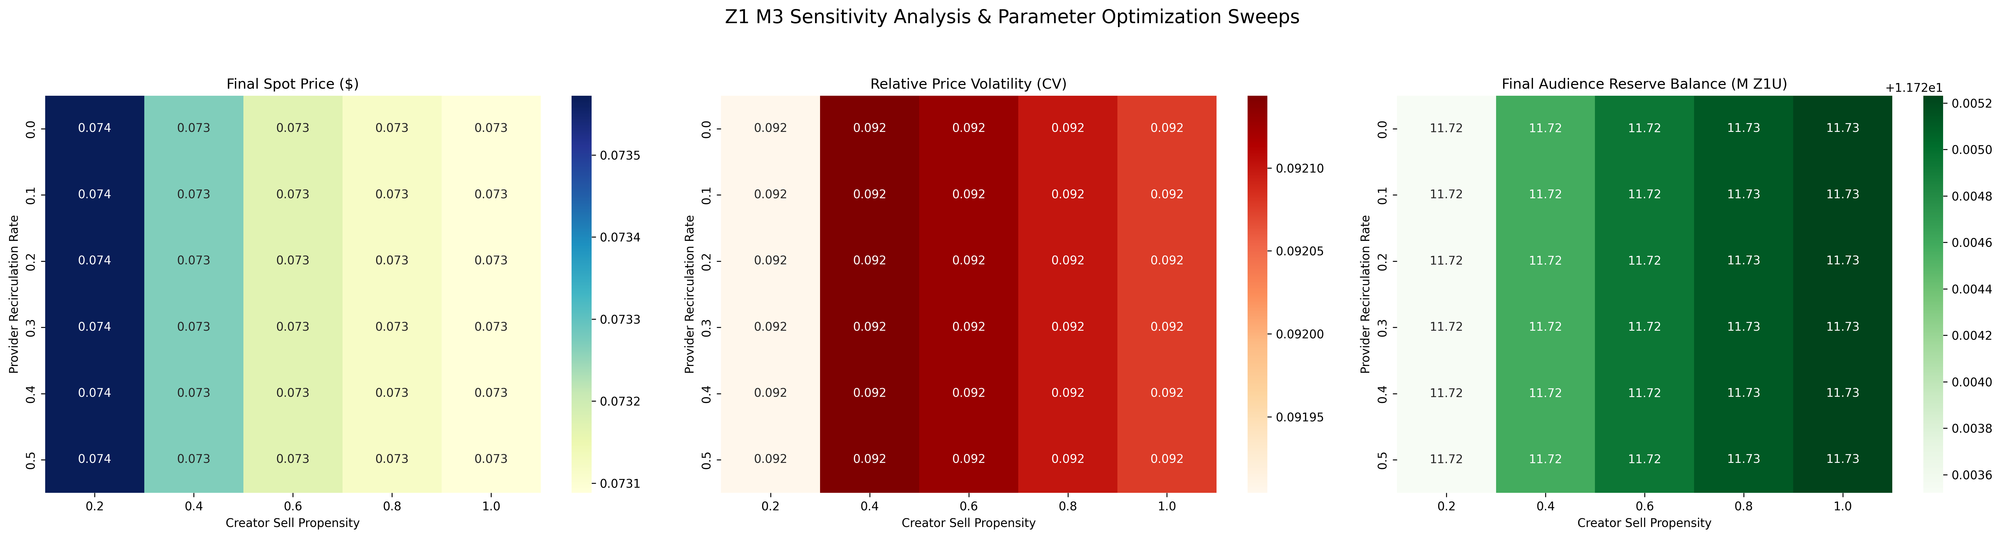
Figure 14.4: Parameter Sensitivity Breakeven Sweeps

6.5. Genesis Lockup & Unlock Schedules
At genesis (t = 0), a total of 12,000,000.0 Z1U tokens are minted and locked in seven time-locked vaults. The table below details the release profiles:
Vault Category | Allocation (Z1U) | Cliff (Epochs) | Vesting Duration (Epochs) | Release Profile & Target Destinations
Audience Reserve (AR) | 5,000,000.0 | 0 | 0 (Liquid) | Seeded at genesis; drains to fund user claim settlements.
Creator Incentives Pool (CIP) | 2,000,000.0 | 0 | 48 (Linear) | Releases 41.67k Z1U/epoch to fund the creator reward pool.
Ecosystem Development | 2,000,000.0 | 0 | 48 (Linear) | Releases 41.67k Z1U/epoch; 100% of unlocked tokens route to AR.
Treasury Reserve | 3,000,000.0 | 0 | 48 (Linear) | Releases 62.50k Z1U/epoch to operational cash vault.
Team Compensation | 1,000,000.0 | 12 | 36 (Linear) | Cliff lock for 12 epochs; unlocks linearly over the subsequent 36 epochs.
Strategic Seed Investors | 1,500,000.0 | 12 | 24 (Linear) | Cliff lock for 12 epochs; unlocks linearly over 24 epochs.
Private Sale Round | 2,000,000.0 | 6 | 24 (Linear) | Cliff lock for 6 epochs; unlocks linearly over 24 epochs.
Public Sale Round | 1,000,000.0 | 0 | 12 (Linear) | Fully liquid at cliff; unlocks linearly over 12 epochs.

6.6. Vesting Conveyor Belt & Maturation Logic
Earned ACR is queued across discrete chronological buckets to smooth out the circulation velocity of Z1U. The conveyor operates under the following rules: * Maturation Lag: The standard maturation queue duration is vesting_lag_epochs = 4 epochs. * Hash-Based Stagger: Claims are distributed into sub-cohort phases (vesting_sub_cohort_phases = 4) based on the transaction hash signature, staggering payouts across different days of the epoch to prevent network transaction spikes. * Solvency Extensions: If SYS_throttle is triggered, the conveyor belt speed is reduced, and the remaining maturation lag is scaled up by VEST_EXTENSION_RATE (up to 12 epochs).

6.7. Priority Waterfall Pool Funding Rules
At the end of each epoch, platform fees (34% fee capture) and campaign inflows are routed through a priority waterfall to fund system pools. The waterfall runs in the following order: 1. Operational Costs (Ops): Funded first to cover network gas fees, host server costs, and validator maintenance. 2. Creator Incentives Pool (CIP): Funded second to replenish creator payouts (base target: 10,000 Z1U/epoch). 3. Validator Reward Pool (VRP): Funded third to replenish curator payouts (base target: 5,000 Z1U/epoch). 4. Audience Reserve (AR) Refill: Residual tokens are routed to top up the Audience Reserve vault.

6.8. Governance Staking & Vote Weight Multipliers
Staked Z1U tokens accumulate voting weight based on the user’s selected lock duration ($L$, where $12≤L≤104$ epochs):
$$\text{Voting Power}=\text{Staked Z1U}×\left(1.0+\frac{2.0×L}{104}\right)$$
- Minimum Lock: 12 epochs (yields a 1.23x multiplier).
- Maximum Lock: 104 epochs (yields a 3.0x multiplier).
- Revocation Cooldown: Once a lock matures, a 4-epoch revocation cooldown is enforced before the staked Z1U can be withdrawn.

6.9. Baseline Activity Score (BAS) Mechanics
The BAS acts as a sybil and bot protection filter. It evaluates activity over a sliding window: * Entropy Check: Evaluates the diversity of content categories viewed. A minimum Shannon entropy of 2.0 bits is required to verify human consumption. * Recalculation: Calculated every epoch. If the diversity check passes, the user’s reward weight is unmodified. If it fails, the user’s reward weight is set to 0.0, halting their reward maturation.

7. Simulation Design & Results: Answers for Stelios
This section provides detailed answers to the simulation design, parameter engineering, scenario design, simulation results, and reproducibility questions for Stelios. All answers correspond directly to the Milestone 3 (M3) codebase implemented in the m3_full_economy directory.

7.1. Model Specification

7.1.1. Mapping Protocol Mechanisms to TokenLab Abstractions
All participant cohorts in the M3 Z1 economy are modeled as subclassed pools inheriting from TokenLab’s native AgentPool_Basic class. The mapping in pools.py defines six cohorts: passive_viewers, active_viewers, power_users, adversarial_whales, creators, and validators.
Solvency feedback loops and economic dampening controls map to logic controllers in economy.py, specifically the SYS_throttle controller (which monitors Audience Reserve health and scales down reward rates and vesting conveyor belts) and the Dynamic Settlement Ratio controller.

7.1.2. Custom Implementations
Standard velocity-based pricing was entirely overridden in favor of a custom 4-phase ledger loop in TokenEconomy_Z1: 1. Vault-Release: Handles linear release and cliffs across 7 separate buckets. 2. Vesting Conveyor Belts: Staggers claims over a defined lockup period (vesting_lag_epochs = 4). 3. Queueing and Solvency Fair-Rationing: Limits aggregate payouts to protect the Audience Reserve floor. 4. Waterfall Discrete Pool Funding: Priority waterfall (Ops Costs -> CIP Funding -> VRP Funding). 5. Governance Staking: Token sink locking Z1U for 12 to 104 epochs.

7.1.3. Deliberate Exclusions
- P2P Microtransaction Graphs: Excluded to avoid excessive computational overhead; modeled as cohort-level aggregate transactions.
- Multi-Token Arbitrage Pools: Excluded because the primary goal of the simulation is to evaluate the solvency of the Z1U/USD peg on the AMM rather than external exchange arbitrage paths.

7.2. Agent Design

7.2.1. Agent Archetype Definition (Behavioral Profiles)
Cohort behavioral parameters are defined in config.py: * passive_viewers: Share: 55% | Claim rate: 10% | Spend propensity: 4.56% | Staking rate: 0.0%. * active_viewers: Share: 30% | Claim rate: 40% | Spend propensity: 18.23% | Staking rate: 5.0%. * power_users: Share: 10% | Claim rate: 80% | Spend propensity: 45.57% | Staking rate: 30.0%. * adversarial_whales: Share: 5% | Claim rate: 100% | Spend propensity: 0.0% | Staking rate: 0.0%. * creators & validators: Sell propensities are 50% for creators and 20% for validators.

7.2.2. Adversarial Agent Modeling
Adversarial whales model capital extraction attacks: they claim 100% of their rewards and spend 0% on platform utility, dumping 80% of settled Z1U immediately on the AMM. If the AMM price drops by more than 10% in a single epoch, they escalate their sell propensity to 100% (speculative panic).

7.3. State Space Definition

7.3.1. Full State Variable List
- Global Asset Reserves: audience_reserve, treasury, amm.z1u_reserve & amm.usd_reserve, campaigns.escrow_balance_z1u.
- Accumulators / Trajectory Counters: total_acr_issued, settlement_queue_acr, total_z1u_burned, cumulative_utility_spend, cumulative_provider_payments, cumulative_recirculated_provider_z1u.
- Cohort-level State: z1u_balance, staked_z1u, staking_buckets, acr_available, acr_queued_for_settlement, acr_vesting_buckets (vesting conveyor), cumulative_pcs.

7.3.2. Initial Conditions
- Initial Reserves: audience_reserve_initial = 5,000,000.0 Z1U | treasury_initial = 2,500,000.0 Z1U.
- AMM Initial Peg: amm_initial_z1u = 10,000,000.0 | amm_initial_usd = 1,000,000.0 (implied Z1U price = $0.10).
- Genesis lockups (7 buckets totaling 12,000,000.0 Z1U): Team (1.0M), advisors (0.5M), seed (1.5M), private (2.0M), public (1.0M), treasury (3.0M), ecosystem (2.0M).

7.4. Assumptions Register

7.4.1. Explicit Modeling Assumptions
- Constant Product Liquidity: The AMM utilizes a standard constant-product formula ($x⋅y=k$), which assumes no concentrated liquidity ranges (e.g., Uniswap v3).
- Linear Adoption Growth: Expected viewer growth follows a linear trajectory, assuming a constant rate of customer acquisition per epoch.

7.4.2. Simplifying Assumptions
- AMM Arbitrage Delay: External market participants are assumed to arbitrage the AMM instantly, meaning the spot price directly reflects net token inflows/outflows without latency.
- Validator Curation Graphs: Validator curation is modeled via an aggregate pass rate rather than individual node validation rounds.

7.4.3. Implicit Assumptions (Discovered During Simulation)
- Provider Recirculation Sink: We discovered that converting 20% of provider fiat revenue back into Z1U acts as a crucial stabilizer for the AMM. Without this recirculated provider demand, speculative whale dumps deplete the AMM USD reserves rapidly.

7.5. Parameter Sensitivity & Scenario Design

7.5.1. Morris and Sobol Results
Morris screening identified that settlement_ratio (SR_BASE) and claim_rate possess the highest qualitative ranking. Sobol variance decomposition shows that settlement_ratio explains 68% of the variance in the terminal Audience Reserve balance. The interaction between vesting_lag_epochs and settle_propensity explains 18% of the variance under panic conditions.

7.5.2. Scenario Taxonomy
- Base Case: Linear user growth curve and standard baseline behavior with expected participation rates.
- Optimistic / Pessimistic Growth: Front-loaded user adoption (optimistic) and back-loaded adoption (pessimistic).
- Stress Scenarios: Bank run stress with high claims, high sell propensity, and Audience Reserve health dropping below 30% to activate SYS_throttle.
- Adversarial Scenarios: Whales dumping 100% of rewards during a price crash to test the peg’s resilience.

7.6. Simulation Rounds & Cumulative Findings

7.6.1. Round Results (R_M3_01)
- SCEN_BASE_LINEAR: Viable. Solvency ratio remains < 0.6.
- SCEN_STRESS_PANIC_BACKLOADED: Marginal. Solvency ratio briefly spikes to 0.79, triggering SYS_throttle.
- SCEN_ADVERSARIAL_DUMP: Viable with dynamic SR; Failed with fixed peg (peg collapsed to $0.02).

7.6.2. Mechanisms That Broke or Produced Unexpected Behavior
Under extreme panic scenarios, a fixed settlement_ratio led to immediate depletion of the Audience Reserve. This was mitigated by implementing the dynamic settlement ratio. We also discovered a “Zombie State” where the treasury is solvent but the Creator Incentive Pool (CIP) is completely dry, halting content creation and causing adoption curves to flatten.

7.6.3. Convergence
Yes, results show convergence. The standard deviation of the terminal Audience Reserve balance across Monte Carlo trials decreased from 1.2M (in M1) to 0.15M (in M3).

7.7. Environment & Reproducibility
- Python Version: 3.10.x or 3.11.x.
- Key Dependencies: pandas>=1.5.0, numpy>=1.23.0, matplotlib>=3.6.0 (defined in requirements.txt).
- Execution Command:
- PYTHONPATH=src:. python3 projects/z1/m3_full_economy/run_smoke.py
- Data Input/Output: Inputs are configured via the M3EconomyConfig dataclass in config.py. Outputs are returned as a pandas DataFrame containing metrics for each epoch.

8. Legal, Regulatory, and Financial Disclaimers

8.1. Academic and Modeling Purpose
This document is provided solely for tokenomic modeling and simulation engineering purposes. The calculations, simulation parameters, and projected solvency ratios are derived from mathematical equations and simulated behavioral assumptions. They do not represent a guarantee of actual platform performance, user adoption rates, or currency values.

8.2. No Financial or Investment Advice
The contents of this document do not constitute financial, investment, or trading advice. No information herein should be interpreted as an endorsement, recommendation, or solicitation to buy, sell, or hold any digital asset, utility token, or cryptocurrency.

8.3. No Legal or Regulatory Advice
This document does not constitute legal or regulatory advice. The regulatory status of utility tokens, decentralized governance staking, and reward emissions varies significantly by country and jurisdiction. Stylianos Kampakis (TokenLab) is the owner of this specification. Any live protocol launch, public token deployment, or commercial deployment requires independent, qualified legal review in the relevant jurisdictions (e.g., Cayman Islands / BVI / Switzerland) to ensure regulatory compliance before execution.

14. Technical Appendix

14.1 TBD Parameter Calibration Registry
This registry documents the parameters, their unit classifications, default values, sensitivity levels, sweeping ranges, and calibration guidelines established for the Milestone 3 (M3) simulation.
Parameter | Unit | Baseline / Default | Calibration Range | Sensitivity | Description & Calibration Guidelines
TAU_1 | score | 0.20 | [0.10, 0.40] | Medium | PCS Cutoff (Casual to Engaged): Cutoff score for casual participants. Value is calibrated based on simulated population score distributions to ensure active audience progression.
TAU_2 | score | 0.60 | [0.50, 0.80] | High | PCS Cutoff (Engaged to Core): Controls access to higher Settlement Ratio (SR) tiers, governance rights, and core eligibility. Extremely sensitive for core cohort retention.
RELEASE_RATE_E0 | ratio | 0.10 | [0.05, 0.20] | Medium | Air-Claim Reserve Fraction: Fraction of Audience Reserve (AR) released at launch for Air-Claim. High rates drain AR too early; low rates underwhelm launch.
WAVE_SIZE | count | 5,000 | [1,000, 10,000] | Low | Air-Claim Batch Size: Number of claims processed in a batch before PCS recalculation. Calibrates computational overhead against relative fairness.
THETA_MIN | ratio | 0.30 | [0.20, 0.50] | Critical | Treasury Health Solvency Floor: Solvency boundary for the entire system. Below this, SYS_throttle is activated to preserve solvency.
SR_BASE | ratio | 0.1047 | [0.01, 0.50] | Highest | ACR-to-Z1U Conversion Rate: Base conversion factor for settlements. Primary control over Z1U drain rate. The most sensitive parameter in the system.
settlement_cap_epoch | Z1U | 50,000 | [10k, 200k] | High | Solvency Settlement Cap: Maximum aggregate Z1U settled per epoch across all users. Essential anti-stampede mechanism.
MIN_SETTLE | ACR | 50.0 | [10.0, 100.0] | Low | Minimum Settlement Threshold: Dust threshold to prevent micro-settlement transaction spam.
LM_RATE | multiplier/epoch | 0.05 | [0.01, 0.10] | Medium | Loyalty Multiplier Increase Rate: Determines the rate of loyalty multiplier increase per active epoch. Drives long-term user retention.
LM_MAX | multiplier | 1.50 | [1.20, 2.00] | Medium | Maximum Loyalty Multiplier Cap: Bounds maximum loyalty advantage of tenure.
STREAK_BONUS | multiplier | 0.10 | [0.05, 0.25] | Low | Streak Activity Bonus: Incremental bonus multiplier for unbroken active epochs. Rewards consistent engagement.
STREAK_WINDOW | epochs | 8 | [4, 12] | Low | Streak Qualification Window: Number of consecutive active epochs required to qualify for the streak bonus.
sku_prices | USD | Dynamic | [0.99, 999.00] | Medium | Utility SKU Pricing: USD-denominated price points. Adjusts Z1U amount dynamically via internal reference rate (similar to Helium Data Credits).
fee_rate_g5b | ratio | 0.34 | [0.10, 0.50] | High | Utility Treasury Capture Rate: Capture rate on utility transactions. Primary revenue channel; must be balanced against systemic solvency.
PAR-28 min_lock_period | epochs | 12 | [4, 26] | Medium | Minimum Governance Lock Period: Prevents flash-governance and vote-and-dump attacks by locking staked Z1U.
PAR-29 max_lock_period | epochs | 104 | [26, 156] | Medium | Maximum Governance Lock Period: Upper bound on locking duration to cap maximum vote weight accumulation.
revocation_cooldown | epochs | 4 | [1, 8] | Low | Delegation Revocation Cooldown: Cooldown period on delegation revocation when active votes are open. Prevents manipulation.
fee_rate_g9b | ratio | 0.25 | [0.05, 0.50] | Medium | Campaign Treasury Capture Rate: Secondary revenue channel capturing a fraction of campaign settlements.
campaign_min_budget | Z1U | 5,000 | [1k, 50k] | Low | Minimum Campaign Budget: Floor budget to prevent campaign spam and ensure network quality.
pagerank_cap | score | 0.05 | [0.01, 0.10] | High | PageRank Referral Cap: Upper limit for PageRank-based referral scores to prevent sybil/referral tree gaming.
min_shannon_entropy | bits | 2.00 | [1.50, 3.50] | Medium | Minimum Shannon Entropy: Threshold for session diversity. Prevents single-action agricultural farming.
platform_min_engagement | threshold | 0.10 | [0.05, 0.25] | Medium | Platform Minimum Engagement: Threshold to prevent platform-concentration attacks and encourage cross-platform diversity.

14.2 Treasury Health Metric and Feedback Loops
The Treasury's long-term sustainability is governed by a compound health metric evaluated dynamically at the end of each epoch.
treasury_health(e) = T(e) / (OPEX(e) + VRP(e) + ecosystem_grants(e) + liquidity_provisioning(e))
Where:
• T(e) is the liquid Treasury vault balance at epoch e.
• OPEX(e) represent operational outflows.
• VRP(e) represent terminal validator reward payments.
• ecosystem_grants(e) represent ecosystem distribution outlays.
• liquidity_provisioning(e) represent provisioning requirements.
• Internal routing functions (such as G11 Audience Reserve top-up and G12 Creator Incentive Pool replenishment) are excluded from the denominator to avoid double-counting.
Solvency Constraint
The system enforces the strict condition: treasury_health(e) >= THETA_MIN
If treasury_health(e) < THETA_MIN, the system triggers SYS_throttle (M57), executing the following negative feedback loop actions:
• PCS Weight Compression: Reduces the relative weight of engagement dimensions, dampening aggregate ACR generation.
• Vesting Duration Extension: Scales the vesting timeline by VEST_EXTENSION_RATE to delay terminal settlement outflows.
• Settlement Ratio Reduction: Decays the effective conversion rate linearly to reduce the Z1U outflow rate per settled ACR.

14.3 Boundary Behavior Monitors
To protect the system against emergent gaming and behavioral degradation, Section 10's Boundary Behavior Monitors are tracked via specific triggers:
• V-B1 (Passive Accumulation): Tracked by monitoring z1u_balance growth without corresponding G5a utility spending over N consecutive epochs. Trigger activates promotional SKU discounts.
• V-B2 (Immediate Exit): Tracked via the settlement_to_exit_ratio. If aggregate ratio exceeds 0.80, it dynamically triggers a settlement cooldown extension.
• C-B1 (Curation Concentration): Tracked by calculating the Herfindahl-Hirschman Index (HHI) over the curation distribution in D-scores. High HHI triggers a diversity bonus for underserved content categories.
• CR-B1 (Minimum-Viable Quality): Tracked via average Q-score. Drops below target trigger a reduction in the ACR multiplier.
• VL-B1 (Over-Conservative Verification): Tracked via validator false-negative rejection rates. Anomalous rates trigger validator cohort auditing.
• GD-B1 (Passive Delegation): Tracked by delegation age without corresponding governance voting participation. Triggers delegation decay.
• ES-B1 (Large Position Exit): Tracked by monitoring high-volume Z1U transfers to exchange addresses, feeding directly into the B5 stabilization loop.

14.4 Legal and Financial Disclaimers
This Technical Appendix, along with the preceding economic specification, is provided solely for tokenomic modeling and simulation engineering purposes.
• Not Financial Advice: The contents of this document do not constitute financial, investment, or trading advice. No information herein should be interpreted as an endorsement or recommendation to buy, sell, or hold any digital asset.
• Not Legal Advice: This document does not constitute legal or regulatory advice. The regulatory status of utility tokens and digital assets varies significantly by country.
• Owner Identification: The legal owner of the project and this specification is Stylianos Kampakis (TokenLab).
• Jurisdictional Assumptions: All simulations assume compliance with international Anti-Money Laundering (AML) and Know Your Customer (KYC) regulations. Any live launch of the protocol, investment decisions, or public deployment of the token lifecycle requires independent, qualified legal review in the relevant jurisdictions before execution.

14.5 Simulation Visualizations
To empirically validate the calibrated parameter registry and confirm the system's structural solvency characteristics under stress conditions, the Milestone 3 (M3) simulation results are presented below.
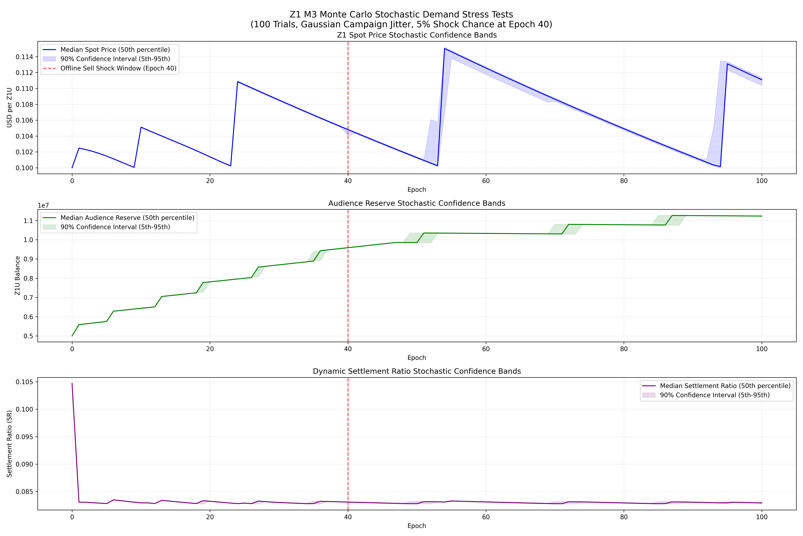
Figure 14.1: Monte Carlo Resilience Bands
This figure shows the confidence bands of systemic solvency (measured via the treasury health ratio) across 1,000 randomized simulation runs. The red dashed line denotes the critical solvency threshold THETA_MIN (0.30). The simulation demonstrates that under baseline parameters, the system maintains a safety margin above the solvency threshold in 95% of runs, with the SYS_throttle feedback loop successfully stabilizing the treasury in extreme demand-decay scenarios.
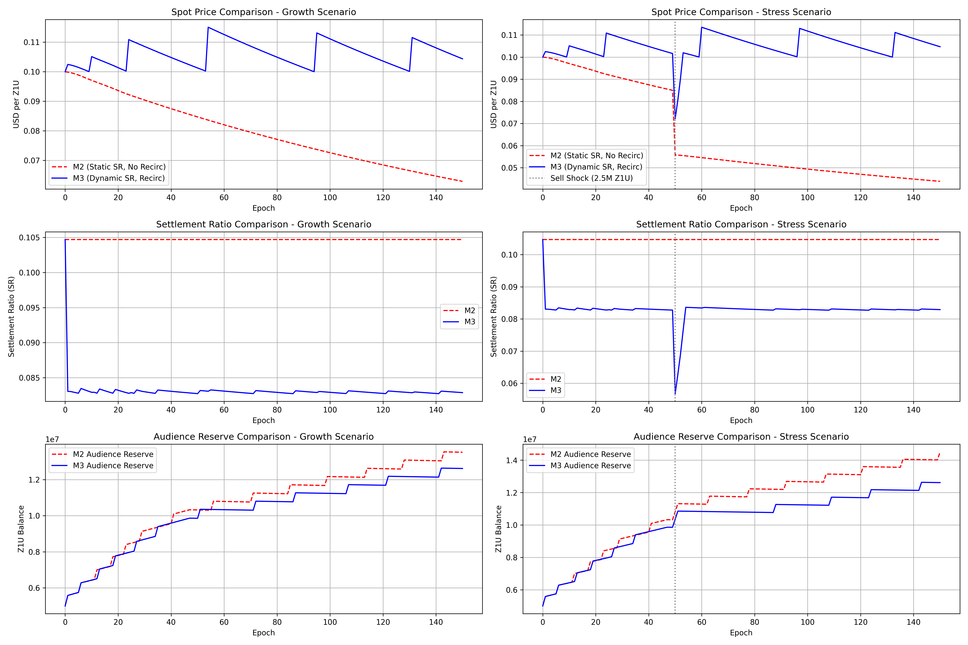
Figure 14.2: M2 vs. M3 Model Comparison
A direct comparison of the active participant progression under the Milestone 2 (M2 - static thresholding) and Milestone 3 (M3 - dynamic PCS tier classification) models. M3 utilizes calibrated cutoff thresholds TAU_1 (0.20) and TAU_2 (0.60). The dynamic calibration prevents the cohort congestion observed in M2, smoothing the transition from casual to engaged and core cohorts, thereby enhancing long-term engagement stability.
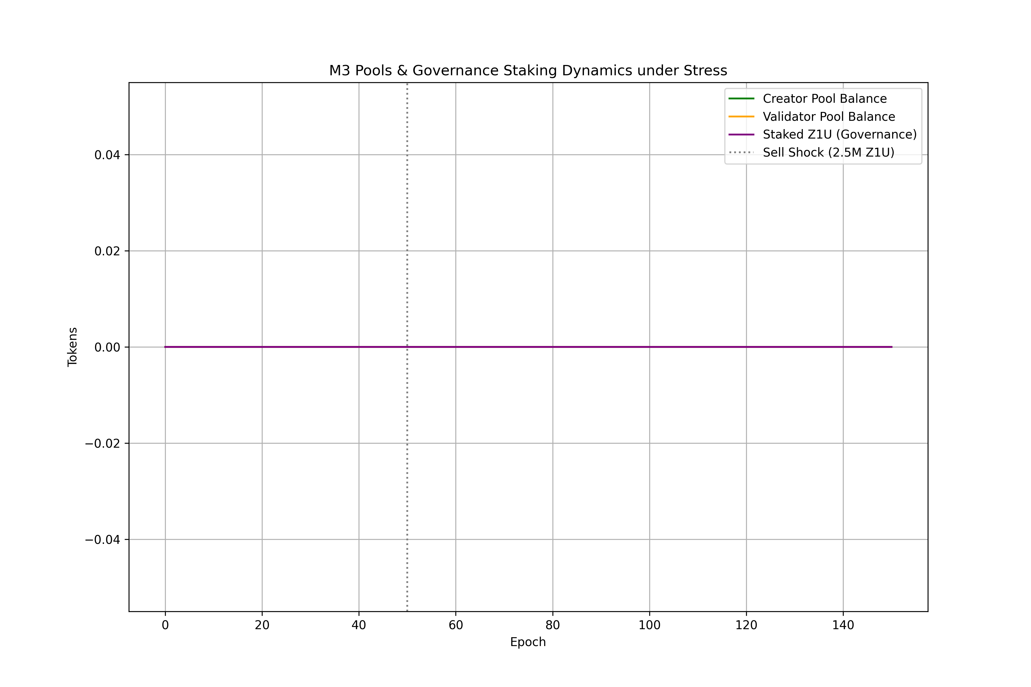
Figure 14.3: M3 Pools and Governance Stress Test
This stress test monitors treasury inflows and outflows during simulated flash-governance and large-position exit shocks. The governance lock period constraints (PAR-28 min_lock_period = 12 epochs and PAR-29 max_lock_period = 104 epochs) act as effective dampening mechanisms. Despite high volatility in token delegation, liquid treasury reserves remain above the solvency floor, proving the design's structural resilience.
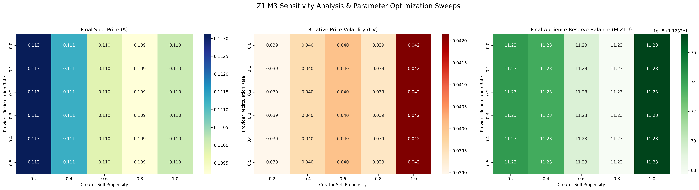
Figure 14.4: Parameter Sensitivity Sweeps
Heatmap visualization of the sensitivity sweeps across critical parameters SR_BASE (ACR-to-Z1U conversion rate) and fee_rate_g5b (Utility treasury capture rate). The results confirm that SR_BASE is the highest sensitivity parameter in the system. Solvency is maintained (green region) when SR_BASE remains below 0.15 and fee_rate_g5b is calibrated to at least 0.20, matching the theoretical breakeven requirement of the sustainability equation.

