1. Step 1 in views.py

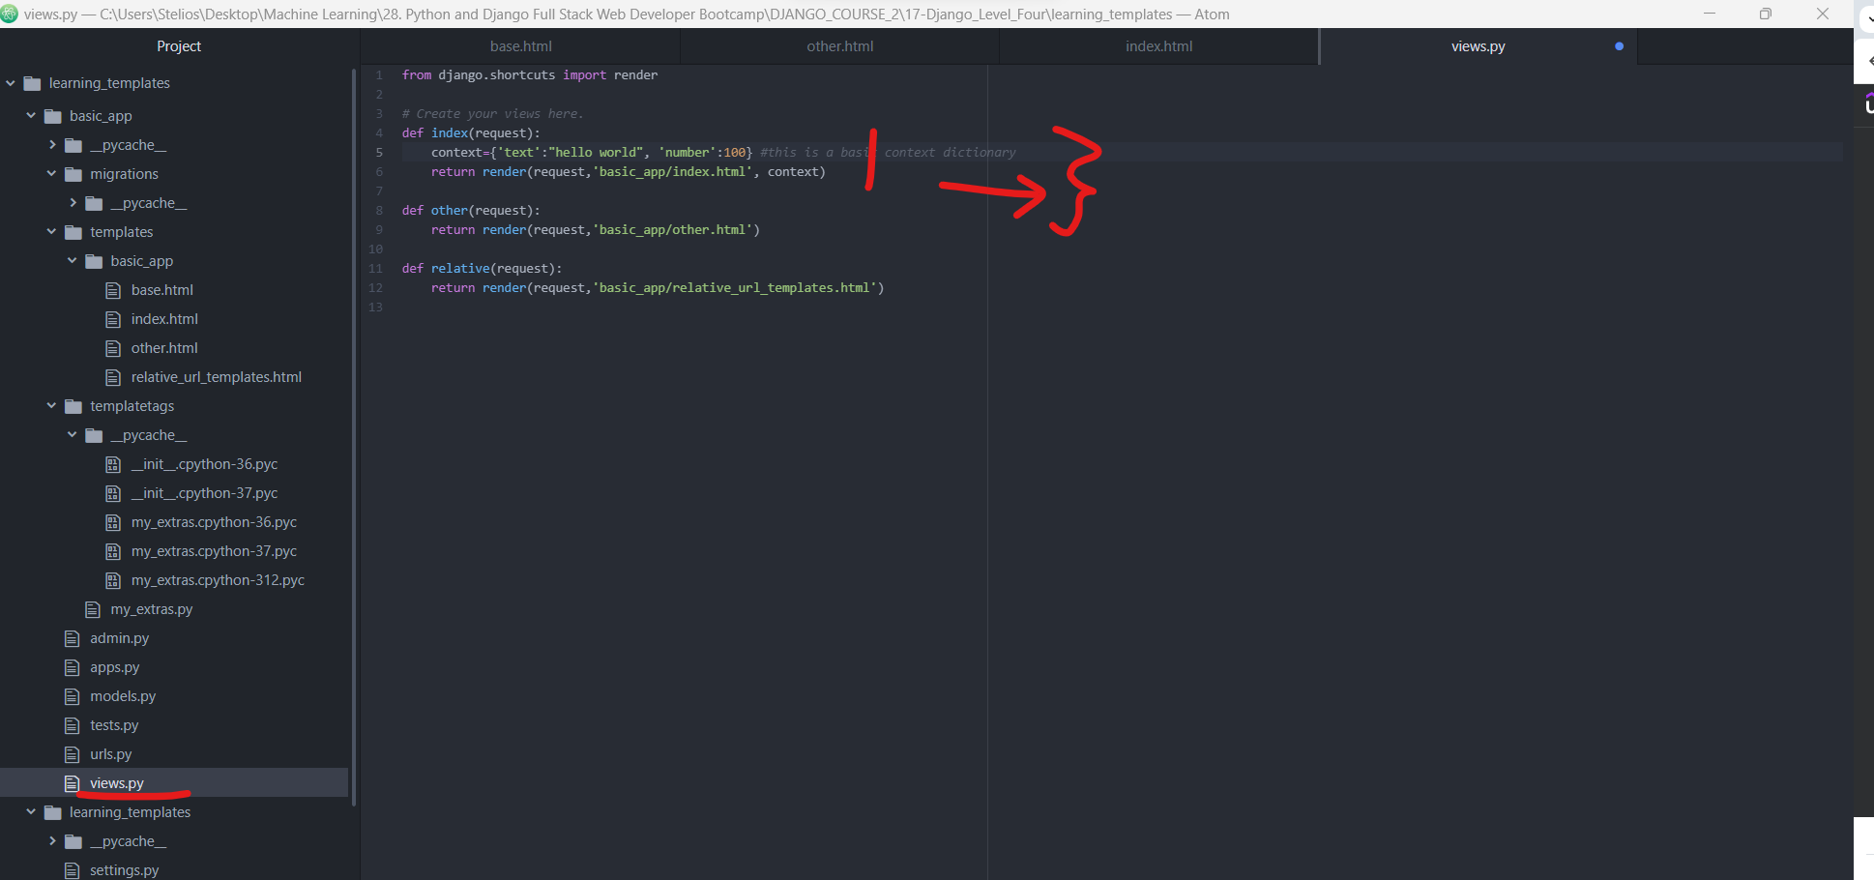

1. Use build-in functions in the filter

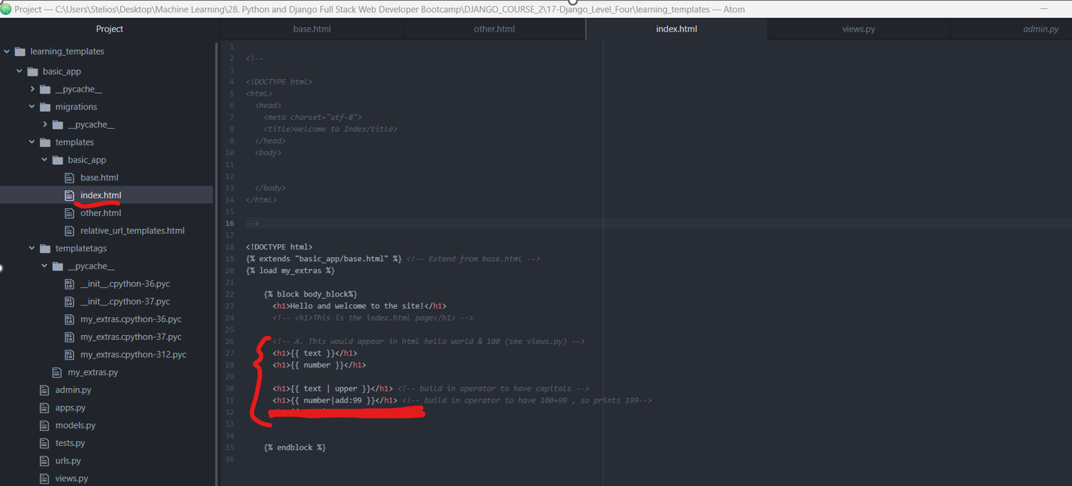

1. Use our own functions – we create a new folder in app with 2 files (one empty __init__ and one .py that we have our own logics)

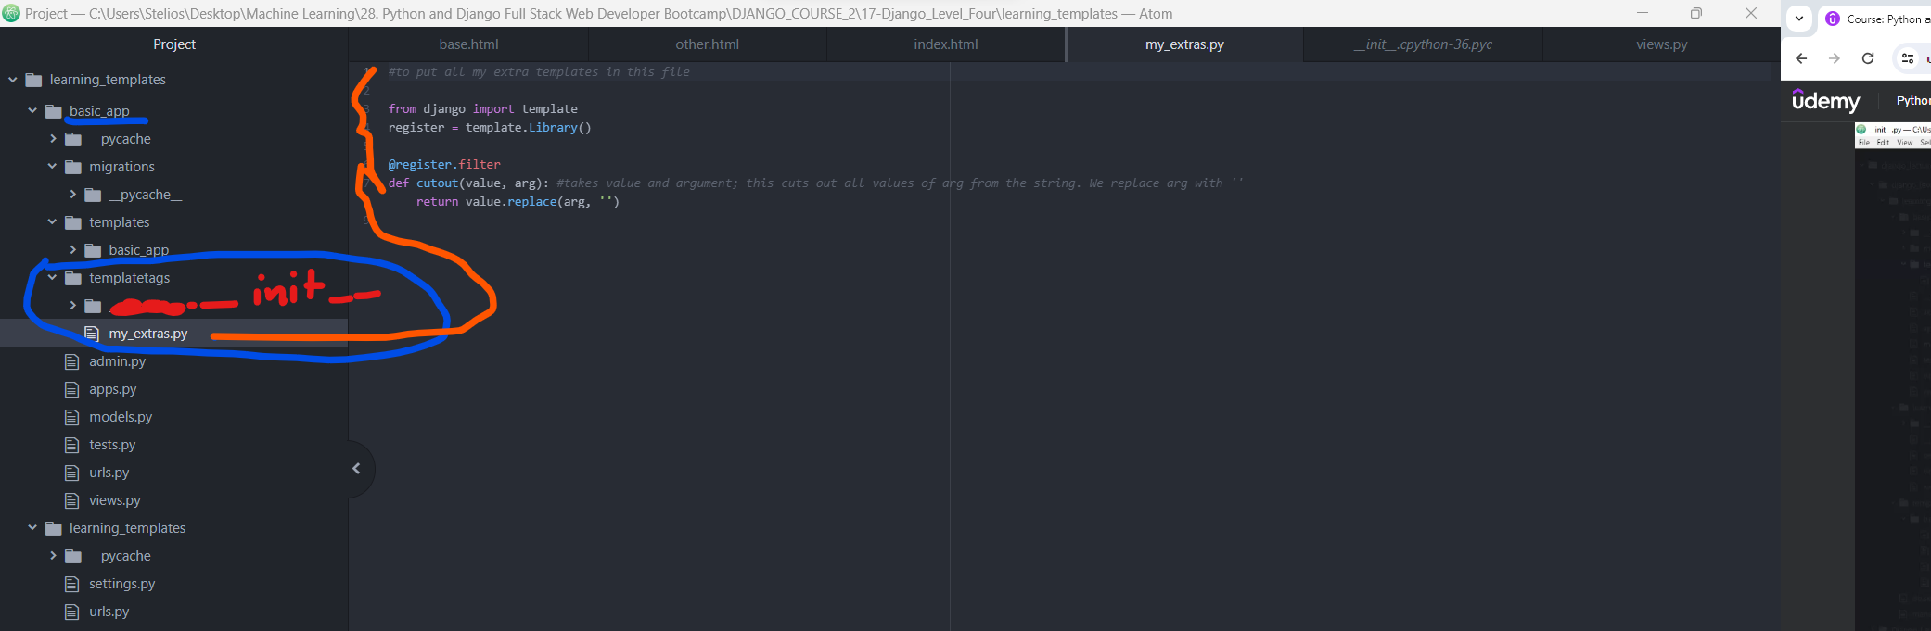

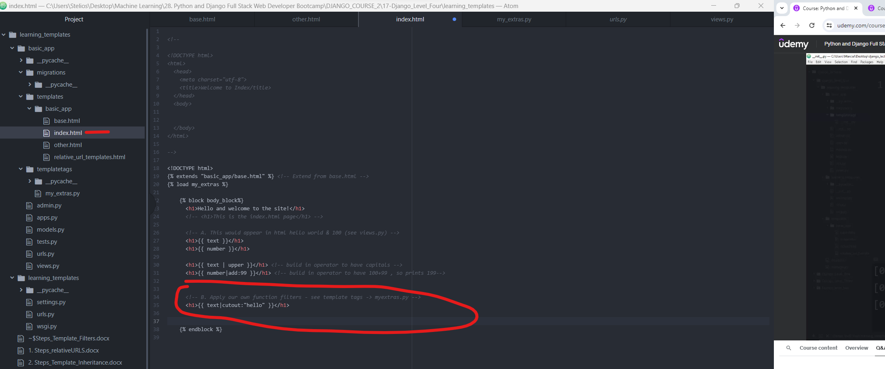

1. RunServer

