
MASTER SERVICES AGREEMENT
Project Aurora • International document-workflow platform
Parties | Northstar Systems Ltd. / Meridian Research Cooperative
Effective date | 15 September 2026
Initial term | 24 months
Service regions | European Union, United Kingdom, United States, Singapore
Document status | Fictional sample — not legal advice

1. Agreement overview
This synthetic agreement demonstrates a structured, multi-page DOCX with native Word constructs. It is designed solely as a visual and editing fixture for Folio; every party, project, address, metric, and obligation is invented.
Recording cue: Scroll through the document, switch to Track Changes, revise a service level, add a comment, and save the resulting DOCX.

2. Principles
- Native document structures remain editable: paragraphs, headings, tables, headers, footers, lists, comments, and revisions.
- The parties use ISO-formatted timestamps in system records and localized dates in human-facing notices.
- Nothing in this fixture represents an actual customer, transaction, or legal commitment.

Schedule 1 — Services and responsibilities
Northstar will provide a browser-based document workspace for the fictional Aurora program. Meridian will supply approved test documents and designated reviewers.

3. Delivery sequence
- Establish the isolated project workspace and validate access roles.
- Import synthetic document templates and confirm pagination baselines.
- Run a controlled review cycle using comments and tracked changes.
- Export the reviewed package and verify it in an independent DOCX consumer.

4. Responsibility matrix
Workstream | Northstar | Meridian | Acceptance evidence
Workspace setup | Configure isolated environment | Nominate reviewers | Access report
Document intake | Validate package boundaries | Provide synthetic files | Import receipt
Review cycle | Maintain editor and audit events | Review proposed changes | Accepted/rejected revisions
Export | Produce a standards-based DOCX | Open in target applications | Signed test record
Incident exercise | Run restoration scenario | Observe and approve | Recovery timeline
All names, organizations, metrics, and obligations are fictional.

5. Deliverables
- Configured browser editor with React and Vue integration examples.
- Headless comparison and native redline workflow for automation.
- Portable DOCX outputs that retain supported package structures.

Schedule 2 — Service levels
The following targets are illustrative and are not commitments by any real organization.
Measure | Target | Measurement window | Service credit
Workspace availability | 99.90% | Calendar month | 2% below target
Interactive save latency | ≤ 2.0 s | P95, rolling 7 days | Operational review
Recovery point objective | ≤ 15 min | Per simulated incident | 5% if exceeded
Recovery time objective | ≤ 60 min | Per simulated incident | 10% if exceeded
Priority-one response | ≤ 30 min | 24 × 7 | Escalation review
All names, organizations, metrics, and obligations are fictional.
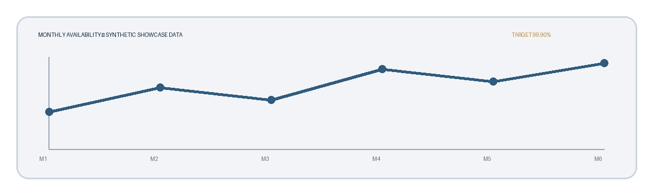
Figure 1. Synthetic availability data used for layout demonstration.
Revision already present: A tracked change later in this document shortens the change-notice period from ten to five business days.

Schedule 3 — Security and data handling

6. Handling principles
Each party will minimize test data, use least-privilege access, and preserve a structured record of document operations. Production personal data is outside the scope of this showcase.
- Encrypt document transfers in transit and retain only the copies required for the test window.
- Separate workspaces and document identifiers across independent projects.
- Review proposed automated edits as comments or tracked changes before acceptance.
- Record export, restoration, and deletion events using stable document identifiers.

7. Localized notice samples
Locale | Human-facing notice | Machine timestamp
English | Review closes 15 September 2026 | 2026-09-15T16:00:00Z
Čeština | Revize končí 15. září 2026 | 2026-09-15T16:00:00Z
العربية | تنتهي المراجعة في ١٥ سبتمبر ٢٠٢٦ | 2026-09-15T16:00:00Z
简体中文 | 审阅于 2026 年 9 月 15 日结束 | 2026-09-15T16:00:00Z
All names, organizations, metrics, and obligations are fictional.

8. Interpretation
Times are interpreted in the recipient’s stated time zone; the audit record remains in UTC. If localized text and the machine timestamp conflict, the machine timestamp controls for this fixture.

Schedule 4 — Change control and signatures

9. Change requests
A party proposing a material scope change will give the other party at least five business days’ written notice. The notice must identify the affected deliverable, schedule impact, and acceptance evidence.

10. Approval workflow
- The requesting party records the proposed change and its reason.
- The reviewing party accepts, rejects, or comments on the proposal.
- The parties preserve the decision and resulting document version in the audit record.

11. Signature blocks
NORTHSTAR SYSTEMS LTD. | MERIDIAN RESEARCH COOPERATIVE
Signature: __________________________ | Signature: __________________________
Name: Avery Morgan | Name: Jordan Lee
Date: 15 September 2026 | Date: 15 September 2026
Important: This document is a synthetic rendering fixture. It is not legal advice and creates no rights or obligations.

For this synthetic fixture, UTC timestamps use ISO 8601 and are included only to exercise footnote and locale rendering.

