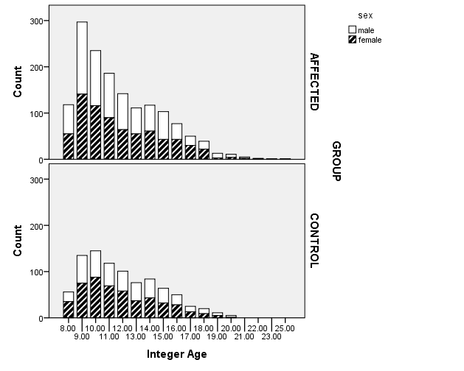

Figure S1. Sample breakdown by age, rounded to the closest integer. “Control” participants were recruited as part of a control family where neither twin had a history of either reading disorder or ADHD symptoms. “Affected” participants were recruited as part of a case family where at least one twin had a history of reading disorder or ADHD symptoms.

Notation S1.

71% of participants completed the Wechsler Intelligence Scales for Children, Revised (Wechsler, 1974), 18% the Wechsler Intelligence Scales for Children, 3rd Edition (Wechsler, 1997), and 6% the short form of the Wechsler Intelligence Scales for Children, 3rd Edition (Donders, 1997). Six percent of the sample completed the Wechsler Adult Intelligence Scale, with version distributed as follows: Revised (5%; Wechsler, 1981), 3rd Edition (1%; Wechsler, 1997), and short form of the 3rd Edition (0.1%).

|  |  |  |  |
| --- | --- | --- | --- |
| Table S1.  *Cognitive Composites* | | | |
| Composite | Measures | Male *M*(SD) | Female *M*(SD) |
| Processing Speed (PS) | Wechsler Symbol Search & Coding B; Colorado Perceptual Speed (DeFries et al., 1997), Identical Pictures (French, Ekstrom, & Price, 1963), Trails A & B (Reitan, 1971) | -.18(.80) | .09(.74) |
| Working Memory (WM) | Wechsler Digit Span & Arithmetic; Sentence Span (Siegel & Ryan, 1989), & Counting Span (Case, Kurland, & Goldberg, 1982) | .03(.82) | -.03(.78) |
| Phoneme Awareness (PA) | Phoneme Deletion 1 and 2 (Olson, Forsberg, Wise, & Rack, 1994), Weighted Pig Latin (Olson, Wise, Conners, Rack, & Fulker, 1989), Lindamood Auditory Conceptualization Test (Lindamood & Lindamood, 1971) | .00(.93) | .00(.88) |
| Verbal Reasoning (VR) | Wechsler Information, Similarities, Vocabulary, & Comprehension | .46(.85) | .33(.82) |
| Inhibition (INH) | GDS Vigilance Commission Errors (Gordon, 1983); Stop Signal Task (Logan, 1994); Stroop Color Word Interference (Golden, 1978) | .04(.60) | .13(.56) |

|  |  |  |  |  |  |  |
| --- | --- | --- | --- | --- | --- | --- |
| Table S2.  *Correlations Between Individual Reading Measures and Cognitive Composites* | | | | | | |
|  | Reading Composite | Phonemic Awareness | Verbal Reasoning | Working Memory | Processing Speed | Inhibition |
| PIAT Reading Recognition | .947 | .706 | .571 | .593 | .460 | .395 |
| Word Recognition | .944 | .674 | .568 | .574 | .487 | .398 |
| PIAT Spelling | .879 | .564 | .474 | .531 | .507 | .382 |
| Nonword Reading | .892 | .794 | .423 | .521 | .377 | .371 |
| Note: Values are two-tailed Pearson correlations. All values statistically significant at *p*<.001. | | | | | | |

|  |  |  |  |  |  |  |
| --- | --- | --- | --- | --- | --- | --- |
| Table S3.  *Correlations Among Cognitive Composites* | | | | | | |
|  | Reading Composite | Phonemic Awareness | Verbal Reasoning | Working Memory | Processing Speed | Inhibition |
| Reading Composite | 1 | .747 | .557 | .605 | .499 | .424 |
| Phonemic Awareness | .747 | 1 | .481 | .570 | .363 | .404 |
| Verbal Reasoning | .557 | .481 | 1 | .561 | .365 | .333 |
| Working Memory | .605 | .570 | .561 | 1 | .461 | .457 |
| PS | .499 | .363 | .365 | .461 | 1 | .526 |
| Inhibition | .424 | .404 | .333 | .457 | .526 | 1 |
| Note: Values are two-tailed Pearson correlations. All values statistically significant at *p*<.001. | | | | | | |

Notation S2.

Normalization of the reading measures prior to creating mean composites could have potentially affected our results. Additionally, measurement invariance was tested using structural equation modeling. Thus, to ensure that our mean composite scores using winsorized indicator variables did not bias the results, we computed reading and cognitive correlate composites in three additional ways: 1) we created mean composites, as described above, but *without* first Winsor-transforming the data; 2) we created factor scores via confirmatory factor analysis in MPlus 7.31, using the Winsor-transformed variables as factor indicators; 3) we created factor scores, as in 2), but using untransformed indicator variables. The distributions of these resulting composites and factor scores are shown in Figures S2 and S3. We tested for male : female difference in the extreme tails of the distribution independently within each reading score, and within each of the hypothesized models. Results of these analyses are listed in Table S4 and were mostly comparable to the main study analyses (i.e. Composite, winds).

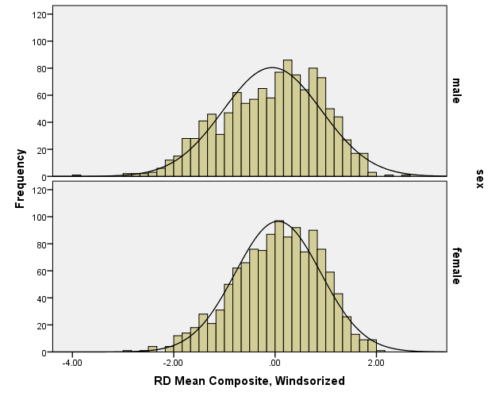 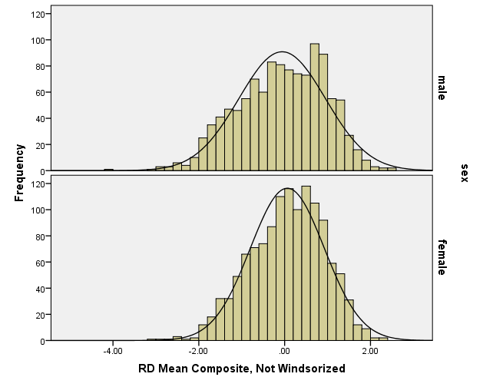

Figure S2. Reading mean composite distributions by sex. Left: variables contributing to factor score were previously Windsor-transformed. Right: variables contributing to factor score were not Windsor-transformed.

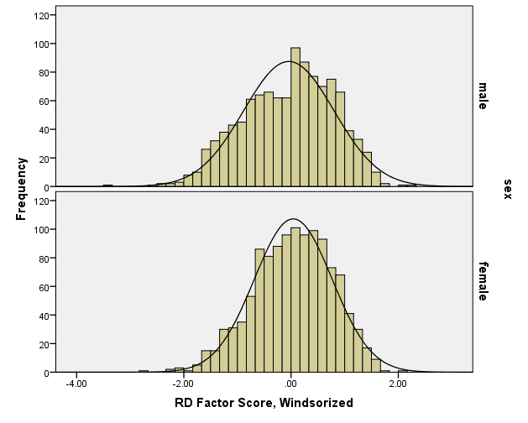 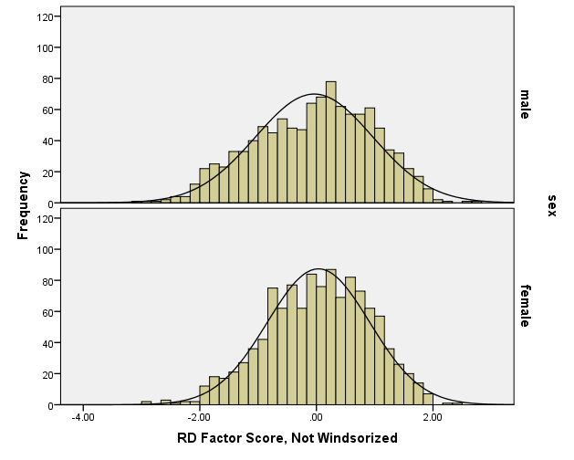

Figure S3. Reading factor score distributions by sex. Left: variables contributing to factor score were previously Windsor-transformed. Right: variables contributing to factor score were not Windsor-transformed.

|  |  |  |  |  |
| --- | --- | --- | --- | --- |
| Table S4.  *Sex distribution in Low and High Reading Performance Tails by Reading Score and Model* | | | | |
|  | RD | VDM | MDM | CDM |
|  | Low 1.5 | | | |
| Composite, winds | M>F | M>F | M>F | ns |
| Composite | M>F | ns | M>F | ns |
| FS, winds | M>F | ns | M>F | ns |
| FS | M>F | M>F | M>F | ns |
|  | Low 2.0 | | | |
| Composite, winds | M>F | ns | ns | ns |
| Composite | M>F | ns | M>F | ns |
| FS, winds | M>F | ns | (m>f) | ns |
| FS | M>F | ns | ns | ns |
|  | High 1.5 | | | |
| Composite, winds | ns | F>M | M>F | ns |
| Composite | ns | F>M | M>F | ns |
| FS, winds | ns | F>M | M>F | ns |
| FS | ns | F>M | M>F | ns |
|  | High 2.0 | | | |
| Composite, winds | ns | ns | ns | F>M |
| Composite | ns | (f>m) | ns | ns |
| FS, winds | ns | F>M | M>F | (f>m) |
| FS | ns | F>M | M>F | Ns |
| RD = Untransformed reading composite; VDM = variance difference model; MDM = mean difference model; CDM = combined variance and mean difference model; Composite = mean z score; FS=factor score; winds = indicator variables Windsor-transformed; relationships in parentheses indicate trends with p=.05 to p=.08. Shaded rows indicate results reported in the main article. | | | | |

Notation S3.

Because our sample included a large number of youth with ADHD symptoms, ADHD is also more prevalent in males, and ADHD and dyslexia are highly comorbid, we tested a second mediation model that included ADHD inattention symptoms as an additional mediator. We chose to test inattention symptoms due to their particularly strong association with reading problems and the potential negative effect of inattention on reading ability. However, inattention was not a statistically significant mediator of the association between sex and reading when the other cognitive endophenotypes were included (ADHD indirect *β* = .01, *p*=.064).

Appendix References

Case, R., Kurland, M., & Goldberg, J. (1982). Operational efficiency and the growth of short-term memory span. *Journal of Experimental Child Psychology, 33*, 386-404.

DeFries, J. C., Filipek, P. A., Fulker, D. W., Olson, R. K., Pennington, B. F., Smith, S. D., & Wise, B. W. (1997). Colorado Learning Disabilities Research Center. *Learning Disabilities: A Multidisciplinary Journal, 8*, 7-19.

Donders, J. (1997). A short form of the WISC-III for clinical use. *Psychological Assessment, 9*(1), 15-20.

French, J. W., Ekstrom, R. G., & Price, L. A. (1963). *Manual for a kit of reference tests for cognitive factors*. Princeton, NJ: Educational Testing Service.

Golden, J. C. (1978). *Stroop color and word test*. Chicago: Stoelting.

Gordon, M. (1983). *The gordon diagnostic system*. DeWitt, NY: Gordon Systems.

Lindamood, C. H., & Lindamood, P. C. (1971). *Lindamood auditory conceptualization test*. Boston: Reading Resources Corporation.

Logan, G. D. (1994). On the ability to inhibit thought and action: A user's guide to the stop signal paradigm. In D. Dagenbach, & T. Carr (Eds.), *Inhibitory processes in attention, memory, and language* (pp. 189-239). San Diego: Academic Press.

Olson, R., Forsberg, H., Wise, B., & Rack, J. (1994). Measurement of word recognition, orthographic, and phonological skills. In G. R. Lyon (Ed.), *Frames of reference for the assessment of learning disabilities: New views on measurement issues* (pp. 243-277). Baltimore, MD: Paul H. Brookes Publishing Co.

Olson, R., Wise, B., Conners, F., Rack, J., & Fulker, D. (1989). Specific deficits in component reading and language skills: Genetic and environmental influences. *Journal of Learning Disabilities, 22*, 339-348.

Reitan, R. M. (1971). Trail making test results for normal and brain-damaged children. *Perceptual and Motor Skills, 33*, 575-581. doi:10.2466/pms.1971.33.2.575

Siegel, L. S., & Ryan, E. B. (1989). The development of working memory in normally achieving and subtypes of learning disabled children. *Child Development, 60*(973), 980.

Wechsler, D. (1974). *Wechsler Intelligence Scale for Children--Revised*. New York: The Psychological Corporation.

Wechsler, D. (1981). *Wechsler Adult Intelligence Scale--Revised*. New York: The Psychological Corporation.

Wechsler, D. (1997). *Wechsler Intelligence Scale for Children--Third Edition*. San Antonio, TX: The Psychological Corporation.