Student Details
Repository Name | DBS25P048
Registration Number | 2024-CS-48

Project
Project Title | ITEC Event Management System
Executive Summary | The ITEC Event Management System is a centralized desktop application developed to streamline the organization of annual ITEC events at the Department of Computer Science, UET Lahore. The system replaces manual processes involving spreadsheets and physical records, addressing critical challenges such as:  - Data Inconsistency: Automates participant registration, committee assignments, and financial tracking.  - Efficiency: Provides tools for scheduling events, allocating venues, and managing duties.  - Reporting: Generates real-time reports for participants, finances, and event schedules.  Built using C# WinForms and MySQL, the application follows a 3-tier architecture (UI, BL, DL) with direct SQL queries for database operations (no Entity Framework). Key features include:  - Multi-edition event management  - Dynamic financial tracking (income/expenses)  - Conflict-free venue allocation  - Automated report generation  The system adheres to strict schema guidelines and uses a normalized database with 15+ tables (committees, participants, finances, etc.).

Interface Name | EventsManageUC
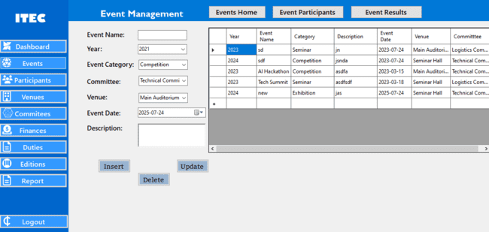
UI Component Name | Type of UI component | Class Attribute name,  Classname, attribute name | Linked to which database column/table
cmbItec | Combo Box | EventsManageUC.cs | SELECT itec_id, year FROM itec_editions
cmbCategory | Combo Box | EventsManageUC.cs | SELECT event_category_id, category_name FROM event_categories
cmbVenue | Combo Box | EventsManageUC.cs | SELECT venue_id, venue_name FROM venues
UpdateBtn | Button | EventsManageUC.cs | $@"UPDATE itec_events  SET itec_id={updatedEvent.ItecId},  event_name  ='{updatedEvent.EventName}',  event_category_id ={updatedEvent.EventCategoryId},  description  = '{updatedEvent.Description}',  event_date  = '{updatedEvent.EventDate:yyyy-MM-dd}',  venue_id ={updatedEvent.VenueId},  committee_id  = {updatedEvent.CommitteeId}  WHERE event_id = {updatedEvent.EventId}"
cmbCommittee | Combo Box | EventsManageUC.cs | SELECT committee_id, committee_name FROM committees
AddBtn | Button | EventsManageUC.cs | $@"INSERT INTO itec_events  (itec_id, event_name, event_category_id, description, event_date, venue_id, committee_id)  VALUES ({newEvent.ItecId}, '{newEvent.EventName}', {newEvent.EventCategoryId}, '{newEvent.Description}', '{newEvent.EventDate:yyyy-MM-dd}', {newEvent.VenueId}, {newEvent.CommitteeId})"
DataGridView1 | DataGridView | EventsManageUC.cs | @"SELECT e.event_id, e.itec_id, e.event_name, e.event_category_id,e.description,e.event_date, e.venue_id,e.committee_id,ie.year as itec_year, ec.category_name as event_category_name, v.venue_name,c.committee_name  FROM itec_events e  LEFT JOIN itec_editions ie on e.itec_id = ie.itec_id  LEFT JOIN event_categories ec on e.event_category_id = ec.event_category_id  LEFT JOIN venues v on e.venue_id = v.venue_id  LEFT JOIN committees c on e.committee_id =c.committee_id"
DeleteBtn | Button | EventsManageUC.cs | $"DELETE FROM itec_events WHERE event_id = {eventId}”

Interface Name | EventsParticipantUC
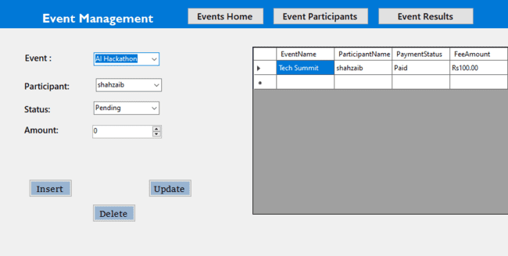

UI Component Name | Type of UI component | Class Attribute name,  Classname, attribute name | Linked to which database column/table
AddBtn | Button | EventsParticipantsUC.cs | $@" INSERT INTO event_participants  (event_id, participant_id, payment_status_id, fee_amount)  VALUES  ({participant.EventId}, {participant.ParticipantId}, {participant.PaymentStatusId}, {participant.FeeAmount})"
UpdateBtn | Button | EventsParticipantsUC.cs | $@"  UPDATE event_participants  SET event_id = {participant.EventId},  participant_id = {participant.ParticipantId},  payment_status_id = {participant.PaymentStatusId},  fee_amount = {participant.FeeAmount}  WHERE registration_id = {participant.RegistrationId}"
DeleteBtn | Button | EventsParticipantsUC.cs | $"DELETE FROM event_participants WHERE registration_id = {registrationId}"
cmbEvent | Combo Box | EventsParticipantsUC.cs | "SELECT event_id, event_name FROM itec_events"
cmbParticipant | Combo Box | EventsParticipantsUC.cs | "SELECT participant_id, name FROM participants"
cmbStatus | Combo Box | EventsParticipantsUC.cs | "SELECT lookup_id, value FROM lookup WHERE category = 'PaymentStatus'"
DataGridView1 | DataGridView | EventsParticipantsUC.cs | @" SELECT ep.registration_id, ep.event_id, ep.participant_id, ep.payment_status_id, ep.fee_amount,  e.event_name, p.name AS participant_name, l.value as payment_status  FROM event_participants ep  LEFT JOIN itec_events e on ep.event_id = e.event_id  LEFT JOIN participants p on ep.participant_id = p.participant_id  LEFT JOIN lookup l on ep.payment_status_id = l.lookup_id"

Interface Name | EventResultsUC
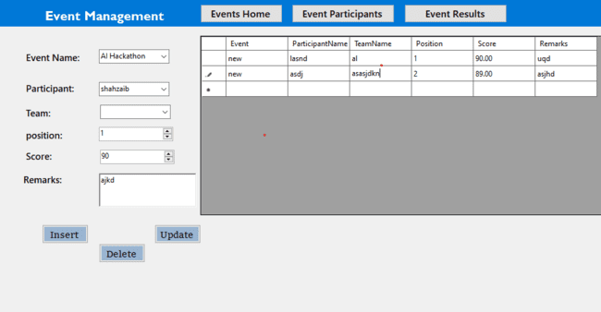

UI Component Name | Type of UI component | Class Attribute name,  Classname, attribute name | Linked to which database column/table
AddBtn | Button | EventsResultsUC.cs | $@"INSERT INTO event_results  (event_id, participant_id, team_id, position, score, remarks)  VALUES  ({result.EventId}, {participantPart}, {teamPart}, {result.Position}, {result.Score}, '{result.Remarks}')"
UpdateBtn | Button | EventsResultsUC.cs | $@"UPDATE event_results  SET event_id = {result.EventId},  participant_id = {participantPart},  team_id = {teamPart},position = {result.Position},score = {result.Score},remarks = '{result.Remarks}'  WHERE result_id ={result.ResultId}"
DeleteBtn | Button | EventsResultsUC.cs | $"DELETE FROM event_results WHERE result_id = {resultId}"
cmbEvent | Combo Box | EventsResultsUC.cs | "SELECT event_id, event_name FROM itec_events"
cmbParticipant | Combo Box | EventsResultsUC.cs | "SELECT participant_id, name FROM participants"
cmbTeam | Combo Box | EventsResultsUC.cs | "SELECT team_id, team_name FROM teams"
DataGridView1 | DataGridView | EventsResultsUC.cs | @"SELECT er.result_id, er.event_id, er.participant_id, er.team_id,  er.position, er.score, er.remarks,  e.event_name, p.name AS participant_name, t.team_name  FROm event_results er  LEFT JOIN itec_events e on er.event_id = e.event_id  LEFT JOIN participants p on er.participant_id = p.participant_id  LEFT JOIN teams t on er.team_id = t.team_id"

Interface Name | ParticipantsUC



UI Component Name | Type of UI component | Class Attribute name,  Classname, attribute name | Linked to which database column/table
AddBtn | Button | ParticipantsUC.cs | $@"INSERT INTO participants  (itec_id, name, email, contact, institute, role_id)  VALUES ({participant.ItecId}, '{participant.Name}', '{participant.Email}', '{participant.Contact}',  '{participant.Institute}', {participant.RoleId})"
UpdateBtn | Button | ParticipantsUC.cs | $@"UPDATE participants  SET itec_id = {participant.ItecId},  name = '{participant.Name}',  email = '{participant.Email}',  contact = '{participant.Contact}',  institute = '{participant.Institute}',  role_id = {participant.RoleId}  WHERE participant_id = {participant.ParticipantId}"
DeleteBtn | Button | ParticipantsUC.cs | $"DELETE FROM participants WHERE participant_id = {participantId}"
cmbItec | Combo box | ParticipantsUC.cs | "SELECT itec_id, year FROM itec_editions"
cmbRole | Combo box | ParticipantsUC.cs | "SELECT role_id, role_name FROM roles"
DataGridView1 | DataGridView | ParticipantsUC.cs | "SELECT  p.participant_id, p.name, p.itec_id, ie.year,p.email, p.contact, p.institute, p.role_id,  r.role_name as r_name  FROM participants p  LEFT JOIN roles r on p.role_id=r.role_id  LEFT JOIN itec_editions ie on p.itec_id=ie.itec_id "

Interface Name | VenuesUC
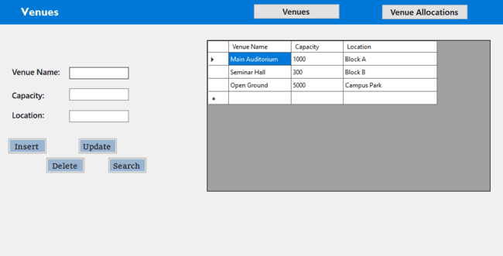

UI Component Name | Type of UI component | Class Attribute name,  Classname, attribute name | Linked to which database column/table
AddBtn | Button | VenuesUC.cs | $@"INSERT INTO venues(venue_name, capacity, location)  VALUES ('{venue.VenueName}', {venue.Capacity}, '{venue.Location}')"
UpdateBtn | Button | VenuesUC.cs | $@"UPDATE venues SET venue_name = '{venue.VenueName}',  capacity = {venue.Capacity},  location = '{venue.Location}'  WHERE venue_id = {venue.VenueId}"
DeleteBtn | Button | VenuesUC.cs | $"DELETE FROM venues WHERE venue_id = {venueId}"
DataGridView1 | DataGridView | VenuesUC.cs | Venues Table

Interface Name | VenueAllocationUC
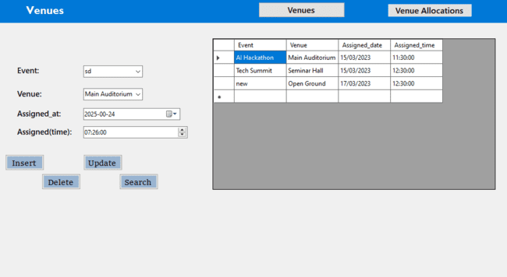

UI Component Name | Type of UI component | Class Attribute name,  Classname, attribute name | Linked to which database column/table
AddBtn | Button | VenueAllocationUC.cs | $@"INSERT INTO venue_allocations(event_id, venue_id, assigned_date, assigned_time)  VALUES ({allocation.EventId}, {allocation.VenueId},'{allocation.AssignedDate:yyyy-MM-dd}','{allocation.AssignedTime:hh\\:mm\\:ss}')"
UpdateBtn | Button | VenueAllocationUC.cs | $@"UPDATE venue_allocations  SET event_id = {allocation.EventId},  venue_id = {allocation.VenueId},  assigned_date = '{allocation.AssignedDate:  yyyy-MM-dd}', assigned_time = '{allocation.AssignedTime:hh\\:mm\\:ss}'  WHERE venue_allocation_id = {allocation.VenueAllocationId}"
DeleteBtn | Button | VenueAllocationUC.cs | $"DELETE FROM venue_allocations WHERE venue_allocation_id = {allocationId}"
cmbEvent | Combo Box | VenueAllocationUC.cs | "SELECT event_id, event_name FROM itec_events"
cmbVenue | Combo Box | VenueAllocationUC.cs | "SELECT venue_id, venue_name FROM venues"
DataGridView1 | DataGridView | VenueAllocationUC.cs | "SELECT va.venue_allocation_id,va.event_id, va.venue_id, va.assigned_date,  va.assigned_time, v.venue_name, ie.event_name  FROM venue_allocations va  LEFT JOIN venues v on v.venue_id=va.venue_id  LEFT JOIN itec_events ie on ie.event_id=va.event_id"

Interface Name | CommitteeMembersUC
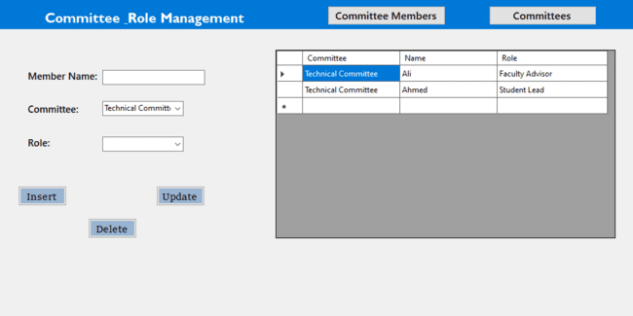

UI Component Name | Type of UI component | Class Attribute name,  Classname, attribute name | Linked to which database column/table
AddBtn | Button | CommitteeMembersUC.cs | $@"INSERT INTO committee_members (committee_id, name, role_id) VALUES ({member.CommitteeId}, '{member.Name}',  {(member.RoleId.HasValue ? member.RoleId.ToString() : "NULL")})"
UpdateBtn | Button | CommitteeMembersUC.cs | $@"UPDATE committee_members  SET committee_id = {member.CommitteeId},  name = '{member.Name}',  role_id = {(member.RoleId.HasValue ? member.RoleId.ToString() : "NULL")} WHERE member_id = {member.MemberId}"
DeleteBtn | Button | CommitteeMembersUC.cs | $"DELETE FROM committee_members WHERE member_id = {memberId}"
cmbCommittee | Combo Box | CommitteeMembersUC.cs | "SELECT event_id, event_name FROM itec_events"
cmbRole | Combo Box | CommitteeMembersUC.cs | "SELECT participant_id, name FROM participants"
DataGridView1 | DataGridView | EventsResultsUC.cs | @"SELECT cm.member_id, cm.committee_id, cm.name, cm.role_id,c.committee_name, l.value AS role_name  FROM committee_members cm  LEFT JOIN committees c on cm.committee_id = c.committee_id  LEFT JOIN lookup l on cm.role_id = l.lookup_id" e.event_name, p.name AS participant_name, t.team_name  FROm event_results er  LEFT JOIN itec_events e on er.event_id = e.event_id  LEFT JOIN participants p on er.participant_id = p.participant_id  LEFT JOIN teams t on er.team_id = t.team_id"

Interface Name | CommitteesUC
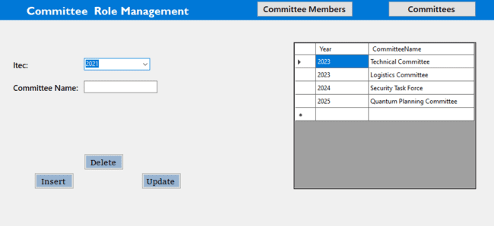

UI Component Name | Type of UI component | Class Attribute name,  Classname, attribute name | Linked to which database column/table
AddBtn | Button | CommitteesUC.cs | $@"INSERT INTO committees  (itec_id, committee_name)  VALUES ({newCommittee.ItecId}, '{newCommittee.CommitteeName}')"
UpdateBtn | Button | CommitteesUC.cs | $@"UPDATE committees  SET itec_id={updatedCommittee.ItecId},  committee_name = '{updatedCommittee.CommitteeName}'  WHERE committee_id = {updatedCommittee.CommitteeId}"
DeleteBtn | Button | CommitteesUC.cs | $"DELETE FROM committees WHERE committee_id = {committeeId}"
cmbItec | Combo Box | CommitteesUC.cs | "SELECT itec_id, year FROM itec_editions"
DataGridView1 | DataGridView | CommitteesUC.cs | "SELECT c.committee_id,c.itec_id,ie.year,c.committee_name FROM committees c  LEFT JOIN itec_editions ie on ie.itec_id=c.itec_id"

Interface Name | FinancesUC
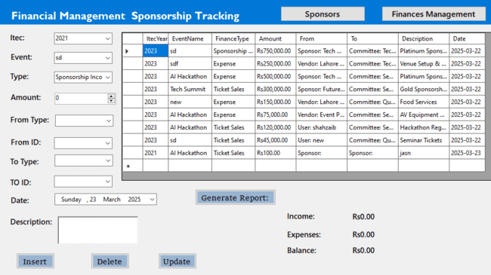

UI Component Name | Type of UI component | Class Attribute name,  Classname, attribute name | Linked to which database column/table
AddBtn | Button | FinancesUC.cs | $@"INSERT INTO finances(itec_id, event_id, type_id, amount, from_entity_type, from_entity_id,  to_entity_type, to_entity_id, description, date_recorded)  VALUES ({transaction.ITECId}, {eventPart}, {transaction.TypeId}, {transaction.Amount},  '{transaction.FromEntityType}', {transaction.FromEntityId},  '{transaction.ToEntityType}', {transaction.ToEntityId},  '{transaction.Description}', '{transaction.DateRecorded:yyyy-MM-dd HH:mm:ss}')"
UpdateBtn | Button | FinancesUC.cs | $@"UPDATE finances SET itec_id = {transaction.ITECId}, event_id = {eventPart}, type_id = {transaction.TypeId}, amount = {transaction.Amount}, from_entity_type = '{transaction.FromEntityType}',  from_entity_id = {transaction.FromEntityId}, to_entity_type = '{transaction.ToEntityType}', to_entity_id = {transaction.ToEntityId},  description = '{transaction.Description}', date_recorded = '{transaction.DateRecorded:yyyy-MM-dd HH:mm:ss}'  WHERE transaction_id = {transaction.TransactionId}"
DeleteBtn | Button | FinancesUC.cs | $"DELETE FROM finances WHERE transaction_id = {transactionId}"
cmbEvent | Combo Box | FinancesUC.cs | "SELECT event_id, event_name FROM itec_events"
cmbItec | Combo Box | FinancesUC.cs | "SELECT event_id, event_name FROM itec_events"
cmbType | Combo Box | FinancesUC.cs | "SELECT lookup_id, value FROM lookup WHERE category = 'FinanceType'"
DataGridView1 | DataGridView | FinancesUC.cs | @"SELECT f.transaction_id, f.itec_id, f.event_id, f.type_id, f.amount, f.from_entity_type, f.from_entity_id, f.to_entity_type, f.to_entity_id,  f.description, f.date_recorded, l.value AS finance_type,  e.event_name, ie.year AS itec_year,  COALESCE(s.sponsor_name, u.username, c.committee_name, v.vendor_name) AS from_entity_name,  COALESCE(s2.sponsor_name, u2.username, c2.committee_name, v2.vendor_name) AS to_entity_name  FROM finances f  LEFT JOIN lookup l ON f.type_id = l.lookup_id  LEFT JOIN itec_events e on f.event_id = e.event_id  LEFT JOIN itec_editions ie ON f.itec_id = ie.itec_id  LEFT JOIN sponsors s ON f.from_entity_type = 'Sponsor' AND f.from_entity_id = s.sponsor_id  LEFT JOIN users u ON f.from_entity_type = 'User' AND f.from_entity_id = u.user_id  LEFT JOIN committees c ON f.from_entity_type = 'Committee' and f.from_entity_id = c.committee_id  LEFT JOIN vendors v on f.from_entity_type = 'Vendor' AND f.from_entity_id = v.vendor_id  LEFT JOIN sponsors s2 ON f.to_entity_type = 'Sponsor' AND f.to_entity_id = s2.sponsor_id  LEFT JOIN users u2 on f.to_entity_type = 'User' and f.to_entity_id = u2.user_id  LEFT JOIN committees c2 on f.to_entity_type = 'Committee' AND f.to_entity_id = c2.committee_id  LEFT JOIN vendors v2 ON f.to_entity_type = 'Vendor' and f.to_entity_id = v2.vendor_id"
GenerateReportBtn | Button | FinancesUC.cs | $@"SELECT SUM(CASE WHEN l.value IN ('Sponsorship Income', 'Ticket Sales') THEN f.amount ELSE 0 END) as TotalIncome, SUM(CASE WHEN l.value = 'Expense' THEN f.amount ELSE 0 END) AS TotalExpenses, (SUM(CASE WHEN l.value IN ('Sponsorship', 'Ticket Sales') then f.amount ELSE 0 END) -  SUM(CASE WHEN l.value = 'Expense' THEN f.amount ELSE 0 END)) AS NetBalance FROM finances f  JOIN lookup l ON f.type_id = l.lookup_id  WHERE f.itec_id = {itecId}"

Interface Name | SponsorshipUC
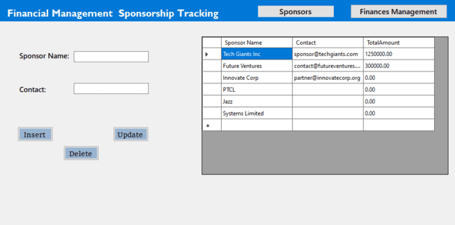

UI Component Name | Type of UI component | Class Attribute name,  Classname, attribute name | Linked to which database column/table
AddBtn | Button | SponsorshipUC.cs | $@"INSERT INTO sponsors (sponsor_name, contact)  VALUES ('{newSponsor.SponsorName}', '{newSponsor.Contact}')"
UpdateBtn | Button | SponsorshipUC.cs | $@"UPDATE sponsors  SET sponsor_name = '{updatedSponsor.SponsorName}',  contact = '{updatedSponsor.Contact}'  WHERE sponsor_id = {updatedSponsor.SponsorId}"
DeleteBtn | Button | SponsorshipUC.cs | $"DELETE FROM sponsors WHERE sponsor_id = {sponsorId}"
DataGridView1 | DataGridView | SponsorshipUC.cs | @"SELECT s.sponsor_id, s.sponsor_name, s.contact,  COALESCE(SUM(f.amount), 0) AS total_amount FROM sponsors s  LEFT JOIN finances f ON s.sponsor_id = f.from_entity_id AND f.from_entity_type = 'Sponsor'  GROUP BY s.sponsor_id, s.sponsor_name, s.contact"

Interface Name | DashboardUC


UI Component Name | Type of UI component | Class Attribute name,  Classname, attribute name | Linked to which database column/table
ApproveBtn | Button | DashboardUC.cs | $"UPDATE users SET role_id = {roleId} WHERE user_id = {userId}"
cmbRole | Button | DashboardUC.cs | "SELECT role_id, role_name FROM roles"
DataGridView1 | DataGridView | DashboardUC.cs | "SELECT * FROM users WHERE role_id IS NULL"

Interface Name | DutiesUC
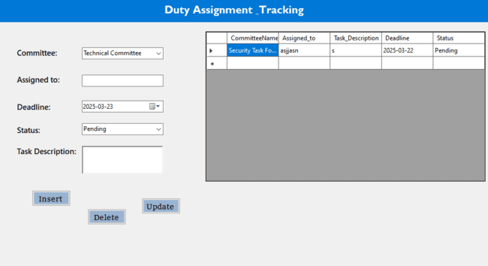

UI Component Name | Type of UI component | Class Attribute name,  Classname, attribute name | Linked to which database column/table
AddBtn | Button | DutiesUC.cs | $@"INSERT INTO duties  (committee_id, assigned_to, task_description, deadline, status_id)  VALUES ({newDuty.CommitteeId}, '{newDuty.AssignedTo}', '{newDuty.TaskDescription}', '{newDuty.Deadline:yyyy-MM-dd}', {newDuty.StatusId})"
UpdateBtn | Button | DutiesUC.cs | $@"UPDATE duties  SET committee_id = {updatedDuty.CommitteeId},  assigned_to = '{updatedDuty.AssignedTo}',  task_description = '{updatedDuty.TaskDescription}',  deadline = '{updatedDuty.Deadline:yyyy-MM-dd}', status_id = {updatedDuty.StatusId}  WHERE duty_id = {updatedDuty.DutyId}"
DeleteBtn | Button | DutiesUC.cs | $"DELETE FROM duties WHERE duty_id = {dutyId}"
cmbCommittee | Combo Box | DutiesUC.cs | "SELECT committee_id, committee_name FROM committees"
cmbStatus | Combo Box | DutiesUC.cs | "SELECT lookup_id, value FROM lookup WHERE category = 'DutyStatus'"
DataGridView1 | DataGridView | DutiesUC.cs | @"SELECT  d.duty_id,d.committee_id, d.assigned_to,d.task_description,d.deadline,d.status_id,c.committee_name,l.value AS status_name FROM duties d  LEFT JOIN committees c on d.committee_id = c.committee_id  LEFT JOIN lookup l on d.status_id = l.lookup_id"

Interface Name | EditioncUC
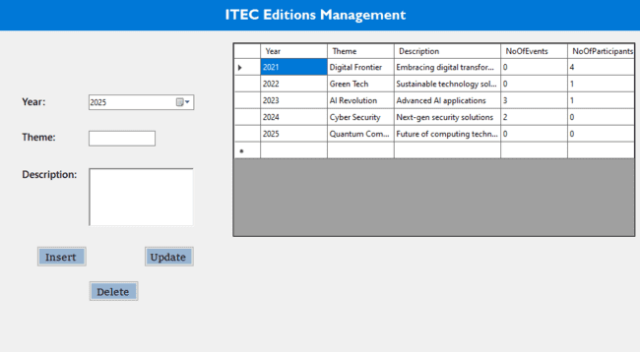

UI Component Name | Type of UI component | Class Attribute name,  Classname, attribute name | Linked to which database column/table
AddBtn | Button | EditioncUC.cs | $@"INSERT INTO itec_editions(year, theme, description)  VALUES({newEdition.Year}, '{newEdition.Theme}', '{newEdition.Description}')"
UpdateBtn | Button | EditioncUC.cs | $@"UPDATE itec_editions  SET year = {updatedEdition.Year}, theme = '{updatedEdition.Theme}',description = '{updatedEdition.Description}'  WHERE itec_id = {updatedEdition.ItecId}"
DeleteBtn | Button | EditioncUC.cs | $"DELETE FROM itec_editions WHERE itec_id = {itecId}"
DataGridView1 | DataGridView | EditioncUC.cs | @"SELECT ie.itec_id, ie.year, ie.theme, ie.description,COUNT(distinct ievent.event_id) AS event_count, COUNT(distinct p.participant_id) AS participant_count  FROM itec_editions ie  LEFT JOIN itec_events ievent on ie.itec_id = ievent.itec_id  LEFT JOIN participants p on ie.itec_id = p.itec_id GROUP BY ie.itec_id, ie.year, ie.theme, ie.description"

Business Report-1
Business Report Name: Financial Report
Sample of report: 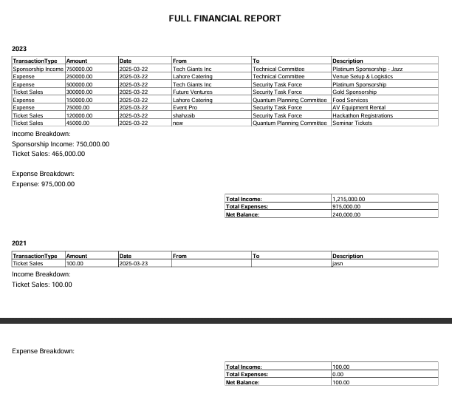
Query to build Report:
@" SELECT e.year AS Year, l.value AS TransactionType, f.amount AS Amount,
DATE_FORMAT(f.date_recorded, '%Y-%m-%d') AS TransactionDate,
COALESCE(s.sponsor_name, v.vendor_name, u.username, c.committee_name) AS FromEntity,
COALESCE(s2.sponsor_name, v2.vendor_name, u2.username, c2.committee_name) AS ToEntity,
f.description AS Description,
CASE
WHEN l.value IN ('Sponsorship Income', 'Ticket Sales', 'Miscellaneous Income') THEN 'Income'
WHEN l.value IN ('Vendor Payment', 'Expense', 'Venue Rental Expense', 'Equipment Purchase',
'Marketing Expense') THEN 'Expense'
END AS FinancialCategory
FROM finances f
JOIN itec_editions e ON f.itec_id = e.itec_id
JOIN lookup l ON f.type_id = l.lookup_id
LEFT JOIN sponsors s ON f.from_entity_type = 'Sponsor' AND f.from_entity_id = s.sponsor_id
LEFT JOIN vendors v on f.from_entity_type = 'Vendor' AND f.from_entity_id = v.vendor_id
LEFT JOIN users u on f.from_entity_type = 'User' and f.from_entity_id = u.user_id
LEFT JOIN committees c ON f.from_entity_type = 'Committee' AND f.from_entity_id = c.committee_id
LEFT JOIN sponsors s2 ON f.to_entity_type = 'Sponsor' AND f.to_entity_id = s2.sponsor_id
LEFT JOIN vendors v2 ON f.to_entity_type = 'Vendor' AND f.to_entity_id = v2.vendor_id
LEFT JOIN users u2 ON f.to_entity_type = 'User' and f.to_entity_id = u2.user_id
LEFT JOIN committees c2 on f.to_entity_type = 'Committee' AND f.to_entity_id = c2.committee_id"

Business Report-2
Business Report Name: Venue Report
Sample of report:
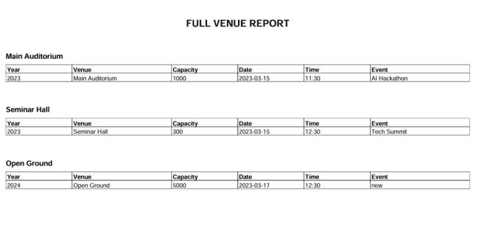
Query to build Report:
@" SELECT e.year AS Year, v.venue_name AS Venue, v.capacity AS Capacity,
ev.event_name AS AssignedEvent,
DATE_FORMAT(va.assigned_date, '%Y-%m-%d') AS AssignmentDate,
TIME_FORMAT(va.assigned_time, '%H:%i') AS AssignmentTime
FROM venue_allocations va
JOIN venues v ON va.venue_id = v.venue_id
JOIN itec_events ev ON va.event_id = ev.event_id
JOIN itec_editions e ON ev.itec_id = e.itec_id";

Business Report-3
Business Report Name: Event Report
Sample of report:
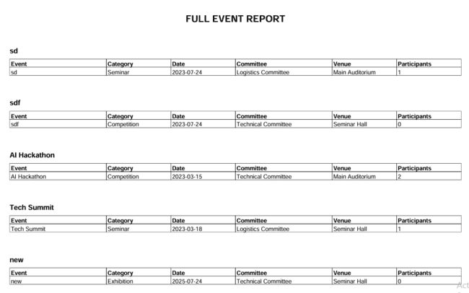
Query to build Report:
@"SELECT e.year AS Year, ev.event_name AS Event, ec.category_name AS Category,
DATE_FORMAT(ev.event_date, '%Y-%m-%d') AS EventDate,
c.committee_name AS ResponsibleCommittee, v.venue_name AS Venue,
COUNT(ep.participant_id) AS ParticipantsRegistered
FROM itec_events ev
JOIN itec_editions e ON ev.itec_id = e.itec_id
LEFT JOIN event_categories ec ON ev.event_category_id = ec.event_category_id
LEFT JOIN committees c ON ev.committee_id = c.committee_id
LEFT JOIN venues v on ev.venue_id = v.venue_id
LEFT JOIN event_participants ep ON ev.event_id = ep.event_id
GROUP BY ev.event_id, e.year, ev.event_name, ec.category_name, ev.event_date, c.committee_name,
v.venue_name";

