가로선

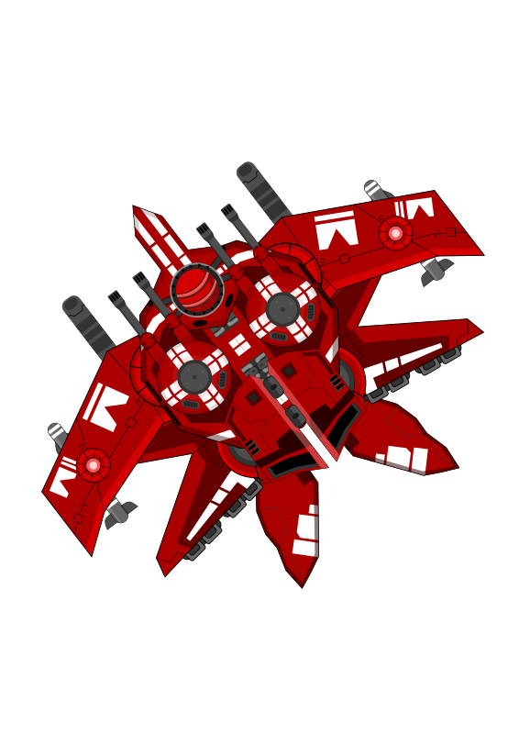

Stellar fighter

Proposed by 20162604 Byeonggon Lee (이병곤)

# Introduction

Stellar fighter is a single or multi player classic air shooter game.

# Objectives

1. Actively use software engineering methodology for development.
2. The game must be simple enough to develop, complicated enough to learn something.
3. If there’s more time we will add more features to improve the software.

# Description

This kind of classic air shooter game may sound redundant, but actually it’s not.

Given a little twist on graphics, enemies, weapons, items or a storyline, the game can be unique and attractive.

Also there’s an advantage of this simple kind of game. We could use a game engine, but it’s optional due to its simplicity. If we don’t use an engine, we are not forced to use specific languages to use the engines so that it becomes easy for teammates to decide what language to use. Moreover, we will have opportunity to implement a game loop, collision detection, scene graph, vector calculation algorithms.

# Target platforms & Development stack

There are 3 possible target platforms for this project:

* Native desktop environment.
* Mobile platform
* Web browser

If teammates want to develop the project in C/C++, then the project will be built for native desktop environment using a library called SDL. The compiler used for C/C++ will be gcc/g++ rather than visual studio’s quirky compiler.

On the other hand if they are more familiar with Java, the project will be developed for Android platform using SurfaceView class in Android SDK.

Also there’s a possibility for teammates to be willing to learn a Lua programming language and a game engine, the game will be created using luajit and Love2D game engine.

Furthermore, they could be more familiar with Javascript language than other languages. In that case we will use a plain HTML5 canvas or PixiJS game engine for the development.

For version control system, we will going to use git, as you expected.

# Incremental Delivery

While referring a following list of milestones, we are going to use incremental delivery technique for the development. It is necessary to reach the first milestone. After that, only if we have more time, we will follow the subsequent milestones.

# Milestones

1. Single player with same kind of enemies and bullets.

If possible, we could implement following milestones.

1. Use ECS design pattern.
2. Single player and variant kinds of enemies.
3. Add guided missiles.
4. Add various items.
5. Use particles.
6. Use Quad-tree algorithm for collision detection.
7. Use scene graph.
8. Add maps, boss enemies and a scenario.
9. Add another player.

# Why did you choose game project? why it is needed?

I chose game development for following reasons: First, it is fun to develop. Usually most people like games and if they enjoy playing games, they can enjoy developing games as well. This fact encourages teammate to develop the project. Second, known architecture. Although we will add some unique features, The game, especially air shooter game has a known architecture. It enables us to find resources over the internet if we are stuck at some point. However it doesn’t mean this project is so simple to develop that it only requires few days to be finished. I expect that it would take weeks to be finished.

# For potential team members

* I have no experience of game development.

-> Air shooter genre is simple enough for the first game development.

# Contact Info

[gonapps (Byeonggon Lee) · GitHub](https://github.com/gonapps)

You can mail to [gonny952@gmail.com](mailto:gonny952@gmail.com)