Diffs:

Classification Report:

precision recall f1-score support

0 0.0000 0.0000 0.0000 4

1 0.0000 0.0000 0.0000 1

2 0.1250 1.0000 0.2222 1

3 0.1316 0.3846 0.1961 13

4 0.4828 0.5833 0.5283 48

5 0.9650 0.6161 0.7520 896

6 0.8103 0.8468 0.8282 111

7 0.4643 0.6190 0.5306 21

8 0.7079 0.6117 0.6562 103

9 0.0000 0.0000 0.0000 5

10 0.8859 0.6111 0.7233 216

11 0.3214 0.5625 0.4091 16

12 0.6102 0.3956 0.4800 91

13 0.0526 0.1667 0.0800 12

14 0.1115 0.5472 0.1853 53

15 0.4444 0.8000 0.5714 5

16 0.2000 1.0000 0.3333 1

17 0.5221 0.8310 0.6413 71

18 0.2500 0.5000 0.3333 12

19 0.2895 0.3143 0.3014 35

20 0.2250 0.2903 0.2535 31

21 0.7143 0.6481 0.6796 54

22 0.0000 0.0000 0.0000 1

23 0.2632 0.6250 0.3704 8

24 0.3676 0.3247 0.3448 77

25 0.2609 0.3243 0.2892 37

26 0.5000 0.5536 0.5254 56

27 0.5143 0.8571 0.6429 21

accuracy 0.5900 2000

macro avg 0.3650 0.5005 0.3885 2000

weighted avg 0.7489 0.5900 0.6404 2000

Macro F1-score: 0.3885

Weighted F1-score: 0.6404  
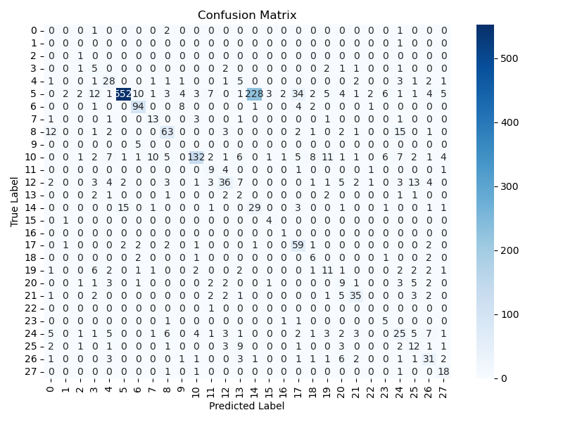  
[131, 85, 259, 279, 265, 79, 205, 270, 182, 240, 75, 107, 17, 90, 125, 6, 111, 157, 194, 215, 214, 55, 61, 46, 71, 87, 285, 228, 222, 4, 216, 208, 44, 25, 146, 154, 150, 86, 249, 181, 293, 33, 98, 218, 148, 47, 89, 242, 283, 239, 133, 64, 200, 59, 268, 171, 272, 43, 142, 88, 101, 274, 21, 247, 39, 14, 141, 250, 112, 23, 53, 196, 36, 284, 238, 76, 174, 189, 230, 49, 161, 204, 5, 99, 198, 255, 286, 120, 100, 234, 261, 132, 51, 162, 41, 147, 290, 123, 172, 45]

TTEST:

Classification Report:

precision recall f1-score support

0 0.0000 0.0000 0.0000 4

1 0.0000 0.0000 0.0000 1

2 0.0000 0.0000 0.0000 1

3 0.1522 0.5385 0.2373 13

4 0.4688 0.6250 0.5357 48

5 0.9552 0.6194 0.7515 896

6 0.8214 0.8288 0.8251 111

7 0.4000 0.5714 0.4706 21

8 0.6989 0.6311 0.6633 103

9 0.0000 0.0000 0.0000 5

10 0.8800 0.6111 0.7213 216

11 0.3667 0.6875 0.4783 16

12 0.5385 0.3846 0.4487 91

13 0.0286 0.0833 0.0426 12

14 0.0992 0.4906 0.1651 53

15 0.5000 0.8000 0.6154 5

16 0.1429 1.0000 0.2500 1

17 0.5714 0.8451 0.6818 71

18 0.2400 0.5000 0.3243 12

19 0.2927 0.3429 0.3158 35

20 0.2381 0.3226 0.2740 31

21 0.6607 0.6852 0.6727 54

22 0.0000 0.0000 0.0000 1

23 0.3077 0.5000 0.3810 8

24 0.3750 0.3117 0.3404 77

25 0.2941 0.2703 0.2817 37

26 0.4754 0.5179 0.4957 56

27 0.5429 0.9048 0.6786 21

accuracy 0.5910 2000

macro avg 0.3589 0.4668 0.3804 2000

weighted avg 0.7411 0.5910 0.6393 2000

Macro F1-score: 0.3804

Weighted F1-score: 0.6393  
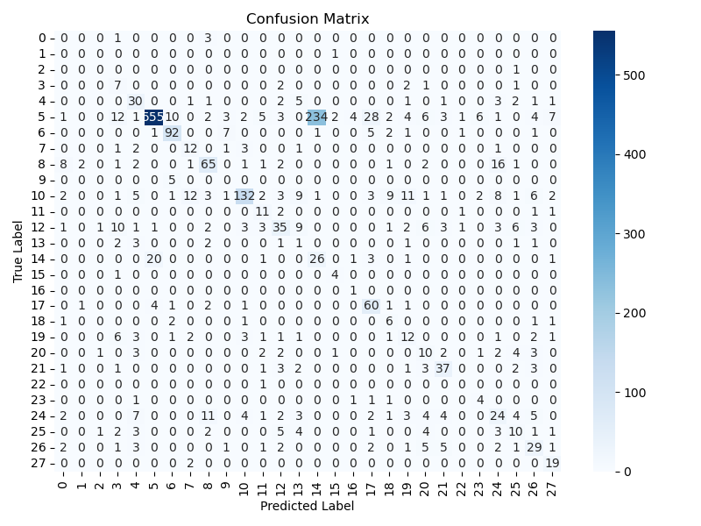

[265, 215, 216, 86, 131, 111, 240, 228, 107, 270, 208, 259, 146, 205, 46, 17, 61, 43, 75, 47, 49, 125, 249, 88, 79, 123, 242, 85, 247, 268, 71, 44, 198, 25, 196, 239, 181, 69, 141, 36, 154, 140, 4, 214, 98, 6, 283, 150, 157, 194, 55, 90, 277, 99, 285, 59, 39, 234, 5, 290, 272, 133, 189, 294, 41, 147, 45, 76, 182, 263, 204, 10, 209, 95, 14, 101, 279, 21, 200, 142, 35, 161, 210, 148, 87, 173, 230, 26, 174, 130, 66, 33, 64, 299, 97, 256, 222, 284, 67, 250]

SKB_mi:  
Classification Report:

precision recall f1-score support

0 0.0000 0.0000 0.0000 4

1 0.0000 0.0000 0.0000 1

2 0.1111 1.0000 0.2000 1

3 0.1379 0.3077 0.1905 13

4 0.4545 0.5208 0.4854 48

5 0.9485 0.6172 0.7478 896

6 0.8476 0.8018 0.8241 111

7 0.4412 0.7143 0.5455 21

8 0.7045 0.6019 0.6492 103

9 0.0000 0.0000 0.0000 5

10 0.9301 0.6157 0.7409 216

11 0.3143 0.6875 0.4314 16

12 0.6000 0.3626 0.4521 91

13 0.0682 0.2500 0.1071 12

14 0.0839 0.4528 0.1416 53

15 0.5000 0.8000 0.6154 5

16 0.2000 1.0000 0.3333 1

17 0.5876 0.8028 0.6786 71

18 0.2333 0.5833 0.3333 12

19 0.2791 0.3429 0.3077 35

20 0.2424 0.2581 0.2500 31

21 0.6610 0.7222 0.6903 54

22 0.0000 0.0000 0.0000 1

23 0.3846 0.6250 0.4762 8

24 0.3649 0.3506 0.3576 77

25 0.3333 0.3243 0.3288 37

26 0.5161 0.5714 0.5424 56

27 0.5152 0.8095 0.6296 21

accuracy 0.5870 2000

macro avg 0.3736 0.5044 0.3950 2000

weighted avg 0.7494 0.5870 0.6406 2000

Macro F1-score: 0.3950

Weighted F1-score: 0.6406

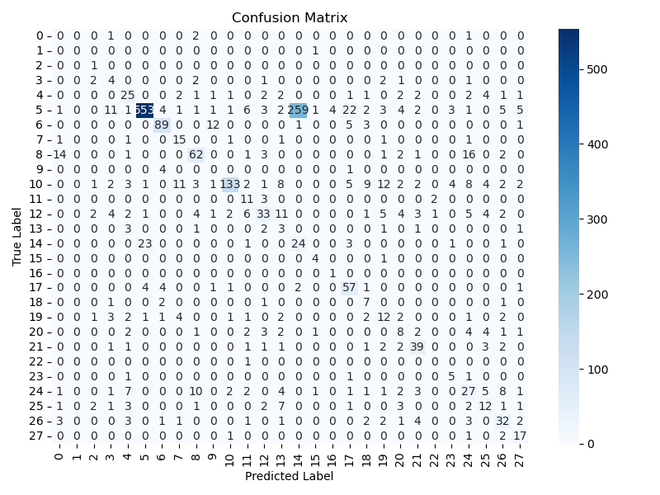  
[48, 270, 17, 263, 90, 172, 231, 283, 88, 71, 111, 249, 99, 87, 86, 218, 141, 46, 26, 234, 230, 182, 63, 292, 5, 299, 41, 265, 27, 157, 124, 232, 47, 216, 134, 9, 257, 125, 205, 10, 142, 123, 240, 76, 59, 14, 24, 290, 49, 38, 116, 144, 131, 174, 214, 20, 250, 7, 222, 101, 206, 146, 285, 255, 92, 204, 113, 247, 79, 198, 6, 28, 132, 243, 85, 161, 61, 150, 277, 259, 239, 21, 133, 162, 293, 215, 168, 268, 238, 294, 55, 69, 242, 34, 260, 117, 51, 64, 140, 274]

交集 200：

Number of common features: 144

Common feature indices: [4, 5, 6, 10, 14, 17, 19, 21, 25, 26, 27, 33, 35, 36, 39, 41, 43, 44, 46, 47, 48, 49, 50, 51, 53, 54, 55, 59, 61, 62, 64, 69, 71, 73, 75, 76, 77, 79, 83, 85, 86, 87, 88, 89, 90, 92, 95, 97, 98, 99, 101, 105, 106, 107, 111, 112, 114, 123, 124, 125, 130, 131, 132, 133, 134, 135, 140, 141, 142, 143, 144, 145, 146, 147, 148, 150, 154, 157, 159, 160, 161, 172, 174, 177, 181, 182, 183, 189, 196, 198, 200, 204, 205, 206, 207, 208, 211, 213, 214, 215, 216, 217, 218, 221, 222, 224, 228, 230, 232, 234, 236, 239, 240, 242, 243, 245, 247, 248, 249, 250, 251, 255, 257, 259, 261, 262, 263, 265, 268, 270, 272, 274, 276, 277, 279, 283, 285, 286, 290, 292, 293, 294, 295, 299]

Classification Report:

precision recall f1-score support

0 0.0000 0.0000 0.0000 4

1 0.0000 0.0000 0.0000 1

2 0.0000 0.0000 0.0000 1

3 0.1818 0.4615 0.2609 13

4 0.4655 0.5625 0.5094 48

5 0.9581 0.6641 0.7844 896

6 0.8532 0.8378 0.8455 111

7 0.3939 0.6190 0.4815 21

8 0.7021 0.6408 0.6701 103

9 0.0000 0.0000 0.0000 5

10 0.8968 0.6435 0.7493 216

11 0.4333 0.8125 0.5652 16

12 0.5833 0.3846 0.4636 91

13 0.0488 0.1667 0.0755 12

14 0.1125 0.5094 0.1843 53

15 0.6667 0.8000 0.7273 5

16 1.0000 1.0000 1.0000 1

17 0.5941 0.8451 0.6977 71

18 0.2609 0.5000 0.3429 12

19 0.2857 0.3429 0.3117 35

20 0.2308 0.2903 0.2571 31

21 0.6852 0.6852 0.6852 54

22 0.0000 0.0000 0.0000 1

23 0.3571 0.6250 0.4545 8

24 0.3733 0.3636 0.3684 77

25 0.3488 0.4054 0.3750 37

26 0.4762 0.5357 0.5042 56

27 0.5278 0.9048 0.6667 21

accuracy 0.6210 2000

macro avg 0.4084 0.4857 0.4279 2000

weighted avg 0.7524 0.6210 0.6649 2000

Macro F1-score: 0.4279

Weighted F1-score: 0.6649

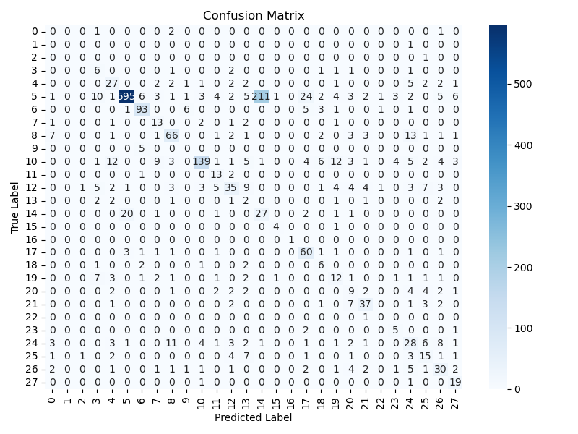

Diffs 200:  
Classification Report:

precision recall f1-score support

0 0.0000 0.0000 0.0000 4

1 0.0000 0.0000 0.0000 1

2 0.0000 0.0000 0.0000 1

3 0.1944 0.5385 0.2857 13

4 0.4909 0.5625 0.5243 48

5 0.9517 0.7042 0.8095 896

6 0.8364 0.8288 0.8326 111

7 0.4615 0.5714 0.5106 21

8 0.6700 0.6505 0.6601 103

9 0.0000 0.0000 0.0000 5

10 0.8773 0.6620 0.7546 216

11 0.5000 0.8125 0.6190 16

12 0.5811 0.4725 0.5212 91

13 0.0625 0.1667 0.0909 12

14 0.1227 0.5094 0.1978 53

15 0.6667 0.8000 0.7273 5

16 1.0000 1.0000 1.0000 1

17 0.6222 0.7887 0.6957 71

18 0.3158 0.5000 0.3871 12

19 0.2895 0.3143 0.3014 35

20 0.2432 0.2903 0.2647 31

21 0.6863 0.6481 0.6667 54

22 0.0000 0.0000 0.0000 1

23 0.4545 0.6250 0.5263 8

24 0.3827 0.4026 0.3924 77

25 0.3864 0.4595 0.4198 37

26 0.5806 0.6429 0.6102 56

27 0.6207 0.8571 0.7200 21

accuracy 0.6465 2000

macro avg 0.4285 0.4931 0.4471 2000

weighted avg 0.7540 0.6465 0.6849 2000

Macro F1-score: 0.4471

Weighted F1-score: 0.6849