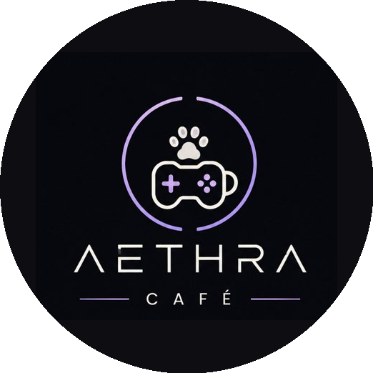
AETHRA CAFÉ
Your Cozy Gaming Escape.
● Cozy ✦ Minimalist ✦ Gaming ✦ Pet-Friendly ✦ Aesthetic ●
BUSINESS PLAN

Subject: Entrepreneurship
Date Submitted: May 22, 2026
Module 7 Activity Assessment

Table of Contents

# | SECTION | PAGE
I | Executive Summary | 3
II | Description of the Business | 3
III | Market Analysis | 4
IV | Production / Operations Plan | 5
V | Organizational Plan | 5
VI | Financial Plan | 6
VII | Conclusion | 7

I. Executive Summary
Aethra Café is a specialty coffee shop, minimalist gaming lounge, and pet-friendly haven designed to provide a cozy, immersive retreat for students, young professionals, gamers, and pet owners in the local community. The café offers a curated menu of artisanal beverages and light meals alongside a comfortable gaming environment equipped with consoles, PC gaming stations, and tabletop game selections — all within a clean, clutter-free minimalist space that also warmly welcomes customers and their pets. Aethra Café targets tech-savvy youth, gaming enthusiasts, and animal lovers aged 15–35 who seek a welcoming third space where they can relax, connect, compete, and enjoy quality drinks, food, and the company of their furry companions.

II. Description of the Business

Nature of Business
Aethra Café is a food-and-beverage and entertainment hybrid business — a minimalist gaming café that combines the warmth of a specialty coffee shop with the excitement of a gaming lounge, all within a pet-friendly environment. It operates as a walk-in establishment offering hourly gaming sessions, gaming packages, and food and drink service in a thoughtfully designed, clutter-free space where customers and their well-behaved pets are equally welcome.

Products and Services Offered
- Specialty coffee drinks: espresso-based drinks, flavored lattes, matcha, and seasonal specials
- Non-coffee beverages: fruit teas, milk teas, smoothies, and hot chocolate
- Light meals and snacks: sandwiches, pasta, fries, waffles, and cake slices
- Pet-friendly menu: pup cups, pet treats, and water stations for animal companions
- PC gaming stations (hourly rental) — 5 units to start
- Console gaming area (PlayStation and Nintendo Switch)
- Tabletop gaming collection (board games, card games)
- Gaming events and small tournaments hosted in-store

What Makes Aethra Café Unique
Aethra Café stands apart from standard internet cafés through three defining qualities. First, its minimalist interior design — clean lines, neutral tones, uncluttered surfaces, and purposeful decor — creates a calming, distraction-free atmosphere that feels elevated without being pretentious. Second, it is one of the very few gaming cafés in the area that openly welcomes pets, giving animal-loving customers a place where they never have to choose between their hobbies and their companions. Third, unlike typical gaming shops, Aethra offers a full café menu with high-quality beverages crafted by a trained barista.

Target Market Rationale
The business caters to students and young professionals who want an alternative to crowded malls or bare internet shops, as well as pet owners who struggle to find cafés that accommodate their animals. Aethra Café gives them a space that is relaxing yet social — ideal for studying with friends, gaming, or simply unwinding after class or work.

III. Market Analysis

Target Customers
- Students aged 15–22 from nearby high schools, colleges, and universities
- Young professionals aged 23–35 who game during off-hours
- Gaming hobbyists and esports enthusiasts in the local community
- Pet owners looking for a café that accommodates their dogs or cats
- Friend groups looking for social hangout spots with a clean, aesthetic vibe

Market Demand
The Philippine gaming industry has grown significantly, with millions of active mobile and PC gamers across the country. Café culture is equally booming, and the pet-friendly lifestyle trend is rising rapidly. Few businesses successfully combine gaming, minimalist design, and pet-friendliness into a single venue — making Aethra Café a timely and strategic offering in the market.

Possible Competitors
- Traditional internet cafés — offer gaming but lack café ambiance, minimalist design, and pet accommodation
- Bubble tea and coffee shops — offer beverages but no gaming or pet-friendly zones
- Pet cafés — welcome animals but do not offer gaming or the full café experience
- Fast food chains — used as hangout spots but not purpose-built for the target market

Marketing Strategy
- Social media presence on TikTok, Instagram, and Facebook with aesthetic content, pet posts, and game clips
- Opening promo: first gaming hour at half price, and a stamp loyalty card for beverages
- "Bring Your Pet" discount days on weekends to attract pet owners
- Word-of-mouth through small in-store tournaments and community gaming nights
- Partnerships with nearby schools and universities for student discounts

IV. Production / Operations Plan

How Products and Services Are Delivered
Aethra Café operates from a small physical location with a café counter, a PC gaming area (5 stations), a console corner, and a pet-friendly lounge section. The space follows a minimalist design — clean, uncluttered, and welcoming. A trained barista handles beverages and light food. Gaming stations are maintained by the owner or a part-time tech assistant.

Materials and Equipment Needed
- Espresso machine, grinder, blender, and basic coffee equipment
- Small refrigerator and food prep area for snacks and beverages
- 5 gaming PCs with monitors, keyboards, mice, and headsets
- 1 PlayStation console and 1 Nintendo Switch
- Basic gaming chairs and minimalist tables
- Stable internet connection (fiber optic)
- Pet zone: water bowls, leash hooks, and washable floor mats
- POS system for orders and billing

Daily Business Operations
- Operating hours: 10:00 AM – 11:00 PM daily
- Morning: setup, cleaning, equipment check, and pet zone sanitizing
- During operations: café counter open, gaming stations active, staff on floor
- Pet policy: well-behaved, leashed pets welcome in the designated lounge area
- End of day: revenue tallied, equipment shut down, area cleaned and restocked

V. Organizational Plan

Organizational Structure
Aethra Café operates with a lean, flat team structure designed for an efficient small business startup. Each role is clearly defined to ensure smooth daily operations.

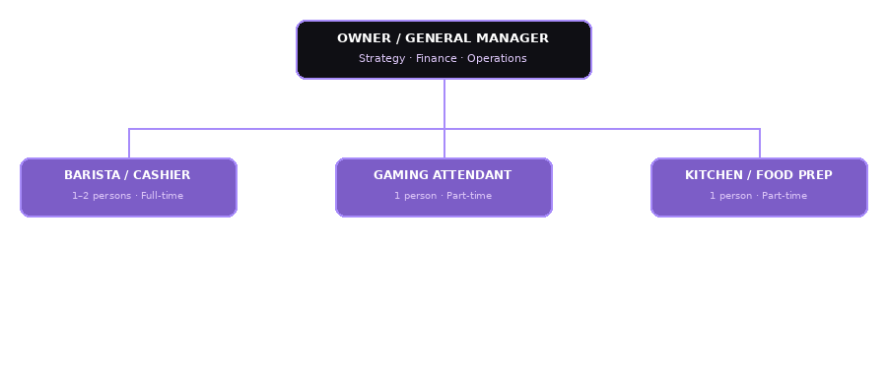

Roles and Responsibilities

POSITION | KEY DUTIES
Owner / General Manager | • Sets business direction, goals, and policies  • Manages finances, bookkeeping, and budgeting  • Handles supplier sourcing and inventory ordering  • Runs social media marketing and promotions  • Oversees daily operations and staff performance
Barista / Cashier | • Prepares and serves coffee, beverages, and snacks  • Takes customer orders and handles payments via POS  • Maintains cleanliness of the café counter and dining area  • Assists customers with menu recommendations  • Ensures inventory of café supplies is adequate
Gaming Attendant | • Manages and monitors gaming station usage and time  • Assists customers with game setup and troubleshooting  • Keeps gaming area clean, organized, and functional  • Records gaming revenue and logs customer sessions  • Sets up and facilitates in-store game nights and tournaments
Kitchen / Food Prep | • Prepares light meals, snacks, and pet-friendly treats  • Maintains kitchen hygiene and food safety standards  • Monitors and restocks food ingredients and supplies  • Supports the barista during peak hours as needed

VI. Financial Plan

A. Estimated Capital
ITEM | AMOUNT
Gaming PCs (5 units @ ₱18,000 each) | ₱90,000
PC peripherals (monitors, chairs, keyboards, mice) | ₱25,000
Console (PlayStation or Nintendo Switch) | ₱25,000
Espresso machine and basic coffee equipment | ₱20,000
Refrigerator and kitchen supplies | ₱8,000
Furniture and minimalist décor | ₱25,000
Renovation and leasehold improvements | ₱20,000
Pet zone setup (mats, bowls, hooks) | ₱3,000
Initial inventory (coffee, food, pet treats) | ₱8,000
POS system / tablet | ₱5,000
Permits and business registration | ₱5,000
Contingency / working capital | ₱16,000
TOTAL ESTIMATED CAPITAL | ₱250,000

B. Estimated Monthly Expenses
EXPENSE | AMOUNT
Rent | ₱8,000
Electricity | ₱6,000
Internet (fiber) | ₱2,500
Staff wages (1 barista + 1 part-time attendant) | ₱14,000
Inventory restocking (coffee, food, pet treats) | ₱8,000
Marketing and promotions | ₱1,500
Maintenance and miscellaneous | ₱2,000
TOTAL MONTHLY EXPENSES | ₱42,000

C. Estimated Monthly Sales / Income
SOURCE OF INCOME | AMOUNT
PC gaming rental (5 PCs × 5 hrs/day × ₱30/hr × 30 days) | ₱22,500
Console gaming (2 hrs/day × ₱40/hr × 30 days) | ₱2,400
Beverages (25 orders/day × ₱100 avg. × 30 days) | ₱75,000
Food / snacks (15 orders/day × ₱80 avg. × 30 days) | ₱36,000
Pet treats and pup cups (5/day × ₱60 × 30 days) | ₱9,000
Events / game nights (est. 2×/month) | ₱2,000
TOTAL ESTIMATED MONTHLY SALES | ₱146,900

D. Estimated Monthly Profit
Total Monthly Sales / Income | ₱146,900
Less: Total Monthly Expenses | (₱42,000)
ESTIMATED MONTHLY PROFIT | ₱104,900

VII. Conclusion
Aethra Café is a realistic and achievable small business that taps into three growing markets: specialty cafés, gaming lounges, and pet-friendly spaces. Starting small — with 5 PC stations, a simple café menu, and a cozy minimalist space — keeps startup costs manageable at around ₱250,000 while still offering a unique and memorable experience that stands out from typical internet shops and coffee spots.

Beyond the numbers, Aethra Café fills a genuine community need — a safe, comfortable, and inclusive hangout space for students, young professionals, gamers, and pet owners alike. As the business grows and builds a loyal customer base, it can expand its gaming stations, menu offerings, and events. Aethra Café is not simply a business; it is a community hub where passion for gaming, love for good coffee, and the joy of pets all come together under one beautifully minimal roof.

— End of Business Plan —

