Philippine Copyright 2026
by the Authors
and the
College of Computer and Information Sciences
Polytechnic University of the Philippines

All rights reserved. Portions of this manuscript may be reproduced with proper referencing and due acknowledgment of the author.

A SMART MEDICATION DISPENSER WITH MOBILE APPLICATION
FOR INTAKE MANAGEMENT AND ALERTS

A Capstone Project
Presented to the Faculty of the College of Computer and Information Sciences
Polytechnic University of the Philippines
Sta. Mesa, Manila

In Partial Fulfilment of the Requirements for the Degree
Bachelor of Science in Information Technology

by

Chinyl J. Acosta
Cristine T. Collado
Elaine I. Verdan
Jae Darielle M. Yumul

September 2026

APPROVAL SHEET

This capstone project Title of the Capstone Project prepared and submitted by [Name of the Researchers (FN MI LN; Alphabetical Order)] in partial fulfilment of the requirements for the degree, Bachelor of Science in Information Technology has been:

Recommended for Approval and Acceptance:
Date:

___ICON C. OBMERGA__________ ________________
Faculty-in-Charge

Approved by the Capstone Project Defense Panel:

_MARIE ANDREA E. ZURBANO, MIT ________________

_ROSARIO D. ALUNAO, MIT____ ________________

_MARK VENCE V. DUNGCA______ ________________

Accepted for the Department of Information Technology:

___________________________ ________________
Marie Andrea E. Zurbano, MIT
Chairperson

Accepted for the College of Computer and Information Sciences:

___________________________ ________________

ACKNOWLEDGMENTS

The researchers would like to express their sincere gratitude to Mrs. Icon C. Obmerga, Faculty-in-Charge, for his continuous guidance, valuable insights, and constructive feedback throughout the development of this capstone project. His expertise and encouragement greatly contributed to the completion of this study.

The researchers also extend their appreciation to the members of the Capstone Defense Panel—Ms. Marie Andrea E. Zurbano, MIT, Mrs. Rosario D. Alunao, MIT, and Mr. Mark Vence V. Dungca—for their time, professional evaluation, and meaningful recommendations that helped improve the system’s design, implementation, and documentation.

Special thanks are given to the healthcare professionals, IT experts, guardians, and respondents who participated in the system evaluation and provided valuable feedback based on ISO/IEC 25010 quality characteristics. Their insights significantly contributed to the validation and enhancement of the proposed system.

The researchers are also deeply grateful to their families and friends for their unwavering support, understanding, and encouragement throughout the development of this project.

Above all, the researchers thank God for the strength, wisdom, and perseverance granted to them in completing this capstone project successfully.

E.I.V.
C.J.A.
CERTIFICATION OF ORIGINALITY

This is to certify that the research work presented in this capstone project, A SMART MEDICATION DISPENSER WITH MOBILE APPLICATION FOR INTAKE MANAGEMENT AND ALERTS for the degree Bachelor of Science in Information Technology at the Polytechnic University of the Philippines embodies the result of original and scholarly work carried out by the undersigned. This capstone project does not contain words or ideas taken from published sources or written works that have been accepted as basis for the award of a degree from any other higher education institution, except where proper referencing and acknowledgement were made.

(Wet Signature)
CHINYL J. ACOSTA

CRISTINE T. COLLADO

ELAINE I. VERDAN

JAE DARIELLE M. YUMUL
Researchers

_____(Day Month Year)____
Date Signed

ABSTRACT

Title : A Smart Medication Dispenser with Mobile Application for Intake
Management and Alerts
Researcher : Chinyl Acosta
Cristine T. Collado
Elaine I. Verdan
Jae Darielle M. Yumul
Degree : Bachelor of Science in Information Technology
Institution : Polytechnic University of the Philippines
Year : 2026
Adviser/FIC : Icon C. Obmerga

Medication non-adherence is a persistent healthcare challenge, particularly among elderly individuals and patients requiring maintenance medications. This study aimed to design and develop a smart medication management system that integrates automated dispensing with a mobile application to improve adherence, monitoring, and caregiver support. The system allows users to set medication schedules, receive real-time reminders, confirm intake, and track adherence history, while enabling guardians to remotely monitor compliance. Cloud-based services were utilized to ensure secure authentication, real-time data synchronization, and timely notifications. The system was evaluated using the ISO/IEC 25010 software quality model, focusing on functionality, usability, reliability, performance efficiency, security, and maintainability. Results showed that the system achieved overall ratings interpreted as “Very Satisfactory,” indicating high acceptability and effectiveness in supporting medication routines. Findings suggest that integrating smart automation with mobile health technology can reduce missed doses, enhance monitoring, and promote consistent medication practices. The study demonstrates that technology-driven healthcare solutions can provide a practical, accessible, and user-centered approach to improving medication adherence and supporting better health outcomes. Keywords: Smart Medication Dispenser, Medication Adherence, Mobile Application, Polytechnic University of the Philippines
Table of Contents

 |  |  | Page
Title Page |  |  | i
Approval Sheet |  |  | ii
Acknowledgments |  |  | iii
Certification of Originality |  |  | iv
Abstract |  |  | v
Table of Contents |  |  | vii
List of Tables |  |  | x
List of Figures |  |  | xi
1 INTRODUCTION
Project Context |  |  | 1
Technical Background |  |  | 3
 | Equipment/Hardware
 | Software
 | Peopleware/Manpower
 | Network Infrastructure/Architecture
 | Storage, Backup and Recovery Procedure
 | Security Procedures
 | Policies and Procedures
Problem Analysis
 | Fishbone Diagram
 | Problem and Solution Statement
 | Problem-Requirements Matrix
Purpose and Description
Specific Objectives
Scope and Limitations
Definition of Terms

2 review of literature, Studies, and systems
Topic 1 |  |  | 11
Topic 2 |  |  | 13
Topic 3 |  |  | 15
Synthesis of the Study |  |  | 16
3 methodology
Requirements Analysis |  |  | 18
 | Requirements – Features Matrix |  | 19
 | Use Case Diagram
 | Use Case Report
Design Specifications
 | Activity Diagram
 | GUI Design
 | Database Schema
 | Data Dictionary
Development Methodology
 | Process Model
 | Development Tools
Test Methodology/Procedures
System Requirements
Quality Plan
Implementation Plan
Evaluation Plan
Ethical Considerations
Data Analysis (Procedure and Treatment)
Statistical Treatments
4 RESULTS AND DISCUSSION
Problem Statement 1

5 SUMMARY OF FINDINGS, CONCLUSIONS AND RECOMMENDATIONS
Summary of Findings
Conclusions
Recommendations
REFERENCES
APPENDICES
Appendix 1 |  | Data Gathering Instrument
Appendix 2 |  | Declaration on the Use of Artificial Intelligence
Appendix 3 |  | Client Forms and Reports
Appendix 4 |  | Evaluation Tools, Test Documents and Test Results
Appendix 5 |  | User’s Manual
Appendix 6 |  | Sample Generated Outputs
Appendix 7 |  | Certification of Similarity Check/Turnitin Results
Appendix 8 |  | Certification of Editing
Appendix 9 |  | Implementation Report
Appendix 10 |  | Capstone Project Revision Matrices
Appendix 11 |  | Ethics Clearance and Terminal Report
Appendix 12 |  | Biographical Statements

LIST OF TABLES

Table No. | Description | Page
1 | Problem – Requirements Matrix | 3
2 | Features Matrix of PillSync | 4
3 | Use Case Report
4 | Users Collection
5 | Medicines Collection
6 | Schedules Collection
7 | Dose Logs Collection
8 | Guardians Collection
9 | Notifications Collection
10 | Scheduled Notifications Collection
11 | FCM Tokens Collection
12 | User Tokens Collection
13 | User Streaks Collection
14 | Schedule Backups Collection
15 | Dispenser Collection
16 | Quality Plan
17 | Distribution of Respondents by Role and Age Group
18 | Distribution of Respondents by Sex
19 | Medication Intake Frequency Among Patient Respondents
20 | Experience using similar health-related applications
21 | Number of Different Medicines Taken Daily by Patient Respondents
22 | Functionality Evaluation Results
23 | Usability Evaluation Results
24 | Reliability Evaluation Results
25 | Performance Efficiency Evaluation Results
26 | Security Evaluation Results
27 | Compatibility and Portability Evaluation Results
28 | Maintainability Evaluation Results
29 | Overall Summary of ISO/IEC 25010 Quality Characteristics
30 | Summary of functional testing results across all use cases.

LIST OF FIGURES

Table No. | Description | Page
1 | Network Architecture Diagram | 3
2 | Internal System Architecture of the Dispenser | 4
3 | Fishbone Diagram
4 | Use Case Diagram of PillSync
5 | Log In / Sign Up Activity Diagram
6 | Add Medication Activity Diagram
7 | Set Schedule Activity Diagram
8 | View Medication Reports Activity Diagram
9 | View Medication History Activity Diagram
10 | Receive Reminder / Notification Activity Diagram
11 | Missed Dose Alert Activity Diagram
12 | Receive Refill Reminder Activity Diagram
13 | Confirm Intake Activity Diagram
14 | View Medication Activity Diagram
15 | View Schedule Activity Diagram
16 | Export Report Activity Diagram
17 | View Refill Status Activity Diagram
18 | Loading Screen of PillSync
19 | Log in and Register Screen of PillSync
20 | Home Screen of PillSync
21 | Add/Edit Medicine and Schedule Screen of PillSync
22 | History Screen of PillSync
23 | Analytics Report of PillSync
24 | Settings Screen of PillSync
25 | Edit Profile of PillSync
26 | User ID of PillSync
27 | Refill Settings of PillSync
28 | User Guide Settings of PillSync
29 | Back up & Recovery of PillSync
30 | Change Settings of PillSync
31 | Logout Settings of PillSync
32 | Notification of PillSync
33 | Low Stock Alert Notification of PillSync
34 | Hardware External Design
35 | Hardware External Design (Top)
36 | Database Schema of PillSync
37 | Process Model

Chapter 1

INTRODUCTION

Project Context

A Smart Medication Dispenser with Mobile Application for Intake Management and Alerts is an innovative healthcare technology project developed to address the widespread challenge of medication non-adherence, especially among individuals who depend on guardians to manage their medication routines. The system integrates an automated medication dispenser with a mobile application designed to support intake management and provide timely alerts. The dispenser automates the release of medications based on set schedules, minimizing the risk of missed or incorrect doses. Meanwhile, the mobile app functions as the control center, enabling users or guardians to configure schedules, monitor adherence in real time, and receive notifications for upcoming or missed doses.
This project was inspired by the growing demand for reliable and accessible medication management solutions. Even for individuals without severe chronic illnesses, missing regular medications such as vitamins, supplements, or preventive prescriptions can negatively impact health and well-being over time. Studies show that many individuals forget or delay taking their medications due to reasons such as busyness and forgetfulness, which may lead to reduced effectiveness and potential health risks (Patel, T. 2022). A smart medication dispenser with app serves as a solution to this problem by providing scheduled reminders, real-time adherence tracking, and guardian monitoring, which help ensure consistent and timely medication intake. Drawing from existing smart health technologies and remote monitoring devices, this solution aims to improve the accuracy of medication intake and provide greater peace of mind for users or guardians.
By combining automated hardware with a user-friendly mobile application, this project strives to contribute significantly to personal healthcare management and to support guardians in delivering consistent and accurate medication assistance, ultimately improving user health and quality of life.

Technical Background

This section provides an in-depth analysis of the hardware, software, data, and processes currently used by the intended users or client organization. This section is essential for ensuring that the proposed system is compatible with existing technology, meets user needs, and addresses any limitations or inefficiencies in their current setup.

Equipment/Hardware

The system utilizes a combination of hardware components to enable automated dispensing, scheduling, monitoring, and notification functions. The system's architecture is built around an embedded microcontroller that manages both the dispensing mechanism and communication with the mobile application.
Core Processing Unit:
ESP32-38P Microcontroller – Serves as the main processing unit featuring a dual-core Xtensa 32-bit LX6 microprocessor with integrated WiFi and Bluetooth capabilities. It controls all hardware components, manages wireless connectivity for cloud synchronization with Firebase, and processes scheduling logic. The ESP32 handles real-time operations including sensor readings, motor control, display updates, and bidirectional data transmission between the dispenser and mobile application.
Storage and Timekeeping:
Micro SD Card Module with SD Card – Provides local non-volatile storage for backup data, system logs, medication history, and offline schedule information. This ensures the system can continue operating and maintain records even during temporary network interruptions.
RTC (Real-Time Clock) Module with Coin Cell Battery – Maintains accurate timekeeping independently of network connectivity using a dedicated oscillator circuit. The coin cell battery (typically CR2032, 3V) ensures the clock continues running during power outages or system resets, guaranteeing scheduled medication dispensing occurs precisely on time. The RTC module typically uses I2C communication protocol for seamless integration with the ESP32.
Dispensing Mechanism:
Stepper Motor – Controls the primary rotational movement of the medication carousel or dispensing drum, providing precise angular positioning in discrete steps (typically 1.8° per step for 200 steps per revolution). This precision ensures accurate alignment of medication compartments with the dispensing gate. The stepper motor operates on 12V and is controlled via a driver circuit that receives step and direction signals from the ESP32.
Servo Motor MG99 – A digital metal gear servo motor that operates the gate or release mechanism to dispense individual medication doses from the selected compartment. With a torque rating of approximately 13 kg·cm at 6V and a rotation range of 180 degrees, it provides reliable and precise control over the dispensing gate. The servo receives PWM (Pulse Width Modulation) signals from the ESP32 to control its position.
Aluminum Z-axis Flexible Coupling – Connects the stepper motor shaft to the dispensing mechanism's drive shaft, allowing smooth torque transfer while accommodating minor angular and parallel misalignments between the motor and the rotating platform. This coupling reduces mechanical stress and vibration, ensuring smoother and quieter operation.
User Interface and Feedback:
LCD Module Display – Provides real-time visual feedback through a character or graphic LCD screen, displaying information such as current time, next scheduled dose with medication name, countdown timer, system status, connectivity status, and any alerts or error messages. The display communicates with the ESP32 via I2C or SPI interface, allowing users to monitor the dispenser's status without accessing the mobile application.
360 Degree Rotary Encoder – A rotary input device that enables intuitive manual navigation through the LCD menu system for local configuration, settings adjustment, and information browsing. The encoder generates digital pulses as it rotates, allowing the ESP32 to detect both rotation direction and speed for responsive menu navigation.
Tactile Switch (Square) – Functions as a physical confirmation button that users press to acknowledge medication intake after the dispenser releases a dose. When pressed, it sends a signal to the ESP32, which logs the medication as "taken" in both local storage and the cloud database. This provides a manual verification method complementing the automated dispensing system, ensuring accurate adherence tracking.
Buzzer – An active or passive piezoelectric buzzer that generates audible alerts at scheduled medication times, when medication is dispensed, when stock is low, or when the dispenser requires attention. The buzzer is controlled via digital output from the ESP32 and can produce different alert patterns (continuous, beeping, urgent) to distinguish between notification types.
Sensors:
Ultrasonic Sensor – Utilizes ultrasonic waves (typically HC-SR04 module operating at 40 kHz) to detect the presence of medication in compartments and measure remaining pill quantities by calculating distance based on echo return time. The sensor's trigger and echo pins connect to ESP32 GPIO pins, enabling non-contact detection with a typical range of 2 cm to 400 cm. This allows the system to provide low-stock alerts before medications run out completely.
Power Management:
12800mAh Lithium Battery – Provides substantial backup power capacity to ensure continuous operation during electrical outages. With a typical voltage of 3.7V (single cell) or 7.4V (dual cell), this high-capacity battery can sustain the system for extended periods, typically ranging from 12 to 48 hours depending on component usage and dispensing frequency.
Power Failure Automatic Switching Standby Battery Module – An intelligent power management circuit that automatically detects main power interruption and seamlessly switches to battery backup without system disruption. When main power is restored, it automatically switches back and recharges the battery, ensuring uninterrupted medication dispensing and system uptime.
DC Buck Converter Step Down Power Supply Module – A high-efficiency switching regulator that converts input voltage (typically 12V from main power) down to the required levels for different components: 5V for the ESP32, LCD, and sensors, and 3.3V for certain modules. The buck converter maintains stable output voltage regardless of input voltage fluctuations, protecting sensitive electronic components.
Mini Rocker Switch – A single-pole single-throw (SPST) mechanical switch that serves as the main power on/off control for the dispenser unit, allowing users to completely disconnect power when needed for maintenance or extended non-use periods.
DC-022 Female DC Power Jack with Nut (5 units) – Industry-standard barrel-type power connectors (typically 5.5mm outer diameter, 2.1mm inner diameter) that provide secure external power input connection points. Multiple jacks allow for modular power distribution to different system sections and facilitate easy connection/disconnection during assembly and maintenance.
Circuit Assembly:
FR4 Universal Protoboard PCB – A fiberglass-reinforced epoxy laminate board with pre-drilled holes in a standard grid pattern (typically 2.54mm spacing) used for mounting and soldering electronic components in a stable, organized circuit layout. The FR4 material provides excellent electrical insulation, mechanical strength, and heat resistance for reliable long-term operation.
Jumper Wires – Flexible insulated wires with pre-crimped connectors that facilitate quick, temporary connections between components during prototyping, assembly, testing, and debugging phases without requiring soldering.
Solid Wire 22 AWG – American Wire Gauge 22 solid-core copper wire (approximately 0.644mm diameter) used for permanent, low-resistance wiring connections within the circuit. Its solid construction provides stable connections when soldered and is ideal for breadboard and PCB applications.
Single Row Pin Header – Straight or right-angle male connector strips (typically 2.54mm pitch) that enable modular, removable connections between the PCB and various sensors, modules, and components. This allows for easy component replacement and system upgrades without desoldering.
Enclosure:
Acrylic Sheets (3 pieces) – Polymethyl methacrylate (PMMA) sheets, 3mm thick, precisely cut and assembled to form a protective casing that houses all internal components. The acrylic enclosure provides medication compartments with individual slots, protects sensitive electronics from dust and physical damage, and presents a clean, professional appearance.
Software

The system is supported by a combination of firmware, cloud services, and mobile application technologies that enable real-time medication management, data synchronization, and user notifications.
Firmware Development:
Arduino IDE – The development environment used for programming the ESP32 microcontroller using C/C++ programming languages. It manages the dispenser's operations including motor control for medication dispensing, sensor readings, LCD display updates, buzzer alerts, WiFi connectivity, and communication with the cloud database. The firmware implements scheduling logic that triggers dispensing actions at predetermined times and logs medication intake data.

Cloud Backend Services:
Firebase Realtime Database – A NoSQL cloud-hosted database that serves as the system's backend for storing and synchronizing data in real time. It maintains user profiles, medication records, schedules, adherence logs, and device pairing information. The database uses a JSON tree structure and provides instant synchronization between the mobile application and the dispenser, ensuring that changes made on either platform are immediately reflected across the system.
Firebase Authentication – Handles secure user registration and login using email and password credentials. It generates authentication tokens for each session and enforces user-specific access controls to protect personal medication data.
Firebase Cloud Messaging (FCM) – Manages push notification delivery to user devices for medication reminders, missed dose alerts, and low stock warnings, ensuring users receive timely notifications even when the app is not actively running.
Mobile Application Development:
React Native – A cross-platform framework that enables the development of the PillSync mobile application using JavaScript. It provides native performance and allows the app to run on Android devices while maintaining a single codebase for efficient development and maintenance.
Expo with Expo Router – A development toolchain built on React Native that simplifies the app development process. Expo Router implements file-based navigation, making it easy to manage screens and user flows. Expo also provides modules for notifications, secure storage, and over-the-air updates, allowing bug fixes and improvements to be deployed without requiring app store updates.

Version Control and Collaboration:
GitHub – A cloud-based platform used for version control and source code management. It tracks all code changes, enables team collaboration through branching and pull requests, and maintains project documentation. GitHub allows developers to work on different features simultaneously and revert to previous versions when needed.

Development Tools:
Visual Studio Code – A source code editor used for writing and debugging both the ESP32 firmware and the mobile application. It provides syntax highlighting, code completion, integrated debugging tools, and extensions for Arduino and React Native development.
Node.js and npm – The runtime environment and package manager required for React Native development. npm manages project dependencies and installs required libraries such as Firebase SDK and UI components.

Data Collection and Evaluation:
Google Forms – An online survey tool used to create and distribute questionnaires for system evaluation. It collects user feedback on system quality based on ISO/IEC 25010 characteristics and automatically generates response summaries and charts for analysis.

Peopleware/Manpower

The successful development and implementation of the Smart Medication Dispenser with Mobile Application requires a dedicated team of students working collaboratively with shared goals and commitment. As a capstone project team, each member contributes multiple skills to ensure the system is functional, reliable, and user-friendly for its intended users.

Development Team:
The four-member student development team collectively handles all aspects of system development, with each member taking on multiple responsibilities based on their strengths and expertise:
Hardware Development and Integration – Team members responsible for this area design and assemble the physical dispenser unit, including selecting and procuring electronic components, designing circuit layouts on the PCB, wiring and soldering connections, programming the ESP32 microcontroller firmware using Arduino IDE, and testing hardware functionality. They ensure all components—motors, sensors, display, and power management—work together seamlessly to achieve accurate and reliable medication dispensing.

Mobile Application Development – Team members in this role develop the PillSync mobile application using React Native and Expo Router. Responsibilities include designing the user interface, implementing navigation flows, integrating Firebase services for authentication and real-time data synchronization, developing features such as medication scheduling and adherence tracking, implementing push notifications, and ensuring the app is responsive and accessible across different Android devices.
System Integration and Testing – Team members ensure that the hardware and software components communicate properly and function as a unified system. This includes testing WiFi connectivity between the dispenser and mobile app, verifying data synchronization with Firebase, conducting usability tests, identifying and resolving bugs or performance issues, and validating that the system meets the requirements outlined in the project proposal.
Documentation and Project Management – All team members contribute to project documentation, including writing the thesis paper, preparing presentations, creating technical diagrams, and maintaining project timelines. The team collaboratively manages tasks, coordinates development activities, communicates with project advisers, and ensures all deliverables are completed according to academic requirements and deadlines.

End Users:
Medicine Takers/Patients – The primary users of the system who manage their own medication schedules independently. They interact with the mobile application to register accounts, add medications, set schedules, receive reminders, confirm intake using the tactile button on the dispenser, and view their adherence history and reports. The system is designed to support their independence while ensuring they take medications correctly and on time.
Family Members/Guardians – Secondary users who monitor medication adherence for their loved ones, particularly elderly family members or those requiring assistance with medication management. Guardians can log in to the medicine taker's account through the same mobile application to view schedules, check adherence records, receive alerts about missed doses, and monitor medication stock levels. This enables remote supervision and provides peace of mind for caregivers while promoting the patient's independence.
Healthcare Professionals – Nurses and health-related faculty members who evaluate the system's effectiveness, provide professional feedback on medication management practices, and assess the system's potential for real-world healthcare applications. These professionals can review adherence data, evaluate the accuracy and reliability of the dispensing mechanism, and offer insights on how the system aligns with medical protocols and patient safety standards. Their expertise helps validate the system's practical value in clinical or home healthcare settings and guides improvements to meet professional healthcare requirements.

Network Infrastructure/Architecture

This section describes the network architecture and connectivity framework that enables communication between the smart medication dispenser, mobile application, and cloud database. The system relies on WiFi connectivity and cloud services to achieve real-time data synchronization, remote monitoring, and timely notifications.

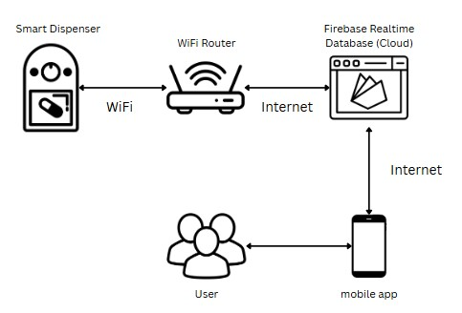
Figure 1. Network Architecture Diagram

The network architecture diagram illustrates the interconnection between system components. The Smart Medication Dispenser, powered by the ESP32 microcontroller, connects to a WiFi router to access the internet and communicate with Firebase Realtime Database, where all medication schedules, user data, and adherence logs are stored and synchronized in real time.
The PillSync Mobile Application connects to Firebase via WiFi or mobile data, allowing users to register accounts, configure medication schedules, view adherence history, and receive push notifications. Firebase serves as the central hub, synchronizing data between the dispenser and mobile app to ensure both platforms reflect the most current information.
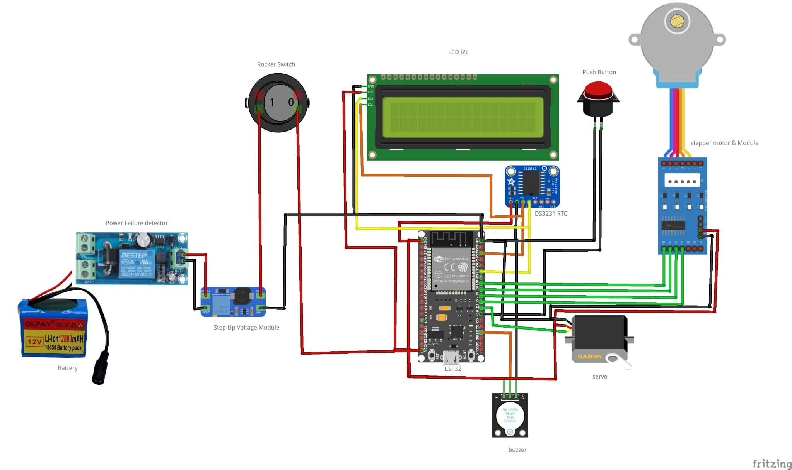
For direct dispenser control—such as manual dispensing—the smartphone must be connected to the same WiFi network as the dispenser. However, for viewing logs, schedules, and receiving notifications, the app can be accessed from anywhere with internet connectivity, enabling remote monitoring by guardians. The RTC module and SD card provide backup functionality, allowing the dispenser to operate and store data locally during internet outages, with automatic synchronization once connectivity is restored.

Figure 2. Internal System Architecture of the Dispenser
The internal system architecture diagram illustrates the wiring and interconnection of hardware components within the smart medication dispenser. At the center is the ESP32 microcontroller, which serves as the control unit for all operations.
The ESP32 connects to the LCD I2C display for visual feedback, the DS3231 RTC module for accurate timekeeping, and the buzzer for audible alerts. The push button (tactile switch) connects to the ESP32 as a confirmation input for users to acknowledge medication intake. The stepper motor with driver module connects to the ESP32 to control the rotation of the medication carousel, while the servo motor (DA04-15) operates the dispensing gate mechanism. Both motors receive control signals from the ESP32 to execute precise dispensing actions.
Power management is handled through multiple components: the 12V Li-Ion battery pack provides backup power, the power failure detector module monitors power status and automatically switches between main power and battery, the step-up voltage module regulates power supply to appropriate voltage levels, and the rocker switch serves as the main power control.
All components are interconnected using color-coded wiring (red for power, black for ground, and various colors for signal lines) on the circuit board, creating a complete system that enables automated medication dispensing, user interaction, timekeeping, and power backup functionality.

Storage, Backup, and Recovery Procedure
The system employs multiple storage mechanisms to ensure data integrity, availability, and recovery in case of failures or connectivity issues.
Primary Cloud Storage:
The system uses Firebase Realtime Database as the primary storage solution for all critical data, including user profiles, medication records, schedules, adherence logs, and device configurations. Firebase provides automatic data replication across multiple servers, ensuring data redundancy and high availability. All data is stored in real-time with instant synchronization between the mobile application and the dispenser, eliminating the need for manual backups.

Local Backup Storage:
The dispenser includes a Micro SD Card that serves as local backup storage. Medication schedules, intake logs, and system events are continuously written to the SD card, providing a secondary storage layer that operates independently of internet connectivity. This local backup ensures that data is preserved even during network outages or cloud service disruptions.
Timekeeping Backup:
The DS3231 RTC module with coin cell battery maintains accurate timekeeping even during complete power failures. This ensures that scheduled medication times remain precise and the system can resume normal operations immediately once power is restored, without requiring time recalibration.
Power Backup:
The 12800mAh battery with automatic power switching module ensures uninterrupted operation during electrical outages. The system automatically switches to battery power when main power fails and switches back when power is restored, preventing data loss and maintaining continuous medication dispensing capability.
Recovery Procedures:
In the event of internet connectivity loss, the dispenser continues operating using locally stored schedules from the SD card and accurate time from the RTC module. Adherence logs are stored locally and automatically synchronized with Firebase once connectivity is restored. If the mobile app loses connection, users can still view previously cached data, and all changes are queued and uploaded when the connection returns.
Firebase's built-in recovery tools allow the development team to restore database snapshots if data corruption occurs. The Firebase console provides access to historical data states and audit logs, enabling quick recovery from accidental deletions or system errors. No manual local backups are required, as all data management is handled securely by Firebase's cloud infrastructure.

Security Procedures
The system implements multiple security layers to protect user data, prevent unauthorized access, and ensure safe medication management.
Authentication and Access Control:
Firebase Authentication manages all user account security using email and password credentials. Users must create an account and authenticate before accessing the system. Firebase generates secure, time-limited authentication tokens (JWT) for each session, which are validated on every database request. This token-based system prevents credential exposure and ensures that only authenticated users can access their personal medication data.
Data Encryption:
All data transmission between the mobile application, cloud database, and dispenser is encrypted using SSL/TLS protocols. This encryption protects sensitive information such as medication details, adherence records, and personal data from interception during transmission over WiFi or mobile networks.

Database Security Rules:
Firebase Database Security Rules enforce strict access controls at the database level. These rules ensure that users can only read and write data associated with their own account, preventing unauthorized access to other users' information. The rules validate authentication tokens and user IDs before allowing any database operations.
Physical Security:
The dispenser's acrylic enclosure protects internal electronics from tampering and physical damage. The rocker switch and power connections are secured within the casing to prevent unauthorized power manipulation. The tactile confirmation button is the only user-accessible control on the dispenser, limiting potential for misuse.
Source Code Security:
The development team maintains version control and restricted access to source code through GitHub, with modification privileges limited to authorized team members only. This prevents unauthorized changes to the system's firmware or application code.
Session Management:
The mobile application automatically logs out inactive users after a period of inactivity, requiring re-authentication to access sensitive data. This prevents unauthorized access if a device is left unattended. These security measures work together to create a comprehensive protection system that safeguards user privacy, prevents unauthorized access, and ensures the integrity of medication management data.

Policies and Procedures
To maintain data privacy, system integrity, and proper system usage, the following policies and procedures are implemented:
User Account Policy:
Each medicine taker must register for a unique account through the PillSync mobile application using a valid email address and secure password. Account credentials are personal and confidential. Guardians or family members may access a medicine taker's account with explicit consent to monitor medication adherence and provide care support.
Data Privacy Policy:
All personal information, medication details, and adherence records are stored securely in Firebase Realtime Database with encryption and access controls. User data is accessible only to authenticated account holders and authorized guardians. No personal or medical information is shared with third parties, sold, or used for purposes other than medication management within the system.
Usage Policy:
Users are responsible for the accuracy of information entered into the system, including medication names, dosages, schedules, and duration. The system provides reminders and tracking support but does not replace professional medical advice. Users should consult healthcare professionals for medical decisions and medication management guidance.

System Maintenance Policy:
Users are responsible for maintaining adequate WiFi connectivity for real-time synchronization, keeping the dispenser powered through electrical connection or charged battery, regularly checking and refilling medication compartments based on stock alerts, and cleaning the dispenser enclosure as needed to ensure proper operation.
Incident Response Procedure:
In the event of system malfunction, users should first check power and WiFi connections, restart the dispenser if necessary, and verify that the mobile app is updated to the latest version. For data discrepancies, the system automatically synchronizes with Firebase once connectivity issues are resolved. In case of suspected security breach or unauthorized access, users should immediately change their account password through Firebase Authentication and report the incident to the development team. The team will conduct a security audit by reviewing Firebase access logs, checking database security rules, and investigating any suspicious activity.
Data Backup Procedure:
The system automatically backs up all data to Firebase's cloud servers with built-in redundancy. Local backup to the SD card occurs continuously during operation. Users do not need to manually backup data, as the system handles all backup processes automatically.
System Update Policy:
The development team may release updates to the mobile application to fix bugs, improve features, or enhance security. Users will be notified of available updates through the app and are encouraged to install updates promptly. Firmware updates for the dispenser may be deployed if necessary, with guidance provided by the development team.

Problem Analysis

This section plays a crucial role in identifying and understanding the core issues that the developed system aims to solve. This section provides a structured approach to analyzing the root causes of the problem, defining the problem and proposed solution, and aligning system requirements with identified issues. It typically includes three key components: the Fishbone Diagram, the Problem and Solution Statement, and the Problem-Requirements Matrix.
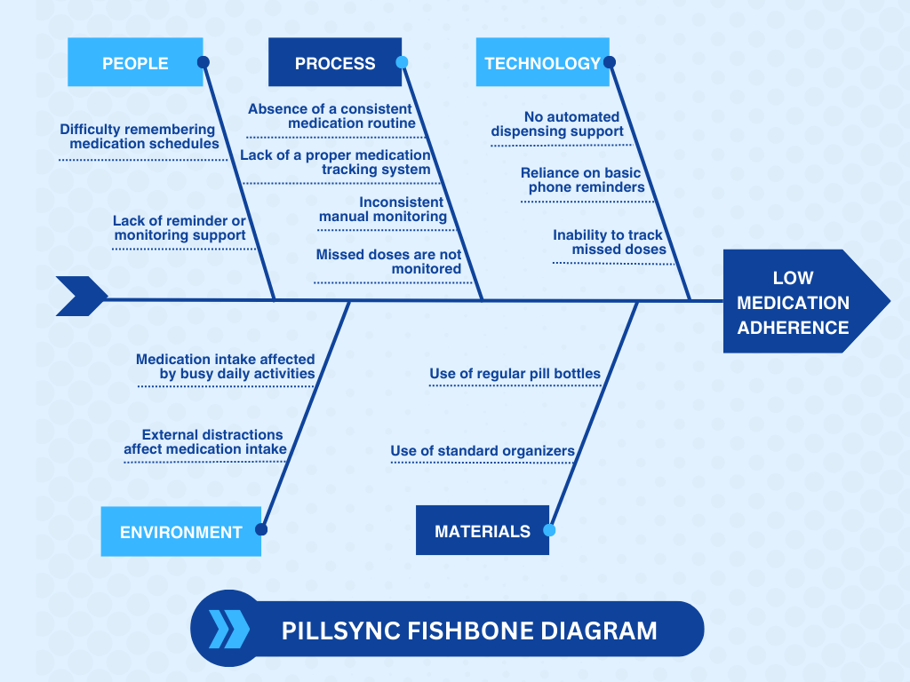
Fishbone Diagram
Figure 3. Fishbone Diagram
The fishbone diagram illustrates the various factors contributing to low medication adherence, which is the most common issue identified in the survey. Many respondents reported difficulty remembering medication schedules and lacking support systems to remind or monitor their intake. This aligns with Venkatraman et al. (2024), who stated that memory lapses remain one of the primary reasons patients fail to take their medications as prescribed.
Under the People category, respondents frequently forget their medication due to memory challenges, age-related cognitive decline, or lack of reminder support. Vaish (2024) emphasized similar issues, noting that patients without supervision or structured reminders are more likely to miss doses.
For the Process category, the survey shows that most users do not follow a consistent routine and lack an organized tracking method. Many rely on manual checking, which is often inconsistent and prone to error. These findings are supported by Rosdi et al. (2021) and Rathod et al. (2023), who noted that the absence of structured routines and reliable tracking systems significantly contributes to medication non-adherence.
The Technology category highlights that respondents rely mostly on basic phone alarms and do not have access to automated tools or smart dispensing systems. Phone alerts are often ignored, leading to missed doses. Studies from Patel et al. (2021) and Cu et al. (2021) show that technology-enabled reminders and automated dispensers can greatly improve adherence through real-time prompts and monitoring.
Environmental factors also contribute to low adherence. Respondents shared that busy daily activities and frequent distractions make it difficult to remember medication schedules. Patil et al. (2022) note that environmental influences, such as workload and home distractions, are common causes of skipped medication intake.
Lastly, the Materials category shows that users still rely on regular pill bottles or basic organizers that do not provide reminders or tracking support. Nigade et al. (2024) stated that traditional medication containers lack the features necessary to support consistent intake, unlike smart organizers or dispensers that provide guidance and alerts.
Overall, the fishbone analysis demonstrates that low medication adherence results from a combination of human factors, process-related gaps, limited technology, environmental distractions, and insufficient medication tools. These findings highlight the importance of developing a smart, supportive medication management system that can improve adherence through reminders, monitoring, and better organization.

Problem and Solution Statement
Problem Statement:
Low medication adherence is a major issue for individuals who need to take medicines regularly. Based on the fishbone analysis, many users struggle with remembering their medication schedules, following a consistent routine, and monitoring their intake. They often rely on basic phone alarms, manual checking, and regular pill bottles that provide no reminders or support. Busy daily activities, distractions, and the lack of organized tools also contribute to missed or late doses. These problems increase the risk of health complications and show the need for a system that helps users manage their medication more effectively.
Solution Statement:
The proposed solution is a Smart Medication Management System that provides reminders, tracking features, and better organization for daily medication intake. The system will send timely alerts, allow users to set schedules, record taken or missed doses, and offer more support than regular pill bottles or simple organizers. By using easy-to-access technology and user-friendly features, the system aims to reduce forgetfulness, improve routine, and help users stay consistent with their medication.
Problem-Requirements Matrix
Problem | Requirement
Difficulty remembering medication schedules | The system must send reminders or alerts.
Lack of reminder or monitoring support | The system must send reminders or alerts.
Absence of a consistent medication routine | The system must allow users to set a daily schedule.
Lack of a proper medication tracking system | The system must record each taken or missed dose.
Inconsistent manual monitoring | The system must automate monitoring of intake.
Missed doses are not monitored | The system must record missed doses and notify the user.
No automated dispensing support | The system should support smart dispensing features.
Reliance on basic phone reminders | The system must provide smart alerts that are harder to ignore.
Inability to track missed doses | The system must record each taken or missed dose.
Medication intake affected by busy daily activities | The system must send alerts based on the user’s schedule.
External distractions affect medication intake | The system must provide repeated or persistent notifications.
Use of regular pill bottles | The system must support organized medication handling.
Use of standard organizers | The system must support medication lists and organized schedules.
Table 1. Problem – Requirements Matrix
Table 1 presents the link between the identified problems and the system requirements designed to solve them. Each problem, such as forgetfulness, lack of reminders, inconsistent routines, distractions, and standard medication tools, is matched with a specific feature that the system must include. By connecting problems to the needed requirements, the table shows how the proposed system directly addresses the real difficulties experienced by users. It also highlights how features like timely alerts, automated tracking, organized schedules, and improved monitoring of missed doses can help users manage their medication more consistently and effectively.

Purpose and Description

The proposed project aims to address the common problem of poor medication adherence among elderly individuals and people who take maintenance medications.
The project proposes the development of A Smart Pill Dispenser with Mobile Application, a system intended to improve medication adherence through scheduled dispensing, intake reminders, and real-time monitoring. The planned system will feature an automated pill dispenser that releases the correct medication at set time schedule, connected to a mobile application that sends notifications, tracks missed doses, and allows users to configure medication schedules. It is also designed to support multiple dispenser management, making it suitable for shared use in homes.
The goal of the proposed project is to create a user-friendly and reliable system that assists users in following their medication schedules. It will also include features that allow family members or guardians to monitor medication intake by accessing the medicine takers account through the same mobile application, helping to support better health outcomes. By combining automated dispensing, mobile app reminders, adherence monitoring, and multi-dispenser management within a single application, this proposed system aims to enhance daily medication management while promoting greater independence and flexibility for its users.

Specific Objectives

1. To design and develop a mobile application for managing, monitoring, and providing alerts for the medication dispenser.
2. To deploy and implement an automated medication dispenser for scheduled medication dispensing.
3. To evaluate the system’s quality based on ISO/IEC 25010 characteristics, including functionality, usability, reliability, performance efficiency, security, and maintainability.

Scope and Limitations

This study will be conducted and tested in Brgy. Talolong, Lopez, Quezon. The project focuses on the development of a medication management system consisting of a smart dispenser device and a mobile application intended to assist users in managing their medication schedules and ensuring timely medicine intake. The evaluation of the system involves 58 respondents, composed of users/patients, guardians, a school nurse, a pharmacist, and a caregiver, to gather feedback from both end-users and healthcare-related stakeholders. The smart dispenser will automatically release medications based on pre-configured schedules, accompanied by buzzer alerts for reminders. The mobile application will serve as the management platform where users can configure medication schedules, receive adherence alerts, view real-time intake logs, and monitor multiple dispenser accounts under a single application. Family members or guardians can monitor medication intake by logging into the medicine taker’s account through the same mobile application. Direct control of the dispenser device is possible only when connected to the same WiFi network, while real-time monitoring of intake logs and notifications can be performed remotely via internet access. The scope of this project is limited to the dispensing of solid oral medications such as tablets and capsules. The dispenser does not support liquid medicines, injectables, or other forms of medication. However, the mobile application can still provide notifications and reminders for these medication types even if the device cannot dispense them. The system is developed exclusively for Android mobile devices and is distributed only as an APK file; it is not available on the Google Play Store, which may limit ease of installation and access for some users. The system requires a stable WiFi or internet connection for real-time updates, remote monitoring, and data synchronization between the mobile application, smart dispenser, and cloud database. This project does not include users aged 17 and below. Furthermore, the project does not include integration with electronic health records, advanced biometric security features, or remote schedule adjustments by guardians; guardians can only monitor and view medication adherence data remotely.

Definition of Terms
The Definition of Terms section provides clear and concise explanations of key terms, technical jargon, and system-specific concepts used throughout the study. This section ensures that all readers—including those who may not be familiar with information technology or the particular domain of the project—can fully understand the manuscript. It also promotes consistency and clarity in communication by standardizing the meaning of important words and phrases.

This section typically includes:
- Technical Terms – Words related to programming, networking, security, or software development (e.g., API, SQL, backend, encryption).
- System Components – Terms that describe modules or features of the developed system (e.g., admin dashboard, user authentication, transaction log).
- Industry-Specific Vocabulary – If the project is tailored to a specific field such as healthcare, education, or business, it should define domain-specific terms (e.g., EMR for healthcare, LMS for education).
- Abbreviations and Acronyms – All abbreviations used in the manuscript should be defined in full the first time (e.g., CRUD – Create, Read, Update, Delete).
- Custom Terms – Any unique terms coined or used by the researchers that are essential to understanding the system.
Here is a sample format for the definition of terms:
- Term. A term used in process must be defined here.

Chapter 2
REVIEW OF LITERATURE, STUDIES, AND SYSTEMS

According to Venkatraman, V., et al. (2024). Their study developed a medication management system using IoT technology, which integrates a mobile application for monitoring medication intake and ensuring timely alerts for patients. The system focuses on enhancing medication adherence by connecting a smart pill dispenser with mobile notifications, addressing common issues like forgetfulness and improper dosage. Their findings emphasize the critical role of technology in reducing human errors and improving patient health outcomes.

According to Rosdi, W. M. F. W. M., Sahani, M., Ahmad, N. S., & Ahmad, S. A. (2021) entitled “Smart Pill Dispenser with Monitoring System” introduced a smart pill dispenser integrated with a monitoring system to improve medication adherence, especially for patients requiring strict medication schedules. The system features automatic pill dispensing, real-time monitoring, and alert notifications to remind users and inform caregivers of missed doses. It uses sensors and embedded programming to ensure accuracy and reliability in pill management. By minimizing the risk of missed or incorrect dosages, the system enhances patient compliance and supports better health outcomes.

According to Vaish, A. (2024) introduced an automated pill dispenser designed to enhance medication adherence, particularly for patients who need to follow strict and consistent medication schedules. The proposed system incorporates scheduled dispensing mechanisms, real-time monitoring capabilities, and alert notifications for both users and caregivers to ensure that medication is taken correctly and on time. This solution tackles common barriers such as forgetfulness, improper dosage, and lack of supervision, which often lead to non-compliance and negative health outcomes. By providing timely reminders and ensuring that each dose is accurately dispensed, the system not only improves the efficiency of medication intake but also increases patient safety and accountability. The integration of smart technology and automation reflects a growing trend in healthcare innovation aimed at supporting patient independence and reducing the burden on healthcare providers.
According to Patel et al. (2021) proposed an IoT-based pill reminder and monitoring system designed to improve medication adherence, particularly among elderly and chronically ill patients. The system utilizes sensors, a microcontroller, and cloud connectivity to send reminders and monitor pill consumption in real time. It includes features such as scheduled alerts, automatic detection of pill intake, and data logging for guardian. By addressing challenges like forgetfulness and lack of supervision, the system enhances medication compliance and patient safety.

According to Rathod et al. (2023) proposed a smart pillbox using the Internet of Things (IoT) to ensure timely medication intake, specifically addressing the needs of elderly individuals and patients with chronic conditions. The system incorporates a NodeMCU microcontroller, real-time clock module, sensors, and a buzzer to alert users when it is time to take their medicine. It also includes a mobile application that provides reminders and maintains a log of medication schedules. This integration of hardware and software enables caregivers to monitor adherence remotely, reducing the risk of missed doses and promoting better health outcomes.

A study presented during the DLSU Research Congress by Cu, G., et al. (2021). Introduced a smart medicine dispenser connected to a mobile application, capable of scheduling, dispensing, and monitoring medication intake. Their local research highlights the significant improvements in medication compliance among patients through real-time tracking and mobile alerts.
According to Patil, C. H., et al. (2022). presented an innovative IoT-based smart medicine dispenser designed to support patients, particularly elderly and dependent individuals, in managing their medication schedules effectively. The system aims to ensure that patients take their medications on time without missing doses, thereby reducing the risks associated with over- or underdosing, which can lead to severe health complications such as delayed recovery or worsening of diseases. The dispenser features an alarm mechanism that notifies patients when their medication is due, and it facilitates instant communication between patients and their caregivers, enhancing monitoring and support. By leveraging IoT technology, the system integrates embedded software and connectivity to provide a reliable and user-friendly solution that promotes patient self-dependence while improving medication adherence. This approach helps address common challenges like forgetfulness and incorrect medication intake, ultimately contributing to better health outcomes.
According to Nigade, M., Vankudre, D., & Ingle, S. (2024) in “Automated Medication Dispenser with Alert Mechanism” introduced an automated medication dispenser with an alert mechanism aimed at improving medication adherence, particularly among elderly individuals and patients with chronic conditions. The system utilizes an ESP32 microcontroller integrated with components such as a real-time clock (RTC) module, servo and stepper motors, an LCD display, and light-dependent resistors (LDRs). It is connected to the Blynk application, enabling real-time monitoring and control via smartphones. The dispenser is designed to automatically deliver medications at scheduled times and includes an alarm system to alert users and caregivers in case of missed doses. By addressing challenges like forgetfulness and lack of supervision, the system enhances medication compliance and patient safety.

RELATED METHODOLOGIES IN RELATED STUDIES
Rashid et al. (2024) examined medication adherence and its associated factors among hypertensive patients in a multicenter cross-sectional study conducted in Oromia, Ethiopia. The results showed that adherence rates were higher among older adults, married individuals, urban residents, and those with moderate monthly incomes. This study identified key demographic factors that influence adherence to antihypertensive medication regimens. Rashid recommended that intervention programs consider these factors to improve medication adherence and, consequently, health outcomes. This research contributes valuable insight into behavioral and socioeconomic determinants of medication adherence in resource-limited settings.

Peddisetti (2024) – "An IoT-based medication adherence system that merges a smart pill dispenser and a smart cup to monitor and verify drug intake" ntroduced an IoT-based medication adherence system that merges a smart pill dispenser and a smart cup to monitor and verify drug intake. The system utilizes an Arduino Nano RP2040, integrated with BLE communication, accelerometers, and ultrasonic sensors to detect user interaction and confirm dosage consumption. Real-time notifications are sent to both users and guardians, promoting consistent adherence. This study demonstrates how sensor fusion and microcontroller technology can be harnessed to create an intelligent healthcare system. The results affirm the system's potential in minimizing missed doses and improving health compliance.

Li et al. (2025) conducted a systematic review on the application of IoT mobile apps in diabetes care among elderly patients. The study outlined how mobile health systems support real-time monitoring, lifestyle tracking, and medication management, which collectively improve patient outcomes. However, challenges such as limited tech literacy, security concerns, and cognitive impairments were acknowledged. The review called for accessible design and guardian integration to ensure usability for the elderly. These insights emphasize the role of IoT solutions in delivering scalable and inclusive healthcare services.

Ali et al. (2024) developed a comprehensive healthcare solution that integrates a smart pill dispenser with vital sign monitoring. The system continuously gathers biometric data while also issuing medication reminders, offering a dual-function tool for chronic disease management. By combining health surveillance with adherence technology, the system strengthens communication between patients and healthcare providers. The findings highlight the benefits of converging medication and health data into a unified platform. The study concluded that real-time insights significantly elevate the standard of care for patients.

Del Rosario et al. (2023) evaluated the impact of smart pill bottle systems on medication adherence through an integrative review. The findings revealed that real-time alerts and automated logging features encourage patients to follow prescribed regimens. Additionally, the review identified issues related to patient acceptance, particularly concerning device complexity. The researchers recommended refining usability features to align with patient preferences. This analysis reinforces the value of smart adherence systems in clinical practice when designed with patient behavior in mind.

Faisal, Ivo, and Patel et al. (2021) conducted a comparative review of smart medication adherence products designed for home use. They analyzed features such as automation, guardian access, and wearable-linked notifications to evaluate effectiveness in promoting adherence. The study emphasized the significance of user education and simplified interfaces to ensure successful implementation. Their work supports the growing importance of designing user-friendly, multi-functional adherence tools. These insights guide future developers in creating next-generation systems for at-home patient support.

Zewdu (2024) – "A cross-sectional study to assess the intention of hypertensive patients in Northwest Ethiopia to use mobile text message reminders for medication adherence". The findings indicated that patients with higher health literacy levels and positive attitudes toward technology were more likely to accept and use these digital health interventions. The study highlights the potential of mobile health solutions to improve medication adherence, especially in resource-limited settings. It also underscores the importance of considering patient perceptions and education when designing adherence technologies. This research contributes valuable insights into the feasibility and acceptance of mHealth tools among populations with chronic conditions.
Thorsen et al. (2022) reviewed essential components of smart medication adherence products, focusing on older adults with chronic illnesses. Key features like automated dispensing, real-time tracking, and guardian access were found to be crucial for sustained adherence. The study noted the rapid expansion of the SMAP market and the need for standard evaluation metrics. It also underscored the necessity of designing intuitive interfaces for older users. This work provides a strong foundation for selecting and refining adherence technologies tailored to aging populations.
RELATED SYSTEM
MedMinder (2021) is a cellular-connected pill dispenser designed to help people remember to take their medication on time. It allows users and their guardians to monitor medication adherence remotely through the cloud-based platform. The device’s compartments unlock according to schedule, and alerts are sent if a dose is missed.
Medication Dispenser “Hero’’(2022) is an automated medication dispenser that stores up to 10 different medications and dispenses the right dose at the right time. The system’s mobile app notifies patients and guardians when it’s time to take medication and provides adherence reports. It integrates with pharmacies to simplify prescription refills.
MedaCube(2023) automates medication management by sorting pills into compartments and dispensing them according to schedule. The device connects to a mobile app, enabling users and guardians to track medication adherence. MedaCube supports multi-user households and helps reduce medication errors.

Philips Medication Dispenser(2021) offers a simple way for users to receive reminders for their medicines and allows guardians to monitor intake remotely. It provides audible and visual alerts to promote adherence and features secure compartments for medication storage.

The AdhereTech(2022) Smart Pill Bottle monitors medication use by tracking when the bottle is opened and sends real-time alerts to patients and their guardians. It is designed to support medication adherence and offers detailed compliance reports.

PillDrill(2021) combines a smart pillbox with a mobile app that sends reminders and tracks medication intake. Guardians can receive notifications and oversee adherence remotely. The system supports barcode scanning to improve tracking accuracy.

MedaCheck(2020) dispenses medications automatically using pre-filled cartridges according to preset schedules. Guardians are notified if medications are missed. The dispenser includes locking features to prevent unauthorized access.

Lumind(2023) automates the dispensing of medications on a schedule and sends adherence alerts through a mobile app. It supports multiple users and provides guardians with real-time updates. The dispenser has a locking mechanism to secure medications.

SYNTHESIS OF THE REVIEWED LITERATURE AND STUDIES
Recent research highlights the vital role of IoT-enabled smart medication management systems in improving adherence, especially for elderly and chronically ill patients. These systems combine automated pill dispensers, mobile apps, and real-time monitoring to address challenges like forgetfulness, incorrect dosing, and lack of supervision.

Studies by Venkatraman et al. (2024), Rosdi et al. (2021), and Vaish (2024) demonstrate how smart dispensers with mobile alerts enhance medication compliance and safety. Technologies such as microcontrollers, sensors, and alert mechanisms improve accuracy and reliability (Nigade et al., 2024; Rathod et al., 2023). Caregiver monitoring through apps enables timely interventions for missed doses (Patel et al., 2021; Patil et al., 2022), with advanced sensor fusion and communication protocols further boosting effectiveness (Peddisetti et al., 2024).

Behavioral studies (Rashid et al., 2024; Zewdu et al., 2024) underscore the importance of addressing socio-demographic factors and patient attitudes toward technology to maximize adherence outcomes. These findings suggest that smart systems must also consider usability, accessibility, and education to foster acceptance, especially in resource-limited or elderly populations (Li et al., 2025; Del Rosario et al., 2023).

Existing system such as MedMinder, Hero, MedaCube, Philips Medication Dispenser, and AdhereTech exemplify these integrated approaches by offering features like scheduled dispensing, remote monitoring, secure storage, and adherence reporting. These systems demonstrate the practical benefits of combining hardware automation with cloud-based platforms to reduce medication errors and support patient independence.
In summary, the convergence of IoT technology, embedded systems, mobile health applications, and behavioral insights drives the evolution of smart medication adherence solutions. These integrated systems not only reduce human error and improve compliance but also enhance communication between patients, caregivers, and healthcare providers, ultimately promoting better health outcomes and quality of life for users.

Chapter 3
METHODOLOGY
Requirements Analysis
Requirements – Features Matrix
Feature | Description | Importance | Notes
Log In / Sign Up | Lets users and guardians create an account or access their existing one. | High | Needed to personalize data and secure access.
Add Medication | Allows users to input medication details such as name, description, and duration. | High | Required before scheduling and reminders can work.
Set Schedule | Enables users to choose when each medication should be taken. | High | Users can customize times based on their needs.
View Medication | Shows the list of medications added to the system. | High | Accessible to both User and Guardian.
View Schedule | Displays the scheduled times for each medication. | High | Helps both actors monitor upcoming doses.
Receive Medicine Notification | Notifies the user when it’s time to take a medication. | High | Includes take medicine, dismiss, and not now options.
Missed Dose Alert | Alerts the user if a medication is not confirmed in time. | High | The system uses a fixed grace period before marking a dose as missed.
Confirm Intake | Lets the user confirm they have taken the medication. | High | Confirmations update the medication log.
Medication History | Shows records of taken and missed medications. | Medium | Helps track consistent intake behavior.
Reports | Displays summaries of adherence such as weekly or monthly reports. | Medium | Useful for monitoring medication habits.
Export Reports | Allows users and guardians to download or export reports. | Medium | Useful for medical consultations or documentation.
Refill Reminder | Sends alerts when medication supply is running low. | Medium | Helps avoid running out of medicine.
View Refill Status | Shows how much medication is left or refill levels. | Medium | Accessible to both User and Guardian.
Table 2. Features Matrix of PillSync
The table above shows the different features included in the PillSync application. Each row describes a feature, what it does, how important it is, and any extra notes. The Feature column lists the name of the function. The Description explains what the feature is for. The Importance column shows how essential the feature is to the system, such as high or medium priority. The Notes column gives extra reminders or details about how the feature works. This matrix helps readers easily understand how each feature supports the needs of the users and which features are most important for the system to work properly.

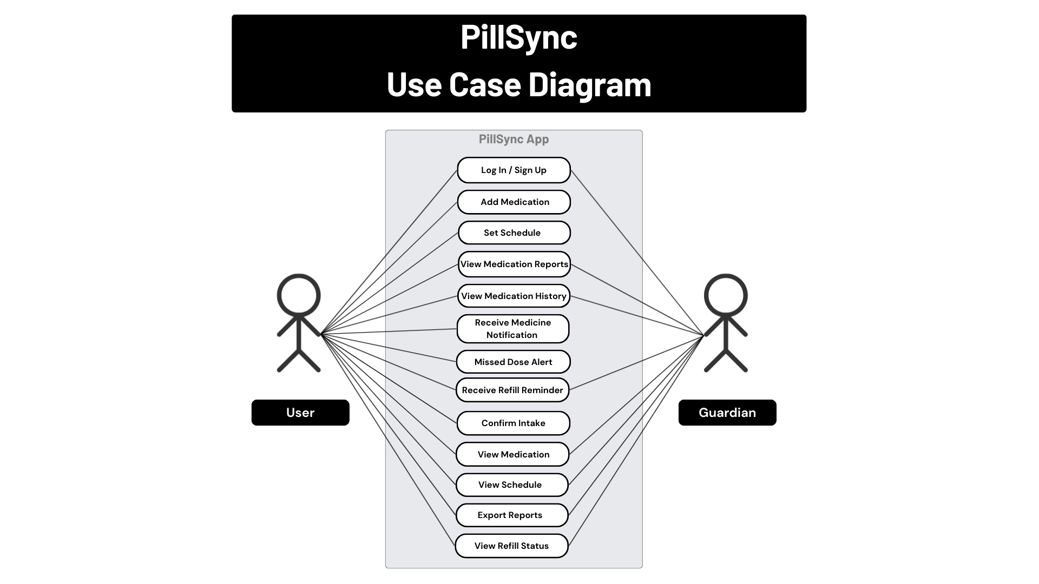
Use Case Diagrams
Figure 4. Use Case Diagram of PillSync
The figure above shows how the User and Guardian interact with the PillSync app. The user can create an account or log in, add medications, set schedules, confirm intake, and view different reports about their medication history and refill status. The user also receives notifications, alerts for missed doses, and reminders when it is time to refill a medicine. The guardian can also log in or sign up to view the user’s medication information, schedules, reports, refill status and receive refill reminder, but only the user can confirm intake. This diagram helps explain how the system works by showing what actions each actor can perform inside the app.

Use Case Reports
Use Case | Description | Actors | Preconditions | Postconditions | Main Success Scenario
Log In / Sign Up | Allows the user or guardian to access the app by logging in or creating an account. | User / Guardian | The app is installed. | User/Guardian is logged in successfully. | 1. User opens the app.  2. Enters login information or registers.  3. Access is granted.
Add Medication | User adds medicine details such as name, dosage, treatment, and instructions. | User only | User is logged in. | Medication is added and saved. | 1. User selects “Add Medication.”  2. Inputs details.  3. Confirms and saves.
Set Schedule | User sets time schedule for each medication. | User only | Medication exists in the list. | Schedule is linked to the medication. | 1. User selects a medication.  2. Sets time.  3. Saves schedule.
View Medication Reports | Shows summaries of doses taken/missed/  pending. | User / Guardian | Some medication history must exist. | Report is displayed with summaries. | 1. User taps “Reports.”  2. System loads data.  3. Summary appears.
View Medication History | Lists each taken, missed, or pending. | User / Guardian | App has medication activity records. | History is displayed. | 1. User selects “History”.  2. System retrieves past medication logs.  3. User views history.
Receive Medicine  Notification | Sends reminders when it is time to take a medication. | User only | Schedule must be set. | Notification is delivered on time. | 1. App checks current time.  2. Matches it with schedule.  3. Sends notification.
Missed Dose Alert | Alerts the user if they did not confirm intake after the reminder. | User only | Reminder was sent but not confirmed. | App sends a missed dose alert. | 1. User does not confirm intake.  2. System waits for the fixed grace period.  3. Sends Missed Dose alert.
Refill Reminder | Alerts the user or guardian when medication supply is low. | User / Guardian | Medication supply level is tracked. | A refill reminder is showed. | 1. System detects low stock.  2. Sends a refill reminder.
Confirm Intake | Allows the user to confirm whether the medication was taken or missed after receiving a reminder. This serves as feedback for accurate logging. | User only | User receives a notification or opens notification and confirm it manually. | Intake status (taken, missed, and not yet) is recorded in the history. | 1. User opens the intake confirmation prompt.  2. Selects “Take Medicine”, “Dismiss”, or “Not Yet”.  3. System saves the intake result to history.
View Medication | Displays the list of medications added to the app. | User / Guardian | User/Guardian is logged in. | Medication list is shown. | 1. User selects “Medicine”  2. System shows all medications.
View Schedule | Shows the schedule for all medications. | User / Guardian | User/Guardian is logged in. | Schedule information is displayed. | 1. User opens “Schedule.”  2. System loads all set schedules.
Export Reports | Allows user or guardian to export reports (e.g., CSV). | User / Guardian | Reports must exist. | Exported file is created. | 1. Chooses Date Range.  2. User clicks “Export Report.”  3. System generates and save file.
View Refill Status | Shows the available slots status. | User / Guardian | Medication stock level is recorded. | Refill status is displayed. | 1. User taps “Refill Settings”  2. System retrieves stock levels.  3. Status is shown.

Table 3. Use Case Report
The table above presents the Use Case Reports for the PillSync system. It includes six columns. The first column lists the Use Case or feature. The second column describes what the use case does. The third column shows the Actor, which can be either the User or the Guardian. The fourth column lists the Preconditions, or what should happen first before the feature can be used. The fifth column presents the Postconditions, or what happens after the feature is successfully completed. The last column explains the Main Success Scenario, which describes the normal step-by-step flow of how the feature works. This table helps readers understand the purpose of each feature and how users interact with the system in different situations.

Design Specifications
Activity Diagram
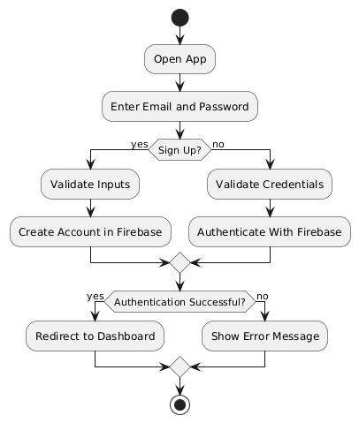

Figure 5: Log In / Sign Up Activity Diagram
This diagram illustrates the authentication workflow for both users and guardians. It shows how the system validates credentials during login and handles account creation during sign-up. The flow ensures secure access to the personalized dashboard, preventing unauthorized entry and maintaining user data integrity.

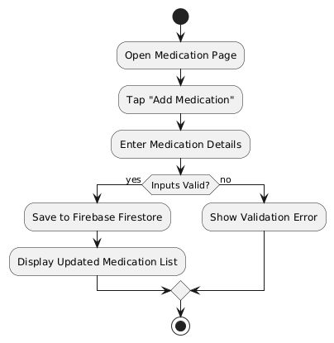

Figure 6. Add Medication Activity Diagram
This diagram represents the process of adding medication into the system. It highlights input validation, database storage, and real-time update in the medication list. The workflow ensures that medication information is correctly saved and accessible for subsequent scheduling and tracking.

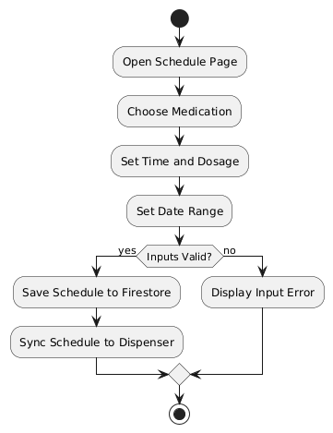

Figure 7. Set Schedule Activity Diagram
This diagram describes the process of creating medication schedules. It shows how the system validates inputs, stores schedule data in Firebase, and synchronizes with the dispenser. It ensures accurate timing for medication dispensing and prevents scheduling errors.

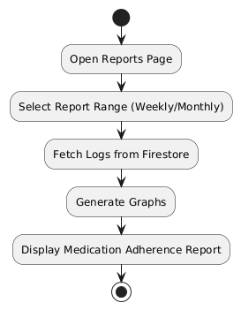

Figure 8. View Medication Reports Activity Diagram
This diagram illustrates how users and guardians access medication adherence reports. It depicts the retrieval of historical logs, generation of visual graphs, and display of reports, providing an overview of compliance trends and enabling monitoring of adherence patterns.

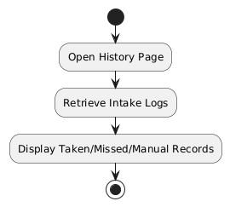

Figure 9. View Medication History Activity Diagram
This diagram shows the workflow for reviewing detailed intake logs. It ensures that each taken, missed, or manually dispensed dose is recorded and viewable, allowing users and guardians to track daily medication management accurately.
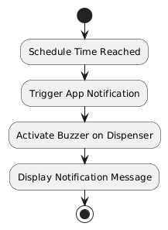

Figure 10. Receive Reminder / Notification Activity Diagram

This diagram represents the notification mechanism triggered by scheduled medication times. It shows simultaneous alerts via the app and dispenser, ensuring that users are reminded promptly to take their medications, supporting adherence and reducing missed doses.
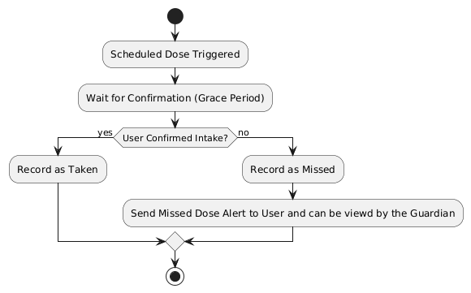

Figure 11. Missed Dose Alert Activity Diagram
This diagram illustrates the handling of unconfirmed doses. If a user fails to confirm intake within the grace period, the system logs it as missed and sends alerts to the user and guardian. This ensures that caregivers are aware of non-compliance and can intervene if necessary.

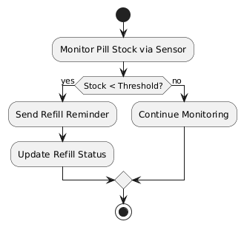

Figure 12. Receive Refill Reminder Activity Diagram
This diagram shows how the system monitors medication stock levels and triggers refill reminders when thresholds are low. It ensures continuity in medication availability and prevents missed doses due to empty compartments.

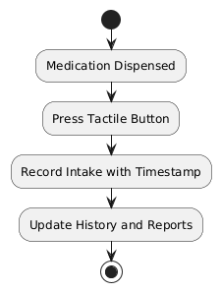

Figure 13. Confirm Intake Activity Diagram
This diagram represents the process of confirming medication intake via the tactile button. It ensures that the system records the action accurately, updates the database, and reflects the confirmation in both history and reports for accountability.
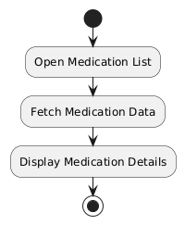

Figure 14. View Medication Activity Diagram
This diagram depicts the retrieval and display of all stored medications. It allows users and guardians to verify current medication details, ensuring transparency and accessibility of the patient’s medication list.

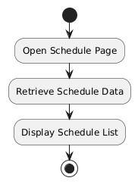

Figure 15. View Schedule Activity Diagram
This diagram illustrates the display of scheduled medication times. It allows users and guardians to track upcoming doses and verify that all schedules are correctly configured, ensuring timely adherence

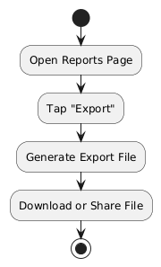

Figure 16. Export Report Activity Diagram
This diagram represents the process of generating and exporting medication reports. It enables users and guardians to download or share adherence data for record-keeping, clinical consultation, or personal monitoring purposes.

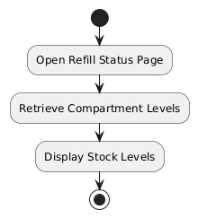

Figure 17. View Refill Status Activity Diagram
This diagram shows the workflow for checking current stock levels in the dispenser. It ensures users and guardians are informed about compartment status, supporting proactive refills and uninterrupted medication management.

GUI Design
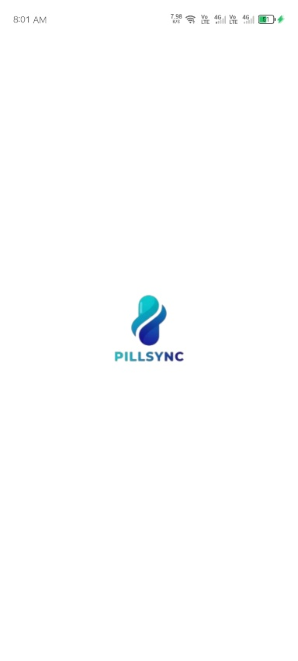

Figure 18. Loading Screen of PillSync
This screen loads all necessary data and syncs your device settings before you enter the app. It ensures your medication schedules, history, and alerts are ready.

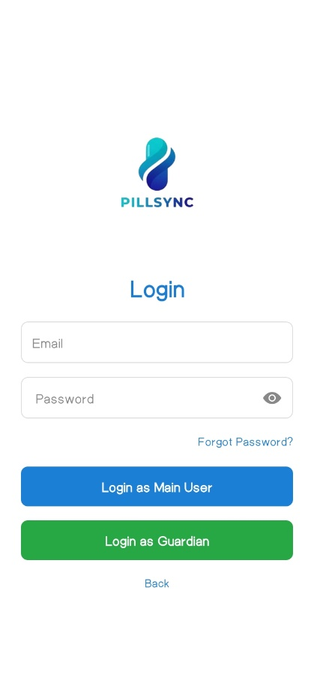
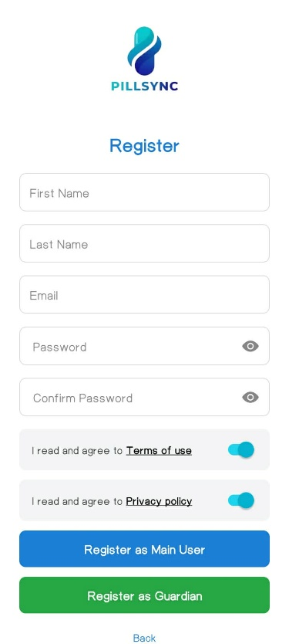
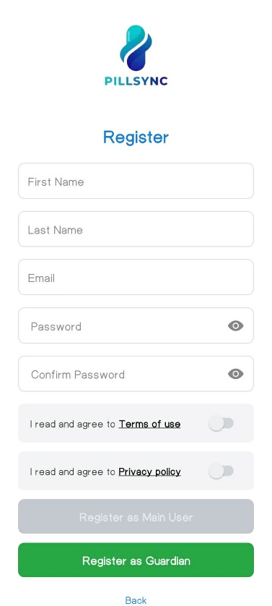

Figure 19. Log in and Register Screen of PillSync
Here you can securely log in if you already have an account or Register to create a new PillSync account to manage your medications and reminders.

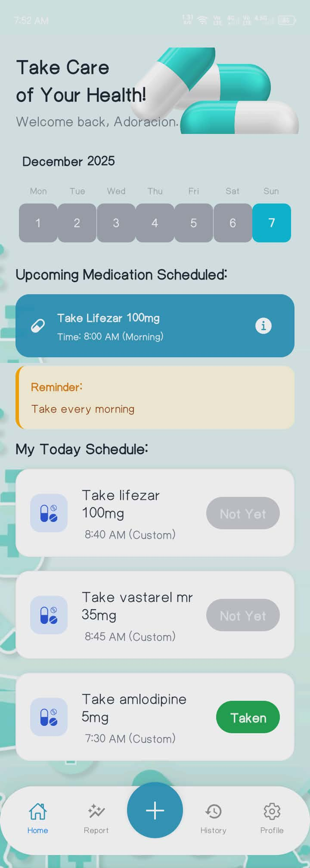

Figure 20. Home Screen of PillSync
The main dashboard that shows your next scheduled dose, today's medication checklist, quick 'Taken' button, and important alerts for easy daily management.

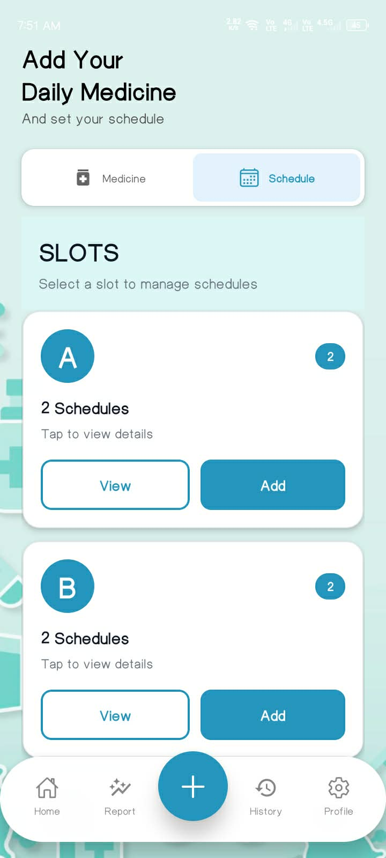
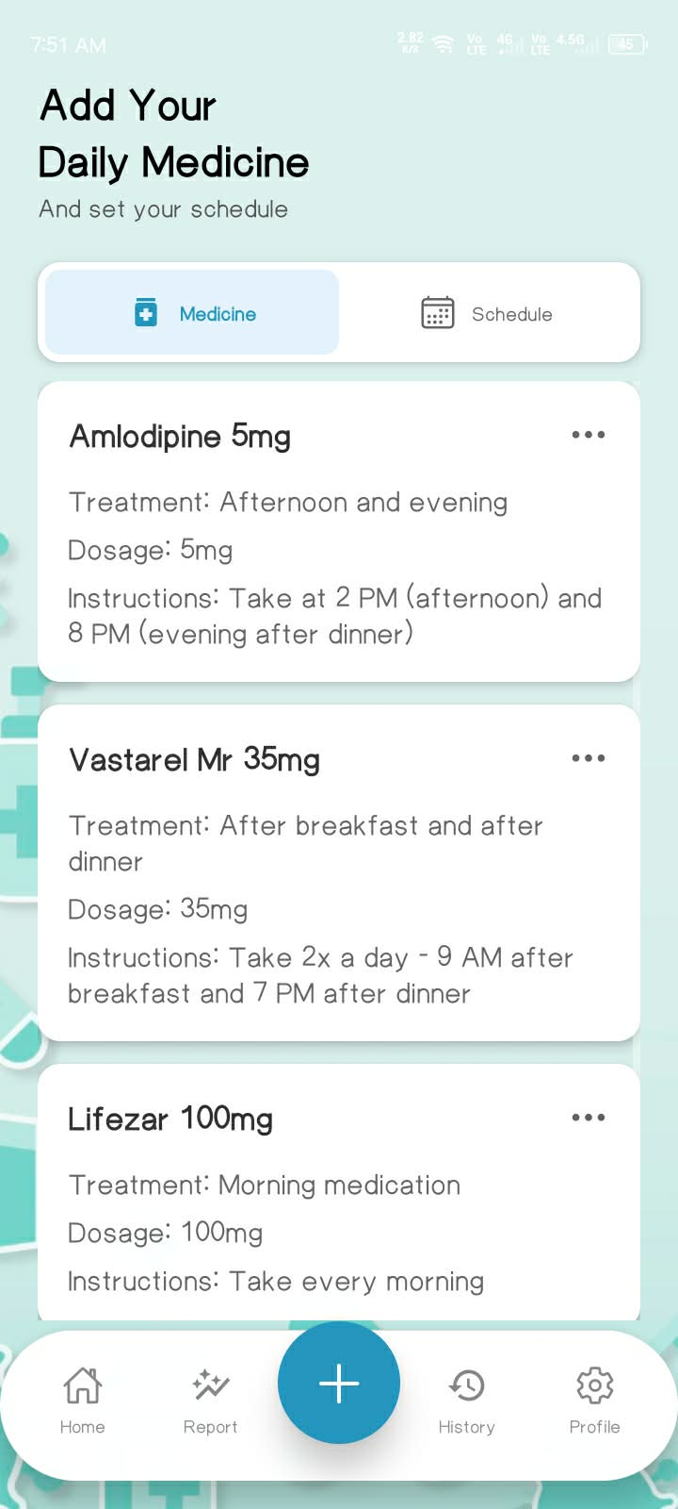

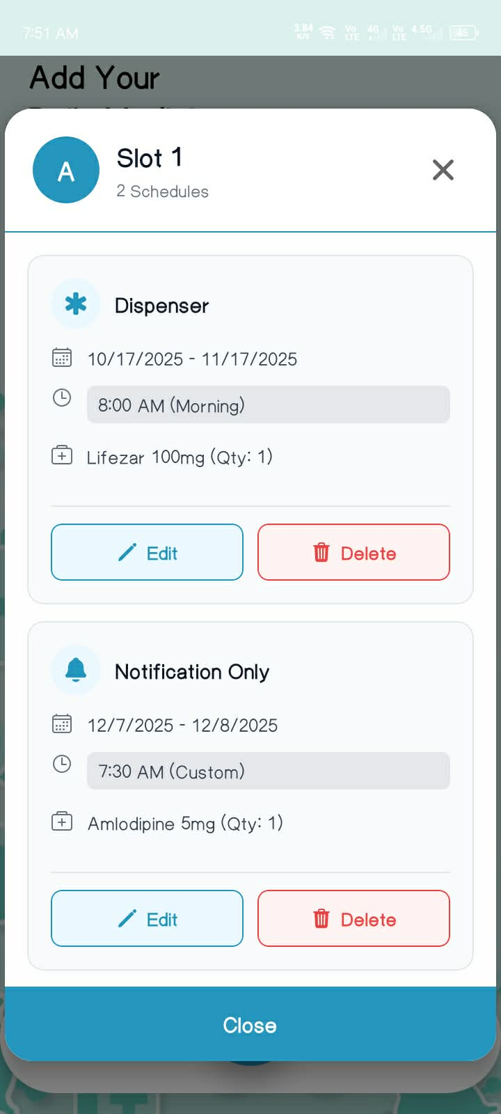
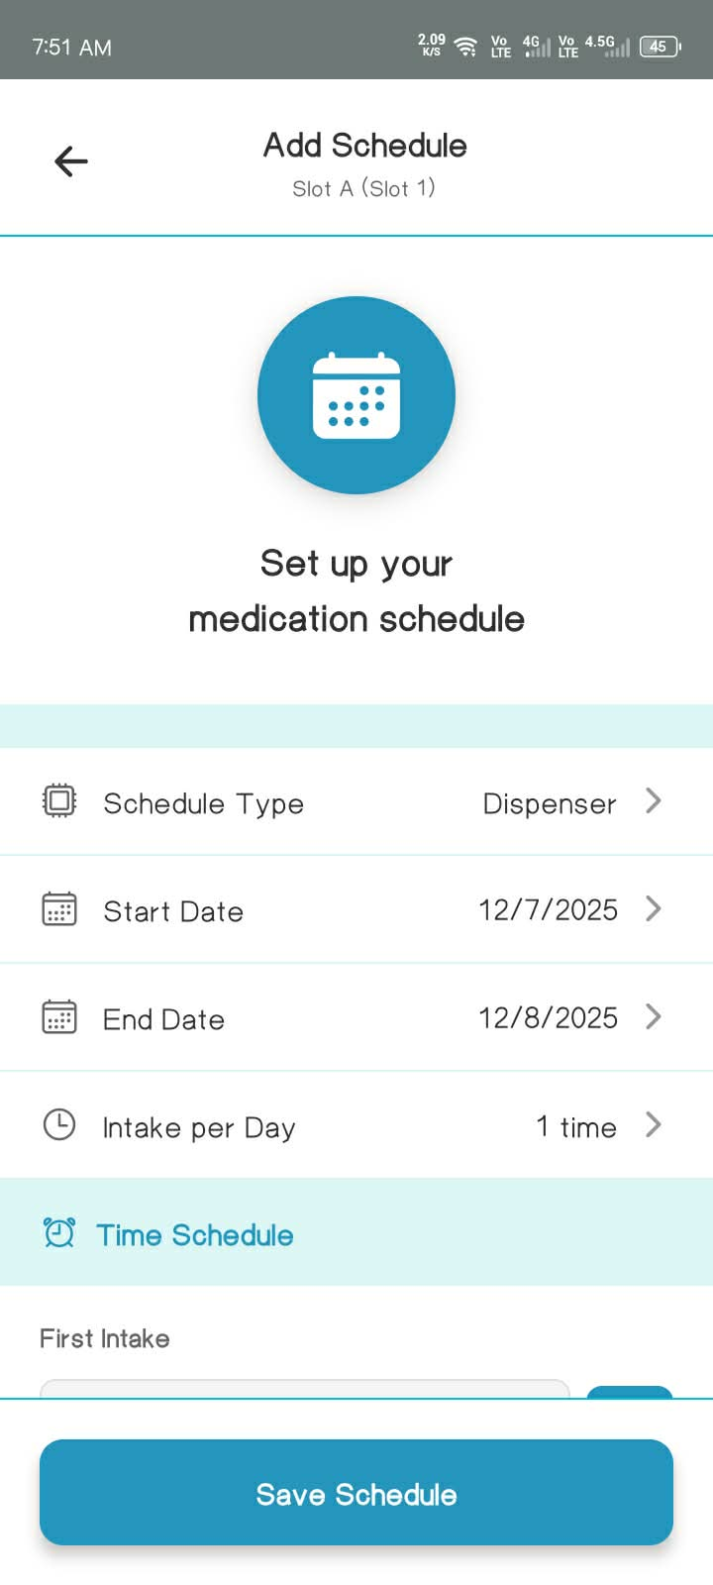

Figure 21. Add/Edit Medicine and Schedule Screen of PillSync
This figure shows the Add new medications/schedule by entering the name, description, duration, dosage, slot, quantity or update existing medication/schedule details when needed.

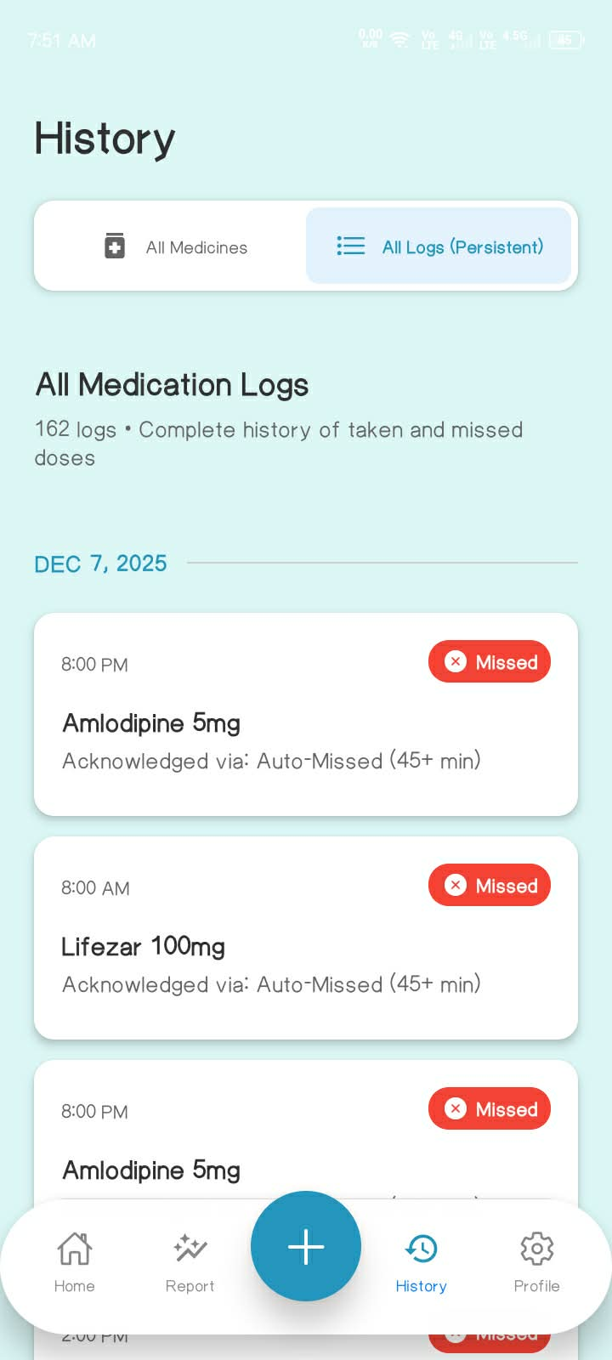
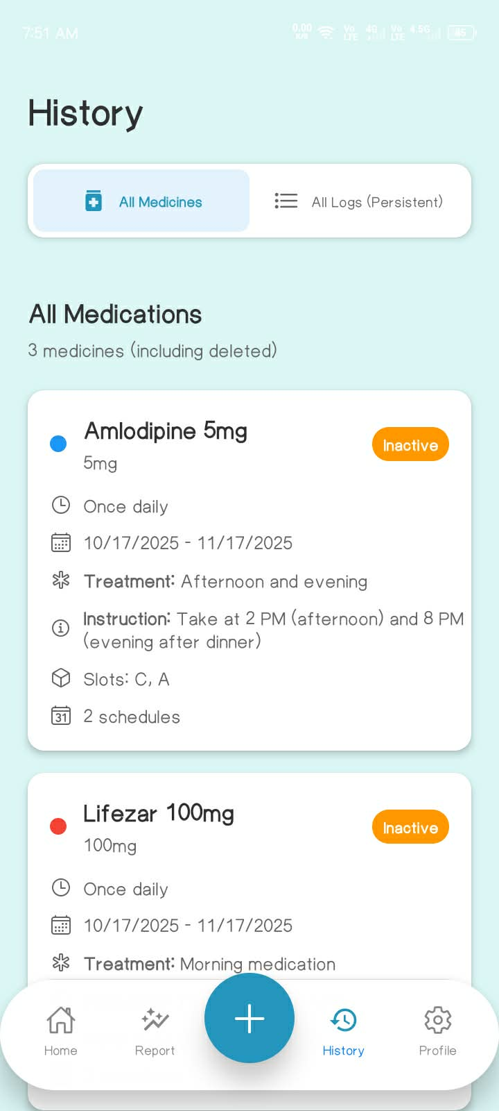

Figure 22. History Screen of PillSync
This figure shows the view of your medication adherence history — including doses taken on time and missed doses.

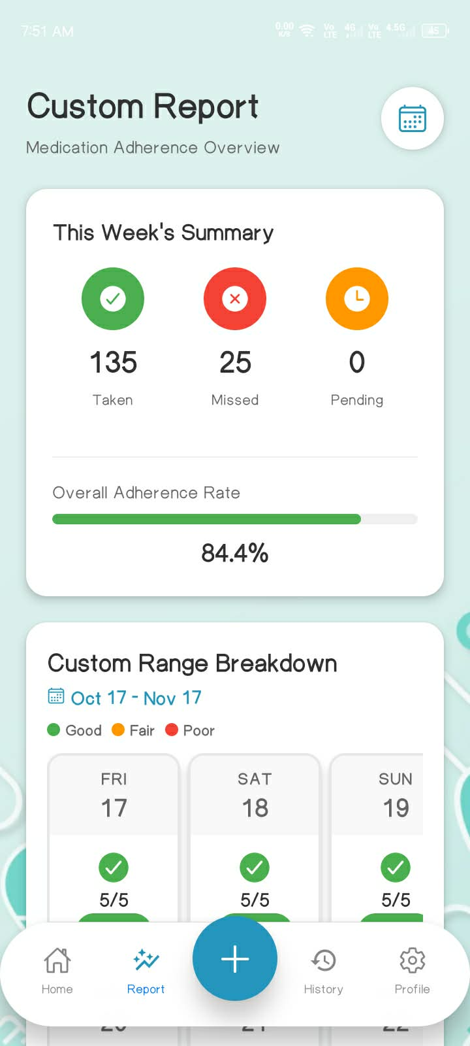
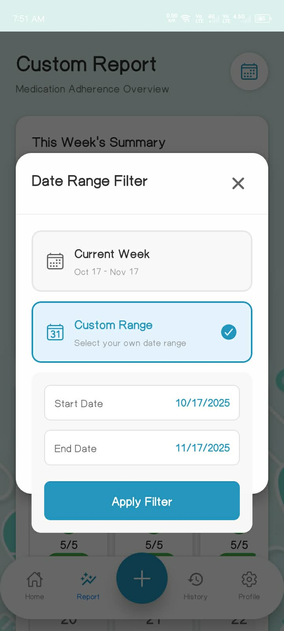

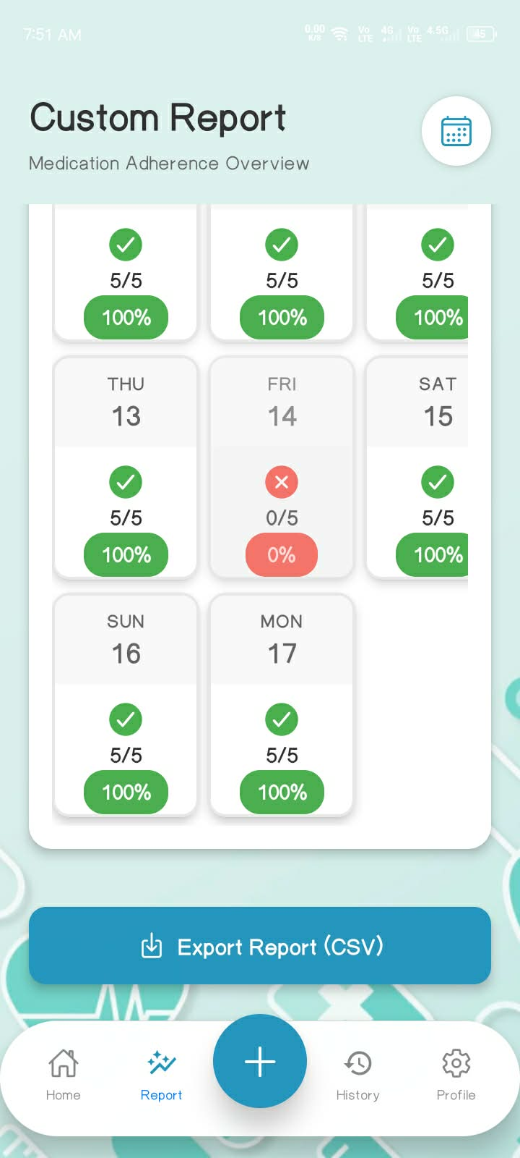
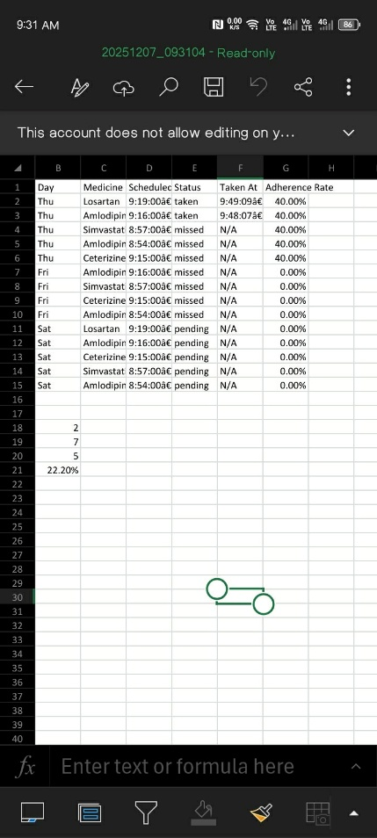

Figure 23. Analytics Report of PillSync
The figure shows the Report section of the app, where users can choose between a custom date range or the current week report. It displays a summary of taken, missed, and pending medications, along with the overall adherence rate. The section also includes an option to export the report as a CSV file for record-keeping or sharing.

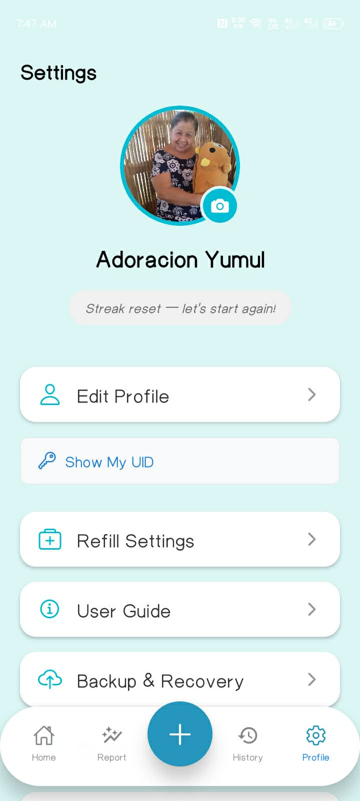

Figure 24. Settings Screen of PillSync
The figure shows the settings screen of a mobile app, featuring the user's profile photo and name ("Adoracion Yumul") at the top. Below are five main options: Edit Profile, My UID, Refill Settings, User Guide, Backup & Recovery, and Log out. A bottom navigation bar provides access to Home, Report, Add, History, and the currently active Profile section. The design uses a light-blue background with a clean, simple layout.

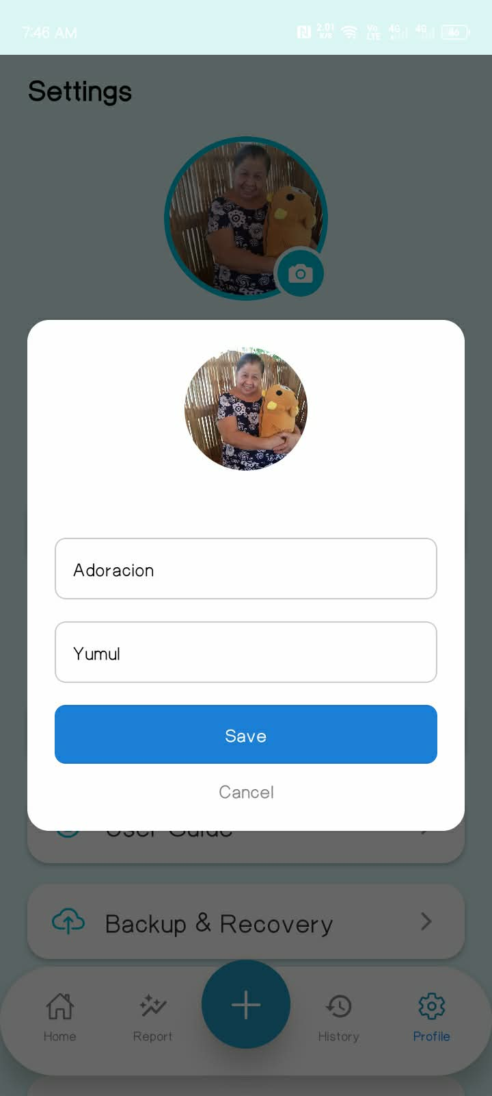

Figure 25. Edit Profile of PillSync
The figure shows the Edit Profile section of the app, allowing the user to edit or change their name. The layout is simple and direct, making it easy for users to update their information and personalize their account.

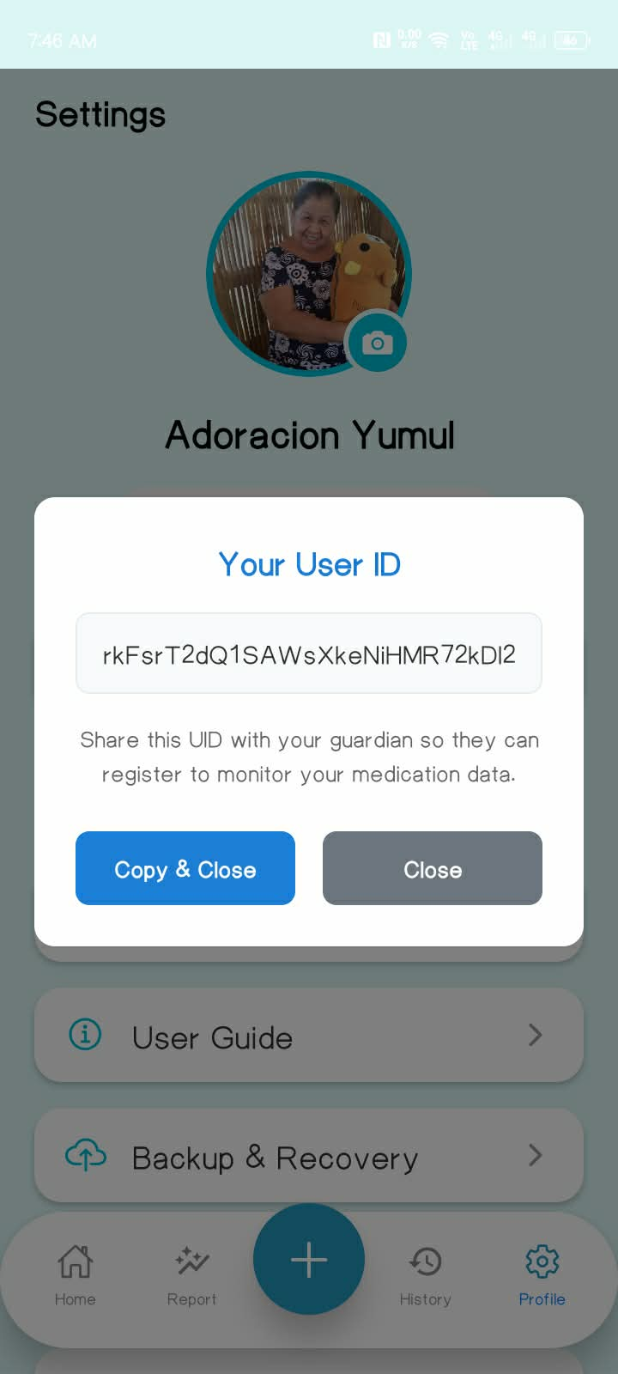

Figure 26. User ID of PillSync
The figure shows the User ID (My UID) section of the app, where the user can view their unique identification code used for linking to a guardian account. The interface is straightforward, allowing easy access and ensuring smooth connection between the user and guardian.

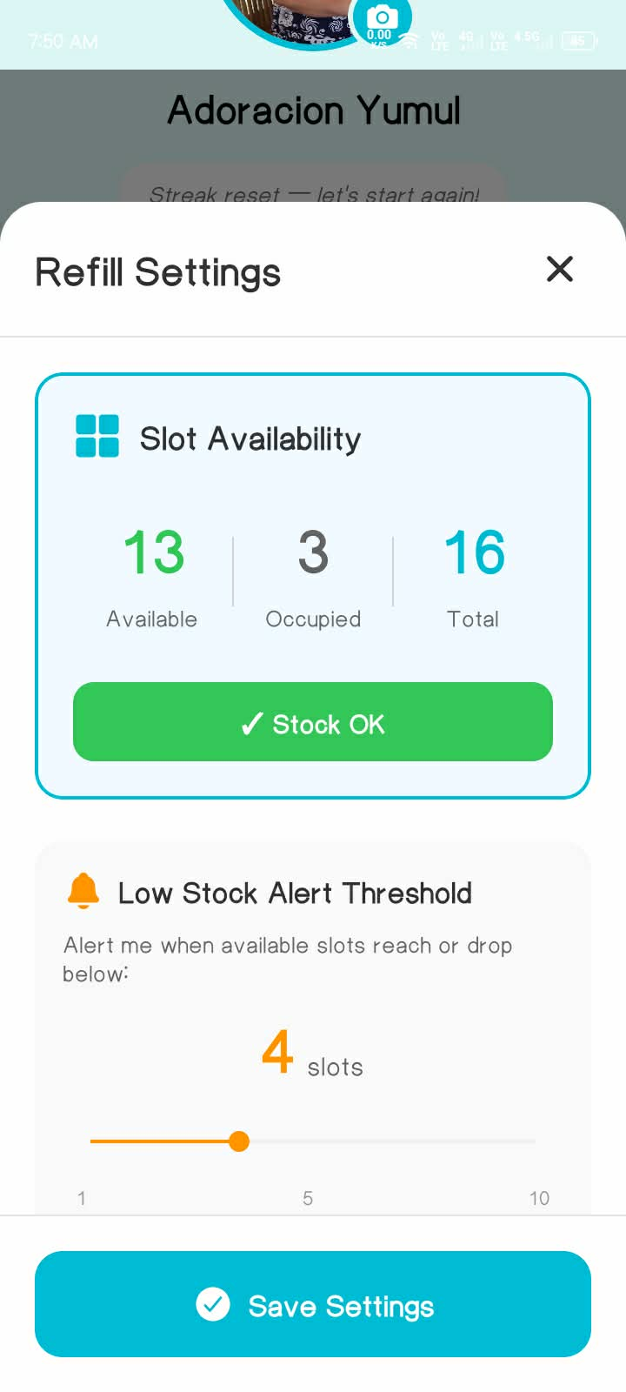

Figure 27. Refill Settings of PillSync
The figure shows the Refill Settings section of the app, where users can view slot availability, occupied slots, and total slots, along with a low-stock alert threshold that shows how many slots remain before a refill is needed.

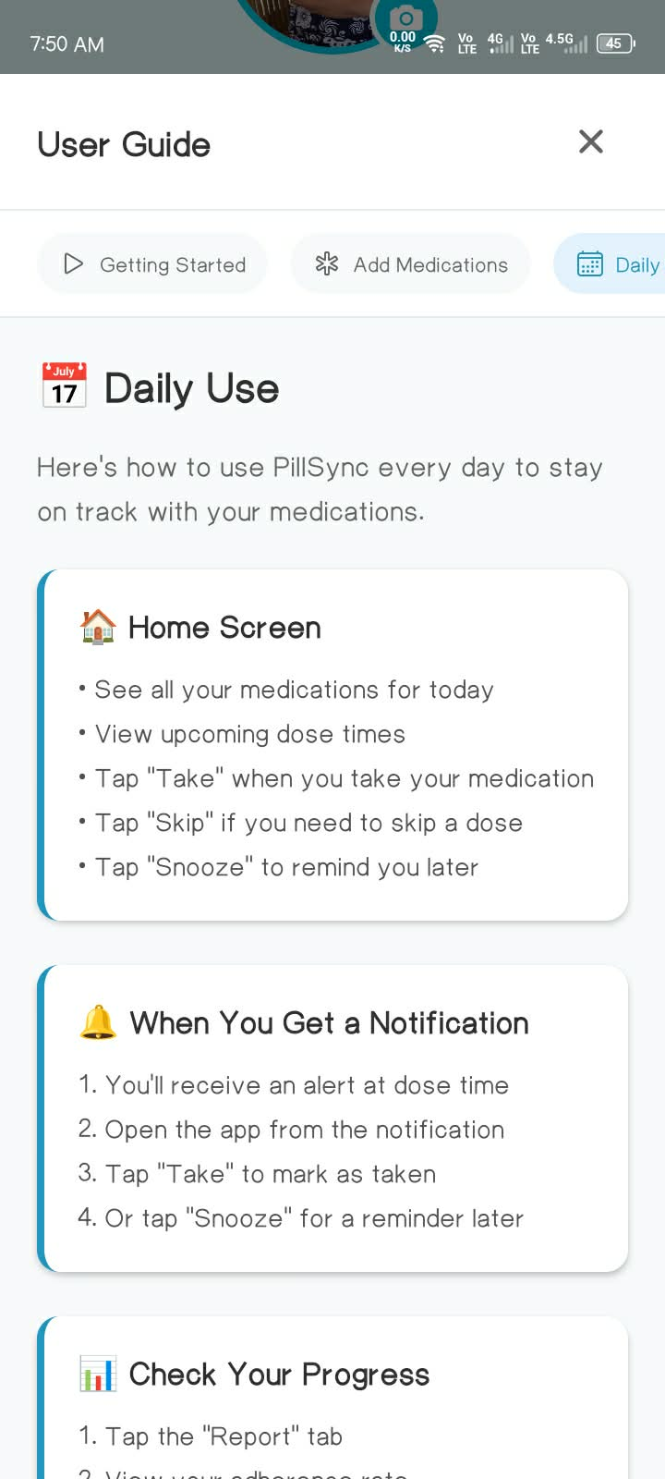
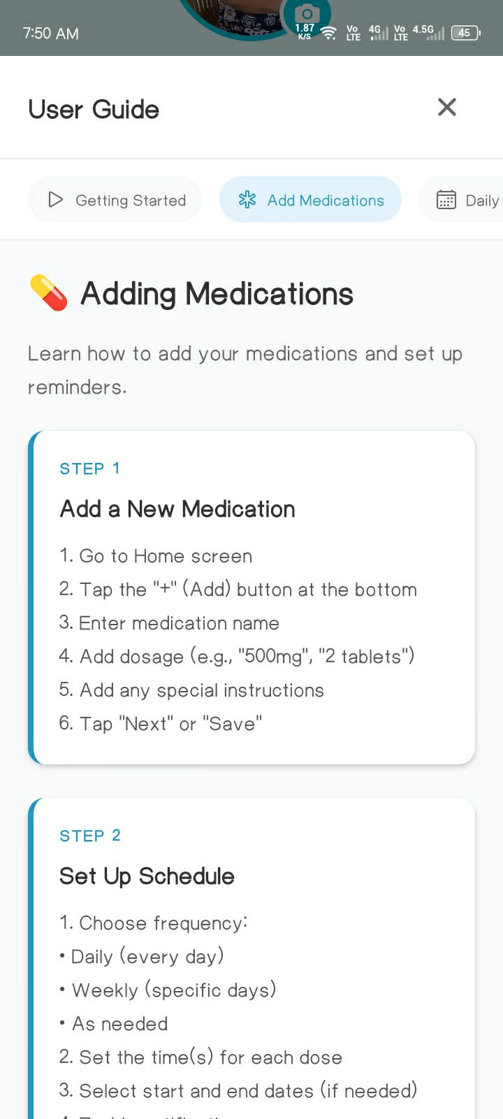
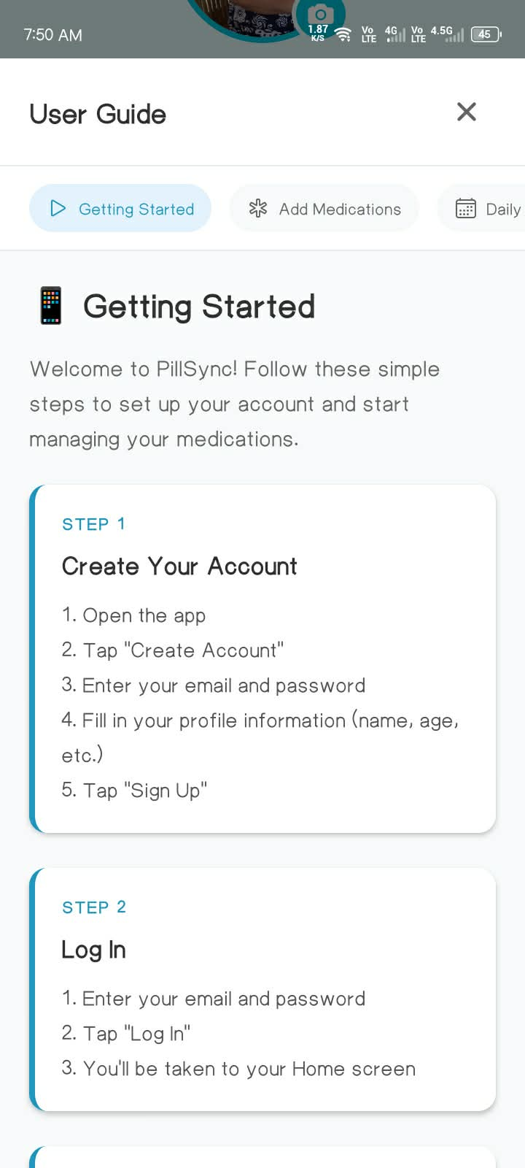
Figure 28. User Guide Settings of PillSync
The figure shows the User Guide section of the app, providing instructions on how to use the system, add medications, and manage daily usage. The interface offers clear and accessible guidance, helping users understand and operate the app effectively.

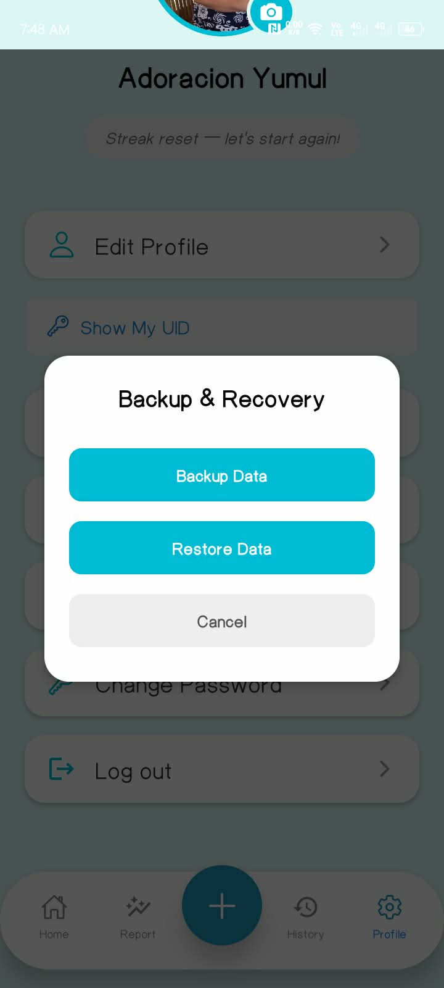

Figure 29. Back up & Recovery of PillSync
The figure shows the Backup & Recovery section of the app, where users can securely back up their data and restore it when needed. This feature ensures that important information is protected and can be easily recovered in case of device loss or system issues.

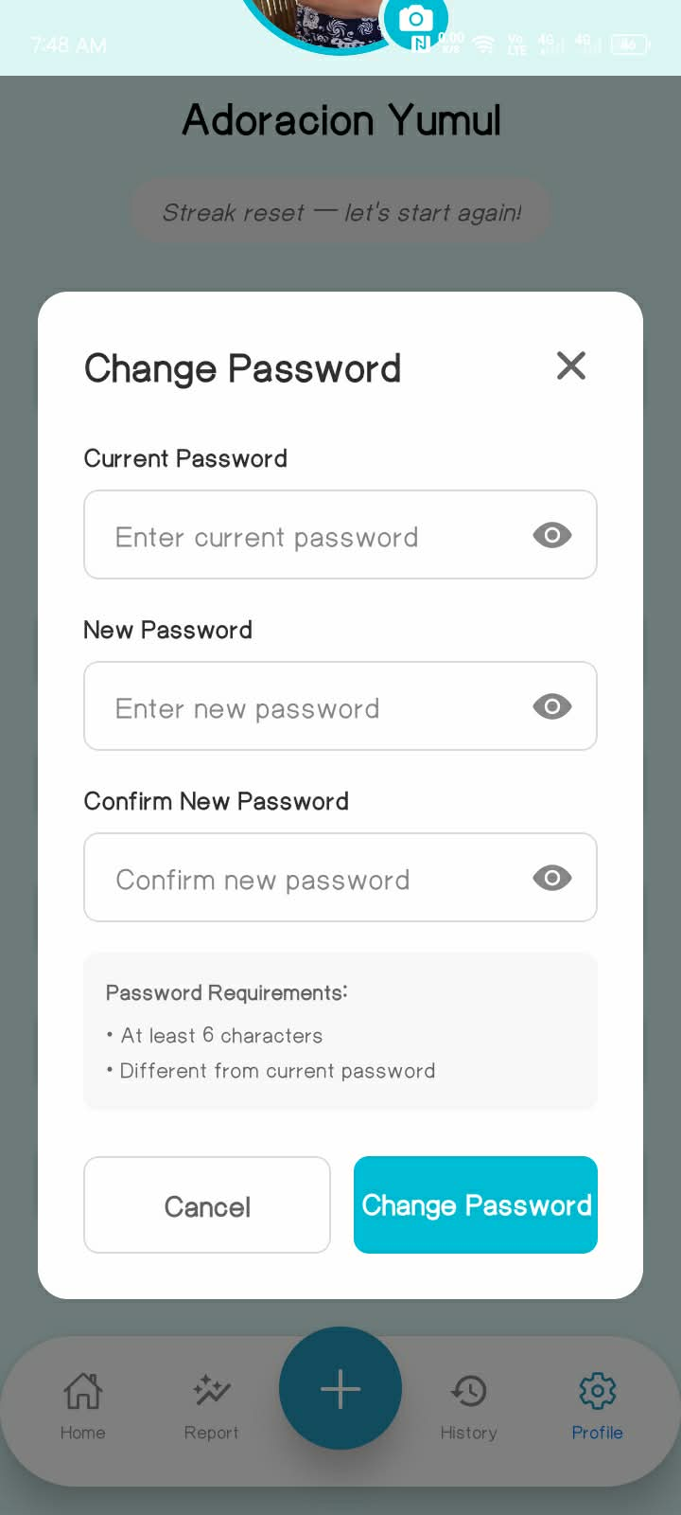

Figure 30. Change Settings of PillSync
The figure shows the Change Password section of the app, where users can update their account security by entering their current password, creating a new password, and confirming the new password.

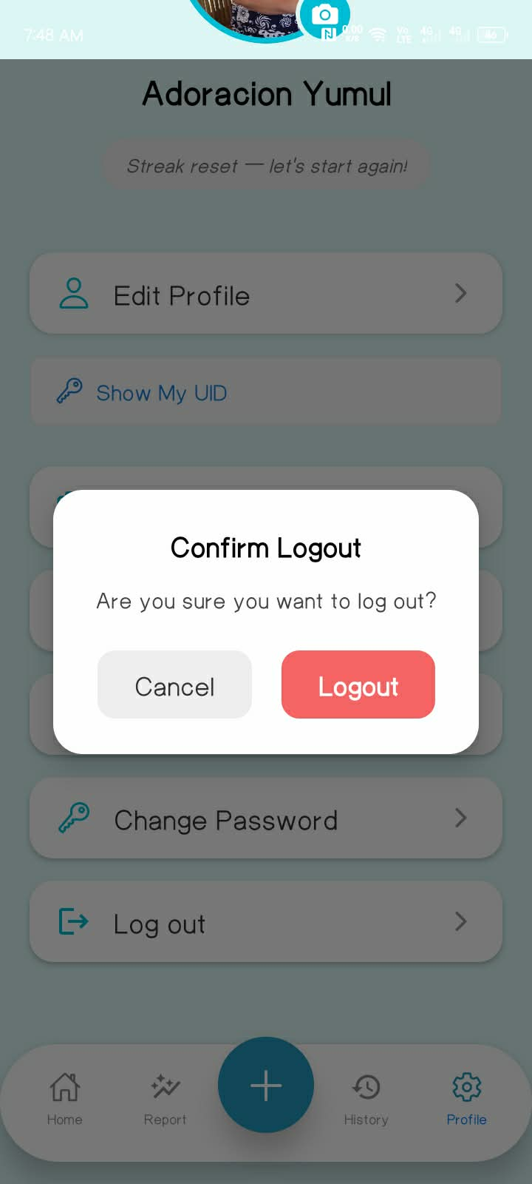

Figure 31. Logout Settings of PillSync
The figure shows the Log Out option of the app, allowing users to securely exit their account. This feature ensures privacy and protects user information when the device is shared or not in use.

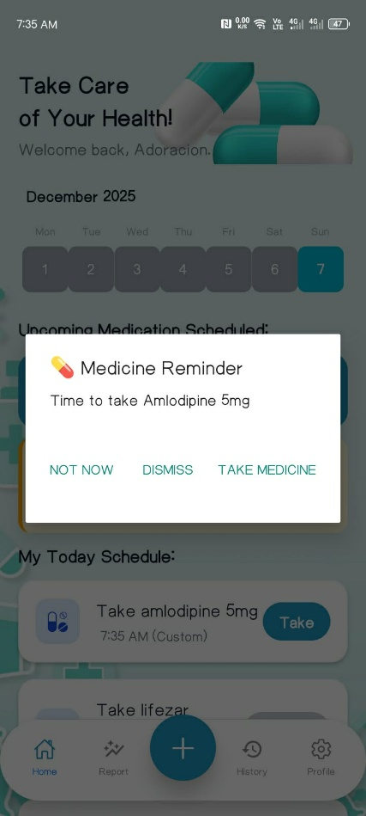
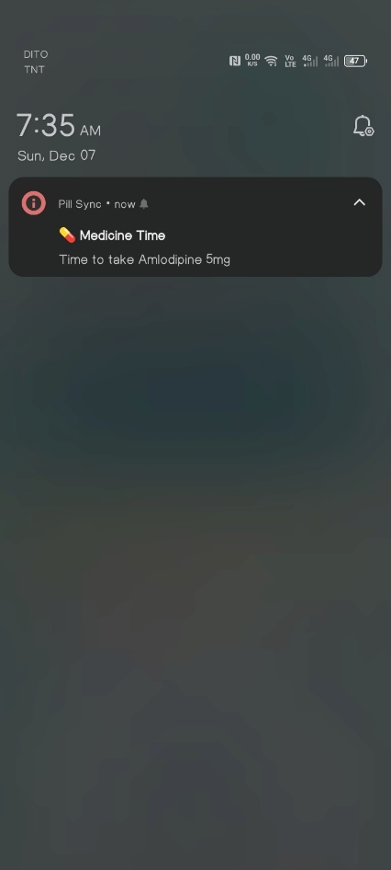
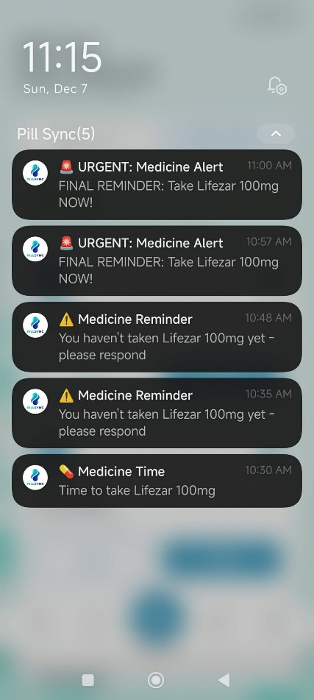
Figure 32. Notification of PillSync
The figure shows the Notification of the app, where users receive alerts to take their medicine. The medicine reminder allows users to choose whether to dismiss, take the medicine, or postpone (Not Now), helping them manage their medication schedule effectively.

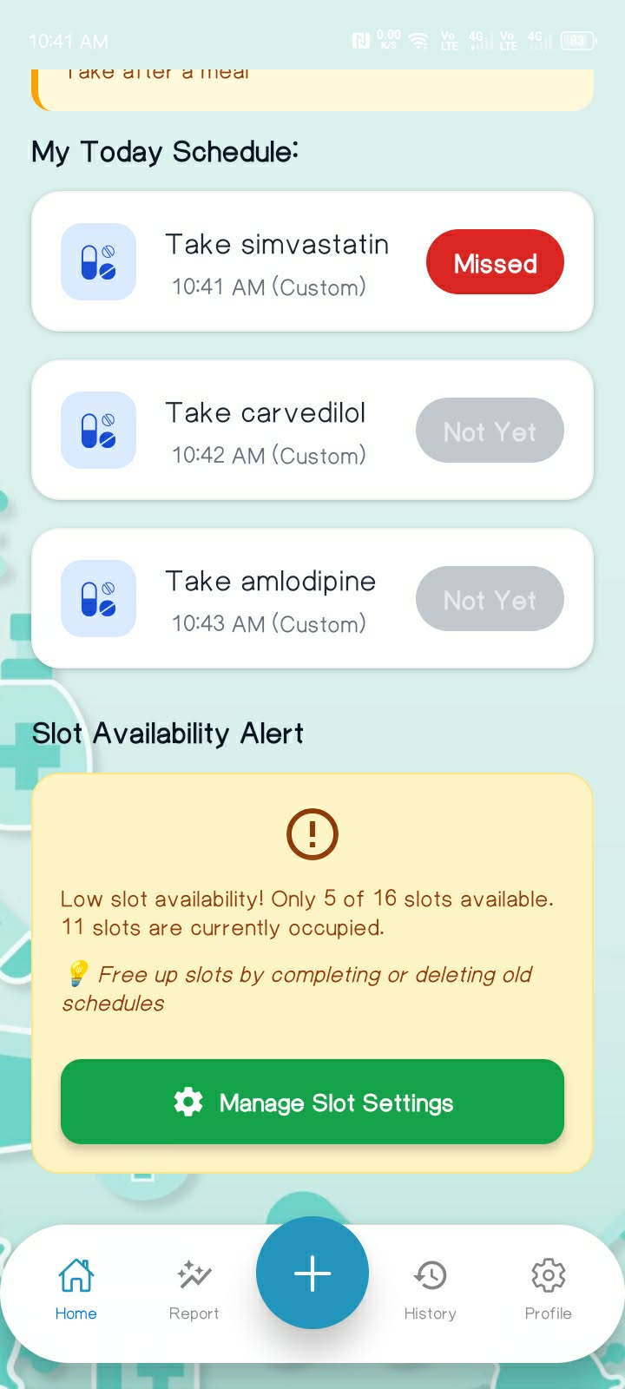
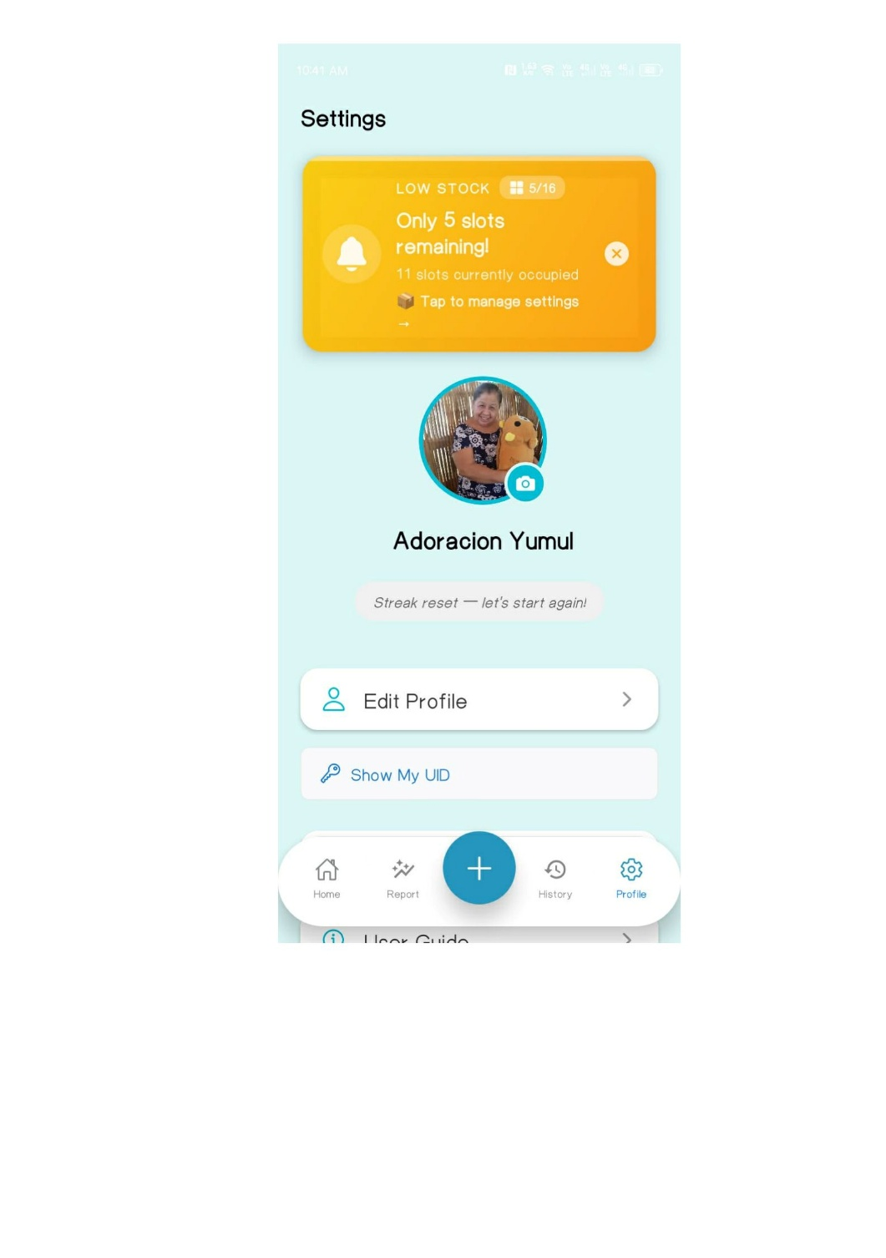

Figure 33. Low Stock Alert Notification of PillSync
The figure shows the Low Stock Alert Notification of the app, which reminds users to manage slot settings , how many slots are being occupied and notifies them of the remaining stock in each slot, ensuring timely refills and uninterrupted medication management.

Prototype Design
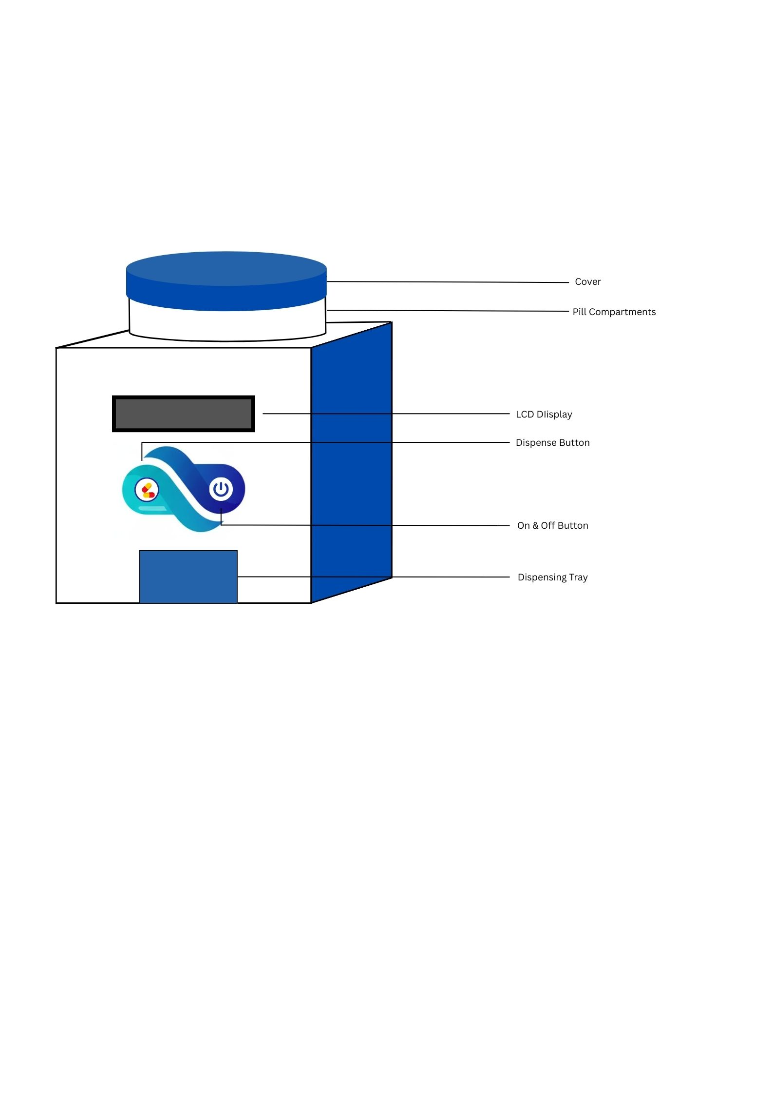

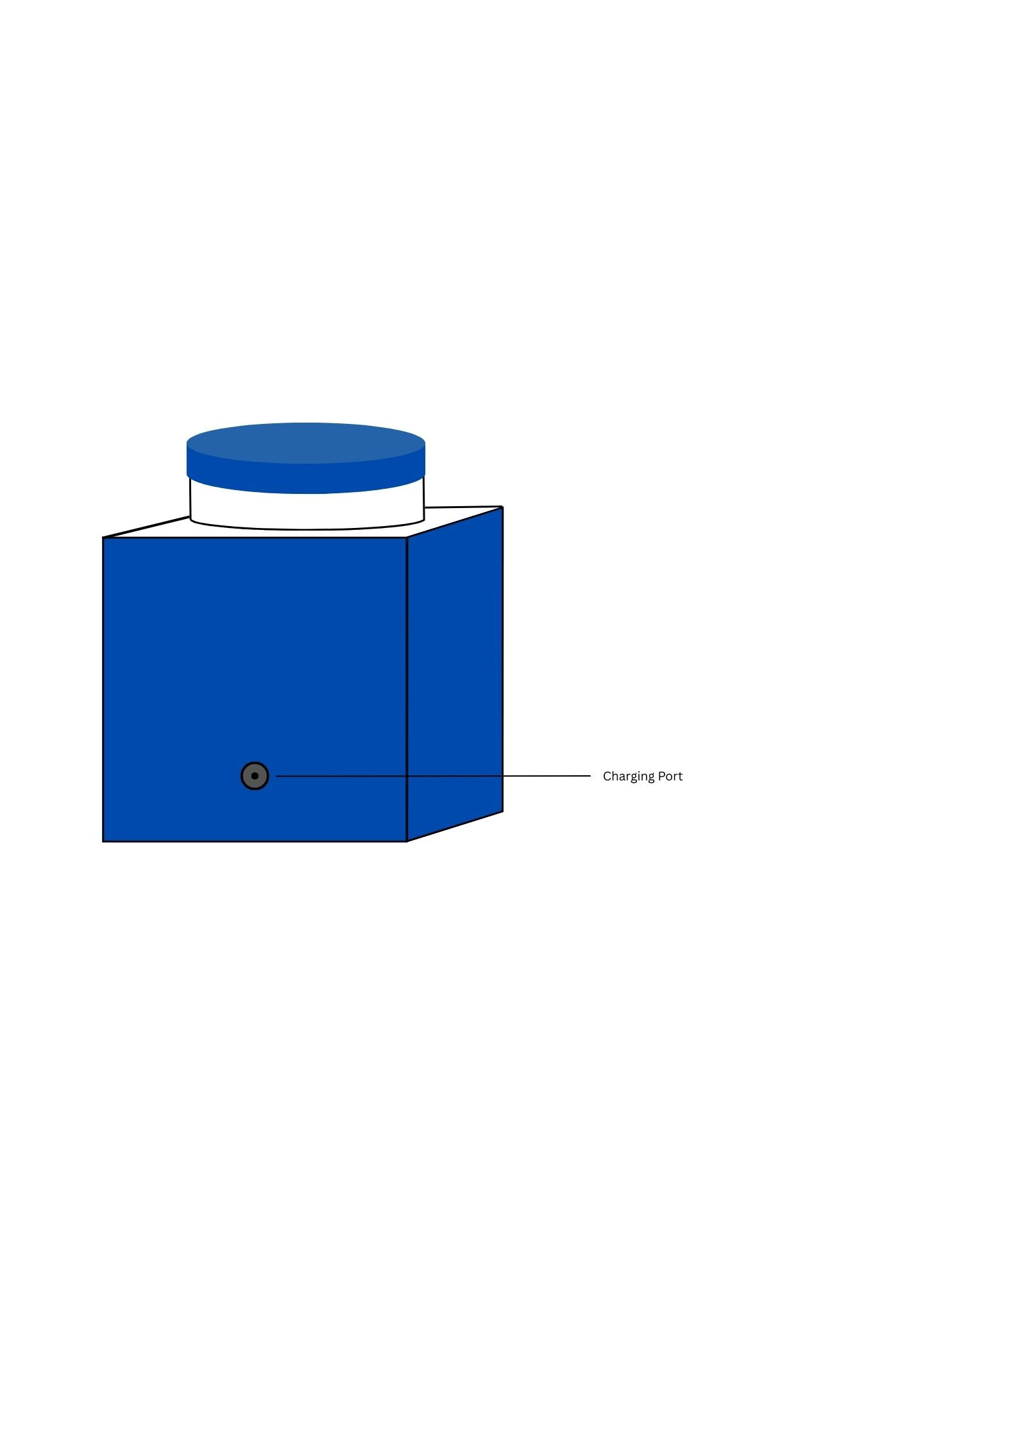

Figure 34. Hardware External Design

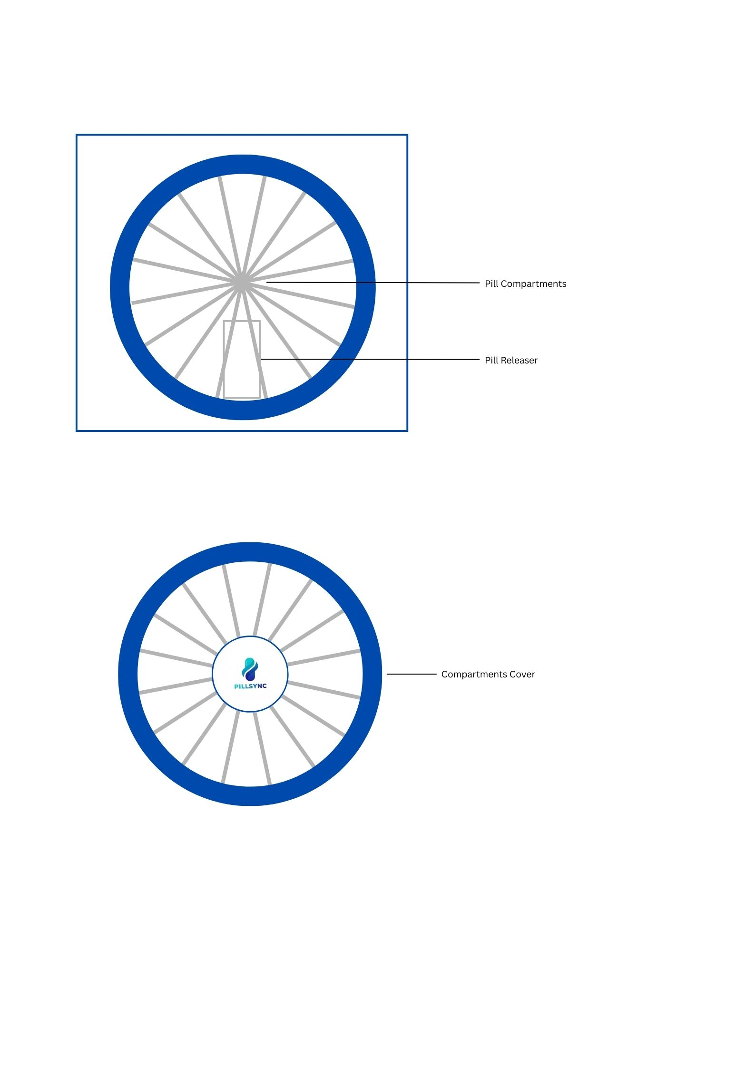

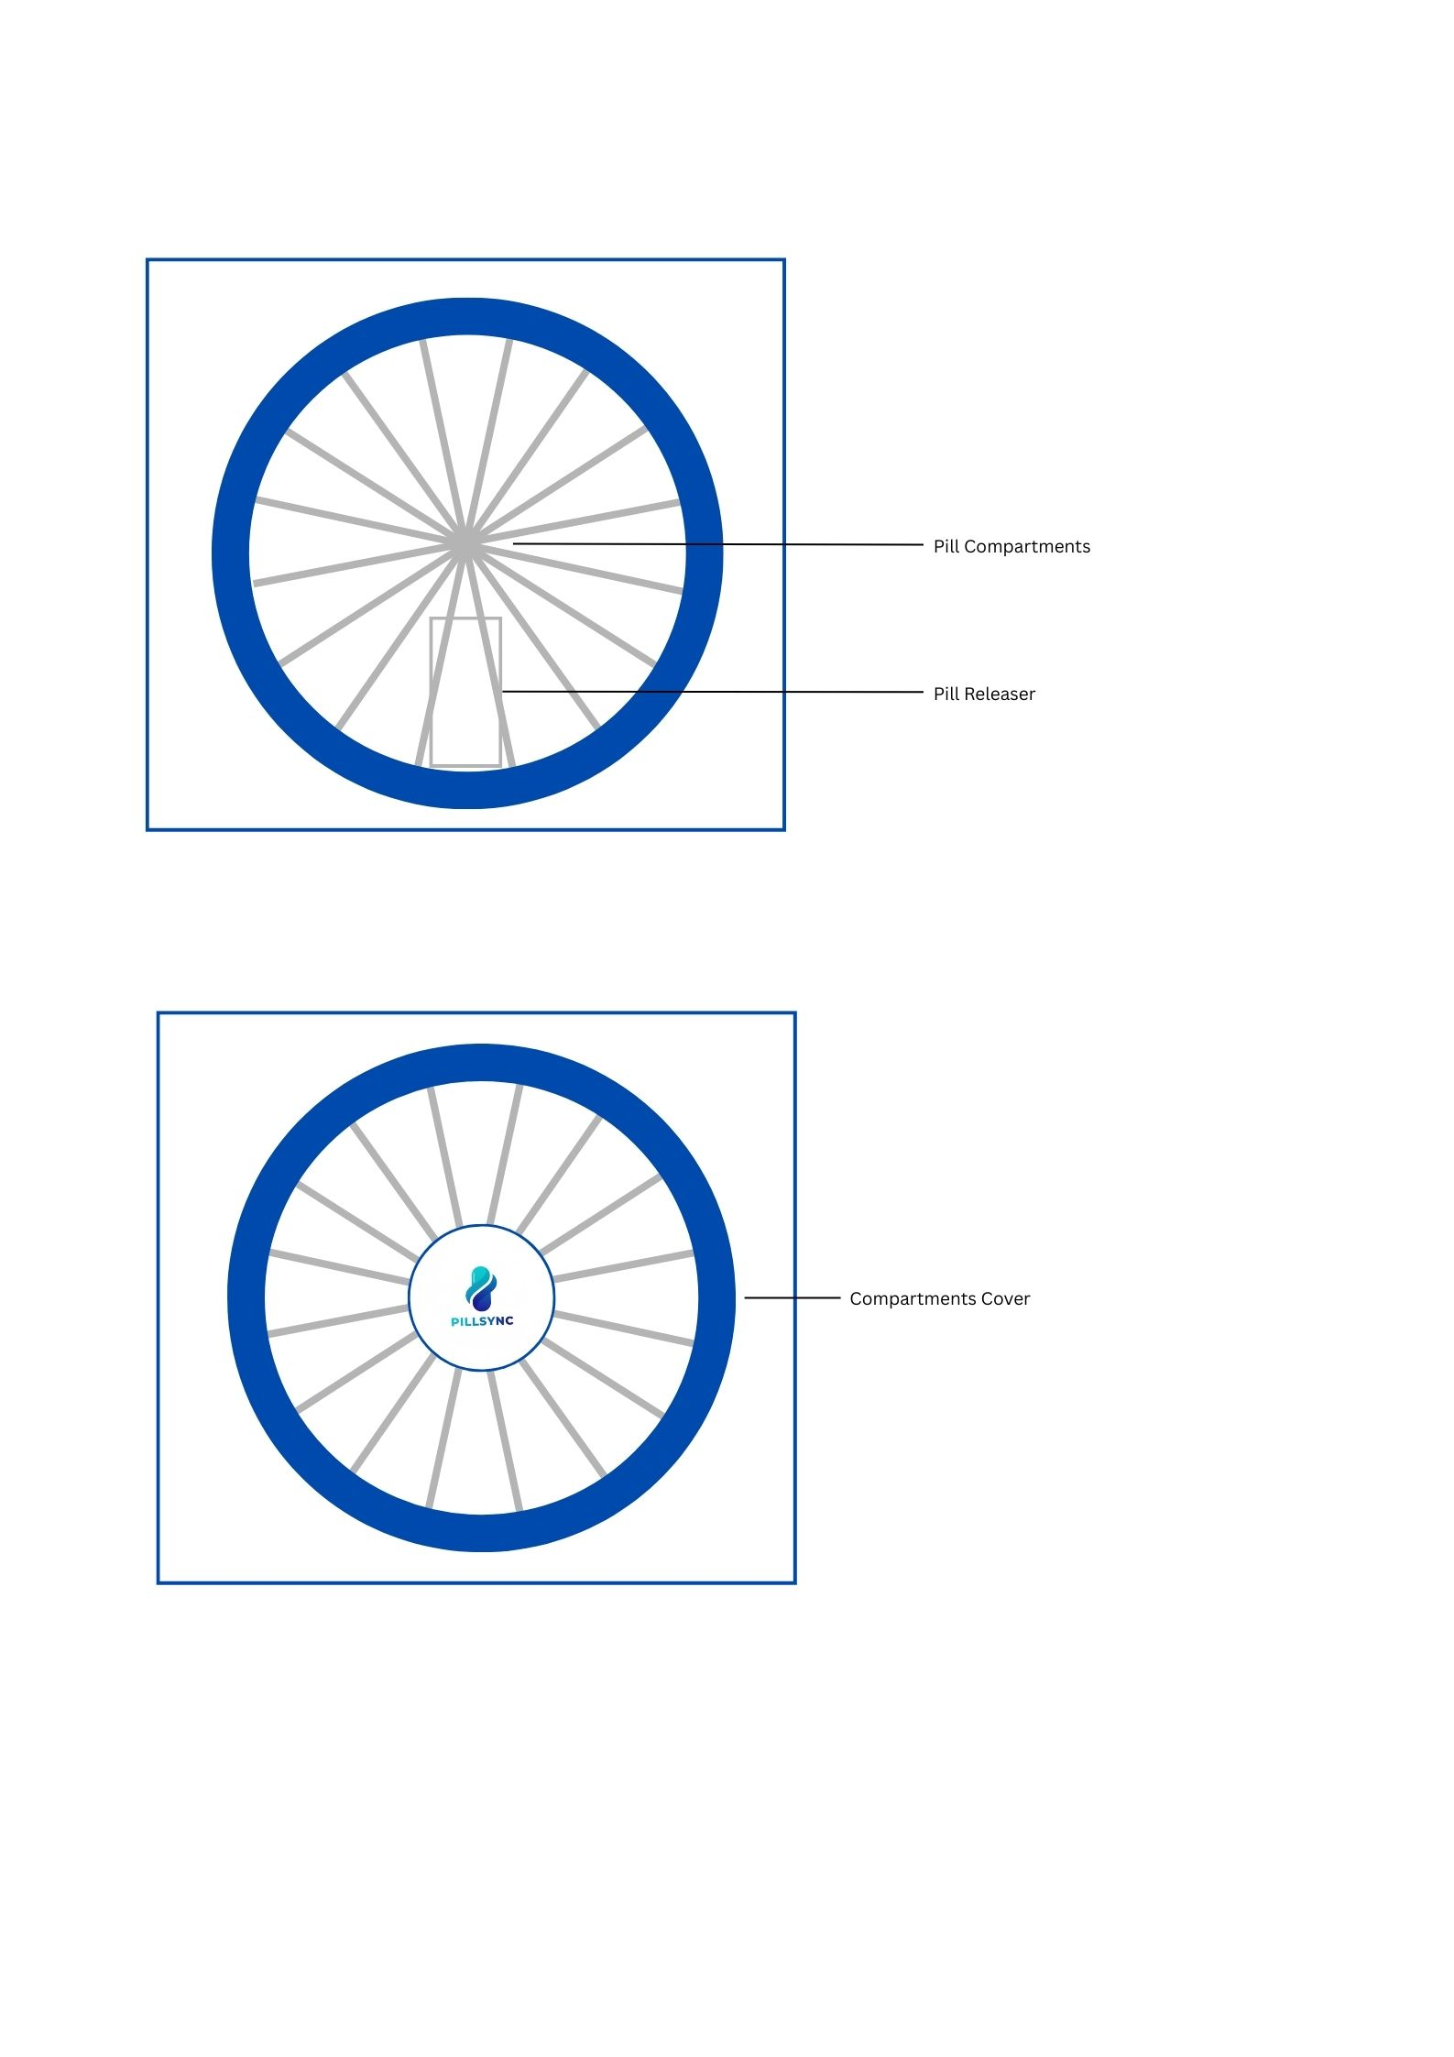

Figure 35. Hardware External Design (Top)

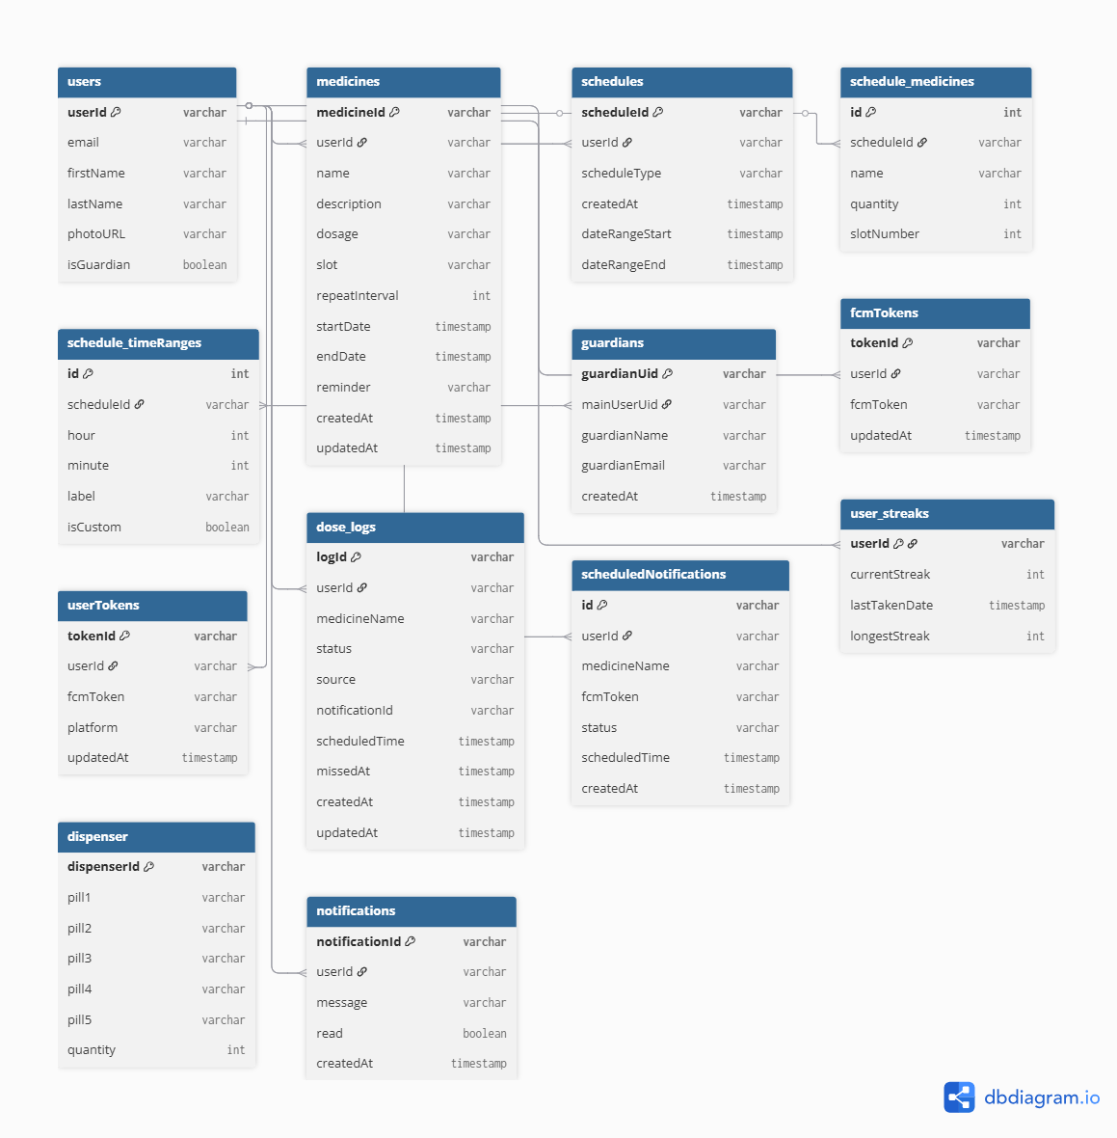
Database Schema
Figure 36. Database Schema of PillSync
The database schema diagram illustrates the structure of the Firebase Firestore database used in the PillSync medication management system. The database is organized into collections represented by blue boxes, with each collection containing specific fields and their data types such as varchar for text, int for numbers, timestamp for dates and times, and boolean for true/false values. The connecting lines between collections represent relationships where collections reference each other through shared identifier fields.
The users collection stores user profile information and serves as the central hub, with most other collections linking to it through userId fields. The medicines collection contains medication details including name, dosage, slot assignment, and medication period dates. The schedules collection defines when medications should be taken, while schedule time Ranges stores the specific hours and minutes for each dose. The schedule medicines collection connects schedules with medications, specifying which medicines are included in each schedule and their quantities.
The dose logs collection maintains a complete history of medication intake events, recording whether doses were taken or missed, when they occurred, and how they were confirmed. The guardian’s collection manages monitoring relationships between caregivers and patients. The notifications and scheduled Notifications collections handle in-app messages and push notification delivery. The fcm Tokens and user Tokens collections store device registration information needed to send push notifications to users' smartphones. The user streaks collection tracks consecutive days of successful medication adherence for gamification purposes, while the dispenser collection represents the physical hardware and tracks medication quantities in each of the five compartments.
This structure enables all system features including medication management, automated dispensing, adherence tracking, guardian monitoring, and push notifications while maintaining data integrity and supporting real-time synchronization between the mobile application and dispenser hardware.
Data Dictionary
Users Collection
Field Name | Data Type | Description
Document ID | String | Unique identifier for each user (auto-generated by Firebase)
email | String | User's email address (used for authentication)
firstName | String | User's first name
lastName | String | User's last name
isGuardian | Boolean | Indicates whether the user has guardian privileges
photoURL | String/Null | URL link to user's profile photo (null if not set)
Table 4: Users Collection
Stores basic profile information for all registered users of the PillSync system, including both medicine takers and guardians.
Medicines Collection
Field Name | Data Type | Description
Document ID | String | Unique identifier for each medicine record
name | String | Name of the medication
description | String | Description or purpose of the medication (e.g., "For hypertension")
dosage | String | Dosage amount per intake (e.g., "50" mg)
slot | String | Dispenser slot assignment (A-E or other identifier)
startDate | Timestamp | Start date and time for medication intake period
endDate | Timestamp | End date and time for medication intake period
reminder | String | Additional reminder note (e.g., "Take after meal")
repeatInterval | Number | Number of days between medication refills or cycles
userId | String | Foreign key linking to the user who owns this medicine
createdAt | Timestamp | Date and time when the medicine record was created
updatedAt | Timestamp | Date and time of last modification
Table 5: Medicines Collection
Contains detailed information about each medication that users manage through the system, including dosage instructions and scheduling parameters.
Schedules Collection
Field Name | Data Type | Description
Document ID | String | Unique identifier for each schedule
dateRange | Object | Contains start and end timestamps for schedule validity
dateRange.start | Timestamp | Start date and time of the schedule period
dateRange.end | Timestamp | End date and time of the schedule period
dosageCount | Number | Number of pills to dispense per scheduled time
medicines | Array | Array of medicine objects included in this schedule
medicines[].id | Number | Medicine identifier
medicines[].name | String | Medicine name
medicines[].quantity | Number | Quantity of this medicine in the schedule
scheduleType | String | Type of schedule ("dispenser" or "reminder")
slotNumber | Number | Physical slot number in the dispenser (1-5)
timeRanges | Array | Array of time objects defining when to dispense
timeRanges[].hour | Number | Hour of scheduled time (0-23)
timeRanges[].minute | Number | Minute of scheduled time (0-59)
timeRanges[].label | String | Display label for the time (e.g., "21:05 (Custom)")
timeRanges[].isCustom | Boolean | Indicates if time is custom-set or preset
userId | String | Foreign key linking to the schedule owner
createdAt | Timestamp | Date and time when schedule was created
Table 6: Schedules Collection
Defines when and how medications should be dispensed, including precise timing, quantities, and slot assignments for the physical dispenser.
Dose Logs Collection
Field Name | Data Type | Description
Document ID | String | Unique identifier for each dose log entry
medicineName | String | Name of the medication that was logged
scheduledTime | Timestamp | Originally scheduled time for this dose
status | String | Status of the dose ("taken", "missed", or "manual")
source | String | How the dose was logged ("button", "timeout", "manual")
notificationId | String | Associated notification identifier
userId | String | Foreign key linking to the user
guardians | Array | Array of guardian UIDs who can view this log
createdAt | Timestamp | When the log entry was created
updatedAt | Timestamp | Last update timestamp
missedAt | Timestamp | When the dose was marked as missed (if applicable)
Table 7: Dose Logs Collection
Records every medication intake event with detailed tracking of timing, status, and how the intake was confirmed or missed.
Guardians Collection
Field Name | Data Type | Description
Document ID | String | Unique identifier for the guardian relationship
guardianEmail | String | Email address of the guardian
guardianName | String | Full name of the guardian
guardianUid | String | Firebase user ID of the guardian
mainUserUid | String | Firebase user ID of the patient being monitored
createdAt | Timestamp | When the guardian relationship was established
Table 8: Guardians Collection
Manages guardian-patient relationships, allowing family members or caregivers to monitor medication adherence for their loved ones.

Notifications Collection
Field Name | Data Type | Description
Document ID | String | Unique identifier for each notification
message | String | Notification message content
read | Boolean | Whether the notification has been read
userId | String | Foreign key linking to the notification recipient
createdAt | Timestamp | When the notification was created
Table 9: Notifications Collection
Stores in-app notifications for users to review medication-related alerts and system messages.
Scheduled Notifications Collection
Field Name | Data Type | Description
Document ID | String | Unique identifier for each scheduled notification
fcmToken | String | Firebase Cloud Messaging token for push delivery
medicineName | String | Name of the medication for this notification
scheduledTime | Timestamp | When the notification should be sent
status | String | Status of the notification ("scheduled", "sent", etc.)
userId | String | Foreign key linking to the notification recipient
createdAt | Timestamp | When the notification was scheduled
Table 10: Scheduled Notifications Collection
Tracks scheduled push notifications to ensure timely medication reminders are delivered to users' devices.
FCM Tokens Collection
Field Name | Data Type | Description
Document ID | String | Unique identifier (typically matches user ID)
fcmToken | String | Firebase Cloud Messaging registration token
userId | String | Foreign key linking to the token owner
updatedAt | Timestamp | Last time the token was updated
Table 11: FCM Tokens Collection
Manages Firebase Cloud Messaging tokens for delivering push notifications to user devices.
User Tokens Collection
Field Name | Data Type | Description
Document ID | String | Unique identifier (typically matches user ID)
fcmToken | String | Firebase Cloud Messaging registration token
platform | String | Device platform ("android" or "ios")
updatedAt | Timestamp | Last time the token was updated
Table 12: User Tokens Collection
Stores device-specific FCM tokens along with platform information for targeted push notification delivery.
User Streaks Collection
Field Name | Data Type | Description
Document ID | String | Unique identifier (typically matches user ID)
currentStreak | Number | Current consecutive days of medication adherence
lastTakenDate | Timestamp/Null | Date of last medication intake
longestStreak | Number | Longest streak of consecutive adherence days
Table 13: User Streaks Collection
Tracks user medication adherence streaks to gamify and encourage consistent medication intake behavior.
Schedule Backups Collection
Field Name | Data Type | Description
Document ID | String | Unique identifier for each backup record
count | Number | Number of schedules backed up
timestamp | Timestamp | When the backup was created
Table 14: Schedule Backups Collection
Maintains historical records of schedule backups for recovery and auditing purposes.

Dispenser Collection
Field Name | Data Type | Description
Document ID | String | Slot identifier (pill1-5, PillNow1-3)
quantity | Number | Current quantity of medication in the slot
Table 15: Dispenser Collection
Tracks the current medication quantity in each physical slot of the dispenser for stock monitoring and low-supply alerts.

Development Methodology
This chapter discusses the methods, processes, and development approach used in creating the Smart Medication Dispenser with Mobile Application.
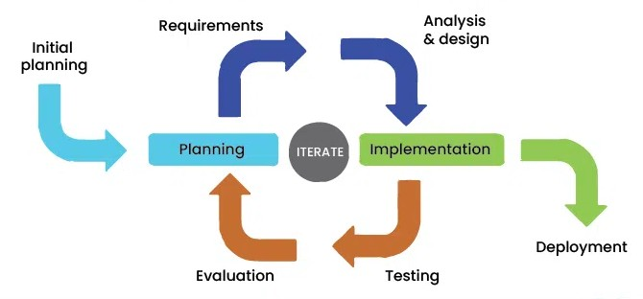
Process Model
Figure 37. Process Model
The project followed the Iterative Model, allowing the researchers to continuously build, test, and refine the system module by module. Instead of completing the system in one linear sequence, each component—such as the dispenser hardware, mobile application, and cloud integration—was developed in repeated cycles of planning, designing, implementing, and evaluating. This approach enabled the team to identify issues early, apply improvements immediately, and ensure that each iteration produced a more stable and functional version of the system. Through this methodology, both hardware and software components were gradually enhanced until they met the project requirements and user needs.The succeeding sections present the system requirements, design specifications, development tools, process model, testing procedures, and evaluation methods utilized throughout the project.
Development Tools
The system was developed using comprehensive tools supporting all aspects of development. For firmware, the team used Arduino IDE for ESP32 programming with C/C++ and the Arduino Serial Monitor for debugging. Mobile development utilized Visual Studio Code as the primary editor, React Native with Expo for cross-platform app creation, Expo Router for navigation, and Node.js with npm for package management. Cloud services were managed through Firebase Console for database and authentication administration. Version control relied on GitHub for code repository management and Git for tracking changes. Hardware design used Fritzing for circuit diagrams. Testing employed React Native Debugger for mobile app debugging and Firebase Emulator Suite for local testing. Data collection used Google Forms for user surveys and Google Sheets for response analysis. Documentation was created with Microsoft Word for thesis writing and Draw.io for system diagrams. This comprehensive toolset supported efficient development across all project components.
Test Methodology/Procedures
This section explains the testing strategies used to validate the system’s performance and functionality. Testing was conducted to identify and fix errors, ensure usability, and verify that all features work as specified in the requirements.

System Requirements
This section outlines the necessary hardware, software, and other resources required for the development, operation, and implementation of the Smart Medication Dispenser with Mobile Application. These system requirements ensure that the dispenser unit, mobile application, and cloud database function properly and are integrated seamlessly.
Hardware Requirements
Dispenser Components:
The ESP32-38P microcontroller serves as the main processing unit, controlling all hardware operations and managing WiFi connectivity for cloud communication. The stepper motor controls the carousel rotation for precise medication slot positioning, while the servo motor MG99 operates the dispensing gate mechanism. The DS3231 RTC module with coin cell battery maintains accurate timekeeping independent of power or network status. The micro SD card module with SD card provides local storage for schedules, logs, and backup data during offline operation.
The LCD module display provides visual feedback showing time, medication names, and system status directly on the dispenser. The 360-degree rotary encoder enables menu navigation, while the tactile switch serves as a confirmation button for users to acknowledge medication intake. The buzzer generates audible alerts for scheduled doses and system notifications. The ultrasonic sensor detects medication presence and monitors remaining quantities in each compartment for stock alerts.
Power management includes a 12800mAh lithium battery for backup power, a power failure automatic switching module that seamlessly transitions between main power and battery, a DC buck converter step-down module for voltage regulation, a mini rocker switch for main power control, and DC-022 female power jacks for external power connections.
Circuit assembly utilizes an FR4 universal protoboard PCB for mounting components, jumper wires for connections during prototyping, solid wire 22 AWG for permanent circuit wiring, and single row pin headers for modular connections. Three acrylic sheets form the protective enclosure housing all components and medication compartments.
End-User Devices:
Android smartphones running version 8.0 or higher are required to run the PillSync mobile application. The device must have internet connectivity via WiFi or mobile data, sufficient storage for app installation (approximately 50-100 MB), and permission to receive push notifications for medication reminders.
Software Requirements
Firmware and Development:
Arduino IDE version 2.x or higher is required for programming the ESP32 microcontroller with C/C++ code. Essential Arduino libraries include WiFi for network connectivity, HTTPClient for Firebase REST API communication, ArduinoJson for parsing JSON data, RTClib for DS3231 real-time clock control, SD for SD card read/write operations, Servo for servo motor control, and AccelStepper or similar for stepper motor control.
Mobile Application:
The mobile application requires Node.js version 18 or higher with npm for package management and dependency installation. React Native version 0.72 or higher provides the cross-platform framework, while Expo SDK 49 or higher with Expo Router simplifies development and enables file-based navigation. Essential npm packages include Firebase SDK for authentication and Firestore operations, Expo Notifications for push notification handling, React Navigation for screen transitions, and a charting library such as Recharts or Victory Native for adherence analytics visualization.
Cloud Backend:
Firebase services provide the complete backend infrastructure. Firebase Firestore serves as the NoSQL database storing all user data, medications, schedules, and logs. Firebase Authentication manages user registration and secure login with email/password credentials. Firebase Cloud Messaging delivers push notifications to user devices for medication reminders and alerts. Firebase Hosting (optional) can host web-based administration interfaces if needed.
Development and Testing Tools:
Visual Studio Code serves as the primary code editor for both firmware and mobile app development. Git provides version control for tracking code changes, while GitHub hosts the remote repository for team collaboration. React Native Debugger enables mobile app debugging and network inspection. Arduino Serial Monitor facilitates firmware debugging by displaying console output. Firebase Emulator Suite allows local testing of database operations and security rules. Google Forms collects user feedback during evaluation, with responses automatically aggregated in Google Sheets for analysis.
Network and Connectivity Requirements
A stable WiFi network with internet access is essential for real-time synchronization between the dispenser, mobile application, and Firebase cloud database. The WiFi router must support 2.4 GHz frequency (required by ESP32) with WPA/WPA2 security. Internet bandwidth should be sufficient for uploading schedules, logs, and downloading notifications, typically requiring minimal bandwidth (1-5 Mbps is adequate).
For direct dispenser control through the mobile app, both devices must connect to the same local WiFi network. For remote monitoring of adherence logs and receiving notifications, the mobile app only requires any internet connection (WiFi or mobile data). The dispenser requires continuous or periodic internet connectivity for schedule updates and log synchronization, but can operate offline using locally stored schedules on the SD card with the RTC module for timekeeping.
User Requirements
For Medicine Takers:
Users must possess a valid email address for account registration and authentication. They should have basic smartphone operation skills including app installation, navigation, and reading notifications. Users are responsible for accurately entering medication information including names, dosages, schedules, and duration. They must ensure the dispenser remains powered and connected to WiFi for proper operation, regularly refill medication compartments when stock alerts appear, and respond to medication reminders by pressing the confirmation button after taking doses.
For Guardians:
Guardians require their own registered account on the PillSync application and must obtain consent from the medicine taker to access their account for monitoring purposes. They need internet-connected smartphones to remotely view adherence data and receive missed dose alerts.
For Healthcare Professionals:
Healthcare professionals evaluating the system need Android devices to test the mobile application, understanding of medication management concepts to assess system appropriateness, and ability to provide structured feedback through surveys for system evaluation.
Environmental and Operational Requirements
The dispenser should be placed in a dry, indoor environment away from direct sunlight, extreme temperatures, or moisture that could damage electronic components. It requires a stable flat surface to prevent tipping and ensure accurate sensor readings. Ambient temperature should range between 15°C to 35°C for optimal electronic operation. The device should be positioned within WiFi range for reliable connectivity and near an electrical outlet for main power connection.
Medications stored in the dispenser must be solid oral forms such as tablets or capsules. The system does not support liquid medications, injectables, or other forms. Each compartment accommodates medications of similar size, and users should avoid overfilling compartments beyond capacity to ensure proper dispensing.
Security and Privacy Requirements
All user accounts must use secure passwords meeting minimum complexity requirements enforced by Firebase Authentication. Data transmission between all system components must use encrypted connections (HTTPS/SSL/TLS protocols). Firebase Database Security Rules must restrict data access so users can only view and modify their own information. The mobile application must request and obtain user permission for notifications, camera access for profile photos, and any other device features utilized. Users should be informed through clear privacy policies about what data is collected, how it is used, and that personal information is not shared with third parties.
Maintenance and Support Requirements
Users should keep the mobile application updated to the latest version for bug fixes and improvements. The dispenser firmware may require occasional updates, which would be performed by technical support or through guided procedures. Regular physical maintenance includes cleaning the acrylic enclosure, checking motor alignment and operation, replacing the RTC coin cell battery when low (typically every 2-3 years), and ensuring SD card has sufficient storage space. The 12800mAh backup battery should be recharged periodically if not used regularly to maintain capacity.
Technical support documentation including user manuals, troubleshooting guides, and FAQ resources should be available to users. For academic evaluation purposes, the development team provides direct support for resolving technical issues and addressing user questions.

Quality Plan
PillSync is a smart medication dispenser with a mobile application that helps users take their medications on time. The system can monitor dispensers, making it easier for users and guardians to track medication intake. This Quality Plan shows how we will maintain and evaluate the system’s quality throughout development and after deployment, using feedback from user surveys and ISO/IEC 25010 standards.
We focus on seven main quality areas: Functionality, Usability, Reliability, Performance Efficiency, Security, Compatibility & Portability, and Maintainability. The survey questionnaire collects evaluations from users and caregivers, helping identify strengths and areas for improvement.
Quality Characteristic | Objective
Functionality | Ensure the dispenser gives the correct medicine at the right time and sends accurate alerts. Measured through user feedback on correct dispensing, alert timing, and medication history.
Usability | Make the app and dispenser simple and easy to use, especially for elderly users. Measured by user ratings on interface simplicity, navigation, and ability to operate with minimal help.
Reliability | Ensure the system works consistently over time with minimal errors. Measured by user reports on consistent operation, accurate data recording, and dependable alerts.
Performance Efficiency | Ensure the system operates smoothly, responds quickly, and uses minimal battery or data. Measured through user observations on app responsiveness, dispenser operation, and performance under weak network conditions.
Security | Protect user accounts and data from unauthorized access. Measured by users’ perception of safe login, restricted access, and confidence in personal information protection.
Compatibility & Portability | Ensure the app works on different android devices and the dispenser functions well in various household environments. Measured by user ratings on app performance on multiple devices, connection to dispenser, and usability in different settings.
Maintainability | Make the system easy to update, repair, and improve. Measured through feedback on ease of cleaning, refilling, updating the app, or replacing parts.
Table 16: Quality Plan
This table shows how the Quality Plan ensures that PillSync meets the needs of both users and guardians. Functionality checks that the dispenser releases the correct medicine and sends alerts on time. Usability ensures that the app and dispenser are easy to use, especially for older users. Reliability makes sure the system works consistently over long periods. Performance Efficiency ensures smooth operation and quick responses without consuming too much battery or data. Security protects user accounts and personal information from unauthorized access. Compatibility and Portability confirm that the app works on different phones, the dispenser connects with multiple devices, and the system performs well in various home environments. Maintainability ensures the system can be updated, repaired, or improved when needed. Feedback from users and guardians will guide future enhancements, helping PillSync remain effective, safe, and user-friendly.
Implementation Plan
The implementation plan outlines the process of deploying the Smart Medication Dispenser with Mobile Application for actual use. The system consists of hardware (the physical dispenser with ESP32 microcontroller) and software (the React Native mobile application with Firebase backend).
The hardware dispenser was assembled and configured with the necessary components including stepper motor, servo motor, LCD display, sensors, and battery backup system. The mobile application was built and packaged as an installable APK file for Android devices. Firebase cloud services were configured for user authentication, real-time database storage, and cloud messaging for notifications.
Prior to full deployment, the system underwent final testing with selected users to ensure proper functionality and usability. User training materials including operation manuals and troubleshooting guides were prepared to assist end-users in operating and maintaining the system.
After successful validation through the respondent evaluation, the system was demonstrated to stakeholders with basic guidelines for operation, medication loading, schedule configuration, and routine maintenance procedures.
Evaluation Plan
The evaluation plan outlines how the system was assessed in terms of functionality, usability, and user satisfaction. The evaluation focused on gathering feedback from target users through structured surveys, hands-on system testing, and open-ended feedback collection.
Participants included 15 users/patients, 15 guardians, 23 caregivers, and 3 healthcare professionals, plus 3 IT professionals who provided technical evaluation. These respondents represented the system's actual target demographic, including elderly patients managing multiple medications and their caregivers.
Evaluation criteria were based on the ISO/IEC 25010 software quality model, assessing seven quality characteristics: Functionality, Usability, Reliability, Performance Efficiency, Security, Compatibility and Portability, and Maintainability. Users performed real-world tasks using the system—such as setting medication schedules, receiving notifications, confirming intake, and viewing adherence reports—and their feedback was analyzed to identify areas for improvement.
Additionally, functional testing was conducted through 13 use cases covering all major system features, achieving passing rate and confirming that the system performs all intended functions correctly.
Ethical Considerations
Ethical considerations outline the ethical standards followed throughout the study to ensure responsible and respectful conduct during system development, data gathering, and user interaction, including conformance with Republic Act 10173 (Data Privacy Act of 2012).
All participants involved in surveys and system testing were fully informed about the purpose of the study and their role in the evaluation. Informed consent was obtained before any data collection, and participation was completely voluntary, with the option to withdraw at any time without consequence.
Confidentiality and data privacy were strictly maintained. All personal information, medication data, and survey responses were kept anonymous and used only for academic research purposes. The Firebase database was configured with appropriate security rules to prevent unauthorized access to sensitive health information.
The system's security features—including user authentication, encrypted data storage, and access controls—were designed to comply with data privacy principles. The study also avoided any form of plagiarism by properly citing all external sources, libraries, frameworks, and reference materials used in system development.

Data Analysis (Procedure and Treatment)
This section explains how the collected data from respondents was processed and analyzed to evaluate the system's effectiveness and acceptability.
Quantitative data from the Likert scale questionnaires (1-5 scale from Strongly Disagree to Strongly Agree) were tallied and averaged to measure user satisfaction across the seven ISO/IEC 25010 quality characteristics. Mean scores were calculated for each evaluation criterion and for each quality characteristic overall, determining whether respondents agreed or disagreed with specific statements about the system's performance.
The mean scores were interpreted using the following scale:
1.00-1.50 | Strongly Disagree
1.51-2.50 | Disagree
2.51-3.50 | Neutral
3.51-4.50 | Agree
4.51-5.00 | Strongly Agree.

This interpretation provided clear insights into which aspects of the system met user expectations and which required improvement.
Qualitative feedback from open-ended questions was categorized by theme and reviewed to identify recurring issues, commonly praised features, and suggestions for improvement. Respondents' comments were grouped into categories such as "Notification System," "Refilling Challenges," "Connectivity Issues," and "Design Suggestions."
Demographic analysis was conducted to understand how different user groups (by role, age, prior experience) rated the system, revealing insights such as age-related usability differences and the impact of prior health app experience on user satisfaction.
Functional testing results from 13 use cases were documented with pass/fail outcomes, with all use cases achieving passing status, confirming technical correctness of all implemented features.
This combination of quantitative ratings, qualitative insights, demographic patterns, and functional validation ensured a comprehensive understanding of the system's strengths and areas needing refinement.
Statistical Treatments
This section explains the statistical methods used to interpret and summarize the data collected from the evaluation of the respondents.
Descriptive statistics were applied to analyze the survey responses, including:
- Frequency and Percentage – Used to summarize demographic data (e.g., number and percentage of respondents by role, age group, sex, medication frequency, and prior app experience) and to show distribution of responses across the Likert scale categories.
- Mean (Arithmetic Average) – Calculated for each evaluation criterion and for each of the seven ISO/IEC 25010 quality characteristics to determine the overall level of user agreement. The formula used was: Mean = Σ(Rating × Frequency) ÷ Total Number of Respondents Where ratings ranged from 1 (Strongly Disagree) to 5 (Strongly Agree).
- Overall Mean – Computed as the grand mean across all quality characteristics to determine overall system acceptability: Overall Mean = Σ(Quality Characteristic Mean) ÷ Number of Characteristics
These statistical measures provided quantifiable evidence of user satisfaction levels and enabled comparison between different quality characteristics to identify relative strengths and weaknesses of the system.
No inferential statistics (such as hypothesis testing or correlation analysis) were employed, as the study focused on descriptive evaluation of system quality and user acceptance rather than testing statistical hypotheses or establishing causal relationships.
The simplicity of the statistical treatment was appropriate for the study's purpose: to measure user satisfaction, identify areas for improvement, and validate that the system meets acceptable quality standards for its intended use.

Chapter 4
RESULTS AND DISCUSSION

This chapter presents the results of the system evaluation conducted to assess the quality and effectiveness of the Smart Medication Dispenser with Mobile Application for Intake Management and Alerts. The evaluation involved 58 respondents comprising users/patients, guardians, and healthcare professionals who tested the system and provided feedback through structured surveys based on ISO/IEC 25010 quality standards. The data collected includes demographic information, quantitative ratings across seven quality characteristics, and qualitative feedback through open-ended questions. This chapter discusses, analyzes, and interprets the findings to provide a comprehensive understanding of the system's performance, strengths, and areas for improvement.
DEMOGRAPHIC PROFILE OF RESPONDENTS
Understanding the demographic characteristics of the respondents provides context for interpreting the evaluation results and ensures that feedback represents the system's intended user base.
Distribution of Respondents by Role and Age Group
Role | 18-25 | 26-35 | 36-45 | 46 - 60 | 61 and above | Total | Percentage
User/Patient | 0 | 0 | 1 | 5 | 9 | 15 | 25.86%
Guardian | 4 | 3 | 4 | 4 | 0 | 15 | 25.86%
School Nurse | 0 | 0 | 0 | 1 | 0 | 1 | 1.72%
Pharmacist | 0 | 0 | 0 | 1 | 0 | 1 | 1.72%
Caregiver | 7 | 10 | 3 | 3 | 0 | 23 | 39.66%
IT Professional | 1 | 2 | 0 | 0 | 0 | 3 | 5.17%
TOTAL | 12 | 15 | 8 | 14 | 9 | 58 | 100%
Table 17: Distribution of Respondents by Role and Age Group
The evaluation included a diverse group of 58 respondents representing different stakeholder perspectives. The distribution shows that 25.86% (15 respondents) identified as users or patients who would directly use the system to manage their own medications, while an equal proportion of 25.86% (15 respondents) served as guardians who would monitor medication adherence for family members or dependents. Caregivers comprised the largest group at 39.66% (23 respondents). All caregivers involved in the evaluation possess formal healthcare-related training, enabling them to provide informed and professional insights into medication management, patient safety, and system usability. Their background allowed them to assess the system not only as end-users but also from a clinical and caregiving perspective, strengthening the reliability of the evaluation results. Healthcare professionals comprised 3.45% (2 respondents), including one school nurse, one pharmacist, providing professional medical perspectives on the system's practical applicability. The inclusion of 5.17% (3 respondents) IT professionals offered technical insights into the system's software and hardware integration.
The age distribution reveals important insights about the target demographic. Among users/patients, the majority fall within the 46-60 age group (5 respondents, 33.33%) and 61 and above (9 respondents, 60%). This concentration of older adult patients is significant because this demographic typically manages multiple chronic conditions requiring consistent medication adherence. The high representation of elderly users validates that the system was tested by its primary intended beneficiaries—individuals most likely to benefit from automated medication reminders and dispensing assistance. Guardian respondents showed a relatively even age distribution across multiple age ranges, with 4 respondents in the 18-25 bracket (26.67%), 3 in the 26-35 range (20%), 4 in the 36-45 bracket (26.67%), and 4 in the 46-60 range (26.67%). This distribution reflects the realistic scenario where adult children, younger family members, or middle-aged individuals assume caregiving responsibilities for elderly relatives or patients with chronic conditions. The absence of guardians in the 61+ category makes sense as elderly individuals are more likely to be care recipients rather than caregivers.
Caregiver respondents were predominantly in the younger age groups, with the highest concentration in the 26-35 bracket (10 respondents, 43.48%), followed by 18-25 (7 respondents, 30.43%), and smaller numbers in the 36-45 and 46-60 ranges (3 respondents each, 13.04% each). This age distribution reflects the typical profile of professional or family caregivers who are of working age and physically capable of managing the demanding tasks of patient care. The predominance of younger caregivers also suggests they may be more comfortable with technology, making them valuable evaluators of the mobile application's usability. The inclusion of healthcare professionals in the 46-60 age range adds valuable expert validation, as these respondents possess professional knowledge of medication management protocols and patient safety standards. Their feedback provides credibility to the evaluation by assessing the system not only from a usability perspective but also from a clinical and professional healthcare viewpoint. The IT professionals, both in the 18-25 and 26-35 age brackets, contributed technical perspectives on system architecture, user interface design, and software-hardware integration quality.
Distribution of Respondents by Sex
 | Male | Female | Total | Percentage
User/Patient | 3 | 12 | 15 | 25.86%
Guardian | 6 | 9 | 15 | 25.86%
School Nurse | 0 | 1 | 1 | 1.73%
Pharmacist | 1 | 0 | 1 | 1.73%
Caregiver | 1 | 22 | 23 | 39.66%
IT Professional | 3 | 0 | 3 | 5.17%
TOTAL | 14 | 44 | 58 | 100%
Table 18: Distribution of Respondents by Sex
The gender distribution shows a female majority, with 75.86% (44 respondents) identifying as female and 24.14% (14 respondents) as male. This imbalance reflects real-world caregiving dynamics, particularly in Filipino settings, where women more commonly assume health management and caregiving roles. Studies consistently indicate that women are more involved in medication oversight and elderly care, making this distribution representative of actual system users.
Among users/patients, 80% were female and 20% male, consistent with demographic trends showing higher life expectancy among women and their greater likelihood of managing chronic conditions in later life. Guardian respondents showed a more balanced distribution (60% female, 40% male), suggesting shared responsibility in monitoring medication adherence within families. The caregiver group exhibited the strongest female dominance, with 95.65% female, aligning with the globally female-dominated nature of professional caregiving roles. Healthcare professionals included one female nurse and one male pharmacist, while all IT professionals were male, contributing technical evaluation perspectives.
Overall, the higher female representation strengthens the evaluation’s relevance, as women are the primary users and managers of medication care in real-world contexts. At the same time, the inclusion of male respondents ensures that the system remains gender-neutral in usability and accessible to all users.

Medication Intake Frequency
Medication Intake Frequency | Frequency | Percentage
Once a Day | 11 | 73.33%
Two times a Day | 2 | 13.33%
Three times a Day | 1 | 6.67%
As Prescribed | 1 | 6.67%
TOTAL | 15 | 100%
Table 19: Medication Intake Frequency Among Patient Respondents
The table shows that among the 15 patient respondents, 73.33% reported taking medication once daily, making it the most common intake pattern. This aligns with typical maintenance treatments for chronic conditions such as hypertension or diabetes, where once-daily dosing is preferred to improve adherence. Smaller proportions reported taking medications twice daily (13.33%), three times daily (6.67%), or on a variable “as prescribed” basis (6.67%).
The dominance of once-daily schedules is encouraging, as it indicates the system effectively supports the most common medication pattern. However, it also suggests that evaluation exposure to more complex dosing regimens was limited. While the system demonstrated capability for multiple daily doses, future testing involving more complex medication schedules would further validate its flexibility and robustness.

Has experience using similar health-related applications
 | Frequency | Percentage
YES | 6 | 10.53%
NO | 52 | 89.47%
Total | 58 | 100%
Table 20: Experience using similar health-related applications
The table shows that among the 58 respondents, only 10.53% (6 respondents) reported prior experience using similar health-related applications, while 89.47% (51 respondents) were first-time users. This is significant, as it indicates that the system was evaluated primarily by novice users, allowing assessment of its intuitiveness and accessibility for individuals with limited or no digital health experience.
Despite this high proportion of inexperienced users, the system achieved high usability ratings (overall mean = 4.42), demonstrating that the interface is user-friendly and easy to navigate even for elderly users. The few experienced respondents, including IT professionals and younger caregivers, provided comparative insights against existing health applications. Overall, the dominance of first-time users supports the system’s core goal of accessibility and confirms that its design, onboarding, and guidance features effectively accommodate real-world users with minimal technological literacy.

Number of Medicines Taken Per Day
Number of Medicines Per Day | Frequency | Percentage
1 | 2 | 13.33%
2 | 2 | 13.33%
3 | 10 | 66.67%
11 | 1 | 6.67%
Total | 15 | 100%
Table 21: Number of Different Medicines Taken Daily by Patient Respondents
Data on daily medication intake shows that 66.67% (10 respondents) of patients take three different medications, making it the most common polypharmacy pattern. Smaller proportions take one or two medications daily (13.33% each), and one respondent (6.67%) manages a complex regimen of 11 medications. The predominance of patients taking multiple medications highlights the system’s relevance, as these users face higher risks of missed doses, incorrect timing, or dosage errors. The Smart Medication Dispenser’s ability to automate schedules, identify medications clearly, and manage multiple doses directly addresses this complexity.
The single patient managing 11 medications represents an extreme test case, and their successful use demonstrates the system’s capacity to handle complex regimens. Overall, 80% of patients managing two or more medications confirms that the evaluation included users who truly need medication management support. Even single-medication users benefit from reminders, representing the lower end of the target user spectrum and ensuring the system’s applicability across varying levels of medication complexity.

EVALUATION BASED ON ISO/IEC 25010 QUALITY CHARACTERISTICS
The system was evaluated across seven quality characteristics defined by the ISO/IEC 25010 software quality model. Respondents rated specific aspects of the system using a 5-point Likert scale ranging from "Strongly Disagree" (1.00) to "Strongly Agree" (5.00). The interpretation guide used was: 1.00-1.50 = Strongly Disagree, 1.51-2.50 = Disagree, 2.51-3.50 = Neutral, 3.51-4.50 = Agree, and 4.51-5.00 = Strongly Agree.
Functionality
 | Functionality Criteria | Mean | Interpretation
1 | The dispenser accurately releases the correct medication at the scheduled time. | 4.44 | Agree
2 | The mobile application sends alerts and reminders on time. | 4.83 | Strongly Agree
3 | The system correctly records and updates medication intake history. | 4.63 | Strongly Agree
4 | The dispenser correctly detects and handles missed or delayed doses. | 4.19 | Agree
5 | The hardware and software work together seamlessly to perform their functions. | 4.12 | Agree
Overall Mean |  | 4.44 | Agree
Table 22: Functionality Evaluation Results
The Functionality characteristic received an overall mean rating of 4.44, indicating strong agreement that the system performs its intended functions. The highest-rated feature was the mobile application's timely alerts and reminders (4.83, Strongly Agree), confirming reliable notification delivery via Firebase Cloud Messaging—essential for medication adherence. Medication intake logging also received strong approval (4.63), validating the accurate recording of doses for users, guardians, and caregivers, and confirming effective synchronization between the hardware dispenser and cloud database.
The dispenser’s accuracy in releasing medications earned a positive rating of 4.44, showing it handles both simple and complex schedules effectively, though minor mechanical or timing issues may exist. Missed or delayed dose detection scored 4.19, indicating adequate performance with some variability across diverse schedules. Hardware-software integration received the lowest rating (4.12) due to occasional synchronization or connectivity delays, especially in weak WiFi conditions. Overall, the high ratings demonstrate that the system reliably automates medication dispensing, reminders, and adherence tracking for a diverse user base, including largely first-time health app users, with minor refinements recommended for mechanical precision and network resilience.

Usability
# | Usability Criteria | Mean | Interpretation
1 | The user interface of the mobile app is simple and easy to navigate. | 4.79 | Strongly Agree
2 | The dispenser's buttons, switches, and indicators are easy to identify and use. | 4.56 | Strongly Agree
3 | The system provides clear visual or audible feedback when dispensing medication. | 4.44 | Agree
4 | I can operate both the dispenser and app with minimal assistance. | 4.19 | Agree
5 | The dispenser is ergonomically designed and easy to handle or place at home. | 4.08 | Agree
Overall Mean |  | 4.41 | Agree
Table 23: Usability Evaluation Results
Usability received an overall mean rating of 4.41, indicating strong user satisfaction across all respondent groups. The mobile application interface scored 4.79(Strongly Agree), showing that the React Native implementation with Expo Router provides an intuitive and accessible design, even for the 89.47% of respondents with no prior experience using health apps. The physical dispenser interface also scored highly (4.56, Strongly Agree), with buttons, LCD display, rotary encoder, and buzzer clearly communicating system status and facilitating interaction across all ages, including patients 61+.
Visual and audible feedback during dispensing received 4.44 (Agree), while independent operation scored 4.19 (Agree), indicating that most users can operate the system with minimal assistance, though some initial guidance may help. Ergonomic design received the lowest rating (4.08, Agree), reflecting minor issues with refilling and compartment accessibility for elderly users. Overall, the consistently high scores across patients, guardians, caregivers, and professionals validate the user-centered design, showing that the system is both accessible and effective for a diverse user base, including those managing multiple medications and with limited technological experience.

Reliability
 | Reliability Criteria | Mean | Interpretation
1 | The dispenser operates consistently without mechanical malfunction. | 3.79 | Agree
2 | The system continues to function properly after repeated use. | 4.22 | Agree
3 | The app records medication data accurately without loss or error. | 4.27 | Agree
4 | Notifications and alerts remain reliable throughout usage. | 4.60 | Strongly Agree
5 | The hardware components (motor, sensors, etc.) perform reliably during operation. | 4 | Agree
6 | The dispenser can recover or resume properly after a power interruption. | 4.26 | Agree
Overall Mean |  | 4.20 | Agree
Table 24: Reliability Evaluation Results
Reliability received an overall mean rating of 4.20, indicating that users generally trust the system to function consistently. The notification system scored highest (4.60, Strongly Agree), confirming timely and dependable alerts essential for elderly patients. Data recording accuracy also received positive feedback (4.27, Agree), demonstrating reliable storage and retrieval of medication histories across varied schedules and medication counts.
The system showed robustness in resilience after repeated use (4.22) and recovery from power interruptions (4.26), validating the RTC module, battery backup, and local SD storage. Mechanical consistency scored lowest (3.78, Agree), with occasional issues in stepper motor or servo gate operation, while hardware component reliability was rated 4.00, indicating some room for improvement in long-term physical performance. Overall, strong software reliability compensates for moderate hardware performance, and the system is considered dependable for daily use, even by elderly users and those managing complex multi-medication regimens.
Performance Efficiency
# | Performance Efficiency Criteria | Mean | Interpretation
1 | The dispenser dispenses medication smoothly and on time. | 3.52 | Neutral
2 | The system performs efficiently without unnecessary delays. | 4.08 | Agree
3 | The mobile app loads quickly and responds promptly. | 4.21 | Agree
4 | The system works properly even under weak Wi-Fi. | 3.92 | Agree
5 | The dispenser operates efficiently without overheating or excessive noise. | 4.48 | Strongly Agree
6 | The hardware performs well within its intended battery or power capacity. | 4.39 | Strongly Agree
Overall Mean |  | 4.13 | Agree
Table 25: Performance Efficiency Evaluation Results
Performance efficiency received an overall mean rating of 4.13, the lowest among the quality characteristics, indicating adequate but improvable performance. Dispensing smoothness and timeliness scored lowest (3.52, Neutral), highlighting mechanical issues such as jerky motor rotation or delayed servo operation, which directly impact user confidence in medication delivery.
Other aspects performed better: app responsiveness (4.21, Agree) and general system efficiency (4.08, Agree) show that software operations are satisfactory, while thermal and acoustic performance (4.48, Agree) and battery/power performance (4.39, Agree) demonstrate effective power management and quiet, safe operation. Weak WiFi performance (3.92, Agree) suggests occasional connectivity challenges, though offline capabilities mitigate most issues. Overall, the ratings indicate that while the system excels in power, safety, and software responsiveness, mechanical dispensing remains the primary area for improvement to enhance overall performance and user satisfaction.

Security
# | Security Criteria | Mean | Interpretation
1 | The system protects personal and medication data from unauthorized access. | 4.55 | Strongly Agree
2 | Access to the mobile app is restricted to registered users. | 4.69 | Strongly Agree
3 | The dispenser's physical access is secure and prevents tampering. | 4.26 | Agree
4 | I feel confident that my personal information is safely stored. | 4.49 | Agree
Overall Mean |  | 4.50 | Agree
Table 26: Security Evaluation Results
Security achieved the highest overall mean rating of 4.50, indicating strong user confidence in data protection and access control. Access control via Firebase Authentication scored 4.69 (Strongly Agree), showing that users trust the login mechanism, while data protection from unauthorized access also received a high rating (4.55, Strongly Agree), reflecting confidence in cloud encryption and Firestore security rules. Safe information storage scored 4.49 (Agree), confirming users understand and trust the system’s cloud-based storage across all age groups and experience levels.
Physical security received a slightly lower rating (4.26, Agree), suggesting minor concerns about tamper resistance of the acrylic enclosure, which could be improved with stronger locks or tamper-evident features. Overall, the high security ratings demonstrate successful trust-building across patients, guardians, caregivers, and healthcare professionals. Achieving the highest rating among all quality characteristics underscores the system’s effectiveness in protecting sensitive health information—a critical factor for adoption in healthcare settings.
Compatibility and Portability
# | Compatibility and Portability Criteria | Mean | Interpretation
1 | The mobile app works properly on different Android devices. | 4.56 | Agree
2 | The dispenser connects seamlessly with the mobile app. | 4.40 | Agree
3 | The dispenser performs well in different household environments. | 3.97 | Agree
4 | The system can be easily updated or reconfigured if needed. | 4.31 | Agree
5 | The dispenser design is suitable for various patient age groups. | 4.10 | Agree
Overall Mean |  | 4.27 | Agree
Table 27: Compatibility and Portability Evaluation Results
Compatibility and portability received an overall mean rating of 4.27, indicating that the system functions well across diverse devices, users, and environments. The mobile app’s cross-device compatibility scored highest (4.56, Strongly Agree), confirming that the React Native framework supports various Android devices used by respondents. The dispenser’s suitability for different age groups (4.10, Agree) shows that physical controls and displays accommodate both elderly patients and younger caregivers, though minor age-specific usability issues may exist.
System reconfigurability (4.31, Agree) indicates users can adjust medication schedules and settings with relative ease, while dispenser-app connectivity (4.40, Agree) suggests occasional pairing or network challenges. Environmental performance received the lowest rating (3.97, Agree), reflecting sensitivity to home conditions such as WiFi strength, temperature, and placement constraints. Overall, the system demonstrates strong cross-device functionality and reasonable adaptability, though hardware robustness and environmental tolerance could be improved in future iterations.
Maintainability
# | Maintainability Criteria | Mean | Interpretation
1 | The dispenser is easy to clean, refill, and reset. | 3.66 | Neutral
2 | The app can be updated or reinstalled easily if needed. | 4.42 | Strongly Agree
3 | The dispenser allows easy inspection or replacement of parts. | 3.97 | Agree
4 | The research team provided clear maintenance instructions. | 4.60 | Strongly Agree
5 | Troubleshooting the dispenser or app is simple and well-documented. | 4.49 | Agree
Overall Mean |  | 4.23 | Agree
Table 28: Maintainability Evaluation Results
Maintainability received an overall mean of 4.23, reflecting generally positive perceptions of system upkeep, with higher satisfaction for software than hardware maintenance. Documentation quality scored highest—maintenance instructions (4.60, Strongly Agree) and troubleshooting guides (4.49, Agree)—indicating that users of all technical backgrounds, including the 89.47% with no prior health app experience, can effectively follow guidance for system upkeep. Software maintainability was also strong (4.42, Agree), as updating or reinstalling the mobile app is straightforward and accessible across all age groups.
Hardware maintenance, however, posed more challenges. Refilling and cleaning the dispenser received a lower rating (3.66, Agree), reflecting difficulties with compartment size, access angles, and regular multi-medication refills. Parts inspection and replacement scored 3.97 (Agree), suggesting limited ease of internal component access. These findings highlight the need for design improvements, such as easier refill mechanisms and modular access panels, to enhance long-term usability and user confidence, particularly for patients managing multiple medications.

 | ISO/IEC 25010 Quality Characteristics | Mean | \Interpretation
1 | Functionality | 4.44 | Agree
2 | Usability | 4.41 | Agree
3 | Reliability | 4.20 | Agree
4 | Performance Efficiency | 4.13 | Agree
5 | Security | 4.50 | Agree
6 | Compatibility and Portability | 4.27 | Agree
7 | Maintainability | 4.23 | Agree
Overall Mean |  | 4.31 | Agree
OVERALL SYSTEM QUALITY ASSESSMENT
Table 29: Overall Summary of ISO/IEC 25010 Quality Characteristics
The evaluation of the Smart Medication Dispenser across all seven ISO/IEC 25010 quality characteristics, conducted with diverse respondents, yielded an overall mean rating of 4.31 (Agree), indicating strong overall satisfaction. All characteristics scored within the "Agree" range (3.51–4.50), demonstrating consistent performance and quality across all evaluated dimensions.
Security (4.50) emerged as the strongest characteristic, reflecting high user confidence in data protection, access control, and privacy. This confidence was consistent across elderly patients (9 aged 61+), caregivers, guardians, and healthcare professionals. Functionality (4.44) and Usability (4.41) were also highly rated, confirming that the system performs its core medication management tasks effectively while remaining intuitive and accessible, even for first-time health app users (89.47%) and patients managing up to 11 medications.
Compatibility and Portability (4.27) showed the system works well across diverse Android devices, WiFi networks, and home environments. Maintainability (4.23) and Reliability (4.20) reflected strong software support and documentation, though physical maintenance and mechanical consistency presented minor challenges. Performance Efficiency (4.13) received the lowest rating, primarily due to dispensing smoothness (3.50) and weak WiFi performance (3.91), while power management (4.40) and thermal/acoustic performance (4.49) were strong.
The narrow range of scores (4.13–4.50) indicates balanced quality with no critical weaknesses, demonstrating that the system delivers consistent performance across functional, usability, security, and operational dimensions. While mechanical performance, physical design, and network resilience represent areas for improvement, the strong overall ratings from this diverse respondent group confirm that the system meets its quality objectives, supports medication adherence, and is ready for real-world deployment, with clear priorities identified for future enhancement.
OPEN-ENDED FEEDBACK ANALYSIS
Open-Ended Feedback Analysis
In addition to the quantitative ratings based on ISO/IEC 25010 quality characteristics, the respondents were asked to provide qualitative feedback through three open-ended questions. These responses offer valuable insights into user experiences, specific pain points, and suggestions for improvement that complement the numerical ratings.
Question 1: Most Useful Hardware Features
Across all respondent categories—patients, guardians, caregivers, and healthcare professionals—the notification and alert system was consistently highlighted as the most valuable feature. Users appreciated both mobile and dispenser alerts, noting that reminders ensure doses are not missed, even during busy hours. Guardian monitoring capabilities were also highly valued, particularly by caregivers and adult children monitoring elderly patients, as they provide peace of mind and early detection of non-adherence. Real-time monitoring and accurate dispensing were frequently mentioned, confirming that the integration of hardware automation and software tracking effectively supports medication management, distinguishing the system from simple reminder apps. Respondents also appreciated the system’s holistic approach, integrating scheduling, automated dispensing, and adherence tracking into one platform.
Question 2: Problems or Challenges Encountered
The most commonly reported challenge involved refilling the dispenser compartments. Respondents noted that small compartments and varying pill sizes made loading difficult, correlating with the quantitative rating of 3.64 for physical maintenance. Connectivity issues were also mentioned, particularly in areas with weak WiFi signals, aligning with the 3.91 rating for system performance under low connectivity. Occasional mechanical delays were reported, confirming the 3.50 rating for dispensing smoothness. Some respondents raised additional concerns: the potential for user setup errors (e.g., incorrect dosage or schedule), lack of guardian intervention when errors are detected, and the need for contingency measures if the dispenser malfunctions. While these issues were generally minor, they highlight areas where user guidance, confirmation prompts, or manual override options could enhance reliability and user confidence. Importantly, most respondents indicated no major problems, emphasizing that the system functions effectively for the majority.

Question 3: Suggestions for Improvement
Respondents primarily suggested refinements rather than new features. Many requested improvements to the refilling process, such as larger compartments, wider openings, color-coded sections, or simplified loading procedures. Connectivity enhancements, including stronger connections, offline support, and alternative alert methods (SMS or email), were also recommended to increase reliability. Suggestions specifically noted the need for confirmation prompts during setup, warnings for incorrect or duplicate dosage entries, and clearer procedures for guardians to monitor without direct intervention. Respondents also expressed interest in ensuring that dispenser failures could be handled manually or through simple troubleshooting, providing reassurance to users in case of mechanical issues. Notably, no respondents suggested removing or replacing existing features, indicating that the core system architecture, alert mechanisms, automated dispensing, and monitoring capabilities are well-aligned with user needs.
Summary
The open-ended responses confirm that users value the system’s real-time alerts, guardian monitoring, and holistic approach to medication management. The feedback identifies key areas for refinement, including refilling, setup validation, mechanical reliability, and connectivity, without challenging the overall feature set. The pattern of suggestions emphasizes polishing existing functions rather than adding new ones, validating the system’s conceptual design while providing clear priorities for future iterations to enhance usability, safety, and user confidence.

FUNCTIONAL TESTING RESULTS
Use Case ID | Use Case Name | Status | Remarks
UC-01 | Log In / Sign Up | Pass | Login and sign-up worked smoothly
UC-02 | Add Medication | Pass | Input validation worked correctly
UC-03 | Set Schedule | Pass | Schedule synced correctly
UC-04 | View Medication Reports | Pass | Reports displayed accurately
UC-05 | View Medication History | Pass | History records accurate
UC-0 | Receive Medicine Notification | Pass | Notification received on time
UC-07 | Missed Dose Alert | Pass | Alert triggered correctly
UC-08 | Receive Refill Reminder | Pass | Low-stock alert sent timely
UC-09 | Confirm Intake | Pass | Button responsive, log save
UC-10 | View Medication | Pass | List displayed correctly
UC-11 | View Schedule | Pass | Schedules displayed accurately
UC-12 | Export Reports | Pass | Reports exported successfully
UC-13 | View Refill Status | Pass | Compartment levels accurate
OVERALL PASS RATE |  | 13/13 | 100%
Table 30. Summary of functional testing results across all use cases.
The functional testing results demonstrate that all 13 use cases successfully passed testing, achieving a 100% pass rate. This outcome indicates that the system performs all its intended functions correctly and meets the specified functional requirements. The testing validated several critical system capabilities. The authentication system (UC-01) processed user credentials correctly with fast response times and proper security validation. Medication and schedule management features (UC-02, UC-03, UC-10, UC-11) demonstrated accurate data handling, with all information correctly stored in the database and retrieved when needed. The notification system (UC-06, UC-07, UC-08) proved reliable, delivering timely alerts through both the mobile app and hardware buzzer. Data recording and reporting capabilities (UC-04, UC-05, UC-09, UC-12) accurately tracked medication intake events, maintained historical records, and generated exportable reports. Finally, hardware-software integration (UC-09, UC-13) functioned seamlessly, with the tactile button responding reliably and compartment levels accurately monitored and synchronized. The complete functional testing documentation, including detailed test steps, expected versus actual results, and screenshots for each use case, is provided in Appendix A.

Chapter 5
SUMMARY OF FINDINGS, CONCLUSIONS, AND RECOMMENDATIONS

Summary of Findings
Following the completion of the system testing and evaluation, the developers consolidated the key findings based on demographic data, quantitative ratings, qualitative feedback, and functional testing results. These findings provide a comprehensive view of the system’s performance, strengths, and areas requiring improvement.
The demographic profile confirms that the system was evaluated by its intended users. A total of 58 respondents participated, composed of 15 users/patients (25.86%), 15 guardians (25.86%), 23 caregivers (39.66%), 2 healthcare professionals (3.45%), and 3 IT professionals (5.17%). Most patient respondents belonged to the 46–60 and 61-and-above age groups and were managing multiple medications, with 66.67% taking three different medicines daily and 73.33% following a once-daily intake schedule. These results indicate that the system was tested by individuals who would significantly benefit from automated medication dispensing and reminder support.
Despite 89.47% of respondents having no prior experience using health-related applications, the system achieved consistently high usability and functionality ratings. This demonstrates that the Smart Medication Dispenser is accessible and easy to use even for non-technical users, including elderly patients and first-time mobile application users.
The ISO/IEC 25010 evaluation yielded an updated overall mean rating of 4.31, interpreted as Agree, indicating strong user acceptance and system quality. Among the evaluated characteristics, Security obtained the highest mean score (4.50), reflecting high user confidence in data protection, access control, and secure storage of personal and medication information. Functionality (4.44) and Usability (4.41) were also highly rated, confirming accurate medication dispensing, timely alert notifications, and an intuitive system interface.
Reliability (4.20) and Maintainability (4.23) showed generally positive results, particularly in software-related aspects such as data accuracy, power recovery, application updates, and troubleshooting documentation. However, hardware-related aspects such as mechanical consistency and ease of refilling received comparatively lower ratings, indicating the need for design refinements. Performance Efficiency recorded the lowest overall mean (4.13), mainly due to neutral ratings on dispensing smoothness (3.52) and moderate performance under weak Wi-Fi conditions (3.92).
Qualitative feedback further reinforced these findings. Respondents consistently praised the system’s alert and notification features, guardian monitoring capability, and overall integration of hardware and mobile application functionalities. Common challenges included difficulty in refilling medication compartments, occasional mechanical delays, and connectivity-related synchronization issues. Notably, an IT expert recommended upgrading to a more advanced microprocessor to improve system responsiveness, mechanical timing accuracy, and long-term scalability.
Functional testing results supported the survey findings, with all 13 defined use cases passing successfully, resulting in a 100% pass rate. This confirms that the system reliably performs its intended functions, including authentication, medication scheduling, dispensing, notification delivery, and report generation.

Conclusions
The findings from the study show that the Smart Medication Dispenser successfully addresses the needs of its intended users, particularly elderly individuals who manage multiple daily medications. The system demonstrated strong overall performance across all ISO/IEC 25010 quality characteristics, achieving an overall rating of 4.31, which reflects a high level of user agreement regarding its effectiveness, usability, and reliability.
The system’s key strengths lie in its secure data handling, accurate and reliable alert mechanisms, intuitive user interface, and comprehensive monitoring features that support patients, guardians, and caregivers alike. High ratings from respondents with no prior experience using health applications further confirm that the system successfully meets its goal of accessibility and ease of use.
Despite its positive reception, the evaluation identified specific areas for improvement. Mechanical dispensing smoothness, refilling convenience, and system responsiveness under weak network conditions were noted as areas requiring enhancement. Additionally, feedback from an IT expert emphasized that adopting a more advanced microprocessor could significantly improve real-time processing, reduce mechanical delays, and support future system expansion.
Overall, the Smart Medication Dispenser demonstrates readiness for real-world deployment, supported by strong functional testing results and consistent user satisfaction across diverse respondent groups. With targeted improvements focused on hardware optimization, physical design, and connectivity resilience, the system has strong potential for wider adoption and long-term effectiveness in improving medication adherence.

Conclusions
Based on the comprehensive evaluation results from diverse respondents and the identified areas for improvement, these recommendations aim to address the specific concerns related to connectivity, usability, and maintainability, ensuring better performance and improved user experience. The following points outline the specific enhancements suggested for future system development:
- Redesign the medication compartments to feature wider openings or deeper slots to make refilling easier, especially for elderly users with limited dexterity. Consider implementing color-coded compartments as suggested by respondents to reduce cognitive load when managing multiple medications
- Improve mechanical dispensing smoothness through motor driver optimization, timing algorithm refinement, and mechanical calibration procedures. Consider using higher-quality stepper motors or implementing smoother motion control profiles.
- Enhance network resilience and offline functionality by implementing more robust offline modes, clearer connectivity status indicators, and optimized data transmission protocols. Consider adding SMS and email alert options as suggested by respondents to provide redundant notification channels that don't depend on internet connectivity.
- Redesign internal components for easier maintenance using modular parts that can be opened or detached without tools. This will improve long-term serviceability and user confidence in the system's longevity.
- Add real-time connectivity notifications to alert users when Wi-Fi is weak or disconnected so they can resolve issues before they affect syncing or dispensing. This proactive approach would help users maintain awareness of system status.
- Conduct additional stress testing under weak or unstable network conditions with a broader range of router types and WiFi environments to further refine offline functionality and synchronization behavior, ensuring the system works reliably across the diverse home environments represented by the 58 respondents.
- Implement enhanced visual and audible feedback during dispensing operations. Consider more distinctive sound patterns, clearer LCD messages, or even haptic feedback mechanisms.
- Expand device compatibility testing to include iOS devices, given the system currently only supports Android. This would broaden the potential user base and accommodate households where guardians and patients use different operating systems.
- Consider implementing adaptive grace periods for missed dose detection that can be customized per user or per medication for missed dose handling and accommodating the diverse medication-taking patterns observed among respondents.
- Implement a physical and software-based lockout mechanism that prevents users from manually rotating or tampering with the dispenser during scheduled operation.
- Upgrade the system’s microprocessor or main processing unit to a more advanced model capable of handling concurrent mechanical operations, real-time notifications, and network communication more efficiently.
These recommendations, informed by both quantitative ratings and qualitative feedback from diverse stakeholders, provide a clear roadmap for enhancing the Smart Medication Dispenser system while maintaining its core strengths in security, functionality, and usability.

REFERENCES
AdhereTech. (2022). AdhereTech smart pill bottle. https://www.adheretech.com/

Ali, H., Usman, M., Ahsan, M., & Awais, M. (2024). Smart pill dispenser and vital sign monitoring system. AIP Conference Proceedings, 3125(1), 030001. https://doi.org/10.1063/5.0214514

Cu, G., Baylon, G., Umali, S., Dela Rosa, L., & Gube, J. (2021). A smart medicine pill box for improving medication adherence. https://www.dlsu.edu.ph/wp-content/uploads/pdf/conferences/research-congress-proceedings/2021/FNH-08.pdf

Del Rosario, E., Bayoran, K., Demdam, J., Gallenero, L., Valdez, D., & Narvaez, R. A. (2023). Evaluation of smart pill bottle systems on medication compliance: An integrative review. Canadian Journal of Nursing Informatics, 18(2), 122–130. https://cjni.net/journal/?p=12215

Faisal, S., Ivo, J., & Patel, T. (2021). A review of features and characteristics of smart medication adherence products. Canadian Pharmacists Journal, 154(5), 312–323. https://doi.org/10.1177/17151635211034198

Hero Health. (2022). Hero smart medication dispenser. https://herohealth.com/

Kushniruk, A. W., & Borycki, E. M. (2021). User-centered design and usability testing in health information technology: Recent advances and future trends. Yearbook of Medical Informatics, 30(1), 100–108. https://doi.org/10.1055/s-0041-1726487

Li, J., Me, R., Ahmad, F., Zhu, Q., & Sorathiya, V. (2025). Investigating the application of IoT mobile app and healthcare services for diabetic elderly: A systematic review. PLOS ONE, 20(4), e0321090. https://doi.org/10.1371/journal.pone.0321090

Lumind. (2023). Lumind smart medication dispenser. https://lumind.io/

MedMinder. (2021). MedMinder smart pill dispenser. https://www.medminder.com/

MedaCheck. (2020). MedaCheck smart medication dispenser. https://medacheck.com/

MedaCube. (2023). MedaCube medication dispenser. https://medacube.com/

Nigade, M., Vankudre, D., & Ingle, S. (2\024). Automated medication dispenser with alert mechanism. IJCAM International Journal, 10(2), 46–54. https://journalspub.com/wp-content/uploads/2024/06/46-54-Automated-Medication-Dispenser-with-Alert-Mechanism.pdf

Patel, K., Parmar, S., Mahamudul H., Gouse P., Mohammad S., & Tasnia T., (2021). IoT based pill reminder and monitoring system. International Research Journal of Engineering and Technology (IRJET), 8(3). https://www.researchgate.net/publication/349899849_IoT_Based_Pill_Reminder_and_Monitoring_System
Patel, T., et al. (2022). An in-home medication dispensing system to support medication adherence for community-dwelling adults: A prospective observational pilot study. JMIR Formative Research, 6(5), e34906. https://doi.org/10.2196/34906

Patil, C. H., Pawar, D. V., & Vibhute, M. A. (2022). An IoT based smart medicine dispenser model for healthcare. In 2022 IEEE World Conference on Applied Intelligence and Computing (AIC) (pp. 123–128). IEEE. https://ieeexplore.ieee.org/abstract/document/9848934/

Peddisetti, V., Kandregula, P. K., John, J. A., Poomdla, S., George, K., & Panangadan, A. (2024). Smart medication management: Enhancing medication adherence with an IoT-based pill dispenser and smart cup. In 2024 IEEE First International Conference on Artificial Intelligence for Medicine, Health and Care (AIMHC) (pp. 137–144). IEEE. https://doi.org/10.1109/AIMHC59811.2024.00032

Philips. (2021). Philips medication dispenser. https://www.usa.philips.com/healthcare/consumer-healthcare/medication-dispensers

PillDrill. (2021). PillDrill medication management system. https://pilldrill.com/

Rathod, P., Ingle, V., Jadhav, N., & Kamble, A. (2023). Smart pill box using IoT. International Research Journal of Engineering and Technology (IRJET), 10(10), 775–778. https://www.irjet.net/archives/V10/i10/IRJET-V10I10130.pdf

Rosdi, W. M. F. W. M., Sahani, M., Ahmad, N. S., & Ahmad, S. A. (2021). Smart pill dispenser with monitoring system. In 2021 IEEE Symposium on Wireless Technology & Applications (ISWTA). IEEE. https://ieeexplore.ieee.org/abstract/document/9587450/

Thorsen, I. K., Yang, Y., Valentiner, L. S., Glümer, C., Karstoft, K., Brønd, J. C., Nielsen, R. O., Brøns, C., Christensen, R., Nielsen, J. S., Vaag, A. A., Pedersen, B. K., Langberg, H., & Ried-Larsen, M. (2022). Key features of smart medication adherence products: A review. JMIR Aging, 5(1), e30602. https://doi.org/10.2196/30602

Vaish, A. (2024). Automated pill dispenser to improve medication compliance, efficiency, and accuracy. In 2024 IEEE World Forum on Public Safety Technology (WFPST) (pp. 192–196). IEEE. https://ieeexplore.ieee.org/abstract/document/10607078

Venkatraman, V., Peddisetti, V., & Panangadan, A. (2024). Smart medication management: Enhancing medication adherence with an IoT-based pill dispenser and smart cup. https://ieeexplore.ieee.org/abstract/document/10504319

APPENDICES

Appendix 1
DATA GATHERING INSTRUMENT
Kindly rate the following characteristics of the proposed system by placing check ( / ) mark on the space/column that best represents your response or fill in the blanks as applicable.
1 - Strongly Disagree 2 - Disagree 3-Neutral 4-Agree 5- Strongly Agree
Note: If you are not the actual user of the dispenser (e.g., guardian or caregiver), please answer the survey based on your monitoring and observation of the user’s experience.
- Role:
☐ User / Patient ☐ Guardian / Caregiver ☐ Other: ____________
- Age:
☐ 18–25 ☐ 26–35 ☐ 36–45 ☐ 46–60 ☐ 61 and above
- Sex:
☐ Male ☐ Female ☐ Prefer not to say
- Frequency of Medication Intake:
☐ Once a day ☐ Twice a day ☐ Three times a day ☐ As prescribed
- How many medicines do you/they take everyday?
☐ 1 ☐ 2 ☐ 3 ☐ 4 ☐ 5 and above
- Experience using similar health-related applications:
☐ Yes ☐ No
System Evaluation Based on ISO/IEC 25010 | Rating
 | 1 | 2 | 3 | 4 | 5
FUNCTIONALITY
1. The dispenser accurately releases the correct medication at the scheduled time.
2. The mobile application sends alerts and reminders on time.
3. The system correctly records and updates medication intake history.
4. The dispenser correctly detects and handles missed or delayed doses.
5. The hardware and software work together seamlessly to perform their functions.
USABILITY
1. The user interface of the mobile app is simple and easy to navigate.
2. The dispenser’s buttons, switches, and indicators are easy to identify and use.
3. The system provides clear visual or audible feedback when dispensing medication.
4. I can operate both the dispenser and app with minimal assistance.
5. The dispenser is ergonomically designed and easy to handle or place at home.
RELIABILITY
1. The dispenser operates consistently without mechanical malfunction.
2. The system continues to function properly after repeated use.
3. The app records medication data accurately without loss or error.
4. Notifications and alerts remain reliable throughout usage.
5. The hardware components (motor, sensors, etc.) perform reliably during operation.
6. The dispenser can recover or resume properly after a power interruption.
PERFORMANCE EFFICIENCY
1. The dispenser dispenses medication smoothly and on time.
2. The system performs efficiently without unnecessary delays.
3. The mobile app loads quickly and responds promptly.
4. The dispenser operates efficiently without overheating or excessive noise.
5. The hardware performs well within its intended battery or power capacity.
SECURITY
1. The system protects personal and medication data from unauthorized access.
2. Access to the mobile app is restricted to registered users.
3. The dispenser’s physical access is secure and prevents tampering.
4. I feel confident that my personal information is safely stored.
COMPATIBILITY AND PORTABILITY
1. The mobile app works properly on different Android devices.
2. The dispenser connects seamlessly with the mobile app.
3. The dispenser performs well in different household environments.
4. The system can be easily updated or reconfigured if needed.
5. The dispenser design is suitable for various patient age groups.
MAINTAINABILITY
1. The dispenser is easy to clean, refill, and reset.
2. The app can be updated or reinstalled easily if needed.
3. The dispenser allows easy inspection or replacement of parts.
4. The research team provided clear maintenance instructions.
5. Troubleshooting the dispenser or app is simple and well-documented.
Open-Ended Questions | Participant’s Response
1. What hardware features did you find most useful?
2. What problems or challenges did you encounter while using the dispenser?
3. What improvements would you suggest for the hardware or mobile app?

Appendix 2
DECLARATION ON THE USE OF ARTIFICIAL INTELLEGENCE

Appendix 3
CLIENT FORMS AND REPORTS
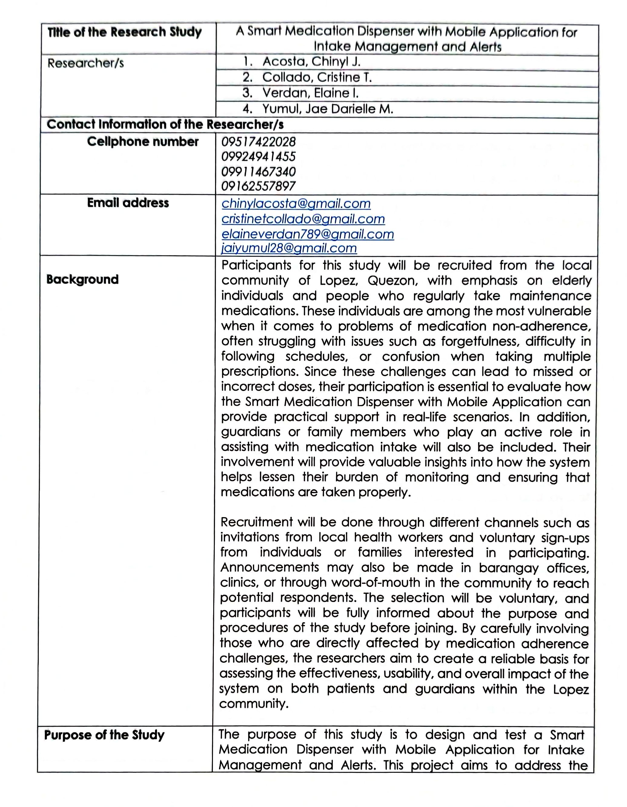

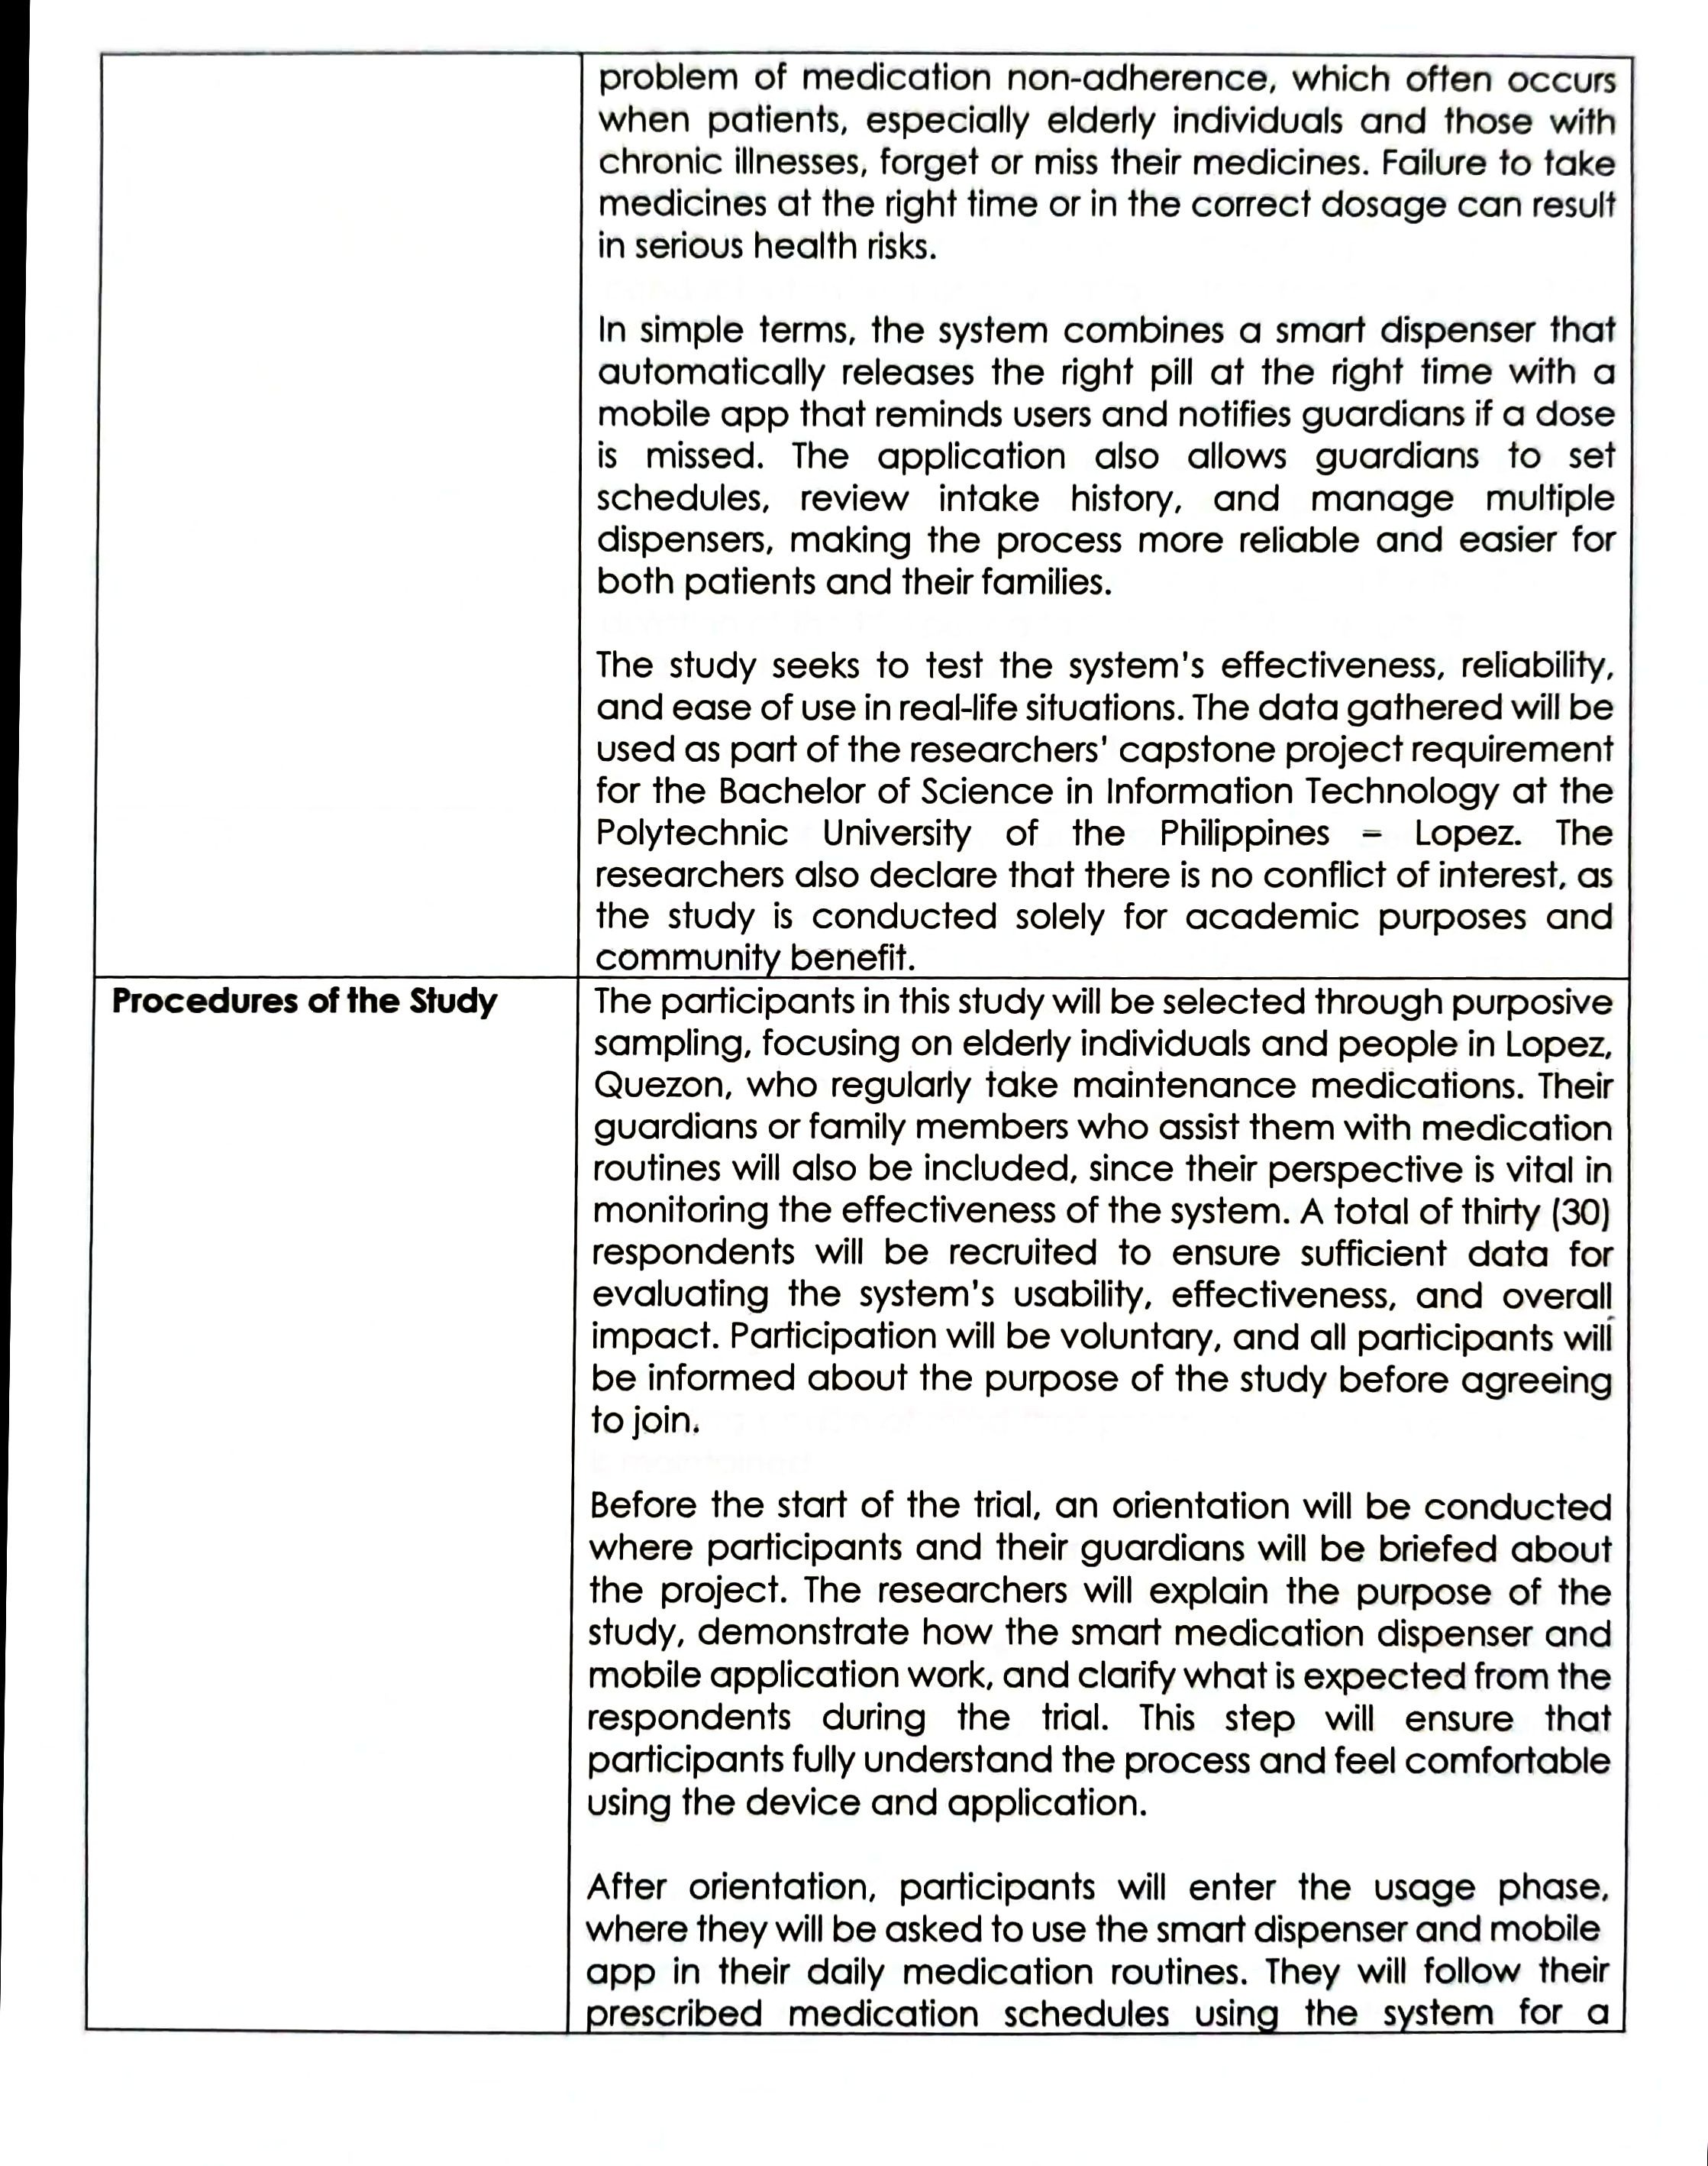

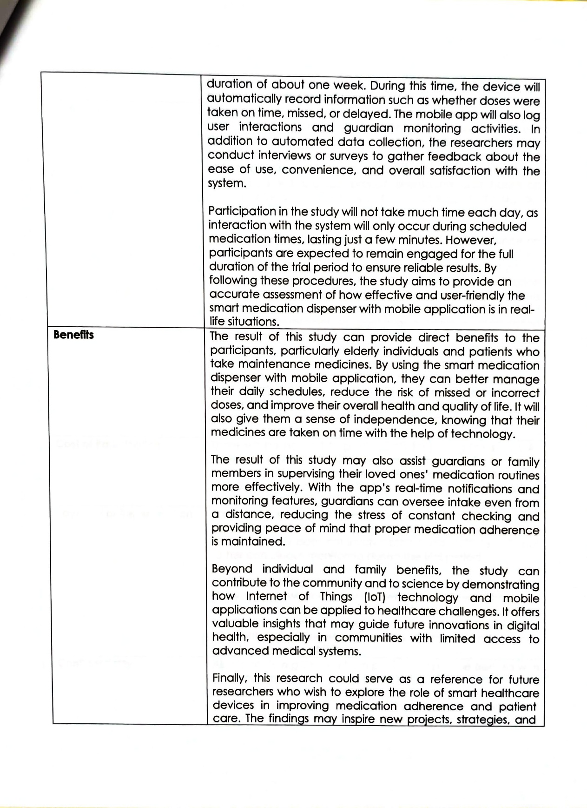

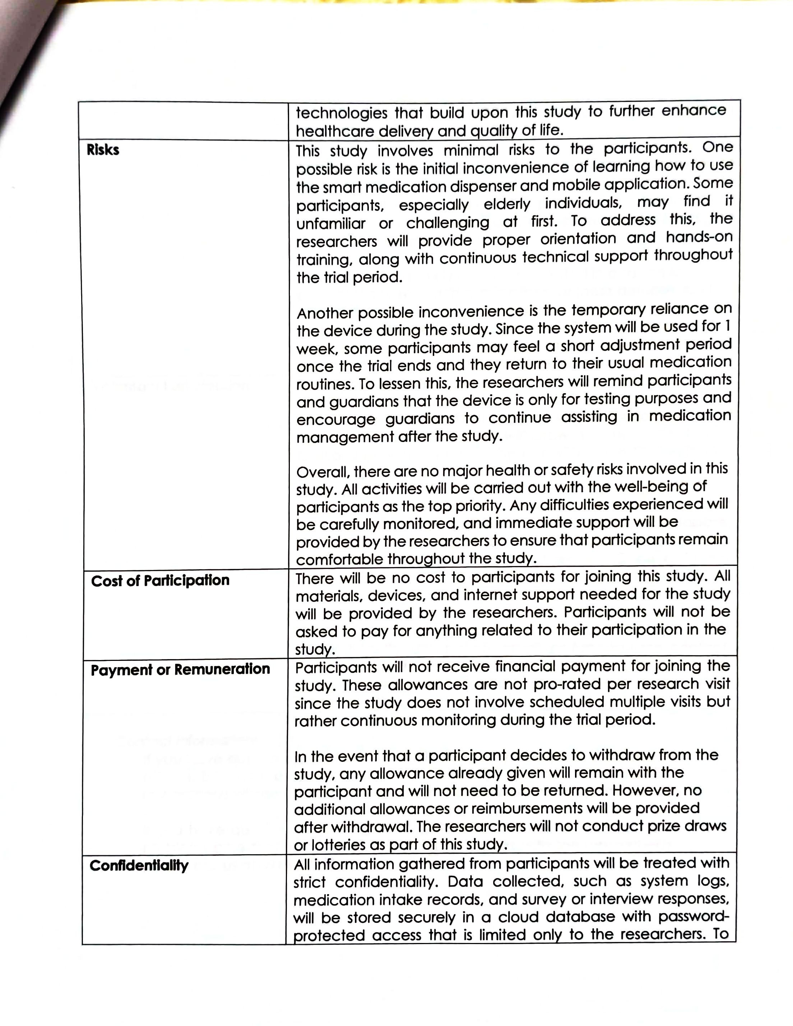

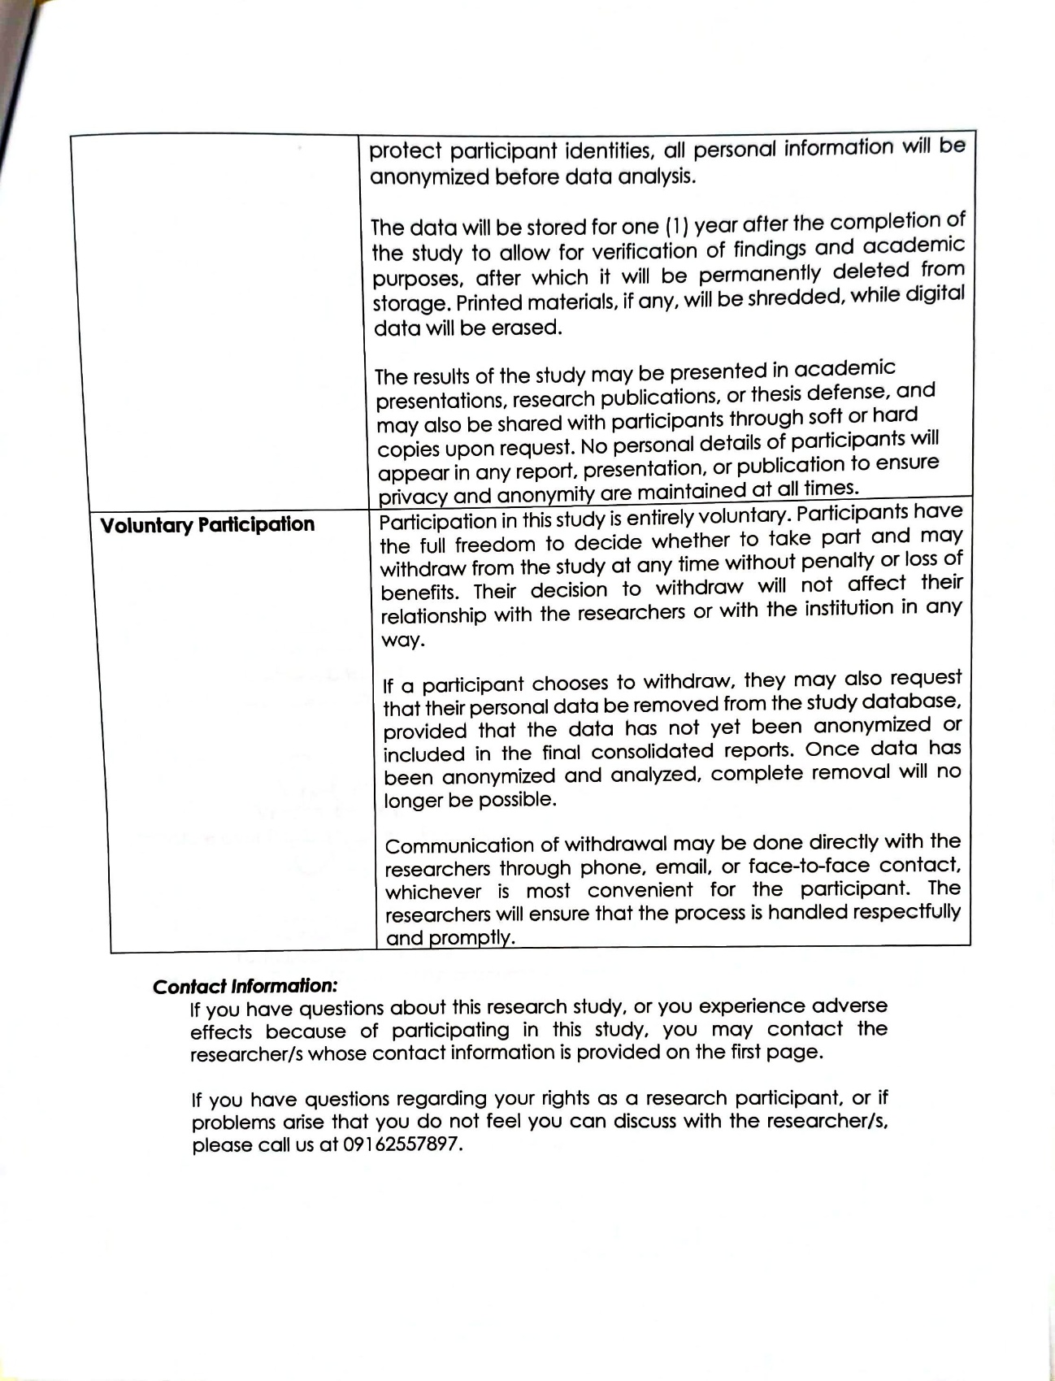

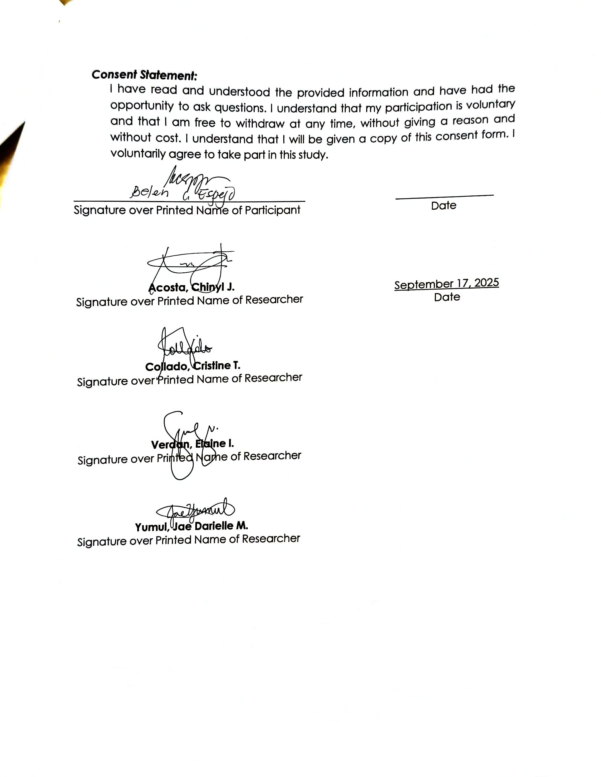

Appendix 4
EVALUATION TOOLS, TEST DOCUMENTS, AND TEST RESULTS
Use Case Test
The following Use Case Test was developed to systematically evaluate whether each functional requirement of the Smart Medication Dispenser with Mobile Application performs according to its intended behavior. Each use case was tested using predefined steps, expected outcomes, and actual system responses.

UC-01: Log In / Sign Up
Field | Description
Use Case ID | UC-01
Use Case Name | Log In / Sign Up
Actors | User, Guardian
Precondition | App installed; internet connection available
Test Steps | 1. Open app  2. Input email/password  3. Tap Log In / Sign Up
Expected Result | Account is created or authenticated; user dashboard loads
Actual Result | User successfully logged in; dashboard displayed with upcoming and current medication schedule.  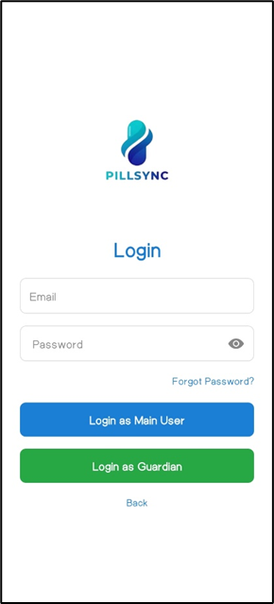  
Status | Pass
Remarks | Login and sign-up worked smoothly; response time fast and dashboard loaded correctly. No issues encountered.

UC-02: Add Medication

Field | Description
Use Case ID | UC-02
Use Case Name | Add Medication
Actors | User
Precondition | Logged in; medication list accessible
Test Steps | 1. Tap “Add Medication” 2. Fill fields 3. Save
Expected Result | Medication is saved in database and appears in list
Actual Result | New medication “Lifezar 100mg” added; appears in medication list    
Status | Pass
Remarks | Medication added successfully; input validation worked.

UC-03: Set Schedule

Field | Description
Use Case ID | UC-03
Use Case Name | Set Schedule
Actors | User
Precondition | At least one medication exists
Test Steps | 1. Open schedule menu 2. Choose medication 3. Set time/dosage 4. Save
Expected Result | Schedule stored in Firestore and synced to dispenser
Actual Result | Schedule for Lifezar set at 8:00 AM daily; synced to dispenser    
Status | Pass
Remarks | Schedule synced correctly; reminder notification accurate.

UC-04: View Medication Reports

Field | Description
Use Case ID | UC-04
Use Case Name | View Medication Reports
Actors | User, Guardian
Precondition | At least one intake log exists
Test Steps | 1. Open Reports tab 2. View weekly/monthly graphs
Expected Result | Reports display accurate adherence data
Actual Result | Weekly adherence report shows intake for lifezar;  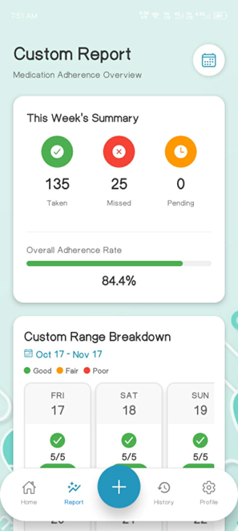
Status | Pass
Remarks | Weekly summary displayed correctly; consider adding graph.

UC-05: View Medication History

Field | Description
Use Case ID | UC-05
Use Case Name | View Medication History
Actors | User, Guardian
Precondition | Logged in; history records available
Test Steps | 1. Open History tab 2. Scroll records
Expected Result | History shows correct taken/missed timestamps
Actual Result | History shows all doses with timestamps; “Taken”, “Missed”, and “Pending” entries accurate  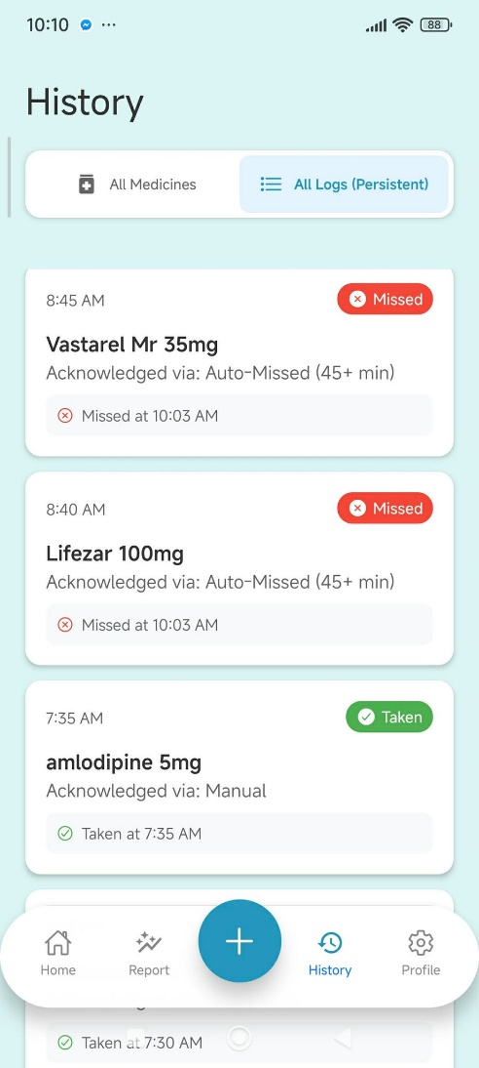
Status | Pass
Remarks | History accurate; scroll performance smooth. May include search/filter option for long histories.

UC-06: Receive Medicine Notification

Field | Description
Use Case ID | UC-06
Use Case Name | Receive Medicine Notification
Actors | User
Precondition | A schedule is active and time is reached
Test Steps | Wait for scheduled time
Expected Result | Notification appears; dispenser alert activates
Actual Result | Notification appeared at the scheduled time; dispenser buzzer activated  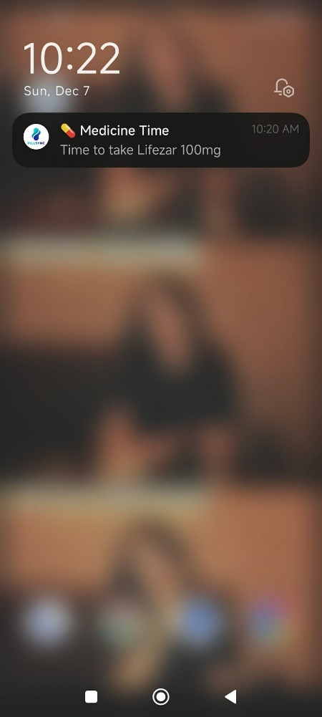  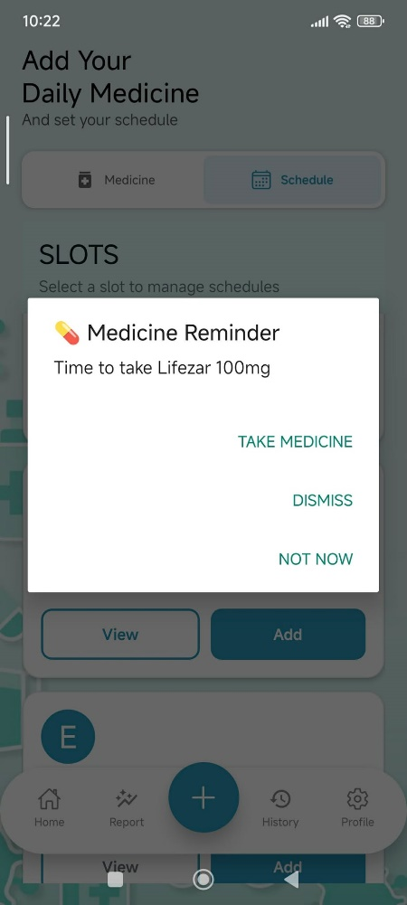
Status | Pass
Remarks | Notification received on time; sound and vibration clear.

UC-07: Missed Dose Alert

Field | Description
Use Case ID | UC-07
Use Case Name | Missed Dose Alert
Actors | User
Precondition | A dispensing event was not confirmed
Test Steps | Do not press confirmation button
Expected Result | Missed dose alert sent after grace period
Actual Result | User missed scheduled dose; send alert to user  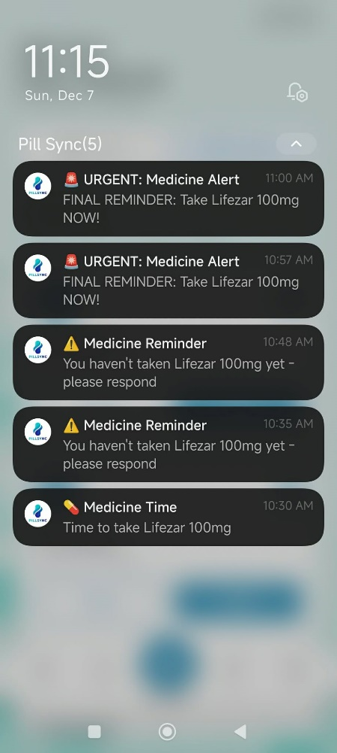
Status | Pass
Remarks | Alert triggered correctly before grace period; notification message clear. Could allow customizable alert duration.

UC-08: Receive Refill Reminder

Field | Description
Use Case ID | UC-08
Use Case Name | Receive Refill Reminder
Actors | User, Guardian
Precondition | Stock level falls below threshold
Test Steps | Reduce pills until low-stock
Expected Result | Low-stock alert is sent to user; guardian can view available stocks
Actual Result | Medication stock reduced below threshold; low-stock alert sent to user  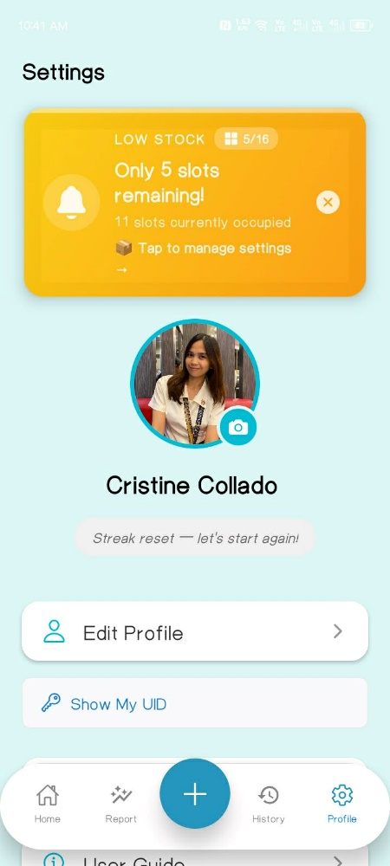
Status | Pass
Remarks | Low-stock alert displayed correctly; alert sent to user and guardian. Alert message clear and actionable; reminder appears timely and consistently. Could include estimated days left for remaining stock for better planning

UC-09: Confirm Intake

Field | Description
Use Case ID | UC-09
Use Case Name | Confirm Intake
Actors | User
Precondition | A dispensing event occurred
Test Steps | Press tactile button
Expected Result | Status changes to “Taken”; log stored in Firestore
Actual Result | User pressed tactile button; status changed to “Taken”; log saved in Firestore  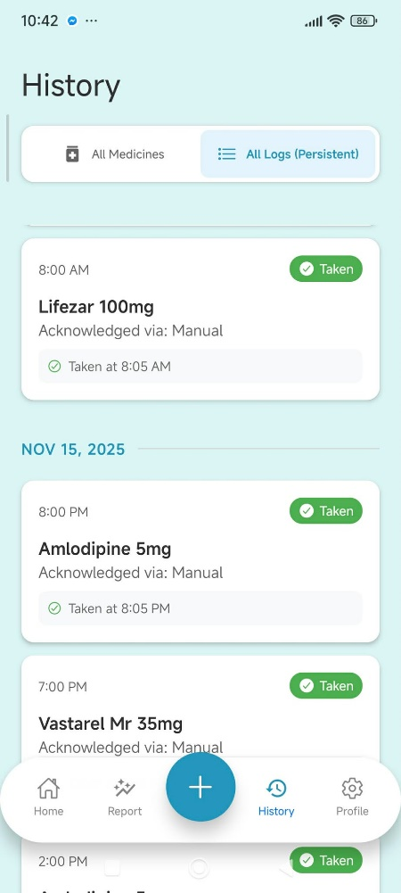
Status | Pass
Remarks | Status changed correctly to “Taken” when the button was pressed. Button was responsive, and the action logged successfully in the system.

UC-10: View Medication

Field | Description
Use Case ID | UC-10
Use Case Name | View Medication
Actors | User, Guardian
Precondition | Medications exist in database
Test Steps | Open medication list
Expected Result | List displays all medications with details
Actual Result | Medication list displayed all medications with names, dosage, treatment, and instructions  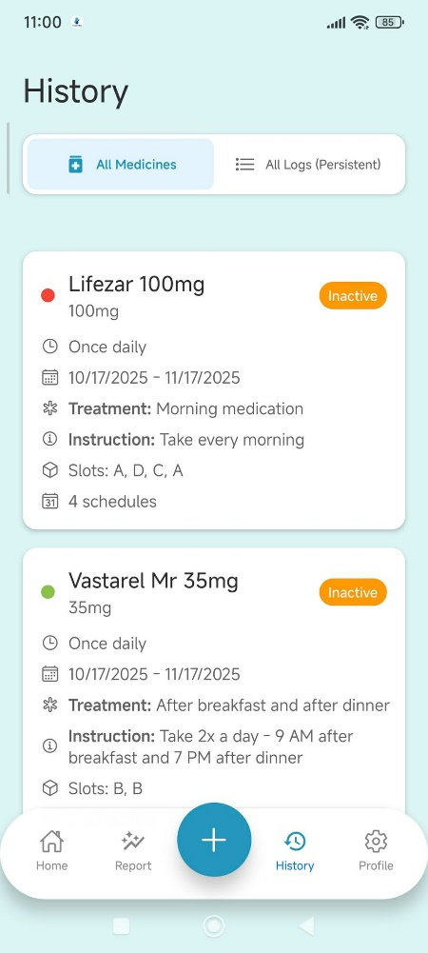
Status | Pass
Remarks | List displayed all medications; details clear. Could include search or sort function for convenience.

UC-11: View Schedule

Field | Description
Use Case ID | UC-11
Use Case Name | View Schedule
Actors | User, Guardian
Precondition | Schedules exist
Test Steps | Open Schedule tab
Expected Result | All active schedules are displayed correctly
Actual Result | All active schedules displayed correctly in the Schedule tab  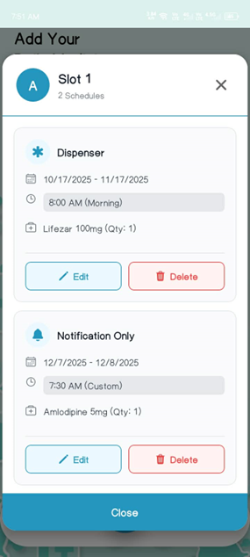  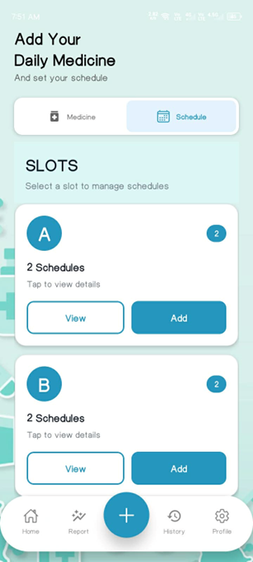
Status | Pass
Remarks | Schedule displayed correctly; UI easy to navigate. May include display overall list of schedules.

UC-12: Export Reports

Field | Description
Use Case ID | UC-12
Use Case Name | Export Reports
Actors | User, Guardian
Precondition | Report data exists
Test Steps | Tap “Export” button
Expected Result | Report file is generated and downloadable
Actual Result | 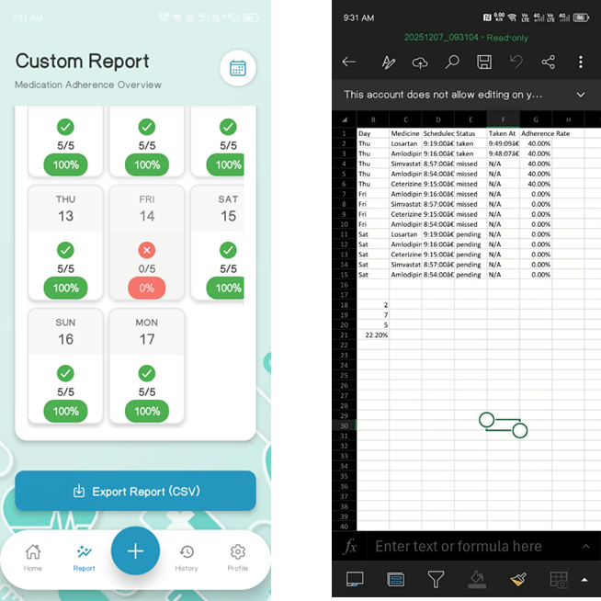  Reports exported as CSV; file downloadable on device
Status | Pass
Remarks | Reports exported successfully; Enhance filename and format. Could allow multiple formats other than CSV.

UC-13: View Refill Status

Field | Description
Use Case ID | UC-13
Use Case Name | View Refill Status
Actors | User, Guardian
Precondition | Refill status data available
Test Steps | Open Refill Status tab
Expected Result | Compartment levels shown accurately
Actual Result | Compartment levels displayed accurately; shows 5/16 slots remaining  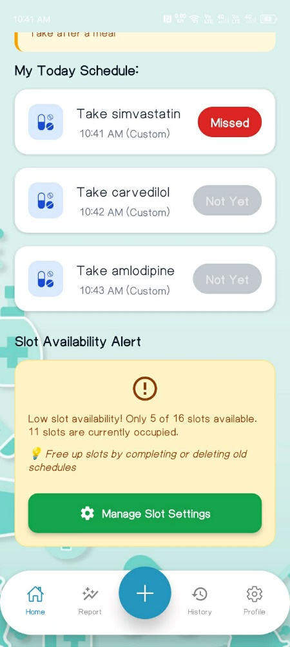  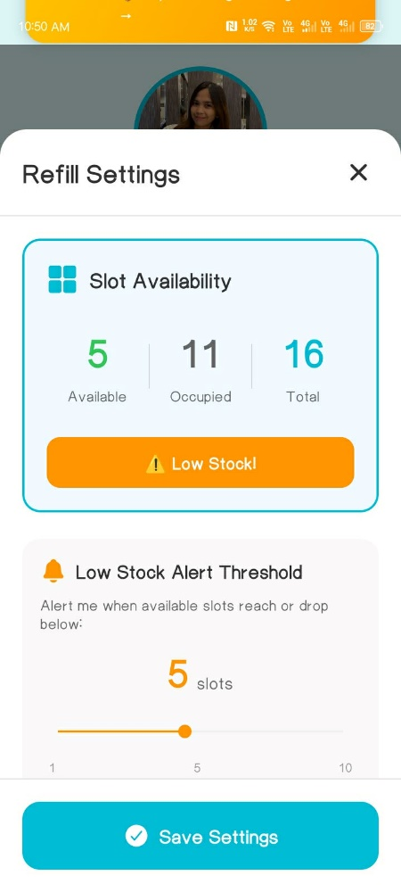
Status | Pass
Remarks | Compartment levels accurate; visual indicators clear. Could include estimated days left for refill.

Appendix 5
USER’S MANUAL
PillSync Quick Start Guide
Smart Medication Dispenser + Mobile App
1. Package Contents
- PillSync Smart Medication Dispenser
- Power Adapter
- QR Code for App Installation
- User Guides & Safety Sheet
2. Getting Started
Step 1 – Power On the Dispenser
- Connect the power adapter.
- Wait for the LCD indicator to signal startup.
Step 2 – Install the PillSync Mobile App
- Scan the provided QR Code.
- Tap Download.
- Enable Install Unknown Apps if prompted.
- Tap Install.
Step 3 – Create Your Account
- Open the app.
- Tap Create Account.
- Enter email, password, and basic details.
- Tap Sign Up.
- Log in.
Step 4 – Connect Dispenser to WiFi
- Go to WiFi Setup.
- Connect to ESP32
- Select your WiFi network.
- Enter password.
- Wait for confirmation.
3. Adding Medications
- Go to Home.
- Tap + Add Medication.
- Enter medication name, dosage, instructions.
- Tap Next.

Schedule Setup
- Choose frequency (Daily / Weekly / As Needed)
- Set dose times
- Assign dispenser slot
- Tap Save
4. Daily Use
When a dose is due:
- App sends a notification.
- Dispenser rotates/drops medication.
- Tap Take, Skip, or Snooze in the app.
5. Tracking Progress
- Reports: View graphs of weekly/monthly adherence.
- History: Review taken, missed, or skipped doses.
6. Refilling the Dispenser
- Open the lid.
- Refill the correct compartment.
- Close lid securely.

7. Basic Troubleshooting
- No WiFi: Restart router and reconnect.
- Not dispensing: Check slot for blockage.
- No notifications: Enable app permissions.
QR Code Placeholder
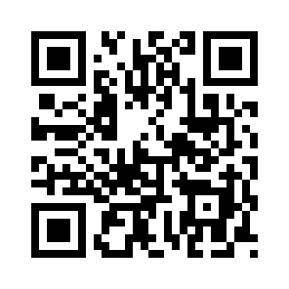

User Manual

Smart Medication Dispenser + Mobile App
1. Introduction
PillSync is an integrated medication management system that automates dosing, improves adherence, and provides easy monitoring through a smart dispenser paired with a mobile application.
This manual provides detailed instructions for installation, configuration, daily operation, maintenance, and troubleshooting.

2. System Overview
Components
- Smart Medication Dispenser (ESP32 powered)
- PillSync Mobile Application (APK via QR code)
- Firebase Realtime Database for syncing schedules and logs
Core Features
- Automated medication dispensing
- Schedule-based reminders
- Adherence tracking and reporting
- Remote monitoring

3. Safety Precautions
- Keep the dispenser away from water or moisture.
- Do not open or tamper with internal components.
- Use only the provided power adapter.
- Keep out of reach of children unless supervised.
- Ensure medications are assigned to the correct compartments.
4. System Requirements
Hardware:
- PillSync Dispenser
- Android Smartphone
- Stable 2.4 GHz WiFi network
Software:
- PillSync APK (via QR Download)
- Firebase backend services
5. Installation & Setup
5.1 Installing the App (via QR Code)
- Scan the QR code provided.
- Tap Download.
- Enable Install Unknown Apps if prompted.
- Tap Install.
5.2 Creating Your Account
- Open the app and tap Create Account.
- Enter email, password, and profile info.
- Tap Sign Up.
- Log in.
5.3 Setting Up Your Profile
- Go to Profile.
- Input health details.
- Configure notification preferences.
- Save changes.
6. Connecting the Dispenser to WiFi
- Plug in the dispenser.
- Wait for the startup indicator.
- Go to WiFi Setup.
- Connect to ESP32
- Select your WiFi network.
- Enter password.
- Wait for confirmation.
7. Medication Management
7.1 Adding a Medication
- Tap + Add Medication.
- Enter name, dosage, and instructions.
- Tap Next.
7.2 Creating a Schedule
- Choose frequency: Daily, Weekly, or As Needed.
- Set time(s) for each dose.
- Select start and end dates.
- Assign compartment.
- Enable notifications.
- Tap Save Schedule.
8. Dispenser Operation
8.1 Automatic Dispensing
- When it's time for a dose, the dispenser rotates the correct slot.
- The medication is dropped into the output area.
- A buzzer or light may indicate dispensing.
8.2 Manual Dispense
- Open the app.
- Select the medication.
- Tap Dispense Now.
9. Notifications & Alerts
Types of Notifications:
- Dose Reminder – Sent at scheduled time.
- Missed Dose Alert – Sent after grace period.
- Refill Reminder – Sent when medication is low.
User Actions:
- Take – Confirms the dose.
- Skip – Logs skipped dose.
- Snooze – Delays reminder.
10. Reports & History
Reports Tab
Shows charts for:
- Weekly adherence
- Monthly adherence
- Most-missed doses
History Tab
Shows:
- Taken doses
- Missed doses
- Skipped doses
- Manual dispensing logs
11. Maintenance
11.1 Cleaning
- Turn off device.
- Wipe exterior with dry cloth.
- Do not use water.
11.2 Refilling Compartments
- Open the dispenser lid.
- Refill assigned slot.
- Close securely.
11.3 Mechanical Check
- Ensure compartments rotate smoothly.
- Inspect interior only if you are trained.

12. Troubleshooting Guide
Issue | Possible Cause | Solution
No WiFi connection | Wrong password | Re-enter password
Not dispensing | Jammed slot | Clear blockage
No notifications | Permissions disabled | Enable notifications
Sync issues | Weak WiFi | Move closer to router

13. FAQ
Q: Can multiple guardians monitor?
Yes, if they have login access.
Q: Does the app work offline?
Reminders require connection; some features work offline.
Q: What medications are supported?
Solid oral medications only.

14. Technical Specifications
- ESP32 Microcontroller
- Servo Motor Rotation System
- Buzzer Indicator
- Firebase Realtime Backend
- React Native Mobile App
- DC Power Adapter
15. Disclaimer
PillSync is an assistive tool and does not replace medical professionals. Users must ensure all medication data entered is accurate.

QR Code Placeholder Page


Appendix 5
SAMPLE GENERATED OUTPUTS



Figure 18. Loading Screen of PillSync
This screen loads all necessary data and syncs your device settings before you enter the app. It ensures your medication schedules, history, and alerts are ready.





Figure 19. Log in and Register Screen of PillSync
Here you can securely log in if you already have an account or Register to create a new PillSync account to manage your medications and reminders.



Figure 20. Home Screen of PillSync
The main dashboard that shows your next scheduled dose, today's medication checklist, quick 'Taken' button, and important alerts for easy daily management.







Figure 21. Add/Edit Medicine and Schedule Screen of PillSync
This figure shows the Add new medications/schedule by entering the name, description, duration, dosage, slot, quantity or update existing medication/schedule details when needed.




Figure 22. History Screen of PillSync
This figure shows the view of your medication adherence history — including doses taken on time and missed doses.






Figure 23. Analytics Report of PillSync
The figure shows the Report section of the app, where users can choose between a custom date range or the current week report. It displays a summary of taken, missed, and pending medications, along with the overall adherence rate. The section also includes an option to export the report as a CSV file for record-keeping or sharing.



Figure 24. Settings Screen of PillSync
The figure shows the settings screen of a mobile app, featuring the user's profile photo and name ("Adoracion Yumul") at the top. Below are five main options: Edit Profile, My UID, Refill Settings, User Guide, Backup & Recovery, and Log out. A bottom navigation bar provides access to Home, Report, Add, History, and the currently active Profile section. The design uses a light-blue background with a clean, simple layout.


Figure 25. Edit Profile of PillSync
The figure shows the Edit Profile section of the app, allowing the user to edit or change their name. The layout is simple and direct, making it easy for users to update their information and personalize their account.



Figure 26. User ID of PillSync
The figure shows the User ID (My UID) section of the app, where the user can view their unique identification code used for linking to a guardian account. The interface is straightforward, allowing easy access and ensuring smooth connection between the user and guardian.



Figure 27. Low Stock Settings of PillSync
The figure shows the Refill Settings section of the app, where users can view slot availability, occupied slots, and total slots, along with a low-stock alert threshold that shows how many slots remain before a refill is needed.





Figure 28. User Guide Settings of PillSync
The figure shows the User Guide section of the app, providing instructions on how to use the system, add medications, and manage daily usage. The interface offers clear and accessible guidance, helping users understand and operate the app effectively.



Figure 29. Back-up & Recovery Settings of PillSync
The figure shows the Backup & Recovery section of the app, where users can securely back up their data and restore it when needed. This feature ensures that important information is protected and can be easily recovered in case of device loss or system issues.



Figure 30. Change password Settings of PillSync
The figure shows the Change Password section of the app, where users can update their account security by entering their current password, creating a new password, and confirming the new password.



Figure 31. Log-out Settings of PillSync
The figure shows the Log Out option of the app, allowing users to securely exit their account. This feature ensures privacy and protects user information when the device is shared or not in use.

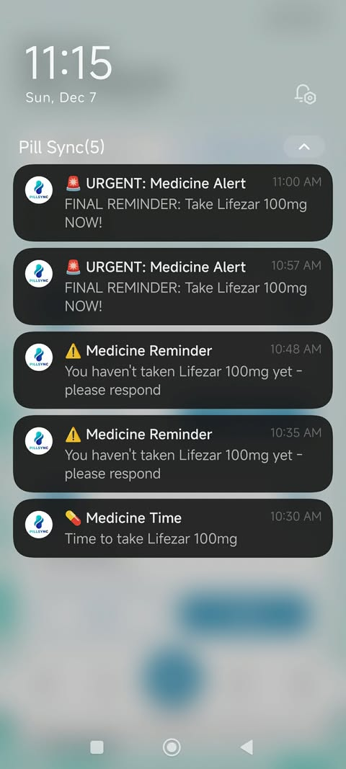
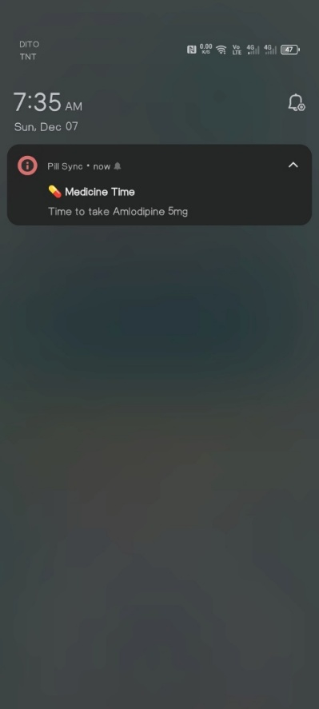
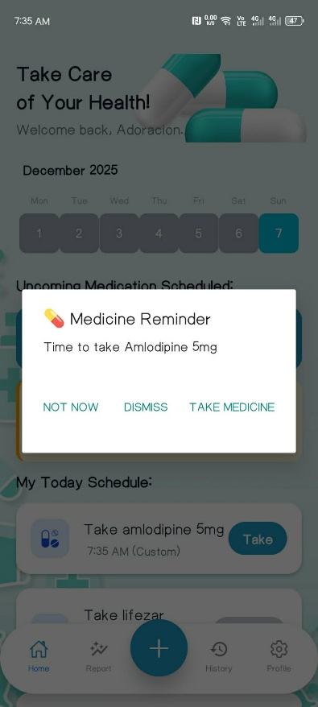

Figure 32. Notification of PillSync
The figure shows the Notification of the app, where users receive alerts to take their medicine. The medicine reminder allows users to choose whether to dismiss, take the medicine, or postpone (Not Now), helping them manage their medication schedule effectively.




Figure 33. Low Stock Alert Notification of PillSync
The figure shows the Low Stock Alert Notification of the app, which reminds users to manage slot settings , how many slots are being occupied and notifies them of the remaining stock in each slot, ensuring timely refills and uninterrupted medication management.

Appendix 6
SAMPLE GENERATED OUTPUTS

Appendix 7
CERIFICATION OF SIMILARITY CHECK/TURNITIN RESULTS

Appendix 8
CERTIFICATION OF EDITING
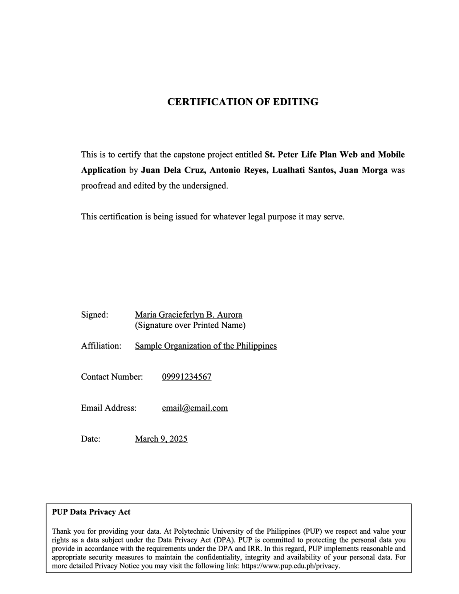

Appendix 9
IMPLEMENTATION REPORT

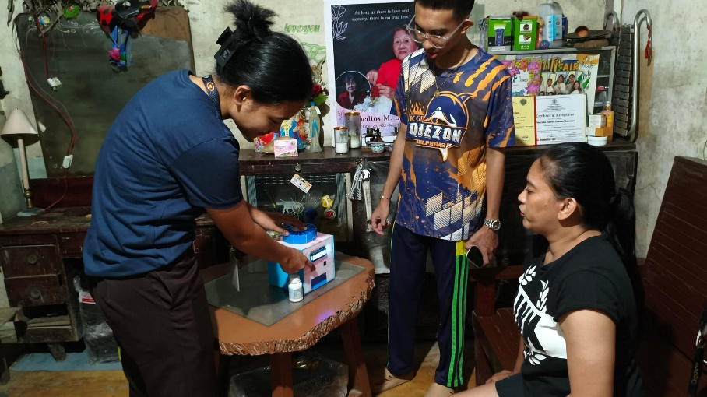

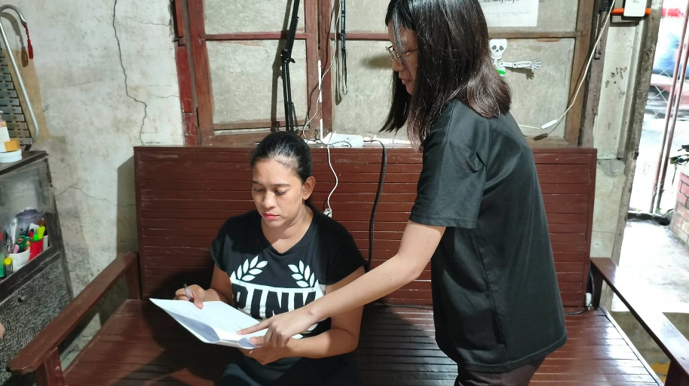





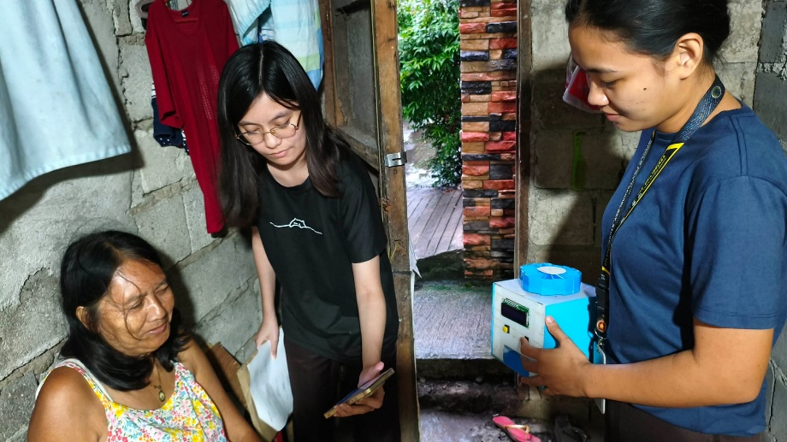



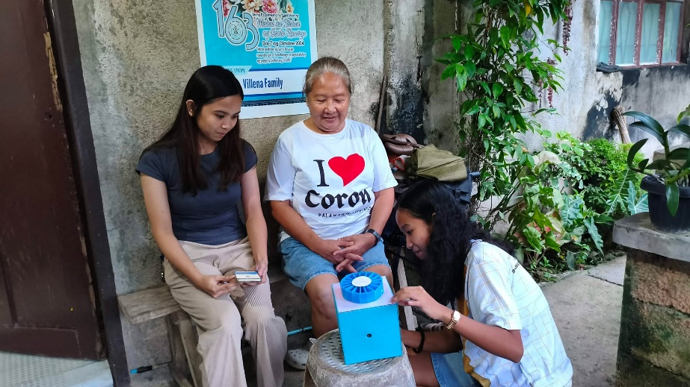





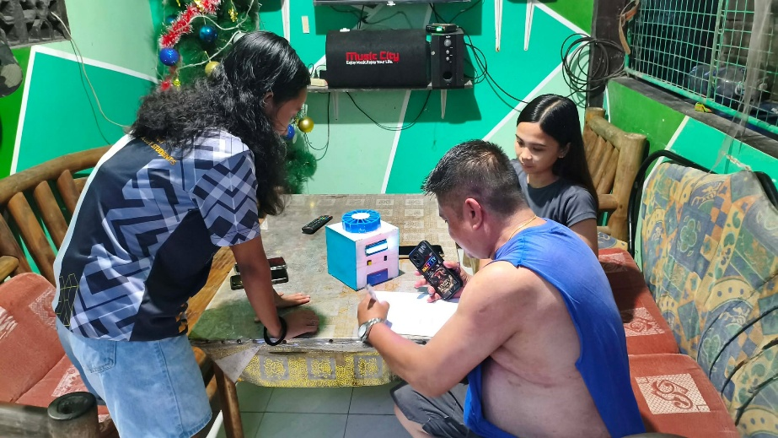







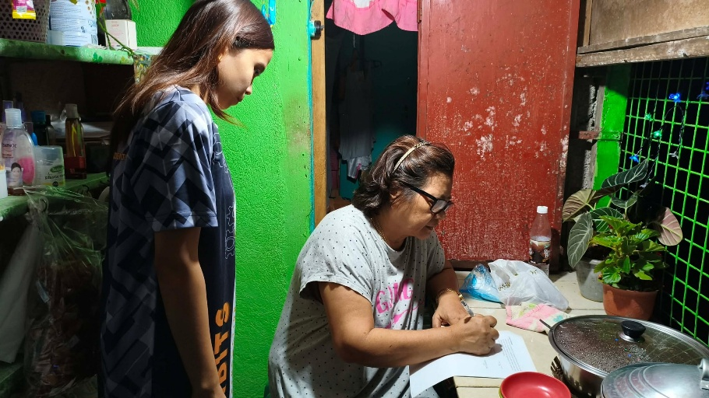

















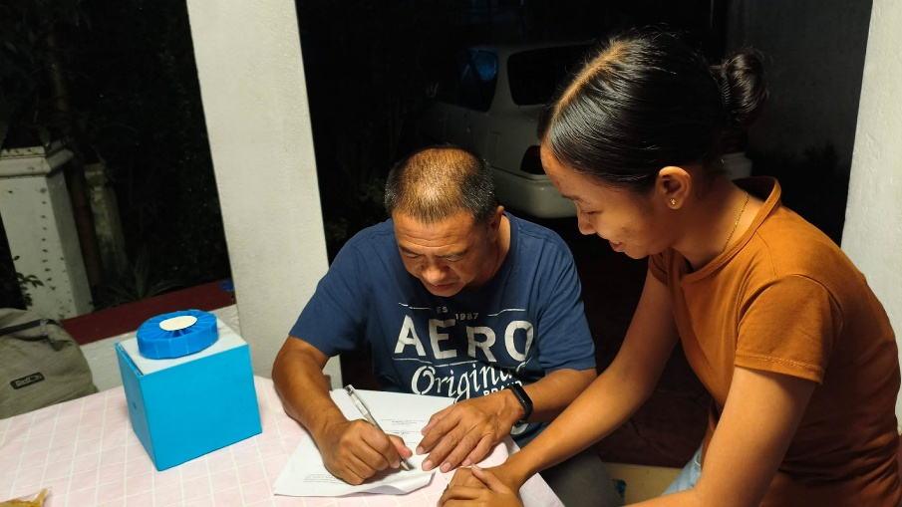

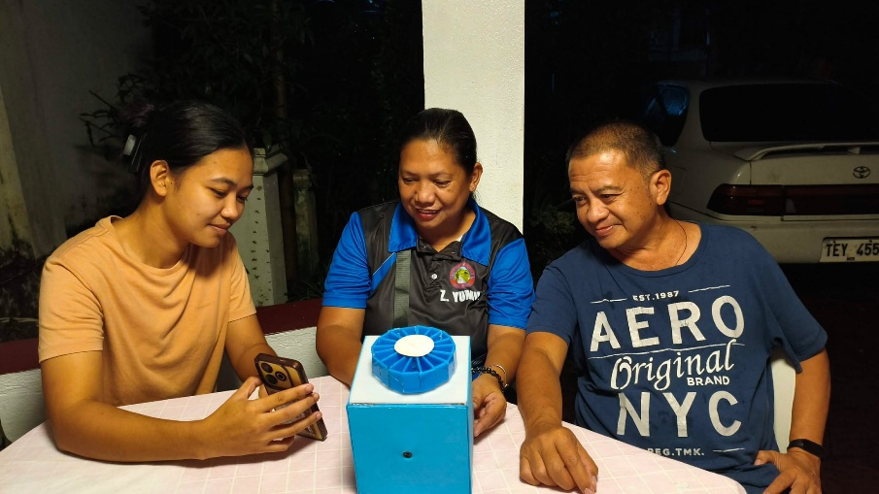

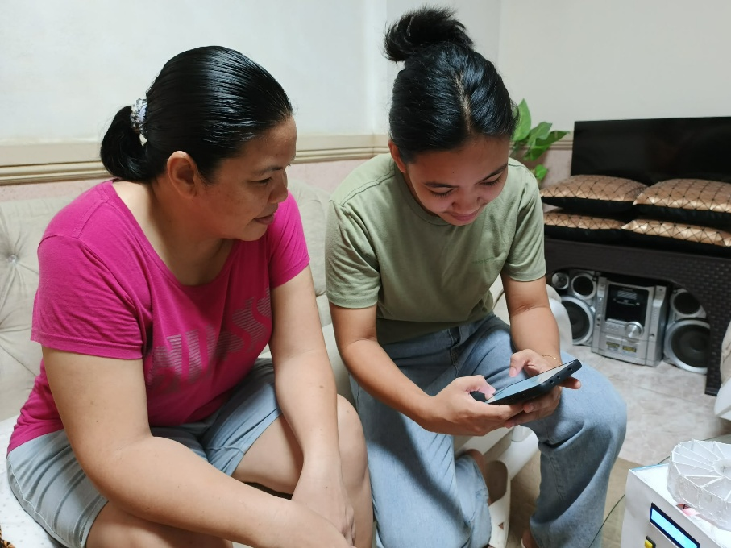

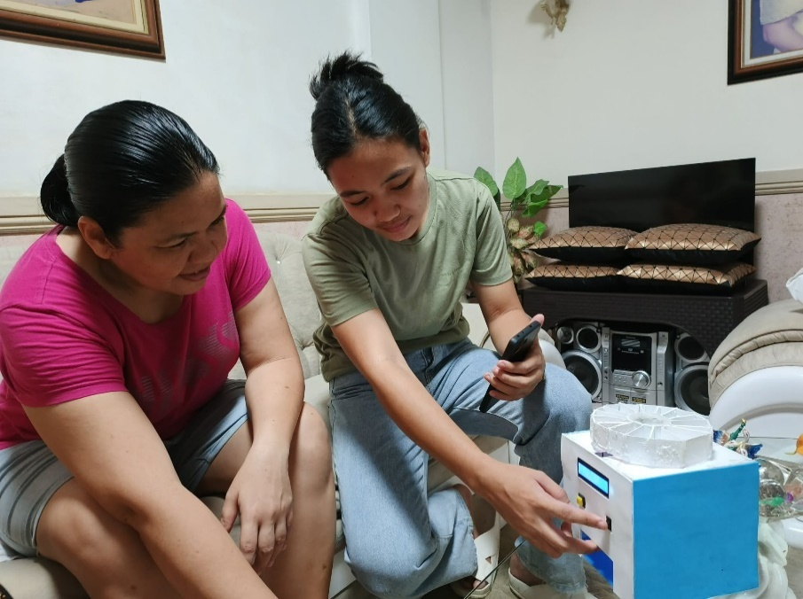

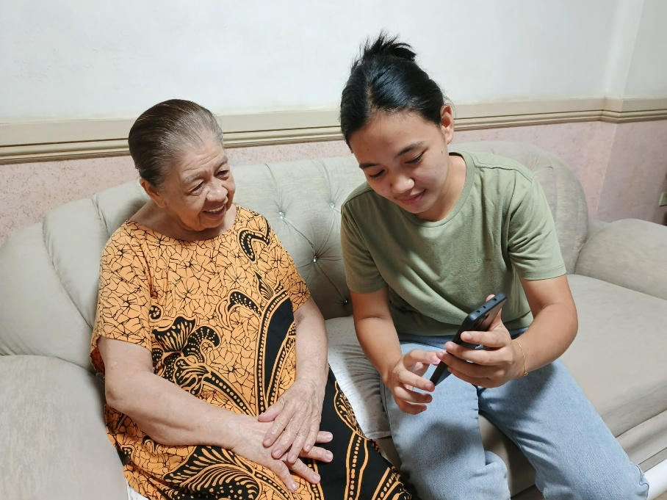

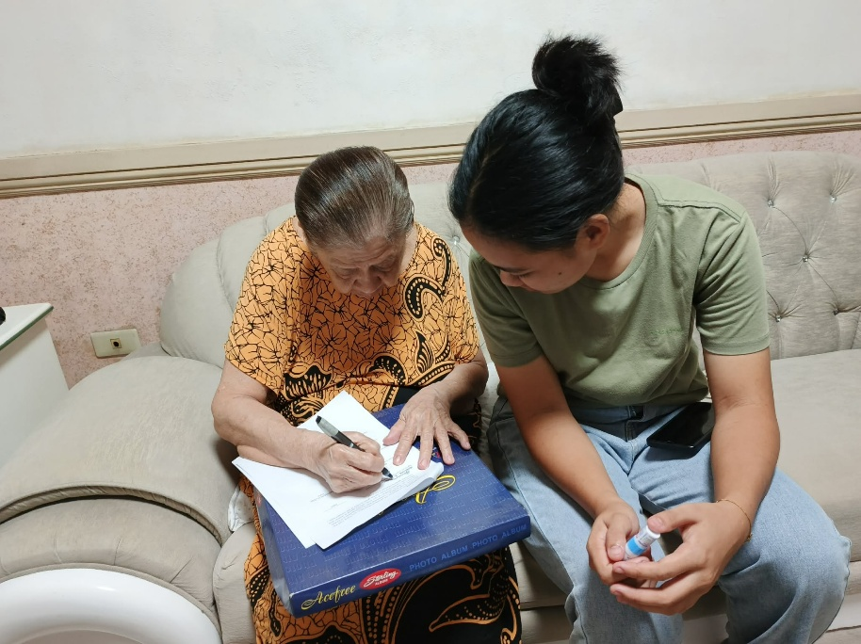

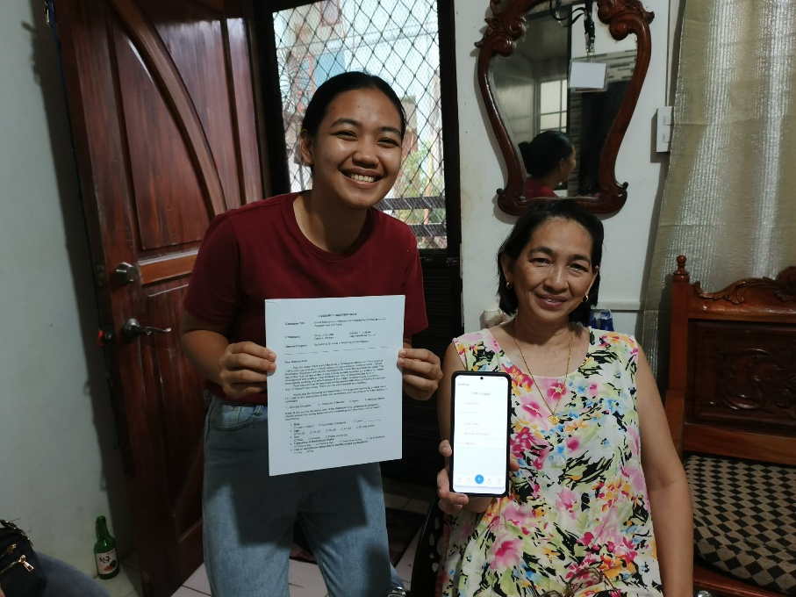

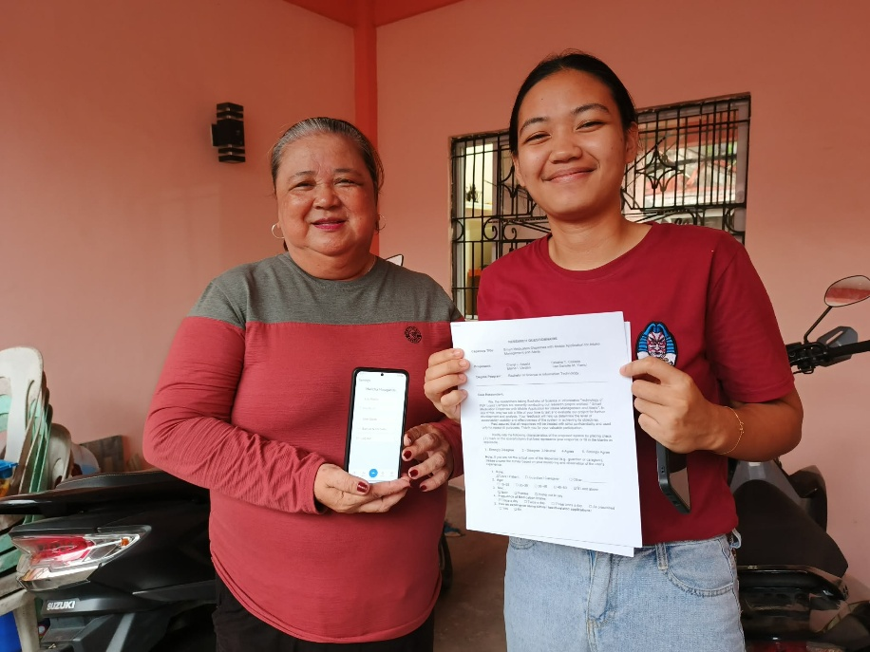

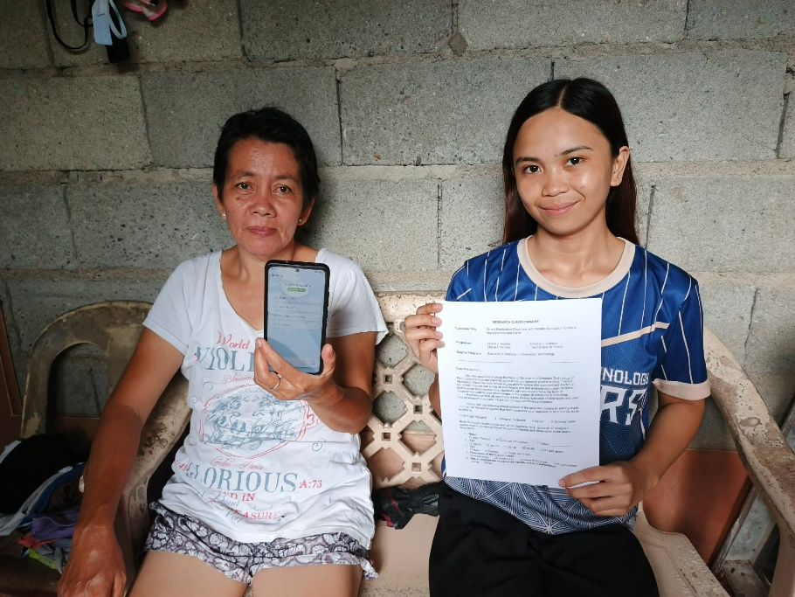

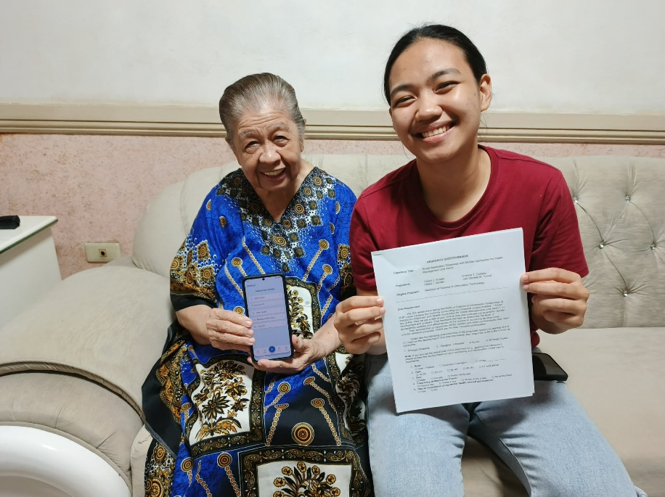

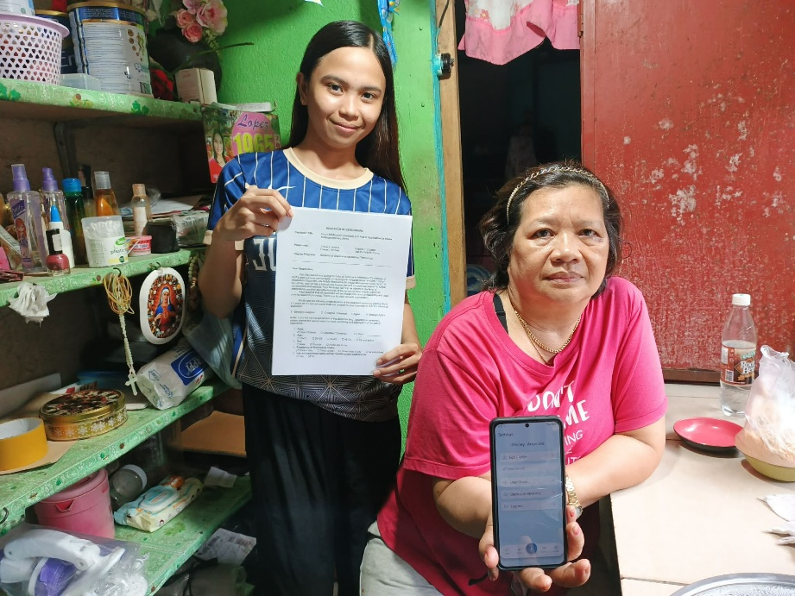

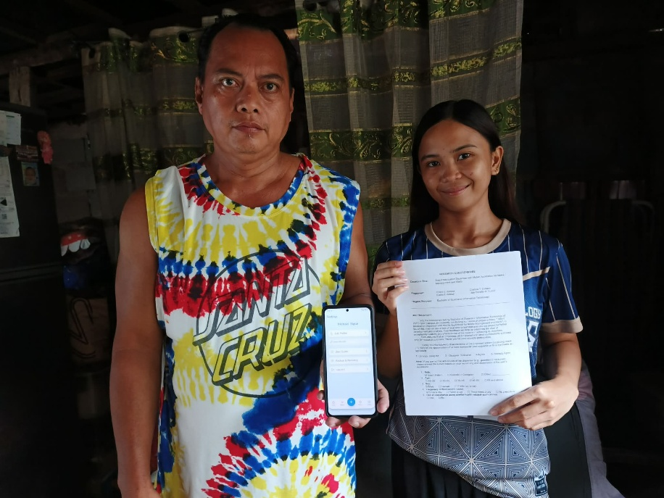

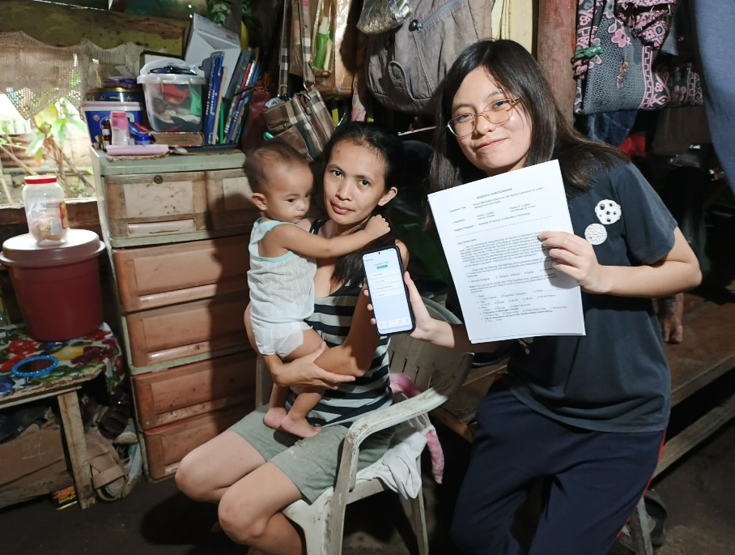

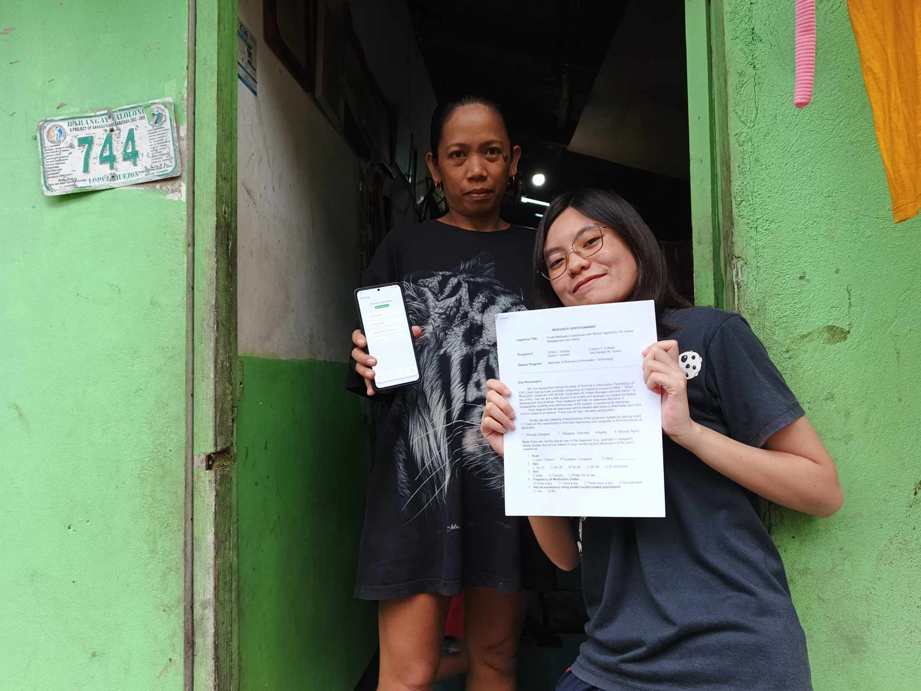

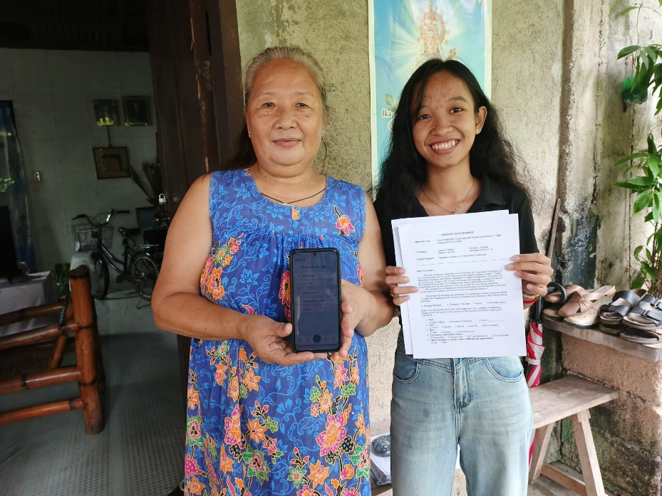

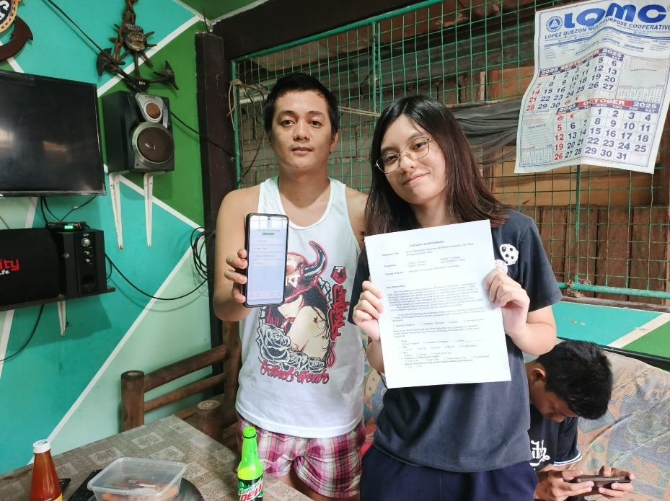

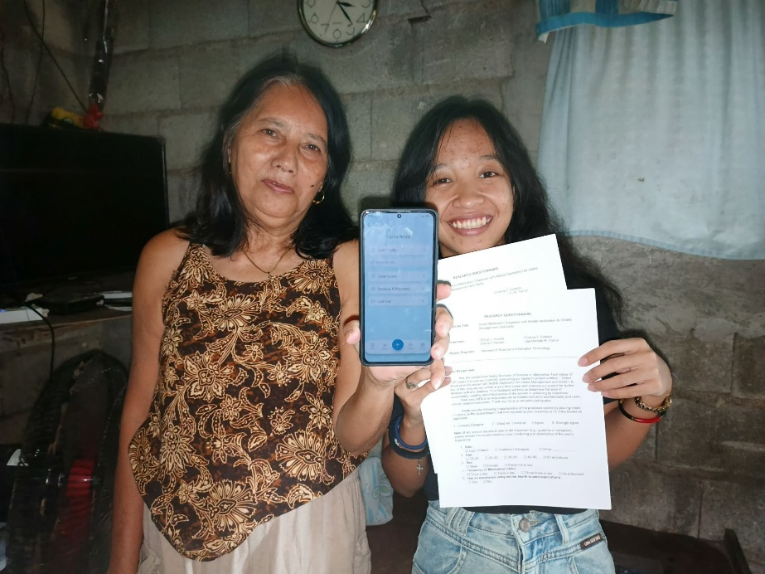

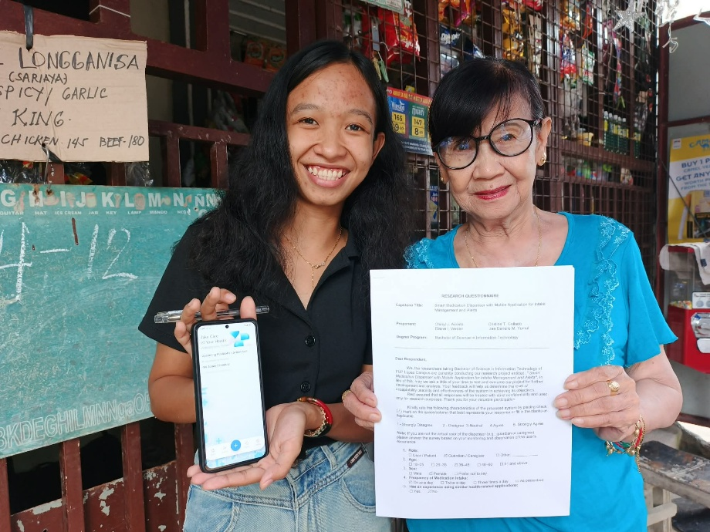

Appendix 10
CAPSTONE PROJECT REVISION MATRICES
Appendix 11
ETHICS CLEARANCE AND TERMINAL REPORT

Appendix 12
BIOGRAPHICAL STATEMENT


Chinyl J. Acosta is a fourth-year Bachelor of Science in Information Technology (BSIT) student with a strong interest in software development, system development, and database management. Throughout her academic journey, she has gained knowledge and hands-on experience in programming, systems analysis and design, and emerging technologies. She has actively participated in academic projects that enhanced her analytical thinking, technical skills, and problem-solving abilities. As one of the proponents of the capstone project, she demonstrated dedication and commitment in developing a technology-driven solution aimed at addressing real-world challenges. As she completes her undergraduate studies, Chinyl aspires to continuously improve her technical expertise and contribute meaningfully to the advancement of the information technology industry.


Cristine T. Collado is a fourth-year Bachelor of Science in Information Technology (BSIT) student with a strong interest in software development, system development, and database management. Throughout her academic journey, she has gained knowledge and hands-on experience in programming, systems analysis and design, and emerging technologies. She has actively participated in academic projects that enhanced her analytical thinking, technical skills, and problem-solving abilities. As one of the proponents of the capstone project, she demonstrated dedication and commitment in developing a technology-driven solution aimed at addressing real-world challenges. As she completes her undergraduate studies, Cristine aspires to continuously improve her technical expertise and contributes meaningfully to the advancement of the information technology industry.


Elaine I. Verdan is a fourth-year Bachelor of Science in Information Technology (BSIT) student with a strong interest in software development, system development, and database management. Throughout her academic journey, she has gained knowledge and hands-on experience in programming, systems analysis and design, and emerging technologies. She has actively participated in academic projects that enhanced her analytical thinking, technical skills, and problem-solving abilities. As one of the proponents of the capstone project, she demonstrated dedication and commitment in developing a technology-driven solution aimed at addressing real-world challenges. As she completes her undergraduate studies, Elaine aspires to continuously improve her technical expertise and contribute meaningfully to the advancement of the information technology industry.


Jae Darielle M. Yumul is a fourth-year Bachelor of Science in Information Technology (BSIT) student with a strong interest in software development, system development, and database management. Throughout her academic journey, she has gained knowledge and hands-on experience in programming, systems analysis and design, and emerging technologies. She has actively participated in academic projects that enhanced her analytical thinking, technical skills, and problem-solving abilities. As one of the proponents of the capstone project, she demonstrated dedication and commitment in developing a technology-driven solution aimed at addressing real-world challenges. As she completes her undergraduate studies, Jae aspires to continuously improve her technical expertise and contribute meaningfully to the advancement of the information technology industry.

