Residual Plots

Stella Lee, Yoon Choi, Aru Fatehpuria

10/29/2019

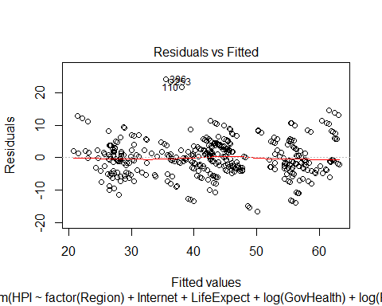

Figure 1a: Residuals vs Fitted Values with explanatory variables *(Region, Internet, Life Expectancy, log (Government Expenditure on Health Care), log (Private Expenditure on Health Care), PPP, log (Population Density))*

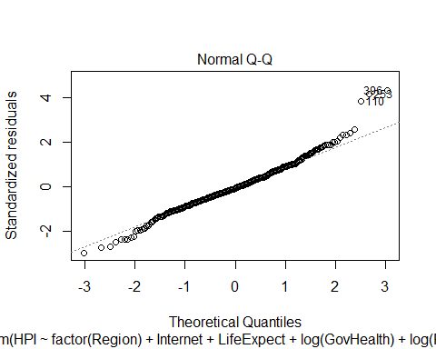

Figure 1b: Normal Q-Q Plot with explanatory variables *(Region, Internet, Life Expectancy, log (Government Expenditure on Health Care), log (Private Expenditure on Health Care), PPP, log (Population Density))*

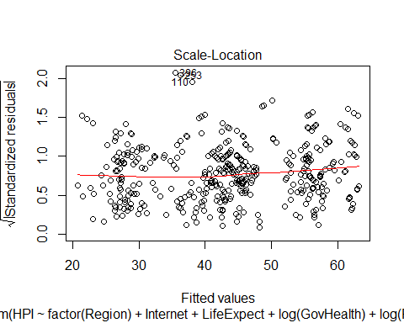

Figure 1c: sqrt (Standardized residuals) vs Fitted Values with explanatory variables *(Region, Internet, Life Expectancy, log (Government Expenditure on Health Care), log (Private Expenditure on Health Care), PPP, log (Population Density))*

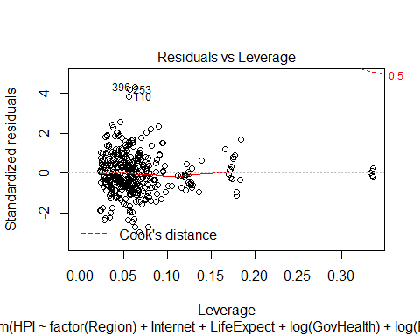

Figure 1d: Standardized residuals vs Leverage with explanatory variables *(Region, Internet, Life Expectancy, log (Government Expenditure on Health Care), log (Private Expenditure on Health Care), PPP, log (Population Density))*

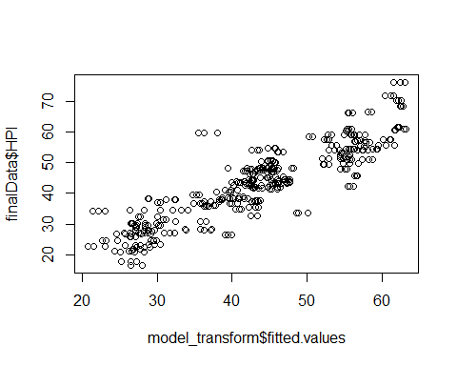

Figure 1e: HPI vs Fitted Values with explanatory variables *(Region, Internet, Life Expectancy, log (Government Expenditure on Health Care), log (Private Expenditure on Health Care), PPP, log (Population Density))*

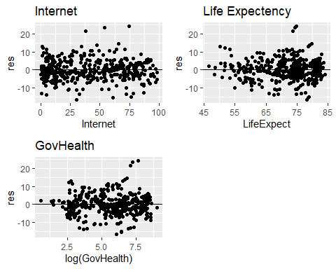

Figure 2a: Residual plots of Internet, Life expectancy, and log (GovHealth) (Government expenditure on health)

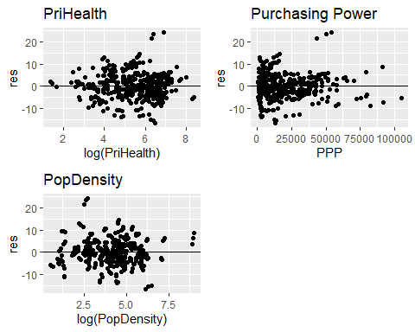

Figure 2b: Residual plots of log (PriHealth) (Private expenditure on health), PPP (Purchasing Power), and log (Population Density)



Figure 3a: Residuals vs Fitted Values with same explanatory variables in Figure 1a and interaction between log (GovHealth) and log (PriHealth)



Figure 3b: Normal Q-Q Plot with same explanatory variables in Figure 1b and interaction between log (GovHealth) and log (PriHealth)



Figure 3c: sqrt (Standardized residuals) vs Fitted Values with same explanatory variables in Figure 1c and interaction between log (GovHealth) and log (PriHealth)



Figure 3d: Standardized residuals vs Leverage with same explanatory variables in Figure 1d and interaction between log (GovHealth) and log (PriHealth)

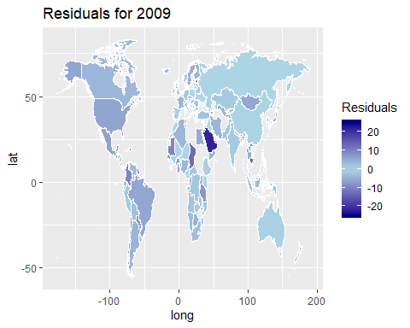

Figure 4a: Residuals plotted on a world map (2009)

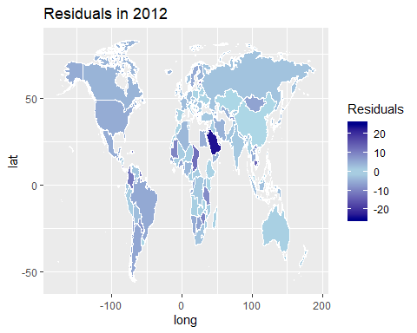

Figure 4b: Residuals plotted on a world map (2012)

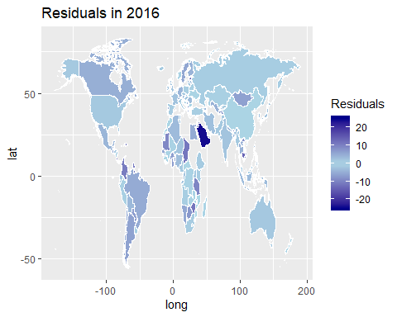

Figure 4c: Residuals plotted on a world map (2016)

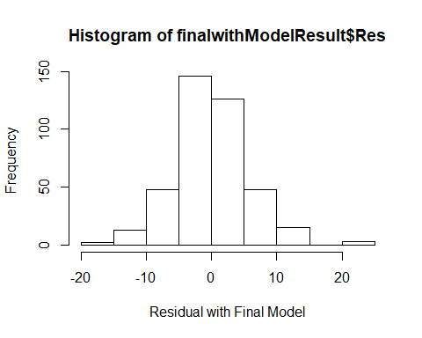

Figure 5a: Histogram of final model’s residuals vs frequency

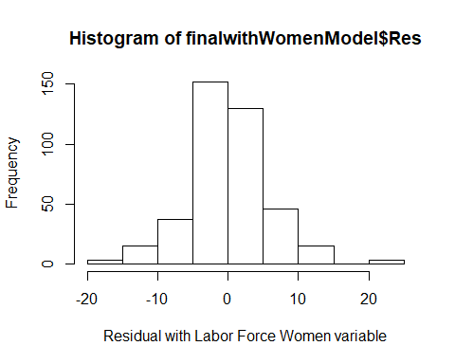

Figure 5b: Histogram of final model’s residuals with labor force vs frequency

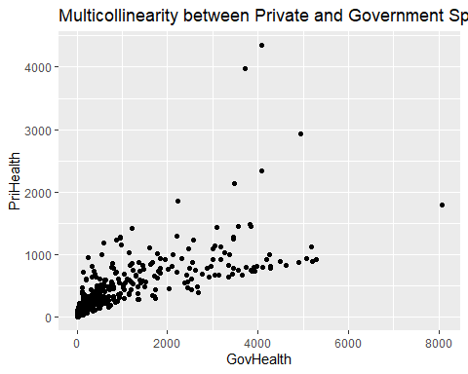

Figure 6: Multicollinearity between private and government spending on health care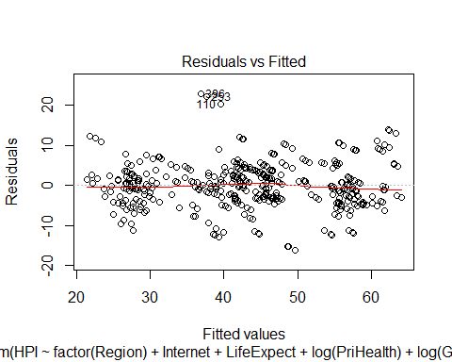

Figure 7a: Residuals vs Fitted Values with explanatory variables from Figure 1a and additional explanatory variables related to women (percentage of women in labor force and in parliament)

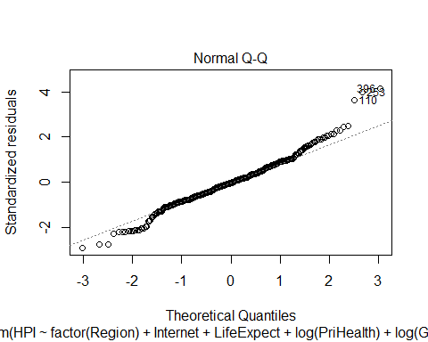

Figure 7b: Normal Q-Q Plot with explanatory variables from Figure 1b and additional explanatory variables related to women (percentage of women in labor force and in parliament)

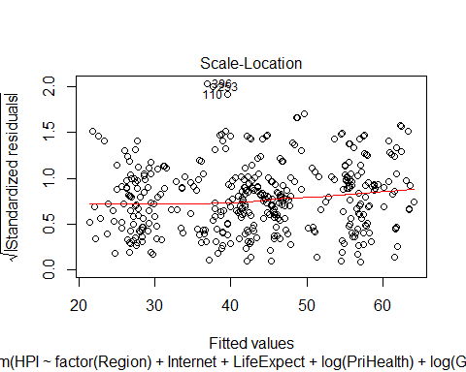

Figure 7c: sqrt (Standardized residuals) vs Fitted Values with explanatory variables from Figure 1c and additional explanatory variables related to women (percentage of women in labor force and in parliament)

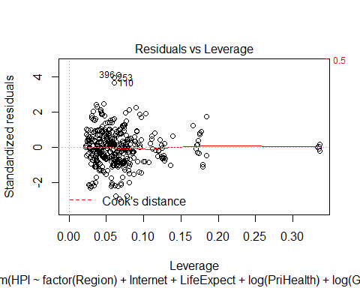

Figure 7d: Standardized residuals vs Leverage with explanatory variables from Figure 1d and additional explanatory variables related to women (percentage of women in labor force and in parliament)

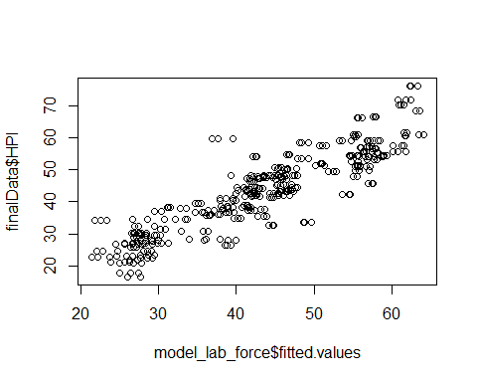

Figure 7e: HPI vs Fitted Values with explanatory variablesfrom Figure 1e and additional explanatory variables related to women (percentage of women in labor force and in parliament)