**I Needed Money, So I Started QData Trading**

<https://quant-galore.medium.com/i-needed-money-so-i-started-qdata-trading-85a9a6f30a05>

With an ever-changing landscape, once profitable strategies have failed to create returns. But with the right data and technology, traders big and small are still reaping profits. Here we show exactly how it works.

## Technology Setup

For this to work, all you need is access to a laptop/desktop. We will be running two programs for this strategy: [OpenBB](https://openbb.co/) and [Options-Quant.](https://options-quant.com/)

We will use OpenBB’s research platform to get our data and several key functions. This is a free and open-source platform which features hundreds of proprietary data functions like volatility surfaces, econometric data, alternative data, and more.

Next, we will be using Options-Quant. This is an options pricing platform that will help us price our options with various models to get a true and fair price. The platform features hundreds of models that are used in hedge funds, universities, and investment banks.

## Strategy

This strategy involves finding the true, fair price of an option that is currently classified as having unusual activity. So, for example, if a call option has a volume of 30,000 but an open interest of just 800, this will be classified as unusual activity, with a Volume/OI ratio of nearly 40x. After seeing this, we will price the option with our model of choice to see if the price holds hidden information or if all extra information is already priced in.

If our calculated price is significantly different than the current market price, we assume that the option with the unusual volume has hidden information behind it, as a large gap persists in the face of our model even after accounting for factors like volatility and slippage.

## The Trade

On June 3rd, we decided to test and see if we could exploit any of these unusual movements.

Using the OpenBB terminal, we run the command:

stocks/options/unu

This brings up 20 of the most notable outliers, but you can change the parameters for more if you’d like. After running this command, we get this table:

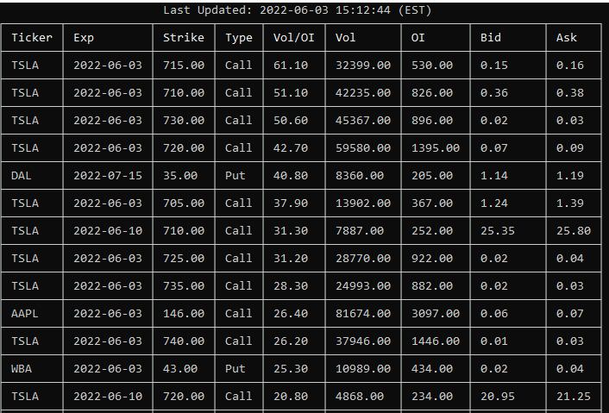

On the 5th row, we see that the 07/15 DAL 35p @ $1.19 option has a Volume/OI ratio of 40.80. This is quite significant, so we must now price the option with our own models to see how large the spread would be.

We will be using the MertonJumpDiffusion model with Options-Quant. This model is a hallmark in many proprietary trading shops and hedge funds as the model is stochastic and does a terrific job at modeling seemingly random processes like option prices. You can read more about the model here (math heavy, optional):

<http://www.columbia.edu/~sk75/MagSci02.pdf>

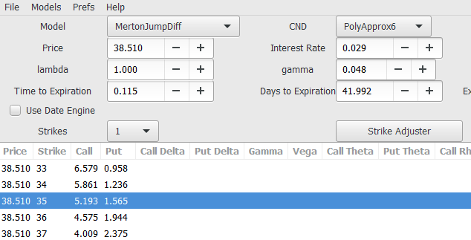

When modeling the option, we see that while the option price traded for $1.19, it should truly have been trading for $1.56. Options-Quant allows you to insert custom parameters to see what may be wrong, but after setting all our parameters to mimic the market while being optimized for volatility, the market price still didn’t match up. Not even close.

So, with the assumption that our calculation is the true, fair price and that the market price may have hidden, non-priced-in information, we bought 100 contracts with the anticipation that the market price would rise to near our calculated price of $1.56.



As the market day drew closer to close, option volume picked up as expected. In line with our model, the price of the option started to move closer to our calculated value. Our calculated value also started to decrease and get closer to that of the market price. As the option gradually rose to $1.53 in the final moments before close, we closed the position for a profit of $3400 (before commission + fees + tax).

## Wrap-Up

In this trade, we sought data to sort and isolate options with unusual activity and potentially hidden information. We then priced that option with a sophisticated model, to see whether the price was fair and reflective of market conditions. After realizing that the market price was indeed, too low, unfair and “incorrect”, we opened a trade to reflect the imbalance. The price converged to our calculated value, and we secured a profit.

With an ever-changing landscape, data-driven trades like these are some of the last ways to make money trading. The quant trading space is alive and well, and there are now more options for retail traders than ever. As evidenced by OpenBB and Options-Quant, finding the right programs to compete isn’t an issue. The name of the game now is cutting out the noise and leveraging sharp data to make sound decisions.

**Disclaimer**: I am not professionally affiliated with these platforms, I gain no financial benefit or incentive from this article.

Let me know how your adventure goes and how I might have helped, I love hearing the success stories emailed to me.

If this article piqued your interest, you’d be glad to know that there are more like it in [The Financial Journal](https://medium.com/the-financial-journal), a new publication home to stories on side hustles, markets, and all things money!