Lab 1 README Stella Wang (#38522637)

- Where (which directory path) is your SOF file located, and what it is called
`Basic_Organ_Solution.sof` at `../rtl/Basic_Organ_Solution.sof`

- What is the status of the lab (what works, what doesn't)
Working:
- Frequency divider
- Tone organ
- LED circuit

- Annotated simulation screenshots as required by the lab
- Frequency divider
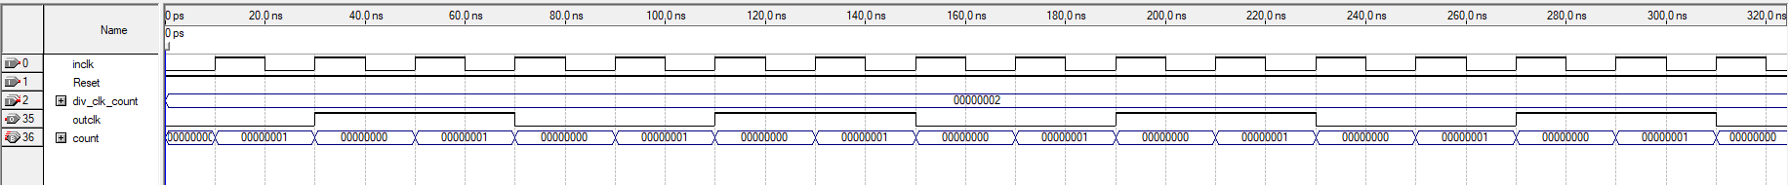
The first screenshot shows the clock divider simulated with an input of `div_clk_count == 2`, meaning `outclk` is high for 2 periods of `inclk` and low for 2 periods. We also see that `count` is being incremented and reset properly – being incremented by 1 per `inclk` cycle from 0 to `div_clk_count - 1` and reset to 0 after it equals `div_clk_count - 1`.
The second screenshot shows the clock divider simulated with an input of `div_clk_count == F`, showing the circuit works with different count inputs. In this simulation `count` is incremented from 0 to 14 by 1 per `inclk` cycle. The `outclk` changes every time `count` is reset such that it is high for 15 periods of `inclk` and low for 15 periods after.

- Tone organ
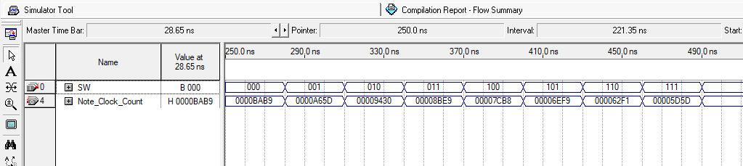
This simulation displays that the correct Note_Clock is output for every possible input of SW[3:1]

- LED circuit
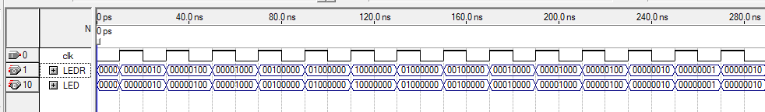
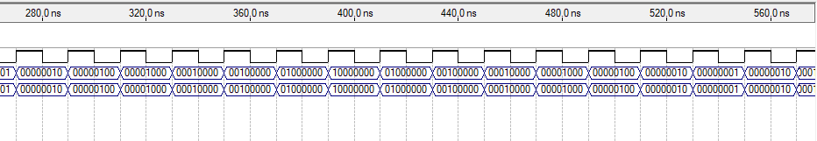
This simulation shows that the output changes every clock cycle and cycles the one hot output from left to right repeatedly.

- Annotated SignalTap screenshots as required by the lab
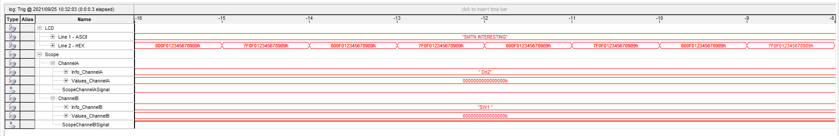

- Information on how to run the simulations (i.e. where the files are located, which program you used to run your simulation)
Simulation files are found under the `../sim/` directory. There are three separate folders for three separate modules named Clock_Divider, Note_Clock_Frequency, and LED_Controller. Each folder has a .qpf project file that can be opened in Quartus 9.0sp2 named Gen_Clock_Divider.qpf, Gen_Note_Clock_Frequency.qpf, and LED_Controller.qpf respectively. Each folder also has a respective .vwf waveform file.

- Any additional information that would be relevant for the TA marking your project.

