Lab 5 README Stella Wang (#38522637)
Amir Ali Barkam (#22041230)

- Where (which directory path) is your SOF file located, and what it is called
`dds_and_nios_lab_time_limited.sof` in `~/rtl`.

- What is the status of the lab (what works, what doesn't)
Everything working

- Annotated simulation screenshots as required by the lab
LFSR
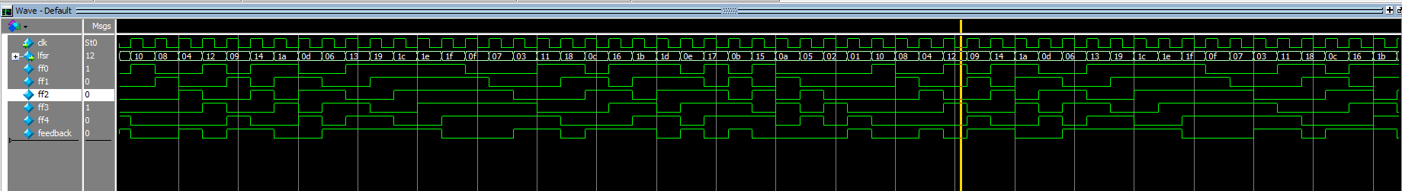
- The sequence repeats after 31 values
- The lfsr output matches the PN5 sequence in the lab handout
DDS
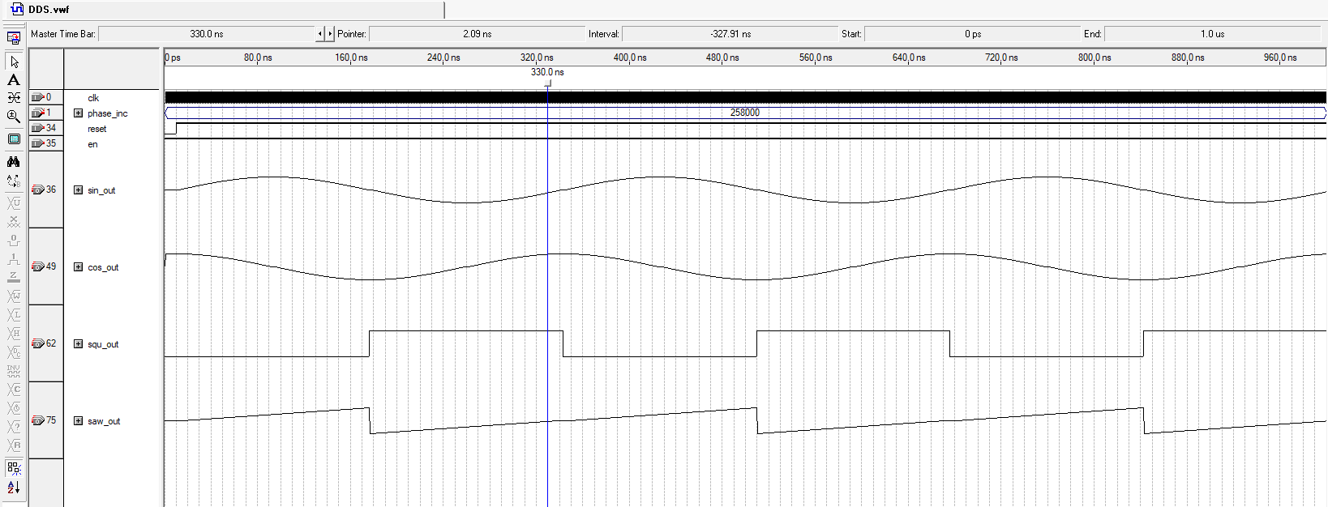
- The sin_out output looks like a sin wave, cos_out is a cos wave, squ_out is a square wave and saw_out is a proper saw wave.
Clock Domain Crossing
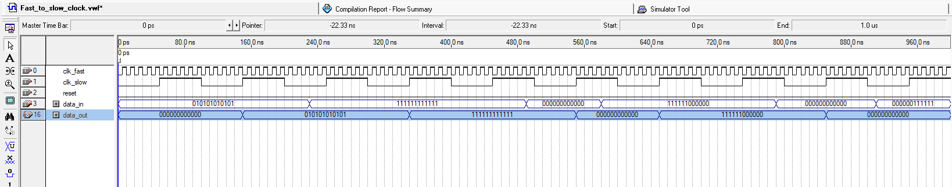
- The correct data_in value is passed to data_out on clk_slow posedge

FSMs
- Annotated SignalTap screenshots as required by the lab
LFSR
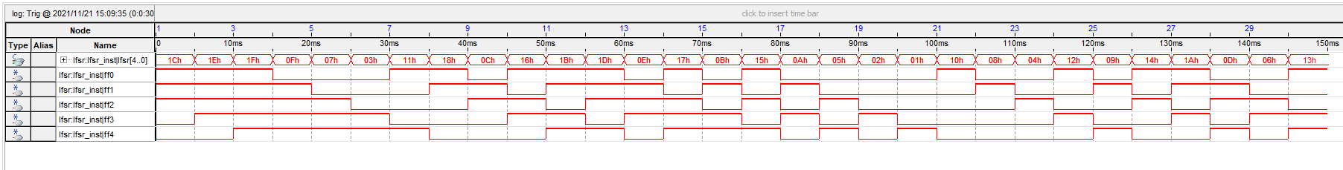
- The sequence repeats after 31 values
- The lfsr output matches the PN5 sequence in the lab handout

DDS
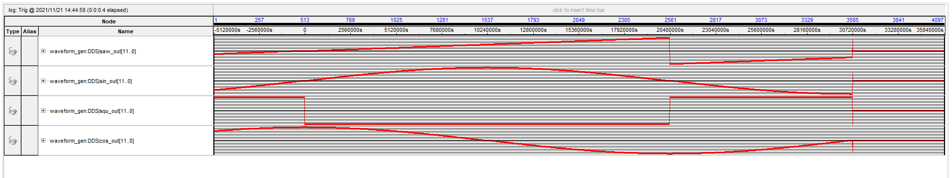
- The sin_out output looks like a sin wave, cos_out is a cos wave, squ_out is a square wave and saw_out is a proper saw wave.

Clock Domain Crossing
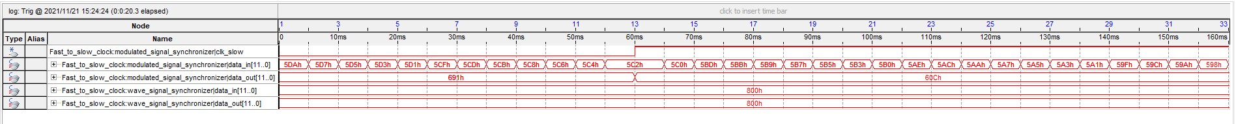
- Data_out is only passed new values on slow clock posedge
FSMs
- Information on how to run the simulations (i.e. where the files are located, which program you used to run your simulation)
Testbenches for quartus 9 can be found under in the `sim` folder under the corresponding folder for each FSM module.
Signal tap file is located at `rtl/lcd_scope.stp`

- Any additional information that would be relevant for the TA marking your project.

