Context:  
 *At the 2023 yearly meeting of Landelijk Coördinatiepunt Research Data Management (LCRDM) first Valentijn Gilissen, Senior Data Manager, Preservation Officer, Data Steward,* [*Data Archiving and Networked Services*](https://dans.knaw.nl/nl) *(DANS, KNAW) presented about mostly technical challenges on file formats, after which I was invited to continue on the unruly behaviour of researchers and their surroundings …*

Memorable conversations  
I (Thinking) had over the years,  
with researchers and surroundings,  
  
suggesting many people could use a  
**more people- and data-centric view**,  
less application-centric.

And some suggestions to help that.  
[**sheet explanations**](https://raw.githubusercontent.com/steltenpower/PowerGists/main/withSheets.txt)

X doesn't work

Thinking What browser ?

Eh …

ThinkingTop left a blue e ?

Colleagues use different apps

Thinking File type in common ?

File what ?

**…**

Thinking How's your data structured ?

With colors[.](https://datacarpentry.org/spreadsheet-ecology-lesson/)

Can't find so-called CSV file

Thinking Same name with Excel icon ?

Ah

[Archive says](https://dans.knaw.nl/en/file-formats/) files wrong

Thinking See me tomorrow

Starting new job then

Can you convert these MP4s ?

Thinking [Maybe](https://www.ffmpeg.org/). It's video, not MP4

Typing same again, waiting forever, repeat

Thinking No API to automate with ?

What ?

Got SPSS files. Where's SPSS ?

Thinking Can hunt it down. Seen [R](https://www.universiteitleiden.nl/en/news/2023/04/goodbye-spss-hallo-r-now-we-can-help-students-who-like-statistics-to-excel) ?

No. Difficult ?

Thinking I can help

We don't have Rstudio they say

Thinking They list contracts only

FAIR’s interoperability seems infinite

Thinking Interop layered yes, start debugging

what's this ‘open standard’ ?

Thinking Lengthy doc specifying truth

File not valid ? Works For Me

Thinking For now. Validate !

**…**

Thinking Can I find a list of all data ?

Here's our application landscape image

Thinking Heard of [Data-Centric Manifesto](http://datacentricmanifesto.org/) ?

As Linked Data, quality issues would show

Thinking Sounds like an opportunity

Metadata for science,  
but what's MY advantage NOW ?

Thinking  Well, …

CONCLUSION:  
  
People not dumb,  
but smart (trying) to focus elsewhere

Let's allow them a hyper-focused flow

USUAL Yes:  
  
- 1-stop shop  
- Prevent over cure  
- DMPs and DataStewards YesYes  
- [Carpentries](https://carpentries.org), to speak common concepts  
- e-Notebooks for team science value  
 (see next sheet: “**Rock Paper Sci**ence-Notebooks”)

[3 minute video,](https://wiki.surfnet.nl/pages/viewpageattachments.action?pageId=59803702&preview=/59803702/65242021/ELN%20-%20V2-1080p-220420%20edit2.mp4) *[DCC - Praktijkgericht Onderzoek](https://wiki.surfnet.nl/pages/viewpageattachments.action?pageId=59803702&preview=/59803702/65242021/ELN%20-%20V2-1080p-220420%20edit2.mp4)*

UNHASSLE more !

- ambient findability:  
find just before search

- power & top usability

**- 4 suggestions** next

**fairly:**  
Git-like connection to data-repo's  
[github.com/ITC-CRIB/fairly](https://github.com/ITC-CRIB/fairly)



Enrich ANY list of files, in ANY tool with  
  
**format**: open? Preferred? Valid file? **icon**

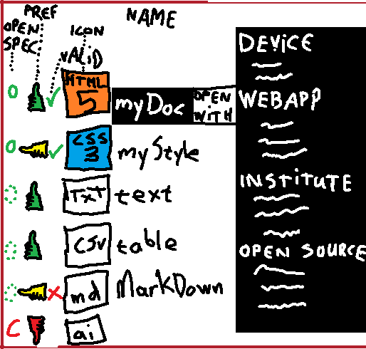  
**Open With**:  
- on device: a, b, c, d  
- web(app): e, f, g, h  
- institute/SURF: i, j, k, l  
- OS site: m, n, o, p

A data view on  
(open-ended-by-design) ‘**software lists’**:

|  |  |  |  |  |  |
| --- | --- | --- | --- | --- | --- |
|  | ORCID | Mendeley | Zotero | Rstudio | DANS |
| Path/URL |  |  |  |  |  |
| File types |  |  |  |  |  |
| Vocab’s |  |  |  |  |  |
| API |  |  |  |  |  |
| Backup |  |  |  |  |  |
| Open source |  |  |  |  |  |
| SUPPORTx |  |  |  |  |  |

**graphs**: networks of (meta)data

FAIR

[LOD-cloud](https://lod-cloud.net/) / LOV

OpenAlex: works, authors, sources, institutions, **concepts**, publishers, and funders.

serendipity[.](https://github.com/steltenpower/Train-Of-Thought)

Please help sharpen thoughts and tools[.](https://htmlpreview.github.io/?https://github.com/steltenpower/PowerGists/blob/main/IFAR.html)

Thanks,

Ruud Steltenpool, hogeschool Saxion

r.g.steltenpool@s......nl