Data representation 7–10
Data is information that is collected, organised and analysed for various purposes. The ability to collect, organise, interpret, represent and analyse data is important for informed decision-making, problem-solving and critical thinking.
Data representations are different ways of organising and displaying data. A data representation can be in the form of numbers, text and/or images. Data representations enable the analysis and evaluation of data. Different methods of representing data can help visualise or interpret data based on the focus of analysis and/or evaluation.
Two common methods of data representation are data displays and statistical measures. Data displays are visual formats for organising, representing and summarising data. Data displays are also referred to as visualisations. Statistical measures are numerical values that summarise a dataset. They provide a way to describe the characteristics of a group of data points.
Across the 7–10 curriculum, students may be required to both interpret and produce data representations for a range of purposes and across different contexts.

Data quality and integrity
When teaching students about data representations, it is important to consider the quality and the integrity of the data used to form the representation.
To ensure accurate and meaningful data representation and analysis, the following should be considered.
Accuracy
Data should be correct and free of errors. Students should understand the importance of verifying that the data they are using, or the representation they are interpreting, accurately reflects findings and has not been altered or misrecorded.
Data accuracy includes considerations of data completeness. Students should check that datasets are complete and be aware of the impact of missing values. When generating their own data representations, students should present data in a way that avoids distortion or misleading interpretations.
Bias and objectivity
Students should be aware of and address potential biases in data collection or analysis and ensure that the data is presented objectively.
Consistency
Data should be consistent across sources or formats to allow for accurate representations. Mismatched units of measurement will result in flawed data representations.
Data privacy
Integrity also involves ethical considerations. If applicable, students may explore the importance of data privacy and ethical considerations when working with sensitive information.
Data validation
Students should evaluate the reliability and credibility of the data source to ensure accuracy. Reliable data comes from credible, accurate and unbiased sources.
Identifying anomalies
Students need to be able to recognise and address unexpected or inconsistent data points.

Supporting diverse learners
Data tables and graphs are powerful tools for communicating information, however they can present challenges for some learners who may require additional support to access, organise and understand information presented.
Considerations for teaching may include:
- explicitly teaching vocabulary related to data representation
- providing examples linked to student knowledge, experiences and interests
- providing high-resolution visuals that incorporate lines of sufficient thickness
- simplifying details and incorporating high-contrast clear images
- incorporating tactile graphics
- presenting data using 3D models or tactile objects
- using a screen reader, an assistive technology that reads on-screen elements as text-to-speech
- providing audio descriptions, or using electronic resources that can be read by screen readers
- annotated examples and non-examples to identify elements of effective data representation
- providing checklists and prompts to guide the processes of data collection and organisation
- providing scaffolds, including sentence starters and planning frameworks, to support interpretation of data
- guiding students to apply examples of data representation to demonstrate their understanding.
Some students with disability may require adjustments to engage with various forms and methods of data representation.
Data representations in the mandatory 7–10 syllabuses
Across the 7–10 curriculum, there are opportunities for students to engage with data. Whole school planning, sequencing and collaboration can support a consistent approach to data. There are a number of mandatory 7–10 syllabuses that explicitly address data in content.
Mandatory 7–10 syllabuses that explicitly address data in the essential content include:
- Geography 7–10
- Mathematics 7–10
- Science 7–10
- Technology 7–8.
To support a consistent approach to data across the 7–10 curriculum, the most common methods of presenting data displays and statistical measures are listed below.

Data displays
- Table
- Pictogram
- Column graph (and bar graph)
- Multiple (or side-by-side) column graph
- Compound column graph
- Sector graph
- Dot map
- Line graph
- Scatter plot
- Box plot
- Infographic
Statistical measures
- Mean
- Median
- Mode
- Range
- Standard deviation

Data displays

Table
A table is a visual representation used for organising data. It is an arrangement of information in rows and columns.
LGAs with the largest Aboriginal and Torres Strait Islander population
2021 LGAs | Count of Aboriginal and Torres Strait Islander Peoples | Percentage (%) of the Aboriginal and Torres Strait Islander state population | Percentage (%) of the total LGA population
Central Coast (NSW) | 17,047 | 6.1 | 4.9
Blacktown | 11,812 | 4.2 | 3.0
Lake Macquarie | 11,759 | 4.2 | 5.5
Penrith | 10,925 | 3.9 | 5.0
Dubbo regional | 9,101 | 3.3 | 16.6
Tamworth regional | 8,032 | 2.9 | 12.7
Newcastle | 7,410 | 2.7 | 4.4
Based on the usual place of residence. Excludes overseas visitors.

Conventions
- Title should be clear, concise and accurately reflect the content of the table.
- Columns and rows should have clear headers.
- Units of measurement should be included in the header for each column and row where applicable.

Working with tables | Subject-specific suggested application
Students:  - read and interpret information from tables  - identify units of measurement used, for example, millions, kilometres  - compare values across rows and columns  - record results from an observation, investigation or experiment  - add columns to a table to conduct numerical analysis. For example, calculating a percentage or the mean, or using a formula  - convert information from a table into another data display to visualise patterns and trends. | - Geography: read population data or comparing climate data from different regions  Stage 4  Liveability of places: Perceptions of liveability  - Methods used to measure, assess or rank liveability  - Mathematics: record results from a probability experiment  Stage 4  Probability: Determine probabilities for chance experiments  - Explore relative frequencies by using a random number generator to repeat a chance experiment a number of times  - Science: record results, for example, the time taken for a reaction when the temperature of reactants is varied  Stage 4  Working scientifically: Conducting investigations  - Record observations and measurements accurately, using correct units for physical quantities  - Technology: identify nutrient quantities in foods to meet the nutritional needs for individuals at different stages of their life  Stage 4  Food and agricultural practices: Identifying and defining food and agricultural practices  - Identify the characteristics and properties of food, fibre and agricultural products

Pictogram
A pictogram is a statistical graph for organising and displaying categorical data. Data is represented using a symbol with a specific value.
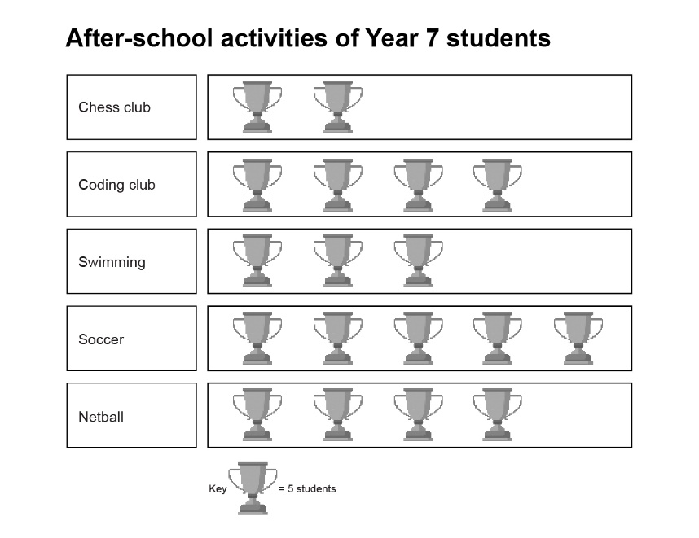
Figure 1: Example of a pictogram

Conventions
- Title should be clear, concise and accurately reflect the content of the pictogram.
- A key should be included to explain the meaning of the symbols used.
- Partial symbols may be used to show fractional quantities.
- Symbols used should not be scaled to represent value. The value of the category is shown by the number of symbols used.
Working with pictograms | Subject-specific suggested application
Students:  - identify what data is being represented  - interpret the meaning and value of the symbols used  - count the symbols and calculate the value of each category  - compare values between each category  - create pictograms to represent data, including calculating how many symbols are needed for each category  - analyse pictograms to identify trends and draw conclusions | - Mathematics: create a pictogram using knowledge of fractions  Stage 4  Data classification and visualisation: Display data using graphical representations relevant to the purpose of the data  - Represent single datasets using graphs, including frequency histograms and polygons, dot plots, stem-and-leaf plots, divided bar graphs, column graphs, line graphs, sector graphs and pictograms, with or without digital tools  - Technology: develop or interpret a pictogram that represents the number of available electric and hybrid vehicle brands in Australia  Stage 4  Engineering technologies and systems: Researching and planning ideas and solutions  - Use graphical communication techniques to present ideas for products and systems  Stage 4  Engineering technologies and systems: Testing and evaluating tools, materials, systems and technologies  - Evaluate engineering technologies and systems developed to improve sustainability

Column graph (and bar graph)
A column graph is used for organising and displaying categorical data. Rectangular columns are constructed for each category, with their height corresponding to the observed frequency or magnitude of the category.
A bar graph uses horizontal rectangular bars for each category. As with a column graph, rectangular bars are used, with their length corresponding to the frequency or magnitude of the category.
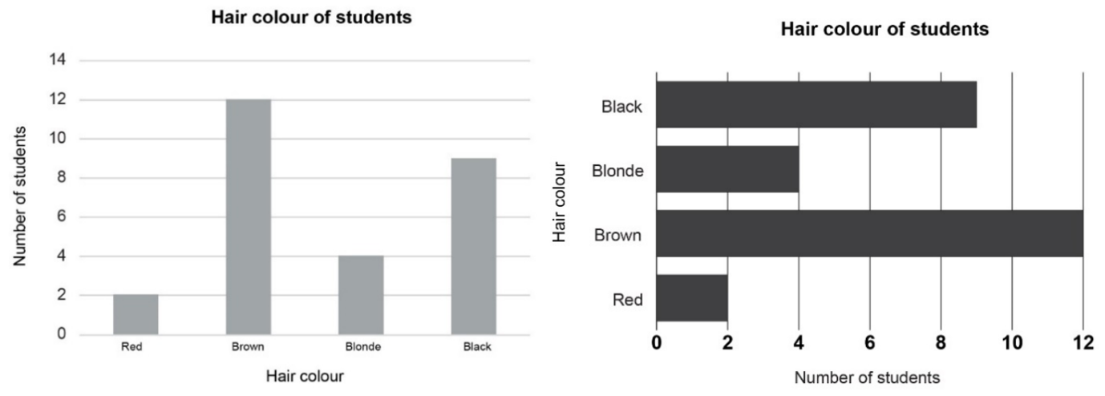
Figure 2: An example of a column graph and a bar graph

Conventions
- Title should be clear, concise and accurately reflect the content of the graph.
- Both the horizontal and vertical axes should be labelled with titles and units of measurement where appropriate.
- Columns/bars should be equal width and evenly spaced.
Working with column graphs | Subject-specific suggested application
Students:  - identify what data is being represented  - interpret the meaning and scale of the axes  - read the values represented by the bars accurately  - compare the heights/lengths of the bars to identify differences and trends  - create column/bar graphs to represent data, including choosing appropriate scales and labels for the axes  - analyse column/bar graphs to identify trends and draw conclusions. | - Geography: compare exports and imports between different countries and regions  Stage 4  Interconnections and trade: Trade flows  - The nature and spatial patterns of trade flows  - Economic, political and environmental influences that shape trade flows  - Mathematics: create a column/bar graph from collected survey data  Stage 4  Data classification and visualisation: Display data using graphical representations relevant to the purpose of the data  - Represent single datasets using graphs, including frequency histograms and polygons, dot plots, stem-and-leaf plots, divided bar graphs, column graphs, line graphs, sector graphs and pictograms, with or without digital tools  - Science: compare the energy efficiency of different appliances.  Stage 5  Energy: Electrical energy  - Investigate the energy star ratings of a range of appliances and explain the criteria used to determine these ratings

Multiple (or side-by-side) column graph
A multiple column graph can be used to organise and display the data that arises when a group of individuals or things are categorised according to 2 or more criteria, which allows for a direct comparison of their values in each category.
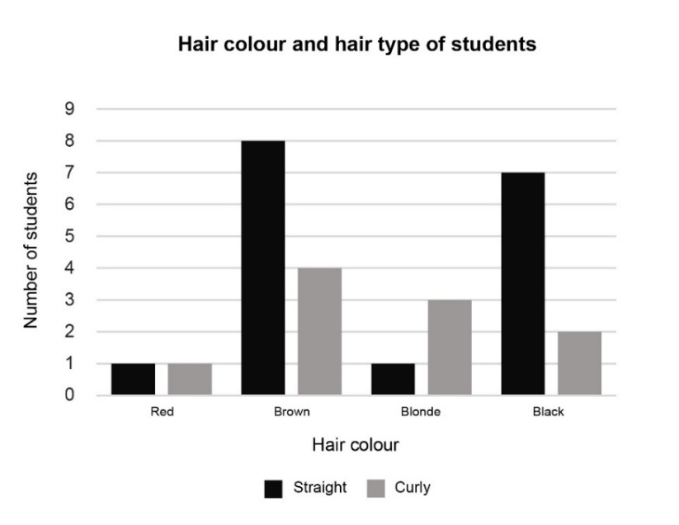
Figure 3: An example of a multiple column graph

Conventions
- Meets all the conventions of a column graph.
- A key should be included to indicate different criteria.
Working with multiple column graphs | Subject-specific suggested application
Students:  - identify what data is being represented  - interpret the meaning and scale of the axes  - interpret the key to identify the different criteria used  - read the values represented by the bars accurately  - compare the heights of the bars to identify differences and similarities  - create multiple column graphs to represent data, including choosing appropriate scales and labels for the axes  - analyse multiple column graphs to identify trends and draw conclusions. | - Mathematics: choose an appropriate scale when creating a multiple column graph  Stage 4  Data classification and visualisation: Display data using graphical representations relevant to the purpose of the data  - Include sources, titles, labels and scales when displaying data in a graph  - Science: measure the amount of salt or sugar that will dissolve in water at different temperatures and record on a graph.  Stage 4  Solutions and mixtures: Solutions  - Conduct and document a practical investigation to measure solubility of different solutes in water, and present data using tables and relevant graphs  - Technology: compare the volume and types of materials accepted at recycling centres to source materials for design ideas and solutions  Stage 4  Materials and production processes: Researching and planning ideas and solutions  - Compare sustainable sourcing practices

Compound column graph
A compound column graph displays data for groups of individuals or things categorised according to 2 or more criteria by stacking these data segments on top of each other in each category. This shows the total value for each category, as well as the contribution of each individual dataset to that total.
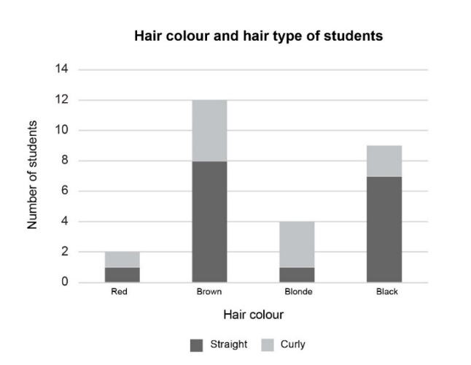
Figure 4: An example of a compound column graph

Conventions
- Meets all the conventions of a column graph.
- A key should be included to indicate different criteria.
- Measured variables have different colours or shading.
- Column height is the total of the measured variables for each category.
Working with compound column graphs | Subject-specific suggested application
Students:  - identify what data is being represented  - interpret the meaning and scale of the axes  - interpret the key to identify the different criteria used  - read the values represented by the bars accurately  - calculate the value of the different criteria accurately  - compare the heights of the bars, including the different criteria to identify differences and trends  - create compound column graphs to represent data, including choosing appropriate scales and labels for the axes  - analyse compound column graphs to identify trends and draw conclusions. | - Geography: interpret a compound column graph that displays the distribution of medical facilities in urban, rural and remote settlements across Australia’s states and territories  Stage 4  Liveability of places: Influences and impacts on liveability  - Access to services and facilities that influence the liveability of places  - Mathematics: calculate the values of the different criteria in a compound column graph  Stage 4  Data classification and visualisation: Interpret data in graphical representations  - Identify and interpret data displayed on graphs  - Science: interpret a compound column graph to compare the type of waste going to landfill in each state and territory  Stage 5  Environmental sustainability: Environmental sustainability in context  - Discuss the link between human activity and one specific environmental pollution concern  - Technology: interpret a compound column graph representing the distribution of softwood and hardwood plantations across Australia’s states and territories.  Stage 4  Materials and production processes: Testing and evaluating tools, materials and technologies:  - Justify the selection and use of a range of tools, materials, techniques and technologies

Sector graph
A sector graph is a circular diagram divided into sectors. Each sector represents a specific category or group in a dataset. The size of each sector is proportional to the quantity or percentage of that category, providing a visual representation of the relative proportions.
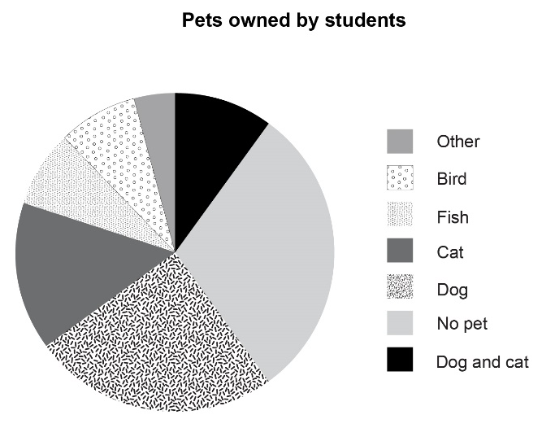
Figure 5: An example of a sector graph

Conventions
- Title should be clear, concise and accurately reflect the content of the graph.
- A key should be included to explain the meaning of each sector.
- Including labels and/or percentages for each sector is optional.
- The total of all sectors should add up to $360°$ or 100%.
Working with sector graphs | Subject-specific suggested application
Students:  - identify what data is being represented  - interpret the key to identify the different categories  - interpret the meaning of the sectors and how each category contributes to the whole  - read the values represented by the sectors accurately  - interpret proportions and relationships between categories  - calculate the size for each sector and use a protractor to accurately draw the sector graph  - create a sector graph using digital tools  - analyse sector graphs to identify trends and draw conclusions. | - Geography: display the percentages of renewable energy produced by different sources (such as solar, wind and hydro) in a country  Stage 5  Environmental change and management: Environmental case study  - Environmental management strategies to enhance sustainability in the selected environment  - Mathematics: create a sector graph for given data by calculating the angle of the sector and using a protractor to draw it  Stage 4  Data classification and visualisation: Display data using graphical representations relevant to the purpose of the data  - Represent single datasets using graphs, including frequency histograms and polygons, dot plots, stem-and-leaf plots, divided bar graphs, column graphs, line graphs, sector graphs and pictograms, with or without digital tools  - Science: interpret a sector graph that displays the sources of marine plastic pollution  Stage 5  Environmental sustainability: Environmental sustainability in context  - Discuss the link between human activity and one specific environmental pollution concern  - Technology: create a sector graph to categorise different types of community food initiatives in the local area  Stage 4  Food and agricultural practices: Researching and planning ideas and solutions  - Describe community food initiatives used to contribute to sustainability

Dot map
A dot map is a visual tool used to represent the distribution of data points across a geographic area.
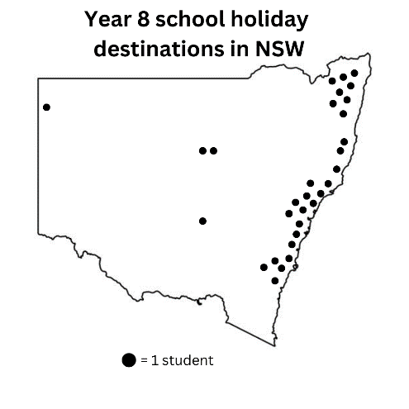
Figure 6: An example of a dot map

Conventions
- Title should be clear, concise and accurately reflect the content of the dot map.
- A key should be included to explain the meaning of the dots.
- The dots can represent one data point or a given quantity, and the size of the dots can vary to represent quantity.
- Dots can be multiple colours to represent different categories.
- The location needs to be specified.
- Some dot maps will include geographical or other features, such as roads or towns.
Working with dot maps | Subject-specific suggested application
Students:  - identify what data is being represented  - interpret the key to identify the meaning and value of the dots  - read the values represented by the dots accurately  - identify the scale of the dot map to understand the distribution of the data  - construct a dot map, where one dot represents a particular value  - analyse dot maps to identify trends and patterns  - draw conclusions by considering the relationship between the dots and the map features, such as proximity to transport. | - Geography: analyse the location, distribution, quantity and density of a population across different regions nationally and internationally  Stage 5  Changing places: Changing settlement patterns  - Differences in the spatial distribution of urban settlements in Australia and a selected country  - Mathematics: interpret a dot map by calculating the value represented by different-sized dots  Stage 4  Data classification and visualisation: Interpret data in graphical representations  - Identify and interpret data displayed on graphs  - Science: interpret a dot map that displays the distribution of endangered species  Stage 4  Living systems: Living systems in context  - Investigate factors that lead to a species becoming endangered or extinct to explain why Australia has some of the world’s highest rates of species population decline and extinction  - Technology: use a dot map to identify the distribution of accessible playgrounds across New South Wales  Life Skills  Engineering technologies and systems: Identifying and defining engineering technologies and systems  - Identify and communicate about engineering design ideas or solutions that improve everyday life

Line graph
A line graph represents the changing relationship between 2 variables. It uses lines to connect individual data points, and is generally used to show how something changes over time.
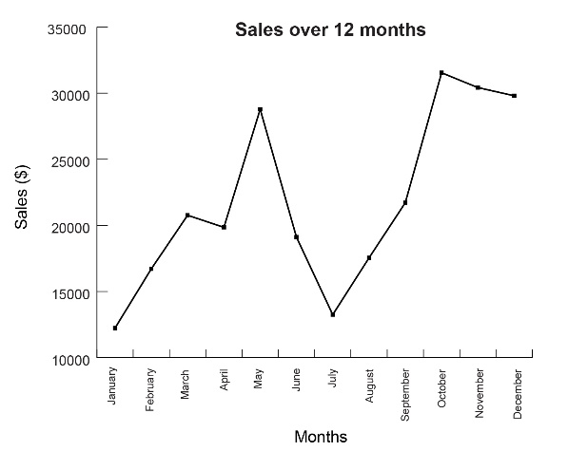
Figure 7: An example of a line graph

Conventions
- Title should be clear, concise and accurately reflect the content of the graph.
- Both the horizontal and vertical axes should be labelled with titles and units of measurement, if appropriate.
- Data points should be clearly plotted with a dot or cross.
- A line is drawn between each data point so that all data points are connected.
- Multiple line graphs representing different datasets can be graphed on the same axis. A key should be included to indicate what each line represents.
Working with line graphs | Subject-specific suggested application
Students:  - Identify what data is being represented  - Interpret the meaning and scale of the axes  - Accurately read the values represented by the data points.  - Interpret line graphs to understand the data and relationship between the 2 variables  - Create a line graph from collected or given data, including choosing an appropriate scale and accurately plotting the data points  - Analyse line graphs to identify trends and patterns and to draw conclusions.  - Compare the different line graphs of multiple datasets to identify similarities and differences in the data and draw conclusions. | - Geography: analyse rates of international migration to Australia over a set period of time  Stage 5  Changing places: Movement of people  - Characteristics and trends of international migration to Australia  - Mathematics: create a line graph from given data  Stage 4  Data classification and visualisation: Display data using graphical representations relevant to the purpose of the data  - Represent single datasets using graphs, including frequency histograms and polygons, dot plots, stem-and-leaf plots, divided bar graphs, column graphs, line graphs, sector graphs and pictograms, with or without digital tools  - Science: investigate and record the pH change during a neutralisation reaction  Stage 5  Reactions: Chemical reactions  - Use pH indicators or meters to measure the pH change of neutralisation reactions  - Technology: create a line graph using collected rainfall data from a weather station  Stage 4  Digital and communication technologies: Researching and planning ideas and solutions  - Collect, use and store data and information from a range of sources

Scatter plot
A scatter plot is a visual representation of bivariate numerical data that uses the position of each dot on the horizontal and vertical axes to indicate the numerical values for an individual data point. Scatter plots are used to observe relationships between variables.
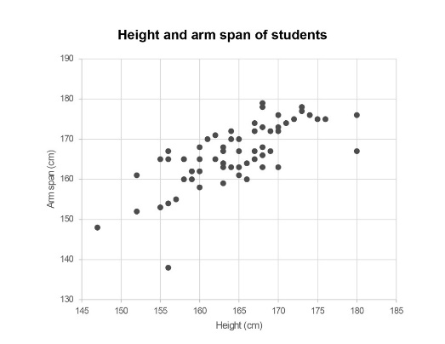
Figure 8: An example of a scatter plot

Conventions
- Title should be clear, concise and accurately reflect the content of the scatter plot.
- Both the horizontal and vertical axes should be labelled with titles and units of measurement.
- Should be of an appropriate scale with consistent divisions.
- Data points should be clearly plotted with a dot or cross.
- A straight line can be drawn through the centre of all data points (this is known as the ‘line of best fit’ or ‘trend line’).
Working with scatter plots | Subject-specific suggested application
Students:  - identify what data is being represented  - interpret the meaning and scale of the axes  - accurately read the values represented by the data points  - identify trends and patterns in the data  - assess the relationship between the variables  - interpret the slope and relationship between the variables if a line of best fit/trend line is present  - create scatter plots, including choosing an appropriate scale and accurately plotting the data points.  - analyse scatter plots to draw conclusions about the relationship between the 2 variables. | - Geography: explore correlations between water quality and life expectancy  Stage 4  Water in the world: Water resources and their value  - Global variations in the distribution, quantity and quality of water resources  - Mathematics: construct a line of best fit and analyse the relationship between 2 variables  Stage 5  Data analysis B: Represent datasets involving 2 numerical variables, using a scatter plot and a line of best fit, by eye  - Create a line of best fit, by eye, on an existing scatter plot  - Science: examine the relationship between light intensity and the rate of photosynthesis  Stage 4  Change: Chemical change  Conduct a practical investigation to model cellular processes, including respiration and photosynthesis, and document findings in a written report

Box plot
A box plot is a graphical representation that displays the 5-number summary of a set of data. The 5-number summary consists of a:
minimum value
lower quartile
median
upper quartile
maximum value.
The ‘box’ covers the middle 50% of scores between the lower and upper quartiles. The ‘whiskers’ extend to the maximum and minimum values in the dataset. A vertical line in the box is used to indicate the location of the median.
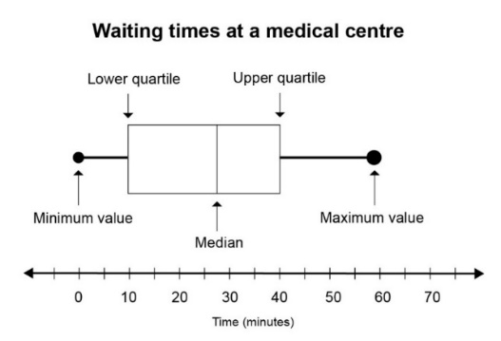
Figure 9: An example of a box plot

Conventions
- Title should be clear, concise and accurately reflect the content of the box plot.
- The axis should be labelled with a title and units of measurement.
- Multiple box plots representing different datasets can be graphed on the same axis.
Working with box plots | Subject-specific suggested application
Students:  - identify what data is being represented  - interpret the meaning and scale of the axis  - read the values of the minimum value, lower quartile, median, upper quartile and maximum value accurately  - interpret and draw conclusions about the spread of the data using the difference between the maximum and minimum values (range), and upper and lower quartiles (the interquartile range)  - compare multiple box plots to identify similarities, differences and trends.  - calculate a 5-number summary from a dataset to construct a box plot  - analyse box plots to draw conclusions. | - Mathematics: calculate a 5-number summary and drawing a box plot to represent the data  Stage 5  Data analysis A: Represent datasets using box plots and use them to compare datasets  - Represent numerical datasets using a box plot to display the median, upper and lower quartiles, and maximum and minimum values  - Science: compare the growth rates of plants grown in different types of fertiliser over a set period of time  Stage 4  Working scientifically: Analysing data and information  - Identify patterns and relationships in graphs, keys, models, diagrams, tables and spreadsheets  - Propose inferences based on presented information and observations

Infographic
An infographic is a chart, diagram or illustration (such as from a book, magazine or website) that uses graphic elements to present information in a visually engaging way.
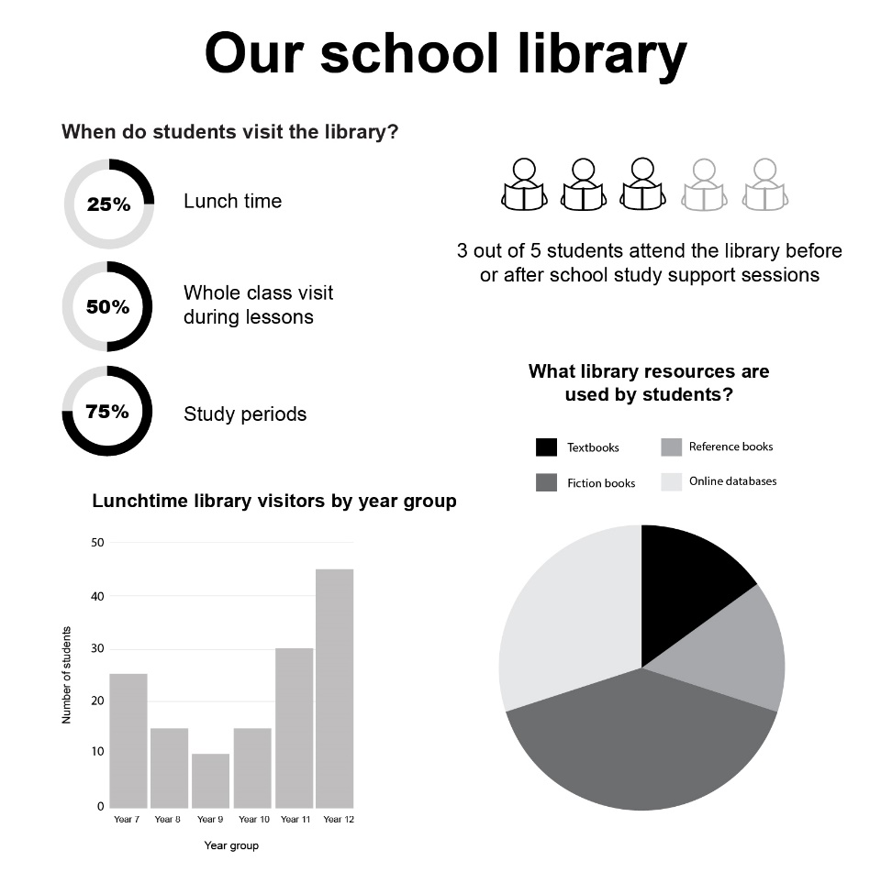
Figure 10: An example of an infographic

Conventions
- Title should be clear, concise and summarise the main topic or message of the infographic.
- Uses a variety of data representations to communicate information.
- Uses clear and accessible language.
- Includes references for data sources.
Working with infographics | Subject-specific suggested application
Students:  - interpret infographics, including by identifying key elements to understand the message  - identify the target audience  - select appropriate data representations to communicate the data  - organise the data so that it is engaging and easy to understand  - evaluate the effectiveness of an infographic, including the choice of data displays and statistical measures to communicate the message  - create an infographic, including by designing the layout and selecting appropriate data representations  - analyse infographics to draw conclusions. | - Geography: illustrate the causes and effects of climate change in Australia  Stage 5  Environmental change and management: Environmental case study  - Causes, extent and consequences of the environmental change affecting the selected environment  - Mathematics: create infographics using a variety of data displays and statistical measures  Stage 4  Data classification and visualisation: Display data using graphical representations relevant to the purpose of the data  - Represent a dataset using a statistical infographic and justify the choice of graphical representation used  - Science: communicate key data about renewable and non-renewable energy consumption in NSW  Stage 5  Energy: Sources of energy  - Evaluate the advantages and disadvantages of using renewable and non-renewable sources of energy to generate electricity, including efficiency, economical and technological considerations  - Technology: communicate data relating to sustainably sourced materials used in the design of outdoor camping hammocks  Stage 4  Materials and production processes: Researching and planning ideas and solutions  - Compare sustainable sourcing practices

Statistical measures
There are 2 main types of statistical measures.
- Measures of centre: a statistic that is used to summarise the centre of a dataset. The 3 common measures of the centre for a dataset are ‘mean’, ‘median’ and ‘mode.
- Measures of spread: a statistic that is used to summarise the spread of a dataset. The most used measures of spread are ‘range’ and ‘standard deviation’.
Outliers are data values that appear to stand out from the other members of a dataset by being unusually high or low. Outliers can have an impact on some measures of centre and spread. For example, if the ages of all people present in a Year 7 class were collected, the teacher's age would be an outlier. This is because it is significantly higher than the ages of the students, who are typically between 11 and 12 years old.

Measures of centre

Mean
The mean (or ‘average') is the sum of values in a dataset, divided by the total number of values in the dataset.
The mean is calculated by adding up all the scores in a dataset and dividing them by the total number of scores. For example:
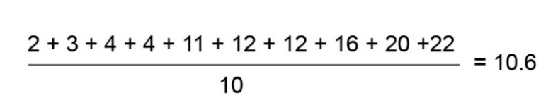
Figure 11: An example of a fraction to calculate mean

Key ideas | Subject-specific applications
The mean:  - is a central value that summarises a dataset  - can be used to make generalisations about a dataset and can be helpful in drawing conclusions  - is affected by the existence of outliers, so it might not be the most appropriate measure of the centre for a dataset. | - Geography: calculate and interpret the mean rainfall in different regions of Australia  Stage 4  Water in the world: Water resources and their value  - Hydrological processes that move water through a catchment area  - Mathematics: calculate and interpret the mean of a survey response  Stage 4  Data analysis: Calculate and compare the mean, median, mode and range for simple data sets  - Calculate the mean $\overline{x}$of a set of data using digital tools  - Calculate and describe the mean, median, mode and range of a dataset  - Science: calculate the mean temperature change for an exothermic reaction  Stage 4  Change: Chemical change  - Undertake experiments to identify the indicators of physical and chemical changes

Median
The median is the value (or ‘middle value’) in a set of ordered data that divides the data into 2 parts.
The median is determined by arranging the values from smallest to largest and identifying the middle value.
For an odd number of values, the median is the middle value.
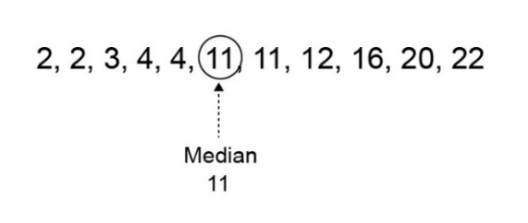
Figure 12: An example of the median in an odd number of values
For an even number of values, the median is between the 2 middle values.
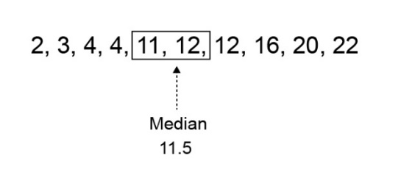
Figure 13: An example of the median in an even number of values

Key ideas | Subject-specific applications
The median:  - gives a central value that summarises a dataset  - is the middle value of the dataset, meaning that half the data points are above it and half are below it  - can be used to make generalisations about a dataset and can be helpful in drawing conclusions  - is less affected by the existence of outliers  - is often used in situations where outliers might significantly impact the mean, such as income distribution or real estate prices. | - Geography: compare populations of towns, cities or regions, where the median population would provide a better measure of typical size without being skewed by very small or very large populations  Stage 5  Changing places: Changing settlement patterns  - Differences in the spatial distribution of urban settlements in Australia and a selected country  - Mathematics: compare the median to other measures of centre to justify the most appropriate measure in a given context  Stage 4  Data analysis: Calculate and compare the mean, median, mode and range for simple datasets  - Classify the mean, median and/or mode as measure(s) of centre to represent the average or typical value of a dataset  - Describe and interpret data displays using mean, median and range  - Science: calculate the median reaction time for students in a class  Stage 5  Working scientifically: Processing data and information  - Calculate a range of descriptive statistics using SI units  Stage 5  Disease: Homeostasis  - Investigate examples of an organism’s observable response to stimuli  - Technology: test and record the median time of different marble runs  Stage 4  Engineering technologies and systems: Researching and planning ideas and solutions  - Collect data and information to develop engineered solutions

Mode
Mode is the most frequently occurring value in a set of data. There can be one, or more than one, mode.
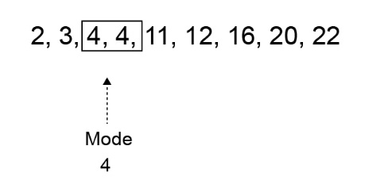
Figure 14: An example of a dataset with one mode
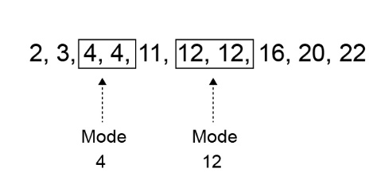
Figure 15: An example of a dataset with more than one mode

Key ideas | Subject-specific suggested application
The mode:  - gives an indication of the most common value in a dataset  - can be useful for identifying the most common characteristic or most popular choice. For example, the most popular flavour of ice cream sold. | - Mathematics: compare the mode to other measures of centre to justify the most appropriate measure in the given context  Stage 4  Data analysis: Calculate and compare the mean, median, mode and range for a simple dataset  - Classify the mean, median and/or mode as measure(s) of centre to represent the average or typical value of a dataset  - Describe and interpret data displays using mean, median and range  - Science: use the mode to determine the most common pH value in an ecosystem based on soil samples  Stage 4  Living systems: Ecosystems  - Identify the components that make up an ecosystem

Measures of spread

Range
The range is the difference between the highest and lowest values in a dataset.
It is calculated by subtracting the lowest value from the highest value.
$$Range= highest value-lowest value$$

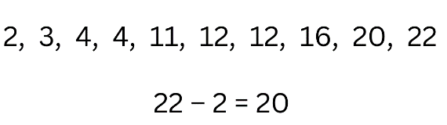
Figure 16: An example of how to calculate the range from a dataset

Key ideas | Subject-specific suggested application
The range:  - provides a simple measure of how widely the data points are distributed  - can be larger, which indicates greater variability (a larger spread), or smaller, which indicates less variability (a smaller spread)  - is affected by the existence of outliers. | - Geography: calculate the temperature range from climate data for a specific location  Stage 4  Liveability of place: Perceptions of liveability  - Environmental, social, economic and political factors that affect the liveability of places  - Mathematics: assess the variability of a dataset  Stage 4  Data analysis: Calculate and compare the mean, median, mode and range from simple datasets  - Identify the range as a measure of spread to describe variation in a dataset  - Science: identify the effective temperature range for a catalyst  Stage 5  Reactions: Rate of chemical reactions  - Investigate and explain how concentration, surface area, temperature and catalysts affect the rate of reactions  - Technology: calculate the range of thread counts in different fabrics to determine the suitability of a fabric for an identified end use  Stage 4  Materials and production processes: Testing and evaluating tools, materials and technologies  - Justify the selection and use of a range of tools, materials, techniques and technologies

Standard deviation
Standard deviation is the measure of the variability, or spread, of a dataset. It provides an indication of the degree to which individual data values are spread around their mean.
Standard deviation measures how spread out the data points are from the mean. Understanding the formula to calculate standard deviation is not necessary in 7–10.
Students can use a scientific calculator or spreadsheet to calculate this measure for a dataset.
Key ideas | Subject-specific suggested application
The standard deviation:  - measures how much the data points deviate from the mean on average  - can be larger, indicating greater variability (a larger spread), or smaller indicating less variability (a smaller spread)  - is less affected by outliers than the range. | - Mathematics: compare datasets by calculating the standard deviation to provide a standardised measure of variability that allows for meaningful comparisons between groups or populations  Stage 5  Data analysis A: Examine standard deviation as a measure of spread  - Identify standard deviation as a measure of spread  - Calculate the standard deviation of a small dataset using digital tools  - Compare small datasets using standard deviation  - Science: analyse the age of onset for a particular disease to determine how it affects different age groups, noting that a small standard deviation means the disease primarily affects people in a specific age range, while a large spread suggests it affects a broader age group  Stage 5  Disease: Infectious and non-infectious diseases  Investigate data relating to a common non-infectious disease affecting Australians today

Australian Bureau of Statistics (2022) New South Wales: Aboriginal and Torres Strait Islander population summary, Australian Bureau of Statistics, accessed 01 October 2024. https://www.abs.gov.au/articles/new-south-wales-aboriginal-and-torres-strait-islander-population-summary.

