Science 7–10 (2023): Stages 4 and 5 – Advice on numeracy

Numeracy across the curriculum
Numeracy involves understanding and applying mathematical knowledge and skills in a wide range of contexts. The application of mathematics across the curriculum enriches the study of other learning areas and helps to develop a broader and deeper understanding of numeracy.
A numerate person (Hogan 2000) uses a blend of:
- mathematical knowledge: concepts and skills within mathematics
- contextual knowledge: to recognise and link mathematics to broader situations
- strategic knowledge: to apply mathematics in situations and evaluate if the solution is reasonable.
Numeracy is a fundamental skill that strengthens learning across all NSW Curriculum areas. While Mathematics provides the foundation for explicit numeracy instruction, other learning areas also play a crucial role. These areas offer opportunities to contextualise, solidify and extend numeracy concepts as students embrace activities rich in numeracy demands.

Identifying opportunities for numeracy in Science 7–10
Students have opportunities to develop their numeracy capability as they investigate concepts fundamental to science. Below are examples of how mathematical knowledge and skills can be addressed in Science 7–10.

Example 1: Using estimation and measurement in scientific investigations (Stage 4)
Focus areas | Observing the Universe  Working scientifically
Syllabus content | - Make relevant observations and measure quantities, including length, mass, temperature and volume  - Make observations using the senses to compare properties of objects, living things and events  - Use a variety of analog and digital measuring devices in scientific investigations to compare the range, sensitivity and accuracy of observations provided by those instruments  - Compare and contrast the accuracy and reliability of observations made using the senses with those obtained using measuring equipment
Possible teaching and learning activity | The teacher conducts a short pre-assessment activity to determine student understanding and skills in estimation and measurement. The teacher leads a discussion on the importance of both accuracy and precision in measurement, highlighting the role of estimation in providing a quick reference to identify potential anomalies during measurement. The discussion should emphasise that inaccurate measurements can lead to misleading results, making it difficult to draw valid conclusions.  The teacher introduces the activity of measuring the volume of water. Students share their knowledge about the units of measurement that are used in volume, including millilitres (mL) and litres (L). The teacher presents students with 2 large containers with different amounts of water in each. Students use different methods to estimate the volume of the containers, such as hefting or comparing the volume to a familiar object such as a drink bottle. Students then record these estimations.  Students are shown how to read and calculate measurements on a range of measuring devices, applying knowledge of fractions and decimals. In small groups, students use different measuring devices to measure the volume of the water. Students record their measurements and compare their results from the different devices and their estimations.  The teacher leads the class in a discussion about the results for the volume investigation. Prompts for discussion could include the differences between the estimations and measurements, comparing the results of using the different measuring devices and discussing the appropriateness of each measuring device.
Key mathematical knowledge and skills | A student:  - estimates a measurement based on a number of uniform informal units  - identifies appropriate metric units to use according to the level of precision required  - uses scaled instruments to measure volume, correctly interpreting any unlabelled calibrations.  Relevant Mathematics K–10 focus areas:  - Volume (Stage 4)

Example 2: Using formulas to calculate force and mass (Stage 4)
Focus area | Forces
Syllabus content | - Define weight force as the mass × the acceleration due to gravity $\left(g\right)\left(F=mg\right)$  - Perform calculations using the equation $F=mg$to solve for unknowns
Possible teaching and learning activity | Students explore concepts of force and mass and perform calculations using the formula $F=mg$. The teacher conducts a pre-assessment activity inviting students to share their knowledge of substitution and find unknown values by using a formula. This activity informs the level of support that students will need to use the formula $F=mg$.  The teacher leads a discussion about the concepts of force and mass. The teacher explicitly instructs students how to use the formula to determine weight force. In small groups, students choose different classroom objects. Using a measuring device such as digital scales, students measure the mass of an object. The teacher demonstrates how to use the formula to calculate weight force. Students perform their own calculation, for example:  - The mass of a student’s pencil case is measured to be 0.3 kg using an electronic balance. What is the weight force of the pencil case? (Answer to the nearest whole newton.)  Using a spring balance or Newton meter, students measure the force (in newtons) that these objects exert when suspended and record this weight force. The teacher demonstrates how to use the formula to calculate mass. Students then perform their own calculation, for example:  - Students measure the weight force of a pencil case using a force meter as 4 N. Calculate the mass of the pencil case (answer to 1 decimal place).
  Write the formula | $$F=mg$$
  List the known values | $$m=0.3 kg$$  $$g=9.8 {ms}^{-2}$$
  Substitute the known values | $$F=0.3×9.8$$
  Evaluate | $$F=2.94$$
  Round the answer to the nearest whole newton | $$F=3$$
  Answer the question | The weight force of the pencil case is $3N$
  Write the formula | $$F=mg$$
  List the known values | $$F=4 N$$  $$g=9.8 {ms}^{-2}$$
  Substitute the known values | $$4=m×9.8$$
  Make $m$ the subject of the equation using inverse operations | $$4=m×9.8$$  $÷9.8$ $÷9.8$  $$4÷9.8=m$$
  Evaluate | $$0.408…=m$$  $$m=0.408…$$
  Round the answer to 1 decimal place | $$m=0.4$$
  Answer the question | The mass of the pencil case is $0.4 kg$
Key mathematical knowledge and skills | A student:  - interprets and uses formulas that describe relationships in various contexts  - rounds decimals to the nearest integer, one or two decimals.  Relevant Mathematics K–10 focus areas:  - Equations (Stage 4)  - Fractions, decimals and percentages (Stage 4)

Example 3: Collecting and representing data to explore Ohm’s law (Stage 5)
Focus areas | Energy  Working scientifically
Syllabus content | - Measure and compare voltage and current at different points in series and parallel circuits  - Conduct an investigation to determine the relationship between voltage ($V$), current ($I$) and resistance ($R$), as described by Ohm’s law ($V=IR$)
Possible teaching and learning activity | Students explore concepts involved in electrical energy including voltage ($V$), current ($I$) and resistance ($R$) by collecting and representing data. Students investigate the relationship between $V$, $I$ and $R$ and establish Ohm’s law. The teacher conducts a short pre-assessment activity to determine student understanding of reading scaled measuring devices, drawing and constructing circuits, directly proportional relationships, and collecting and representing data.  The teacher demonstrates the correct use of an ammeter (connected in series) and voltmeter (connected in parallel) in a circuit.  In small groups, students set up circuits to record the voltage and current. Students identify the independent variable (voltage) and the dependent variable (current) for this investigation. Students adjust the voltage (using a variable power supply), recording the different values of current on the ammeter. To ensure accurate measurements, the power should be turned off between each reading to prevent the temperature of the wire from affecting resistance. The resistance of the circuit should remain constant throughout the experiment.  Students use their collected data to develop an equation to show the relationship between voltage and current. Students may need support to develop the equation.  Students graph voltage against current, for example:  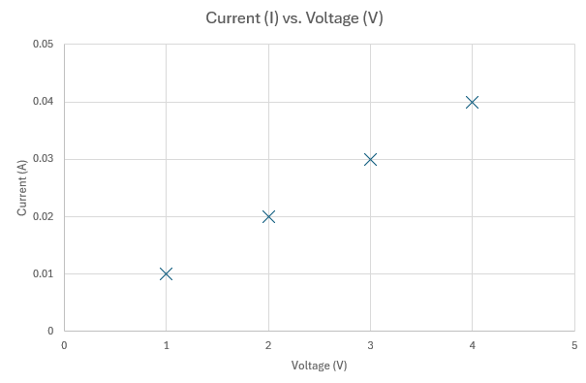  Figure 1: Voltage–current graph  Image long description: A graph illustrating current $(I)$ on the $y$-axis versus voltage $(V)$ on the $x$-axis. Points trend upwards along both axes, with the first point being 0.01 on the $y$-axis and 1 and on the $x$-axis, the second point is 0.02 on the $y$-axis and 2 on the $x$-axis, and so on.  Collaboratively students use their observations and scatterplot to draw conclusions about the relationship between voltage and current in a series or a parallel circuit. Students plot a graph of current ($I$) on the $y$-axis and voltage ($V$) on the $x$-axis. This graph will represent the directly proportional relationship between current and voltage (according to Ohm's law, $V=IR$), where the slope of the line will represent the constant resistance.  Students are guided to construct a line of best fit on their scatterplot and observe that the steepness of the line of best fit indicates the magnitude of the resistance. The teacher guides students to develop a mathematical representation of this relationship, that being Ohm’s law, where $V=IR$.  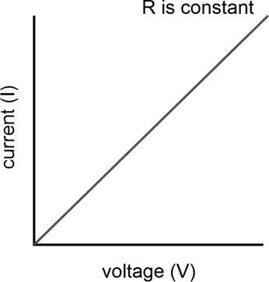  Figure 2: Ohm’s law graph  Image long description: A line graph illustrating Ohm's law, showing a straight line with a positive slope. The $x$-axis represents current $(I)$, and the $y$-axis represents voltage $(V)$. The line demonstrates a direct proportional relationship between voltage and current, indicating constant resistance $(R)$.
  Voltage $V$  (V) | Current $I$  (A)
  $$1$$ | $$0.01$$
  $$2$$ | $$0.02$$
  $$3$$ | $$0.03$$
  $$4$$ | $$0.04$$
Key mathematical knowledge and skills | A student:  - creates algebraic expressions to represent relationships  - plots relationships on a graph using a table of values representing authentic data  - describes and interprets the graphical features of linear growth in authentic problems  - identifies proportional relationships and uses proportional thinking flexibly to explore this relationship.  Relevant Mathematics K–10 focus areas:  - Data analysis B (Stage 5)  - Variation and rates of change A (Path) (Stage 5)  - Data classification and visualisation (Stage 4)

Example 4: Using data analysis to examine disease control and prevention (Stage 5)
Focus areas | Disease  Working scientifically
Syllabus content | - Analyse data about immunisation programs and the occurrence of infectious diseases to identify trends, patterns and relationships, and document conclusions in a written text  - Describe patterns and trends, including inconsistencies in data and information
Possible teaching and learning activity | Students will apply their knowledge and skills in data analysis to examine disease control and prevention. The teacher conducts a short pre-assessment activity to determine student understanding of statistical measures (e.g. mean, median, mode, range) and data displays.  The teacher presents the class with data that has been collected about the occurrence of an infectious disease that has an immunisation program, for example chickenpox (varicella). The teacher could also present students with the data about the vaccination rates of Aboriginal and Torres Strait Islander children as part of an immunisation program for disease control and prevention. Data on Australian childhood immunisation coverage can be found online.  Students analyse the data using statistical measures and data displays to determine the impact that the introduction of the varicella (chickenpox) vaccination in 2005 has had on the rate of hospitalisation. Students will identify trends, patterns and relationships, and will present this as a written report or presentation. For example:  - The mean number of hospitalisations for chickenpox decreased significantly after the introduction of the chickenpox vaccine in 2005. Between 1994 and 2005, the mean was 137.6 cases per year. However, after the vaccine was added to the Australian National Immunisation Program, the rate dropped from 146 cases in 2006 to 85.8 in 2007. From 2007 to 2016, the mean was only 33.4 cases per year, representing a decrease of 104.2 cases compared to the pre-vaccine mean.
Key mathematical knowledge and skills | A student:  - uses simple descriptive statistics such as mode, mean or median as measures to represent typical values of a distribution  - interprets and describes patterns in graphical representations of data from real-life situations  - investigates the association of 2 numerical variables through the representation and interpretation of bivariate data.  Relevant Mathematics K–10 focus areas:  - Data analysis B (Stage 5)  - Data classification and visualisation (Stage 4)  - Data analysis (Stage 4)

Example 5: Describing rates of chemical reactions (Stage 5)
Focus areas | Reactions  Working scientifically
Syllabus content | - Investigate and explain how concentration, surface area, temperature and catalysts affect the rate of reactions  - Conduct a practical investigation to test a measurable hypothesis, with a cause-and-effect relationship, that predicts changes to the rate of a chemical reaction, and graph data that communicates the investigation findings in a scientific report  - Describe relationships between variables
Possible teaching and learning activity | When investigating the rate of chemical reactions, students apply understanding of rates to explain how concentration, surface area, temperature and catalysts affect the rate of reactions. The teacher conducts a short pre-assessment activity to determine student knowledge of rates. Student responses should inform the activity.  The teacher clarifies that the rate of a reaction refers to how quickly a reaction occurs, typically measured by how much product is formed or how much reactant is used up over time. Students conduct a series of practical investigations to measure the rates of reactions. Students explain how concentration, surface area, temperature and catalysts affect the rate of reactions by describing the relationship between variables. For example:  - Surface area – the reaction between the same volume and concentration of hydrochloric acid (HCl) and the same mass of a range of different-sized marble chips (calcium carbonate – CaCO₃). As the surface area of the marble chips increases (e.g. by using smaller chips or powder), the rate of reaction with hydrochloric acid also increases.  The teacher guides students in graphing the rate of reactions. For example, when investigating how the surface area of marble chips affects the rate of reaction with hydrochloric acid, students can construct a graph to display the relationship based on their observations. The graph should plot the reaction rate on the $y$-axis (measured as volume of gas) and the elapsed time of reaction with the various surface areas of the marble chips on the $x$-axis, highlighting how an increase in surface area leads to a faster reaction.  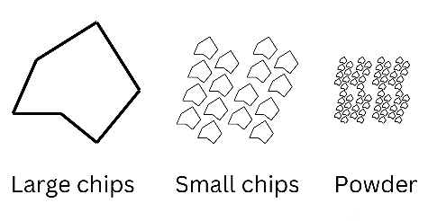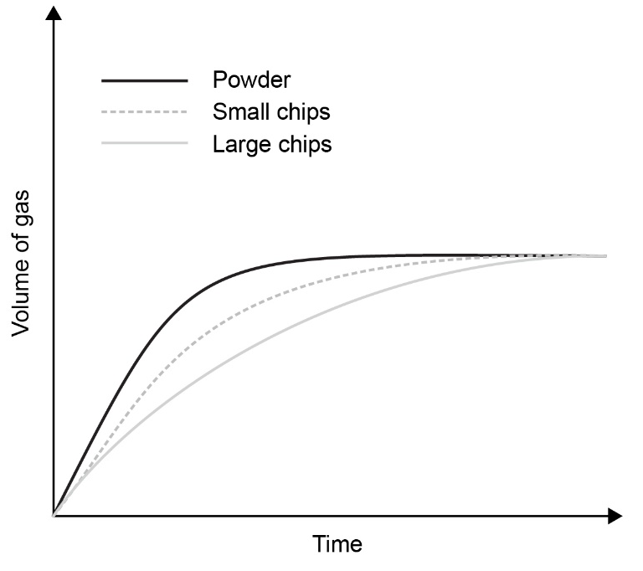  Figure 3: Different-sized marble chips and rates of reaction  Image long description: Images representing the different sizes of marble chips are shown from left to right. They are labelled ‘Large chips’, ‘Small chips’ and ‘Powder’. A graph shows the rates of reaction of each chip over time against the volume of gas. Powder reacted the fastest, followed by small chips and then the large chips.  Students explore how the graph visually communicates the relationship between the variables and the difference in the rate of reaction, for example:  - the time to completion for the reaction remains the same for each surface area (powder, small chips, large chips)  - the powder curve is initially steeper than the curve of the small chips, which is steeper than the curve of the large chips. This demonstrates that the reaction of the powder happens at a faster rate than that of the small chips, which reacts at a faster rate than the large chips  - the graph indicates that as the surface area of the marble chips increases, the rate of reaction with hydrochloric acid also increases.
Key mathematical knowledge and skills | A student:  - identifies, compares, represents and solves problems involving different rates in real-world contexts.  Relevant Mathematics K–10 focus areas:  - Variation and rates of change B (Path) (Stage 5)  - Ratios and rates (Stage 4)

Strategies for supporting numeracy
Strategies for supporting numeracy should be selected based on the learning needs of each student. Examples of strategies are listed below.
- Use mathematical terms while teaching and be explicit about their meaning: use mathematical terms from the NSW syllabuses in accordance with how they have been defined in the accompanying glossary (for example, ratio, scale). Be explicit about what the terms mean in relation to the subject. This reinforces understanding and supports students to connect key terms across different subjects.
- Model numeracy strategies: model the steps to use when undertaking a process or solving a problem, describing each step as you go.
- Create a positive classroom culture: encourage questions, perseverance and the value of learning from mistakes. Encourage students to share their thinking processes when using mathematical knowledge and provide opportunities for peer collaboration and support.
- Use visual representations and digital tools: encourage students to use visual representations like diagrams, graphs and charts, and tools such as calculators, spreadsheets and graphing applications to explore concepts and solve problems.

Supporting EAL/D learners
EAL/D learners may demonstrate varying levels of numeracy skill due to language and cultural considerations. Along with the strategies listed above, the following may be required:
- enabling students to use their home language or dialect to build their field of understanding when discussing concepts and contexts related to numeracy
- making connections between the grammatical structures of the English language typically used in mathematically worded problems and questions, and grammatical structures of their home language or dialect
- using culturally relevant and familiar contexts to support understanding
- building connections between familiar contexts and unfamiliar contexts.

Hogan J (2000) 'Numeracy across the curriculum', Australian Mathematics Teacher, 56(3):17–20.

