Science 7–10 (2023): Sample unit (Stage 5) – Energy
Sample units are provided by NESA to illustrate teaching, learning and assessment of syllabus outcomes and content. Teachers should refer to Curriculum registration and accreditation requirements and programming and record keeping advice for further information.
Unit title: What is energy? See – Sample scope and sequence: Sample scope and sequence: Stage 5
Duration: 10 weeks
Description: Students explore the different types of energy and how it can be stored, transferred and used to run everyday devices. They develop skills in observing and conducting investigations using electrical circuits to compare voltage, current and resistance in order to prove Ohm's law. Students learn how electrical energy flows through different types of circuits. They learn how to evaluate data so that they can make better energy choices in future.
Working scientifically processes:
  - Observing
  - Conducting investigations
  - Problem-solving.
Some resources and activities in this unit may need to be adjusted for students with vision impairment. This could include the use of 3D models and tactile graphics to interpret and represent data.
Outcomes | Subject-specific information
- SC5-EGY-01 evaluates current and alternative energy use based on ethical and sustainability considerations  - SC5-WS-01 selects and uses scientific tools and instruments for accurate observations  - SC5-WS-04 follows a planned procedure to undertake safe, ethical, valid and reliable investigations  - SC5-WS-07 selects suitable problem-solving strategies and evaluates proposed solutions to identified problems | This unit of work builds on the concept of Energy transfers in the Change focus area from Stage 4.  Change introduced students to the law of conservation of energy and included investigations relating to the transfer and transformation of energy. Students described systems that store energy and the cycle of energy within a system.  Students will build on the Working scientifically processes from Stage 4 using given evaluation criteria to select optimal solutions to problems.

Unit information

What is energy?
Syllabus content | Suggested teaching, learning and assessment
- Use the law of conservation of energy, and calculations, to explain that total energy is maintained in energy transfers and transformations in a closed system  - Explain efficiency in relation to energy transfers  - Explain how to improve energy efficiency in energy transfers and transformations  - Use the law of conservation of energy, and calculations, to explain that total energy is maintained in energy transfers and transformations in a closed system  - Explain efficiency in relation to energy transfers  - Explain how to improve energy efficiency in energy transfers and transformations | The teacher observes and assesses student’s prior knowledge of key concepts. This may take place through activities such as a class discussion or an online quiz. Key concepts include:  - the practice of science using the scientific method  - the importance of energy for doing work  - different forms of energy, including potential, gravitational potential, mechanical, chemical, elastic potential, nuclear, electrostatic, thermal  - how energy is stored  - energy transfers, including forces, electrical currents, heating (conduction, convection, radiation), waves (sound, electromagnetic, seismic, water)  - the law of conservation of energy, that is that energy cannot be created or destroyed, only transferred or converted  - collecting and analysing datasets.  Some students may benefit from further opportunities to revise and consolidate understanding before continuing.  Energy transfers and transformations  The teacher demonstrates a variety of energy sources to show energy being transferred and transformed through examples such as:  - a simple circuit with battery and light globe (electrical to light and thermal energy)  - air being released from an inflated balloon (elastic potential to sound and kinetic energy)  - a wind-up toy (elastic potential to sound and kinetic energy)  - a pendulum (gravitational potential to kinetic energy)  - burning a candle or a potato chip/cereal (chemical to heat and light)  - condensation trails in a cloud chamber (nuclear to kinetic to electrical to gravitational)  - Crooke’s radiometer (electromagnetic to thermal to kinetic energy)  - bouncing a ball on a racquet (gravitational potential to kinetic to elastic and sound)  - strumming a ukelele (chemical in muscles to kinetic to sound and thermal).  The teacher explains how the selected examples demonstrate the conservation of energy as it moves from one form to another.  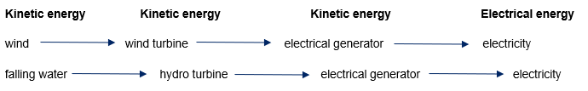  Students create labelled diagrams showing energy transfers. For example:  Figure 1: Transfer of kinetic energy to electrical energy  Image long description: A diagram showing the transfer of kinetic energy to electrical energy using the examples of wind and falling water. ‘wind’ appears under the heading ‘Kinetic energy’ with an arrow pointing to ‘wind turbine’. An arrow points from ‘wind turbine’ to ‘electrical generator’. An arrow then points from ‘electrical generator’ to ‘electricity’ which sits under a heading ‘Electrical energy’. ‘falling water’ appears under the heading ‘Kinetic energy’ with an arrow pointing to ‘hydro turbine’. An arrow points from ‘hydro turbine’ to ‘electrical generator’. An arrow then points from ‘electrical generator’ to ‘electricity’ which sits under a heading ‘Electrical energy’.  The teacher may provide feedback progressively to support student development of energy transfer diagrams.  Energy  The teacher introduces joules (J) as a unit that measures the amount of energy transferred or transformed. One joule is the energy needed (i.e. work done) in moving a force of one newton over a distance of one metre in the direction of the force. For energy to be conserved, the energy input to a system equals the output energy.  This can be written as a calculation:  - energy input $=$ energy output (which is written as E_{i} $=$ E_{o})  The teacher models a calculation involving energy transfers. For example, a light globe in a circuit where:  - electrical energy input $=$ E_{i} $=$ 100J  - thermal energy output $=$ 90J  - light energy output $=$ 10J  can be written as E_{i} $=$ E_{o} (that is, $100 = 90+10$).  These calculations can also be represented using a Sankey diagram which is scaled to represent the ratio of energy inputs to energy outputs. The teacher provides examples of closed systems and explains that although energy is conserved in closed systems, input energy may be transformed into less useful forms (for example, heat energy is not the desired energy for a light globe).  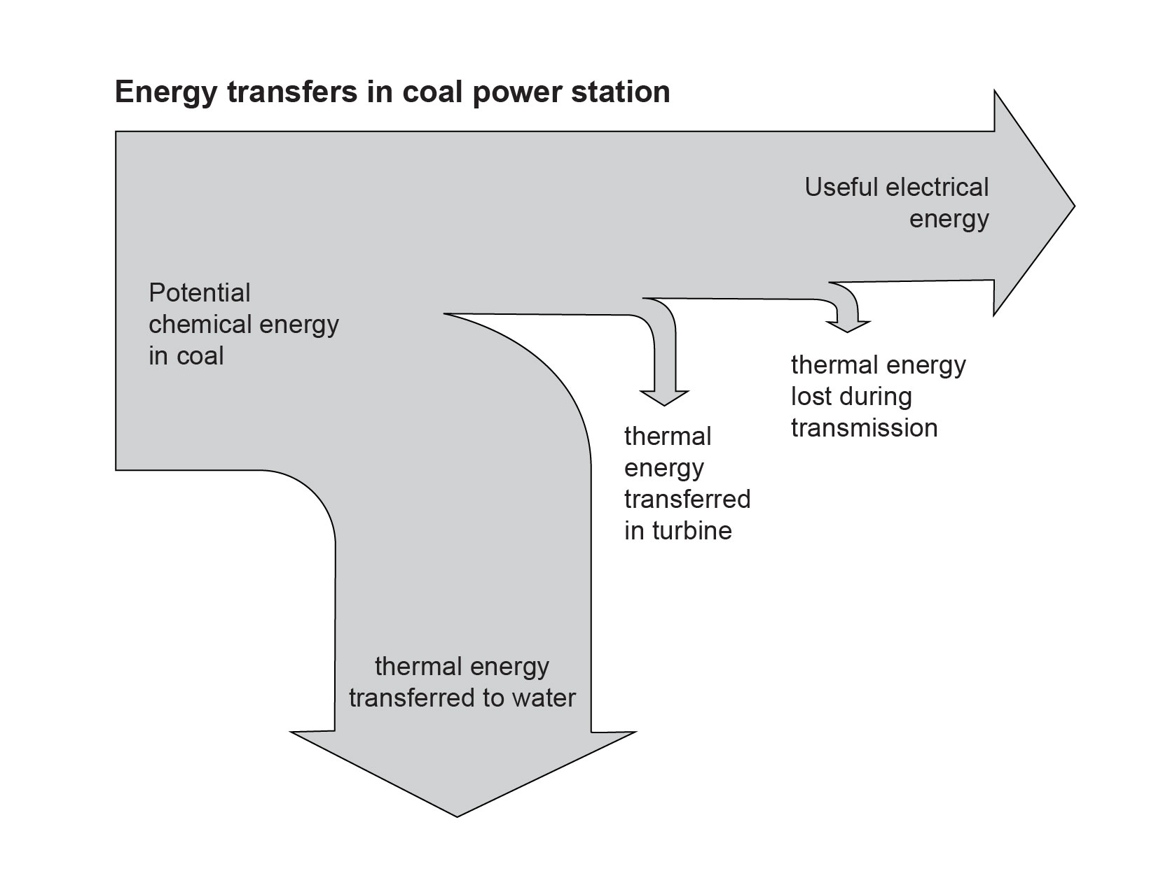  Figure 2: Energy transfers in coal power station  Image long description: A Sankey diagram that displays energy transfers in a coal power station. The text ‘Potential chemical energy in coal’ sits to the left of the arrow which splits into 2 directions; the end of the straight arrow pointing left to right contains the text ‘Useful electrical energy’ while the end of the arrow curving down from the left contains the text ‘thermal energy transferred to water’. Two smaller arrows branch off the straight arrow and point down; the first to the text ‘thermal energy transferred in turbine’ and the second to the text ‘thermal energy lost during transmission’.  Students complete calculations in pairs using algebraic techniques.  - 3000 MJ of chemical energy stored in coal is transformed to 1050 MJ of useful electrical energy. Calculate the energy lost in heat in the turbines and transmission lines.  - 10% of stored energy flows between trophic levels (refer to Science 7–10 Data Book). Calculate the amount of energy contained in leaves if caterpillars receive 5 J of energy from eating the leaves. Find the amount of energy lost as heat in this exchange.  - A speaker produces 5 J of useful sound energy for 200 J of electrical input. Find the amount of energy transformed to heat energy.  Students provide peer feedback on the calculations and develop their own calculations for other groups to solve.  The teacher checks student understanding of the conservation of energy and energy transfers by observing the calculations.  The teacher guides students to extend their understanding of energy inputs and outputs to consider the concept of efficiency. They introduce the below formula to calculate the efficiency of a device.  $$efficiency=\frac{total energy-waste energy}{total energy}×100$$  In pairs or small groups, students solve mathematical problems relating to efficiency, including rearranging the equation to solve for various unknowns.  Students plan and conduct investigations in the laboratory to model the impact of energy efficient features. For example, students could use dataloggers, multimeters, thermometers and stopwatches to find the impact on energy use for:  - modelling different window covering materials by placing them around a beaker with warm water  - modelling double and triple glazed windows using beakers placed inside each other in sunshine  - engaging in heat sink analysis by comparing materials and their ability to retain heat for passive heating  - comparing solar water heating using black hosepipe with electrical water heating with a filament  - comparing LED and incandescent lamp heat or light production in a closed system  - comparing a living green roof with regular roof material on a model house  - comparing different orientations of a passive solar design to show how orientation affects internal temperature.  Students create a report to communicate how to improve energy efficiency based on the data they have collected. In the report they can include:  - formulation of their predictions  - the systematic and accurate collection and recording of data, information, evidence and findings  - explained cause-and-effect relationships of features to improve efficiency and impact on energy use.  The teacher may provide a worked example of a report or develop one with students. Students can use this worked example as a success criteria for monitoring their own progress and generating informal, descriptive peer feedback. Some students may benefit from scaffolds to structure their report and/or a review of scientific terminology to facilitate communication.  The teacher evaluates the student investigations and written reports to check for student understanding of how to improve energy efficiency, as well as their ability to conduct investigations, make observations and solve problems.  Student learning can be extended by investigating devices which repurpose ‘waste’ energy. For example:  - energy capture from braking or a flywheel  - heat sinks to retain heat for passive heating  - Aboriginal Peoples’ use of waste hot coals and stones from fire being used to create an earth oven for roasting food  - energy return footwear.  Students can present the results of their investigation as a podcast, slideshow or educational video. When observing or making judgements about student learning and achievement, the teacher should be mindful of how forms of communication may influence the understanding or skills being assessed. If students present the results from their investigation in a specific communication form, the teacher should use all available information about student learning, including information gained prior to this point, to make judgements about progress and inform next steps in teaching and learning.
- Describe how electrical energy can be produced from different types of sources  - Evaluate the advantages and disadvantages of using renewable and non-renewable sources of energy to generate electricity, including efficiency, economical and technological considerations | The teacher guides students to brainstorm the origin of energy sources and reminds them that energy cannot be created or destroyed. Examples of energy sources include biogas, biomass, coal, crude oil, gas, geothermal, nuclear, solar, wind and tidal.  Students complete a matching activity to match the energy source with a description and then place each source under renewable or non-renewable headings. The teacher may refer to the Science 7-10 Glossary for definitions.  In groups, students create a working model to demonstrate the production of electrical energy using one type of energy source. For example, a hand-powered generator, solar circuit, wind turbine, hydroelectric circuit or solid fuel steam engine. The teacher guides students to use valid and reliable information sources and shows students how to cite these sources using an accepted method. An expert from each group describes the way their model represents the processes involved in the production of electrical energy before returning to their own group to share their learnings.  The teacher observes and provides feedback to prompt students to reflect on and assess their models and the effectiveness of their knowledge exchange process.  The teacher shares information, data and statistics with students to introduce the idea that increases in the human population and their standard of living is linked to increased demand for electrical energy. The teacher explains how to evaluate a statement by using scientific evidence to make an informed judgement. A scaffold can be provided for students to record research and sources, and the teacher models how to use the scaffold to develop an evaluation.  In pairs or small groups, students use the scaffold to record and organise research about:  - differences between non-renewable and renewable energy sources  - different electrical energy production techniques (using the jigsaw activity learnings)  - the relative and absolute efficiency of different energy production techniques  - economic and technological considerations, including:  - the age of current infrastructure and time until decommissioning  - the lead-in times to develop full capacity for new production  - transport and transmission costs for electrical energy  - the impact of new development on residents and the environment  - managing construction and maintenance of new production  - accounting for environmental impacts.  Students present their evaluation in an individual or collaborative digital presentation.  Students take part in peer review and use peer feedback to improve their content. This feedback may be:  - verbal  - supported by descriptive checklists  - promoted through collaboration exercises.  The teacher observes student learning and levels of understanding regarding the production of electrical energy, and the advantages and disadvantages of renewable energy. Some students may require further support in how to evaluate information about energy from sources before proceeding to next steps in teaching and learning. This ensures that teaching is targeted to assess the aligned content for this activity.
- Identify the elements of a complete circuit  - Construct circuits and draw circuit diagrams that contain several components to show the flow of electricity through a complete circuit  - Measure and compare voltage and current at different points in series and parallel circuits  - Conduct an investigation to determine the relationship between voltage ($V$), current ($I$) and resistance ($R$), as described by Ohm’s law ($V=IR)$  - Conduct an investigation to compare the energy transformed over time in model circuits or appliances  - Investigate the energy star ratings of a range of appliances and explain the criteria used to determine these ratings | The teacher shares the Science 7–10 Data Book with students and highlights the circuit symbols page. The teacher shows students the laboratory equipment which matches each symbol. They remind students that a complete unbroken path is required for current to flow and guide students to complete a risk assessment for circuit building (example in table below).  Risk assessment  In small groups, students design and construct a complete circuit using wires, light globes, batteries and switches to support their understanding of the required components of a complete circuit. Students draw the circuit diagrams using the correct symbols from the Science 7–10 Data Book.  Students can build on their understanding using online simulations to check the effectiveness of their circuit diagrams.  The teacher observes the safe construction of circuits and checks that circuit construction matches the diagrams, providing actionable feedback where needed. Some students may require consolidation of practical skills or worked examples to support next steps in this learning, especially regarding the use of circuit diagrams to accurately represent electrical circuits.  The teacher uses an analogy like water moving in a closed pipe system to introduce the concepts of current (‘flow of water’), voltage (‘water pump’) and resistance (‘restriction in the pipe’). Students access the Science 7–10 Glossary to record definitions and units for current, voltage and resistance.  The teacher models the correct use of an ammeter (in series) and voltmeter (in parallel) in a circuit and draws a circuit diagram for student groups to follow to construct a series and a parallel circuit.  In small groups, students set circuits, and record voltage and current at different points around the circuit. Students recognise that in a series circuit, the current at every point is the same, while the voltage across each load adds up to the source voltage. In a parallel circuit, the voltage across each path is the same, while the current in each path adds up to the current from the source. In pairs or small groups, students use their observations and experimentation to develop equations to show the relationships between voltage and current in a series and a parallel circuit.  The teacher checks the equations to determine student understanding of the relationship between voltage and current in circuits. Students may need scaffolding to develop the equations and worked examples to consolidate understanding.  Students construct a circuit and record the current through and voltage across an ohmic resistor. Students repeat the investigation for a range of input voltages. Students graph average voltage against average current and observe that the steepness of the line of best fit correlates with the magnitude of the resistance. Students are guided to develop a mathematical representation of this relationship (i.e. Ohm’s Law).  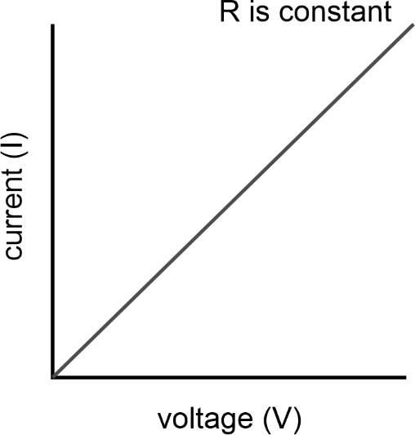  Figure 3: Graph of Ohm’s law  Image long description: A line graph illustrating Ohm's Law, showing a straight line with a positive slope. The x-axis represents current (I), and the y-axis represents voltage (V). The line demonstrates a direct proportional relationship between voltage and current, indicating constant resistance (R).  Students plan and conduct an investigation about energy transformation for components in circuits. For example, light globes transform electrical energy into heat and light energy, while buzzers transform electrical energy into sound and heat energy. Students use data loggers, light sensors, stopwatches and thermometers to take appropriate measurements. Students can compare the energy output of a component in joules with the electrical energy input. Students demonstrate their understanding using calculations and comparative charts.  Students may extend their understanding of energy transfers in circuits by immersing a heating coil in an insulated container of water (calorimeter) and calculating how much energy is transformed from electrical to thermal energy. Students use the specific heat capacity of water $(c=4.18Jg^{-1}{°C}^{-1})$ to determine output energy $q=mc∆T$ and the electrical power equation to find input energy. Students can compare the time taken for different heating effects and share their results using a written report.  Teachers check student calculations and conclusions to observe levels of understanding. In order to consolidate and extend on their knowledge and skills, students may benefit from being provided with clear labelled diagrams of the equipment needed, scaffolded results tables, and/or worked examples of problems.  Application of learning activity  The teacher may choose to use summative assessment of student achievement by providing students with a circuit component of unknown resistance and asking students to apply their knowledge and skills to experimentally determine the value of its resistance. This process could include designing and constructing a circuit, making observations and performing calculations using appropriate formulae. The teacher can combine observations about student achievement in this experiment with previous observations of student learning and progress related to their use of scientific tools and planned procedures to make observations.  Energy ratings  Students access the Australian Government’s Energy Rating website in pairs or small groups. They prepare a presentation on how the energy ratings for different devices are calculated and compare the efficiency of devices they use personally. The presentation should include calculations about usage, comparative charts and graphs, and take the form of:  - a digital presentation  - a poster  - an educational video.  Students view each presentation to understand links between particular features of a device and the efficiency of that device. Students share their views with other groups to develop a class set of energy efficiency features. The class builds on the set by accessing the Nationwide House Energy Rating Scheme (NatHERS) website to investigate a variety of ways to make homes and personal transport more efficient.  The teacher provides examples of informative articles to students as model texts. In pairs or groups, students create an informative article explaining how to make houses more energy efficient. Students may share their learning during a school assembly or a P&C meeting.  Students peer review the articles for accuracy and effectiveness of communication. Reviews should focus on explaining the use of criteria to determine energy ratings. The teacher observes student progress in creating and reviewing the articles to determine their understanding of energy efficiency. Some students may benefit from a template to structure their article and cite their sources. Students may need guidance in collaborating with others and providing respectful, targeted feedback.
  Hazard | Risk | Mitigation
  heating wires and resistor | minor burns | Check wires for break in insulating material and do not touch wires when the switch is closed.
- Evaluate ways to optimise current energy use  - Examine data to identify past trends in energy use, and predict possible future demands, at a state, national and global level  - Explain reasons for the development of alternative sources of energy | The teacher guides a class discussion about trends in energy use, including how analysing past trends and predicting future trends can help to identify ways to optimise current energy use. Students can consider historic sources of energy like coal and natural gas, and the way that Aboriginal and Torres Strait Islander Peoples have lived sustainably for millennia using renewable energy practices passed on through Culture, Knowledges and Histories.  Students can access large datasets of historical energy use, for example through:  - the NSW State of the Environment website (state level)  - the Australian Energy Regulator website or Australian Bureau of Statistics (ABS) website (national level)  - the International Energy Agency website (global level).  Students examine data using a digital spreadsheet to create graphs of energy use over time for a variety of energy sources. In pairs or small groups, students observe trends in the graphs, and use information sources to correlate concurrent events with statistical changes in energy usage. For example, long hot summers lead to heavier use of air conditioners, or policy changes encouraging solar panel installation reduces the reliance on electrical energy from coal stations.  Students use the pattern or trend of the graphed data to extrapolate about possible future energy use. Students develop a range of predictions based on different scenarios, such as policy changes or global supply issues. Students can collate their graphs and evaluations into a presentation to be shared with their local government to highlight ways that communities can optimise energy use and ensure alignment with international agreements, such as the Paris Agreement.  The teacher provides feedback to students about their use of data analysis tools and skills in communicating ideas. Feedback should focus on how students communicate reasons for the development of alternative energy sources. The teacher guides students to reflect on the way they have used data and information sources to create a valid evaluation based on evidence.  The teacher introduces the concept of the Climate Clock and shares the scientific basis for the timeline with students. The teacher guides the students to compare their predicted energy use calculations with the Climate Clock data, and to consider reasons for the development of alternative sources of energy.  Students share their graphic organisers with one or more peers, and provide and receive peer feedback about their communication of the reasons to develop alternative sources of energy. To guide peer feedback and self-assessment, the teacher further models how to develop explanations that communicate these reasons.  The teacher observes the presentations and may provide feedback to prompt students to reflect on and assess their own explanations.
- Use data, evidence and research to evaluate the development of alternative energy sources to meet and reduce global energy demand | Students investigate data about global energy demand, such as whether particular countries, regions or cities have higher energy demands than others and why. Students explore existing or emerging alternative energy sources in different global areas by reading academic papers and accessing news stories from reputable sources. Students use the information and datasets to identify trends and patterns in energy use, then predict possible solutions to reducing consumption. The teacher may focus students’ investigations on a particular area of global energy demand to reduce cognitive load and support student learning. This may involve providing shorter extracts from academic papers and news stories to streamline the process of gathering evidence for students.  Students identify instances of published stories that contradict their predictions about energy use, using stimuli provided by the teacher or information gathered via research. Stimuli may include a range of types of material, such as promotional pieces created by lobby groups. In pairs or small groups, students identify and explain the bias in these materials, using a selected mode of communication. Students can extend their analysis by holding a debate with specific roles assigned to members of the class to represent various interest groups in the community.  The teacher can provide feedback on the student explanations and debates to enhance student understanding and encourage students to consider innovative strategies for reducing global energy demand. Some students may benefit from guidance in locating reliable sources of information and scanning them to find and interpret relevant content.  Application of learning activity  The teacher may choose to use summative assessment of student achievement by asking students to evaluate the energy use in a household or the school, and quantitatively determine the impact of implementing one or more of the energy saving measures explored in this focus area. The activity may be extended to determine the impact of the implementation of the measure(s) on national and/or global energy demand. The teacher can use observations about student achievement through this activity to determine levels of student achievement regarding the evaluation of energy use.

Reflection and evaluation (space for teacher to reflect on and evaluate the unit)

