NSW Syllabus

**Investigating Science**

**Stage 6**

**Syllabus**

© 2017 NSW Education Standards Authority (NESA) for and on behalf of the Crown in right of the State of New South Wales.

The NESA website holds the ONLY official and up-to-date versions of these documents available on the internet. ANY other copies of these documents, or parts of these documents, that may be found elsewhere on the internet might not be current and are NOT authorised. You CANNOT rely on copies from any other source.

The documents on this website contain material prepared by NESA for and on behalf of the Crown in right of the State of New South Wales. The material is protected by Crown copyright.

All rights reserved. No part of the Material may be reproduced in Australia or in any other country by any process, electronic or otherwise, in any material form, or transmitted to any other person or stored electronically in any form without the prior written permission of NESA, except as permitted by the Copyright Act 1968.

When you access the material you agree:

* to use the material for information purposes only
* to reproduce a single copy for personal bona fide study use only and not to reproduce any major extract or the entire material without the prior permission of NESA.
* to acknowledge that the material is provided by NESA.
* to include this copyright notice in any copy made
* not to modify the material or any part of the material without the express prior written permission of NESA.

The material may contain third-party copyright materials such as photos, diagrams, quotations, cartoons and artworks. These materials are protected by Australian and international copyright laws and may not be reproduced or transmitted in any format without the copyright owner’s specific permission. Unauthorised reproduction, transmission or commercial use of such copyright materials may result in prosecution.

NESA has made all reasonable attempts to locate owners of third-party copyright material and invites anyone from whom permission has not been sought to contact the Copyright Officer.

Phone: (02) 9367 8289

Fax: (02) 9279 1482

Email: [copyright@nesa.nsw.edu.au](mailto:copyright@nesa.nsw.edu.au)

Published by

NSW Education Standards Authority

GPO Box 5300

Sydney NSW 2001

Australia

[www.educationstandards.nsw.edu.au](http://www.educationstandards.nsw.edu.au)

DSSP–27616

D2016/58518

# Contents

Introduction 4

Investigating Science Key 7

Rationale 9

The Place of the Investigating Science Stage 6 Syllabus in the K–12 Curriculum 10

Aim 11

Objectives 12

Outcomes 13

Year 11 Course Structure and Requirements 15

Year 12 Course Structure and Requirements 16

Assessment and Reporting 17

Content 18

Investigating Science Year 11 Course Content 31

Investigating Science Year 12 Course 45

Glossary 60

# Introduction

## Stage 6 Curriculum

NSW Education Standards Authority (NESA) Stage 6 syllabuses have been developed to provide students with opportunities to further develop skills which will assist in the next stage of their lives.

The purpose of Stage 6 syllabuses is to:

* develop a solid foundation of literacy and numeracy
* provide a curriculum structure which encourages students to complete secondary education at their highest possible level
* foster the intellectual, creative, ethical and social development of students, in particular relating to:
  + application of knowledge, understanding, skills, values and attitudes in the fields of study they choose
  + capacity to manage their own learning and to become flexible, independent thinkers, problem-solvers and decision-makers
  + capacity to work collaboratively with others
  + respect for the cultural diversity of Australian society
  + desire to continue learning in formal or informal settings after school
* provide a flexible structure within which students can meet the challenges of and prepare for:
  + further academic study, vocational training and employment
  + changing workplaces, including an increasingly STEM-focused (Science, Technology, Engineering and Mathematics) workforce
  + full and active participation as global citizens
* provide formal assessment and certification of students’ achievements
* promote the development of students’ values, identity and self-respect.

The Stage 6 syllabuses reflect the principles of the NESA *K–10 Curriculum Framework* and *Statement of Equity Principles*, the reforms of the NSW Government *Stronger HSC Standards* (2016), and nationally agreed educational goals. These syllabuses build on the continuum of learning developed in the K–10 syllabuses.

The syllabuses provide a set of broad learning outcomes that summarise the knowledge, understanding, skills, values and attitudes important for students to succeed in and beyond their schooling. In particular, the attainment of skills in literacy and numeracy needed for further study, employment and active participation in society are provided in the syllabuses in alignment with the *Australian Core Skills Framework* (ACSF).

The Stage 6 syllabuses include the content of the Australian curriculum and additional descriptions that clarify the scope and depth of learning in each subject.

NESA syllabuses support a standards-referenced approach to assessment by detailing the important knowledge, understanding, skills, values and attitudes students will develop and outlining clear standards of what students are expected to know and be able to do. The syllabuses take into account the diverse needs of all students and provide structures and processes by which teachers can provide continuity of study for all students.

## Diversity of Learners

NSW Stage 6 syllabuses are inclusive of the learning needs of all students. Syllabuses accommodate teaching approaches that support student diversity, including students with special education needs, gifted and talented students, and students learning English as an additional language or dialect (EAL/D). Students may have more than one learning need.

### Students with Special Education Needs

All students are entitled to participate in and progress through the curriculum. Schools are required to provide additional support or adjustments to teaching, learning and assessment activities for some students with special education needs. [Adjustments](http://educationstandards.nsw.edu.au/wps/portal/nesa/11-12/Diversity-in-learning/stage-6-special-education/adjustments) are measures or actions taken in relation to teaching, learning and assessment that enable a student with special education needs to access syllabus outcomes and content, and demonstrate achievement of outcomes.

Students with special education needs can access the outcomes and content from Stage 6 syllabuses in a range of ways. Students may engage with:

* Stage 6 syllabus outcomes and content with adjustments to teaching, learning and/or assessment activities; or
* selected Stage 6 Life Skills outcomes and content from one or more Stage 6 Life Skills syllabuses.

Decisions regarding curriculum options, including adjustments, should be made in the context of [collaborative curriculum planning](http://educationstandards.nsw.edu.au/wps/portal/nesa/11-12/Diversity-in-learning/stage-6-special-education/collaborative-curriculum-planning) with the student, parent/carer and other significant individuals to ensure that decisions are appropriate for the learning needs and priorities of individual students.

The *Science Life Skills Stage 6 Syllabus* has been developed from the rationale, aim and objectives of the *Investigating Science Stage 6 Syllabus*.

Further information can be found in support materials for:

* Investigating Science
* Special education needs
* Life Skills.

### Gifted and Talented Students

Gifted students have specific learning needs that may require adjustments to the pace, level and content of the curriculum. Differentiated educational opportunities assist in meeting the needs of gifted students.

Generally, gifted students demonstrate the following characteristics:

* the capacity to learn at faster rates
* the capacity to find and solve problems
* the capacity to make connections and manipulate abstract ideas.

There are different kinds and levels of giftedness. Gifted and talented students may also possess learning difficulties and/or disabilities that should be addressed when planning appropriate teaching, learning and assessment activities.

Curriculum strategies for gifted and talented students may include:

* differentiation: modifying the pace, level and content of teaching, learning and assessment activities
* acceleration: promoting a student to a level of study beyond their age group
* curriculum compacting: assessing a student’s current level of learning and addressing aspects of the curriculum that have not yet been mastered.

School decisions about appropriate strategies are generally collaborative and involve teachers, parents and students with reference to documents and advice available from NESA and the education sectors.

Gifted and talented students may also benefit from individual planning to determine the curriculum options, as well as teaching, learning and assessment strategies, most suited to their needs and abilities.

### Students Learning English as an Additional Language or Dialect (EAL/D)

Many students in Australian schools are learning English as an additional language or dialect (EAL/D). EAL/D students are those whose first language is a language or dialect other than Standard Australian English and who require additional support to assist them to develop English language proficiency.

EAL/D students come from diverse backgrounds and may include:

* overseas and Australian-born students whose first language is a language other than English, including creoles and related varieties
* Aboriginal and Torres Strait Islander students whose first language is Aboriginal English, including Kriol and related varieties.

EAL/D students enter Australian schools at different ages and stages of schooling and at different stages of English language learning. They have diverse talents and capabilities and a range of prior learning experiences and levels of literacy in their first language and in English. EAL/D students represent a significant and growing percentage of learners in NSW schools. For some, school is the only place they use Standard Australian English.

EAL/D students are simultaneously learning a new language and the knowledge, understanding and skills of the *Investigating Science Stage 6 Syllabus* through that new language. They may require additional support, along with informed teaching that explicitly addresses their language needs.

The *ESL Scales* and the[*English as an Additional Language or Dialect: Teacher Resource*](http://www.acara.edu.au/curriculum/student-diversity/english-as-an-additional-Language-or-dialect) provide information about the English language development phases of EAL/D students. These materials and other resources can be used to support the specific needs of English language learners and to assist students to access syllabus outcomes and content.

# Investigating Science Key

The following codes and icons are used in the *Investigating Science Stage 6 Syllabus*.

## Outcome Coding

Syllabus outcomes have been coded in a consistent way. The code identifies the subject, Year and outcome number. For example:

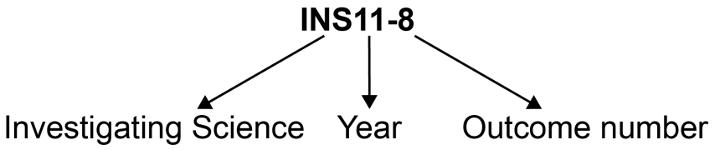

| **Outcome code** | **Interpretation** |
| --- | --- |
| INS11/12-1 | Investigating Science – outcome number 1 |
| INS11-8 | Year 11 Investigating Science – outcome number 8 |
| INS12-12 | Year 12 Investigating Science – outcome number 12 |

Working Scientifically outcomes 1–7 are common across Year 11 and Year 12.

Knowledge and Understanding outcomes in Year 11 are numbered 8–11.

Knowledge and Understanding outcomes in Year 12 are numbered 12–15.

## Learning Across the Curriculum Icons

Learning across the curriculum content, including cross-curriculum priorities, general capabilities and other areas identified as important learning for all students, is incorporated and identified by icons in the syllabus.

**Cross-curriculum priorities**

Aboriginal and Torres Strait Islander histories and cultures icon Aboriginal and Torres Strait Islander histories and cultures

Asia and Australia’s engagement with Asia icon Asia and Australia’s engagement with Asia

Sustainability icon Sustainability

**General capabilities**

Critical and creative thinking icon Critical and creative thinking

Ethical understanding icon Ethical understanding

 Information and communication technology capability icon Information and communication technology capability

Intercultural understanding icon Intercultural understanding

Literacy icon Literacy

Numeracy icon Numeracy

Personal and social capability icon Personal and social capability

**Other learning across the curriculum areas**

Civics and citizenship icon Civics and citizenship

Difference and diversity icon Difference and diversity

Work and enterprise icon Work and enterprise

# Rationale

The *Investigating Science Stage 6* *Syllabus* is designed to assist students of all abilities engage with scientific processes, and apply those processes to investigate relevant personal, community and global scientific issues.

The ongoing study of science and the specific Working Scientifically skills processes and their application have led humans to accumulate an evidence-based body of knowledge about human interactions – past, present and future – with the world and its galactic neighbourhood. The course is firmly focused on developing the Working Scientifically skills, as they provide a foundation for students to value investigation, solve problems, develop and communicate evidence-based arguments, and make informed decisions.

The course promotes active inquiry and explores key concepts, models and phenomena. It draws and builds on the knowledge, understanding, skills, values and attitudes gained in Science Stage 5. The Stage 6 course is designed to enhance students’ understanding of the value of evidence-based investigations and the use of science-based inquiry in their lives.

The Investigating Science course is designed to complement the study of the science disciplines by providing additional opportunities for students to investigate and develop an understanding of scientific concepts, their current and future uses, and their impacts on science and society. The course draws on and promotes interdisciplinary science, by allowing students to investigate a wide range of STEM (Science, Technology, Engineering and Mathematics) related issues and concepts in depth.

Investigating Science encourages the development of a range of capabilities and capacities that enhance a student’s ability to participate in all aspects of community life and within a fast-changing technological landscape. The knowledge, understanding and skills gained from this course are intended to support students’ ongoing engagement with science, and to form the foundation for further studies and participation in current and emerging STEM-related post-school activities and industries.

# The Place of the Investigating Science Stage 6 Syllabus in the K–12 Curriculum

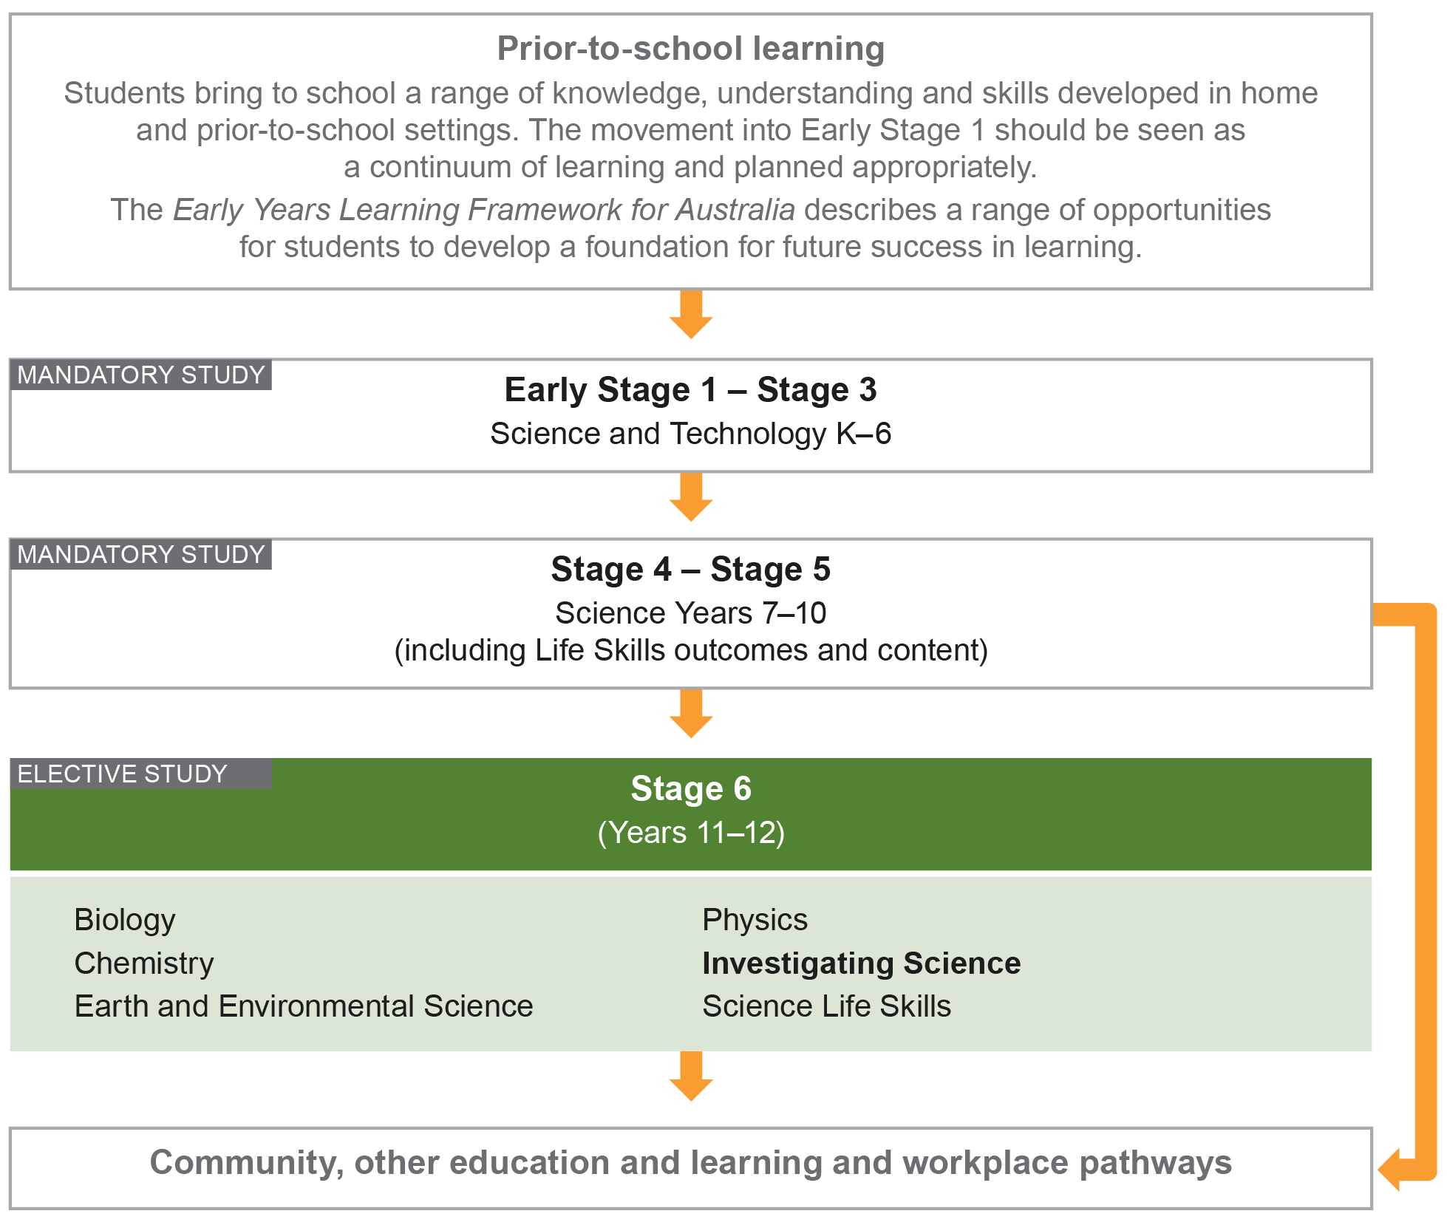

# Aim

The study of Investigating Science in Stage 6 enables students to develop an appreciation and understanding of science as a body of knowledge and a set of valuable processes that provide humans with an ability to understand themselves and the world in which they live. Through applying Working Scientifically skills processes, the course aims to enhance students’ analytical and problem-solving skills, in order to make evidence-based decisions and engage with and positively participate in an ever-changing, interconnected technological world.

# Objectives

## Skills

Students:

* develop skills in applying the processes of Working Scientifically.

## Knowledge and Understanding

Year 11 students:

* develop knowledge and understanding of cause and effect
* develop knowledge and understanding of models, theories and laws.

Year 12 students:

* develop knowledge and understanding of science and technology
* develop knowledge and understanding of contemporary issues involving science.

## Values and Attitudes

Students:

* develop positive, informed values and attitudes towards science
* recognise the importance and relevance of science in their lives
* recognise the influence of economic, political and societal impacts on the development of scientific knowledge
* develop an appreciation of the influence of imagination and creativity in scientific research.

# Outcomes

## Table of Objectives and Outcomes – Continuum of Learning

### Skills

|  |
| --- |
| **Objective**  Students:   * develop skills in applying the processes of Working Scientifically |
| **Stage 6 course outcomes**  A student: |
| **Questioning and predicting**  **INS11/12-1** develops and evaluates questions and hypotheses for scientific investigation |
| **Planning investigations**  **INS11/12-2** designs and evaluates investigations in order to obtain primary and secondary data and information |
| **Conducting investigations**  **INS11/12-3** conducts investigations to collect valid and reliable primary and secondary data and information |
| **Processing data and information**  **INS11/12-4** selects and processes appropriate qualitative and quantitative data and information using a range of appropriate media |
| **Analysing data and information**  **INS11/12-5** analyses and evaluates primary and secondary data and information |
| **Problem solving**  **INS11/12-6** solves scientific problems using primary and secondary data, critical thinking skills and scientific processes |
| **Communicating**  **INS11/12-7** communicates scientific understanding using suitable language and terminology for a specific audience or purpose |

The Working Scientifically outcomes at the beginning of each module are targeted for emphasis. The other Working Scientifically outcomes may also be addressed in each module**.**

### Knowledge and Understanding

| **Year 11 course** | **Year 12 course** |
| --- | --- |
| **Objective**  Students:   * develop knowledge and understanding ofcause and effect | **Objective**  Students:   * develop knowledge and understanding of science and technology |
| **Year 11 course outcomes**  A student: | **Year 12 course outcomes**  A student: |
| **INS11-8** identifies that the collection of primary and secondary data initiates scientific investigations | **INS12-12** develops and evaluates the process of undertaking scientific investigations |
| **INS11-9** examines the use of inferences and generalisations in scientific investigations | **INS12-13** describes and explains how science drives the development of technologies |
| **Objective**  Students:   * develop knowledge and understanding of models, theories and laws | **Objective**  Students:   * develop knowledge and understanding of contemporary issues involving science |
| **Year 11 course outcomes**  A student: | **Year 12 course outcomes**  A student: |
| **INS11-10** develops, and engages with, modelling as an aid in predicting and simplifying scientific objects and processes | **INS12-14** uses evidence-based analysis in a scientific investigation to support or refute a hypothesis |
| **INS11-11** describes and assesses how scientific explanations, laws and theories have developed | **INS12-15** evaluates the implications of ethical, social, economic and political influences on science |

# Year 11 Course Structure and Requirements

| **Year 11 course**  **(120 hours)** | **Working Scientifically Skills** | **Modules** | **Indicative hours** | **Depth studies** |
| --- | --- | --- | --- | --- |
| **Module 1**  Cause and Effect – Observing | 60 | *30 hours  in Modules 1–4 |
| **Module 2**  Cause and Effect – Inferences and Generalisations |
| **Module 3**  Scientific Models | 60 |
| **Module 4**  Theories and Laws |

*30 hours must be allocated to depth studies within the 120 indicative course hours.

## Requirements for Practical Investigations

Scientific investigations include both practical investigations and secondary-sourced investigations. Practical investigations are an essential part of the Year 11 course and must occupy a minimum of 35 hours of course time, including time allocated to practical investigations in depth studies.

Practical investigations include:

* undertaking laboratory experiments, including the use of appropriate digital technologies
* fieldwork.

Secondary-sourced investigations include:

* locating and accessing a wide range of secondary data and/or information
* using and reorganising secondary data and/or information.

# Year 12 Course Structure and Requirements

| **Year 12 course**  **(120 hours)** | **Working Scientifically Skills** | **Modules** | **Indicative hours** | **Depth studies** |
| --- | --- | --- | --- | --- |
| **Module 5**  Scientific Investigations | 60 | *30 hours  in Modules 5–8 |
| **Module 6**  Technologies |
| **Module 7**  Fact or Fallacy? | 60 |
| **Module 8**  Science and Society |

*30 hours must be allocated to depth studies within the 120 indicative course hours.

## Requirements for Practical Investigations

Scientific investigations include both practical investigations and secondary-sourced investigations. Practical investigations are an essential part of the Year 12 course and must occupy a minimum of 35 hours of course time, including time allocated to practical investigations in depth studies.

Practical investigations include:

* undertaking laboratory experiments, including the use of appropriate digital technologies
* fieldwork.

Secondary-sourced investigations include:

* locating and accessing a wide range of secondary data and/or information
* using and reorganising secondary data and/or information.

# Assessment and Reporting

Information about assessment in relation to the Investigating Science syllabus is contained in *Assessment and Reporting in Investigating Science Stage 6*. It outlines course-specific advice and requirements regarding:

* Year 11 and Year 12 school-based assessment requirements
* Year 11 and Year 12 mandatory components and weightings
* External assessment requirements including HSC examination specifications.

This information should be read in conjunction with requirements on the [Assessment Certification Examination (ACE)](http://ace.bostes.nsw.edu.au/) website.

Additional advice is available in the *Principles of Assessment for Stage 6*.

# Content

Content defines what students are expected to know and do as they work towards syllabus outcomes. It provides the foundations for students to successfully progress to the next stage of schooling or post-school opportunities.

Teachers will make decisions about content regarding the sequence, emphasis and any adjustments required based on the needs, interests, abilities and prior learning of students.

Content in Stage 6 syllabuses defines learning expectations that may be assessed in Higher School Certificate examinations.

## Organisation of Content

The following diagram provides an illustrative representation of elements of the course and their relationship.

The Year 11 and Year 12 courses each comprise four modules. The skills of Working Scientifically are integrated as course content throughout the syllabus. Each module includes a specific focus on some of the Working Scientifically skills. However, there is scope within each module to engage with all of the Working Scientifically skills.

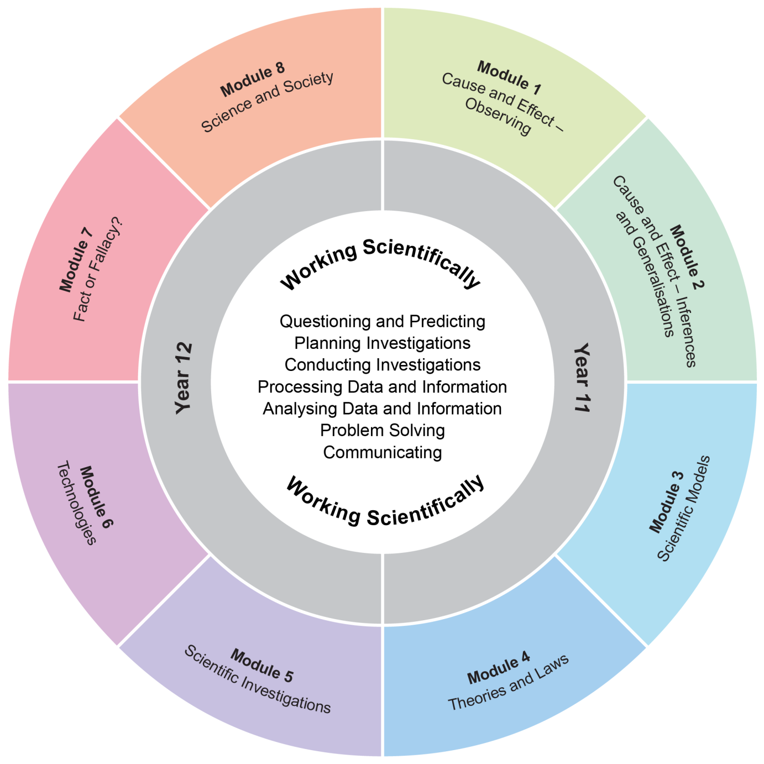

The Working Scientifically outcomes and content are integrated into each module wherever students undertake an investigation.

## Working Scientifically

Working Scientifically skills are at the core of conducting practical and secondary-sourced investigations in science.

Opportunities should be provided for students to engage with all the Working Scientifically skills in investigations. In each module, particular outcomes have been identified as those that are most relevant to the intended learning.

Students are challenged to further develop their understanding of Working Scientifically as a group of dynamic and interdependent processes that are applied in each scientific investigation in a way that is appropriate and determined by the activity. This dynamism and interrelatedness adds a level of sophistication to students’ understanding of the true nature and practice of science. Through regular involvement in these processes, applying them as appropriate, in a range of varied practical investigations, students can broaden their interpretation of Working Scientifically beyond the common linear model.

Students are encouraged to select the most appropriate gateway to the Working Scientifically processes. The pathways within the processes become self-evident through the nature of the investigation. An investigation may be instigated by, for example:

* direct observation of a phenomenon
* inconsistencies arising from results of a related investigation
* the quantitative and qualitative analysis of data
* secondary-sourced research.

Students are challenged to be open to:

* refining or redeveloping their chosen procedures
* redefining their questions and/or hypotheses
* modifying their methodologies or designs
* conducting further practical investigations
* conducting further secondary research.

Students are also encouraged to communicate evidence-based conclusions and suggest ideas for future research. Unexpected results are to be welcomed to refine methodologies and to generate further investigation. Knowledge and understanding of science is essential to these processes. Through this practice of science, students can acquire a deeper knowledge and understanding of scientific concepts.

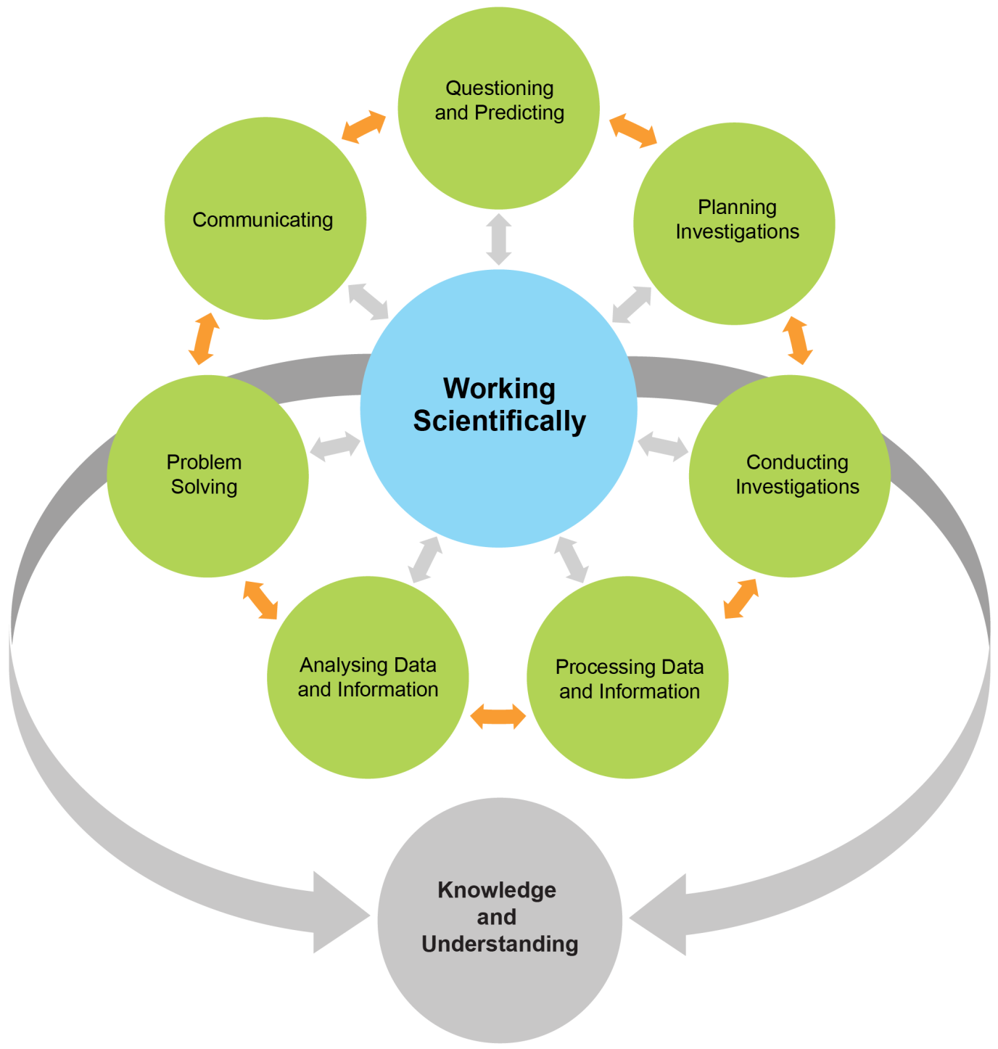

Each of the seven Working Scientifically outcomes represents one of the interdependent dynamic processes that are central to the study of science and the acquisition of scientific knowledge and skills. This course is structured to provide ongoing opportunities for students to implement these processes, particularly through the depth study provision. The following descriptions of the Working Scientifically outcomes provide further information about the skills students are expected to develop throughout the course.

### Questioning and Predicting

Developing, proposing and evaluating inquiry questions and hypotheses challenge students to identify an issue or phenomenon that can be investigated scientifically by gathering primary and/or secondary-sourced data. Students develop inquiry question(s) that require observations, experimentation and/or research to aid in constructing a reasonable and informed hypothesis. The consideration of variables is to be included in the questioning process.

### Planning Investigations

Students justify the selection of equipment, resources chosen and design of an investigation. They ensure that all risks are assessed, appropriate materials and technologies are sourced, and all ethical concerns are considered. Variables are to be identified as independent, dependent and controlled to ensure a valid procedure is developed that will allow for the reliable collection of data. Investigations should include strategies that ensure controlled variables are kept constant and an experimental control is used as appropriate.

### Conducting Investigations

Students are to select appropriate equipment, employ safe work practices and ensure that risk assessments are conducted and followed. Appropriate technologies are to be used and procedures followed when disposing of waste. The selection and criteria for collecting valid and reliable data is to be methodical and, where appropriate, secondary-sourced information referenced correctly.

### Processing Data and Information

Students use the most appropriate and meaningful methods and media to organise and analyse data and information sources, including digital technologies and the use of a variety of visual representations as appropriate. They process data from primary and secondary sources, including both qualitative and quantitative data and information.

### Analysing Data and Information

Students identify trends, patterns and relationships; recognise error, uncertainty and limitations in data; and interpret scientific and media texts. They evaluate the relevance, accuracy, validity and reliability of the primary or secondary-sourced data in relation to investigations. They evaluate processes, claims and conclusions by considering the quality of available evidence, and use reasoning to construct scientific arguments. Where appropriate, mathematical models are to be applied, to demonstrate the trends and relationships that occur in data.

### Problem Solving

Students use critical thinking skills and creativity to demonstrate an understanding of scientific principles underlying the solutions to inquiry questions and problems posed in investigations. Appropriate and varied strategies are employed, including the use of models to qualitatively and quantitatively explain and predict cause-and-effect relationships. In Working Scientifically, students synthesise and use evidence to construct and justify conclusions. To solve problems, students: interpret scientific and media texts; evaluate processes, claims and conclusions; and consider the quality of available evidence.

### Communicating

Communicating all components of the Working Scientifically processes with clarity and accuracy is essential. Students use qualitative and quantitative information gained from investigations using primary and secondary sources, including digital, visual, written and/or verbal forms of communication as appropriate. They apply appropriate scientific notations and nomenclature. They also appropriately apply and use scientific language that is suitable for specific audiences and contexts.

## Investigations

An investigation is a scientific process to answer a question, explore an idea or solve a problem. Investigations include activities such as planning a course of action, collecting data, processing and analysing data, reaching a conclusion and communicating. Investigations may include the collection of primary and/or secondary-sourced data or information.

Practical investigations involve the collection of primary data. They may include:

* undertaking laboratory investigations, including fair tests and controlled experiments
* undertaking fieldwork and surveys
* constructing models.

Secondary-sourced investigations can include:

* researching by using a variety of media
* extracting and reorganising secondary-sourced information in the form of flow charts, tables, graphs, diagrams, prose, keys, spreadsheets and databases
* using models to inform understanding.

### Safety

Schools have a legal obligation in relation to safety. Teachers will need to ensure that they comply with relevant legislation as well as system and school requirements in relation to safety when implementing their programs. This includes legislation and guidelines relating to Work Health and Safety, and the handling and storage of chemical and dangerous goods.

### Animal Research

Schools have a legal responsibility in relation to the welfare of animals. The keeping of animals and all practical activities involving animals must comply with relevant guidelines or legislation.

## Inquiry Questions

Inquiry questions are included in the course content and used to frame the syllabus content within each module. The depth of knowledge and understanding and skill development required to fully address the inquiry questions may vary. This allows for differentiation of the course content to cater for the diversity of learners.

## Depth Studies: Year 11 and Year 12

### What are Depth Studies?

A depth study is any type of investigation/activity that a student completes individually or collaboratively that allows the further development of one or more concepts found within or inspired by the syllabus. It may be one investigation/activity or a series of investigations/activities.

Depth studies provide opportunities for students to pursue their interests in science, acquire a depth of understanding, and take responsibility for their own learning. Depth studies promote differentiation and engagement, and support all forms of assessment, including assessment for, as and of learning. Depth studies allow for the demonstration of a range of Working Scientifically skills.

A depth study may be, but is not limited to:

* a practical investigation or series of practical investigations and/or a secondary-sourced investigation or series of secondary-sourced investigations
* presentations, research assignments or fieldwork reports
* the extension of concepts found within the course, either qualitatively and/or quantitatively.

The length of time for any individual study and the pedagogies employed are not prescribed. The time for the depth studies may be allocated to a single study or spread over the year, and incorporate several studies depending on individual school and/or class requirements.

### Requirements for Depth Studies

* A minimum of 30 hours of in-class time is allocated in both Year 11 and Year 12.
* At least one depth study must be included in both Year 11 and Year 12.
* The two Working Scientifically outcomes of Questioning and Predicting, and Communicating must be addressed in both Year 11 and Year 12.
* A minimum of two additional Working Scientifically skills outcomes, and further development of at least one Knowledge and Understanding outcome, are to be addressed in all depth studies.

### Ideas for Depth Studies

#### Practical Investigations

* Design and conduct experiments
* Test a claim
* Test a device.

#### Secondary-sourced Investigations

* Make a documentary or media report
* Conduct a literature review
* Develop an evidence-based argument
* Write a journal article
* Write an essay – historical or theoretical
* Develop an environmental management plan
* Analyse a work of fiction or film for scientific relevance
* Create a visual presentation
* Investigate emerging technologies.

#### Creating

* Design and invent
* Create a working model
* Create a portfolio.

#### Fieldwork

Fieldwork may be a starting point for a practical investigation or secondary-sourced study and could be initiated by the following stimuli:

* an excursion
* engagement with community experts.

#### Data Analysis

Data analysis may be incorporated into a practical investigation or secondary-sourced investigation. For example:

* construction and analysis of graphs/tables
* data analysis from a variety of sources
* research analysis, eg of longitudinal data, resource-management data.

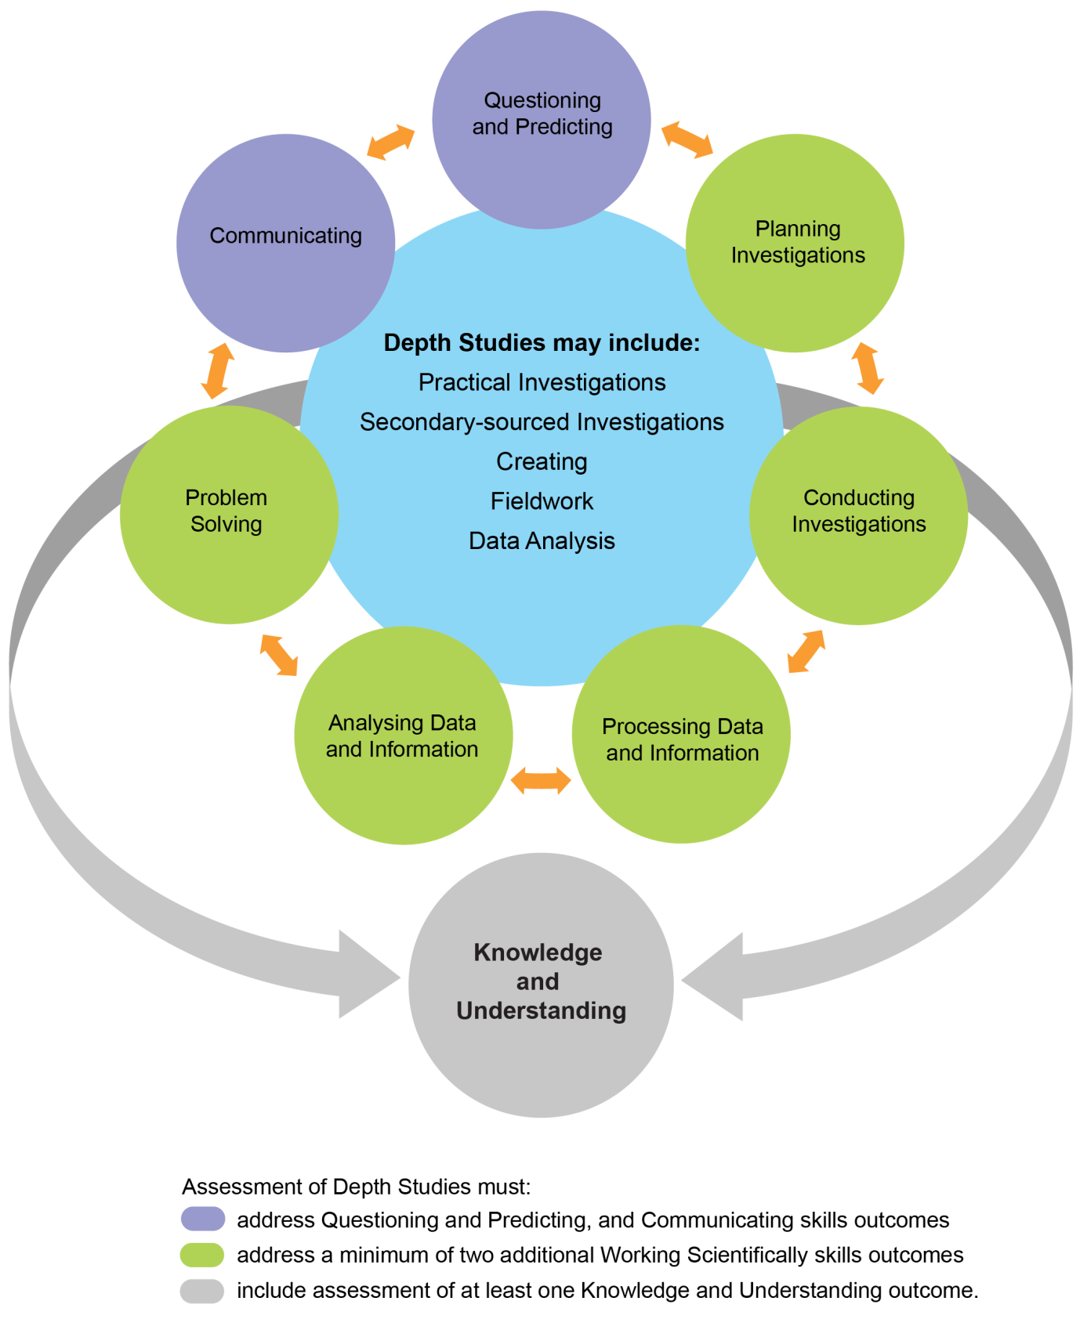

## Learning Across the Curriculum

Learning across the curriculum content, including the cross-curriculum priorities and general capabilities, assists students to achieve the broad learning outcomes defined in the NESA *Statement of Equity Principles*, the *Melbourne Declaration on Educational Goals for Young Australians* (December 2008) and in the Australian Government’s *Core Skills for Work Developmental Framework* (2013).

Cross-curriculum priorities enable students to develop understanding about and address the contemporary issues they face.

The cross-curriculum priorities are:

* Aboriginal and Torres Strait Islander histories and cultures Aboriginal and Torres Strait Islander histories and cultures icon
* Asia and Australia’s engagement with Asia Asia and Australia’s engagement with Asia icon
* Sustainability. Sustainability icon

General capabilities encompass the knowledge, skills, attitudes and behaviours required to assist students to live and work successfully in the 21st century.

The general capabilities are:

* Critical and creative thinking Critical and creative thinking icon
* Ethical understanding Ethical understanding icon
* Information and communication technology capability  Information and communication technology capability icon
* Intercultural understanding Intercultural understanding icon
* Literacy Literacy icon
* Numeracy Numeracy icon
* Personal and social capability. Personal and social capability icon

NESA syllabuses include other areas identified as important learning for all students:

* Civics and citizenship Civics and citizenship icon
* Difference and diversity Difference and diversity icon
* Work and enterprise. Work and enterprise

Learning across the curriculum content is incorporated, and identified by icons, in the content of the *Investigating Science Stage 6 Syllabus* in the following ways.

### Aboriginal and Torres Strait Islander Histories and Cultures Aboriginal and Torres Strait Islander histories and cultures icon

Aboriginal and Torres Strait Islander communities have diverse cultures, social structures and a history of unique, complex knowledge systems. In Investigating Science students are provided with opportunities to learn about how Aboriginal and Torres Strait Islander Peoples have developed and refined knowledge about the world through observation, making predictions, testing (trial and error) and responding to environmental factors within specific contexts. Students investigate examples of Aboriginal and Torres Strait Islander Peoples’ understanding of the environment and the ways in which traditional knowledge and Western scientific knowledge can be complementary.

When planning and programming content relating to Aboriginal and Torres Strait Islander histories and cultures teachers are encouraged to:

* involve local Aboriginal communities and/or appropriate knowledge holders in determining suitable resources, or to use Aboriginal or Torres Strait Islander authored or endorsed publications
* read the [*Principles and Protocols*](https://ab-ed.nesa.nsw.edu.au/principles-and-protocols) relating to teaching and learning about Aboriginal and Torres Strait Islander histories and cultures and the involvement of local Aboriginal communities.

### Asia and Australia’s Engagement with Asia Asia and Australia’s engagement with Asia icon

Asia and Australia’s engagement with Asia provides rich and engaging contexts for developing students’ science and technology knowledge, understanding and skills. In Investigating Science students are provided with opportunities to recognise that the Asia region includes diverse environments. They are provided with opportunities to appreciate how interactions within and between these environments and the impacts of human activity influence the region, including Australia, and have significance for the rest of the world.

Asia plays an important role in scientific and technological research and development in areas such as medicine, natural resource management and natural disaster prediction and management.

### Sustainability Sustainability icon

Sustainability is concerned with the ongoing capacity of the Earth to maintain all life. It provides authentic contexts for exploring, investigating and understanding systems in the natural and human-made environments. In Investigating Science students are provided with opportunities to investigate relationships between systems and system components, and consider the sustainability of food sources and the natural and human environments. Students engage in ethical debate and with different perspectives in solving ethical problems.

### Critical and Creative Thinking Critical and creative thinking icon

Critical and creative thinking are integral to activities where students learn to generate and evaluate knowledge, clarify concepts and ideas, seek possibilities, consider alternatives and solve problems. Critical and creative thinking are embedded in the skills and processes of Working Scientifically. In order to make evidence-based decisions, students are provided with opportunities to develop critical and creative thinking skills through: asking and posing questions; making predictions; engaging in practical and secondary-sourced investigations; and analysing and evaluating evidence.

### Ethical Understanding Ethical understanding icon

Students are provided with opportunities to develop the capability to assess ethical values and principles, and to understand how reasoning can assist ethical judgement. In Investigating Science students are provided with opportunities to form and make ethical judgements in relation to scientific investigations, design, codes of practice, and the use of scientific information and applications. Students explore the importance of reporting honestly based on evidence. They apply ethical guidelines in their investigations, particularly in regard to the implications for others and the environment.

### Information and Communication Technology Capability Information and communication technology capability icon

Information and communication technology (ICT) can be used effectively and appropriately to access, create and communicate information and ideas, solve problems and work collaboratively. In Investigating Science students are provided with opportunities to develop ICT capability when they: develop ideas and solutions; research science concepts and applications; investigate scientific phenomena; and communicate their scientific and technological understandings. In particular, they have opportunities to learn to: access information; collect, analyse and represent data; model and interpret concepts and relationships; and communicate scientific and technological ideas, processes and information.

### Intercultural Understanding Intercultural understanding icon

Students develop intercultural understanding as they learn to understand themselves in relation to others. This involves students valuing their own cultures and those of others, and engaging with people of diverse cultures in ways that recognise commonalities and differences, create connections and cultivate respect. In Investigating Science students are provided with opportunities to appreciate how diverse cultural perspectives have impacted on the development, breadth and diversity of scientific knowledge and applications. They learn about and engage with issues requiring cultural sensitivity, and learn that scientists work in culturally diverse teams to address issues and solve problems of national and international importance.

### Literacy Literacy icon

Literacy is the ability to use a repertoire of knowledge and skills to communicate and comprehend effectively, using a variety of modes and media. Being ‘literate’ is more than the acquisition of technical skills – it includes the ability to identify, understand, interpret, create and communicate effectively using written, visual and digital forms of expression and communication for a number of purposes. In Investigating Science students are provided with opportunities to understand that language varies according to the context and engage with different forms of written and spoken language to communicate scientific concepts. Students learn that scientific information can also be presented in the form of diagrams, flow charts, tables, graphs and models.

### Numeracy Numeracy icon

Numeracy involves recognising and understanding the role of mathematics in the world. Students become numerate as they develop the confidence, willingness and ability to apply mathematics in their lives in constructive and meaningful ways. In Investigating Science students are provided with opportunities to develop numeracy skills through practical measurement and the collection, representation and interpretation of data from first-hand investigations and secondary sources. Students consider issues of uncertainty and reliability in measurement and have opportunities to learn data analysis skills, identifying trends and patterns from numerical data and graphs. They apply mathematical equations and concepts in order to solve problems.

### Personal and Social Capability Personal and social capability icon

Students develop personal and social capability as they learn to understand and manage themselves, their relationships and their lives more effectively. This includes establishing positive relationships, making responsible decisions, working effectively individually and in teams, and constructively handling challenging situations. Through applying the processes of Working Scientifically, students can develop skills in collaboration, peer assessment and review. They plan and conduct a depth study either individually or in a team.

### Civics and Citizenship Civics and citizenship icon

Civics and citizenship content involves knowledge and understanding of how our Australian society operates. In Investigating Science students are provided with opportunities to broaden their understanding of aspects of civics and citizenship related to the application of scientific ideas and technological advances, including ecological sustainability and the development of environmental and sustainable practices at a local, regional and national level.

### Difference and Diversity Difference and diversity icon

Difference and diversity comprise gender, race and socio-economic circumstances. Students are provided with opportunities to understand and appreciate the difference and diversity they experience in their everyday lives. Working Scientifically provides opportunities for students to work collaboratively, where they can develop an appreciation of the values and ideas of all group members. This appreciation also enables students to identify individual rights, challenge stereotypes and engage with opinions that are different to their own.

### Work and Enterprise Work and enterprise icon

Students can develop work-related skills and an appreciation of the value of working individually and collaboratively when conducting investigations. In Investigating Science students are provided with opportunities to prioritise safe practices and understand the potential risks and hazards present when conducting investigations. They engage with risk assessment while working safely in the laboratory or the field.

# Investigating Science Year 11 Course Content

## Year 11 Course Structure and Requirements

| **Year 11 course**  **(120 hours)** | **Working Scientifically Skills** | **Modules** | **Indicative hours** | **Depth studies** |
| --- | --- | --- | --- | --- |
| **Module 1**  Cause and Effect – Observing | 60 | *30 hours  in Modules 1–4 |
| **Module 2**  Cause and Effect – Inferences and Generalisations |
| **Module 3**  Scientific Models | 60 |
| **Module 4**  Theories and Laws |

*30 hours must be allocated to depth studies within the 120 indicative course hours.

### Requirements for Practical Investigations

Scientific investigations include both practical investigations and secondary-sourced investigations. Practical investigations are an essential part of the Year 11 course and must occupy a minimum of 35 hours of course time, including time allocated to practical investigations in depth studies.

Practical investigations include:

* undertaking laboratory experiments, including the use of appropriate digital technologies
* fieldwork.

Secondary-sourced investigations include:

* locating and accessing a wide range of secondary data and/or information
* using and reorganising secondary data and/or information.

## Working Scientifically Skills

**It is expected that the content of each skill will be addressed by the end of the Stage 6 course.**

## Questioning and Predicting

### Outcomes

**A student:**

* develops and evaluates questions and hypotheses for scientific investigation INS11/12-1

### Content

Students:

* develop and evaluate inquiry questions and hypotheses to identify a concept that can be investigated scientifically, involving primary and secondary data Literacy icon
* modify questions and hypotheses to reflect new evidence Critical and creative thinking icon

## Planning Investigations

### Outcomes

**A student:**

* designs and evaluates investigations in order to obtain primary and secondary data and information INS11/12-2

### Content

Students:

* assess risks, consider ethical issues and select appropriate materials and technologies when designing and planning an investigation Ethical understanding icon Personal and social capability icon
* justify and evaluate the use of variables and experimental controls to ensure that a valid procedure is developed that allows for the reliable collection of data
* evaluate and modify an investigation in response to new evidence Critical and creative thinking icon

## Conducting Investigations

### Outcomes

**A student:**

* conducts investigations to collect valid and reliable primary and secondary data and information INS11/12-3

### Content

Students:

* employ and evaluate safe work practices and manage risks Personal and social capability icon Work and enterprise icon
* use appropriate technologies to ensure and evaluate accuracy  Information and communication technology capability icon Numeracy icon
* select and extract information from a wide range of reliable secondary sources and acknowledge them using an accepted referencing style Literacy icon

## Processing Data and Information

### Outcomes

**A student:**

* selects and processes appropriate qualitative and quantitative data and information using a range of appropriate media INS11/12-4

### Content

Students:

* select qualitative and quantitative data and information and represent them using a range of formats, digital technologies and appropriate media Literacy icon Numeracy icon
* apply quantitative processes where appropriate Numeracy icon
* evaluate and improve the quality of data Critical and creative thinking icon Numeracy icon

## Analysing Data and Information

### Outcomes

**A student:**

* analyses and evaluates primary and secondary data and information INS11/12-5

### Content

Students:

* derive trends, patterns and relationships in data and information
* assess error, uncertainty and limitations in data Critical and creative thinking icon
* assess the relevance, accuracy, validity and reliability of primary and secondary data and suggest improvements to investigations Critical and creative thinking icon Numeracy icon

## Problem Solving

### Outcomes

**A student:**

* solves scientific problems using primary and secondary data, critical thinking skills and scientific processes INS11/12-6

### Content

Students:

* use modelling (including mathematical examples) to explain phenomena, make predictions and solve problems using evidence from primary and secondary sources Critical and creative thinking icon
* use scientific evidence and critical thinking skills to solve problems Critical and creative thinking icon

## Communicating

### Outcomes

**A student:**

* communicates scientific understanding using suitable language and terminology for a specific audience or purpose INS11/12-7

### Content

Students:

* select and use suitable forms of digital, visual, written and/or oral forms of communication Literacy icon Numeracy icon
* select and apply appropriate scientific notations, nomenclature and scientific language to communicate in a variety of contexts Literacy icon Numeracy icon
* construct evidence-based arguments and engage in peer feedback to evaluate an argument or conclusion Civics and citizenship icon Difference and diversity icon

## Module 1: Cause and Effect – Observing

### Outcomes

**A student:**

* develops and evaluates questions and hypotheses for scientific investigation INS11/12-1
* conducts investigations to collect valid and reliable primary and secondary data and information INS11/12-3
* selects and processes appropriate qualitative and quantitative data and information using a range of appropriate media INS11/12-4
* identifies that the collection of primary and secondary data initiates scientific investigations   
  INS11-8

**Related Life Skills outcomes:** SCLS6-1, SCLS6-3, SCLS6-4, SCLS6-8

### Content Focus

Observation instigates all scientific experimentation. Investigative scientific processes can only be applied to phenomena that can be observed and measured. Detailed observations motivate scientists to ask questions about the causes and the effects of phenomena they observe. In this way, science continues to progress and enhance the lives of individuals and society by encouraging a continued search for reason and understanding.

Students explore the importance of observation and the collection of quantitative and qualitative data in scientific investigations. They conduct their own practical investigation, either individually or collaboratively, which is used to demonstrate the importance of making detailed and accurate observations, determining the types of variables and formulating testable scientific hypotheses.

### Working Scientifically

In this module, students focus on developing hypotheses that arise from their observations and evaluate these in order to gather, select and process appropriate qualitative and quantitative data. Students should be provided with opportunities to engage with all Working Scientifically skills throughout the course.

### Content

#### Role of Observations

**Inquiry question:** How does observation instigate scientific investigation?

Students:

* carry out a practical investigation to record both quantitative and qualitative data from observations, for example:
* burning a candle floating in a closed container
* the behaviour of slaters in a dry/wet or light/dark environment
* the Bernoulli effect
* strata in rock cuttings
* discuss and evaluate the characteristics of observations made compared to inferences drawn in respect of the practical investigation Literacy icon
* research how observation has instigated experimentation to investigate cause and effect in historical examples, including but not limited to: Critical and creative thinking icon  Information and communication technology capability icon
* Archimedes observing the displacement of water
* Alexander Fleming’s observations of the effect of mould on bacteria
* Galileo’s observations of the movement of Jupiter’s moons
* assess ways in which Aboriginal and Torres Strait Islander Peoples use observation to develop an understanding of Country and Place in order to create innovative ways of managing the natural environment, including but not limited to: Aboriginal and Torres Strait Islander histories and cultures icon Sustainability icon Ethical understanding icon Intercultural understanding icon Difference and diversity icon
* firestick farming
* knowledge about plants for medicinal purposes

#### Observations

**Inquiry question**: What are the benefits and drawbacks of qualitative and quantitative observations?

Students:

* carry out a practical activity to qualitatively and quantitatively describe, for example:
* microscopic images of a variety of cells
* geological strata in rock faces and road cuttings
* an object falling due to gravity
* characteristics of acids and bases
* analyse the quantitative data from the following information sources, including but not limited to:  Information and communication technology capability icon Numeracy icon Work and enterprise
* digital images and hand-drawn diagrams of cells
* geological succession obtained from rock strata
* graphs of results obtained from observations of an object falling due to gravity
* data showing the pH of acids and bases
* evaluate the differences between qualitative and quantitative observations and data and where these are used  Information and communication technology capability icon Numeracy icon Work and enterprise

#### Observations as Evidence

**Inquiry question:** How does primary data provide evidence for further investigation?

Students:

* use data gathered to plan a practical investigation to: Critical and creative thinking icon Literacy icon
* pose further questions that will be investigated
* discuss the role of variables
* determine the independent and dependent variables
* formulate a hypothesis that links the independent and dependent variables
* describe at least three variables that should be controlled in order to increase the validity of the investigation
* develop a method to collect primary data for a practical investigation by: Critical and creative thinking icon Literacy icon
* describing how to change the independent variable
* determining the characteristics of the measurements that will form the dependent variable
* describing how the data will be collected
* describing how the controlled variables will be made consistent
* describing how risks can be minimised
* evaluate how observation is limited by the observational tools available, including but not limited to:Critical and creative thinking icon  Information and communication technology capability icon Numeracy icon
* observing the Universe
* digital versus analogue technologies

#### Observing, Collecting and Recording Data

**Inquiry question:** How does the collection and presentation of primary data affect the outcome of a scientific investigation?

Students:

* carry out the planned practical investigation, above, to collect primary data Critical and creative thinking icon  Information and communication technology capability icon Work and enterprise
* apply conventions for collecting and recording observations to qualitatively and quantitatively analyse the primary data, including but not limited to: Critical and creative thinking icon  Information and communication technology capability icon Literacy icon Work and enterprise
* tabulation
* graphing
* visual representations
* digital representations
* compare the usefulness of observations recorded in the initial practical activity with the primary data gathered in this planned practical investigation

#### Conclusions Promote Further Observations

**Inquiry question:** How do conclusions drawn from the interpretation of primary data promote further scientific investigation?

Students:

* draw conclusions from the analysis of the primary data collected in the practical investigation Critical and creative thinking icon Work and enterprise
* evaluate the process of drawing conclusions from the primary data collected
* assess the findings of the scientific investigation in relation to the findings of other related investigations
* assess the need to make further observations by gathering data about other phenomena arising from the practical investigation Critical and creative thinking icon Work and enterprise

## Module 2: Cause and Effect – Inferences and Generalisations

### Outcomes

**A student:**

* develops and evaluates questions and hypotheses for scientific investigation INS11/12-1
* designs and evaluates investigations in order to obtain primary and secondary data and information INS11/12-2
* selects and processes appropriate qualitative and quantitative data and information using a range of appropriate media INS11/12-4
* examines the use of inferences and generalisations in scientific investigations INS11-9

**Related Life Skills outcomes:** SCLS6-1, SCLS6-2, SCLS6-4, SCLS6-9

### Content Focus

Scientific inquiry follows on from humans making inferences and generalisations from commonly held understandings. Such inferences and generalisations have led to a wide range of investigations being performed throughout history, culminating in breakthroughs in scientific understanding. Many hypotheses, when found to be correct, have generated further inquiry and created the need to develop new technologies for further observation.

Students consider primary and secondary-sourced data and its influence on scientific investigations. In this module, students engage in gathering primary and secondary-sourced data to assist them in conducting and reporting on investigations, and to further develop their understanding of the central roles of scientific questioning and collaboration in the pursuit of scientific truth.

### Working Scientifically

In this module, students focus on designing and evaluating investigations, drawing inferences, making generalisations, and developing and testing hypotheses through the collection and processing of data. Students should be provided with opportunities to engage with all Working Scientifically skills throughout the course.

### Content

#### Observations and Inferences

**Inquiry question**: What inferences can be drawn from observations?

Students:

* investigate the practices of Aboriginal and Torres Strait Islander Peoples that relate to observations and inferences, including but not limited to: Aboriginal and Torres Strait Islander histories and cultures icon
  + leaching of toxins in bush tucker
  + locating sources of freshwater within bodies of salt water
* conduct a collaborative practical investigation and collect a range of qualitative and quantitative primary data from one of the following: Critical and creative thinking icon  Information and communication technology capability icon Numeracy icon
  + growth of plants
  + reactions of calcium carbonate
  + the ‘life’ of different batteries under different circumstances
  + water quality of a pond or local stream
* make inferences and conclusions derived from the primary data collected in this collaborative practical investigation

#### Using Secondary-sourced Data

**Inquiry question:** How is secondary-sourced data used in practical investigations?

Students:

* collect qualitative and quantitative secondary-sourced data to validate the inferences and conclusions drawn from the practical investigation carried out above, based on one or more of the following: Critical and creative thinking icon  Information and communication technology capability icon Literacy icon
  + the effect of soil salinity on plant growth
  + chemical reactions in cave formation
  + energy storage
  + methods of water monitoring
* discuss how secondary-sourced data adds to the inferences and conclusions drawn from primary data
* evaluate the usefulness of considering secondary-sourced research before undertaking an investigation to collect primary data, in order to: Critical and creative thinking icon
  + make inferences
  + develop inquiry questions
  + construct suitable hypotheses
  + plan suitable investigations
  + avoid unnecessary investigation

#### Observing Patterns

**Inquiry question:** How does humans’ ability to recognise patterns affect the way they interpret data?

**Students:**

* describe patterns that have been observed over time throughout the Universe and in nature using, for example: Critical and creative thinking icon
  + animal migration
  + movement of comets
  + formation and shape of snow crystals
  + elements exhibiting certain properties
* interpret data in order to propose a hypothesis based on an irregular pattern observed over time in the Universe and in nature using, for example: Critical and creative thinking icon Literacy icon Numeracy icon
  + the Aurora Australis
  + fractals in nature
  + the behaviour of unstable isotopes
* examine the human tendency to observe patterns and misinterpret information, for example:
  + pareidolia
  + optical illusions
* discuss how the tendency to recognise patterns, even when they may not exist, can lead to misinterpretation of data
* discuss the role and significance of outliers in data

#### Developing Inquiry Questions

**Inquiry question:** How can hypotheses and assumptions be tested?

Students:

* gather secondary-sourced data describing historical instances of long-standing assumptions that have been updated by scientific investigation, including but not limited to: Critical and creative thinking icon Ethical understanding icon
  + spontaneous generation and the investigations that led to the proposal of the germ theory
  + radioactivity: including the work of Henri Becquerel and Marie Curie
  + phlogiston theory
  + human influences on atmospheric pollution
* propose an inquiry question, construct a hypothesis and conduct an investigation that tests a common assumption, for example:
  + washing with antibacterial soap kills more germs than washing with normal soap
  + the Sun rises in the East and sets in the West
  + what goes up must come down
* use appropriate representations to analyse the data Critical and creative thinking icon  Information and communication technology capability icon Literacy icon Numeracy icon

#### Generalisations in Science

**Inquiry question:** What generalisations and assumptions are made from observed data?

Students:

* make generalisations to describe any trends found in the data  Information and communication technology capability icon Numeracy icon
* draw conclusion based on generalisations  Information and communication technology capability icon Numeracy icon

#### Peer Review

**Inquiry question:** What role do peers play in scientific investigation?

Students:

* assessthe input that collaborative teams and alternative perspectives have had on the development of hypotheses and research questions that have contributed to the development of, for example: Intercultural understanding icon Difference and diversity icon
  + particle accelerators
  + periodic table
  + study of bioastronomy
  + geological uniformitarianism
* assess the scientific community's current understanding of scientific mysteries and outline why this understanding remains incomplete, including but not limited to: Critical and creative thinking icon  Information and communication technology capability icon
  + origins of life on the Earth
  + the idea that feynmanium is the last chemical on the periodic table that could exist
  + the expanding Universe and Hubble constant
* evaluatebiases that may have affected the scientific thinking of European settlers about Aboriginal and Torres Strait Islander Peoples’ ecological understanding and knowledge of Country and Place in relation to agricultural practices and the biological and natural resources of Australia Aboriginal and Torres Strait Islander histories and cultures icon Sustainability icon Ethical understanding icon Intercultural understanding icon Civics and citizenship icon

## Module 3: Scientific Models

### Outcomes

**A student:**

* designs and evaluates investigations in order to obtain primary and secondary data and information INS11/12-2
* conducts investigations to collect valid and reliable primary and secondary data and information INS11/12-3
* selects and processes appropriate qualitative and quantitative data and information using a range of appropriate media INS11/12-4
* develops, and engages with, modelling as an aid in predicting and simplifying scientific objects and processes INS11-10

**Related Life Skills outcomes:** SCLS6-2, SCLS6-3, SCLS6-4, SCLS6-10

### Content Focus

Scientific models are developed as a means of helping people understand scientific concepts and representing them in a visual medium. Models are used to make predictions. They may include physical and digital models, which can be refined over time by the inclusion of new scientific knowledge.

Students recognise that many scientific models have limitations and are modified as further evidence comes to light. For this reason, scientific models are continually evaluated for accuracy and applicability by the global scientific community through the process of peer review. Students construct and evaluate their own models, which are generated through practical investigation.

### Working Scientifically

In this module, students focus on designing and evaluating investigations to collect valid and reliable primary and secondary qualitative and quantitative data, and apply scientific modelling. Students should be provided with opportunities to engage with all Working Scientifically skills throughout the course.

### Content

#### Models to Inform Understanding

**Inquiry question**: What is a scientific model?

Students:

* examine the types of models that may be used in science, including: Critical and creative thinking icon  Information and communication technology capability icon Work and enterprise
  + diagrams
  + physical replicas
  + mathematical representations
  + analogies
  + computer simulations

**Inquiry question**: What makes scientific models useful?

Students:

* examine the use of scientific models, including but not limited to: Critical and creative thinking icon  Information and communication technology capability icon Work and enterprise
  + epidemic models
  + models of the Universe
  + atomic models
  + climate models
* outline how models have been used to illustrate, simplify and represent scientific concepts and processes Critical and creative thinking icon Literacy icon
* explain how scientific models are used to make predictions that are difficult to analyse in the real world due to time frames, size and cost Critical and creative thinking icon  Information and communication technology capability icon Literacy icon
* assess the effectiveness of models at facilitating the understanding of scientific processes, structures and mathematical relationships through the use of: Critical and creative thinking icon  Information and communication technology capability icon
  + diagrams
  + physical replicas
  + mathematical representations
  + analogies
  + computer simulations
* evaluate how scientific models draw on a growing body of data from a wide range of disciplines and technologies to refine predictions and test new hypotheses Critical and creative thinking icon  Information and communication technology capability icon Literacy icon

#### Types of Models

**Inquiry question:** When should a particular model be used?

Students:

* explain why new evidence can challenge the use of existing scientific models and may result in those models being contested and refined or replaced, including but not limited to the development of: Critical and creative thinking icon  Information and communication technology capability icon
  + epidemic models
  + models of the Universe
  + atomic models
  + climate models
* compare the limitations of simple and complex scientific models Critical and creative thinking icon  Information and communication technology capability icon

#### Constructing a Model

**Inquiry question:** How can a model be constructed to simplify understanding of a scientific concept?

Students:

* investigate a scientific concept or process that can be represented using a model, by: Critical and creative thinking icon  Information and communication technology capability icon Literacy icon Work and enterprise
  + planning a model with reference to the scientific literature
  + constructing a model using appropriate resources to represent the selected scientific concept
  + demonstrating how the model could be used to make a prediction
  + presenting and evaluating the model through peer feedback Critical and creative thinking icon  Information and communication technology capability icon Personal and social capability icon

## Module 4: Theories and Laws

### Outcomes

**A student:**

* analyses and evaluates primary and secondary data and information INS11/12-5
* solves scientific problems using primary and secondary data, critical thinking skills and scientific processes INS11/12-6
* communicates scientific understanding using suitable language and terminology for a specific audience or purpose INS11/12-7
* describes and assesses how scientific explanations, laws and theories have developed INS11-11

**Related Life Skills outcomes:** SCLS6-5, SCLS6-6, SCLS6-7, SCLS6-10

### Content Focus

The term ‘science’ comes from the Latin *scientia*, which means ‘a knowledge based on demonstrable and reproducible data’. Reproducible data is used by scientists to develop theories and laws to explain and describe phenomena. Theories provide a coherent understanding of a wide range of phenomena. A law is usually a statement that can be expressed as a mathematical relationship. It describes phenomena in nature, with no exceptions, at a point in time. Testing scientific theories drivesscientific breakthroughs and questions current understandings.

Students examine how complex models and theories often require a wide range of evidence, which impacts on society and the environment. In this module, students engage in practical and secondary investigations that are related to major theories or laws and their application.

### Working Scientifically

In this module, students focus on analysing and evaluating data to solve problems and communicate ideas about the development of theories and laws. Students should be provided with opportunities to engage with all Working Scientifically skills throughout the course.

### Content

#### Introduction to Scientific Theories and Laws

**Inquiry question:** What are the differences and similarities between scientific theories and laws?

Students:

* collect primary data to investigate the law of conservation of mass  Information and communication technology capability icon Literacy icon Numeracy icon
* collect secondary-sourced data to investigate the theory of plate tectonics  Information and communication technology capability icon Literacy icon Numeracy icon
* compare the characteristics of theories and laws Critical and creative thinking icon Work and enterprise

#### Development of a Theory

**Inquiry question:** What leads to a theory being developed?

Students:

* gather secondary-sourced data to investigate the supporting evidence and development of theories, including but not limited to: Critical and creative thinking icon  Information and communication technology capability icon Literacy icon Numeracy icon
  + germ theory
  + oxygen theory of combustion
* gather secondary-sourced data to investigate how aspects of a theory can be disproved through the collection of evidence, including: Critical and creative thinking icon  Information and communication technology capability icon Literacy icon Numeracy icon
  + Geocentric Theory (of the solar system)
  + Theory of Inheritance of Acquired Characteristics
  + Dalton’s atomic theory
  + Steady State Theory of the Universe (in cosmology)

#### Development of Laws

**Inquiry question:** What leads to the acceptance of a scientific law?

Students:

* gather secondary-sourced data to investigate and assess the evidence that supports scientific laws, including but not limited to: Critical and creative thinking icon  Information and communication technology capability icon Literacy icon Numeracy icon
  + Newton’s Second Law of Motion
  + Avogadro’s Law
  + law of superposition
  + Mendel’s Law of Dominance
* design and collect primary data to show that results can be predicted by laws, including but not limited to: Critical and creative thinking icon
  + Ohm’s Law
  + law of conservation of energy

#### Application of Theories and Laws in Science

**Inquiry question:** How are theories and laws used in science?

Students:

* investigate how the law of conservation of energy is applied in different science disciplines through primary and secondary-sourced research, including but not limited to: Critical and creative thinking icon  Information and communication technology capability icon Literacy icon Numeracy icon
  + Chemistry
  + Physics
  + Human Biology
  + Earth and Environmental Science
* demonstrate, using evidence and examples, how diverse phenomena have been unified into specific theories, for example: Critical and creative thinking icon  Information and communication technology capability icon Literacy icon Numeracy icon
  + atomic theory
  + theory of evolution
  + Big Bang theory
  + plate tectonic theory
* gather secondary-sourced data to investigate how scientific investigations of nuclear reactions and decay changed the way in which the law of conservation of mass and law of conservation of energy are interpreted Critical and creative thinking icon  Information and communication technology capability icon Literacy icon Numeracy icon

# Investigating Science Year 12 Course Content

## Year 12 Course Structure and Requirements

| **Year 12 course**  **(120 hours)** | **Working Scientifically Skills** | **Modules** | **Indicative hours** | **Depth studies** |
| --- | --- | --- | --- | --- |
| **Module 5**  Scientific Investigations | 60 | *30 hours  in Modules 5–8 |
| **Module 6**  Technologies |
| **Module 7**  Fact or Fallacy? | 60 |
| **Module 8**  Science and Society |

*30 hours must be allocated to depth studies within the 120 indicative course hours.

### Requirements for Practical Investigations

Scientific investigations include both practical investigations and secondary-sourced investigations. Practical investigations are an essential part of the Year 12 course and must occupy a minimum of 35 hours of course time, including time allocated to practical investigations in depth studies.

Practical investigations include:

* undertaking laboratory experiments, including the use of appropriate digital technologies
* fieldwork.

Secondary-sourced investigations include:

* locating and accessing a wide range of secondary data and/or information
* using and reorganising secondary data and/or information.

## Working Scientifically Skills

**It is expected that the content of each skill will be addressed by the end of the Stage 6 course.**

## Questioning and Predicting

### Outcomes

**A student:**

* develops and evaluates questions and hypotheses for scientific investigation INS11/12-1

### Content

Students:

* develop and evaluate inquiry questions and hypotheses to identify a concept that can be investigated scientifically, involving primary and secondary data Literacy icon
* modify questions and hypotheses to reflect new evidence Critical and creative thinking icon

## Planning Investigations

### Outcomes

**A student:**

* designs and evaluates investigations in order to obtain primary and secondary data and information INS11/12-2

### Content

Students:

* assess risks, consider ethical issues and select appropriate materials and technologies when designing and planning an investigation Ethical understanding icon Personal and social capability icon
* justify and evaluate the use of variables and experimental controls to ensure that a valid procedure is developed that allows for the reliable collection of data
* evaluate and modify an investigation in response to new evidence Critical and creative thinking icon

## Conducting Investigations

### Outcomes

**A student:**

* conducts investigations to collect valid and reliable primary and secondary data and information INS11/12-3

### Content

Students:

* employ and evaluate safe work practices and manage risks Personal and social capability icon Work and enterprise icon
* use appropriate technologies to ensure and evaluate accuracy  Information and communication technology capability icon Numeracy icon
* select and extract information from a wide range of reliable secondary sources and acknowledge them using an accepted referencing style Literacy icon

## Processing Data and Information

### Outcomes

**A student:**

* selects and processes appropriate qualitative and quantitative data and information using a range of appropriate media INS11/12-4

### Content

Students:

* select qualitative and quantitative data and information and represent them using a range of formats, digital technologies and appropriate media Literacy icon Numeracy icon
* apply quantitative processes where appropriate Numeracy icon
* evaluate and improve the quality of data Critical and creative thinking icon Numeracy icon

## Analysing Data and Information

### Outcomes

**A student:**

* analyses and evaluates primary and secondary data and information INS11/12-5

### Content

Students:

* derive trends, patterns and relationships in data and information
* assess error, uncertainty and limitations in data Critical and creative thinking icon
* assess the relevance, accuracy, validity and reliability of primary and secondary data and suggest improvements to investigations Critical and creative thinking icon Numeracy icon

## Problem Solving

### Outcomes

**A student:**

* solves scientific problems using primary and secondary data, critical thinking skills and scientific processes INS11/12-6

### Content

Students:

* use modelling (including mathematical examples) to explain phenomena, make predictions and solve problems using evidence from primary and secondary sources Critical and creative thinking icon
* use scientific evidence and critical thinking skills to solve problems Critical and creative thinking icon

## Communicating

### Outcomes

**A student:**

* communicates scientific understanding using suitable language and terminology for a specific audience or purpose INS11/12-7

### Content

Students:

* select and use suitable forms of digital, visual, written and/or oral forms of communication Literacy icon Numeracy icon
* select and apply appropriate scientific notations, nomenclature and scientific language to communicate in a variety of contexts Literacy icon Numeracy icon
* construct evidence-based arguments and engage in peer feedback to evaluate an argument or conclusion Civics and citizenship icon Difference and diversity icon

## Module 5: Scientific Investigations

### Outcomes

**A student:**

* develops and evaluates questions and hypotheses for scientific investigation INS11/12-1
* designs and evaluates investigations in order to obtain primary and secondary data and information INS11/12-2
* conducts investigations to collect valid and reliable primary and secondary data and information INS11/12-3
* develops and evaluates the process of undertaking scientific investigations INS12-12

**Related Life Skills outcomes:** SCLS6-1, SCLS6-2, SCLS6-3, SCLS6-11

### Content Focus

Students learn that the experimental method is a dynamic process influenced by initial observations, new evidence, unexpected results or phenomena arising from the investigation. They examine the interrelated roles of practical and secondary-sourced investigations. When conducting practical and secondary-sourced investigations, students use peer feedback to refine their investigative designs and report on their findings.

Students explore the importance of accuracy, validity and reliability in relation to the investigative work of a scientist. They examine the differences between a scientific investigation and a scientific report, recognising that although the report format follows a sequential order, the investigation need not.

### Working Scientifically

In this module, students focus on: developing and evaluating hypotheses and questions; designing and evaluating investigations; and undertaking valid scientific investigations. Students should be provided with opportunities to engage with all Working Scientifically skills throughout the course.

### Content

#### Practical Investigations to Obtain Primary Data

**Inquiry question**: What initiates an investigation?

Students:

* research the factors that led scientists to investigate the following, including but not limited to:  Information and communication technology capability icon Civics and citizenship icon
  + peptic ulcers (Marshall and Warren)
  + plant growth (Von Helmont)
  + microwaves (Spencer)
* propose a reason for the scientists undertaking their investigations above by examining the type of data or information that they sought, for example: Critical and creative thinking icon
  + finding relationships or patterns in identified phenomena
  + testing the conclusion of a previous investigation
  + utilising scientific knowledge and understanding to make more accurate predictions and develop new technologies
* determine the hypotheses that were tested in each of the scientific investigations above
* describe where deviations from the traditional and linear models of scientific methodology were necessary in order to test each hypothesis in the investigations above

#### Different Types of Scientific Investigations

**Inquiry question:** What type of methodology best suits a scientific investigation?

Students:

* using examples, evaluate the objectives and data collected in an investigation by a recognised scientist or team of scientists, including but not limited to: Literacy icon Critical and creative thinking icon
  + Marshall and Warren and peptic ulcers
  + Eratosthenes and Earth’s circumference
  + Doppler and the Doppler effect
  + Priestley’s experiments with oxygen
* evaluate the methodology of the scientific investigations above by:  Information and communication technology capability icon Literacy icon
  + justifying the method chosen based on the subject of the investigation and the context, for example: experimental testing, fieldwork, locating and using information sources, conducting surveys and using modelling and simulations
  + evaluating the relevance of the investigation by considering the peer-reviewed literature in the area of study Critical and creative thinking icon Literacy icon
  + justifying the suitability of the type of data that is to be collected Critical and creative thinking icon Literacy icon Numeracy icon

#### Student Investigation

Students:

* develop a method most appropriate to test a hypothesis following observation
* justify the type of methodology used to test the hypothesis

#### Reliability and Validity

**Inquiry question**: How is the integrity of a scientific investigation judged?

Students:

* evaluate the design of the student investigation by:
  + explaining the choice of independent, dependent and controlled variables with reference to the research question Critical and creative thinking icon
  + explaining the sample selection and sample sizes used for gathering data Critical and creative thinking icon
  + justifying the suitability of materials used based on their relevance to the research question, availability, cost, risk and familiarity of use Critical and creative thinking icon
  + assessing the ethics of conducting the investigation by considering confidentiality, humane treatment and animal welfare Ethical understanding icon
  + predicting an achievable time frame to conduct the investigation
  + justifying working individually or collaboratively Personal and social capability icon
* conduct the planned investigation and collect, record and analyse primary data
* draw a conclusion or conclusions, and suggest further investigation or research by:
  + analysing the results and interpreting the data Critical and creative thinking icon Literacy icon Numeracy icon
  + explaining the relevance of the findings of the investigation in relation to the inquiry question and hypothesis Critical and creative thinking icon  Information and communication technology capability icon
  + justifying the methodology and any changes made to improve the data collected Critical and creative thinking icon
  + describing potential beneficial and harmful consequences when the findings are applied to a real-world scenario Work and enterprise icon
* evaluate the validity of the investigation by determining whether the tests measured what they were intended to measure
* evaluate the reliability of the investigation by determining:
  + consistency of the results obtained
  + measures taken to reduce error

#### Reporting

**Inquiry question**: What is the structure of an investigative report?

Students:

* review a published and peer-reviewed scientific report to determine the conventions of writing a report on a practical investigation  Information and communication technology capability icon Literacy icon
* use a sample of a published and peer-reviewed secondary source to identify: Critical and creative thinking icon  Information and communication technology capability icon Literacy icon Personal and social capability icon Difference and diversity icon
  + the purpose of the report
  + measures taken to reduce error
  + the language style used
  + the presentation and structure of the report
* compare and contrast the structures and functions of a scientific investigation and its written report Critical and creative thinking icon Literacy icon
* prepare a report on the student investigation that was carried out Critical and creative thinking icon  Information and communication technology capability icon Literacy icon

## Module 6: Technologies

### Outcomes

**A student:**

* develops and evaluates questions and hypotheses for scientific investigation INS11/12-1
* designs and evaluates investigations in order to obtain primary and secondary data and information INS11/12-2
* selects and processes appropriate qualitative and quantitative data and information using a range of appropriate media INS11/12-4
* describes and explains how science drives the development of technologies INS12-13

**Related Life Skills outcomes:** SCLS6-1, SCLS6-2, SCLS6-4, SCLS6-12

### Content Focus

The rapid development of new technologies has enhanced industrial and agricultural processes, medical applications and communications. Students explore the dynamic relationship between science and technology where the continuing advancement of science is dependent on the development of new tools and materials. They also examine how advances in science inform the development of new technologies and so reflect the interdependence of science and technology.

Students consider experimental risks as they engage with the skills of Working Scientifically. They investigate the appropriateness of using a range of technologies in conducting practical investigations, including those that provide accurate measurement.

### Working Scientifically

In this module, students focus on developing hypotheses and questions and process appropriate qualitative and quantitative data. They demonstrate how science drives demand for the development of further technologies. Students should be provided with opportunities to engage with all Working Scientifically skills throughout the course.

### Content

#### Scientific Investigation and Technology

**Inquiry question**: How does technology enhance and/or limit scientific investigation?

Students:

* design a practical investigation that uses available technologies to measure both the independent and dependent variables that produce quantitative data to measure the effect of changes of, including but not limited to: Critical and creative thinking icon  Information and communication technology capability icon Numeracy icon
  + temperature on reaction rate
  + temperature on volume of gas
  + speed on distance travelled
  + pressure on volume of gas
* conduct the practical investigation to obtain relevant data and evaluate the limitations of the technologies used Critical and creative thinking icon  Information and communication technology capability icon Work and enterprise
* investigate the range of measuring devices used in the practical investigation and assess the likelihood of random and systematic errors and the devices' degree of accuracy Critical and creative thinking icon  Information and communication technology capability icon Work and enterprise
* using specific examples, compare the accuracy of analogue and digital technologies in making observations Critical and creative thinking icon  Information and communication technology capability icon
* assess the safety of technologies selected for the practical investigation by using chemical safety data and Work Health and Safety guidelines as appropriate Critical and creative thinking icon

#### A Continuous Cycle

**Inquiry question:** How have developments in technology led to advances in scientific theories and laws that, in turn, drive the need for further developments in technology?

Students:

* using examples, assessthe impact that developments in technologies have had on the accumulation of evidence for scientific theories, laws and models, including but not limited to: Critical and creative thinking icon  Information and communication technology capability icon
  + computerised simulations and models of the Earth’s geological history
  + X-ray diffraction and the discovery of the structure of deoxyribonucleic acid (DNA)
  + technology to detect radioactivity and the development of atomic theory
  + the Hadron collider and discovery of the Higgs boson
* using examples, assessthe impact that developments in scientific theories, laws and models have had on the development of new technologies, including but not limited to: Critical and creative thinking icon  Information and communication technology capability icon
  + the laws of refraction and reflection on the development of microscopes and telescopes
  + radioactivity and radioactive decay on the development of radiotherapy and nuclear bombs
  + the discovery of the structure of DNA and the development of biotechnologies to genetically modify organisms
  + Newton’s laws and the technology required to build buildings capable of withstanding earthquakes
* investigate scientists’ increasing awareness of the value of Aboriginal and Torres Strait Islander Peoples’ knowledge and understanding of the medicinal and material uses of plants and, in partnership with communities, investigate the potential for ethical development of new drug treatments and synthetic chemicals through the bioharvesting of plants from Country and Place Aboriginal and Torres Strait Islander histories and cultures icon Sustainability icon  Information and communication technology capability icon Intercultural understanding icon

## Module 7: Fact or Fallacy?

### Outcomes

**A student:**

* selects and processes appropriate qualitative and quantitative data and information using a range of appropriate media INS11/12-4
* analyses and evaluates primary and secondary data and information INS11/12-5
* solves scientific problems using primary and secondary data, critical thinking skills and scientific processes INS11/12-6
* communicates scientific understanding using suitable language and terminology for a specific audience or purpose INS11/12-7
* uses evidence-based analysis in a scientific investigation to support or refute a hypothesis   
  INS12-14

**Related Life Skills outcomes:** SCLS6-4, SCLS6-5, SCLS6-6, SCLS6-7, SCLS6-13

### Content Focus

The scientific process is the most powerful tool available for generating knowledge about the world. It uses evidence and measurement to find truth and highlight misinterpretations and misrepresentations. Science as a human endeavour is subject to human failings, which can contribute to fallacies, misinterpretations and, on occasion, fraud. For this reason, scientific processes attempt to compensate for human failings by questioning evidence, re-testing ideas, replicating results and engaging with peer review in order to evaluate research.

Students investigate claims through conducting practical and secondary-sourced investigations and evaluate these based on scientific evidence. They explore examples of scientific claims made in the media and investigate the benefits of peer review.

### Working Scientifically

In this module, students focus on selecting, processing, analysing and evaluating primary and secondary data and information sources. Students communicate scientific understanding and information about factual or fallacious claims. Students should be provided with opportunities to engage with all Working Scientifically skills throughout the course.

### Content

#### Testing Claims

**Inquiry question**: How can a claim be tested?

Students:

* plan and conduct an investigation based on testing a claim, and consider: Critical and creative thinking icon  Information and communication technology capability icon Numeracy icon Work and enterprise
  + validity of the experimental design
  + reliability of the data obtained
  + accuracy of the procedure, including random and systematic error
* using examples, evaluate the impact that sample selection and sample sizes can have on the results of an investigation Critical and creative thinking icon Numeracy icon
* compare emotive advertising with evidence-based claims, including but not limited to: Critical and creative thinking icon Ethical understanding icon  Information and communication technology capability icon Numeracy icon
  + health claims on food packaging
  + claims about the efficacy of a product

#### Impacts on Investigations

**Inquiry question**: What factors can affect the way data can be interpreted, analysed and understood?

Students:

* using examples, justify the use of placebos, double-blind trials and control groups in order to draw valid conclusions Critical and creative thinking icon Ethical understanding icon Work and enterprise
* evaluate the impact of societal and economic influences on the collection and interpretation of data, including but not limited to: Critical and creative thinking icon Work and enterprise
  + predicting variations in climate
  + suggesting remedies for health conditions
  + manipulating statistical data

#### Evidence-based Analysis

**Inquiry question:** What type of evidence is needed to draw valid conclusions?

Students:

* evaluate how evidence of a correlation can be misinterpreted as causation, including but not limited to: Critical and creative thinking icon  Information and communication technology capability icon
* the Hawthorne effect
* 1991 study that linked hormone replacement therapy to coronary heart disease
* the Mozart Effect on child development

#### Reading Between the Lines

**Inquiry question:** How does the reporting of science influence the general public’s understanding of the subject?

Students:

* examine a contemporary scientific debate and how it is portrayed in the mainstream media, including but not limited to: Critical and creative thinking icon  Information and communication technology capability icon Literacy icon
  + accuracy of information
  + validity of data
  + reliability of information sources
* evaluate the use and interpretation of the terms ‘theory’, ‘hypothesis’, ‘belief’ and ‘law’ in relation to media reporting of scientific developments Literacy icon
* compare the difference in reporting between a peer-reviewed journal article and a scientific article published in popular media
* analyse how conflicts of interest can result in scientific evidence being suppressed, misinterpreted or misrepresented and discuss measures to counteract such conflicts, including but not limited to: Ethical understanding icon
  + tobacco industry and lung cancer
  + fossil fuel industry and climate change
  + commercial industries researching products for market
  + asbestos mining and lung cancer
* describe the halo effect and, using examples, explain how the influence of positive perceptions can result in the rejection of valid alternative perspectives, including but not limited to:  Information and communication technology capability icon
  + celebrities endorsing products or viewpoints
  + popular brand companies making misleading advertising claims
* using examples, analyse a pseudo-scientific claim and how scientific language and processes can be manipulated to sway public opinion, including but not limited to: Critical and creative thinking icon
  + astrology
  + numerology
  + iridology

#### Science as Self-correcting – the Issues

**Inquiry question:** Can the scientific community and process of peer review find ‘the truth’?

Students:

* conduct an investigation using secondary sources to research a scientist who has falsified their scientific experimental results, and discuss the process used to uncover the fraudulent research Critical and creative thinking icon Ethical understanding icon  Information and communication technology capability icon Civics and citizenship icon
* analyse the scientific debate surrounding ‘publication’ and discuss the implications of scientists’ need to ‘publish or perish’ Critical and creative thinking icon Ethical understanding icon
* evaluate the increasing volume of scientific papers being published and assess the feasibility of science to effectively manage, review, replicate and validate investigations, for example: Personal and social capability icon Critical and creative thinking icon
  + Pons and Fleischmann's cold fusion announcement in 1989
  + Alex [Smolyanitsky](http://www.nist.gov/mml/acmd/nanoscale_reliability/alex-smolyanitsky.cfm)’s falsified scientific paper using the pseudonyms Maggie Simpson and Edna Krabapple, accepted for publication in 2014
  + Tom Spears’ nonsense journal submission accepted for publication in 2013
* analyse the benefits of peer review in relation to the advancement of science Critical and creative thinking icon  Information and communication technology capability icon Literacy icon Personal and social capability icon
* [discuss](http://www.nist.gov/mml/acmd/nanoscale_reliability/alex-smolyanitsky.cfm) the impact of fake science journals on the public perception of science Critical and creative thinking icon Literacy icon

## Module 8: Science and Society

### Outcomes

**A student:**

* analyses and evaluates primary and secondary data and information INS11/12-5
* solves scientific problems using primary and secondary data, critical thinking skills and scientific processes INS11/12-6
* communicates scientific understanding using suitable language and terminology for a specific audience or purpose INS11/12-7
* evaluates the implications of ethical, social, economic and political influences on science   
  INS12-15

**Related Life Skills outcomes:** SCLS6-5, SCLS6-6, SCLS6-7, SCLS6-14, SCLS6-15

### Content Focus

Those who pursue the study of science have created processes, tools and products that challenge and influence society and some of its belief systems, ethics and societal norms. In response, society debates and regulates science in order to prevent harmful developments and unacceptable outcomes, and to allow for new and beneficial products, processes and ideas. Science also can be affected by society, as well as governments, industry, economic interests and cultural perspectives.

Students explore the impacts of ethical, social, economic and political influences on science and its research.

### Working Scientifically

In this module, students focus on analysing and evaluating primary and secondary data to solve problems and communicate scientific understanding about the position and application of science in society. Students should be provided with opportunities to engage with all Working Scientifically skills throughout the course.

### Content

#### Incidents, Events and Science

**Inquiry question:** How do science-related events affect society’s view of science?

Students:

* investigate case studies of past events to consider how they have affected the public image of science, including but not limited to: Critical and creative thinking icon Ethical understanding icon  Information and communication technology capability icon Literacy icon
  + meltdowns of nuclear reactors
  + development of the smallpox vaccine
  + development of flight
  + positive and negative aspects of damming rivers

#### Regulation of Scientific Research

**Inquiry question:** Why is scientific research regulated?

Students:

* investigatethe need for the regulation of scientific research in, for example:Aboriginal and Torres Strait Islander histories and cultures icon Asia and Australia’s engagement with Asia icon Sustainability icon Intercultural understanding icon
  + genetic modification of sex cells and embryos
  + development of biotechnological weaponry
  + testing of pharmaceuticals
  + products and processes of the nuclear industry
  + protection of Indigenous cultural and intellectual property
* investigate and assess ethical issues surrounding current scientific research in, for example: Aboriginal and Torres Strait Islander histories and cultures icon Sustainability icon Critical and creative thinking icon Ethical understanding icon  Information and communication technology capability icon Intercultural understanding icon Difference and diversity icon
  + use of radiation
  + pharmaceutical research
  + gene manipulation in biotechnology
  + mining practices
  + bioprospecting
* investigate a range of international scientific codes of conduct in regard to scientific research and practice in the areas of, for example: Critical and creative thinking icon Ethical understanding icon Personal and social capability icon Difference and diversity icon
  + cloning
  + stem cell research
  + surrogacy
  + genetically modified foods
  + transplantation of organs
* evaluate the effectiveness of international regulation in scientific research and practice

#### Influence of Economic, Social and Political Forces on Scientific Research

**Inquiry question:** How do economic, social and political influences affect scientific research?

Students:

* evaluate the costs involved in space exploration compared to investments in social issues, for example poverty and human global food supply Critical and creative thinking icon Ethical understanding icon
* evaluate how scientific research aids economic development and human progress in relation to, for example: Asia and Australia’s engagement with Asia icon Critical and creative thinking icon Ethical understanding icon  Information and communication technology capability icon
  + nuclear power generation
  + use of antimicrobial drugs
  + genetically modified foods
  + use of petroleum products
  + robotics and the use of drones
* evaluate the impacts of scientific research, devices and applications on world health and human wellbeing, including but not limited to: Critical and creative thinking icon Ethical understanding icon
* medical surgical devices
* surgical procedures
* water purification and wastewater treatment
* vaccination programs for the eradication of disease
* using examples, analyse the impacts that governments and large corporations have on scientific research, including but not limited to: Sustainability icon Critical and creative thinking icon Ethical understanding icon  Information and communication technology capability icon Intercultural understanding icon
* corporations and market opportunities
* university research project budgets
* governmental budgets and limited time priorities
* benefit-sharing in research using Indigenous intellectual and cultural property
* evaluate how personal, cultural and socioeconomic perspectives can influence the direction of scientific research, for example: Aboriginal and Torres Strait Islander histories and cultures icon Sustainability icon  Information and communication technology capability icon Intercultural understanding icon
* perceptions about diet in a multicultural society
* investigating traditional medical treatments
* mining practices

# Glossary

| **Glossary term** | **Definition** |
| --- | --- |
| **Aboriginal and Torres Strait Islander Peoples** | Aboriginal Peoples are the first peoples of Australia and are represented by over 250 language groups each associated with a particular Country or territory. Torres Strait Islander Peoples whose island territories to the north east of Australia were annexed by Queensland in 1879 are also Indigenous Australians and are represented by five cultural groups.  An Aboriginal and/or Torres Strait Islander person is someone who:   * is of Aboriginal and/or Torres Strait Islander descent * identifies as an Aboriginal person and/or Torres Strait Islander person, and * is accepted as such by the Aboriginal and/or Torres Strait Islander community in which they live. |
| **conclusion** | A judgement based on evidence. |
| **controlled variable** | A variable that is kept constant (or changed in constant ways) during an investigation. |
| **Country** | An area that is traditionally owned and looked after by an Aboriginal language group or community or certain people within that group. The term may indicate more than simply a geographical area – it is also a concept that can encompass the spiritual meanings and feelings of attachment associated with that area. |
| **dependent variable** | A variable that changes in response to changes to the independent variable in an investigation. |
| **digital technologies** | Systems that handle digital data, including hardware and software, for specific purposes. |
| **environment** | All surroundings, both living and non-living. |
| **hypothesis** | A tentative explanation for an observed phenomenon, expressed as a precise and unambiguous statement that can be supported or refuted by investigation. |
| **independent variable** | A variable that is changed in an investigation to see what effect it has on the dependent variable. |
| **Indigenous cultural and intellectual property** | Includes objects, sites, cultural knowledge, cultural expression and the arts, that have been transmitted or continue to be transmitted through generations as belonging to a particular Indigenous group or Indigenous people as a whole or their territory. |
| **investigation** | A scientific process of answering a question, exploring an idea or solving a problem, which requires activities such as planning a course of action, collecting data, interpreting data, reaching a conclusion and communicating these activities. Investigations can include practical or secondary-sourced data or information. |
| **law** | A statement describing invariable relationships between phenomena in specified conditions, frequently expressed mathematically. |
| **model** | A representation that describes, simplifies, clarifies or provides an explanation of the workings, structure or relationships within an object, system or idea. |
| **pareidolia** | A psychological phenomenon involving a stimulus (an image or a sound) where the human mind perceives a familiar pattern of something where none actually exists. |
| **Place** | A space mapped out by physical or intangible boundaries that individuals or groups of Torres Strait Islander Peoples occupy and regard as their own. Places are spaces that have varying degrees of spirituality. |
| **practical investigation** | An investigation that involves systematic scientific inquiry by planning a course of action and using equipment to collect data and/or information. Practical investigations include a range of hands-on activities, and can include laboratory investigations and fieldwork. |
| **primary sources/primary data** | Information created by a person or persons directly involved in a study or observing an event. |
| **reliability** | An extent to which repeated observations and/or measurements taken under identical circumstances will yield similar results. |
| **risk assessment** | The determination of quantitative or qualitative estimate of risk related to a well-defined situation and a recognised threat (also called hazard). |
| **secondary-sourced investigation** | An investigation that involves systematic scientific inquiry by planning a course of action and sourcing data and/or information from other people, including written information, reports, graphs, tables, diagrams and images. |
| **technology** | All types of human-made systems, tools, machines and processes that can help solve human problems or satisfy needs or wants, including modern computational and communication devices. |
| **theory** | A set of concepts, claims and/or laws that can be used to explain and predict a wide range of related observed or observable phenomena. Theories are typically founded on clearly identifiable assumptions, are testable, produce reproducible results and have explanatory power. |
| **validity** | An extent to which tests measure what was intended, and to which data, inferences and actions produced from tests and other processes are accurate. |
| **variable** | In an investigation, a factor that can be changed, maintained or measured − eg time, distance, light, temperature. |