**Sequence AAV-pCAG-FLEX-nrepRedquorin-WPRE (7728pb)**

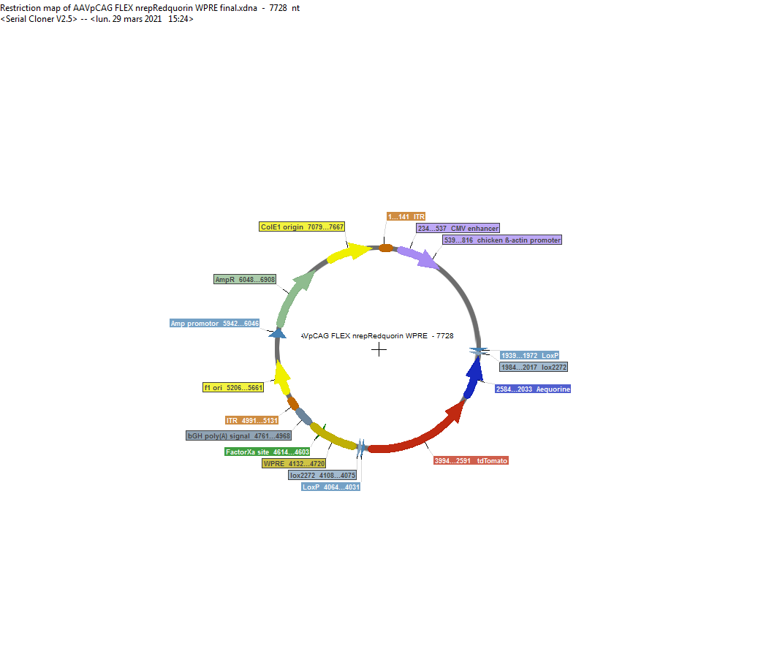

cctgcaggcagctgcgcgctcgctcgctcactgaggccgcccgggcaaagcccgggcgtcgggcgacctttggtcgcccg

gcctcagtgagcgagcgagcgcgcagagagggagtggccaactccatcactaggggttcctgcggccgcacgcgaaacaa

ttctgcaggaatctagttattaatagtaatcaattacggggtcattagttcatagcccatatatggagttccgcgttaca

taacttacggtaaatggcccgcctggctgaccgcccaacgacccccgcccattgacgtcaataatgacgtatgttcccat

agtaacgccaatagggactttccattgacgtcaatgggtggagtatttacggtaaactgcccacttggcagtacatcaag

tgtatcatatgccaagtacgccccctattgacgtcaatgacggtaaatggcccgcctggcattatgcccagtacatgacc

ttatgggactttcctacttggcagtacatctacgtattagtcatcgctattaccatggtcgaggtgagccccacgttctg

cttcactctccccatctcccccccctccccacccccaattttgtatttatttattttttaattattttgtgcagcgatgg

gggcggggggggggggggggcgcgcgccaggcggggcggggcggggcgaggggcggggcggggcgaggcggagaggtgcg

gcggcagccaatcagagcggcgcgctccgaaagtttccttttatggcgaggcggcggcggcggcggccctataaaaagcg

aagcgcgcggcgggcggggagtcgctgcgacgctgccttcgccccgtgccccgctccgccgccgcctcgcgccgcccgcc

ccggctctgactgaccgcgttactcccacaggtgagcgggcgggacggcccttctcctccgggctgtaattagcgcttgg

tttaatgacggcttgtttcttttctgtggctgcgtgaaagccttgaggggctccgggagggccctttgtgcggggggagc

ggctcggggggtgcgtgcgtgtgtgtgtgcgtggggagcgccgcgtgcggctccgcgctgcccggcggctgtgagcgctg

cgggcgcggcgcggggctttgtgcgctccgcagtgtgcgcgaggggagcgcggccgggggcggtgccccgcggtgcgggg

ggggctgcgaggggaacaaaggctgcgtgcggggtgtgtgcgtgggggggtgagcagggggtgtgggcgcgtcggtcggg

ctgcaaccccccctgcacccccctccccgagttgctgagcacggcccggcttcgggtgcggggctccgtacggggcgtgg

cgcggggctcgccgtgccgggcggggggtggcggcaggtgggggtgccgggcggggcggggccgcctcgggccggggagg

gctcgggggaggggcgcggcggcccccggagcgccggcggctgtcgaggcgcggcgagccgcagccattgccttttatgg

taatcgtgcgagagggcgcagggacttcctttgtcccaaatctgtgcggagccgaaatctgggaggcgccgccgcacccc

ctctagcgggcgcggggcgaagcggtgcggcgccggcaggaaggaaatgggcggggagggccttcgtgcgtcgccgcgcc

gccgtccccttctccctctccagcctcggggctgtccgcggggggacggctgccttcgggggggacggggcagggcgggg

ttcggcttctggcgtgtgaccggcggctctagagcctctgctaaccatgttcatgccttcttctttttcctacagctcct

gggcaacgtgctggttattgtgctgtctcatcattttggcaaagaattgatttgataccgcgggccccgcgtggacggta

cccttcaggtcgacgtcgataacttcgtatagcatacattatacgaagttatccgaatcgcaataacttcgtataggata

ctttatacgaagttatttggcgcgccGCTAGCTTAggggacagctccaccgtagagcttttcgcaagcaggatccatggt

gtaccaaaatcccagatgctgtcttgtcatctcatcaacatcgagttgtccactttcatcaatatcgcacactctgaatg

tttcctcgcaatcttctgatgattggatgataccagcagctttggtgtatgctttccattcatccagtgtaatagctcca

ttttgatctttgtcaacgatatcaaacaaagcatcaccccagatgcggatgagggttggttcgtttttggcgtatttctc

caattcatcagtagccaattttttccatccttcaatatatgcaggccaatcagtttccacaccatatttcattccagctc

ctccgaagaaggcttccacagcatctttgtgtcgtttggcttgctcaggtgttgctccaaggttattgatgacaatatca

gatgccttgtagaccatctcgtcaagagagatttttccattgtggttgacatcaaggaaattgaacatatgcttgtgtcg

tccaatccatcttgggttgtcgaatccggacagaaacagatggtgcctcccctcgctccgctcatactgctccacaatgg

tgtagtcttcgttatggctagtaatatccagctttgtgtcgacgtaatagtagccaggcagctgcacgggtttcttggcc

atgtagatggttttgaattcgaccagataatgccctccatctttcagcttcagtgcctggtggatctctcccttcagcac

gccgtctctggggtacagcctttctgttgaagcctcccagcccattgtcttcttctgcatgactgggccatcagggggaa

aattggtgccgcgcattttcaccttatagatcagagtgccgtcctgcagagagctgtcctgggtgacagtcaccaggccc

ccgtcttcgaagttcatcactctttcccacttaaacccctctgggaagctcagtttcttgtaatctggaatgtcagcagg

gtgtttcacgtaggctttacttccatacataaactgaggagacaggatgtcccatgcgaatggcagagggccgccctttg

tcactttcagctttgctgtctgggtgccctcatagggcctcccttccccctctccttcaatctcaaactcgtgcccgttc

atgctgccctccatcctgactttaaacctcataaactccttaatcacggccatgttgttgtcctcggaggaggcggtgcc

ggagctgccgctgccggtgctgccggtaccatgccccaggaacaggtggtggcggccctcggagcgctcgtactgttcca

cgatggtgtagtcctcgttgtgggaggtgatgtccagcttggtgtccacgtagtagtagccgggcagttgcacgggcttc

ttggccatgtagatggtcttgaactccaccaggtagtggccgccgtccttcagcttcagggcctggtggatctcgccctt

cagcacgccgtcgcgggggtacaggcgctcggtggaggcctcccagcccatggtcttcttctgcattacggggccgtcgg

gggggaagttggtgccgcgcatcttcaccttgtagatcagcgtgccgtcctgcagggaggagtcctgggtcacggtcacc

agaccgccgtcctcgaagttcatcacgcgctcccacttgaagccctcggggaaggacagcttcttgtaatcggggatgtc

ggcggggtgcttcacgtacgccttggagccgtacatgaactggggggacaggatgtcccaggcgaagggcagggggccgc

ccttggtcaccttcagcttggcggtctgggtgccctcgtaggggcggccctcgccctcgccctcgatctcgaactcgtgg

ccgttcatggagccctccatgcgcaccttgaagcgcatgaactctttgatgacctcctcgcccttgctcacCATggtggc

GCTAGCggcgcgccaacctggccggccttgataacttcgtataatgtatgctatacgaagttatccgaatcgcaataact

tcgtataaagtatcctatacgaagttatcgaagatcatcaagcttatcgataatcaacctctggattacaaaatttgtga

aagattgactggtattcttaactatgttgctccttttacgctatgtggatacgctgctttaatgcctttgtatcatgcta

ttgcttcccgtatggctttcattttctcctccttgtataaatcctggttgctgtctctttatgaggagttgtggcccgtt

gtcaggcaacgtggcgtggtgtgcactgtgtttgctgacgcaacccccactggttggggcattgccaccacctgtcagct

cctttccgggactttcgctttccccctccctattgccacggcggaactcatcgccgcctgccttgcccgctgctggacag

gggctcggctgttgggcactgacaattccgtggtgttgtcggggaaatcatcgtcctttccttggctgctcgcctatgtt

gccacctggattctgcgcgggacgtccttctgctacgtcccttcggccctcaatccagcggaccttccttcccgcggcct

gctgccggctctgcggcctcttccgcgtcttcgccttcgccctcagacgagtcggatctccctttgggccgcctccccgc

atcgataccgagcgctgctcgagagatcgatctgcctcgactgtgccttctagttgccagccatctgttgtttgcccctc

ccccgtgccttccttgaccctggaaggtgccactcccactgtcctttcctaataaaatgaggaaattgcatcgcattgtc

tgagtaggtgtcattctattctggggggtggggtggggcaggacagcaagggggaggattgggaagacaatagcaggcat

gctggggacacgtgcggaccgagcggccgcaggaacccctagtgatggagttggccactccctctctgcgcgctcgctcg

ctcactgaggccgggcgaccaaaggtcgcccgacgcccgggctttgcccgggcggcctcagtgagcgagcgagcgcgcag

ctgcctgcaggggcgcctgatgcggtattttctccttacgcatctgtgcggtatttcacaccgcatacgtcaaagcaacc

atagtacgcgccctgtagcggcgcattaagcgcggcgggtgtggtggttacgcgcagcgtgaccgctacacttgccagcg

ccctagcgcccgctcctttcgctttcttcccttcctttctcgccacgttcgccggctttccccgtcaagctctaaatcgg

gggctccctttagggttccgatttagtgctttacggcacctcgaccccaaaaaacttgatttgggtgatggttcacgtag

tgggccatcgccctgatagacggtttttcgccctttgacgttggagtccacgttctttaatagtggactcttgttccaaa

ctggaacaacactcaaccctatctcgggctattcttttgatttataagggattttgccgatttcggcctattggttaaaa

aatgagctgatttaacaaaaatttaacgcgaattttaacaaaatattaacgtttacaattttatggtgcactctcagtac

aatctgctctgatgccgcatagttaagccagccccgacacccgccaacacccgctgacgcgccctgacgggcttgtctgc

tcccggcatccgcttacagacaagctgtgaccgtctccgggagctgcatgtgtcagaggttttcaccgtcatcaccgaaa

cgcgcgagacgaaagggcctcgtgatacgcctatttttataggttaatgtcatgataataatggtttcttagacgtcagg

tggcacttttcggggaaatgtgcgcggaacccctatttgtttatttttctaaatacattcaaatatgtatccgctcatga

gacaataaccctgataaatgcttcaataatattgaaaaaggaagagtatgagtattcaacatttccgtgtcgcccttatt

cccttttttgcggcattttgccttcctgtttttgctcacccagaaacgctggtgaaagtaaaagatgctgaagatcagtt

gggtgcacgagtgggttacatcgaactggatctcaacagcggtaagatccttgagagttttcgccccgaagaacgttttc

caatgatgagcacttttaaagttctgctatgtggcgcggtattatcccgtattgacgccgggcaagagcaactcggtcgc

cgcatacactattctcagaatgacttggttgagtactcaccagtcacagaaaagcatcttacggatggcatgacagtaag

agaattatgcagtgctgccataaccatgagtgataacactgcggccaacttacttctgacaacgatcggaggaccgaagg

agctaaccgcttttttgcacaacatgggggatcatgtaactcgccttgatcgttgggaaccggagctgaatgaagccata

ccaaacgacgagcgtgacaccacgatgcctgtagcaatggcaacaacgttgcgcaaactattaactggcgaactacttac

tctagcttcccggcaacaattaatagactggatggaggcggataaagttgcaggaccacttctgcgctcggcccttccgg

ctggctggtttattgctgataaatctggagccggtgagcgtgggtctcgcggtatcattgcagcactggggccagatggt

aagccctcccgtatcgtagttatctacacgacggggagtcaggcaactatggatgaacgaaatagacagatcgctgagat

aggtgcctcactgattaagcattggtaactgtcagaccaagtttactcatatatactttagattgatttaaaacttcatt

tttaatttaaaaggatctaggtgaagatcctttttgataatctcatgaccaaaatcccttaacgtgagttttcgttccac

tgagcgtcagaccccgtagaaaagatcaaaggatcttcttgagatcctttttttctgcgcgtaatctgctgcttgcaaac

aaaaaaaccaccgctaccagcggtggtttgtttgccggatcaagagctaccaactctttttccgaaggtaactggcttca

gcagagcgcagataccaaatactgtccttctagtgtagccgtagttaggccaccacttcaagaactctgtagcaccgcct

acatacctcgctctgctaatcctgttaccagtggctgctgccagtggcgataagtcgtgtcttaccgggttggactcaag

acgatagttaccggataaggcgcagcggtcgggctgaacggggggttcgtgcacacagcccagcttggagcgaacgacct

acaccgaactgagatacctacagcgtgagctatgagaaagcgccacgcttcccgaagggagaaaggcggacaggtatccg

gtaagcggcagggtcggaacaggagagcgcacgagggagcttccagggggaaacgcctggtatctttatagtcctgtcgg

gtttcgccacctctgacttgagcgtcgatttttgtgatgctcgtcaggggggcggagcctatggaaaaacgccagcaacg

cggcctttttacggttcctggccttttgctggccttttgctcacatgt

1-141 ITR

234-537 CMV enhancer

539-816 chicken β-actin promoter

1939-1972 LoxP

1984-2017 lox2272

2584-2033 Aequorine

3994-2591 tdTomato

4108-4075 lox2272

4067-4031 LoxP

4132-4720 WPRE

4761-4968 bGH poly(A) signal

4991-5131 ITR

* **DIGESTION SmaI du plasmide**

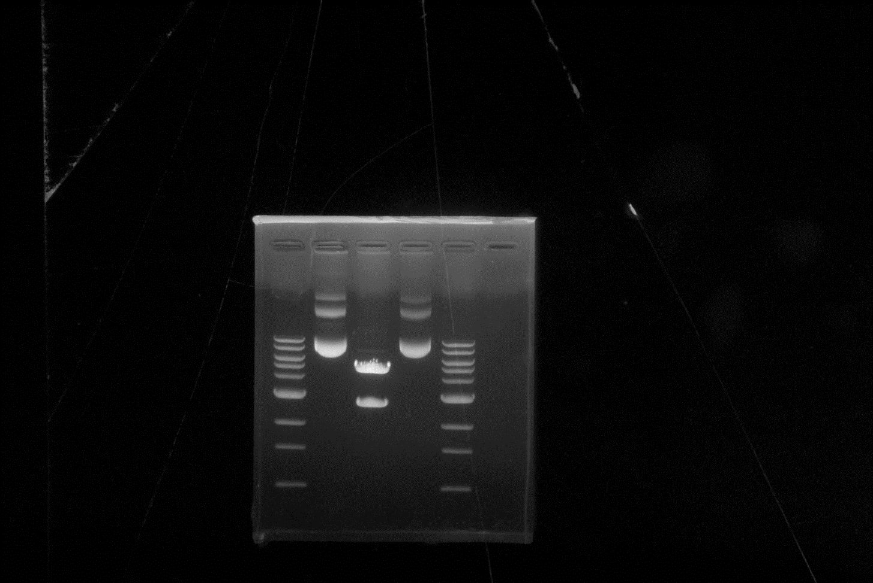

**kb**

**10.0**

**0.5**

**1.0**

**5.0**

**2.0**

**3.0**

**4.0**

**6.0**

**8.0**

**SmaI**

**Non digéré**

**DNA Ladder**

**NEB N3292**

* Concentration du plasmide = 6.74 ug/ul repris dans TE-EF (Kit Nucleobond Xtra Maxi EF Macherey-Nagel)
* Pureté du plasmide (DO 260/280) = 1.83

