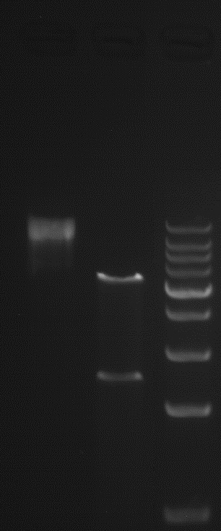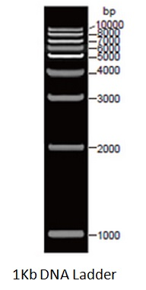

Lane1：Y0015991-1 plasmid DNA

Lane2：Digested with HindIII / NotI (Expected Size:2548/5784bp)

Lane3：DNA Marker

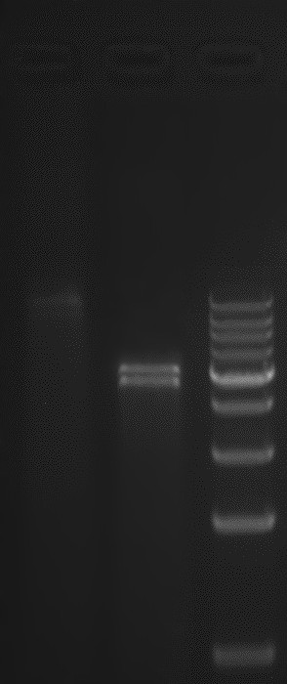

Lane1：Y0015991-1 plasmid DNA

Lane2：Digested with SmaI (Expected Size:11/11/3702/4608bp)

Lane3：DNA Marker