# NADIN – Online Big Band Sheet Music Manager

NADIN is a PHP program made to provide big band musicians with the needed sheet music and recordings thereof by means of personal access data. To that end, the PDF files can be taken apart to make them available selectively, so that e.g. saxophonists can only obtain the saxophone score etc. This ensures that the arrangements are protected and do not spread uncontrollably. Substitutes can be registered in the system, too; they receive a login carrying an expiration date.

In NADIN, a band’s complete music library can be managed. NADIN administrators can put together the set lists of gigs by mouse clicks and make them available to the band members, including download links for the appropriate notes and recordings. Past gigs can be archived. In the administration, user rights can be defined (e.g. access only to the sax score for the current gigs, but not to archived gigs, and not to the music library).

NADIN is purely file-based; therefore, it needs no database. It was developed by Urs Petermann and Stefan Minder for the Uptown Big Band Bern and is available to all interested parties free of charge. Any warranty and liability is excluded.

Installation Guide on the next page.

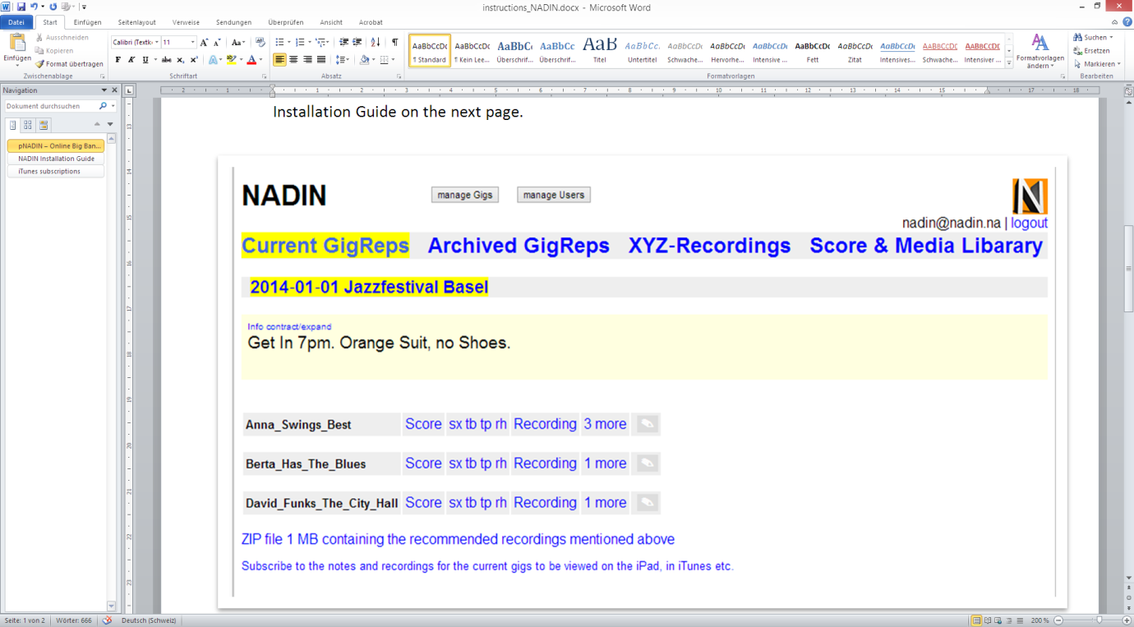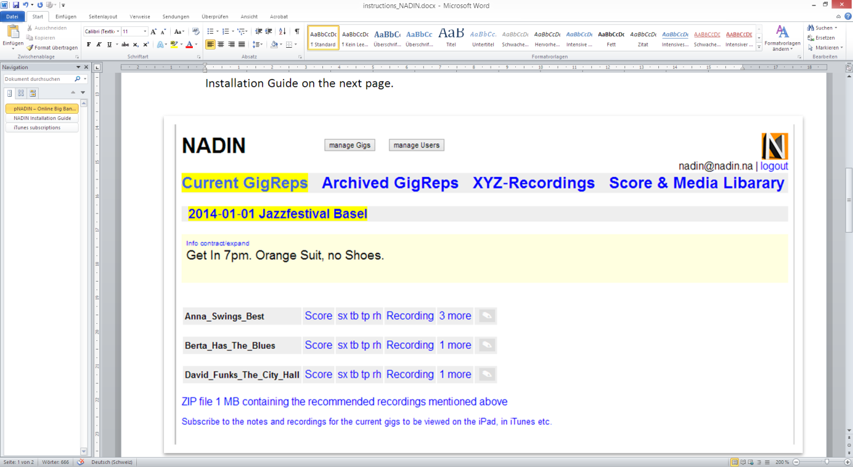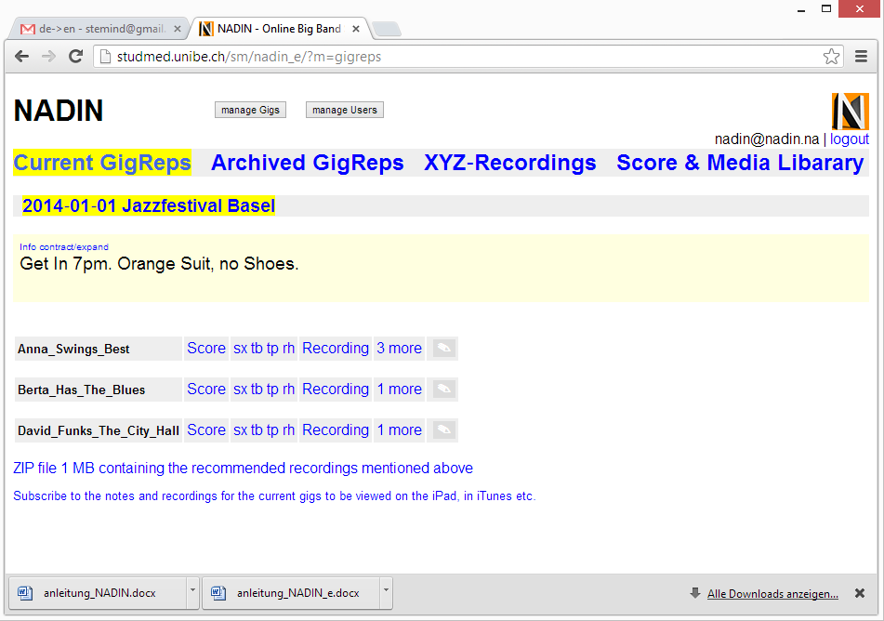

# NADIN Installation Guide

1. Unzip nadin_en.zip and make sure that the folder structure is preserved.
2. Open the file config.inc.php in a text editor and define the variables $bb and $salt.
3. IF on your provider’s system, PHP runs as CGI, not as a module, **which is rare**, see *.  
   IF your site’s URL starts with http**s**:// instead of http://, see **.
4. Read the comment “//IMPORTANT:” at the top of the config.php file carefully and take the necessary measures.
5. Create a subfolder named, for example, ‚nadin‘ on your webhost’s server’s accessible folder (usually named ‚public_html‘ or similar) assigned to your site and upload to it the unzipped files and folders.
6. Visit <http://www.yourbigband.ch/nadin/> and log into the admin section by entering the required data in the initial login box displayed.
7. Click on the ‚Manage Users‘ button and register users following the directions given there. If you cannot save the entries, it means that the rights on the server are insufficient, so that the server itself has no write permission during the FTP transfer. In this case, change the rights of the following directories including subdirectories recursively to 777:  
   **library, userdatei**, **gigreps**, **gigrepsarchiv** and **gigrepsdeleted,** as well as **filesdeleted** and **abo/zip.**
8. By now, most of it should work except iTunes subscriptions.
9. Now you need to set the path in the file abo/.htaccess. There, the given path is  
    AuthUserFile "/var/webs/www.sophisware.ch/hostingwebs/bigbandweb/abb/nadin/userdatei/.htpasswd"  
   which is incorrect for your installation. Find out the correct path by visiting <http://www.yourbigband.ch/nadin/server.php> and consult ["SCRIPT_FILENAME"]. If, for instance, you see  
   string(60) "/srv/www/studmed.unibe.ch/public_html/nadin/server.php" there, the correct path is AuthUserFile "/srv/www/studmed.unibe.ch/public_html/nadin/userdatei/.htpasswd".  
   If you fail to carry out point 9, the Pro-Gig ZIP file that contains the recommended recordings cannot be downloaded. (iTunes subscriptions require this setting, too). To enable that, the file userdatei/.htpasswd must contain the appropriate passwords. Do NOT write manually into this file! In the backend, click the button **manage Users** and save there by clicking the **s**-button; now the file is generated. Attention: If you are adding new users and - in the same session in the form - are deleting or overwriting the user with which you are currently logged-in, you can save the form but .htpasswd won’t be updated. In that case, log out and log in again and then go to the users again and save them again!
10. Security check: Each one of the folders, library, userdatei, gigreps, gigrepsarchiv and gigrepsdeleted, as well as filesdeleted must contain an .htaccess file globally disallowing visits. These .htaccess files are actually part of the NADIN ZIP file; however, they may get lost during the FTP transfer to your host server.

# iTunes subscriptions

1. In case you do want to offer these $offeritunesabo to 'yes' in config.inc.php.
2. If you want iTunes subscriptions to work properly, follow the directions‚ PREREQUISITES FOR WORKING iTUNES SUBSCRIPTIONS in config.inc.php.

* IF on your provider’s system, PHP runs as CGI, not as a module, **which is rare**, open config.inc.php and set $autoresolvefastcgiproblems to 'yes' near the end of the file code; in abo/.htaccess, delete all the pound signs (#) except in the line #http://www.besthostratings.com/articles/http-auth-php-cgi.html  
** IF your site’s URL starts with https:// instead of http://, change $nadin='http://'.$_SERVER['SERVER_NAME'].$_SERVER['PHP_SELF']; in config.inc.php accordingly.