1.Using Mongo shell, create a database and insert the following documents.
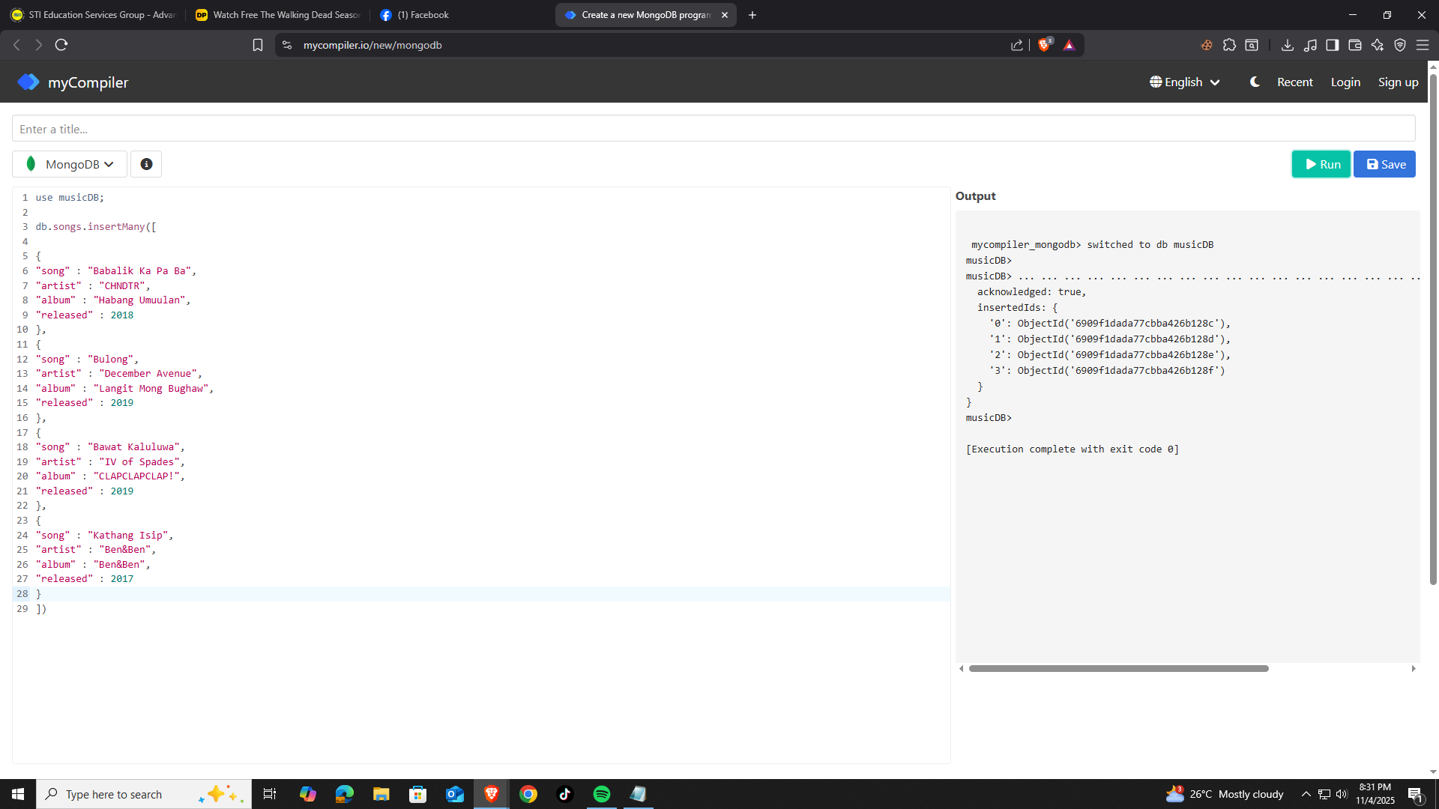
2. Find the documents or songs that were released in the years 2017 and 2018.
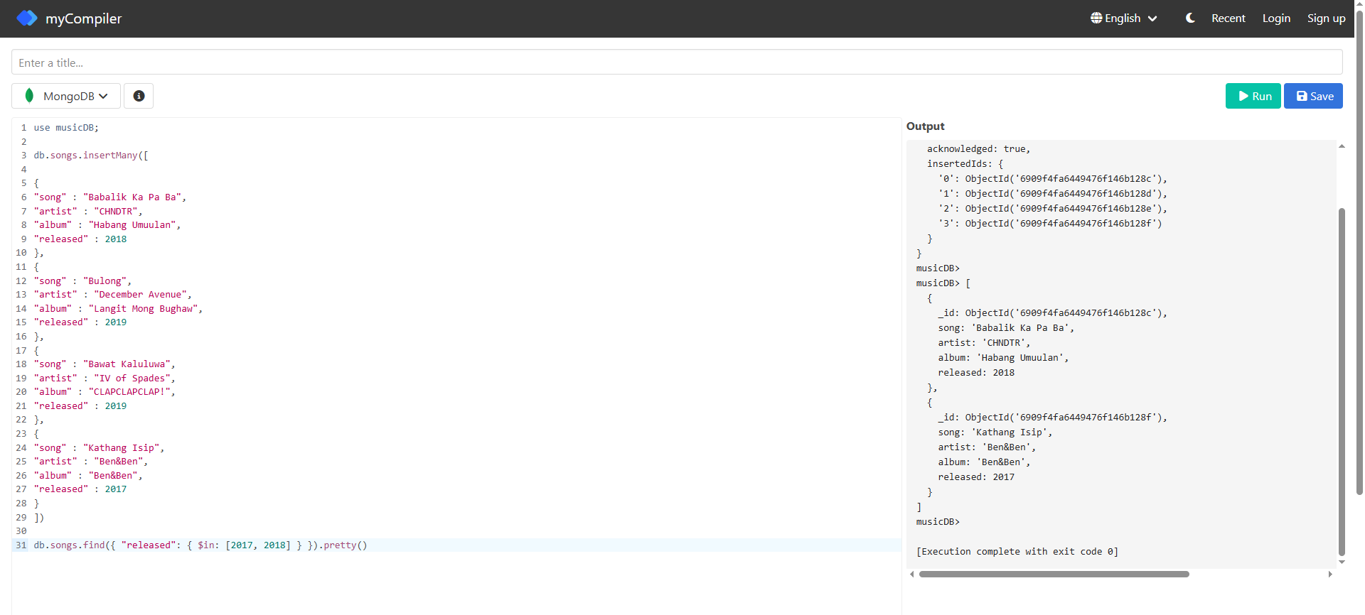

3.Using the deleteOne command, remove the document which contains the song “Bawat Kaluluwa”.
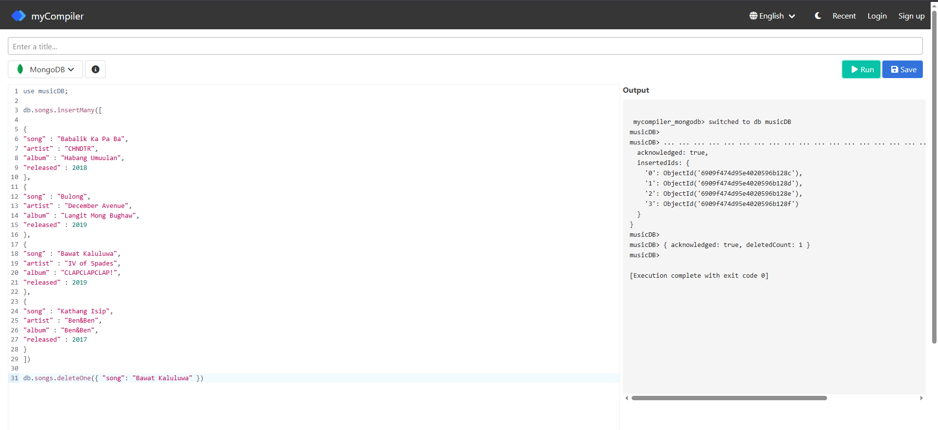
4.Find the document that has a value of "Bulong".
