TargetAI Counselor Platform

Your Complete College Counseling Command Center

The AI Age of College Counseling
The landscape of college counseling is transforming. In the AI age, practices must evolve to remain competitive and effective. The choice is clear: work alongside AI to enhance your capabilities and scale your impact, or risk being replaced by those who do.
TargetAI positions you at the forefront of this evolution—empowering you to deliver personalized, data-driven guidance at unprecedented scale while maintaining the human insight that defines exceptional counseling.

Platform Overview
TargetAI is a comprehensive college counseling platform designed for professional counselors. Manage your entire caseload, conduct meetings, track student progress, analyze college strategies, and leverage AI-powered insights—all from one intelligent command center.

Core Features

1. Students Management

1.1 Student Dashboard
Your central hub for managing all students with real-time insights.
Key Capabilities: - View all students with key metrics (total students, upcoming meetings, high schools, colleges) - Search and filter by name, email, grade, or school - Quick action buttons for each student (chat, email, profile, delete) - Student type badges (Regular vs Prospect) - Export student data for external analysis
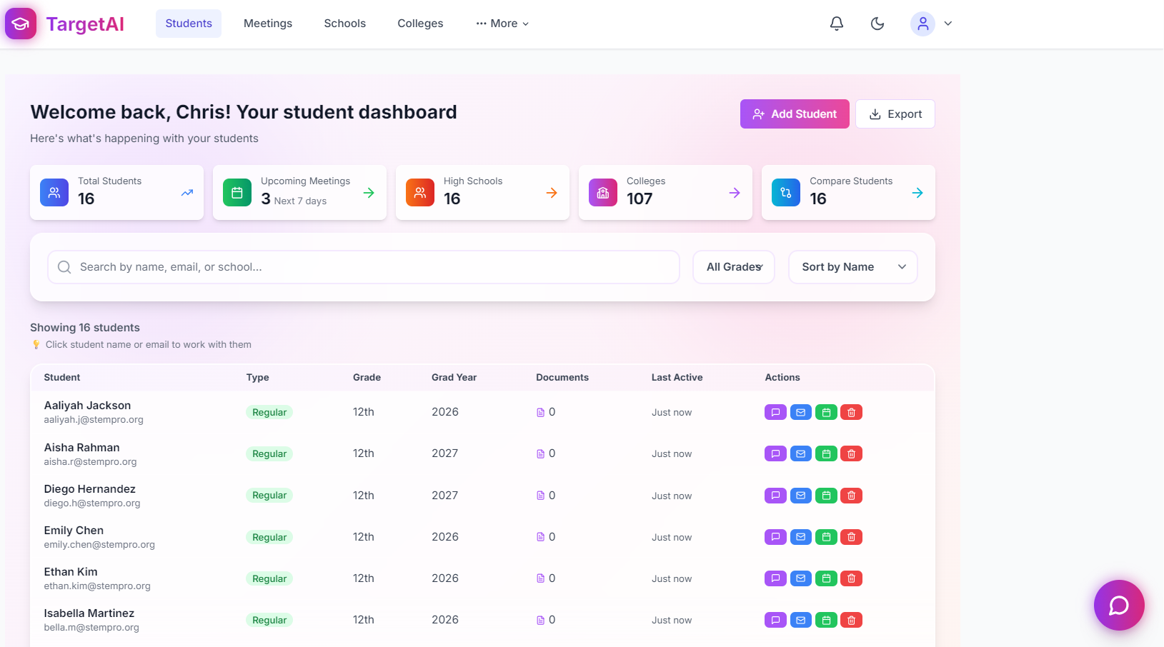 Screenshot: students.png - Student dashboard with metrics cards and student list

1.2 Add New Student
Create student profiles and send login credentials instantly.
Key Capabilities: - Student information (name, email, graduation year, home state, zip code) - High school search and selection - Parent information and education level - Email notification toggle for credentials - Mark as prospect student option
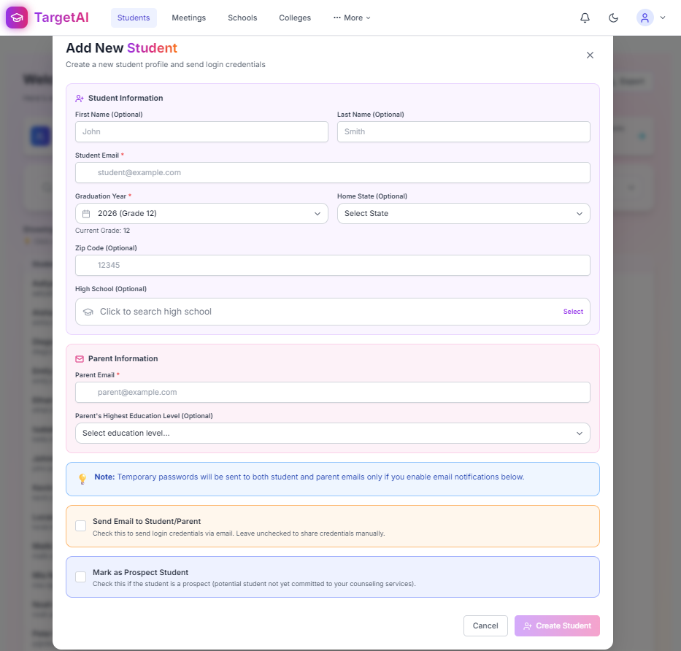 Screenshot: add_student.png - Add new student form with parent information

1.3 AI Chat Assistant for Students
Get instant AI-powered insights for any student with one click.
Key Capabilities: - Context-aware AI assistant with complete student portfolio access - Quick-action prompts (Profile Summary, Strengths & Gaps, College Suggestions, Next Steps, Timeline) - Real-time analysis and recommendations - Available directly from student dashboard
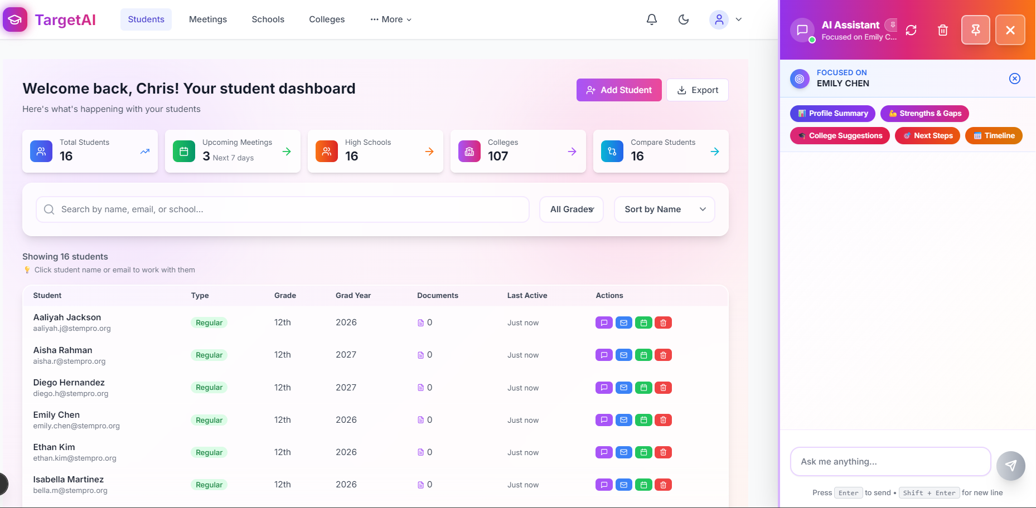 Screenshot: students_chat.png - Student dashboard with AI Assistant drawer open showing quick action buttons

1.4 Student Profile
Comprehensive student profile with completion tracking.
Key Capabilities: - Profile completion percentage by section - Personal information and contact details - Demographics and background information - Section-by-section progress tracking (Personal Info, Academics, Activities, Essays) - Easy editing and updates
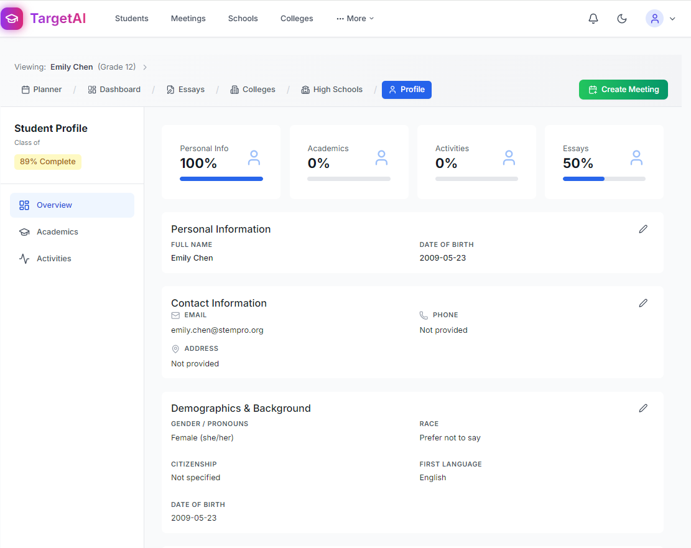 Screenshot: profile.png - Student profile overview with completion metrics

1.5 Compare Students
Benchmark students side-by-side for strategic insights.
Key Capabilities: - Compare up to 3 students simultaneously - Academic overview (GPA, SAT, ACT, class rank) - Activities and leadership comparison - AI-powered student suggestions for comparison - Smart copy feature for reusable strategies
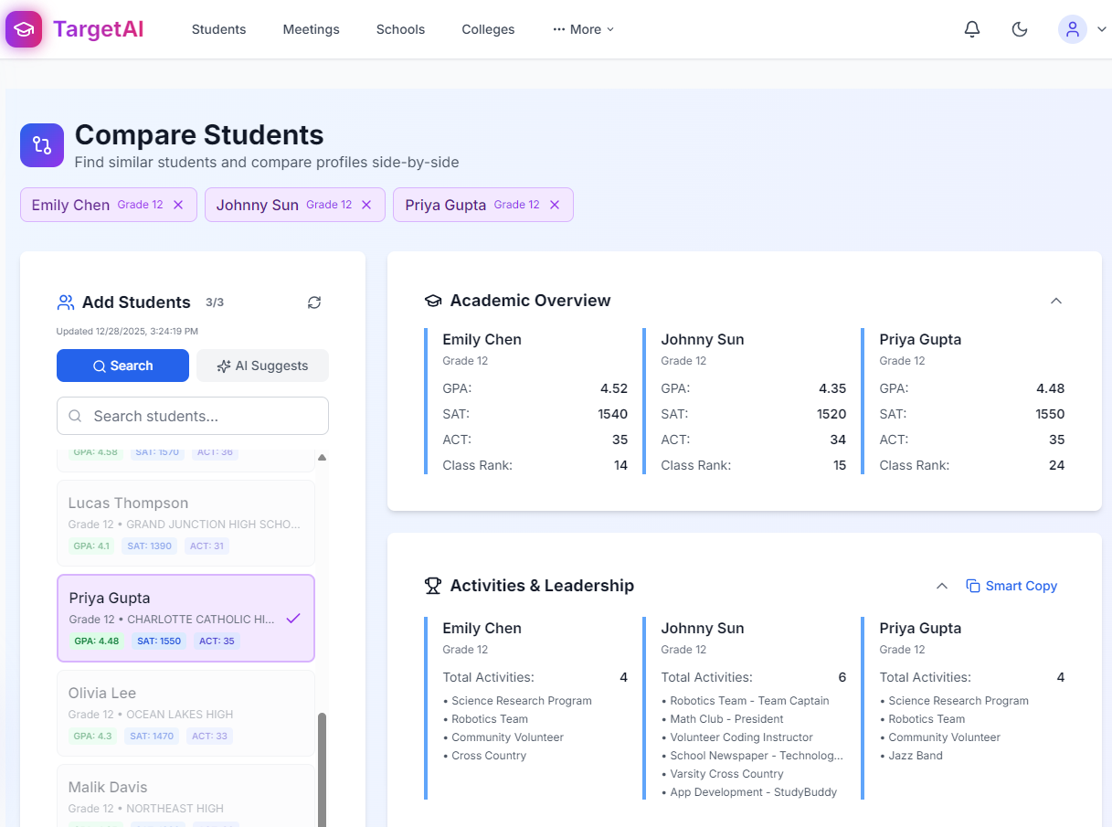 Screenshot: compare.png - Side-by-side student comparison with academic and activities data

2. Meetings

2.1 Meeting Dashboard
Streamline your calendar with powerful meeting management.
Key Capabilities: - Meeting statistics (total meetings, scheduled, completed, this week) - Search by student name or topics - Filter by time range (All Time, Today, Tomorrow, Next 7 Days, This Week, This Month, etc.) - Filter by status (All Status, Scheduled, Completed, Cancelled) - Meeting type badges (Regular Counselor Meeting, Essay & App Review, Initial Consultation) - Student type indicators (Regular vs Prospect)
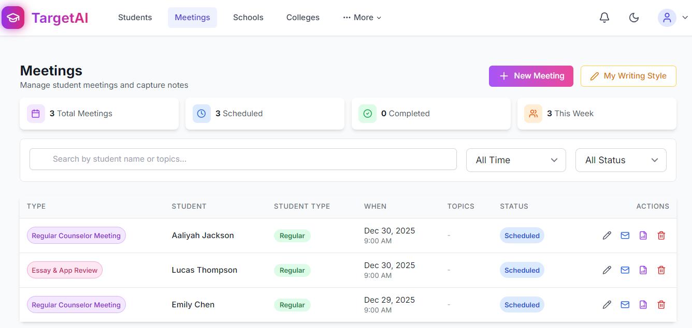 Screenshot: meetings.png - Meetings list with stats, filters, and action buttons

2.2 Individual Meeting Management
Capture every detail with real-time recording and AI-powered documentation.
Key Capabilities: - Student information display (name, email, graduation year, zip code) - Real-time recording options (Audio and Video) - Quick actions (Upload Document, Take Photo, Record Audio Note, Record Video Note, Create Text Note) - Meeting documents with AI cleanup and analysis - Attendees and topics management - Meeting notes section - AI-generated meeting reports
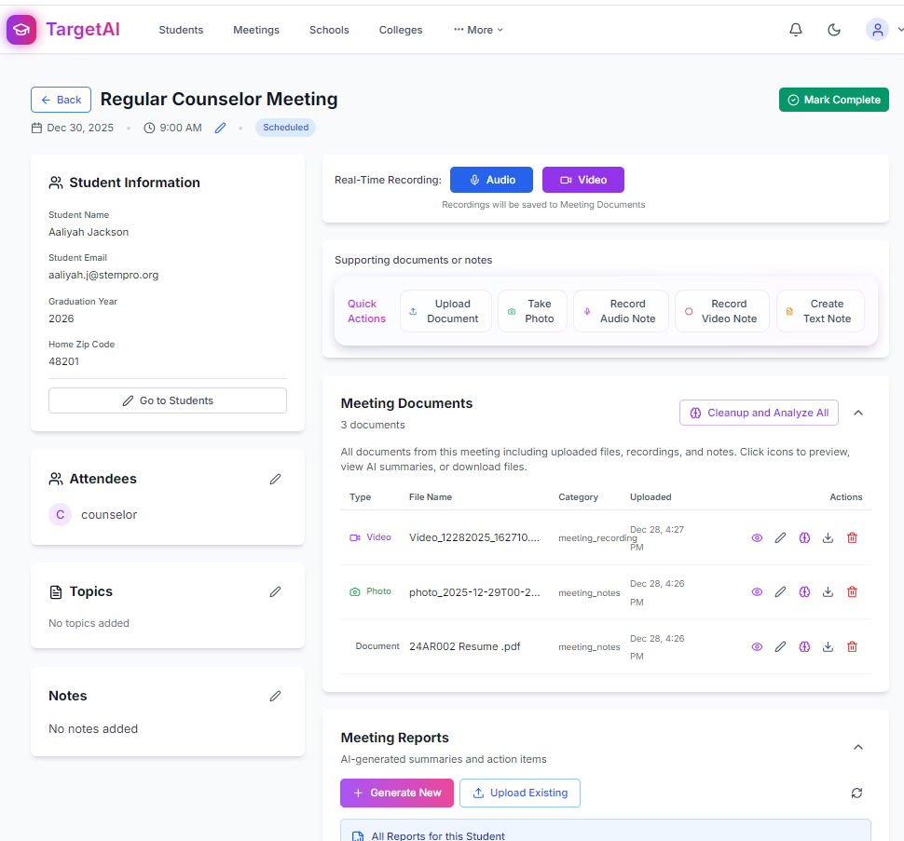 Screenshot: meeting_individual.png - Meeting details page with recording options and document management

2.3 AI Meeting Report Generation
Transform sessions into professional reports instantly.
Key Capabilities: - Multiple report types (Counseling Report) - Student data inclusion options (None, Basic Profile, Full Portfolio) - Include essays if available - Auto-update student portfolio based on meeting insights - Multiple output formats (PDF, DOCX) - Processing time estimate (1-3 minutes)
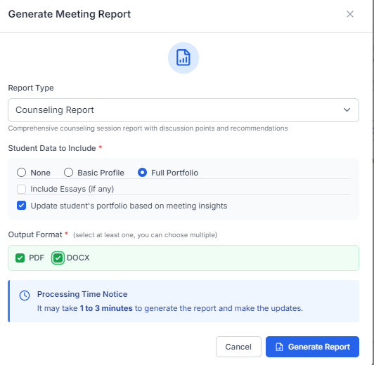 Screenshot: create_report.png - Meeting report generation modal with options

3. Schools Intelligence

3.1 High Schools Overview
Understand your student distribution across high schools.
Key Capabilities: - View all high schools from your student caseload - Toggle between “My Students” and “All Students” views - List view and scatter plot visualization options - Filter by student scope - Location information for each school - Student count per school - Quick actions (chat, view details, research)
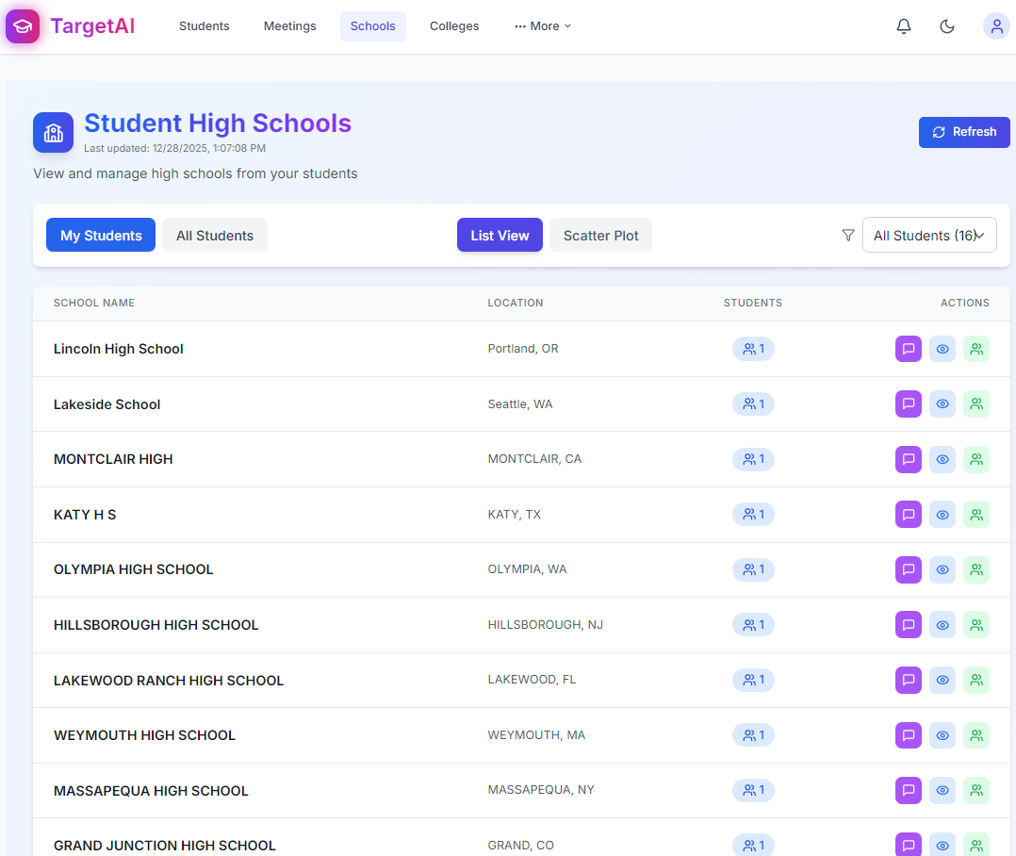 Screenshot: highschool.png - High schools list view with locations and student counts

3.2 AI Chat for School Research
Get instant insights about any high school with AI assistance.
Key Capabilities: - Context-aware AI focused on specific schools - Quick action prompts (School Profile, Course Offerings, Activities, College Outcomes, Maximize Prep) - Research high school data automatically - Compare schools and analyze patterns
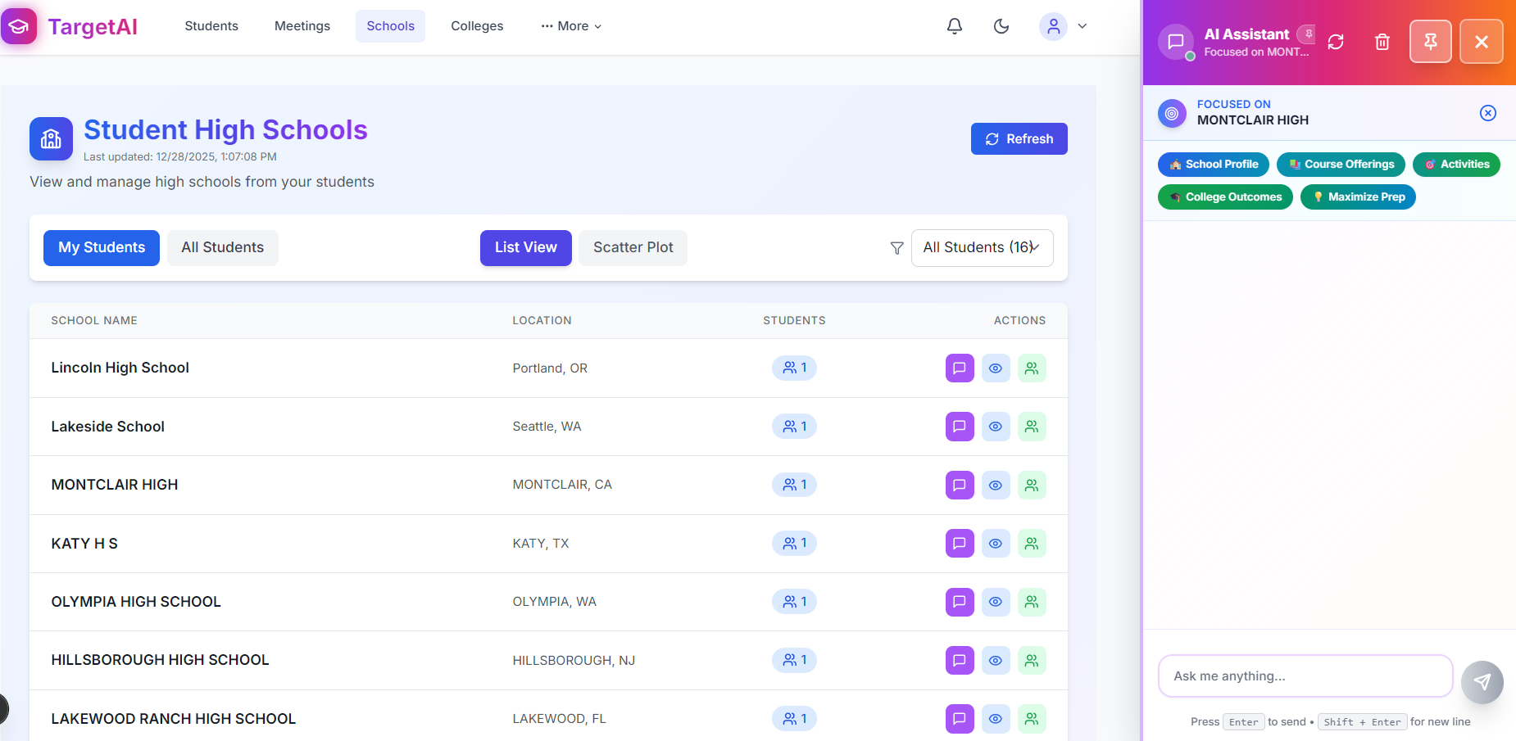 Screenshot: high_school_2.png - High schools page with AI Assistant focused on school context

4. Colleges Intelligence

4.1 Counselor Colleges View (Aggregated)
Understand college trends across your entire caseload.
Key Capabilities: - View all colleges across assigned students - Toggle between “My Students” and “All Students” scopes - List view and scatter plot visualization - Competitiveness badges (High, Medium, Regular) based on acceptance rates - High: < 20% acceptance rate - Medium: 20-60% acceptance rate - Regular: > 60% acceptance rate - Student count per college - Expandable view to see which students are interested - Student tier classifications (Reach, Target, Safety)
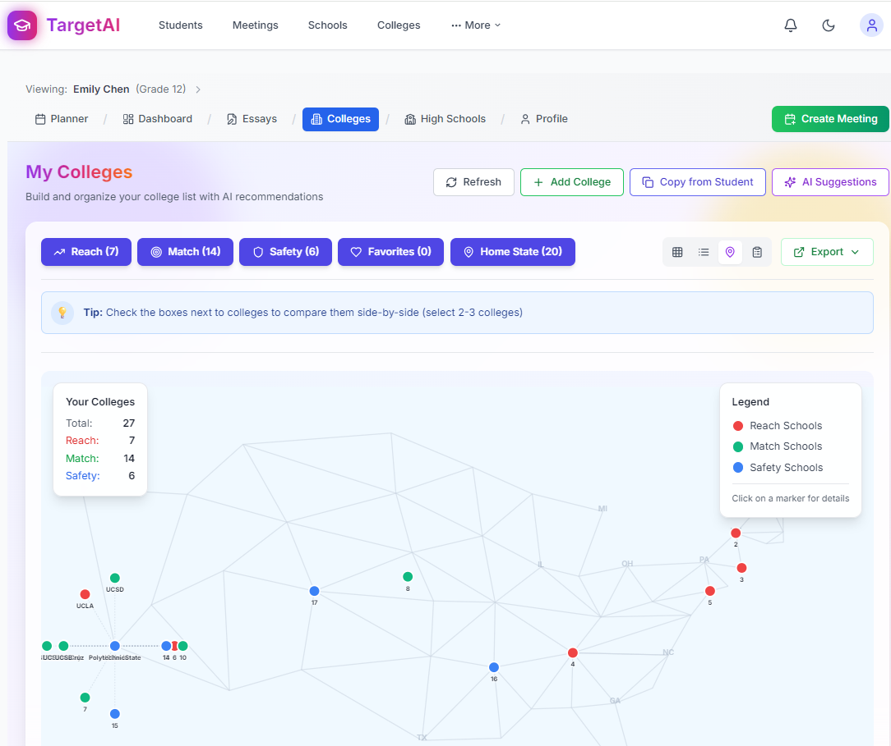 Screenshot: colleges.png - Aggregated colleges list with competitiveness indicators and student breakdown

4.2 Student Colleges View (Individual)
Build and visualize strategic college lists for each student.
Key Capabilities: - College list organized by tier (Reach, Match, Safety) - Total count per tier category - Platform filters (Common App, UC, Coalition, Texas) - Tier filters with color coding - Status filters (Not Started, In Progress, Completed) - Add colleges, copy from another student, AI suggestions - Multiple view options (Grid, List, Map, Timeline) - Export college list
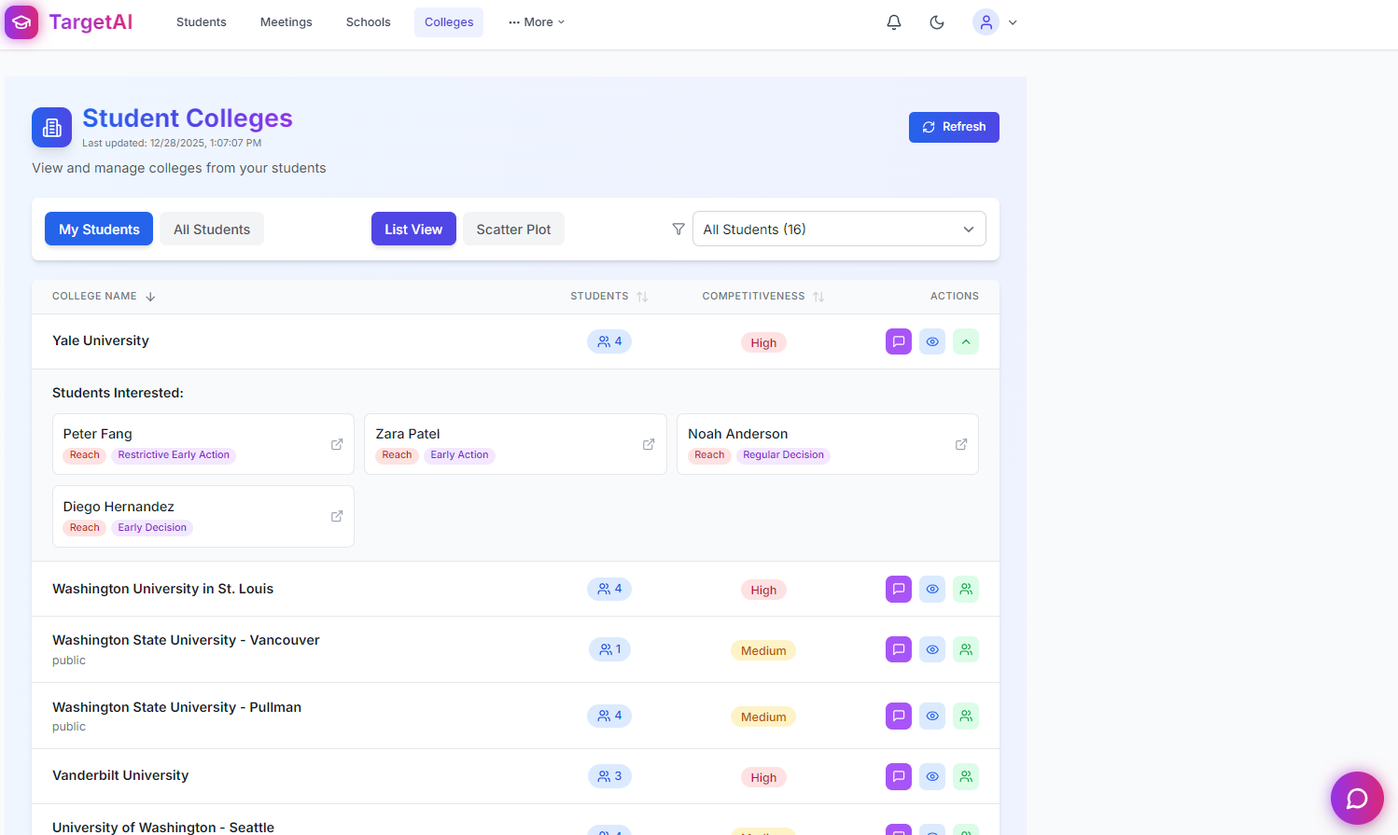 Screenshot: college.png - Student’s college list with scatter plot visualization and tier breakdown

4.3 Gap Analysis & Recommendations (Student Dashboard)
Visualize college strategy with AI-powered gap analysis.
Key Capabilities: - Scatter plot showing Reach, Match, and Safety colleges - Selectiveness vs. fit visualization - Home state colleges highlighted - Filter by major categories (STEM, Engineering, Business, Liberal Arts, Life Sciences, Arts & Humanities) - Tier distribution (Reach, Match, Safety counts) - AI chat with college-focused quick actions - “Fine tune college list” and “Complete Profile” CTAs
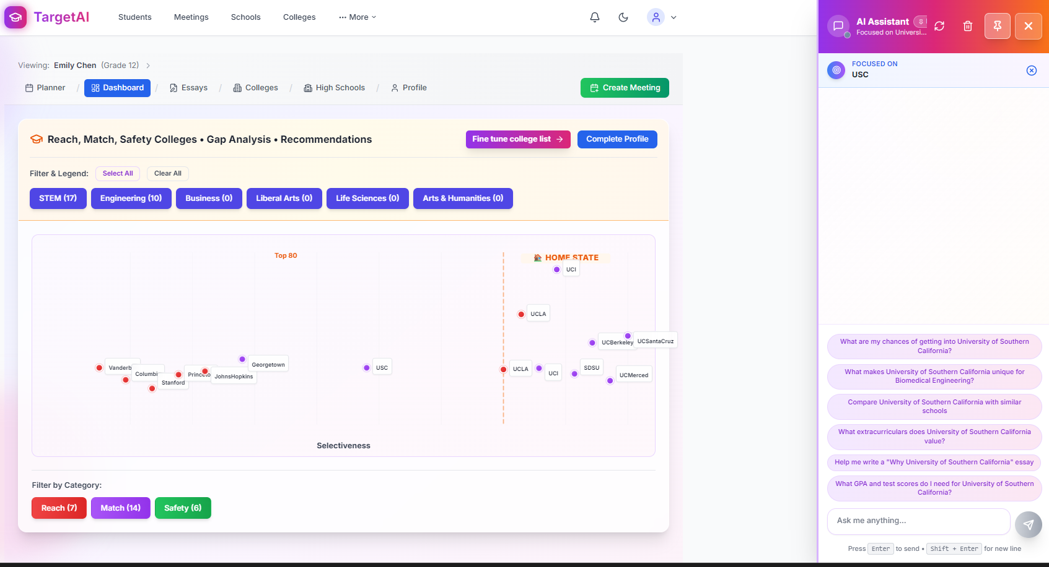 Screenshot: dahsboard2.png - Student dashboard showing gap analysis visualization with AI suggestions

5. Essays & Applications

5.1 College Essays Visualization
Strategically plan essays by theme and writing style.
Key Capabilities: - Essay scatter plot by theme (Personal, Academic, Community) and style (Reflective, Creative, Analytical) - Platform filters (Common App, UC, Coalition, Texas) - Tier filters (Reach, Target, Safety) - Status tracking (Not Started, In Progress, Completed) - Toggle between scatter plot and list view - Refresh with AI for optimization suggestions - Visual clustering of essays by positioning strategy
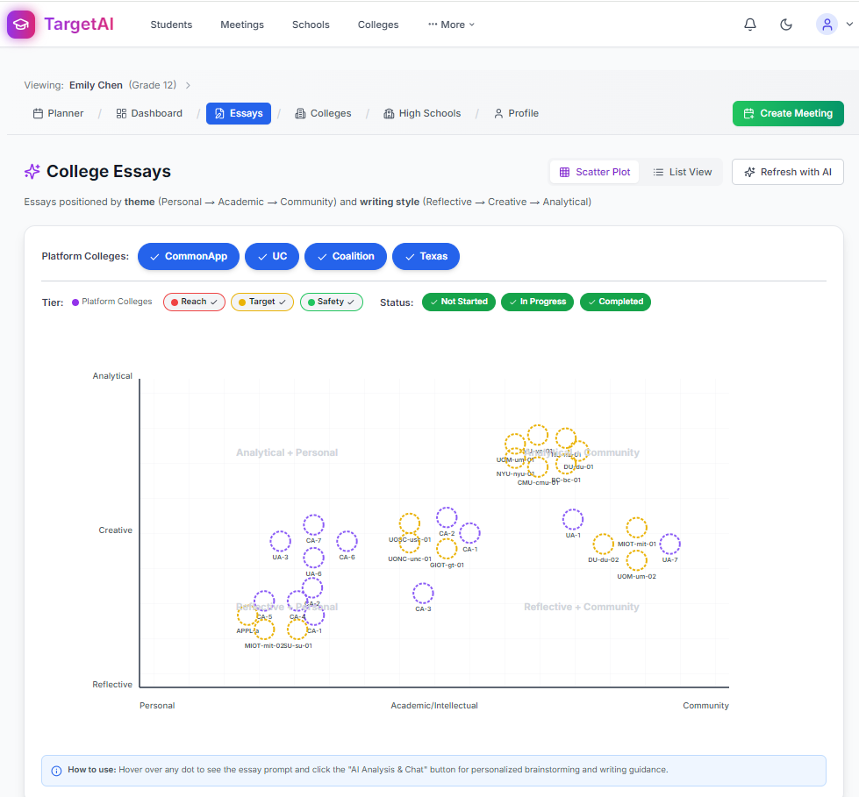 Screenshot: essasy.png - Essay scatter plot showing positioning by theme and writing style

6. Admin Controls

6.1 Admin Dashboard
Platform-wide management for administrators.
Key Capabilities: - View all meetings, students, documents, and admins - Search students across all counselors - Filter by status (current, graduated) - Filter by grade level - Filter by counselor assignment - Student list with counselor assignments visible - Quick actions (Reassign counselor, Graduate student) - Status indicators (Current, Graduated)
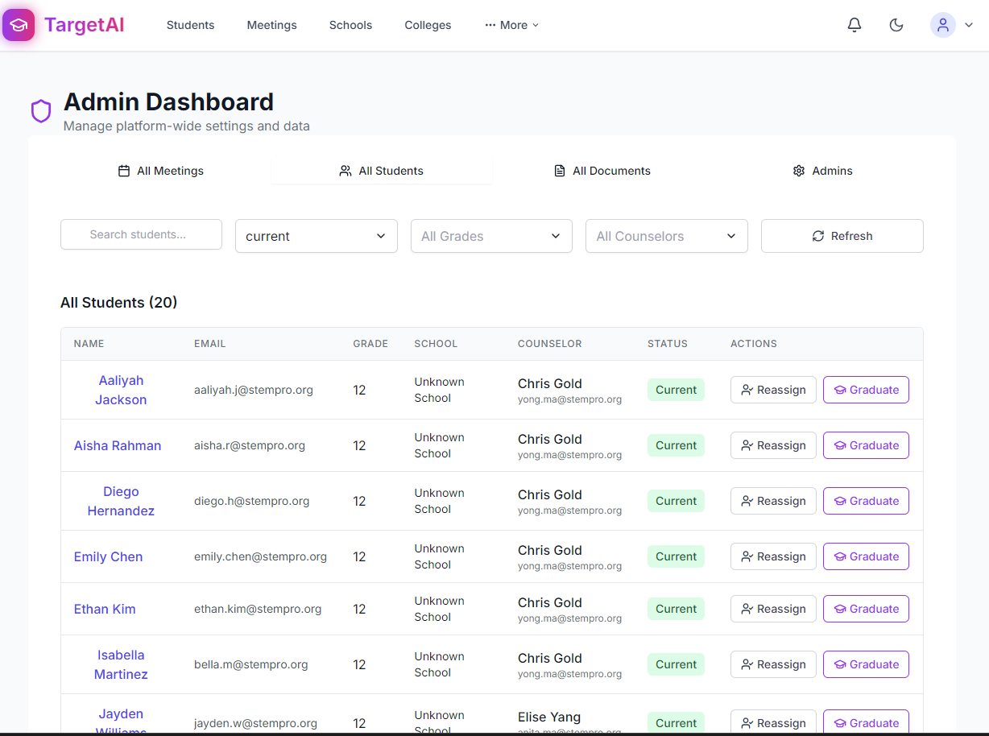 Screenshot: admin.png - Admin dashboard showing all students with counselor assignments

7. AI Assistant (Platform-Wide)
The AI Assistant is integrated throughout TargetAI, providing context-aware support on every page:
Key Features: - Student Context: Profile summaries, strengths analysis, college suggestions, next steps, timeline - School Context: School profiles, course offerings, activities, college outcomes, prep strategies - College Context: Admissions insights, competitiveness analysis, fit assessment - Meeting Context: Report generation, notes summarization, action items - Always Available: Purple chat button accessible from any page - Focus Mode: Automatically loads relevant context based on current page
The AI Assistant learns from your complete student portfolio to provide personalized, actionable recommendations.

Getting Started

For New Counselors:
- Add Your First Student - Use the “Add Student” button or send an invitation
- Schedule Initial Meeting - Create a meeting and use real-time recording
- Generate Meeting Report - Let AI create professional summaries in minutes
- Build Student Profile - Complete profile sections with AI-extracted data
- Develop College Strategy - Use gap analysis and AI recommendations

Quick Win Features
Save hours every week with these time-saving capabilities:
- AI Chat Assistant - Get instant student insights with one-click portfolio analysis
- AI Meeting Reports - Save 30+ minutes per meeting with auto-generated summaries
- Real-Time Recording - Capture audio and video during meetings with automatic transcription
- College Gap Analysis - Visualize reach/match/safety balance instantly
- Essay Positioning Map - Strategically plan essay themes across all applications
- Student Comparison - Benchmark multiple students side-by-side
- Competitiveness Intelligence - See college selectivity across your entire caseload

Version: 2.0 Last Updated: December 2025 Platform: TargetAI Counselor Platform

