Report: Data Analysis of WeRateDogs Twitter Entries

# Introduction

This report describes a brief data analysis conducted for the WeRateDogs (@dog_rate) Twitter tweets. WeRateDogs is a humoristic Twitter account where followers send pictures of dogs that are rated based on that all dogs are good dogs.

The analysis aims to give some insights into:

* The prediction outcomes of the image classifier neural network
* Source system of generated tweets
* Which type of dog generate the most retweets

# Analysis

## Prediction outcomes

The neural network output data is used to present the most common outcomes. The image classifier data shows the three most likely objects shown in the images and can identify breed of dogs. Sometimes it misclassifies things completely, classifying a dog as a fruit or something completely different.

1st predicted object counts (top 5)

1. Golden retriever
2. Labrador retriever
3. Pembroke
4. Chihuahua
5. Pug

2nd predicted object counts (top 5)

1. Labrador retriever
2. Golden retriever
3. Cardigan
4. Chesapeake bay retriever
5. Pomeranian

3rd predicted object counts (top 5)

1. Labrador retriever
2. Chihuahua
3. Golden retriever
4. Eskimo dog
5. Kelpie

All of the above a breeds of dogs **except** for “Cardigan” which is a piece of clothing.

The three following images shows the top 25 identified objects for 1st, 2nd and 3rd object prediction. The rest is grouped together as “other”.

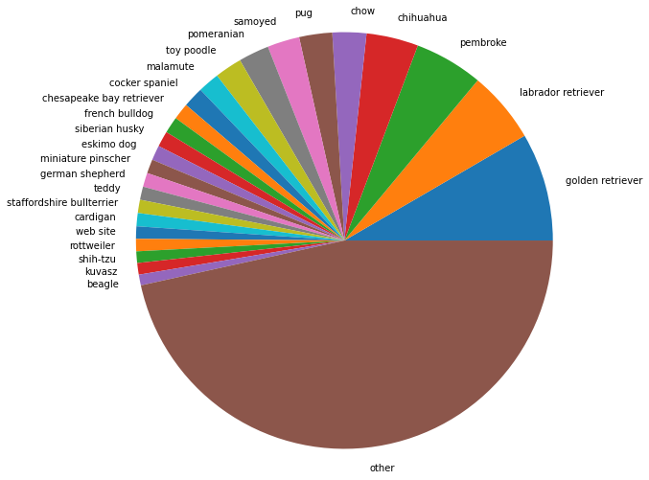

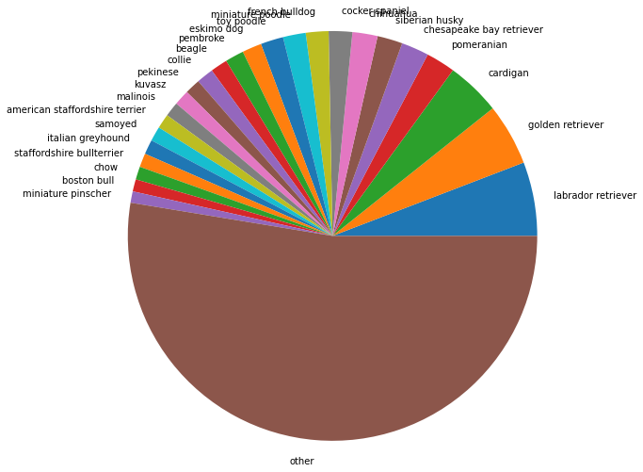

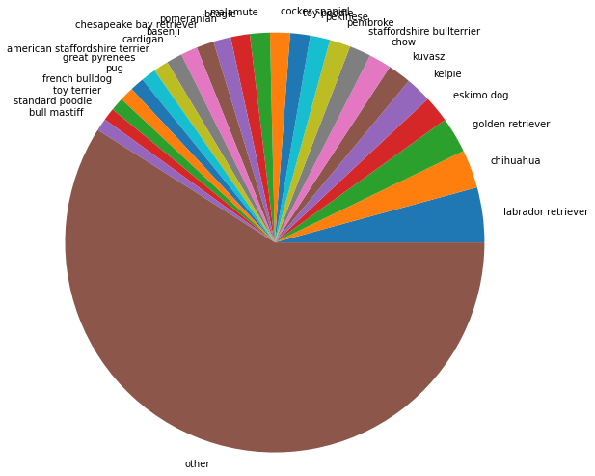

## Source system of generated tweets

Below, the ratio of source system that generated the tweets on the WeRateDogs account is shown.

* iPhone: 92.8 %
* Vine 5.6 %
* Web Client: 1.1 %
* TweetDeck: 0.6 %

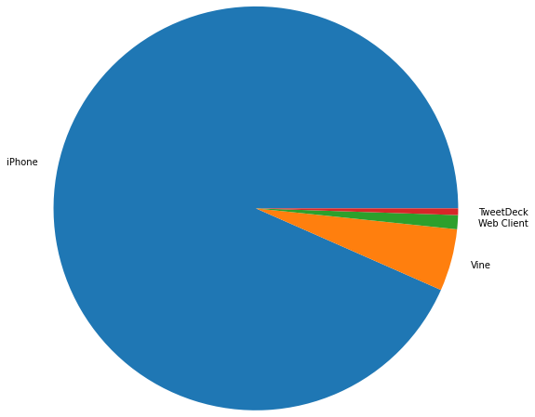

Clearly, the owner(s) of the WeRateDogs account like to use an iPhone to create tweets.

## Retweets based on dog type

Some dogs on WeRateDogs get classified as a “doggo”, “floofer”, “pupper” or “puppo”. Many are also not classified.

Based on this classification, insight is provided below on which types generate most retweets with the average amount of retweets for each dog type presented in the diagram.

Note that combined dog types like “doggo, floofer” were excluded as there were very few occurrences and not deemed significant for this analysis.

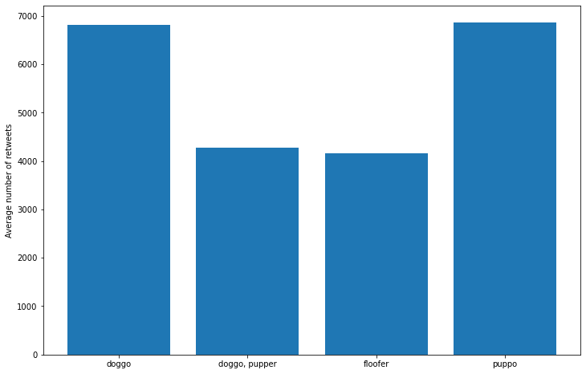

Clearly, “doggo” and “puppo” seem to be the most popular to retweet.