Stage Construction Plan:
The following are the design schematics for a removable indoor stage to be used at a potential concert hall in Montclair, NJ. The stage will be 27in in height, just over 2 ft off the ground, assembled in 3 separate parts and pieced together on the premises. It will be made almost entirely out of wood and will be using 72 cinderblocks underneath the stage for extra support. The stage will have high density carpet installed on top of it for comfort; the entire structure, once finished, will be able to support over 3,600lbs.

Materials used:
Electric screwdriver (supplied) | $0
Circular Saw (supplied) | $0
(12) 4x8ft ½ in plywood boards  [9 for the frame deck, 3 for the face paneling] | $84.00
(33) 8ft 2x4’s  [12 for the frame, 16 for the legs, 5 for the leg braces] | $50.88
(94) 5in x ½ in lag bolts | $24.44
(188) ½ in flat washers | $16.22
(94) ½ hex nuts | $12.02
(1) box of 3in standard thread drywall screws (100ct) | $3.66
(72) 16x8x8 cinder blocks | $103.68  $69.12
(2) strips of 6x8ft high density carpeting (supplied) | $0
1 gallon of black exterior paint for face paneling | $15.00
Total without tax | $309.90
With sales tax | $331.93

The design for this stage is taken from a video tutorial on building small and movable stages for theatre. The tutorial was written by Grady Johnson who is the producer of a theatre troupe called Strange Company. The tutorial can be found here: http://www.ehow.com/videos-on_2842_build-small-stage.html

After watching the video series and making notes, I have made design adjustments to help the stage support more weight. For example, in the videos, they suggest assembling 6 legs per 4x8 ft stage section. Our stage is one ft higher than their design and I thought it best to assemble 13 legs, essentially adding a single leg in between every other on the stage. For extra support, I’m placing (4) 3-stack cinderblock sets under every 4x4ft half of stage, 48 in the entire stage assembly. The extra 24 cinderblock-sets under each third of stage essentially adds an extra 1700 pounds of stone support under that third of stage, strengthening it exponentially.

Attached is the layout design for a 4x4ft half of a stage section. (1/6th of stage)
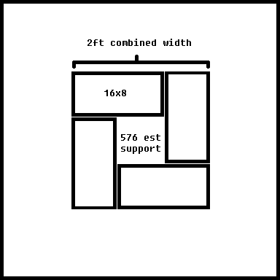
Each cinderblock is said to hold over 72 pounds by itself. 3 stacked cinderblocks holds 216, and 4 sets of 3 holds 864 pounds. 864 pounds of solid support per half stage section is a lot of support. There are three stage sections and 2 halves per section, so the cinderblocks add support up to 5,184 pounds.

Attached here is a diagram of the ‘completed’ stage design. There will be (39) 2ft legs, (5) 8ft 2x4s supporting them together along the bottom of the legs, and 2ft high plywood boards covering up the legs from the braces on the bottom to the top surface.
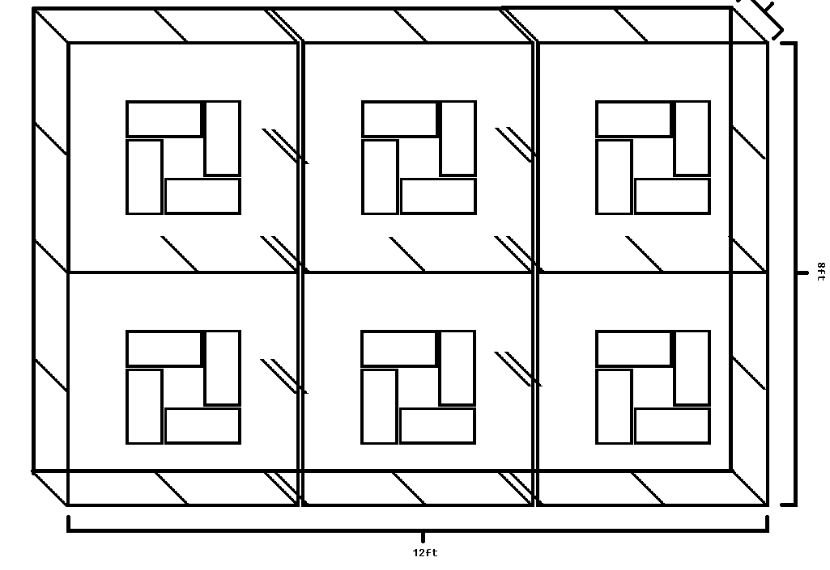
Each stage section (4x8 ft – 1/3rd of final stage) will have 13 legs, each leg will be mounted to the stage frame by two lag bolts (5in x ½ in), with two ½ in flat washers and one ½ in hex nut per bolt. To connect the stage sections, 4 lag bolts (without washers) will be placed at the stage frame pieces, in the middle points between the legs on the connecting sides of the stage sections. Each section’s frame will be covered with a ½ piece of 4x8ft plywood board. When all the sections are mounted together, with all three pieces of board facing vertically, two more layers of board will be placed upon the stage surface placed in alternating directions. The first additional layer of board will be faced horizontally, with two sheets of 4x8ft plywood covering up both the top left/top middle and bottom left/bottom middle stage sections as seen in the diagram above. The final piece of board will be cut into (2) 4x4 pieces to take up the final section. The second additional layer of ½ in plywood board will be placed in the same vertical fashion as it was bolted to the stage frame itself. These extra layers help support the stage surface and help to make it slightly higher.

