Multi-User, Multi-Tenant, Multi-Role User Management API System

High-Level & Low-Level Architectural Design Specification

Part I: High-Level Architectural Design

1. Executive Summary
This document defines the high-level system architecture for a scalable, multi-tenant, multi-role user management API platform. The system is engineered to provide strict logical tenant isolation at the row level while facilitating granular Role-Based Access Control (RBAC). It enables Vendor System Administrators to manage top-level tenant provisioning and grants Organization Super Users the capability to administer standard users and assign vendor-defined static roles within their tenant scope. Additionally, it enforces strict initial default password change policies, robust self-service/administrative password recovery workflows, and comprehensive audit logging with explicit action execution timestamps.

2. Architectural Overview & Routing Model
The platform enforces a clear separation of concerns between Vendor Management operations and Tenant-specific user operations. Request routing, JWT validation, tenant identification, password policy enforcement, and audit timestamping are handled systematically across distinct API boundaries.
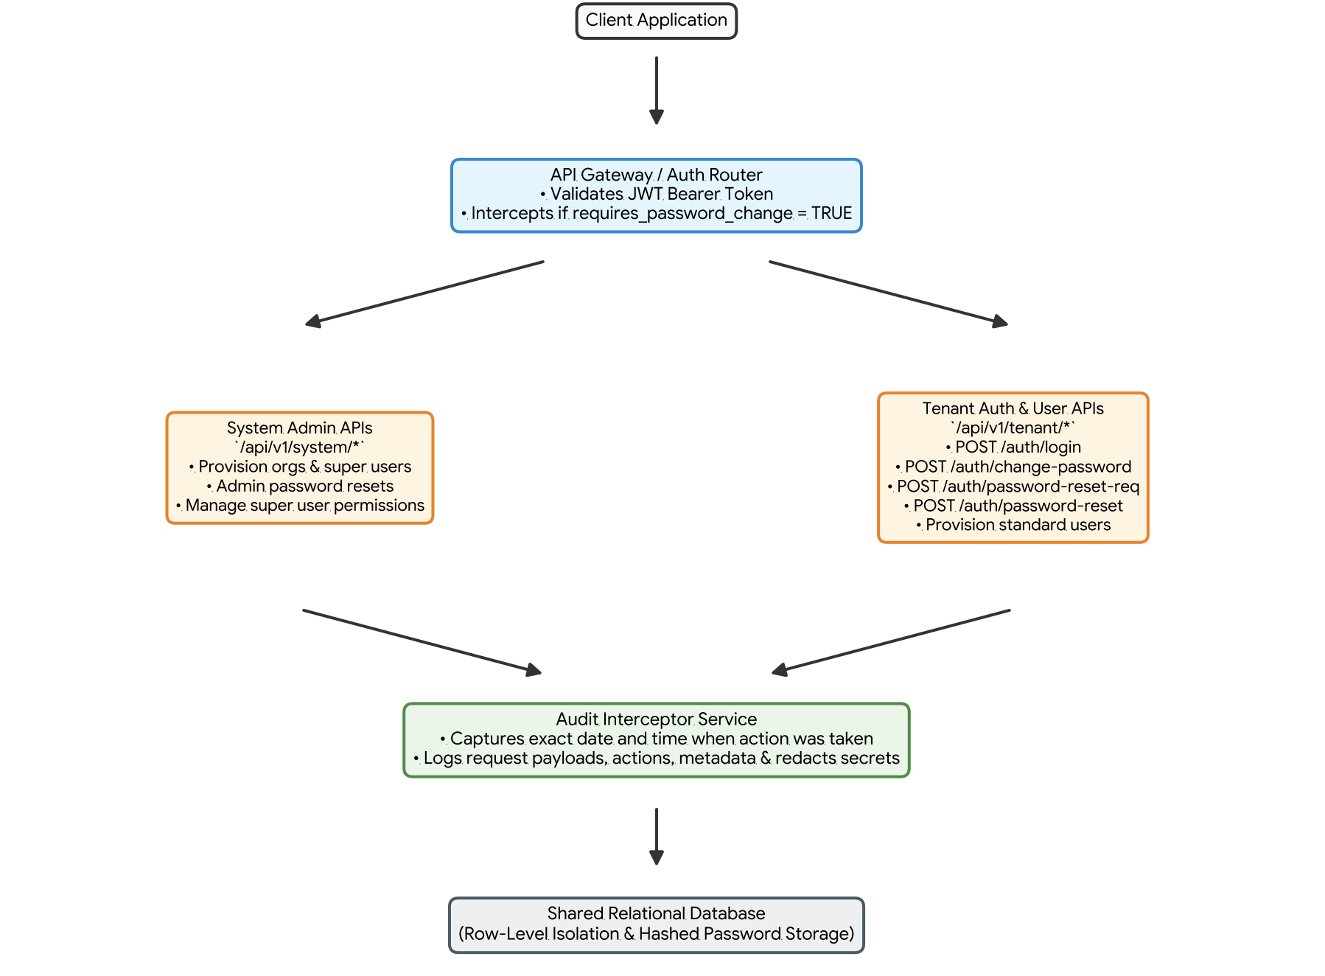

3. Credential Lifecycle & Password Governance

3.1 Initial Password & First-Login Workflow
- Account Creation: When an account is created (Super User by System Admin or Standard User by Super User), a default temporary password is set in the request payload. The system stores the password as a secure hash and sets requires_password_change = TRUE.
- Restricted Token Issuance: Upon authenticating via /api/v1/tenant/auth/login, the API returns a JWT token flagged with requires_password_change: true.
- Password Change Interception: The API Gateway restricts access to all business APIs when requires_password_change is true, permitting only calls to /api/v1/tenant/auth/change-password. Once updated, requires_password_change becomes FALSE, unlocking full access.

3.2 Recovery & Administrative Resets
- Self-Service Recovery: Users trigger /auth/password-reset-request to receive a time-bound email token for resetting passwords via /auth/password-reset.
- Administrative Reset: Super Users (for Standard Users) and System Admins (for Super Users) can trigger administrative resets (/admin-reset-password), generating a temporary password and forcing a password change on next login.

4. Access Control & Governance Model

4.1 Actor Roles & Governance Matrix
Actor Type | Scope | Capabilities & Password Authorities
Vendor System Admin | Global / Cross-Tenant | Provisions organisations and initial Super Users. Performs admin password resets for Super Users. Manages Super User permissions. Uses distinct /api/v1/system/* endpoints.
Organization Super User | Tenant-Scoped (organisation_shortcode) | Provisions Standard Users with default passwords. Assigns vendor roles. Performs admin password resets for Standard Users. PROHIBITED from self-modifying or modifying permissions of other Super Users.
Standard User | Tenant-Scoped (organisation_shortcode) | Authenticates via /auth/login, changes own password, requests self-service resets, and executes authorized business operations.

4.2 Core Governance Policies
- Stateless Authentication: Users authenticate using JWT Bearer tokens passed in the standard HTTP Authorization header.
- Payload-Based Tenant Isolation: Tenant context (organisation_shortcode) is supplied in JSON request payloads for tenant API operations.
- Row-Level Tenancy: Every database table (except global system entities) incorporates an organisation_id column.
- Super User Immutability Policy: Super Users cannot alter their own assigned roles or modify other Super Users in the same organisation. Permission modifications for Super Users require Vendor System Admin execution.
- Comprehensive Timestamped Audit Logging: An asynchronous Audit Interceptor Service captures full trace details of every API invocation—specifically recording the precise UTC date and timestamp when the action was executed—ensuring credentials (passwords, tokens) are automatically redacted from logs.

