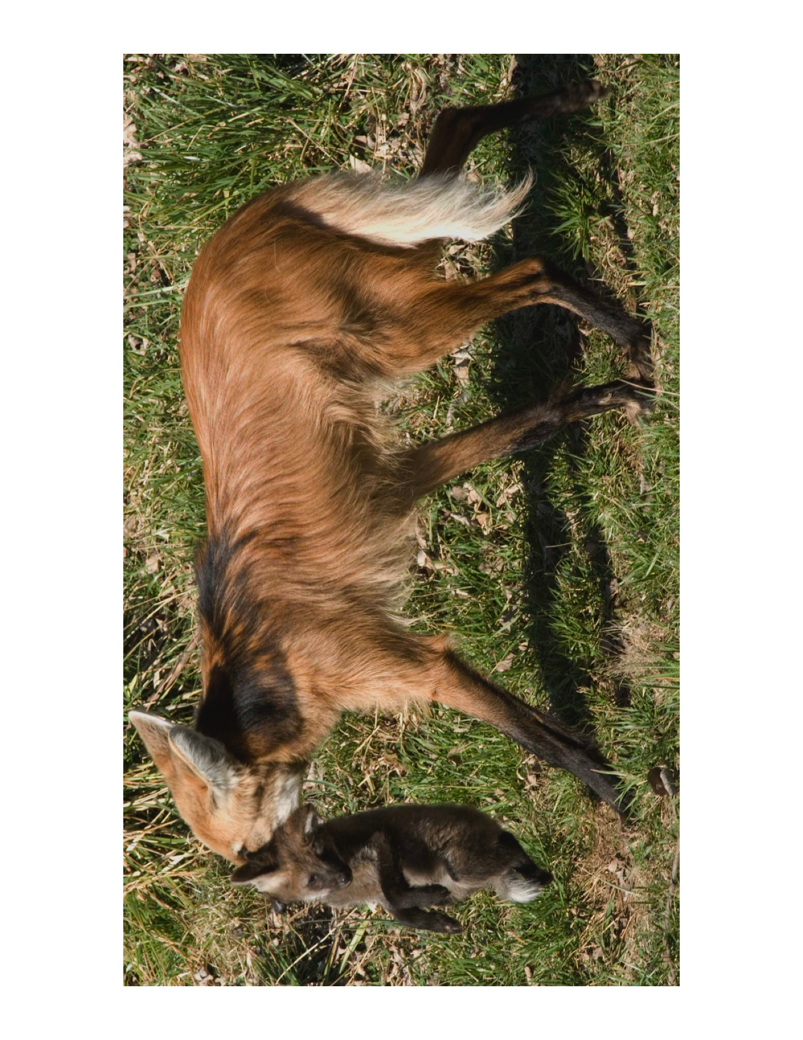

You have used NGS methods to sequence the whole genome of a novel virus of the endangered maned wolf causing high morbidity and mortality. Your virologist colleagues have identified the isolate as sharing traits consistent with GDW2017 genus. There is a reference genome for a non-pathogenic form. The GDW2017 genus contains ~ 30 known isolates that are species-specific to a range of host species within the Order Carnivora.

You have great skills as a genomic researcher of viral disease but have no idea about maned wolves or carnivores. The conservation community is alarmed, and wants you to help—what is your strategy?

We do have genome of the maned wolf.

We do know the species that the 30 species specific strains are found.

1. How does this new strain differ from the non pathogenic strains?
2. Alignment whole genome of 31 strains.
3. Test for recombination
4. We have recombination

Is our isolate a new recombinant or just a recurring one?

1. Test for recombination across all strains
2. Unique ?

Good phylogeny of carnivores?

Science & Nature?

Criteria of what is good: how much data, full or partial genome? Partitioning data? Measure of support…

Map out the phylogenetic placement of the hosts.

Cross-species transmission

Geographic distribution

Co-evolution patterns

Dating the pathogen

Monophyletic within Canidae

Inter-species transmission and timing of recombination events.

Why is it pathogenic?

What is happening on on gene by gene?

Unique genes?

For each gene using comparative genomics across 31 strains.

Coding?-ORF

Among site rate heterogeneity

Hot spots versus conservative motifs

Indels

ILS

What genes support the species specificity and what genes tell another story.

50 genes in the virus

30 support expected relationships

20 do not.

1. location on genome
2. we would focus the 20 that don’t’
3. Are these all part of a recombinant?

If yes, we have found a target.

If not, what are the function of these 20 genes?

Comparative genomics.

Look for sites that are under positive selection or those that are fixed

Manager side of the story—isolated infected individuals

Assembly a coalition of brilliant scientists at GDW2017

Host? If survivors?

Systems biology: KEGG, STRINGS