Dear Drs. Brooke and Elena and Reviewers,

Thank you for the thoughtful and overall positive review of this paper. We appreciate you feedback and the many good points you raised. We have revised the paper to address your concerns as detailed below. The paper is improved as a result, and we thank you for continuing to consider it for publication in Virus Evolution.

Sincerely,

Mark Stenglein and Lexi Keene-Snickers, on behalf of the authors

Reviewer: 1
Comments to the Author
The manuscript takes a thorough look at the prevalence, phylogenetics and population genetics of Galbut virus, a relatively recently described partivirus in D. melanogaster. I think the findings are interesting and highlight the power of insect viruses to examine fundamental questions about virus evolution and biology. Some comments below:
Intro: Gets straight into Galbut virus biology, which I quite like, but I think an initial paragraph placing the work in the broader context and some info on Drosophila viruses in general would be nice. I’d also like to see a little bit more on Galbut’s vertical transmission mode in the intro.
We have revised the introduction by adding this paragraph and these two sentences to the start of the now second paragraph:

Understanding the community of viruses infecting individual organisms is becoming increasingly relevant to the study of genetics, evolution and host-pathogen interactions. With the rise of high throughput sequencing methods, it has become evident that organisms are infected with far more viruses than previously thought. D. melanogaster is no exception and due to its status as a common model organism, its virome of has been well characterized. D. melanogaster are regularly infected with viruses from across the viral family tree. Focused study of several of these viruses like, D. melanogaster sigma virus, have revealed the transcriptomic and evolutionary responses to regular viral infection.

The presence of persistently infecting viruses in the natural D. melanogaster virome provides a means to study the host-pathogen interactions associated with prolonged viral infection.

L94 – is your RpL32 D.mel specific or might you have D.sim in your sample as well (the females are quite tricky to tell apart from D.mel in particular)? I would mention here that for RNAseq you looked at host reads for species ID (L608-611) as I was wondering this.
These primers are not D. mel specific and would amplify sequences from D. sim and many other related species. We have added the following text to the methods section to clarify this point.
RpL32 messenger RNA was detected using exon junction-spanning primers [REF: #37, Cao et al]. The Primer BLAST tool predicted that these primers should amplify RpL32 mRNA sequences from a wide range of species related to D. melanogaster [REF PMID: 22708584]. For instance, there are 0 mismatches in the primer binding sites in D. simulans RpL32 mRNA (XM_016174142) and 4 internal mismatches in the primer binding sites in D. innubila RpL32 mRNA (XM_034628911; 2 each in the forward and reverse primers).

We also added this sentence to the methods, in the sampling section:
We focused testing on flies that were morphologically consistent with D. melanogaster, but also included morphologically distinct flies from Ohio (see below for a description of molecular species assignment for these).

We seem to have largely collected and analyzed D. melanogaster and not D. simulans. This conclusion is based on CO1-based species assignment of the flies we sequenced, all but one of which were D. melanogaster (excluding the Ohio Megaselia flies).

Lexi, should we just omit the Megascelia flies from the paper? That would make things a lot simpler, and we wouldn’t really expect them to be infected by galbut virus?

We need to better address ME-M-3. I am going to add in the species ID information as a supplemental table.

Please see also our responses to reviewer #2 on this topic.
L179 – I would mention somewhere there are Australian D.mel (and a few US Dsim) so you have some confidence this is a host species rather than geographic effect.
We’ve added this sentence to address this:
Existing galbut virus sequences derived from D. melanogaster and D. simulans from the USA, Australia, and China, and sequences from museum specimens [REFs].
For the geographic clustering L194-202 might be good to do some Fst type statistics to look at genetic differentiation by sampling site?

Need to address: this relates to a point from reviewer #2. I am looking into methods to do this.
L201 – re historical vs contempory samples: Have you tried a dated tips clock tree (BEAST or similar) given you have museum samples going back to 1919? Poss some issues related to ancient RNA degradation that might need to be addressed.

We have done this. In fact, estimating molecular clock rates was one of our primary motivations for sequencing old samples [described in ref #12]. But the old sequences were so similar to contemporary sequences that there was not sufficient temporal signal to generate a reliable estimate (see PMID 27774300 and our preprint ref #12).

The old RNA was degraded (ref #12). It was fragmented and there was evidence of chemical damage, notably deamination. The fragmentation was not a problem for sequence recovery or accuracy, given sufficient coverage, which there was for the sequences we included here. The deamination could be a problem: if a high enough fraction of cytosines were deaminated at some site in the genome, it could produce a consensus-changing signal (e.g. a C to T substitution in the consensus sequence). We did not observe any evidence of this happening in our old galbut virus sequences. In any case, such damage-caused substitutions would make sequences appear more divergent rather than less, and we saw very little divergence between old and contemporary sequences.
L318-319 – some context needed on what the model is doing is needed
We have now added the explanatory statement at the end of the sentence:
“…to directly estimate nonsynonymous and synonymous mutations across sites without the need for prior assumptions.”

L367-368 is this just not a reflection of a much smaller end for samples without chaq? Do an F-test or Welch’s t test to check this?

We used Levene’s test as an alternative to the F-test because the data were not normally distributed (see, e.g., Fig. 10B). This did not show a significant difference in variance, but as you suggest this could reflect the small number of chaq-less samples. We added the following sentence to address this:

Analysis of a larger number of chaq-less samples would increase power to detect a significant difference in variance.
478: Not sure “evolutionarily active” is the right phrase here.

We have changed this sentence to read:
The most diverse galbut virus segment was RNA 3, which exhibited more nucleotide diversity than RNA 1 or RNA 2 and more evidence of diversifying selection.
L521 – check whether presence of multiple genotypes in a single infection leads to changes in viral load (as you’ve done for chaq -/+ samples)?
Need to address? This would require separate quantification of co-infecting sequences.
The methods are short – I would put them before the results to aid understanding (folk can skip them if they wish) as I found they helped clarify a few things.
We moved methods before results. We have also added methodological detail as described in the above responses and in the responses to reviewer #2.

Reviewer: 2
Comments to the Author
This manuscript presents an extensive analysis of the prevalence and population genetics of Galbut partitivirus, the most prevalent virus in Drosophila melanogaster. The data are very interesting, and bear on important topics such as selection and reassortment. Given the pre-eminence of the host as a model, I have no doubt that this work will be interesting to a large number of (Drosophila) researchers, in addition to those working on partiti- and other segmented viruses.
However, as currently presented, the work has a very strong observational / anecdotal feel; there is very little in the presentation to justify its interest to a wide virus audience such as that of Virus Evolution. Given this, the manuscript feels over-long and rather unfocussed – I feel the key points of broad interest could be got across in two thirds the space, with many of the figures moving to supplementary material. In addition, there is a lack of analytical detail in the methods section – indeed no mention of the statistics at all, which were largely uninterpretable.

As described below and above in responses to reviewer #1, we have added methodological detail, including more detail about statistics. We’ve also moved a number of figures and tables to supplemental material as described in responses. We’ve revised the text with the goal of making it shorter, and deleted the following sentences/paragraphs. This effort was offset in part by additions to the text to respond to reviewer concerns.

Ways in which the (main) text was shortened:

Moved to supplemental materials
Table 1
Figure 2
Figure 8
Nevertheless, I want to emphasise that with sufficient revision and a refocussing on biological or evolutionary questions, this could be appropriate for VE. Specific comments follow below:
Major:
1. Abstract And Intro – I feel this should allude to a wider literature and biological questions. I’m not sure that “enrich[ing] our understanding of this promising model system” or “set[ing] the stage for additional experiments to better understand galbut virus” is sufficient for Virus Evolution.

We have revised the introduction as described above in the response to reviewer #1, who similarly requested an expanded introduction.

We have changed the last sentence of the abstract to:

These findings reinforce the ecological success of galbut virus and set the stage for experiments to uncover the mechanisms underlying reassortment incompatibility and clade-specific phenotypes.

2. L96, Figs 1b and 1d, and elsewhere. How compelling are the very low titre infections? Could this be surface contamination or (for RNAseq) barcode hopping? What is the detection limit of the qRTPCR?

We have found evidence that cross-contamination and RT-qPCR false positives can occur by a couple of mechanisms: 1) flies that live in bottles in lab together can ingest viral RNA-contaminated food [not relevant here] and 2) flies that are stored frozen together in tubes or bags can cross-contaminate each other. However, we also have substantial evidence that there are legitimate “low positive” infections. This includes low level only infection in certain lab populations. We are working on a paper describing this separately.

Because we were aware of this possibility when we did the sampling for this project, we stored wild-caught flies from Colorado individually in 96-well plates prior to RNA extraction. We’ve revised the corresponding methods section to better describe this:
Flies collected in Colorado were trapped in buckets baited with banana and yeast with organdy mesh (Oriole Textile, 2060) on top of the fermenting fruit. Flies from buckets were captured using a handheld electric insect aspirator (Lexi, have more info about this?) Following collection, individual flies were then stored in individual 96 well plate wells at -20˚C until RNA extraction. Flies were stored individually to minimize the possibility of cross-contamination during pooled storage. Flies captured in Maine, Pennsylvania and Ohio were trapped using 3D printed fly traps, frozen, and shipped to Colorado in 2 mL tubes.

Lexi, can you please double check the accuracy of this revised section? Also: were samples from other states shipped in bulk?

One thing I think we need to better address is the ME-M-3 sample, which looks to be D. simulans but has a melA galbut virus.

We used unique-dual indexed full-length adapters to minimize the likelihood of index hopping. See methods section under: NGS Library Preparation.

We have not quantified the LOD of our RT-qPCR assays in RNA copies. Our negative control qPCRs were uniformly negative [Lexi: is true about negatives?].
3. Kruskal-wallis: How are KW tests being used here? I cannot work out what the input is… they test whether the samples come from the same (non-Gaussian) distribution. But what are the ‘samples’? Not population prevalences, because those are what are being compared. Individual state? But then this is a binomial distribution, which would be an odd use of a KW test. If infected/uninfected, why not a 2xn_Pops fisher exact test? Or why not a binomial GLM (directly test if the prevalence is the same across populations). A binomial GLM seems like an obvious analysis, given that binomial CIs are presented for prevalence in Fig1. I am equally confused in (e.g.) L307-607… How can KS be used here? Diversity is a property of a group of sequences – so if KS says the segments are different, what is the unit of replication?

Lexi, please address

The KW test is being used here because we wanted to compare prevalence by location and by time. The groups for location (site of collection) are location and the groups for time are time (month collected). The samples are the individual relative qPCR values.
4. The discovery of Megaselia among the sequenced samples is of great concern to me. How could these have possibly been misidentified as Dmel? They are not even the same family!

We understand why this would be concerning and realize that we did not sufficiently describe how this went down. We did not misidentify the Megaselia samples as D. melanogaster. We knew that these were not D. melanogaster but tested them because we thought maybe they were infected by galbut virus or at least some galbut-like virus. All non-Colorado samples were from volunteers who had no species ID experience, and we figured we would analyze the samples they sent, especially since there weren’t that many volunteer-contributed samples. But given that we wouldn’t necessarily expect that these other flies would be galbut virus infected, and given the confusion that this is causing, we’ve removed description of the Megaselia samples from the paper.

This then suggests that some of the other ‘uninfected’ flies might have been other species – which makes the prevalence estimates lower bounds rather than estimates. And, it also highlights that collections were potentially (likely) a mix of Dmel and Dsim, which means that ‘prevalence’ cannot really be estimated at all, because these are separate host populations.

This is a good point and one also raised by reviewer #1. Most samples were from Colorado, and we collected those ourselves and identified them morphologically as D. melanogaster (or possibly D. simulans). But D. simulans do not seem to be common (or even present) in Colorado: we have never sampled any confirmed D. simulans among the thousands of “melanogaster” flies we’ve collected here. The idea that virtually all of our samples were D. melanogaster is confirmed by the molecular species identification we did using CO1-mapping reads: all but one of the samples we sequenced was D. melanogaster (excluding the Megaselia samples). Only a single fly from Maine was identified as simulans.

Note that the denominator for prevalence estimates is RpL32+ samples.
We have clarified this in the text by

5. Figure 2 and elsewhere: Is the RNAseq data expressed as virus reads per million total reads, or virus reads per million Fly reads? – it should be the latter. RNA viruses can have VERY high titres (>20% total non-rRNA). If normalised per million total reads, such flies would give a falsely low galbut titre. [imagine … uninfected fly A has 10^6 strands of fly RNA; galbut fly B has 10^6 strands fly RNA, 10^3 Galbut RNA; double infected fly C has 10^6 fly, 10^3 galbut, and 10^5 of another virus … if you normalise by total - rather than by fly - flies B and C will appear to have different galbut titres … even though they would be the same by rpl32.].

In the original submission this was all normalized to million total reads in each dataset. In the revised paper everything is normalized to million host-mapping reads. Figs X,Y,Z, now show host-normalized RPM values as indicated in legends, figures, and corresponding methods.

Lexi, I think we should capitulate to this request. I am quantifying host-mapping reads now.
6. This then leads me to two more important methodological questions. (1) Are there other viruses in here? And at what titres, and

These datasets include a lot of other viruses, including previously undescribed viruses. We are obviously interested in these other viruses and are in the process of analyzing them and are working on a separate paper describing them. But the original goal of the study, and the goal of the present paper, was to focus on galbut virus. This paper (as submitted) already has 12 main figures and 9 supplemental figures. Adding in all the other viruses would make this paper even longer (we note that the reviewer requested a shorter paper) and would cause the paper to lose its focus. The other paper will not focus on a single virus but will instead broadly describe the viral diversity in these flies (including titers, correlated abundances, co-occurrence, etc.).

(2) were these libraries poly-A selected or rRNA depleted? The methods don’t say, but depending on whether Galbut virus is polyadenylated or not, the former might lead to biased estimates of titre. Fig2 is on a log10 scale, was the regression done on a log 10 scale? What does that -3.12 intercept say about the difference in absolute estimates? What if you normalise virus reads RPKM to rpl32 reads RPKM?

We tried to convey this detail by describing “total RNA sequencing” but to further clarify we’ve added the following sentence to the library preparation methods paragraphs:

Input RNA consisted of total RNA that was neither poly-A selected nor ribosomal RNA depleted.

The regression was also done on a log 10 scale.
Lexi, can you please respond to the question about regression? We should move Fig 2 to supplemental material to make the paper shorter. Normalizing to RpL32 mapping reads would be interesting, but we’d have to quantify that separately using an RNA-seq-style analysis.

7. Tree figures (and relevant to line 208-209): the legends say that the trees are midpoint rooted (e.g. line 618), but they are visibly not. (except the tanglegram trees)

The trees in Figs 3-6 and corresponding supplemental figures were midpoint rooted, by iTOL (https://itol.embl.de/). But it looks like iTOL produces different midpoint root locations than e.g. FigTree or R/phytools (the tanglegrams were produced using R/phytools). iTOL seems to place the root location halfway between the 2 nodes flanking the midpoint rather than at the midpoint itself? We aren’t sure because it seems that the iTOL source code is not publicly available. See this figure:

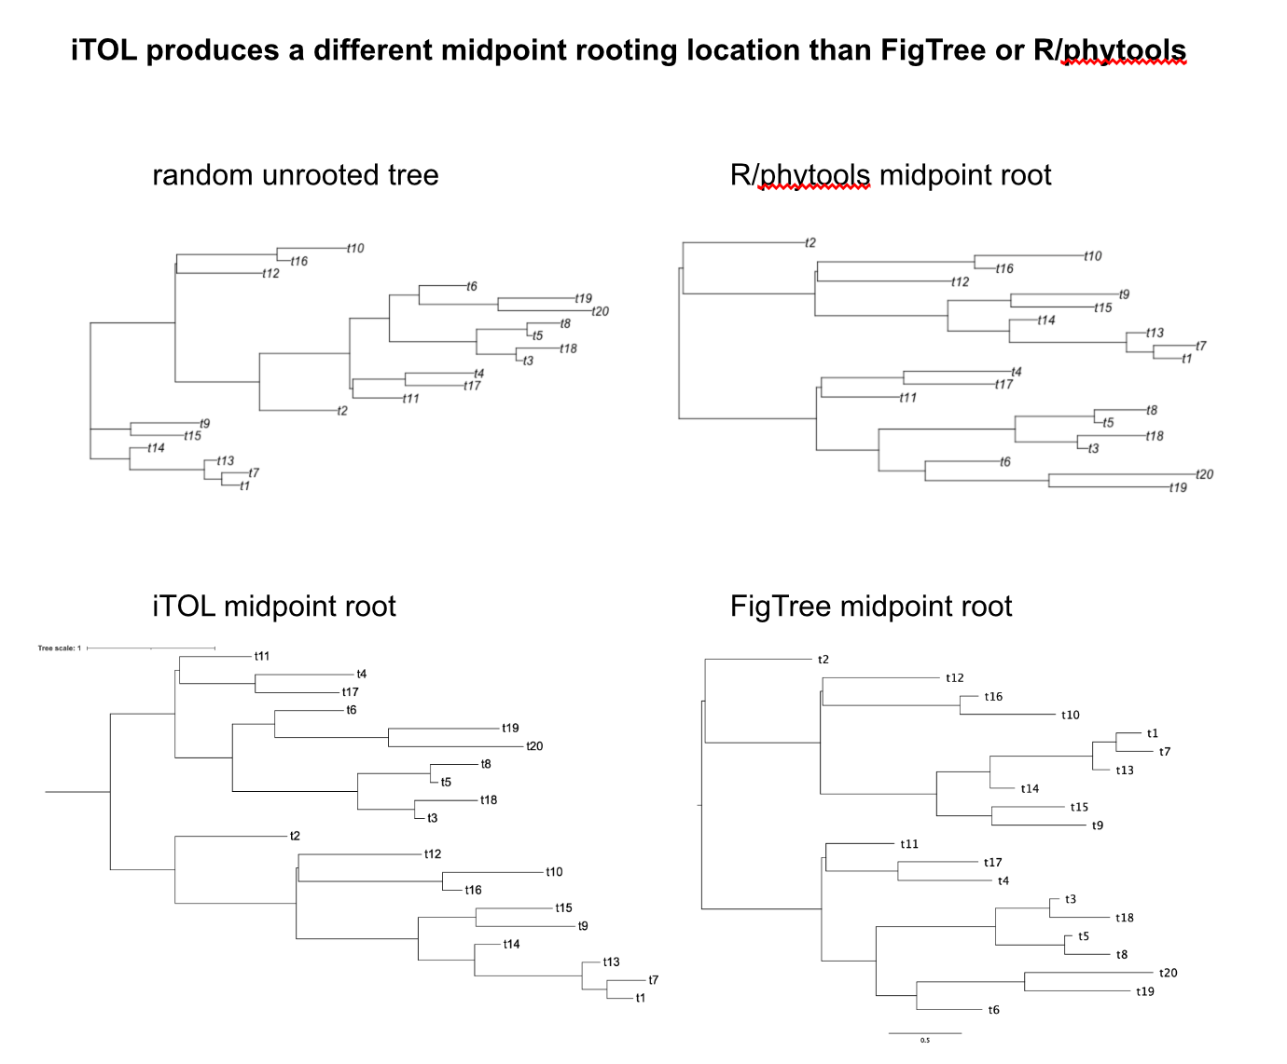

You can see that the iTOL midpoint root is halfway between the nodes upstream of t2 and t11. In contrast the other midpoint roots are close to the node upstream of t2 (presumably reflecting the actual midpoint location). This causes the FigTree and R/phytools midpoint rooted trees to look more balanced than the iTOL midpoint rooted trees.
This is a subtle difference that we didn’t appreciate until looking into this because of your comment. We’ve now switched all trees to XYZ

Lexi: I looked into this and I think the non-tanglegram trees were midpoint rooted by iTol. But it looks like iTol produces different midpoint rooting root location than FigTree or R/phytools (I think). Both FigTree and R/phytools produce more “balanced looking” midpoint rooted trees than iTol. I wonder if this is what the reviewer means. We can discuss how to proceed. You used iTol to root trees, right?

8. L264-274 What thresholds were used to tell if a multiple infection was present? I.e. if there were two simple co-infections, but they have near-identical Segment 1’s, slightly difference segments 2’s, and very different segment 3’s (which, in any case is more likely to be differentiated, because it has higher diversity) at what point would you call this as a 1,2,2,3,3 or a 1,2,3,3 rather than a simple 1,1,2,2,3,3 infection? In other words, how similar do two copies of a segment have to be before there are artefactually collapsed?

Lexi we should discuss this. This has been somewhat confusing for me too.
9. How is reassortment formally tested for? I’m not sure that being ‘evident’ is sufficient.

I will look into this. There are some software tools that detect reassortment from trees.
10. L470-476. I find this very dubious. Short branches show little evolution, not slow evolution – for that, one would need a calibration. This could be provided by the museum samples, but – if there is no detectable clock – we would need to know bounds on the rate consistent with the information available in the historic samples. Or, if the virus really did co-diverge with the host species (likely MRCA much closer to 3Mya than 5 Mya), then what is the rare of the virus? Is it credible for an RNA virus? Is it consistent with the population structure (i.e., would America only clades have had to diverge in Africa)?
We have revised this paragraph to read:
The similarity of sequences within clades may indicate that galbut virus is well adapted to its host (Figs. 3-6 and Supp. Figs. 1-4)¹⁹. The fact that sequences from museum specimens from over a hundred years ago were nearly identical to contemporary sequences supports this observation, as does the preponderance of purifying selection (Figs. 3-6 & 9)¹².

We don’t have any evidence that there are any “America only clades”, depending on how you define clades. There are “micro clades” of highly related sequences from individual locations but major genotypes seem to be present worldwide.

Minor:
1. L27 “.. diversity within clades was low but higher between clades” higher between clades seems like a necessary truth?

We have changed this sentence to read:

Between clade pairwise nucleotide diversity was as low as 75%, but diversity within clades was low.
2. L112 – could the change in prevalence be due to population turnover. Is there host RNAseq data that could be sued to see if host allele frequencies have changed greatly at the same time?
We agree that population turnover is a likely explanation for these changes. Because we only sequenced a fraction of samples (<20%) we lack sufficient numbers of (sequenced) flies from multiple timepoints at any one location to test this.
3. Table 1 should be supplementary. Were all of these confirmed as Dmel?

We moved Table 1 to supplemental material.

All but a single sequenced fly were confirmed to be D. melanogaster. The one non-melanogaster fly (ME-M-3, from Maine) was D. simulans.

Need to address the species issue and the melA galbut virus in an apparent simulans.
4. L1945-196 There are standard approaches to quantifying structure like this (proportion of tips neighbouring one from the same population, relative to random labelling. Maybe ‘Snn’?)

5. Figures 3,4,5 could be panels of one figure, or perhaps only include the tanglegram trees in the main text?

Lexi, we should discuss. I don’t think we can combine them in one figure: the tip labels would be tiny.
6. Sup fig 5: As a ‘partitivirus’ is galbut virus actually multipartite, or merely segmented? Is the difference in copy number thought to be about expression level or segment copy number? Can this be distinguished by the strand of the reads?

Galbut virus is presumed to be multipartite like other partitiviruses, but this has not been experimentally demonstrated.

I have been looking into this strandedness/mapping question and the reviewer seems to be correct: there is just as much negative strand galbut virus RNA in flies, which would correspond to the dsRNA in virus genomes. There is just less +strand RNA, meaning that RNA seems to be transcribed less efficiently than RNA2 or RNA3. I am working on changing this figure and the corresponding text.

Re: strandedness of reads: in total RNA from whole flies, which is what we sequenced in this study, ~98% of galbut virus RNA is +strand (determined from strand-specific library preparation/sequencing: see preprint ref #12). This presumably corresponds to viral mRNA.

So, differences in RNA levels (mRNA levels) could result from differences in
7. Fig 8 should be supplementary

We moved this figure to supplemental material.
8. L454 – why us the an r^2 here?

The r was a typo and has been removed. The superscript 2 referred to ref #2, Webster et al, the paper that originally described galbut and chaq virus.
9. Line 621 – author name is mis-spelled
We corrected the spelling of Kosakovsky Pond

