**MIP 280A4: Microbial Sequence Analysis**

**Phylogenetic Trees, In-class exercise questions**

**Questions to answer at the beginning of class**

1. Do you think bears are (more closely related to) cats or dogs? (1 pt)
2. Do you think hyenas are more closely related to cats or to dogs? (1 pt)

**Based on the 4 bear/cat/dog trees shown in the lecture:**

1. Using each of the 4 possible bear/cat/dog trees shown in lecture, answer the question: Are bears more closely related to cats or dogs? (1 pt each)
   1. Tree 1
   2. Tree 2
   3. Tree 3
   4. Tree 4

**After discussing the carnivore tree from Van Valkenburgh et al:**

1. Are bears more closely related to cats or dogs? (1 pt)
2. Are hyenas more closely related to cats or dogs? (1 pt)
3. Using the tree pictured below, which are more evolved, humans or lizards? (1 pt)

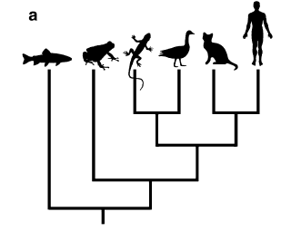

1. What distinguishes a phylogram from a cladogram? (1 pt)

**Based on the tree in the lecture from Gorbalenya (2020):**

1. Which of the four “common cold” CoVs (golden labels) are most closely related to SARS-CoV and SARS-CoV-2? (1 pt)
2. What virus shown on the coronavirus phylogeny in lecture is most closely related to the original SARS-CoV (labeled SARS-CoV)? (1 pt)
3. Is it possible that there are other viruses more closely related to SARS-CoV-2 than the bat-derived RaTG13 shown here? (1 pt)

**Before next class:**

1. Find an existing phylogeny on the internet or in a paper and interpret it (correctly) in a way that is unexpected or interesting to you. Next class you will show us this tree and describe your interpretation. (1 pt)
2. Find an existing phylogeny on the internet or in a paper and interpret it incorrectly on purpose to create a misleading conclusion. Next class you will show us this tree and describe your false interpretation. (1 pt)