Substitution of red meat with legumes and risk of primary liver cancer in UK Biobank participants: a prospective cohort study

Niels Bock[1]

Fie Langmann[2]

Christina C. Dahm[3]

2024-05-12

# Abstract

Objective:

Research Design and Methods:

Results:

Conclusions:

# Introduction

The main aim of this study was to estimate the effect of substituting unprocessed red meat, processed red meat and total red meat with legumes on primary liver cancer in a free-living population.

# Research Design and Methods

**Study population**

The UK Biobank, a population-based prospective cohort, was initiated in 2006. (1) During 2006-2010, more than 500,000 participants, aged 40-69, were recruited and visited designated assessment centres across the UK Participants provided information about age, sex, sociodemographic factors (education, Townsend deprivation index, living alone) and lifestyle factors (smoking, alcohol consumption, physical activity) via touch screen questionnaires and computer-assisted interviews. Anthropometric data (BMI, waist circumference) were collected via physical measurements (reference to UKB document here).

**Dietary assessment**

A web-based 24-hour dietary recall was administered at the end of the initial assessment visit for the last 70,000 recruited participants (reference from UKB document here). From February 2011 to April 2012, 320,000 participants who had provided an e-mail address were invited on four separate occasions to complete the 24-hour dietary recall, the Oxford WebQ, of which 210,947 participants completed at least one. The Oxford WebQ covered 206 food items and 32 beverage items commonly consumed in the UK. Intakes were reported in standard units of measurements, e.g., servings, cups, slices, etc. with intake categories ranging from 0 to 3+ units (2). The Oxford WebQ has been validated againts interviewer-based 24-hour dietary recalls and biomarkers (3,4).

Researchers defined79 food groups and 14 beverage groups from the Oxford WebQ using the UK National Diet and Nutrition Survey categories (2). These food and beverage groups were used when defining the food groups used in the substitution analyses (Supplementary Table 1). Legumes were defined as dietary pulses, baked beans, tofu-based products, peas, hummus, soy drinks, and soy-based desserts and yogurt. Red meat intake was defined as intake of beef, pork, lamb, or other meat, including offal. Processed meat intake was defined as sausages, bacon (with and without fat), ham, or liver pate. Other food groups included were animal-based foods, unhealthy plant-based foods, healthy plant-based foods, and alcoholic beverages (Supplementary Table 1). Animal-based and healthy and unhealthy plant-based food foods were grouped based on plant-based diet indices from previous studies (5–8). An overview of included foods in each food group is displayed in Supplementary Table 1.

Due to the incapability of a single 24-hour dietary recall to properly assess habitual dietary intake and variation in diet over time (9,10), only participants who completed two or more Oxford WebQs were eligible for inclusion in this study.

**Liver cancer assessment**

Liver cancer was defined according to ICD-10 diagnosis codes C22.0 for Hepatocellular carcinoma (HCC) or C22.1 for Intrahepatic cholangiocarcinoma (ICC). Incident and prevalent cases of liver cancer and corresponding diagnosis dates were obtained via linkage to central cancer registries or hospital inpatient episodes (1).

**Assessment of confounders**

Confounders were defined *a priori* from a literature review of the background literature and illustrated using directed acyclic graphs (Supplementary Figure 1). The following confounding variables were selected: age at baseline (years, continuous), sex (male, female), educational level (high: College or University degree, intermediate: A levels/AS levels, O levels/GCSEs, or equivalent, low: none of the previous mentioned), Townsend Deprivation Index (continuous), Living alone (yes, no), waist circumference (cm, continuous), physical activity (above/below the 2017 UK Physical activity guidelines of 150 minutes of moderate activity per week or 75 minutes of vigorous activity, or unknown), smoking (pack years as a proportion of lifespan exposed to smoking, continous), and alcohol intake (g/day, continuous). All confounders except age were selected from the initial assessment visit before the start of follow-up.

**The substitution model**

The substitution analyses were conducted by replacing an equal mass of meat with legumes. The size of the substitution was set to 15 g of legumes for 15 g of meat to keep the substitution size below the mean intake of any of the substituted food groups in the cohort. The substitutions were modelled using the leave-one-out-approach in which variables for every food group along with a variable for total food intake are included, except the food group that are to be substituted (11). To estimate substitution of 15 g of all red meats (red and processed) with 15 g of legumes, the following model was defined:

$$log(h(t;x))=log(h(0;t))+β_{1}Legumes(15g)+β_{2}Totalfoodintake(g)+β_{3}Otherfoodgroups(g)+β_{4}Covariates$$

When substituting only red meat with legumes, processed meat was added to the model:

$$log(h(t;x))=log(h(0;t))+β_{1}Legumes(15g)+β_{2}Processedmeat(15g)+β_{3}Totalfoodintake(g)+β_{4}Otherfoodgroups(g)+β_{5}Covariates$$

When substituting only processed meat with legumes, red meat was added to the model:

$$log(h(t;x))=log(h(0;t))+β_{1}Legumes(15g)+β_{2}Redmeat(15g)+β_{3}Totalfoodintake(g)+β_{4}Otherfoodgroups(g)+β_{5}Covariates$$

**Statistical analysis**

Multivariable-adjusted Cox proportional hazards regression models were used to estimate hazard ratios (HR) with corresponding 95% confidence intervals (CI) with age as the underlying timescale. Participants were followed from the date of their last completed Oxford WebQ until the occurrence of the event of interest or due to right censoring, whichever came first. Participants were right censored in the event of death, loss to follow-up, or administrative end of follow-up (January 31, 2022). Two levels of adjustments were added to the substitution model. Model 1 was minimally adjusted for age, total weight of food intake, and all other food groups to fit the substitution model. Model was further adjusted for sex, educational level, Townsend Deprivation Index, living alone, physical activity, smoking, alcohol intake, and waist circumference.

In secondary analyses, each cancer type was analysed separately to evaluate if the pooling of HCC and ICC as one outcome in the main analysis was justified. Furthermore, to estimate the effect of legume intake regardsless of other dietary components, legume consumers (divided into quartiles) were compared to non-consumers in secondary analyses.

To evaluate the robustness of the main analyses, sensitivity analyses were performed on subsamples of participants by excluding those with high alcohol intake (more than 32 grams per day for men and 24 grams per day for women), participants with plausible energy intake misreporting (≤ 3200 or ≥ 16800 kJ/day for men and ≤ 2000 or ≥ 14000 kJ/day for women), participants with any other liver disease before baseline, and participants with any type of cancer before baseline.

Furthermore, sensitivity analyses were conducted by including only those with ≥3 completed Oxford WebQs.

3.       (Mangler)

Sensitivity analyses were modelled like the main analyses.

All analyses were conducted in R (version) with a significance level of 5 %.

# Results

After excluding participants with liver cancer and participants lost to follow-up before baseline, 126,744 participants remained who had completed two or more diet questionnaires. During a median follow-up time of 11.3 years, 173 participants developed liver cancer. Participants who developed liver cancer were older at baseline, had a higher waist circumference, were less physically active, fewer had never smoked, and more were male, compared to all included participants (Table 1).

Mean daily energy intake and food intake and median daily intake of all specified food groups are presented in table 2.

No association was found for substituting 15 g/day of legumes with 15 g/day of total meat, red meat, or processed meat and risk of primary liver cancer in model 1 (Table : total meat: 0.98 (95% 0.93 to 1.04); red meat: 0.97 (95% 0.91 to 1.03); processed meat: 1.02 (95% 0.93 to 1.13)). The estimated associations changed minimally but remained non-significant with further adjustments (Table : total meat: 1.02 (95% 0.96 to 1.08); red meat: 1.00 (95% 0.94 to 1.07); processed meat: 1.09 (95% 0.98 to 1.20)).

In secondary analyses, when analyzing the substitution association for HCC and ICC separately, the risk of HCC was positively associated with substituting total, red, or processed meat with legumes (Supplementary Table 2, total meat: 1.06 (95% 0.97 to 1.16); red meat: 1.05 (95% 0.95 to 1.15); processed meat: 1.09 (95% 0.95 to 1.26)). The association between substituting total, red, or processed meat with legumes and ICC indicated inverse associations (Supplementary Table 2, total meat: 0.97 (95% 0.90 to 1.05); red meat: 0.95 (95% 0.87 to 1.03); processed meat: 1.07 (95% 0.93 to 1.22)). The magnitude or direction of associations were not significantly different across strata of liver cancer types.

In the adjusted non-substitution analysis, a mean intake of 6.3 grams of legumes per day was associated with a reduced risk of liver cancer, compared to no intake (0.59 (95% 0.35 to 0.98)); however, no associations were observed with further increase in legume intake (supplementary table 6).

In sensitivity analyses, excluding participants with high alcohol intake or participants with plausible energy intake misreporting or setting inclusion criteria to ≥ 3 completed diet questionnaires did not alter the estimates in any statistically significant way (supplementary tables 3 to 5).

# Discussion

## Summary of results

## Strength and limitations

Selection bias: Incomplete registries regarding cancer. Participants who completed >= 2 diet questionnaires are healthier than the those who didn’t?

Lavt bortfald.

kun 5% deltagelse.

Information bias: Underreporting of unhealthy habits? Non-differentiated misclassification. Participants with unhealthy habits are underreporting? differentiated misclassification.

incomplete registries, information problem.

Confounding

residual confounding: broad food groups erase effect of specific foods. Are processed meat eaten with legumes in the UK? (baked beans and bacon). Aflatoxins

Few events: trade off between statistical validity and residual confounding.

## Other studies: substitution analyses and foods related to disease

Discuss studies on legumes/red meat and liver cancer/other diseases. Other substitutions

## Discuss results

e.g, why estimates for HCC and ICC go in opposite direction. sensitivity analyses

## Perspectives

# Conclusions

# Acknowledgements

# References

1. Sudlow C, Gallacher J, Allen N, Beral V, Burton P, Danesh J, Downey P, Elliott P, Green J, Landray M, et al. UK Biobank: An Open Access Resource for Identifying the Causes of a Wide Range of Complex Diseases of Middle and Old Age. PLOS Medicine [Internet] 2015;12:e1001779. Available from: <http://dx.doi.org/10.1371/journal.pmed.1001779>

2. Piernas C, Perez-Cornago A, Gao M, Young H, Pollard Z, Mulligan A, Lentjes M, Carter J, Bradbury K, Key TJ, et al. Describing a new food group classification system for UK biobank: analysis of food groups and sources of macro- and micronutrients in 208,200 participants. European Journal of Nutrition [Internet] 2021;60:2879–90. Available from: <http://dx.doi.org/10.1007/s00394-021-02535-x>

3. Liu B, Young H, Crowe FL, Benson VS, Spencer EA, Key TJ, Appleby PN, Beral V. Development and evaluation of the Oxford WebQ, a low-cost, web-based method for assessment of previous 24 h dietary intakes in large-scale prospective studies. Public Health Nutrition [Internet] 2011;14:1998–2005. Available from: <http://dx.doi.org/10.1017/S1368980011000942>

4. Greenwood DC, Hardie LJ, Frost GS, Alwan NA, Bradbury KE, Carter M, Elliott P, Evans CEL, Ford HE, Hancock N, et al. Validation of the Oxford WebQ Online 24-Hour Dietary Questionnaire Using Biomarkers. American Journal of Epidemiology [Internet] 2019;188:1858–67. Available from: <http://dx.doi.org/10.1093/aje/kwz165>

5. Thompson AS, Tresserra-Rimbau A, Karavasiloglou N, Jennings A, Cantwell M, Hill C, Perez-Cornago A, Bondonno NP, Murphy N, Rohrmann S, et al. Association of Healthful Plant-based Diet Adherence With Risk of Mortality and Major Chronic Diseases Among Adults in the UK. JAMA Network Open [Internet] 2023;6:e234714. Available from: <http://dx.doi.org/10.1001/jamanetworkopen.2023.4714>

6. Heianza Y, Zhou T, Sun D, Hu FB, Qi L. Healthful plant-based dietary patterns, genetic risk of obesity, and cardiovascular risk in the UK biobank study. Clinical Nutrition [Internet] 2021;40:4694–701. Available from: <http://dx.doi.org/10.1016/j.clnu.2021.06.018>

7. Satija A, Bhupathiraju SN, Spiegelman D, Chiuve SE, Manson JE, Willett W, Rexrode KM, Rimm EB, Hu FB. Healthful and Unhealthful Plant-Based Diets and the Risk of Coronary Heart Disease in U.S. Adults. Journal of the American College of Cardiology [Internet] 2017;70:411–22. Available from: <http://dx.doi.org/10.1016/j.jacc.2017.05.047>

8. Satija A, Bhupathiraju SN, Rimm EB, Spiegelman D, Chiuve SE, Borgi L, Willett WC, Manson JE, Sun Q, Hu FB. Plant-Based Dietary Patterns and Incidence of Type 2 Diabetes in US Men and Women: Results from Three Prospective Cohort Studies. Moore SC, editor. PLOS Medicine [Internet] 2016;13:e1002039. Available from: <http://dx.doi.org/10.1371/journal.pmed.1002039>

9. Thompson FE, Subar AF. Dietary assessment methodology. Elsevier; 2013. p. 5–46. Available from: <http://dx.doi.org/10.1016/B978-0-12-391884-0.00001-9>

10. Gurinović M, Zeković M, Milešević J, Nikolić M, Glibetić M. Nutritional assessment. Elsevier; 2017. Available from: <http://dx.doi.org/10.1016/B978-0-08-100596-5.21180-3>

11. Ibsen DB, Laursen ASD, Würtz AML, Dahm CC, Rimm EB, Parner ET, Overvad K, Jakobsen MU. Food substitution models for nutritional epidemiology. The American Journal of Clinical Nutrition [Internet] 2021;113:294–303. Available from: <http://dx.doi.org/10.1093/ajcn/nqaa315>

# Tables

| **Table 1. Baseline characteristics of UK Biobank participants who completed ≥ 2 Oxford WebQ 24-hour diet recall.** | | |
| --- | --- | --- |
|  | **Cohort** | **Liver cancer** |
| **Variable** | **N = 126,744***1* | **N = 173***1* |
| **Typical diet yesterday*2*** | 73,213 (58%) | 105 (61%) |
| **Age, years** | 60 (53, 65) | 64.0 (60.0, 68.0) |
| **Sex** |  |  |
| Female | 70,659 (56%) | 65 (38%) |
| Male | 56,085 (44%) | 108 (62%) |
| **Educational level*3*** |  |  |
| High | 59,416 (47%) | 76 (44%) |
| Intermediate | 41,817 (33%) | 52 (30%) |
| Low | 25,472 (20%) | 45 (26%) |
| Missing | 39 |  |
| **Townsend Deprivation Index** | -2.4 (-3.8, 0.0) | -2.6 (-3.7, -0.7) |
| Missing | 149 |  |
| **Living alone** | 22,658 (18%) | 34 (20%) |
| Missing | 171 |  |
| **Physical activity*4*** |  |  |
| Above | 58,111 (46%) | 61 (35%) |
| Below | 50,712 (40%) | 79 (46%) |
| Missing | 17,921 (14%) | 33 (19%) |
| **Smoking** |  |  |
| Never | 72,583 (57%) | 75 (43%) |
| Ever | 54,122 (43%) | 98 (57%) |
| Missing | 39 |  |
| **Alcohol intake, g/day** | 11 (0, 26) | 11 (0, 29) |
| **Waist circumference, cm** | 88 (79, 97) | 98 (89, 107) |
| Missing | 168 |  |
| *1*Median (IQR) for continous variables; n (%) for categorical variables | | |
| *2*Participants who reported eating a typical diet yesterday for all completed diet questionnaires. | | |
| *3*High: College or University degree; Intermediate: A levels/AS levels, O levels/GCSEs, or equivalent; Low: none of the previous mentioned. | | |
| *4*Above or below the 2017 UK Physical activity guidelines of 150 minutes of moderate activity per week or 75 minutes of vigorous activity. | | |

| **Table 2. Daily dietary intake of food groups, total food and total energy intake in UK Biobank participants who completed ≥ 2 Oxford WebQ 24-hour diet recall.** | | |
| --- | --- | --- |
|  | **Cohort** | **Liver cancer** |
| **Daily food intake** | **N = 126,744***1* | **N = 173***1* |
| **Total food intake** | | |
| Energy, kJ | 8,430 (7,179, 9,856) | 8,579 (7,413, 10,048) |
| Weight, g | 3,144 (2,720, 3,621) | 3,162 (2,737, 3,659) |
| **Food groups, g/day** | | |
| Legumes | 11 (0, 34) | 8 (0, 35) |
| Red and processed meat | 53 (15, 86) | 60 (30, 95) |
| Red meat | 30 (0, 60) | 45 (0, 73) |
| Processed meat | 9 (0, 30) | 8 (0, 31) |
| Other animal-based foods*2* | 475 (361, 603) | 448 (322, 604) |
| Healthy plant-based foods*3* | 1,806 (1,454, 2,198) | 1,791 (1,365, 2,158) |
| Unhealthy plant-based foods*4* | 472 (324, 662) | 491 (365, 698) |
| Alcoholic beverages | 132 (0, 342) | 144 (0, 375) |
| *1*Median (IQR) | | |
| *2*Other animal-based foods include: poultry, fish, dairy, eggs, and mixed dishes with animal products. | | |
| *3*Healthy plant-based foods include: whole grains, vegetables, fruits, nuts, plant oils, and beverages (coffee, tea, water). | | |
| *4*Unhealthy plant-based foods includes: refined grains, potatoes, mixed vegetarian dishes, sweets and snacks, fruit juice, and sugar sweetened beverages. | | |

| **Table 3. Substitution of total meat, red meat and processed meat with legumes and hazard ratios and 95% confidence intervals for primary liver cancer.** | | |
| --- | --- | --- |
|  | **Model 1*1*** | **Model 2*2*** |
| **15 g/day substitution** | **HR** **(95% CI)** | **HR** **(95% CI)** |
| Legumes for total meat | 0.98 (0.93 to 1.04) | 1.02 (0.96 to 1.08) |
| Legumes for red meat | 0.97 (0.91 to 1.03) | 1.00 (0.94 to 1.07) |
| Legumes for processed meat | 1.02 (0.93 to 1.13) | 1.09 (0.98 to 1.20) |
| *1*Adjusted for age (as underlying timescale), other food groups, and total food intake. | | |
| *2*Further adjusted for sex, educational level, Townsend deprivation index, living alone, physical activity, smoking, alcohol intake, and waist circumference. | | |

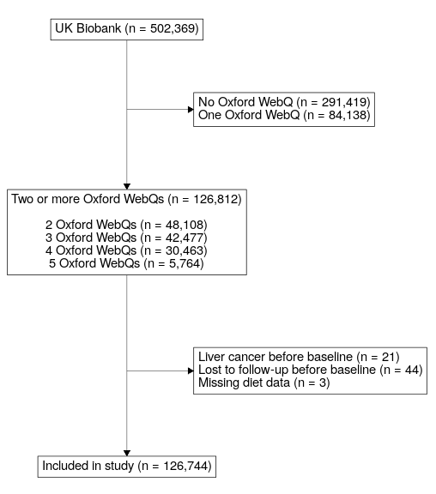

**Figure** **:** Figure 1. Flowchart of included participants.

# Supplemental Material

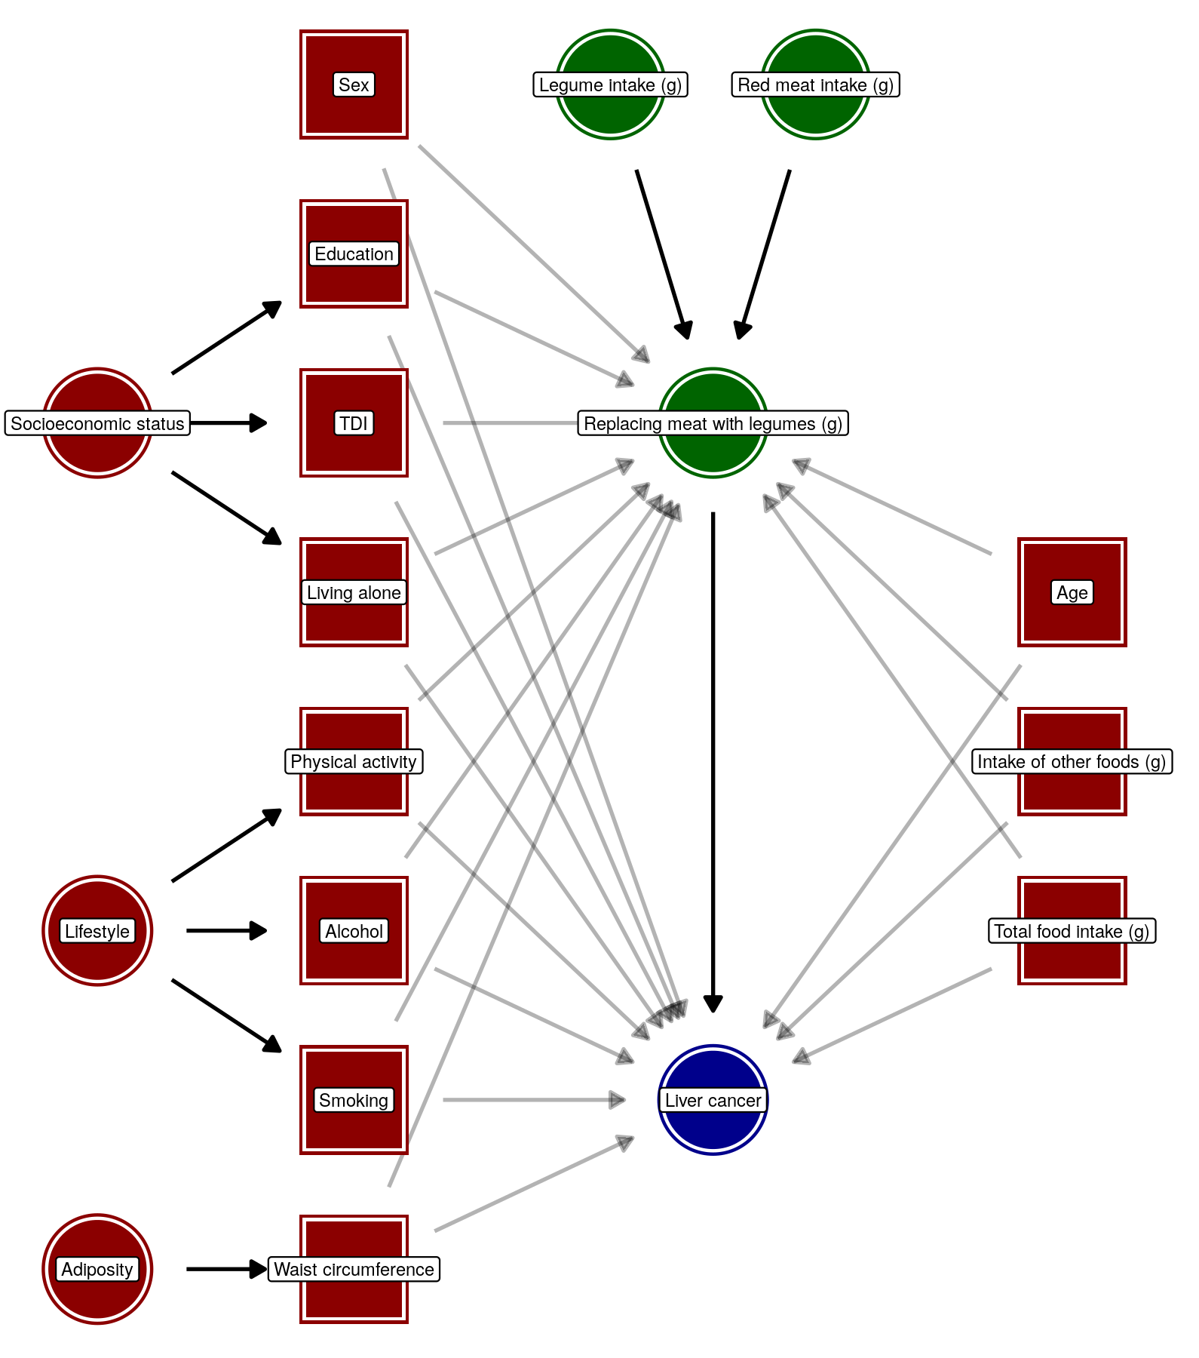

**Figure** **:** Supplementary figure 1. Directed acyclic graph (DAG) visualizing the hypothesised causal relationship between replacing meat with legumes and liver cancer based on assumptions of biasing paths. Red nodes represent confounders. Square nodes represent the minimal sufficient adjustment set for estimating the effect of replacing meat with legumes on liver cancer. Shadowed arrows represent biasing paths.

| **Supplementary table 1. Summary of included foods for each food group.** | |
| --- | --- |
| **Food group** | **Includes** |
| **Legumes** | Soya-based desserts, Baked beans, pulses, Soya drinks (including calcium fortified), Tofu-based products, Hummus, Peas |
| **Red meat** | Beef, Lamb, Other meat including offal, Pork |
| **Processed meat** | Sausages, bacon (with and without fat), ham, liver pate |
| **Animal-based foods** |  |
| Poultry | Fried poultry with batter/breadcrumbs, Poultry (with/without skin) |
| Fish | Fried fish with batter/breadcrumbs, Oily fish, including salmon, Prawns, lobster, crab, shellfish, Tinned tuna, white fish, other fish |
| Dairy | Spreadable/lower fat butter, dairy-based very low fat spread, Spreadable normal fat butter, dairy-based normal fat spread (including cholesterol lowering spread), Ice cream, milk puddings, milk-based desserts, cheesecake, Dairy-based smoothies, milk-based drinks, hot chocolate, Whole milk yogurt (plain), Cheese >17.5 g fat per 100 g, including hard cheese, soft cheese, spreadable, Blue, Feta, Mozzarella, Goats, other), Fat free and lower fat yogurt, plain or flavoured, Cheese <=17.5g fat per 100 g, including hard and spreadable lower fat cheese, Cottage, Semi-skimmed milk >1 g fat per 100 g (cow, other), Skimmed milk <1 g fat per 100 g (cow, cholesterol lowering, powdered), Whole milk >3.6 g fat per 100 g (cow, goat, sheep), Cream (cow's milk) |
| Eggs | Whole eggs and processed (omelette, scotch eggs, other) |
| Sauces | Mayonnaise, salad dressing, pesto, cheese sauce, white sauce, gravy, Yeast, chutney, olives, ketchup, brown sauce, tomato sauce |
| Mixed dishes | Pizza (including gluten free crust), Crisps, savoury biscuits, cheese snacks, other savoury biscuits, Soups, homemade, powdered and canned, Sushi |
| **Healthy plant-based foods** |  |
| Whole grains | Mixed, brown or seeded bread, sliced, baguette, bap, roll, Wholemeal bread, sliced, baguette, bap, roll, Wholewheat biscuit cereal, Bran cereal, Porridge oats (including milk/dried fruit added), Oatcrunch breakfast cereal, Muesli (with or without dried fruit), Brown and wholemeal pasta and rice |
| Fruits | Apples and pears, Blackberries, strawberries, blueberries, raspberries, cherries, Grapefruit, orange, satsuma, Dried fruit, prunes, Bananas, mixed fruit, grapes, mango, melon, peach, pineapple, kiwi, other, Stewed fruit, plums |
| Nuts | Peanut-butter and chocolate-based spread, Unsalted peanuts and nuts, Salted peanuts and nuts |
| Plant oils | Olive oil, Olive oil based lower fat spread, plant-based lower fat margarine and soya-based lower fat spread (including cholesterol lowering spread), Olive oil based spread, plant-based soft or hard margarine and soya-based spread (including cholesterol lowering spread) |
| Beverages | Normal instant, filter, cappuccino, espresso coffee, Decaffeinated instant, filter, cappuccino, espresso coffee, Black, green and other tea, Decaffeinated black, herbal tea, rooibos, Plain water, sparkling water |
| Vegetables | Garlic, leek, onion, Broccoli, cabbage, kale, cauliflower, spinach, sprouts, Mixed side salad, lettuce, watercress, Beetroot, carrots, celery, parsnip, turnip, Fresh and tinned tomatoes, Mushrooms, mixed vegetables, avocado, broad beans, green beans, butternut squash, courgettes, peppers, other, Coleslaw, salad with added fat/mayonnaise, guacamole, sweetcorn |
| **Unhealthy plant-based foods** |  |
| Refined cereals | Chocolate biscuits, plain biscuits, sweet biscuits and cookies, Naan, garlic bread, other bread (including gluten free), White bread, sliced, baguette, bap, roll, Oatcrunch breakfast cereal, Crisps, savoury biscuits, cheese snacks, other savoury biscuits, White pasta, rice, couscous, gluten free pasta |
| Potatoes | Potatoes, sweet potatoes, boiled or baked, Potatoes and chips, fried or roasted with fat, Potatoes, mashed |
| Fruit juice | Orange, grapefruit drink and 100% fruit juice |
| Mixed dishes, vegetarian | Double and single crust pies, crumble pies, Yorkshire pudding, snackpot noodles, Indian samosa, pakora snacks, Quorn-based and vegetarian burgers and products |
| Sweets & snacks | Table sugar, honey, jam and preserves, Chocolate bar (including white, milk and dark chocolate), chocolate-covered raisins, chocolate-covered sweets, Pancakes, croissant, Danish pastries, scones, fruitcakes, cakes, doughnuts, sponge puddings, other desserts, cereal bars, sweet snacks, Hard and soft sweets (including sugar free) |
| Sugar sweetened beverages | Rice and oat vegetable drinks, Low calorie fizzy drinks and squash, Fizzy sugary drinks, squash, fruit smoothies |
| **Alcoholic beverages** | Beer and cider, Spirits and other alcoholic drinks, Fortified wine, Red and rose wine, White wine |

| **Supplementary table 2. Substitution of total meat, red meat and processed meat with legumes and hazard ratios and 95% confidence intervals for hepatocellular carcinoma and intrahepatic cholangiocarcinoma.** | | |
| --- | --- | --- |
|  | **Model 1***1* | **Model 2***2* |
| **15 g/day substitution** | **HR** **(95% CI)** | **HR** **(95% CI)** |
| **Hepatocellular carcinoma** | | |
| Legumes for total meat | 1.01 (0.93 to 1.10) | 1.06 (0.97 to 1.16) |
| Legumes for red meat | 1.01 (0.92 to 1.11) | 1.05 (0.95 to 1.15) |
| Legumes for processed meat | 1.01 (0.88 to 1.16) | 1.09 (0.95 to 1.26) |
| **Intrahepatic cholangiocarcinoma** | | |
| Legumes for total meat | 0.94 (0.87 to 1.02) | 0.97 (0.90 to 1.05) |
| Legumes for red meat | 0.92 (0.85 to 1.00) | 0.95 (0.87 to 1.03) |
| Legumes for processed meat | 1.02 (0.89 to 1.17) | 1.07 (0.93 to 1.22) |
| *1*Adjusted for age (as underlying timescale), other food groups, and total food intake. | | |
| *2*Further adjusted for sex, educational level, Townsend deprivation index, living alone, physical activity, smoking, alcohol intake, and waist circumference. | | |

| **Supplementary table 3. No intake of legumes vs. quartiles of daily legume intake and hazard ratios and 95% confidence intervals for primary liver cancer.** | | |
| --- | --- | --- |
|  | **Model 1***1* | **Model 2***2* |
| **Characteristic** | **HR** **(95% CI)** | **HR** **(95% CI)** |
| Categories:*3* |  |  |
| No intake | — | — |
| Q1 | 0.58 (0.35 to 0.96) | 0.59 (0.35 to 0.98) |
| Q2 | 0.87 (0.56 to 1.33) | 0.89 (0.58 to 1.36) |
| Q3 | 0.75 (0.47 to 1.19) | 0.75 (0.47 to 1.19) |
| Q4 | 0.98 (0.64 to 1.51) | 1.06 (0.69 to 1.64) |
| *1*Adjusted for age (as underlying timescale), other food groups, and total food intake. | | |
| *2*Further adjusted for sex, educational level, Townsend deprivation index, living alone, physical activity, smoking, alcohol intake, and waist circumference. | | |
| *3*mean daily intake of legumes in grams for each quartile: Q1: 6.3, Q2: 15.7, Q3: 34.3, Q4 109. | | |

| **Supplementary table 3. Sensitivity analyses** | | | | | | |
| --- | --- | --- | --- | --- | --- | --- |
|  | **Exclusion of participants with:** | | | |  |  |
|  | **High alcohol intake** | **Implausible food intake** | **Liver disease before baseline** | **Fewer than 3 Oxford WebQs** | **Death register as source for liver cancer events** | **Exclusion of waist circumference from analysis** |
| **15 g/day substitution** | **HR** **(95% CI)** | **HR** **(95% CI)** | **HR** **(95% CI)** | **HR** **(95% CI)** | **HR** **(95% CI)** | **HR** **(95% CI)** |
| Legumes for total meat | 1.00 (0.94 to 1.07) | 1.02 (0.96 to 1.08) | 1.00 (0.93 to 1.06) | 1.04 (0.97 to 1.12) | 1.02 (0.97 to 1.08) | 1.00 (0.94 to 1.06) |
| Legumes for red meat | 0.99 (0.92 to 1.06) | 1.00 (0.94 to 1.06) | 0.97 (0.91 to 1.04) | 1.02 (0.94 to 1.11) | 1.01 (0.95 to 1.07) | 0.99 (0.92 to 1.05) |
| Legumes for processed meat | 1.04 (0.93 to 1.17) | 1.09 (0.98 to 1.20) | 1.08 (0.96 to 1.20) | 1.11 (0.97 to 1.27) | 1.07 (0.97 to 1.18) | 1.05 (0.95 to 1.16) |

1. Department of Public Health, Aarhus university, Aarhus, Denmark
2. Department of Public Health, Aarhus university, Aarhus, Denmark
3. Department of Public Health, Aarhus university, Aarhus, Denmark