UKB Data management

Valg af smoking:

p20162,Pack years adult smoking as proportion of life span exposed to smoking,152789,https://biobank.ndph.ox.ac.uk/ukb/field.cgi?id=20162

p22508,Amount of tobacco currently smoked,2870,https://biobank.ndph.ox.ac.uk/ukb/field.cgi?id=22508

p3446,Type of tobacco currently smoked,39540,https://biobank.ndph.ox.ac.uk/ukb/field.cgi?id=3446

Valg af alcohol

p20403,Amount of alcohol drunk on a typical drinking day,143636,https://biobank.ndph.ox.ac.uk/ukb/field.cgi?id=20403

Fysisk aktivitet

p22040,Summed MET minutes per week for all activity,402303,https://biobank.ndph.ox.ac.uk/ukb/field.cgi?id=22040

Index of multiple deprivation

p26410,Index of Multiple Deprivation (England),432645,https://biobank.ndph.ox.ac.uk/ukb/field.cgi?id=26410

p26426,Index of Multiple Deprivation (Wales),21184,https://biobank.ndph.ox.ac.uk/ukb/field.cgi?id=26426

p26427,Index of Multiple Deprivation (Scotland),35846,https://biobank.ndph.ox.ac.uk/ukb/field.cgi?id=26427

Outcomes

p40000 (date of death) har to instances, hvad skal der ske med dem?

p41280,Date of first in-patient diagnosis - ICD10,440014,https://biobank.ndph.ox.ac.uk/ukb/field.cgi?id=41280

p41281,Date of first in-patient diagnosis - ICD9,20299,https://biobank.ndph.ox.ac.uk/ukb/field.cgi?id=41281

p41282,Date of first operative procedure - OPCS4,440153,https://biobank.ndph.ox.ac.uk/ukb/field.cgi?id=41282

p131668,Date K75 first reported (other inflammatory liver diseases),3171,https://biobank.ndph.ox.ac.uk/ukb/field.cgi?id=131668

p131670,Date K76 first reported (other diseases of liver),14708,https://biobank.ndph.ox.ac.uk/ukb/field.cgi?id=131670

p131674,Date K80 first reported (cholelithiasis),33836,https://biobank.ndph.ox.ac.uk/ukb/field.cgi?id=131674

p131676,Date K81 first reported (cholecystitis),6509,https://biobank.ndph.ox.ac.uk/ukb/field.cgi?id=131676

Loss to follow-up

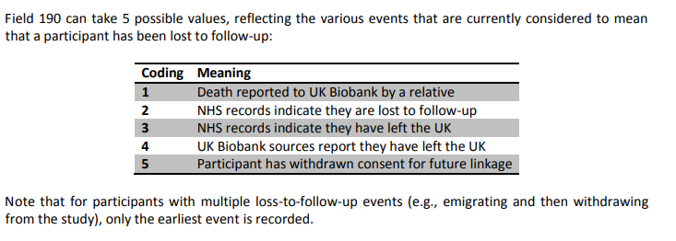

Sti til bibliografi? /home/rstudio-server/leha

Hvordan skal jeg kode familiesygdom (p20107, p20110, p20111)? Er det bedst at have de relevante sygdomme hver for sig, fx diabetes hos far; ja, nej; hypertension hos far; ja, nej. Eller giver det mening at lave en samlet variabel: MAFLD relaterede sygdom hos far; ja, nej.?