Flower Catalog Website
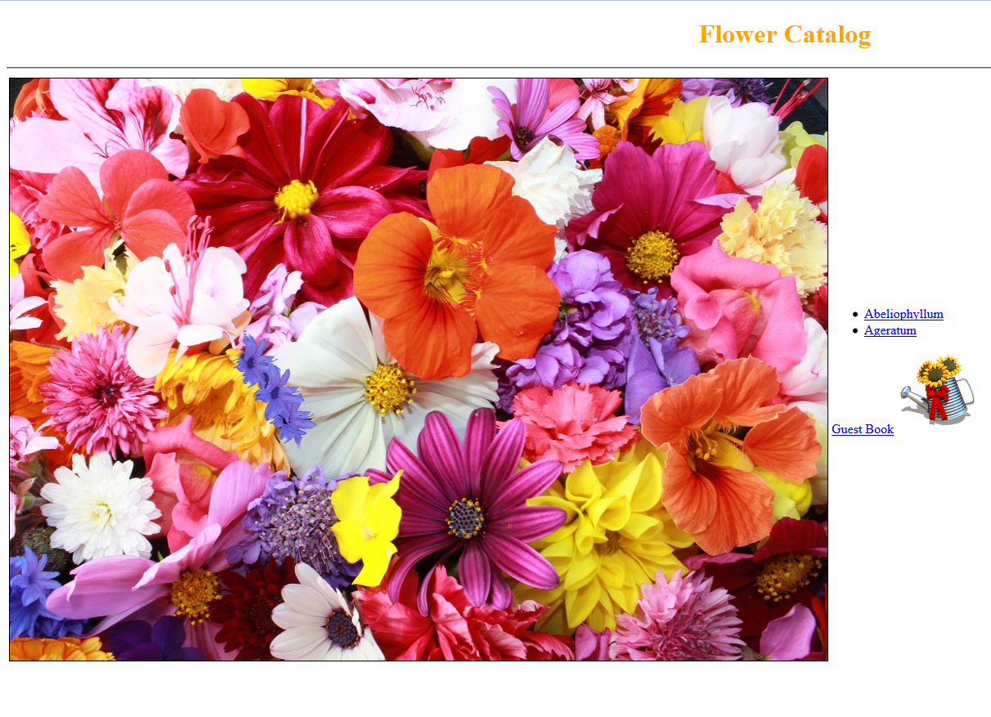
This is the landing page of the website.
- Title “Flower Catalog” at the top.
- Image of flowers
- Links to pages of Abeliophyllum, Ageratum and a guest book.
- A watering Jar image, which when clicked will hide for a second
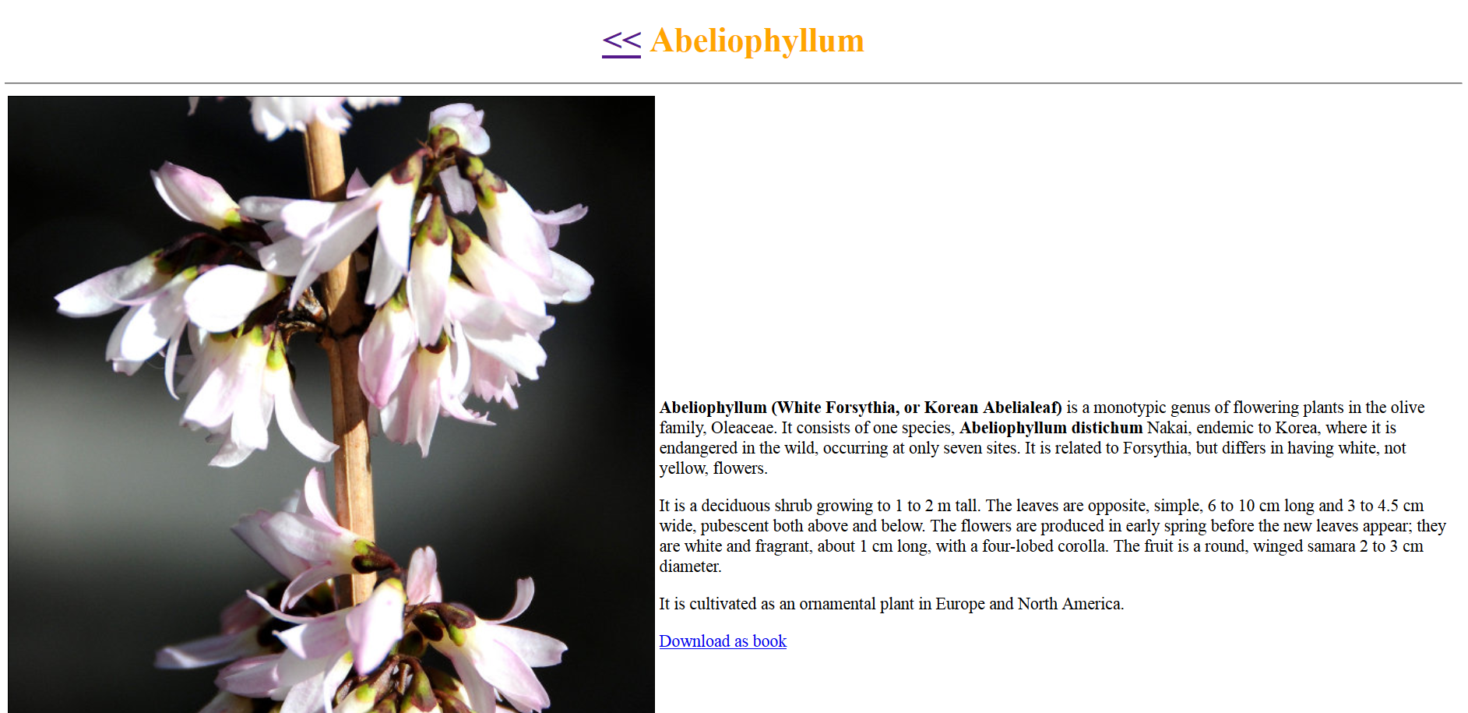

This is the page for Abeliophyllum.
- Image on left
- Centered title at top
- A link to go back to home page
- Formatted Content on the right of the image with information on the flower.
- A link to download the content as pdf.

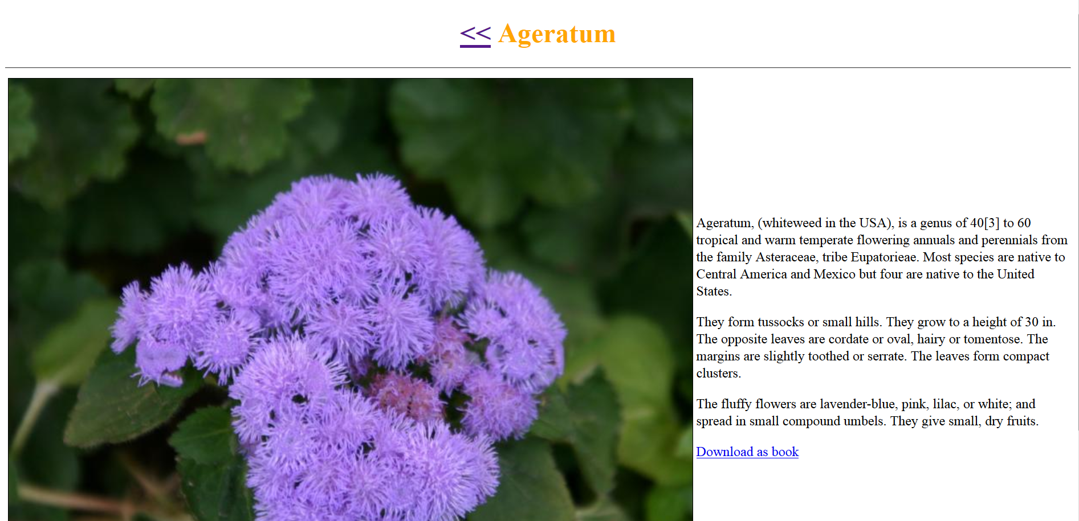
This is the page for Ageratum.
- Image on left
- Centered title at top
- A link to go back to home page
- Formatted Content on the right of the image with information on the flower.
A link to download the content as pdf.
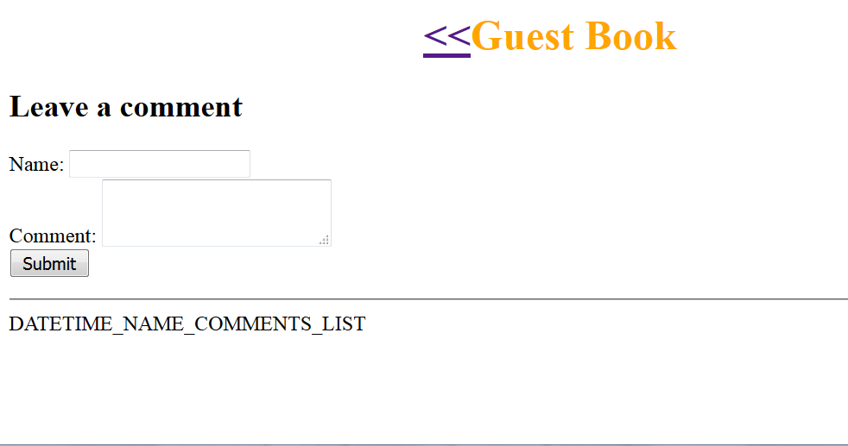
This is the page for Guest book.
- Centered title at top
- A link to go back to home page
- Text fields to take name & a comment.
- Submit button, which takes the comment
- A list of comments by different guest until now with Date-time, Name and Comment of each ordered with latest comment in reverse chronological order.

