A Prototype Machine Learning Land Use Classifier Using Housing Market Dynamics.

**Abstract:** There is ample evidence of the role of land use and transportation interactions in determining urban spatial structure. The increased digitization of human activity produces a wealth of new data that can benefit longitudinal studies of changes in land value distributions and integrated urban microsimulation models. To produce a comprehensive dataset, information from various sources needs to be merged at the land parcel level to enhance datasets with additional attributes, while maintaining the ease of data storage and retrieval and respecting spatial and temporal relationships. This paper proposes a prototype of a workflow to augment a dataset of real estate transactions with data from multiple urban sources and use machine learning to classify land use of each record based on housing market dynamics.

**Stepan Oskin**

University of Toronto

[stepan.oskin@mail.utoronto.ca](mailto:stepan.oskin@mail.utoronto.ca)

# 1 Introduction

There is ample evidence of the role of land use and transportation interactions in determining urban spatial structure(Wegener 1994). Accessibility and mobility provided by transportation systems drive economic development and impact travel behaviour and location choices of households and firms. Similarly, urban development and location of activities drive travel demand and the need for building transport networks(Manheim 1978). Land values in a metropolitan region are an outcome of such land use-transportation interactions(Alonso 1964; Knight and Trygg 1977; Martinez 2018; Spengler 1930).

The fundamental link between transportation and urban form creates a feedback relationship between land development, travel needs, viability of alternative modes, accessibility, and other important characteristics of the urban transportation system(Kelly 1994). Numerous "top-down" and "bottom-up" models have been designed to analyze and forecast the behaviour of urban regions and interaction of their transportation and land use systems, with the latest generation being the family of microsimulation models(Iacono, Levinson, and El-Geneidy 2008).

Among the major barriers to implementation of integrated urban models since their introduction were such aspects as data hungriness and computational requirements(Miller, Kriger, and Hunt 1998). In the past decades, continuing methodological advances in computing, such as cost-effective High-Performance Computing (HPC), detailed GIS-based datasets and machine learning methods, have turned former barriers into opportunities for model system development(Miller 2018). Since microsimulation models are dynamic and disaggregated in their nature, their design and calibration efforts could benefit from the use of data sources that are longitudinal (time-series) and highly disaggregated spatially (to a parcel level) (Miller 2019). In our times, the amount and diversity of new data sources relating to cities grows exponentially and these new sources present new challenges and new opportunities for researchers interested in longitudinal and spatially disaggregated aspects of interactions of urban systems.

## 1.1 New data sources and their challenges

Increased digitization of human activity produces a wealth of new information that can be used to study interactions between urban systems at a fine spatial and temporal scale (Arribas-Bel 2014; Chen et al. 2016). An example of such digitization is the introduction of the POLARIS land registration system by the Government of Ontario in 1985, which led to the creation of an extensive dataset of real estate transactions by Teranet Enterprises Inc.(Teranet Enterprises Inc. 2019). Teranet’s dataset captures all real estate transactions that have been recorded in the Province of Ontario since 1985, which makes it a great asset for longitudinal housing market studies and for design and calibration efforts of microsimulation models.

However, despite its high spatial and temporal resolution, the version of Teranet’s dataset available to researchers at University of Toronto Transportation Research Institute (UTTRI) suffered from a severe lack of attributes describing each transaction, such as the category of the property being sold. To add new features, Teranet’s dataset can be augmented using a range of urban data sources, such as information from Census and transportation surveys and land use data. At the same time, joining these sources together can be challenging, since they all use different spatial units and are available at varying temporal spans.

The difference in units between urban data sources could be addressed by uniting all polygon-based data at the level of time-indexed points, as represented by real estate transactions recorded in Teranet’s dataset. In addition, temporal spans needed to be established when relating datasets to ensure proper alignment of urban data both on spatial and temporal dimensions. Finally, since none of the land use data sources that were available for the Greater Toronto-Hamilton Area (GTHA) covered the complete time interval from 1986 to 2017, a machine learning model was trained to classify land use based on housing market dynamics. This information was then stored in the form of a relational database to facilitate ease of access and reduce hardware requirements, allowing a broader group of researchers to take advantage of the new powerful data source.

This paper presents an analysis of such a database for the GTHA. Specifically, it presents methods developed for dealing with two important technical issues in making use of Teranet’s dataset:

1. Merging diverse datasets spatially and temporally.

2. Using machine learning to classify land use from housing market dynamics.

Section 2 describes the data used in this study. These data come from a variety of sources, have different spatial and temporal representations, and contribute different attributes characterizing land use, buildings and market transactions within the GTHA. Section 3 describes the method developed to combine these disparate datasets into a functionally usable overall database suitable for supporting real estate market analysis and modelling. Section 4 presents a novel application of machine learning methods to classify land use based on parcel transaction data, along with other data attached to the transaction data, as described in Section 3. Section 5 evaluates the effectiveness of the machine learning model presented in Section 4. Section 6 summarizes the findings and conclusions of the study and suggests directions for further research.

# 2 Data

This paper discusses the process of development of the housing market database for the GTHA; this database was constructed by joining a detailed dataset of real estate transactions with other urban data sources and a new feature produced by a machine learning algorithm.

## 2.1 Teranet’s dataset

At the heart of the GTHA housing market database lies Teranet’s dataset—an extensive historical record of real estate transactions recorded in the Province of Ontario since the beginning of the nineteenth century; for the purposes of this paper, the period of time from 1986 to 2017 was considered, since records prior to 1986 appear to be less consistent in Teranet’s data.

All land owned in Canada is registered in a public land registry in the applicable province; the registry system is a public record of documents evidencing transactions affecting land(McKean and Di Cresce 2015). In 1985, the Government of Ontario initiated the Province of Ontario Land Registration Information System (POLARIS) pilot project for the purposes of the conversion between land registry systems and records automation. The Land Registration Reform Act (Ontario) was introduced in 1990 to facilitate electronic search and registration of properties and the automation of paper-based records (The Government of Ontario 1990).

POLARIS was built by the Province to house and process electronic land records, which in turn led to the creation of an extensive dataset of land registration records managed by Teranet Enterprises Inc., an e-services organization with whom the Government of Ontario established a partnership in 1991. The partnership was established to convert Ontario’s land registration system to a more modernized electronic title system. Teranet’s mandate involved taking a 200-year-old paper-based system and creating a database with electronic records for more than five million parcels of land. As a result, 99.9% of property in Ontario was parcelized and administered under the Land Titles system. Teranet fully automated the conversion of millions of paper-based documents and records into the Ontario Electronic Land Registration System (ELRS). Today, the data contained in POLARIS is the official land registration data of the Province of Ontario(Teranet Enterprises Inc. 2019).

Teranet’s dataset holds data on the GTHA housing market that has a very high spatial and temporal resolution; at the same time, using the version of the dataset available to UTTRI researchers in its raw form for meaningful analysis and modeling was challenging for two main reasons:

1. It lacked features describing each transaction, other than its date, coordinate and consideration amount; there were no features to distinguish residential, commercial and industrial transactions.
2. No reliable parcel-level source of land use information for GTHA covering the full period from 1986 to 2017 could be found.

At the same time, since each Teranet transaction has a timestamp (date) and location information, Teranet data can be joined to a variety of other geocoded urban data sources, such as Census demographics, Transportation Tomorrow Survey (TTS) and parcel-level land use information. As is discussed in section 3, joining these data sources together required special consideration, as they use different spatial units and are available at different temporal spans.

## 2.2 Select variables from the Census of Canada

One of the major sources of demographic and statistical data in Canada are the datasets collected under the national Census program. Census datasets provide valuable insights into the latest economic, social and demographic conditions and trends in Canada and are used to plan important public services. Statistics Canada collects every five years the national Census of Canada and disseminates the information by a range of geographic units, also referred to as ”Census geography”(Map and Data Library 2019).

## 2.3 Select variables from the Transportation Tomorrow Survey (TTS)

# Another major source of information for most transportation planning studies concerned with Southern Ontario is the Transportation Tomorrow Survey (TTS), an origin-destination travel survey(Data Management Group 2014). The Transportation Tomorrow Survey (TTS), undertaken every five years since 1986, is a cooperative effort by local and provincial government agencies to collect information about urban travel in southern Ontario. TTS represents a retrospective survey of travel taken by every member (age 11 or over) of the household during the day previous to the telephone or web contact. The information collected and the method of collection has remained relatively consistent over the seven surveys; TTS survey data includes characteristics of the household, characteristics of each person in the household, and details of the trips taken by each member of the household, including details on any trips taken by transit(Ashby 2018).

## 2.4 Land use from DMTI Spatial Inc. by year (2001-2014)

# DMTI Spatial Inc., a Digital Map Products company, is a major provider of location-based information in Canada. DMTI has been providing industry leading enterprise Location Intelligence solutions for more than a decade to Global 2000 companies and government agencies(DMTI Spatial Inc. 2014).

## 2.5 Detailed land use information from University of Toronto’s Department of Geography collected in 2012 and 2013

# The detailed land-use data provided by University of Toronto’s Department of Geography is a combination of parcel boundaries (from Teranet) and manually coded land-use data produced using Google maps and streetviews; it was collected by Prof. Andre Sorensen and Prof. Paul Hess’s research project.

# 3 Establishing spatial and temporal relationships among data sources

This section discusses the introduction of the new spatial and temporal relationships that were used to implement the referential integrity constraints of the GTHA housing market database.

## 3.1 Spatial relationships between urban data sources

Most urban areas are divided into zones or planning areas on the basis of maintaining similar population sizes and following built or natural boundaries like roads or rivers. Census geography follows a certain hierarchy defined by Statistics Canada, with the largest top-level divisions being provinces and territories,

and the lowest-tier divisions to which Census data is disseminated being Dissemination Areas (DAs)(Statistics Canada 2018). Statistics Canada defines a Dissemination Area as a small area composed of one or more neighboring

dissemination blocks, roughly uniform in population size targeted from 400 to 700 persons to avoid data suppression(Statistics Canada 2015).

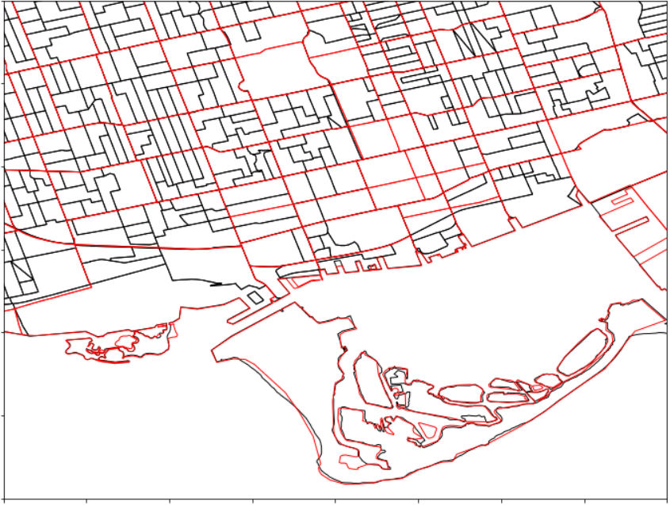

Figure 1. Spatial relationship between datasets: difference between Traffic Analysis Zones (TAZ, red) and Census Dissemination Area (DA, black).

To simulate the changes in accessibility, metropolitan regions are usually broken down into a set of small geographic zones, similar (or in many cases identical) to the set of zones used for regional travel forecasting. For TTS variables, the finest level of spatial aggregation is that of the Traffic Analysis Zone (TAZ). A TAZ is a polygon which typically falls along the centre line of roads or the natural geographic boundaries(Data Management Group 2019). Not as a rule, but TAZ zones roughly follow Census tract boundaries, which are slightly bigger than DA boundaries. Figure 1 presents an example of TAZ polygons overlaid with Census DA boundaries.

Over the years, TTS data has been collected for changing TAZ boundaries, or in other words, different zone systems due to growing population and expanding extents of the survey in the GTHA region over the years. To make the TTS data consistent for comparing over all years from 1986 to 2016, the Data Management Group (DMG) at the UTTRI, the custodian of the dataset derived from TTS, made all surveys available in the 2001 zone system, for convenience of researchers (any zone system could have been chosen for that matter). UTTRI used the 2001 TAZ system to model travel times for the GTHA in the EMME network modeling system for all TTS years based on the origin-destination trip data collected in the survey. The travel time data was used to create further transportation accessibility variables.

Land use data collected by DMTI and by the Department of Geography uses the spatial unit of a parcel polygon. Teranet records have attributes representing x and y coordinates matching to parcel centroids.

Below is the summary of spatial units used by the data sources that were combined into the GTHA housing market database:

• Point data

– Teranet

• Parcel-level data (polygons)

– detailed land use from the Department of Geography

– land use from DMTI

• DA-level data (polygons)

– Census variables

• TAZ-level data (polygons)

– TTS variables

When joining these data sources, differences in spatial units need to be respected, which can be more challenging when spatially joining polygons with polygons, since it might require area-weighted spatial interpolation of data to a common unit of analysis. In addition, polygon-based data can also vary with time, as is the case with DMTI’s land use information, which is available by year. To simplify relating

different polygon-based data sources with each other, all of them can be brought together to a single level of time-indexed points, such as Teranet transactions. This allows flexibility in combining variables from polygon-based data sources to a common level of time-indexed points while maintaining the integrity of spatial and temporal relationships through polygon-to-point spatial joins.

## 3.2 Temporal relationships between data sources

In addition to using different spatial units, data sources joined with Teranet’s dataset are available at different temporal spans:

• Teranet records have individual timestamps (date) on each record

• Census and TTS variables are sampled once in 5 years

• DMTI’s land use data is available by year and covers a time span from 2001 to 2014

• Detailed land use from the Department of Geography was collected at a single point in time during the summers of 2012 and 2013

Figure 2 presents the temporal spans assigned to each data source for joining with Teranet records.

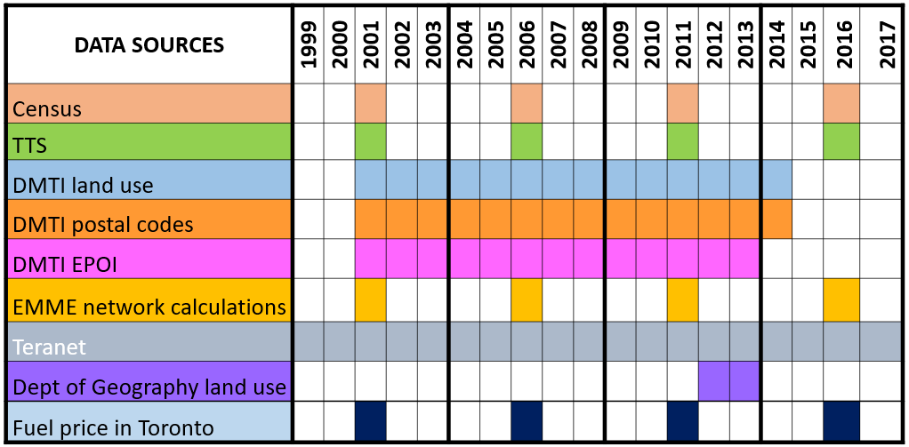

Figure 2. Temporal spans of data sources used in the GTHA housing market database (part of the diagram from 1999 to 2017; Census, TTS variables and Teranet data are available up to 1986).

Temporal matching between Teranet records and DMTI data could be done directly: DMTI land use for each year from 2001 to 2014 was spatially joined with a subset of Teranet records from the corresponding year; this approach ignores changes of land use that occur within a year, but recognizes land use changes that happen between the years for which DMTI land use data was available. Since the detailed land use provided by the Department of Geography was collected at a single point in time, it was joined to all Teranet records, keeping in mind that it is most accurate around its time of collection in 2012 and 2013.

As for Teranet and Census / TTS variables, they could be matched in a number of ways, such as:

1. By direct match with appropriate Teranet subsets (match Census / TTS variables only with Teranet records from the corresponding year).

2. Via interpolation of discrete Census / TTS variables.

3. Through assignment of temporal spans as new features to Teranet records, indicating to which Census / TTS survey each record could be matched (each Census / TTS survey is assigned a temporal span of 5 years; this 5-year span represents a group of Teranet records to which variables from this survey can be matched).

To utilize the maximum number of Teranet records and avoid additional interpolation assumptions and use the actual values recorded from Census and TTS surveys, the third option has been chosen for matching Teranet records with Census / TTS variables. Each Census / TTS survey was assigned a 5-year time span centered at the survey year (i.e., 2014–2018 for 2016 survey year) and new foreign keys were introduced to Teranet records to allow matching with 5-year time spans of Census / TTS variables.

## 3.3 Data preparation

Reproducibility of the data preparation process for data sources related to the GTHA housing market database has been established via a streamlined data preparation workflow using Python via a series of jupyter notebooks. It accomplishes three

main objectives:

• Clean Teranet dataset and correct its records for consistency.

• Introduce new keys that would allow efficient joining of other data sources, such as Census and TTS variables or parcel-level land use information, while maintaining the integrity of spatial and temporal relationships.

• Engineer the new features that can be used by the machine learning algorithm along with the features from the joined datasets to classify land use.

To implement the spatial and temporal relationships between the data sources discussed in section 2, a number of new foreign keys was introduced to Teranet records via a series of spatial joins and feature engineering. Figure 3 presents the Entity Relationship (ER) diagram of the GTHA housing market database.

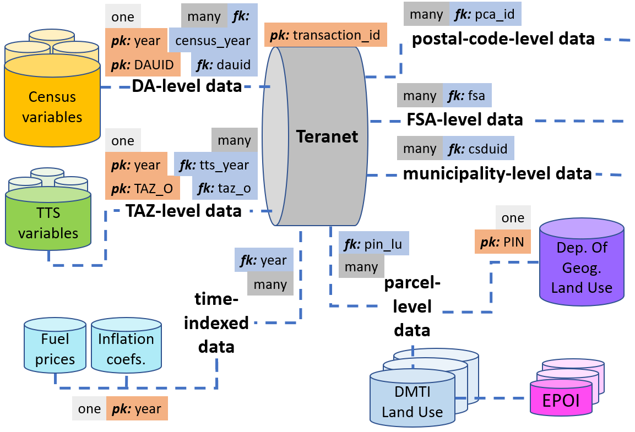Figure 3. Entity Relationship (ER) diagram of the GTHA housing market database; its referential integrity constraints were set up using the new keys introduced based on the spatial and temporal relationships between data sources.

In addition to producing new keys for joining datasets, a number of the new features was engineered from original Teranet attributes. These new features were intended to give each Teranet record spatial and temporal “context” of the housing market dynamics by grouping records using different spatial (parcel-level) and temporal (yearly) criteria (e.g., rolling count of transactions coming from a particular coordinate pair, ratio of price to median for that year, etc.). These new features have been tested with a machine learning algorithm to classify land use from housing market dynamics.

# 4 Prototype of a machine learning workflow to classify land use

One of the major features that was missing from the available version of Teranet’s dataset was the information about the type of property being transacted, which introduced a major limitation on how Teranet’s data can be used. None of the available sources of land use information covered the full time interval from 1986 to 2017; the most detailed and accurate source was the land use data collected in 2012 and 2013 by University of Toronto’s Department of Geography (introduced in section 2.5).

To address this issue, detailed land use from the Department of Geography was used as labelled data to train a machine learning model capable of recognizing certain property types that have characteristically different behavior on the housing market. For example, this model can differentiate a detached house from a condo through such features as high / low volume of transactions from a coordinate pair, time interval between subsequent transactions, ratio of price to median price for that year, etc. This section discusses a basic prototype of a machine learning workflow to classify land use from housing market dynamics.

## 4.1 Target variable

The target variable was constructed by reducing the land use codes with the highest counts of Teranet records found in the Department of Geography’s land use dataset to three major land use classes. Since many machine learning algorithms are subject to a frequency bias in which they place more emphasis on learning from data observations which occur more frequently, the three classes were selected to have a comparable number of Teranet records between themselves and thus produce a more balanced dataset.

In addition, the chosen groupings of land use types combine categories that have a similar distribution of price and count of sales per coordinate pair between categories that form a single class. For example, detached and semi-detached houses and townhouses have a much smaller frequency of transaction and a higher median price per coordinate pair when compared to condos and strata townhouses.

The three target classes that were introduced were:

• Class 0: “condo”, including Apartments/Condos/Residence and Strata Townhouses.

• Class 1: “house”, including Single Detached Houses, Duplex/Semi-Detached and Townhouses.

• Class 2: “other”, including Commercial/Shopping, Mix (Commercial Residential), Industrial/Employment Lands, and everything else.

## 4.2 Dimensionality reduction and hyperparameter tuning

To reduce the dimensionality of the augmented Teranet dataset and only include features that are the most relevant to the classification algorithm, a combination of algorithmic feature selection techniques has been utilized. Feature selection algorithms present a practical approach to feature selection at scale; such algorithms combine a search strategy for proposing new feature subsets with an objective function to evaluate these subsets; objective function plays the role of a feedback signal used by the search strategy to choose between candidate subsets. Figure 4 presents the top 11 features that were selected by at least four different feature selection methods.

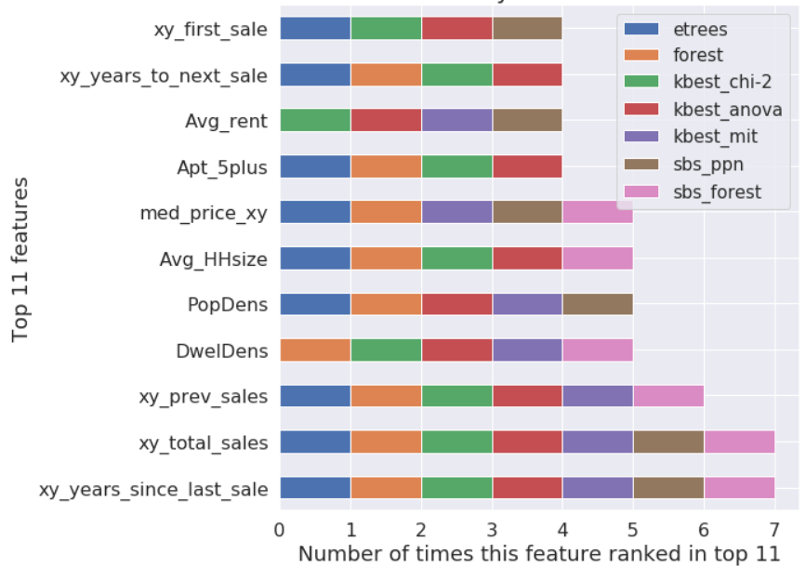

Figure 4. Feature Subset Selection (FSS) results: 11 features that were selected by at least four different feature selection methods.

There are two types of parameters in machine learning: those that are learned by parametric models from training data (i.e., weights in logistic regression), and the parameters that tune the performance of a learning algorithm, or its hyperparameters (i.e., regularization parameter in logistic regression or maximum depth of a decision tree). An acceptable bias-variance trade-off for a classifier can be found by tuning its hyperparameters, but care must be taken to ensure unbiased assessment of its generalization performance.

To facilitate unbiased performance evaluation of classifiers, all GTHA Teranet records from 2011 to 2014 have been split into two subsets using random subsampling: 70% of the data was used to train models and tune their hyperparameters, while 30% of the data has been used as a test subset for final evaluation of a classifier. Train and test subsets have been stratified across the target classes: in this context, stratification means that training and test subsets will have the same proportions of class labels as the input dataset. To avoid overfitting a model to the test set while tuning its hyperparameters, *k*-fold cross validation was used via grid search. To improve convergence of gradient-based linear models in the presence of outliers, quantile transformation (uniform PDF) was applied to input features; to improve performance of nearest neighbors, input features were standardized.

## 4.3 Model selection

An important point to be summarized from the famous No Free Lunch Theorems (NFL)(Wolpert 1996; Wolpert and Macready 1997) is that no single classifier works best across all possible scenarios, as there is a lack of a priori distinctions between learning algorithms. In practice, it is essential to compare the performance of at least a handful of different classification algorithms, since each of them has its inherent biases. After tuning hyperparameters, performance of the following models has been compared: perceptron learning algorithm (η = 0.5, max_iter=5), logistic regression (L2, L1 regularization, C=0.1), linear discriminant analysis classifier, quadratic discriminant analysis classifier, Linear Support Vector Classification (L2, L1 regularization, C = 0.1), decision tree and random forest, K-Nearest Neighbors (Manhattan and Euclidean distance, 4 neighbors), and Gaussian Naive Bayes.

# 5 Evaluation of results

This section discusses the evaluation of predictive performance of machine learning algorithms used for classifying land use from the housing market dynamics.

## 5.1 Metrics for evaluating model performance

Classification accuracy (ACC) is a common metric used to compare the performance of different classifiers; it is defined as the proportion of correctly classified instances. Precision (PRE) is defined as a fraction of relevant examples (true positives) among all of the examples that were predicted to belong in a certain target class. Recall (REC) is defined as a fraction of examples which were predicted to belong to a class (true positives) with respect to all of the examples that truly belong to that class. F1 score, also known as balanced F-score or F-measure,

combines precision and recall into a single metric.

Precision, recall, and F1 score are metrics specific to binary classification systems. In case of a multi-class classification problem, these metrics can be produced using individual confusion matrices constructed separately for each class using One-versus-All technique (OvA), and micro- or macro-averaged. Micro-averaging can be useful to weigh each instance or prediction equally, while macro-averaging evaluates the overall performance of a classifier with regard to the most frequent class labels by weighting all classes equally(Raschka and Mirjalili 2017).

## 5.2 Evaluating model performance

Four different subsets of data have been used to test the best performing models: train, test, and two additional validation subsets. The train and test subsets represent Teranet records from 2011 to 2014 randomly sampled into 70% train and 30% test subsets; these are the primary subsets that were used for training and tuning the hyperparameters and then evaluating the performance of classifiers on

unseen test data, as was described in section 4.2. The two additional validation subsets were composed of Teranet records from 2010 and 2015. Since the Department of Geography land use information (target variable) was collected in 2012 and 2013, it can be less accurate for these subsets; thus, they have not

been used for model selection, training or primary evaluation, but were utilized to test fitted models as an additional reference for the generalization of performance of classifiers. Figure 5 presents model performance on train, test, and two additional validation subsets.

. 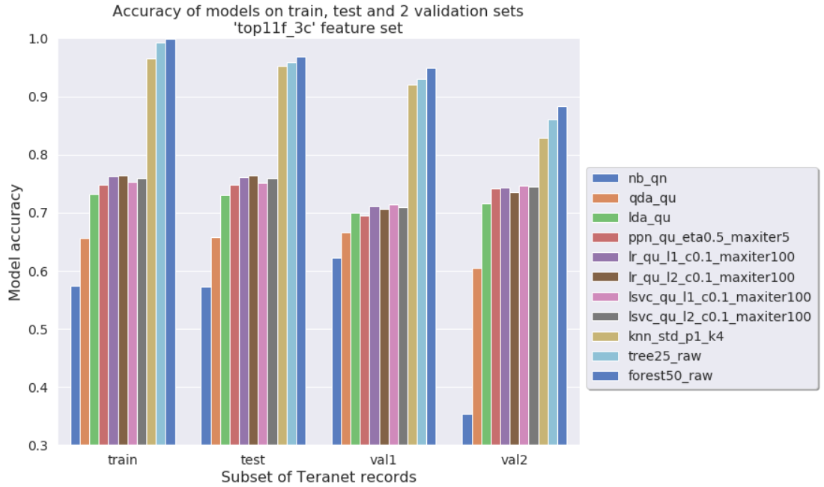

Figure 5. Model performance (accuracy) on train, test, and two additional validation subsets.

As can be seen on figure 5, in terms of prediction accuracy, tree-based and nearest neighbors models dramatically outperform linear models, such as logistic regression, linear SVC, perceptron and LDA classifier. This indicates that in the current feature space target classes are not linearly separable. Best-performing linear models were able to reach classification accuracy around 75% on the test set,

with all linear models performing close to each other. This performance was consistent across the train, test, and both extra validation subsets. Linear models do not seem to overfit the data, but instead suffer from high bias. In comparison, tree-based models capable of drawing complex non-linear decision boundaries were able to achieve much higher classification accuracy, with both decision tree and random forest scoring above 95% on the test set. These models have a much lower bias on this dataset compared to linear models, but do overfit the training data to some degree under the current size of the training subset, as was validated by plotting their learning curves.

## 5.3 Best performing model: Random Forest

As can be seen on figure 5, random forest with 50 estimators and Gini impurity criterion showed the best results in terms of accuracy on all subsets. Figure 6 presents the classification report showing all model performance metrics discussed in section 5.1 and figure 7 presents confusion matrices for the best performing model: random forest with 50 estimators using Gini impurity criterion.

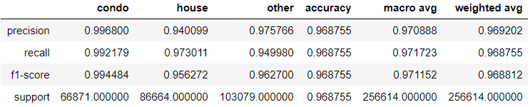

Figure 6. Best model performance on test set: classification report for random forest with 50 estimators using Gini impurity criterion.

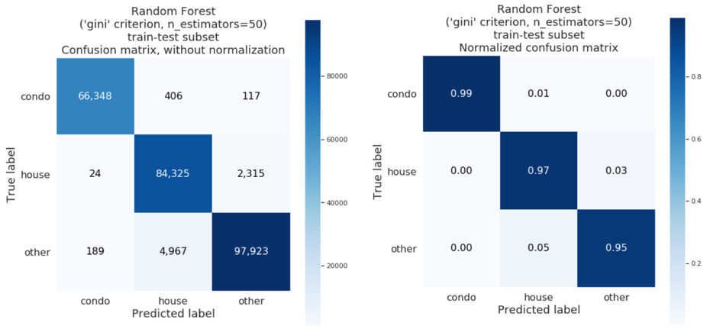

Figure 7. Confusion matrices for best performing model: random forest.

It can be seen that the model is capable of recognizing all the major property classes with a high degree of accuracy. Thus, features produced from the housing market dynamics have a strong predictive power when classifying land use at a parcel level. The best performing model was used to classify land use of all Teranet records from 1986 to 2017 and save the result as a new feature in the GTHA housing market database. Figure 8 presents feature importance for random forest with 50 estimators and Gini impurity criterion.

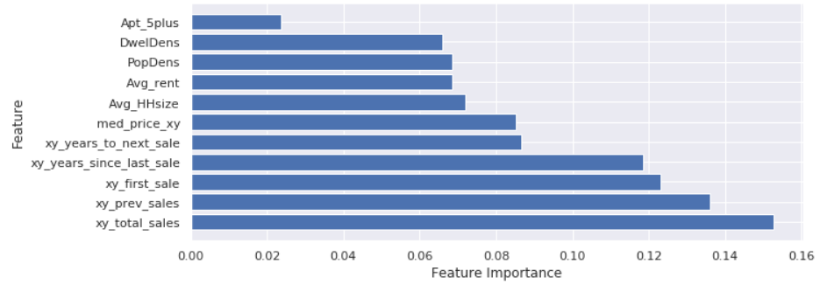

Figure 8. Feature importance for best performing model: random forest classifier with 50 estimators using Gini impurity criterion.

# 6 Summary, conclusions and future work

Microsimulation models present the latest generation of integrated land use and transportation models and are well suited to analyze the complex interaction of transportation and land use. New data sources that appear with the increased digitization of human activity present opportunities to look at urban processes at unprecedented spatial and temporal scale, and thus possess a lot of value for design and validation of integrated urban models and for longitudinal studies concerned with evolution of urban form. Introduction of the POLARIS electronic land registration system by the Province of Ontario in 1985 led to the creation of an extensive dataset of real estate transactions by Teranet Enterprises Inc.

However, despite having very high spatial and temporal resolution, the available version of Teranet’s dataset suffered from severe lack of features describing each individual transaction.

One of the major attributes missing from Teranet data was the type of property being transacted, or land use information for the parcel where a transaction is recorded. Along with selected Census and TTS variables, detailed parcel-level land use from the Department of Geography and DMTI land use data have been spatially joined to each Teranet record. However, since both of these data sources have their limitations, detailed land use data from the University of Toronto Department of Geography has been used to train an algorithm capable of classifying land use based on the housing market dynamics; this way, land use information can be made available for each Teranet record for the full timespan covered by the Longitudinal Housing Market Research conducted by UTTRI.

To augment Teranet’s dataset, new variables were engineered from its native attributes to capture the housing market dynamics at the parcel level. To augment Teranet data with demographic and transport information, the new Teranet features were spatially and temporally joined with Census and TTS variables recorded at the level of a Dissemination Area and TAZ zone, respectively. Finally, the augmented Teranet dataset has been tested with machine learning algorithms, attempting to classify land use for each Teranet record within the span of Census / TTS variables, thus recognizing land use changes with time.

The new features engineered from native Teranet attributes have shown to have strong predictive power when classifying land use. When joined with Census variables at the level of Dissemination Areas, new features engineered from Teranet’s dataset allowed the classification of land use with a high level of accuracy. A random forest model was trained using a random 70% sample of all Teranet records with new features from 2011 to 2014 stratified by target classes (“condo”, “house”, or “other”); the model achieved 97% of accuracy on the test subset composed of the remaining 30% of records from 2011 and 2014. Tree-based models did show some degree of overfitting and could benefit from further increase in the size of training data, as indicated by their learning and validation curves.

Features engineered from native Teranet attributes that capture price ratios to median and frequency of transactions from a coordinate pair have strong predictive power for land use classes, as indicated by feature selection techniques and model coefficients. This workflow could be further improved by joining more Census / TTS variables to engineer new features; target classes also could be redefined to allow

more meaningful classification. In addition, results of the classification performed by this workflow need to be investigated. A map produced with counts of misclassified Teranet records per DA shows that errors seem to be highly concentrated and correspond to high-frequency transactions, such as condos

and mixed-use properties. Augmented Teranet dataset with land use produced by the classification algorithm, along with related Census and TTS tables, has been transformed into a relational database to facilitate ease of access by a broader group of specialists.

# Acknowledgements

The research reported in this paper was supported by an Ontario Research Fund Research Excellence Round 7 grant, a Natural Sciences and Engineering Research Council Discovery grant, and Teranet Enterprises Inc. The contributions of Dena Kasraian, Shivani Raghav and JieLan Xu to the work are gratefully acknowledged. And we thank Profs. Andre Sorensen and Paul Hess for providing access to their parcel land use dataset.

# References

Alonso, William. 1964. *Location and Land Use, Towards a General Theory of Land Rent*. Cambridge: Harvard University Press. https://www.hup.harvard.edu/catalog.php?isbn=9780674730854.

Arribas-Bel, Daniel. 2014. “Accidental, Open and Everywhere: Emerging Data Sources for the Understanding of Cities.” *Applied Geography* 49: 45–53. http://dx.doi.org/10.1016/j.apgeog.2013.09.012.

Ashby, Bess. 2018. *TTS 2016 City of Toronto Summary by Ward*. Toronto. http://dmg.utoronto.ca/pdf/tts/2016/2016TTS_Summaries_Toronto_Wards.pdf.

Chen, Cynthia et al. 2016. “The Promises of Big Data and Small Data for Travel Behavior (Aka Human Mobility) Analysis.” *Transportation Research Part C: Emerging Technologies*.

Data Management Group. 2014. “Data Management Group at the University of Toronto Transportation Research Institute.” *http://dmg.utoronto.ca*. http://dmg.utoronto.ca.

———. 2019. “Survey Boundary Files.” *http://dmg.utoronto.ca*. http://dmg.utoronto.ca/survey-boundary-files.

DMTI Spatial Inc. 2014. “CanMap ® RouteLogistics User Manual V2014.2.” (2014.2): 1–130. www.dmtispatial.com A.

Iacono, Michael, David Levinson, and Ahmed El-Geneidy. 2008. “Models of Transportation and Land Use Change: A Guide to the Territory.” *Journal of Planning Literature*.

Kelly, Eric Damian. 1994. “The Transportation Land Use Link.” *Journal of Planning Literature* 9(2): p.128-145. https://journals-sagepub-com.myaccess.library.utoronto.ca/doi/10.1177/088541229400900202.

Knight, Robert L., and Lisa L. Trygg. 1977. *Land Use Impacts of Rapid Transit (DOT-TPI-10-77-29)*. Washington, D.C. https://www.osti.gov/servlets/purl/5952387.

Manheim, Marvin L. 1978. *Fundamentals of Transportation Systems Analysis Volume 1: Basic Concepts*. Cambridge, MA: MIT Press. https://mitpress.mit.edu/books/fundamentals-transportation-systems-analysis-volume-1.

Map and Data Library. 2019. “Canadian Census Geography (Unit) Definitions.” *University of Toronto*. https://mdl.library.utoronto.ca/canadian-census-geography-unit-definitions.

Martinez, Francisco J. 2018. *Microeconomic Modeling in Urban Science*.

McKean, Heather, and Stella Di Cresce. 2015. *The International Comparative Legal Guide to: Real Estate 2015, Chapter 6: Canada*. London, UK. https://www.osler.com/osler/media/Osler/reports/real-estate/Real-Estate-Law-in-Canada.pdf.

Miller, Eric J. 2018. “The Case for Microsimulation Frameworks for Integrated Urban Models.” *Journal of Transport and Land Use* 11(1): 1025–37.

———. 2019. “Travel Demand Models, The Next Generation: Boldly Going Where No-One Has Gone Before.” In *Mapping the Travel Behavior Genome, The Role of Disruptive Technologies, Automation and Experimentation*, eds. K.G. Goulias and A.W. Davis.

Miller, Eric J, David S Kriger, and John Douglas Hunt. 1998. TCRP Report 48 *Integrated Urban Models for Simulation of Transit and Land Use Policies Guidelines for Implementation and Use*.

Raschka, Sebastian, and Vahid Mirjalili. 2017. *Python Machine Learning, 2nd Ed.* 2nd ed. Birmingham, UK: Packt Publishing.

Spengler, Edwin H. 1930. *Land Values in New York in Relation to Transit Facilities*. New York, NY: Columbia University Press.

Statistics Canada. 2015. “Dissemination Area (DA).” *Census Program Reference materials, 2011 Census Dictionary*. https://www12.statcan.gc.ca/census-recensement/2011/ref/dict/geo021-eng.cfm.

———. 2018. “Hierarchy of Standard Geographic Units.” *Illustrated Glossary 92-195-X*. https://www150.statcan.gc.ca/n1/pub/92-195-x/2011001/other-autre/hierarch/h-eng.htm.

Teranet Enterprises Inc. 2019. “About POLARIS, Teranet.” *www.teranet.ca*. https://www.teranet.ca/registry-solutions/about-polaris/.

The Government of Ontario. 1990. *Land Registration Reform Act, R.S.O. 1990, c. L.4*. Toronto: The Government of Ontario. https://www.ontario.ca/laws/statute/90l04.

Wegener, Michael. 1994. “Operational Urban Models State of the Art.” *Journal of the American Planning Association* 60(1): 17–29. https://www.tandfonline.com/doi/abs/10.1080/01944369408975547.

Wolpert, David H. 1996. “The Lack of A Priori Distinctions Between Learning Algorithms.” *Neural Computation* 8(7): 1391–1420.

Wolpert, David H, and William G Macready. 1997. 1 IEEE TRANSACTIONS ON EVOLUTIONARY COMPUTATION *No Free Lunch Theorems for Optimization*. https://ti.arc.nasa.gov/m/profile/dhw/papers/78.pdf.