system preferences

-Pentium III 800 MHz or more;
-128 МB RAM (minimum);
-monitor with resolution of 1024х768;
-10 MB at the hard drive(for the brauser cache).

-brauser wich support JavaScript
-1 Mb/s internet or higher.

Help
When you go to the isochrone.com.ua, you can see minimalistic menu which has 4 buttons.


When u push the Map button, you can see map та кнопку and button which show u isochrone maps builder. At the Origin field automaticly inserted you geolocation (place where you are). You can write here any you want. In the Time field you must input time. The select the type of isochronic map.
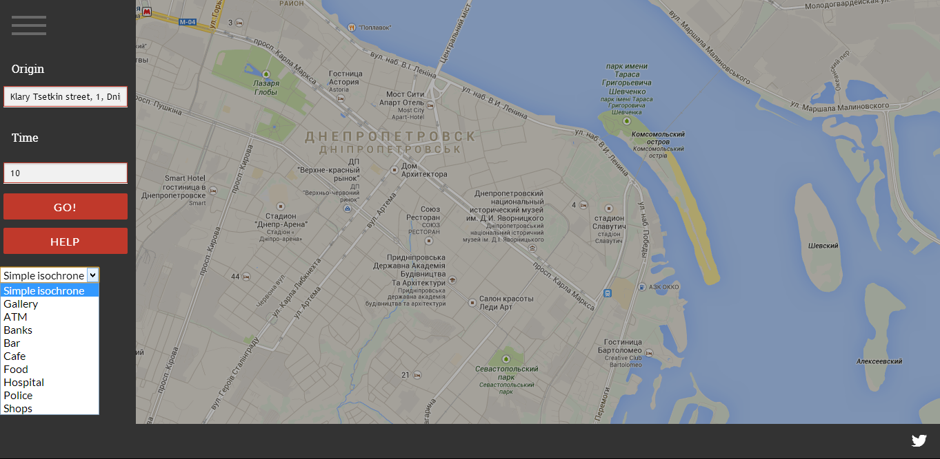

Site structure
