**Game Manual**

**Key of Clairvoyance**

**by**

**Supakrit Paoliwat 5730593821**

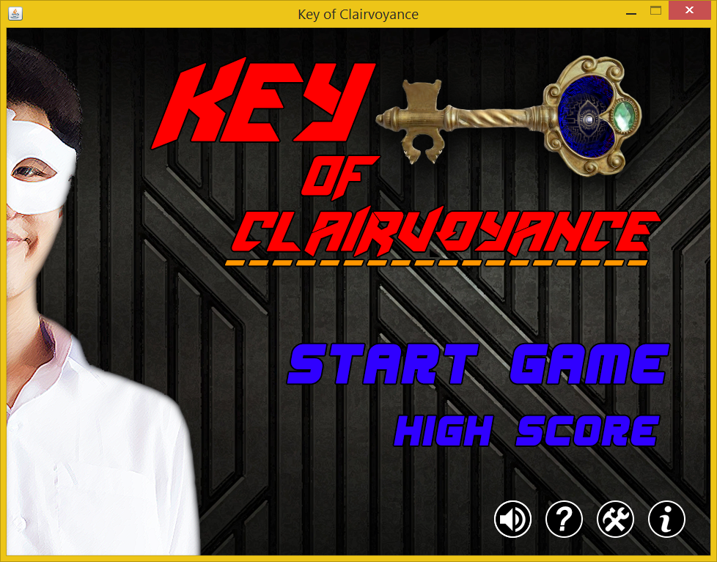**Sitthichai Saejia 5730625221**

**2110215 Programing Methodology**

**1st Semester Academic Year 2015**

**Chulalongkorn University**