DB Practice on Azure SQL Database

Use “Query Editor” in Azure SQL Database to query the following questions from the “All_Electronics” DB to get the same result.

1. The top 3 best-selling products in terms of **total** quantities (Qty)

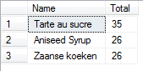

1. Total amount of sold items (**total** quantities) group by place made

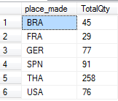

1. The list of customers order by their **total** spend money in descending order

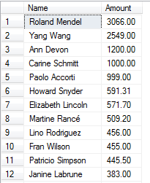

1. **Total** sale amount of each employee in descending order

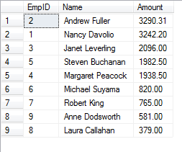

1. The list of the products from the company “Leka Trading” sold for each receip (TransID)

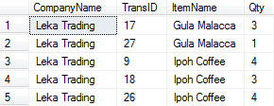

1. **Total** sale of the products from the company “Leka Trading”

