Project Report
Title of Project: PawFund
Name of the Innovator: Subham Mote
Start Date: 27-10-2025
End Date: 31-10-2025

Day 1: Empathise & Define
Step 1: Understanding the Need
- Which problem am I trying to solve?
I’m solving the problem of limited funding and visibility for stray and ill dogs. Many animal shelters and rescuers struggle to rAIse money for treatments. My platform helps simulate how online donations and emotional storytelling can increase awareness and support for animal welfare.

- Who is affected by this problem?
Stray dogs, small animal shelters, pet owners struggling with vet costs, and animal lovers wanting to help.
- How did I find out about this?

- Observation
- Online Research
Step 2: What is the problem?
Lack of centralized, transparent, and emotionally engaging donation systems for animal care. Traditional charity drives rarely reach enough people, so this mock platform demonstrates how technology can amplify compassion and donations.

Why is this problem important to solve?
Encourages empathy for animals, showcases the potential of digital fundrAIsing, and spreads awareness about animal health and shelter challenges.Take-home task
Ask 2-3 people what they think about the project:
- Animal rescuer – “A site like this could help us rAIse awareness for dogs in treatment faster.”
- Veterinarian – “Transparency and good stories make people more willing to donate.”
- Pet lover – “I’d love to see real progress bars and pictures—it makes the cause feel alive.”

AI Tools you can use for Step 1 and 2:
AI Tools Used:
1. Meta MGX
- Used as a no-code development tool to design and deploy the PawFund app.
- It helps create interactive workflows, user interfaces, and logic without programming.
- Ideal for building features like user registration, location-based data, and skill modules.
2. ChatGPT
- Used for idea generation, content structuring, and chatbot conversation design.
- Helped in framing the AI-powered virtual assistant’s responses for guiding students.
- Also useful for generating career recommendations, FAQs, and improving user interaction flow.
3. Chatbot References (Structure Design):
To design the AI virtual assistant, you can take reference from:
- Google Dialogflow – for understanding intent detection and response flow.
- IBM Watson Assistant – for creating structured Q&A and personalized career guidance.
- Microsoft Bot Framework – for understanding conversation trees and user profile integration.
Day 2: Ideate
Step 3: Brain-storming solutions
• PawFund Donation Website –GoFundMe-style app for dogs
• Pet Health Awareness Blog
• Donation Tracker Dashboard
• Adoption Campaign Platform
• AI Story Generator for Shelter Dogs Step 4: My favourite solution:
My favorite solution is PawFund, a complete digital platform designed to support animal welfare and promote awareness for dogs in need. It features a simulated donation system where users can explore real-looking campaigns, view stories of dogs undergoing treatment, and contribute through an interactive, fake donation interface. Built using VS Code with HTML, CSS, and JavaScript, the platform is easy to access, update, and customize—making it a long-term, practical, and visually engaging solution for showcasing how technology and empathy can come together to inspire social good.
Step 5: Why am I choosing this solution?
It combines emotional design, storytelling, and interactive UI to make people understand how online empathy can drive donations—even in a demo environment. AI Tools you can use for Step 3-5:
AI Tools for Step 3–5
1. Meta MGX
- Used to design and build the AIwithout coding.
- Helps create the AI assistant, skill modules, and location-based features.
2. ChatGPT
- Helps brAInstorm solutions and generate ideas for career guidance features.
- Can structure conversations for the AI virtual assistant.
- Assists in writing content for skill modules, FAQs, and recommendations.
3. AI Chatbot References (for design and flow)
- Dialogflow – Understands user intent and conversation flow.
- IBM Watson Assistant – Helps design structured Q&A for personalized guidance.
- Microsoft Bot Framework – Shows how to connect user inputs with recommendations and actions.
4. AI Research Tools
- Google Scholar / Research AI – For exploring existing solutions and innovative ideas for Steps 3–5.
- AI Text & Summarization Tools – Helps summarize solutions, select the best approach, and present them clearly.
AI Tools you can use for the take-home task:
Canva AI/CoPilot AI/Meta AI: Use these mobile-based tools to generate images for the solution they want to design
Day 3: Prototype & Test
Step 6: Prototype – Building my first version
What will my solution look like?
• Home Screen: Hero banner “Help Every Tail Wag Again”
• Dog Cards: Name, illness, photo, goal, and donation bar
• Fake Donation Modal: User chooses fake amount and sees progress
• Recent Stories: Fake success stories of recovered dogs
• Admin Mode: Add/edit dog profiles.
Design Style:
- warm, clean, emotional, realistic donation app
Prototype Tools:
- Built using Meta MGX, no coding required, with all features interactive and testable.
What AI tools will I need to build this?
AI Tools Needed to Build PawFund
- Meta MGX
  - No-code platform to design and deploy the app.
  - Allows building interactive screens, chat interfaces, and skill modules without coding.
- ChatGPT (or similar LLMs)
  - To generate content, conversation flows, and career guidance responses.
  - Can help personalize recommendations for users based on their profile and location.
- AI Chatbot Design References
  - Google Dialogflow / IBM Watson Assistant / Microsoft Bot Framework
  - To structure conversation logic and handle user queries effectively.
- AI Recommendation Tools (Optional but useful)
  - For matching students with careers, scholarships, and nearby opportunities.
  - Could use ML-based ranking algorithms or existing AI APIs for personalization.
- AI Data Analysis Tools (Optional for insights)
  - Python AI libraries (Pandas, Scikit-learn) or AI analytics platforms
  - To analyze user interactions and improve recommendations over time.

What AI tools I finally selected to build this solution?
- Chat GPT
- Metamgx

< Build The Innovation>
<DASHBOAD OF THE TOOL>
Tool Link: https://694568-304747aa5c924abc9824a935189ecbd2-3-latest.app.mgx.dev/

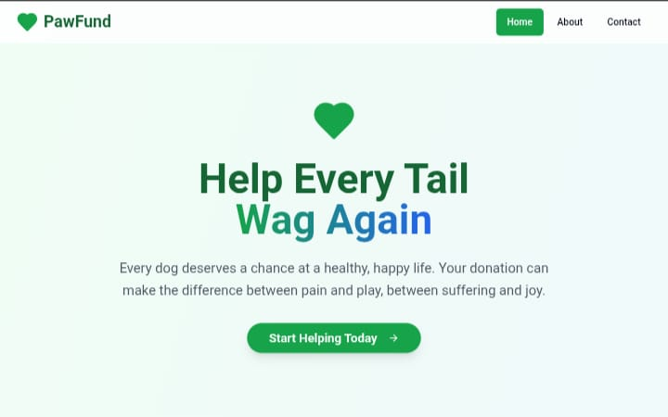

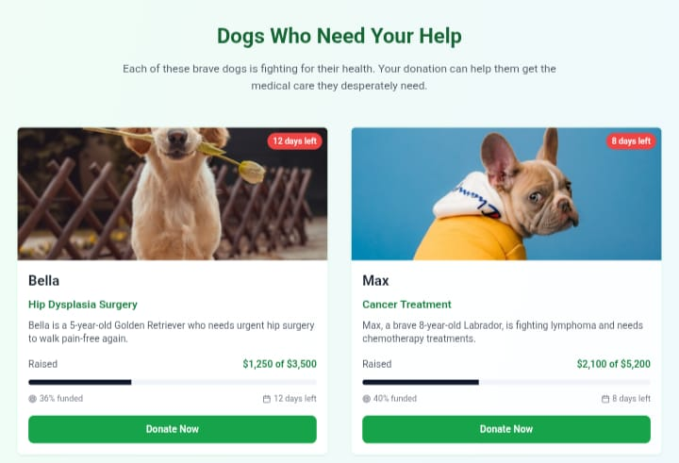
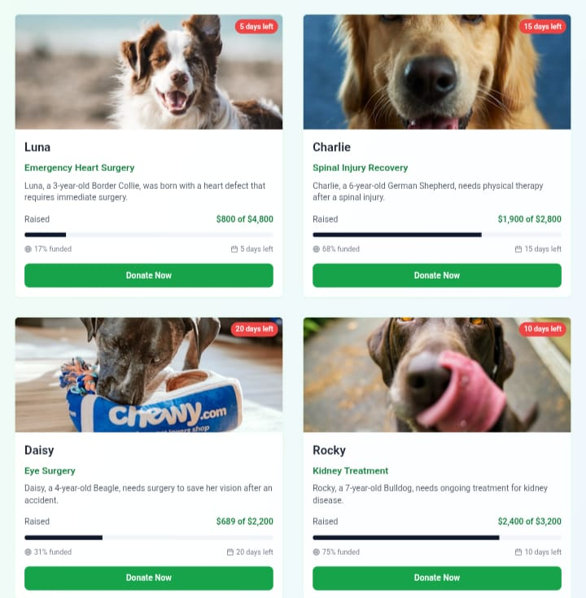

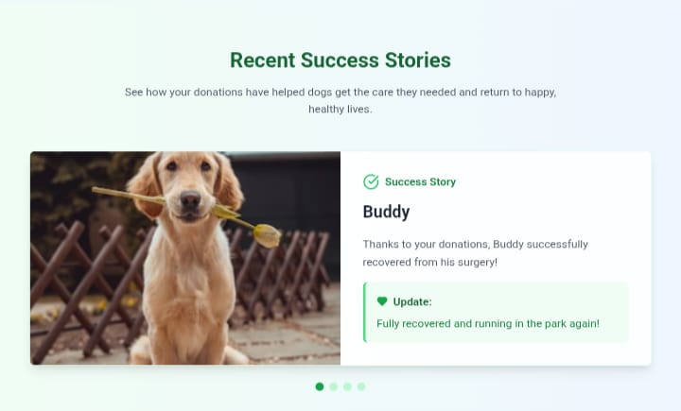
🔧 What needs improvement:

Virtual Assistant Logic: The assistant currently follows a limited, rule-based conversation pattern. It needs integration with a proper language model or NLP-based system to generate dynamic, context-aware responses and make the interaction feel more natural.
• Backend and Database Support: Since the project is a front-end simulation, donations and user data are not stored permanently. Adding backend integration (using Firebase or a simple Python/Node.js API) would allow real-time tracking, user authentication, and secure data storage.
• Authentic Data and Campaign Management: All donation stories and images are randomly generated. In a future version, verified data input and admin moderation tools could improve authenticity and credibility.
• Mobile Responsiveness and Optimization: Although the layout adapts to different screen sizes, some components—like modals and progress bars—require better responsiveness and smoother transitions for smaller devices.
• Accessibility and Readability: Contrast, font size, and ARIA attributes should be improved to make the site more accessible for all users, including those using assistive technologies.
• Engagement Features: Features such as comment sections, campaign updates, or “follow this story” options could enhance user involvement and retention.
• Ethical Transparency: Future iterations should include disclaimers or educational content clarifying that the app is a simulation and not a real fundraising platform, ensuring ethical use in public demos.
AI Tools you can use for Step 6-7:
ChatGPT/Perplexity AI/Claude AI/Canva AI/Chatling AI/Figma AI/Metamgx/Gamma AI: You can use these tools to build solutions/models or mock-up dummy prototypes
Day 4: Showcase
Step 8: Presenting my Innovation:
I am presenting PawFund, a digital career guidance and skill development platform for rural youth. It features:
- An AI-powered virtual assistant that provides personalized career, scholarship, and job guidance.
- Skill development modules for English, aptitude, and soft skills.
- Location-based suggestions for nearby colleges, training centers, and opportunities.
- A user-friendly, mobile-friendly interface built on Meta MGX with lifetime access and easy updates.
Impact: PawFund helps students make informed decisions, improves employability, and bridges the guidance gap in rural areas.

<SHOWCASE YOUR INNOVATION TO YOUR PEERS>

Step 9: Reflections
- What did I enjoy the most during this project-based learning activity?
I enjoyed building PawFund using a no-code tool and seeing my idea take a real, interactive form. It was exciting to design the AI assistant, skill modules, and location-based features, and imagine how it could empower rural youth to make better career decisions.

What was my biggest challenge during this project-based learning activity?
My biggest challenge was integrating all features smoothly in the prototype using a no-code tool, especially ensuring the AI assistant, skill modules, and location-based recommendations worked together effectively with limited resources.
Take-home task
https://github.com/stepdad-thatsme/PawFund
AI Tools you can use for Step 8:
Canva AI: You can use this to design your pitch document. Download your pitch document as a PDF file and upload on GitHub



