Google Analytics

Contents

Introduction 1

Creating a Property 1

Start 1

Web Application 2

Specify Website 3

Insert Tracking Code 3

Audience Overview 5

Behavior Overview 6

Final Comments 7

# Introduction

The overall purpose of Google Analytics (GA) is to monitor website traffic. In addition, there are some more specific things we can do like check users' locations, which pages are accessed the most, and even which browser users use. Currently, both consiliastats.com and mysamplesize.com are registered with Google Analytics. These are considered two *Properties* for our GA account.

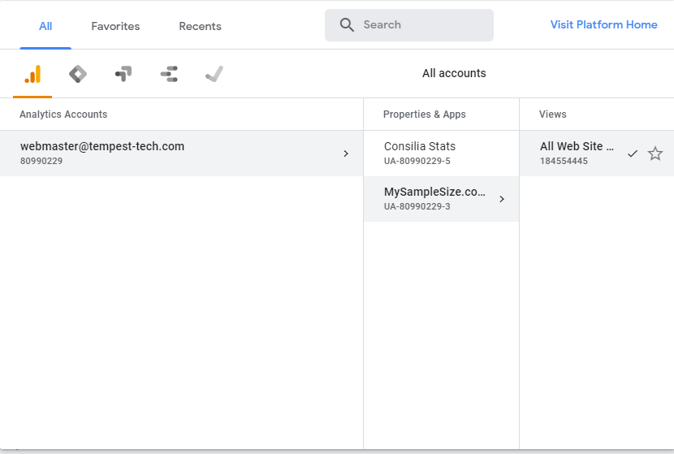

Figure 1: Accounts and Properties

## Login

At <https://analytics.google.com>, log in with the [webmaster@tempest-tech.com](mailto:webmaster@tempest-tech.com) email to access Google Analytics.

# Creating a Property

If we add another site, we may want to create another Property. This will go through the steps to do so.

## Start

First, under settings, click "Create Property"

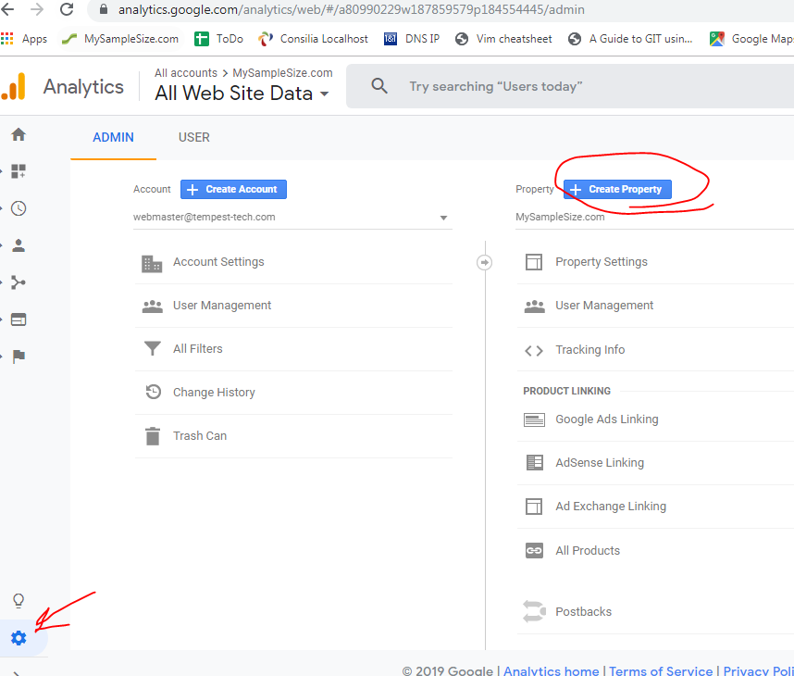

Figure 2: Create Property

## Web Application

For our purposes, we select Web.

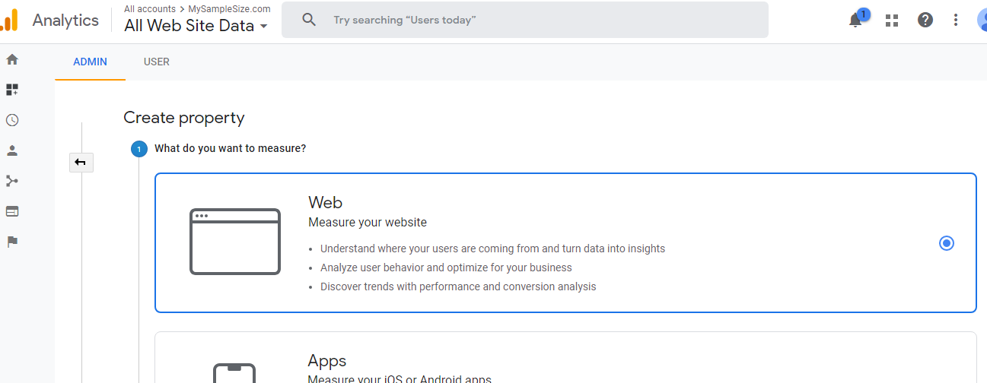

Figure 3: Create a Web Property

## Specify Website

For example, we will fill in information related to the main Tempest website.

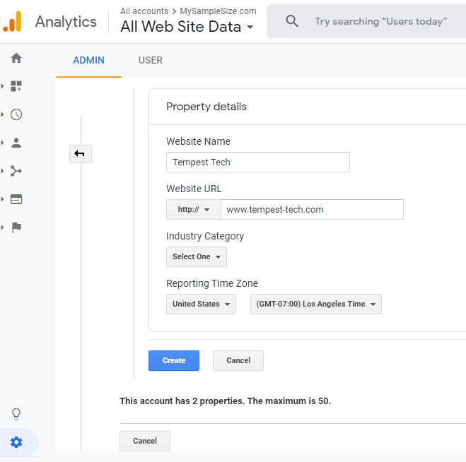

Figure 4: Information for Web Property

## Insert Tracking Code

Finally, we need to allow Analytics on the website site by inserting code we see below in the *Tracking Code* section. To track every page, this must be inserted into every single page. For our AngularJS applicatoin (MySampleSize.com), index.html is the first entry point for every page, so we only need to add the code there.

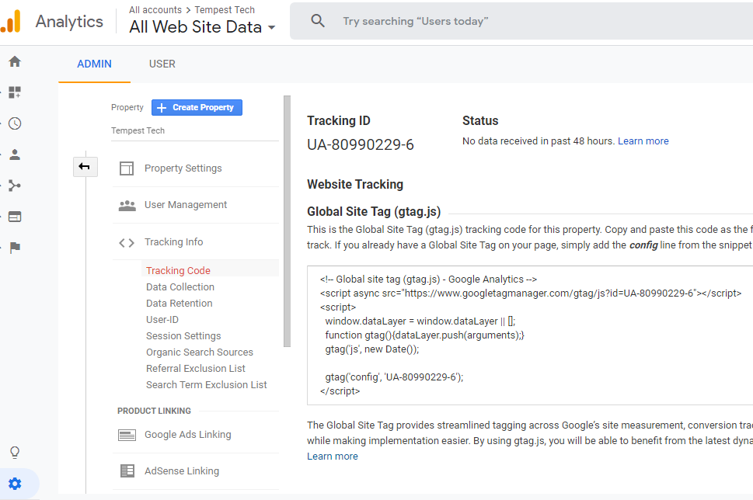

Figure 5: Tracking ID and JS Code

After doing this, our page will start using Google Analytics.

Home Page

On the Analytics home page, it shows realtime users as well as historical information for users per day.

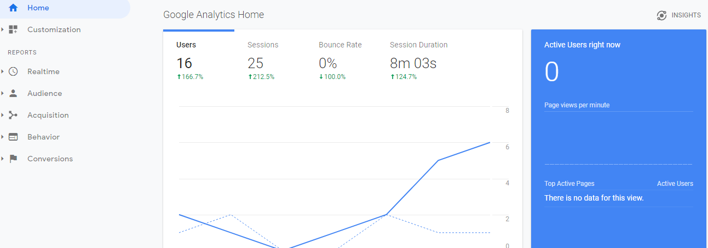

Figure 6: Analytics Home Page

# Audience Overview

In the Overview page of the Audience section, we can see how many users, new users, and pageviews, and also specify a custom date range for which to view this data.

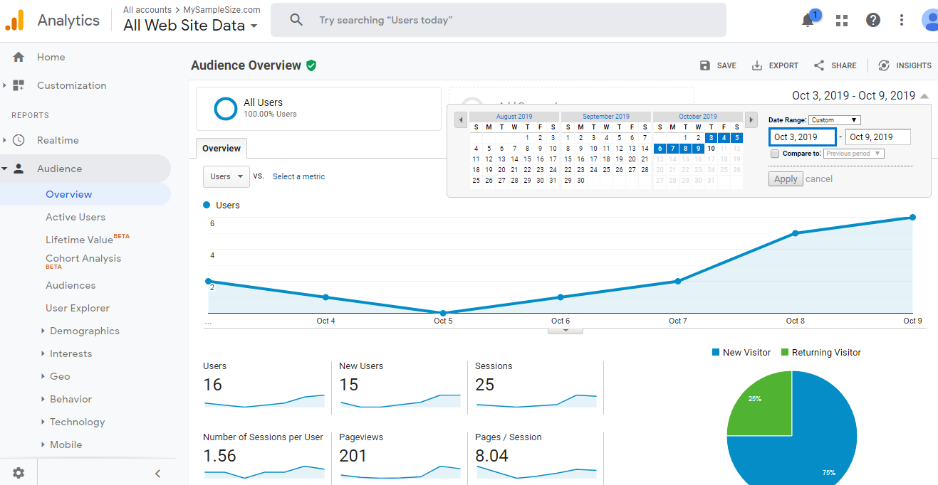

Figure 7: Audience Overview

If you scroll down, you can also click on Browser and OS to obtain information about users' browser preferences.

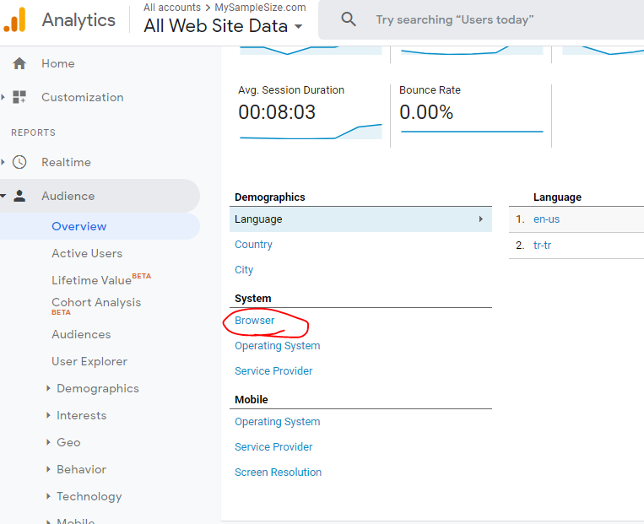

Figure 8: Audience OS and Browser Info

# Behavior Overview

The page I look at the most is the Behavior Overview and related pages. This provides information about which pages are actually looked and visited most or least by users.

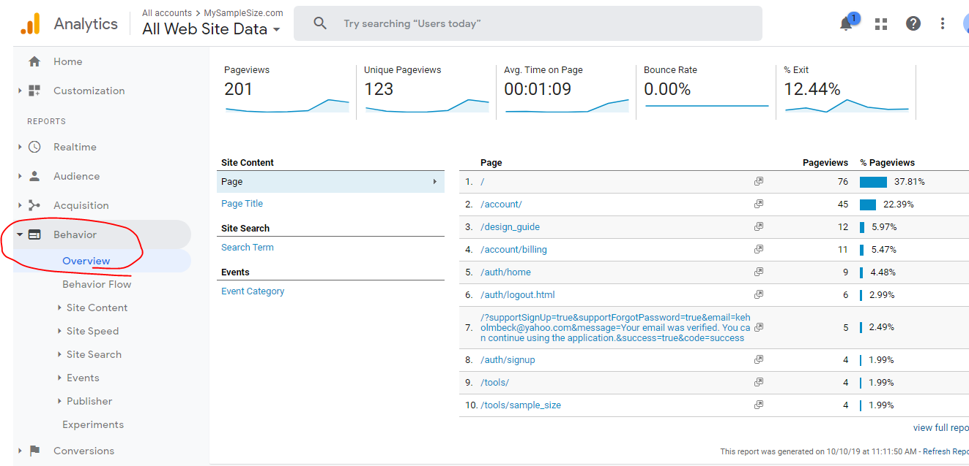

Figure 9: Behavior Overview

# Final Comments

There is a lot of information that can be viewed in multiple ways with the Google Analytics tool. User demographics (gender, age, etc.) can be viewed, but we may have to put an "I Accept Cookies" disclaimer on the site in order to appropriately use this data.

Use the search bar at the top to search for a specific section, or simply just play around with all the different options to see which are most useful. The ones that are most useful can be placed in a custom view.

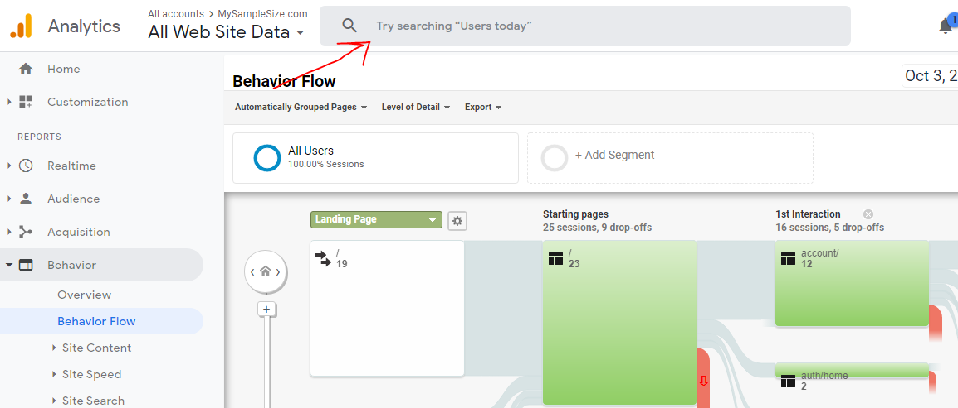

Figure 10: Search for specific user information

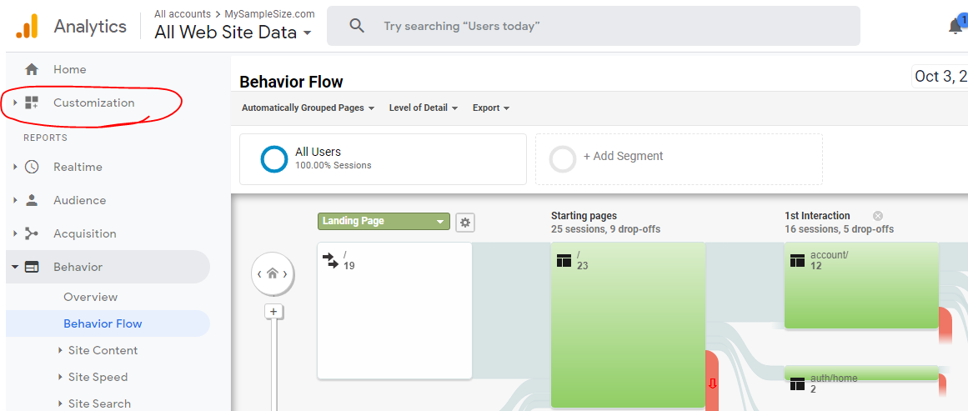

Figure 11: Customize Views