Search Engine Optimization

Kristin Holmbeck, February 2019

# Introduction

Search Engine Optimization (SEO) is the process of creating a website that makes it easy for search engines to read and access. If you want to attract more users and/or customize the experience, SEO is vital to implement and understand. Without basic knowledge on SEO techniques, your website will not reach its full potential.

The first question to ask is: which search engines matter? The most common search engines as of 2018 are Google (used by almost 75% of users), Baidu (a Chinese search engine), Bing, and Yahoo.

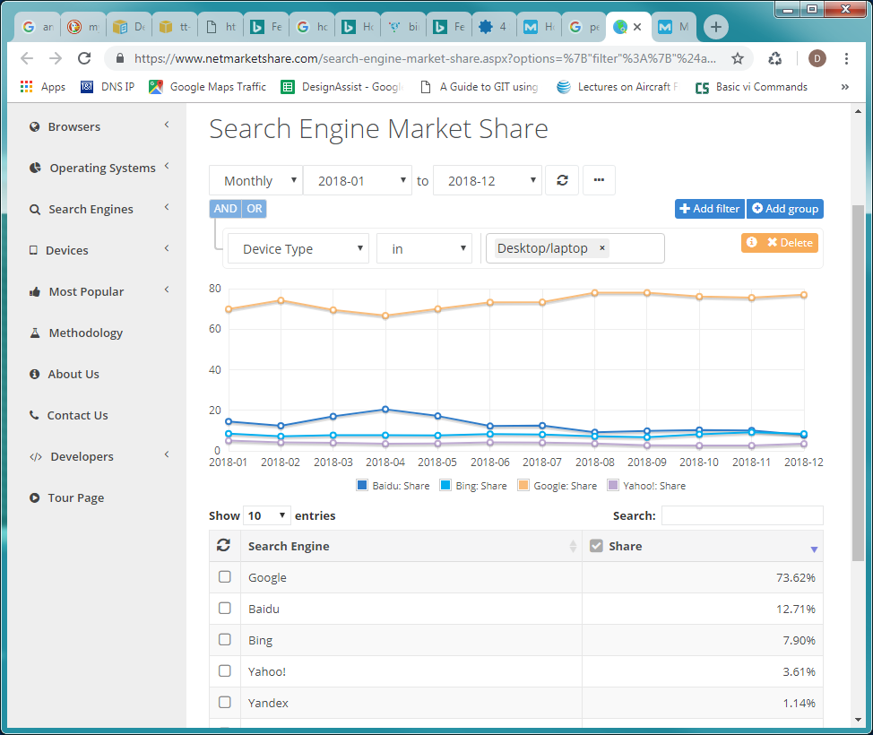

Figure 1: Search Engine Market Share (source: netmarketshare.com)

However, it is important to note that Yahoo actually uses Bing searches [1] – the SEO will not be any different. Thus, we will be dedicating our website SEO to the Google and Bing search engines.

# Sitemaps

The sitemap is an XML (Extensible Markup Language) file that describes which pages exist in the site, and when they were last modified. An example excerpt of a sitemap for MySampleSize.com is provided in Figure 2.

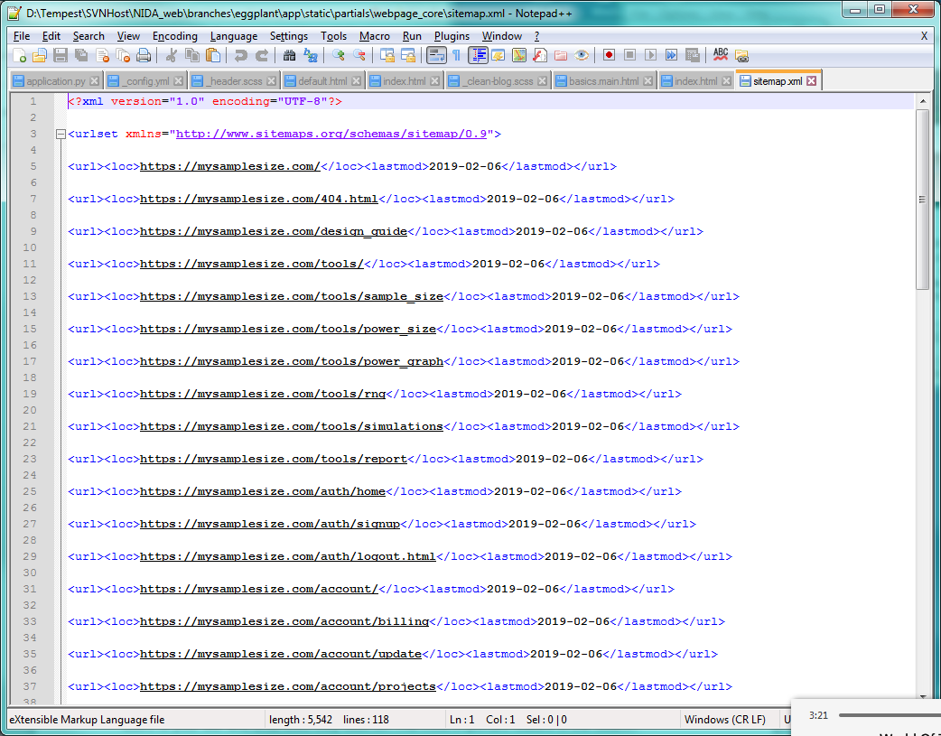

Figure : Sitemap Excerpt

The current sitemap is generated by running the Python file /branches/eggplant/app_routes.py. See [this post](https://moz.com/blog/xml-sitemaps) for more information on sitemaps.

# Google SEO

The first step to helping Google find your website is to register as a [webmaster](https://www.google.com/webmasters/). This allows us to use the Search Console and Analytics features provided by Google to identify bottlenecks, see where users are coming from, and how the website appears in a search. We are currently registered under [webmaster@tempest-tech.com](mailto:webmaster@tempest-tech.com).

## Analytics

Google Analytics is useful for identifying how many visits per day and how users organically find the website – for example, through a search or from another website.

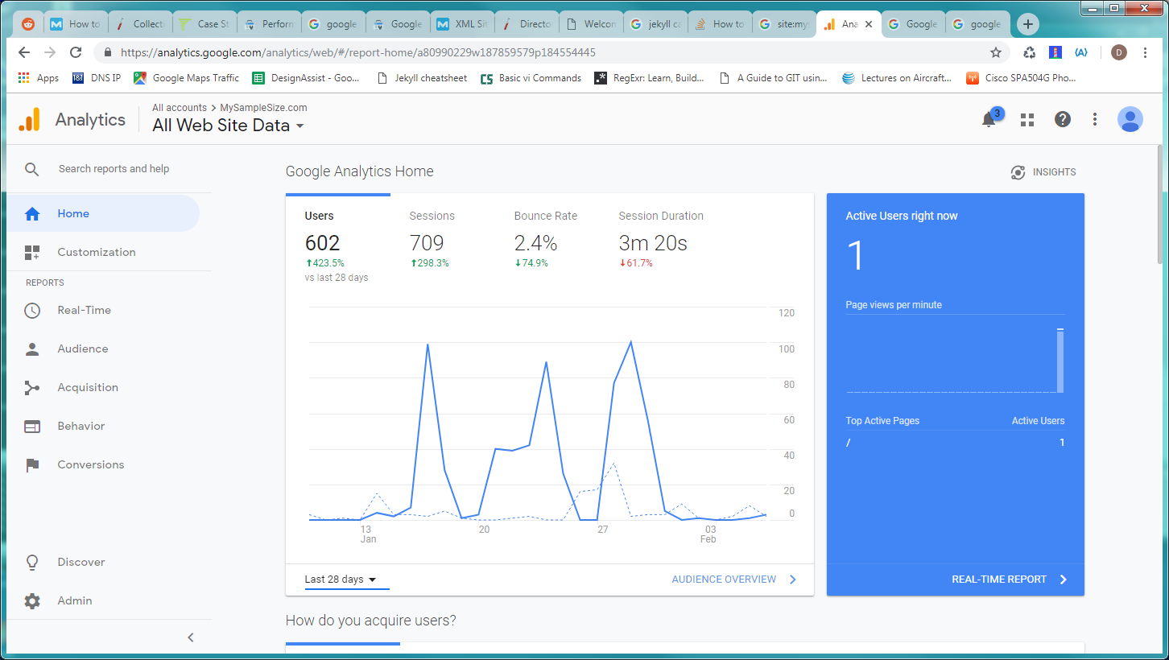

Figure 3: Google Analytics home

The Analytics dashboard provides historical as well as real-time information on users.

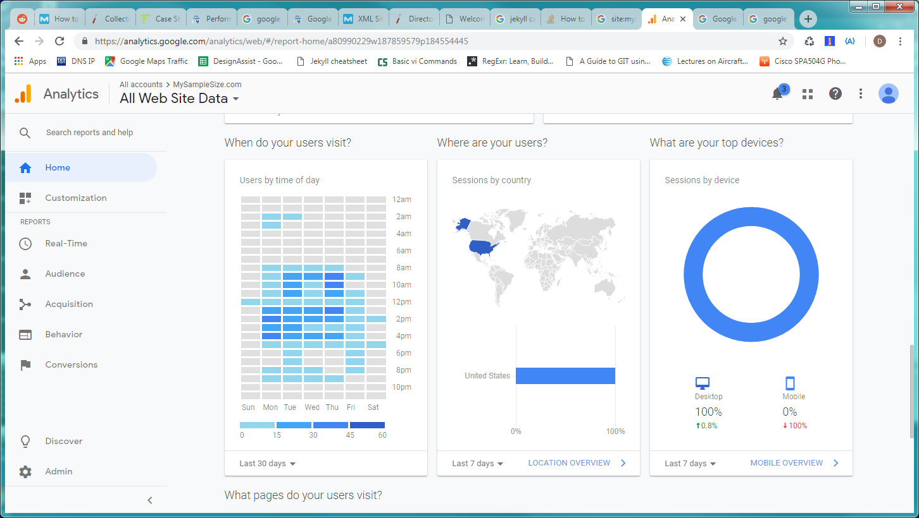

Figure 4: More Google Analytics information

You can use Analytics to also check which pages users view most, as well as any pages that have bounce rates. As we gain more users, viewing the Analytics insights will become more important.

## Search Console

Search Console tools and reports help you measure your site's Search traffic and performance, fix issues, and make your site shine in Google Search results. [2]

The [Google Search Console](https://search.google.com/search-console/about) is used in conjunction with Analytics to see which keywords bring users to your site and what links they click on. The most important feature of the Search Console is to submit a sitemap for your website.

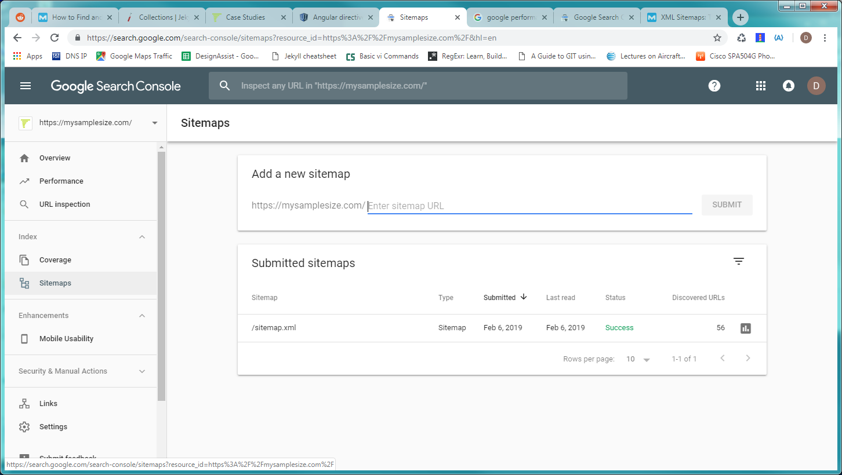

First, we need to submit a sitemap. After submitting, you may wait up to a week to see any updates in a live search. For every change that is made, it will take Google a week or more to process the changes. This is due to Google crawling the website at its own leisure. Below (Figure 3) is an example of what the search results show.

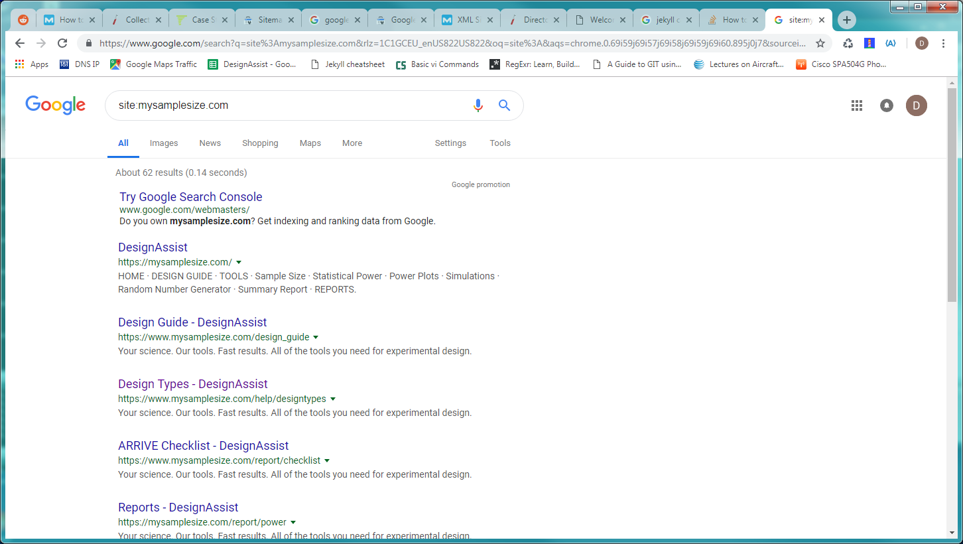

Figure 5: Google search for site:mysamplesize.com on 7 Feb 2019

The key for website searching is to provide rich content in your HTML pages. There is no trick to this – plain keywords that are in the direct content will help boost your SEO provided it is relevant to a user's search. To that end, we decided to write a blog in addition to the main capabilities of the website. A blog will serve to provide more information and direct future users to the main website. The details of the blog are located in a separate document.

# Structured Data

Structured Data is a way to include content on a web page to display in a search. Structured Data is ideally search-engine-agnostic, meaning it is written for most search engines to interpret and display to users.

1. http://news.bbc.co.uk/1/hi/business/8174763.stm
2. https://search.google.com/search-console/about