# Application Folder Structure and Motivation

As of SVN version 38 for the repository svn://shakespeare/NIDA_web/, we outline the structure and key ideas of the DesignAssist web application. This is meant to be a reference and not an exhaustive guide to each component.

The different website components are meant to be organized by pages (e.g. tools, help, authorization) so as to create a logical structure that is intuitive for future maintenance.

# Top-Level structure

The main entry point to the folder contains files needed to run on a localhost server as well as key files required for successful deployment to an Amazon EC2 instance.

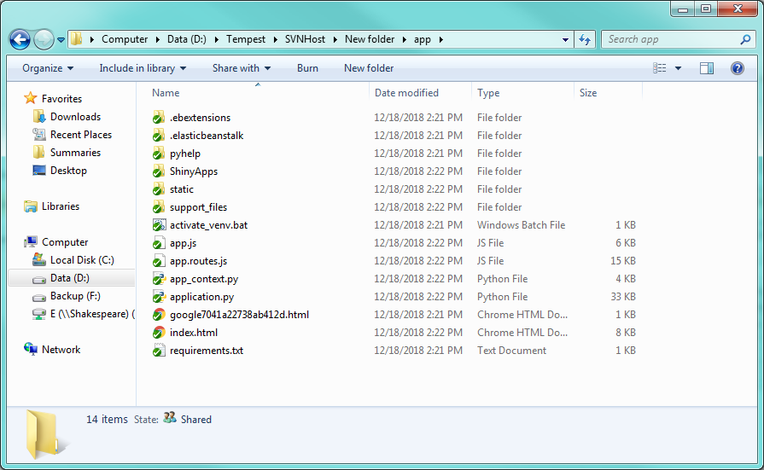

## AWS Folders

The folders /.ebextensions, /.elasticbeanstalk, and /support_files are the ones needed for AWS deployment, and are not required to run the application in a localhost environment. The /.elasticbeanstalk folder contains an information text file for the Elastic Beanstalk (EB) environment, whose structure and convention comes from running eb init. In other words, this file is not edited directly and only for identification purposes in the AWS EB CLI.

The /.ebextensions folder contains *.config text files which act as commands while the application is being deployed to EB. Our configuration files indicate which yum packages to install, move files from /support_files to their necessary locations, and change wsgi.conf to allow different ports through Apache. These configuration files are highly customizable for performing actions before the app is deployed.

## Python Files

The .py Python files location in the /pyhelp folder are the backend driver for running the application. They specify endpoints, call necessary APIs (such as Stripe for payments and Auth0 for user account creation), and contain helper functions. The main driver is application.py, located in the root directory. Of course, all these .py files could be merged into a single application.py file, but we opted to separate them based on application logic and ease of use.

## /ShinyApps

The /ShinyApps folders contain the R code for interfacing with Python as well as the internal SQLite database for saving user projects.

# /static

The files and folders in the /static folder are one of these file types: CSS, HTML, JS, or image files (jpg, png). These types of files are usually referred to as static files in a web application, hence the folder name.

## /js

The JavaScript files in /static/js are modules needed for import into the Angular app. They are written by third-parties and can be called using their CDN location instead of a relative location to the server. The only exception is the nv.d3.js file, which was modified by Tempest to customize D3 graphs for our simulation tools.

## Modules

The ./module_* folders were written to separate the various parts of JavaScript logic of the Angular application.

### /module_auth

This folder contains the service for calling Auth0 (login) information, the payment information and frontend interface for Stripe, and the controller for accessing a user's account.

### /module_designguide

This folder contains the controller for the actual design guide and walkthrough for designing your study, and the persistent information needed to communicate to the Tools and Reports page.

### /module_help

This folder contains the controllers that interact with plotting in the Help section, as well as some modals (popups) for further information on a topic.

### /module_modals

This folder contains some directives (that should probably be in another folder) and modals that pop up in the design guide click-for-more buttons.

### /module_reports

This folder contains controllers for report generation, and uses the design guide service (persistent data) from the module_designguide folder.

### /module_tools

This folder contains large files that control all the tools – power and sample size, power plots, simulations, and the random number generator tools.

## /partials

The ./partials folder contains all the HTML files that build our application. HTML files are included with AngularJS code with the ng-include attribute.