Tawk.to

Yun Wang

Created 12 Sep 2019

Contents

Introduction 2

Sign In 2

Administration Settings 2

Widget Appearance 3

Widget Content 3

Online Offline Settings 4

Agent Status 4

# Introduction

Tawk.to is a live chat support & messaging application. The platform monitors and chats with the visitors on the website.

The account was initially setup by Alyssa Butler and transferred to yun.wang@consiliastats.com.

# Sign In

To sign in on a desktop, open URL <https://dashboard.tawk.to> then sign in with an email address (e.g. [yun.wang@consiliastats.com](mailto:yun.wang@consiliastats.com)) and password.

To sign in on a mobile phone, install tawk.to mobile app first. The sign in procedure is the same as on a desktop.

# Administration Settings

What can be managed by an administrator are summaries in the following figure,

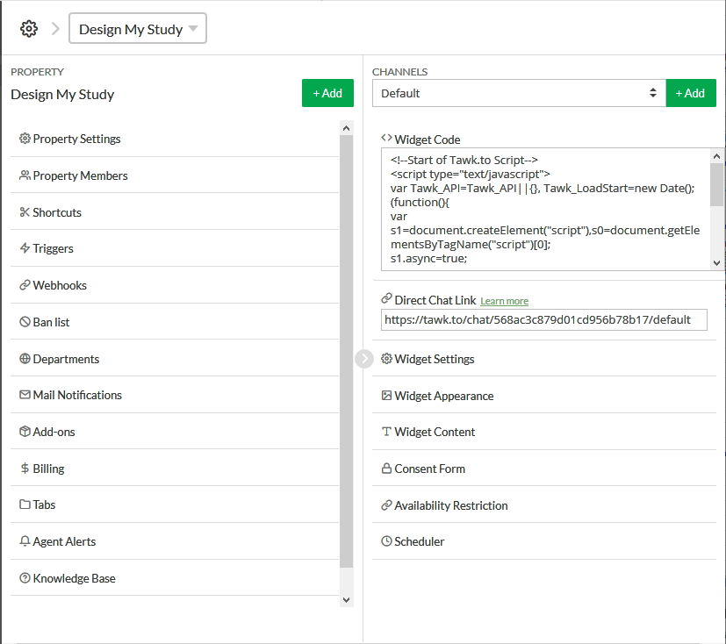

The left panel is to define the property for a specific PROPERTY that is uniquely associated with an URL.

The right panel is dedicated to the widget for the PROPERTY.

## Widget Appearance

The appearance of the widget, left, right, up, down, shape, color, etc. is setup under Widget Appearance:

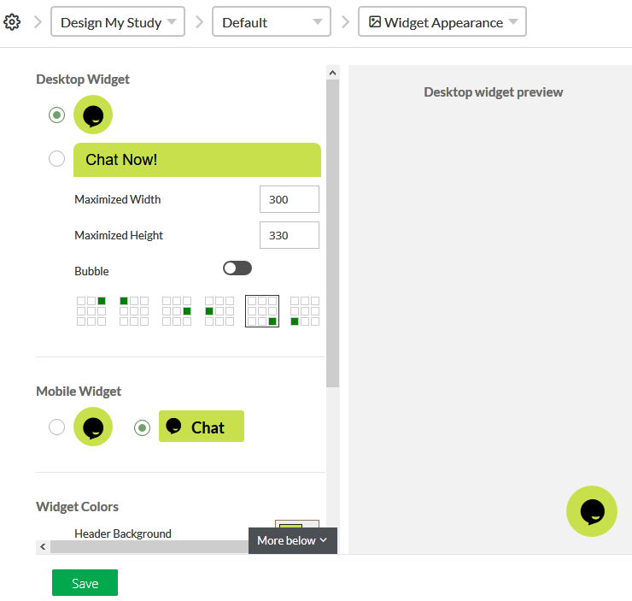

## Widget Content

What are displayed when the chat is Online or Offline is created in Widget Content. The content is highlighted with the green background in the following figure.

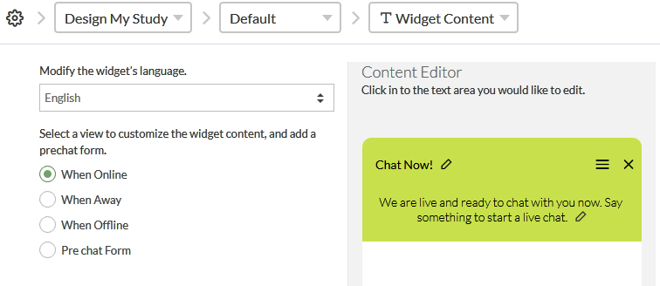

There are four contents, each for When Online, When Away, When Offline and Pre chart Form.

## Online Offline Settings

Whether the widget is showing Online or Offline depends on whether any agents are signed in and how the schedule is set if the scheduler is turned on. If the scheduler is turned on, the widget status is shown in the following figure:

.

|  |  |  |  |
| --- | --- | --- | --- |
| Shown  on  Web | | Agent | |
| on | off |
| Scheduler | on | ON | off |
| off | off | off |

Therefore, agents should always be signed in. The scheduler will determine whether a visitor sees Online or Offline widget on the client end.

# Agent Status

An agent can have four statuses:

* Online – default signed-in status
* Offline – default logout status
* Away
* Invisible

The default status is Online when an agent signed in and Offline when the agent is logged out.

The status of Away and Invisible can be set when the agent is signed in. Bring up the agent panel by click the agent symbol on top left. After clicking, the agent panel displays. Click Online next to the green dot, Away and Invisible will present. The agent can choose what status to use.

  