Stephanie Ramos
February 15, 2026
Module 5.2 Assignment:
Value Stream Mapping
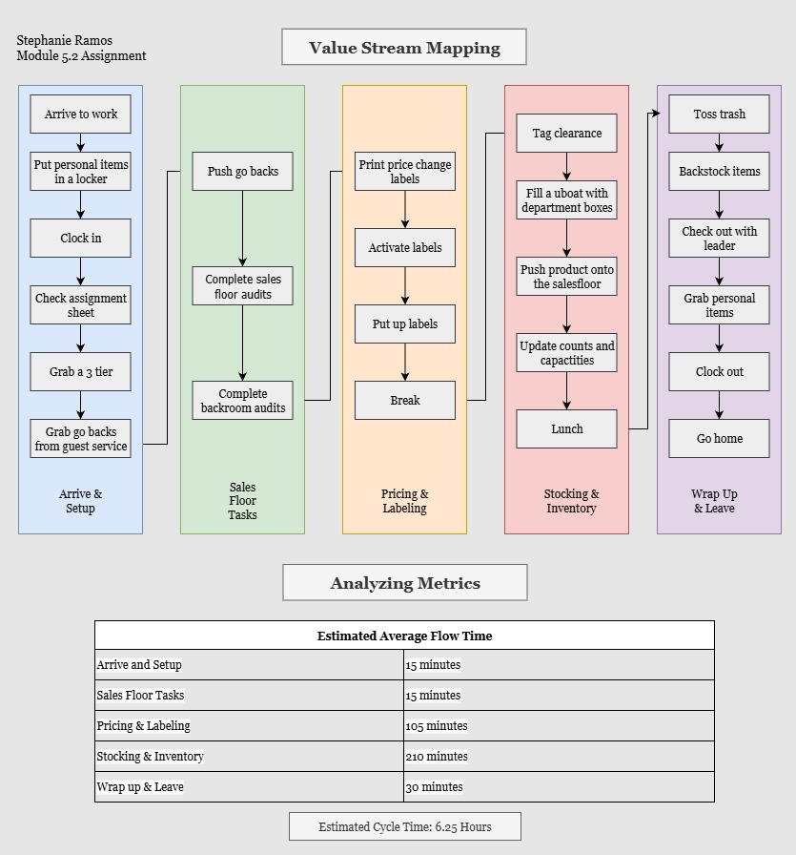

Optimize Work Routine
Eliminate Waste:
One area where waste can be reduced is during backroom audits. These can be completed while grabbing a 3-tier or filling a U-boat with product, since I am already in the backroom, which helps prevent unnecessary trips between the sales floor and stockroom and could save about 5-7 minutes per shift. Another opportunity to reduce waste is to complete the salesfloor audits and push go-backs if they are in the same aisle. Doing this reduces extra walking and improves overall flow during my shift.
Workflow Orchestration:
If I do not need someone to cover my area during lunch, it prevents time spent finding someone from the style department or checking the grid to see who is not on break. This allows me to go straight to lunch without interrupting the flow of work. Also, when price change is completed on the previous day, it allows me to move directly into stocking and inventory tasks without rearranging my workflow. Organizing tasks this way helps reduce delays and keeps the shift moving efficiently.
Governance Models:
When there is no leftover work from the closer, more time can be spent completing assigned tasks instead of fixing unfinished work. In the same way, if the fulfillment team keeps boxes organized and does not create a mess, it prevents time being spent reorganizing pallets. Having clear expectations across teams helps keep the workflow running smoothly. These standards hold people accountable, reduce rework, and help the shift stay on track.
References:
Knight, L. (2020, October 29). 3 easy steps for using VSM in everyday life. ConnectALL. https://www.connectall.com/3-easy-steps-for-using-vsm-in-everyday-life/
OpenAI. (2025). ChatGPT (40 mimi). https://chat.openai.com/chat

