Stephanie Ramos
December 7, 2025
Module 9 Programming Assignment
Screenshots
MySQL 5.7 Server Successfully Started
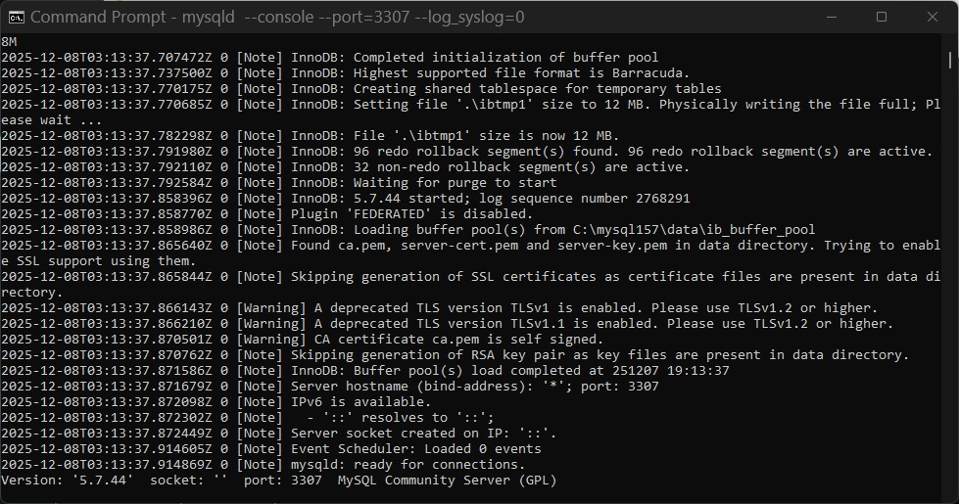
Logging Into MySQL as student1 and Viewing Databases
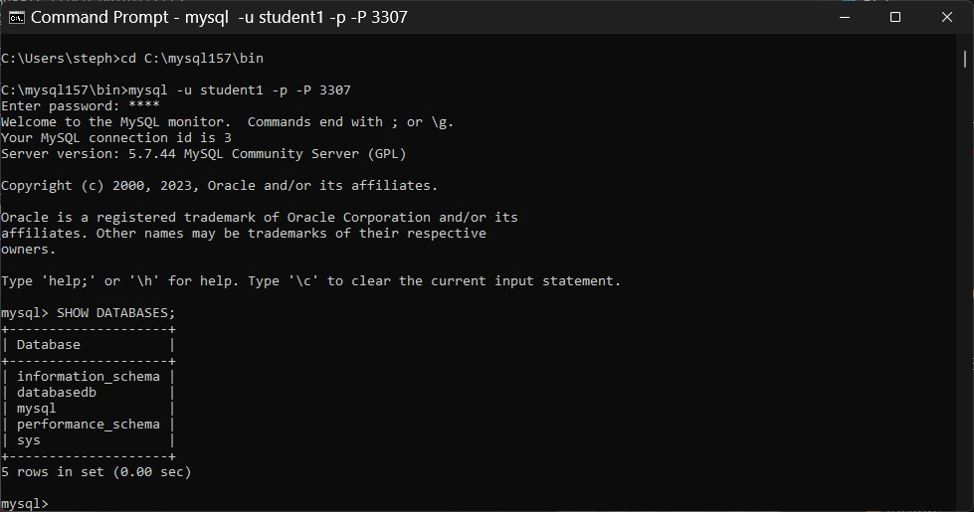
databasedb Before Table Creation (No Tables Present)
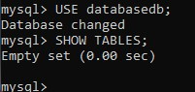
Table address33 Created via CreateTable.java
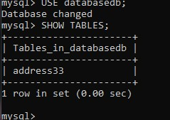
InsertData.java Successfully Inserted Rows
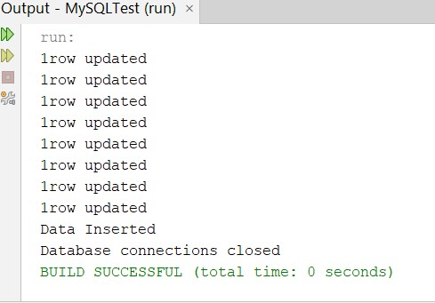
Records Successfully Stored in address33
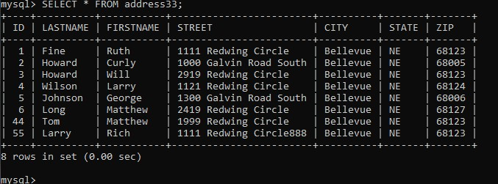
Select5.java Successfully Retrieved Database Records
