Stephanie Lara
March 15, 2026
M11 Assignment
Coding Standards
Consistency plays an important role in keeping systems organized and understandable. In software development, this is especially important when multiple developers work on the same project. If each developer writes code using a different style, the program can become difficult to read, maintain, and update over time. Coding standards help address this issue by providing shared guidelines that define how code should be written, formatted, and structured. In this paper, I will explain what coding standards are, how development teams apply them, and why they are important in helping organizations maintain consistency and quality in software development.
There are many organizations that create their own coding standards based on the programming languages and systems they develop. These guidelines help ensure that code written by different developers continues to follow the same rules and structure as the rest of the project. Coding standards often include practices such as using meaningful variable names, proper indentation, and clear comments so that the purpose of the code is easier to understand (GeeksforGeeks, 2024). When developers follow the same coding guidelines, it becomes easier for others to review the code, identify errors, and make updates while keeping the project consistent.
Development teams use several methods to ensure that new code follows established coding guidelines. One common practice is code reviews, where developers examine code before it becomes part of the main project. Code reviews allow team members to confirm that code follows the project’s standards and does not introduce errors into the system (Dovgal, 2026). According to Dovgal, this process helps maintain a consistent codebase while also improving collaboration between developers. As a result, problems can often be caught early before they affect the entire project.
Version control systems also support coding standards during software development. These systems help teams track changes and organize updates to the codebase. Version control tools allow developers to manage code changes and collaborate while maintaining consistency across the project (Dovgal, 2026). This allows multiple developers to work on different parts of the program without interfering with each other’s work. By keeping changes organized, development teams can manage large projects more effectively.
Automated tools also help development teams enforce coding standards. Many organizations use tools that scan code to detect formatting problems or violations of style guidelines. Linters and static analysis tools can automatically review code and identify issues related to formatting, security, or coding practices (Dovgal, 2026). These tools help developers detect problems early in the development process. Because of this, teams can maintain coding standards while also saving time during development.
Coding standards are important because they improve the readability and maintainability of software systems. When code follows consistent formatting and naming rules, developers can understand how a program works much more quickly. Consistent coding practices also make it easier for new developers to understand an existing codebase when joining a project (Patel, 2024). This reduces the time needed to learn the system and allows developers to focus more on improving the software.
Coding standards also improve collaboration between developers. Large software systems are often built by teams of engineers who work on different parts of the same project. Consistent coding standards help development teams work together more efficiently because everyone follows the same structure and formatting rules (GeeksforGeeks, 2024). This consistency allows developers to review each other's work more easily and identify problems faster. As a result, coding standards support better teamwork during software development.
Coding standards also help improve the overall quality and reliability of software systems. Many coding guidelines include recommendations for handling errors, validating user input, and writing secure code. Following these practices can reduce programming mistakes and help developers build more reliable applications (Dovgal, 2026). This structured approach prevents disorganized code that becomes difficult to maintain later. As a result, coding standards contribute to stronger, more stable software systems.
In conclusion, coding standards are an important part of modern software development. They provide development teams with guidelines that help maintain consistency, readability, and organization within a project. These standards guide how developers structure programs, name variables, and document code so that teams can collaborate more effectively. By following coding standards, development teams can reduce errors, improve teamwork, and maintain software more efficiently. As software systems continue to grow in complexity, coding standards remain essential for producing reliable and maintainable applications.

References
Dovgal, A. (2026, January 5). Coding standards and best practices guide: Implementation tips. DevCom. https://devcom.com/tech-blog/coding-standards-and-best-practices-guide-implementation-tips/
GeeksforGeeks. (2024). Coding standards and guidelines. https://www.geeksforgeeks.org/software-engineering/coding-standards-and-guidelines/
Patel, R. (2024, June 5). Understanding coding standards: Why they matter. Medium. https://medium.com/@ravipatel.it/understanding-coding-standards-why-they-matter-cc75adcba245

Example
Code without following the guidelines:
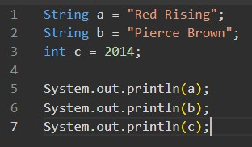
Code that follows the guidelines:
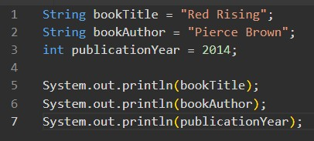
Following these guidelines makes it easier for other developers to understand what the variables represent. Without clear variable names, it would be difficult to recognize that the information is describing a book.

