Stephanie Lara
March 8, 2026
Module 10 Assignment
Creating Custom Tags in JSP
When developing web applications, things can start to get confusing as the project grows. As more features are added, the code inside the webpage can become harder to read and manage. For example, when too much programming logic is written directly inside a JSP page, it can make the page difficult to follow or update later. Because of this, developers need better ways to organize their code. Java Server Pages (JSP) provide a feature called custom tags that help with this problem. Custom tags allow developers to create reusable elements that perform specific tasks while keeping the JSP page cleaner. In this paper, I will discuss some of the advantages and disadvantages of using custom tags, explain what is required to create them, and share my opinion on why they are helpful when working with JSP.
One major advantage of custom tags is that they help separate business logic from the JSP page. Instead of placing Java code directly into the page using scriptlets, the logic is moved into a separate Java class called a tag handler (GeeksforGeeks, 2025). This makes the page easier to read because the JSP file mainly focuses on displaying the information rather than performing all of the processing. Another advantage is that custom tags can be reused in multiple places. Developers can create a tag once and then use it across different JSP pages without rewriting the same code again (GeeksforGeeks, 2025). This helps reduce duplicated code and keeps the application more organized. Custom tags can also make things easier for front-end developers because they can use the tag without needing to understand the entire Java implementation behind it.
Even though custom tags provide several benefits, there are also a few disadvantages. One issue is that creating custom tags requires more setup than simply writing a small amount of code directly inside the JSP page. Developers need to create a tag handler class, define a Tag Library Descriptor (TLD) file, and configure the tag library before the tag can be used (TutorialsPoint, n.d.). Because of this, it can take more time to set everything up at the beginning. Another potential drawback is debugging. Since the logic is separated into multiple files instead of being located directly in the JSP page, it may take a little longer to find where an error is coming from.
There are several requirements that must be met when creating custom tags in JSP. The first requirement is a tag handler class. The tag handler is a Java class that contains the logic that will run when the custom tag is used in a JSP page. Developers often create these classes by extending SimpleTagSupport and implementing the doTag() method to define what the tag should do (TutorialsPoint, n.d.). This class is important because it controls how the tag behaves when the JSP page is processed by the server.
Another requirement is the Tag Library Descriptor (TLD) file. This file describes the tag library and defines the tags that belong to it, including their attributes and the Java classes that implement them (GeeksforGeeks, 2025). The TLD file allows the JSP container to understand how each custom tag should behave when it appears on a page. The last requirement is the taglib directive inside the JSP page. This directive tells the JSP page which tag library is being used and what prefix should be used to access the tags. The taglib directive allows the JSP page to recognize custom tags and process them correctly (Oracle, n.d.). Without this declaration, the JSP page would treat the custom tag as normal text instead of executing its functionality.
In my opinion, custom tags are a very useful feature in JSP development. They were created to solve the problem of mixing too much Java code directly into JSP pages. When Java code and page layout are mixed, the page can quickly become messy and difficult to maintain. By moving the logic into tag handlers, the JSP page becomes easier to read and understand. This is one of the main reasons I would consider using custom tags in JSP applications. They also allow developers to reuse functionality across multiple pages, which can save time and keep the application more consistent. While some developers might avoid custom tags because of the additional setup, the disadvantages are relatively small compared to the benefits. In many cases, the improved organization and readability make custom tags a better option.
In conclusion, custom tags are a helpful feature that improves the structure of JSP applications. They allow developers to move processing logic out of the JSP page and into reusable Java classes. This helps keep JSP pages cleaner and easier to manage. Although custom tags require some extra setup at the beginning, the long-term benefits usually make them worth using. As web applications grow larger and more complex, tools like custom tags can help developers keep their code organized and easier to maintain.
References
GeeksforGeeks. (2025, July 23). Custom tags in JSP.
https://www.geeksforgeeks.org/java/custom-tags-in-jsp/
Oracle. (n.d.). Custom tags in JSP pages. The Java EE Tutorial.
https://docs.oracle.com/javaee/1.4/tutorial/doc/JSPIntro9.html
TutorialsPoint. (n.d.). JSP custom tags.
https://www.tutorialspoint.com/jsp/jsp_custom_tags.htm
Code Examples
Tag Handler: This is a simple tag handler that prints a book recommendation.
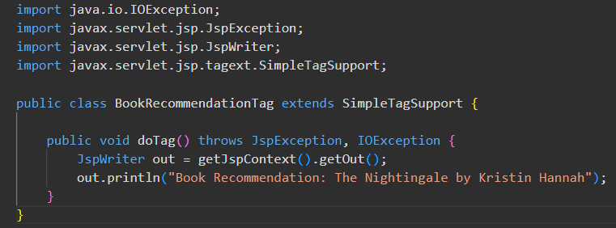
Tag Library Descriptor (TLD): This defines the custom tag and links it to the tag handler class.
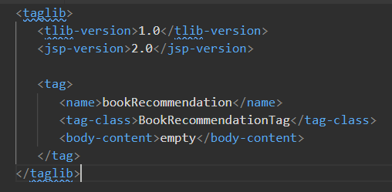
JSP Page Using the Custom Tag: This shows how the custom tag would be used inside a JSP page.
