Stephanie Lara
March 26, 2026
Module 1.2 Assignment
GitHub Setup
GitHub Link: https://github.com/steph31090/csd-440.git
GitHub Screenshot:
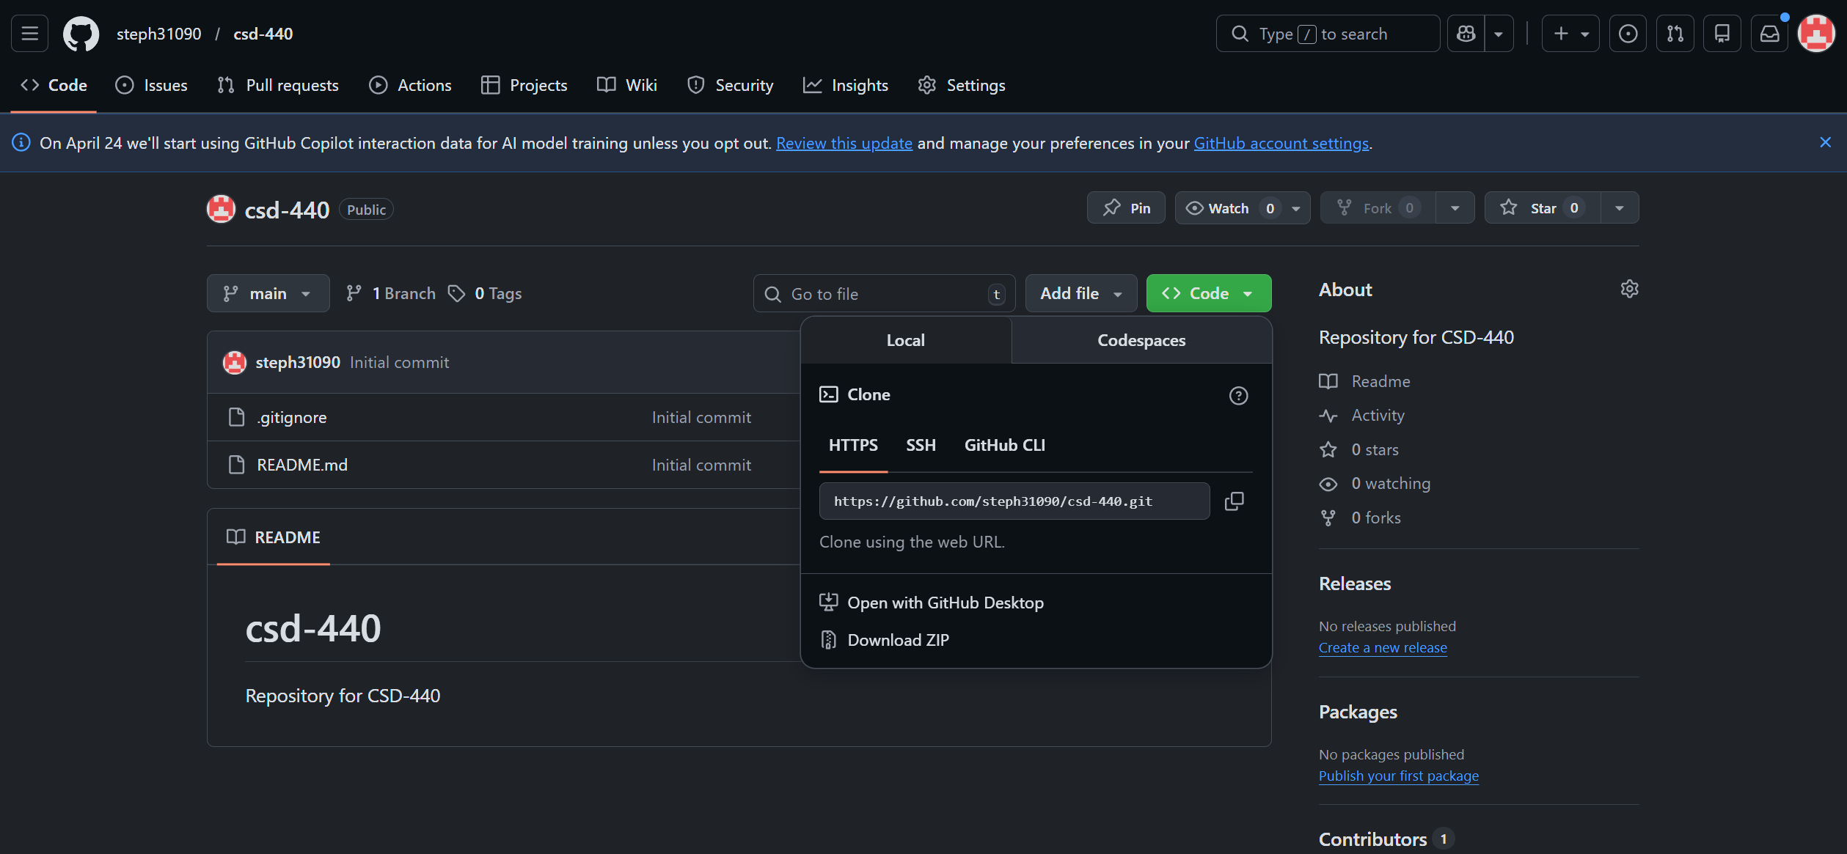
Directory:
