MITIC 5e | Name : Bobinaz | First name : Alice
MITIC 5e | Class : 5e | Date :
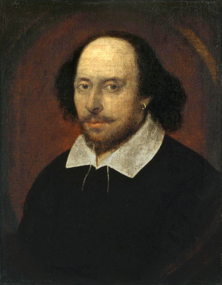
MUCH ADO ABOUT NOTHING
by William Shakespeare

DRAMATIS PERSONAE:
- DON PEDRO, Prince of Arragon.
- DON JOHN, his bastard Brother.
- CLAUDIO, a young Lord of Florence.
- BENEDICK, a young Lord of Padua.
- BEATRICE, Niece to Leonato.
- MARGARET, Waiting-gentlewoman attending on Hero.
- URSULA, Waiting-gentlewoman attending on Hero
- …

Act II
Scene 3. LEONATO'S Garden.

[Enter Benedick.]
BENEDICK. Boy!
[Enter a Boy.]
BOY Signior?
BENEDICK. In my chamber-window lies a book; bring it hither to me in the orchard.
BOY. I am here already, sir.
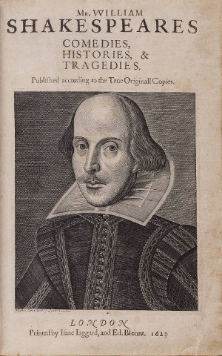
BENEDICK. I know that; but I would have thee hence, and here again. [Exit Boy.] I do much wonder that one man, seeing how much another man is a fool when he dedicates his behaviours to love, will, after he hath laughed at such shallow follies in others, become the argument of his own scorn by falling in love: and such a man is Claudio.
(…)
He was wont to speak plain and to the purpose, like an honest man and a soldier; and now is he turned orthography; his words are a very fantastical banquet, just so many strange dishes. May I be so converted, and see with these eyes? I cannot tell; I think not: I will not be sworn but love may transform me to an oyster; but I'll take my oath on it, till he have made an oyster of me, he shall never make me such a fool. One woman is fair, yet I am well; another is wise, yet I am well; another virtuous, yet I am well; but till all graces be in one woman, one woman shall not come in my grace.
[Withdraws.]
(…)

hither : ici
scorn : mépris

