Storyboard
- Bob adds a new drone to the fleet.
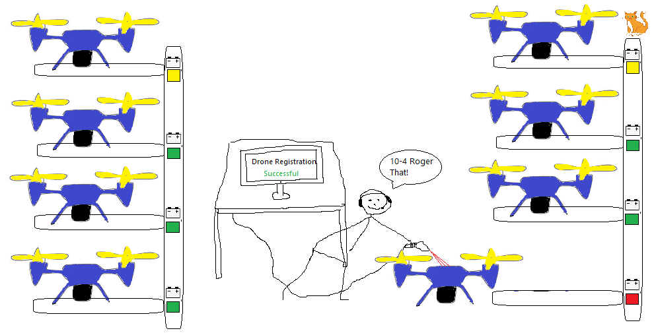
- Jim, the operator, confirms successful registration of the new drone,
but notices there is a problem with another drone.
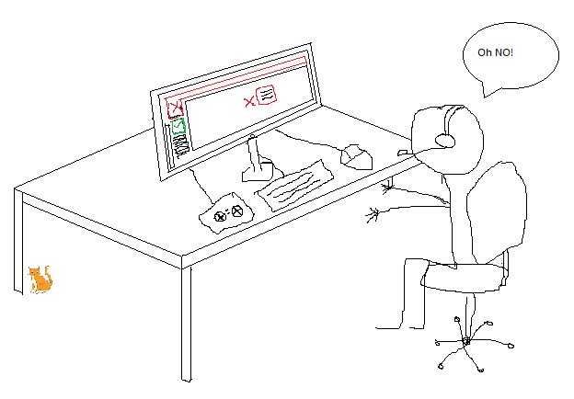
- The drone is stuck in a tree.
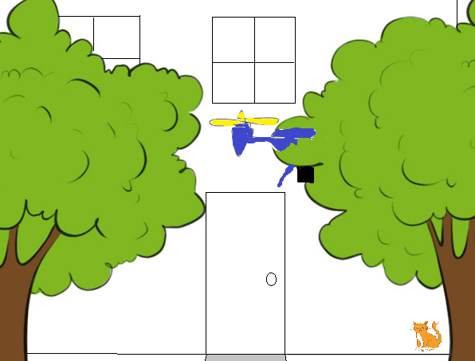

- Jim attempts to manually control the drone.
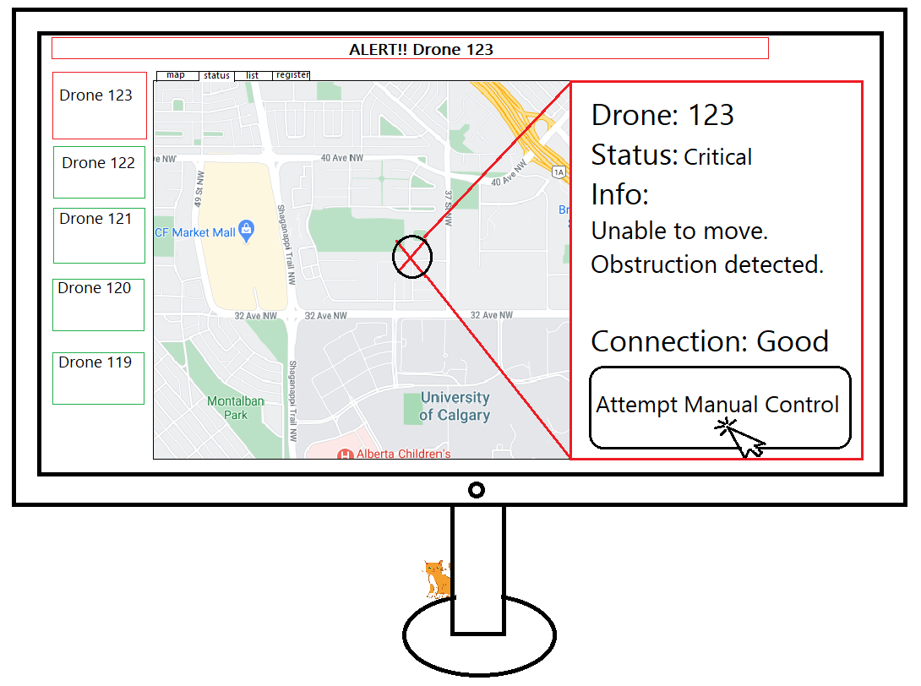
- Jim sees from the drone view that the drone is stuck in a tree and is unable to fix it remotely.
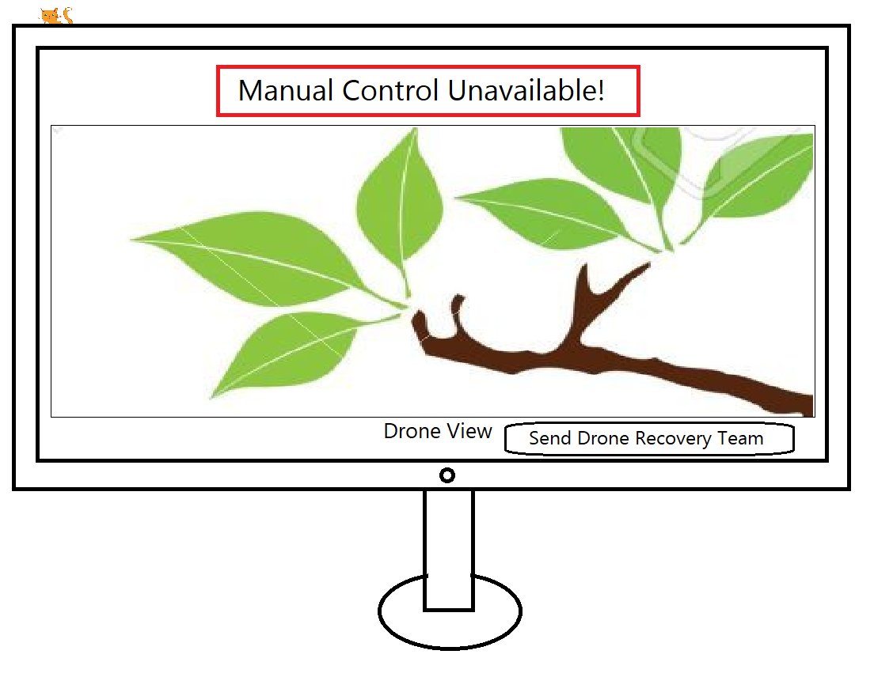
- Jim sends a request to the drone recovery team.
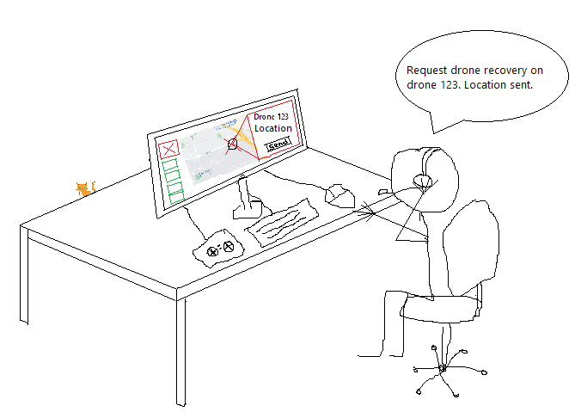
- Sam recovers the drone from the tree.
