Establish DNS between on-premises and the Cloud (45’)

In this exercise, you will have to discover the resources in the s2s resource group. The following architecture has been deployed:

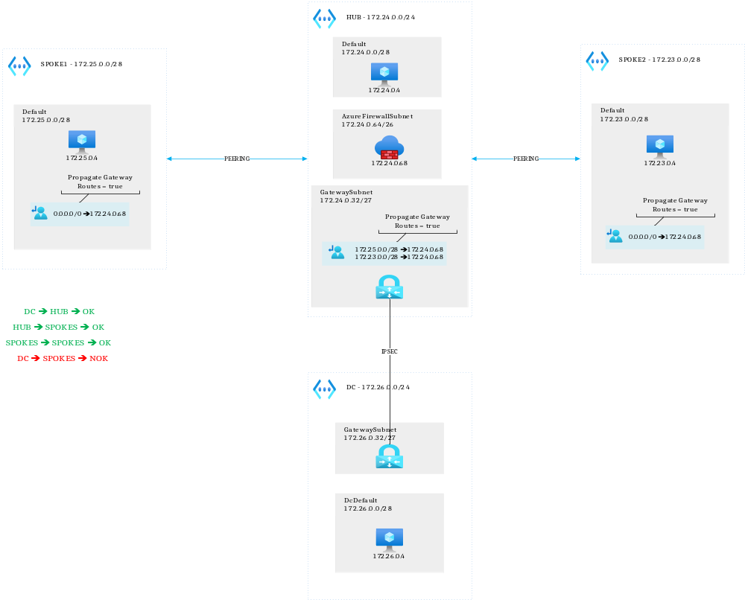
Since you should have fixed connectivity between on-premises and the cloud, it is now time to create proper DNS.
You will need:
- A private DNS resolver
- An on-premises DNS server
- An outbound endpoint
- A DNS forwarding ruleset
- To setup conditional forwarding on the on-prem DNS server

You have 45 minutes to:
- Make sure the DC VM can resolve any of the cloud VMs
- The cloud VMs can resolve the on-premises domain

Virtual machines username/password:

stephaneey
@1StrongPwd

